UNITY LPK INSTALLATION GUIDE

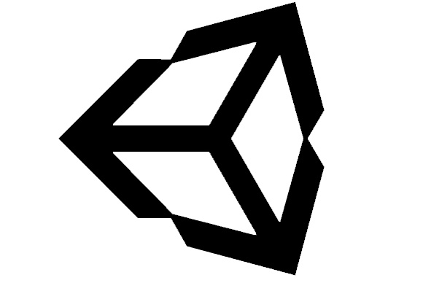

By Christopher Onorati

Last Update: 7/24/19

Contents

Document Purpose 2

Extracting the Files 3

Importing Unity Packages 4

Importing Unity Packages (continued) 5

XInputInterface.dll 6

Q/A 7

Credits 7

# Document Purpose

The purpose of this document is to outline how to install the files included within the Unity LPK .zip file for use in your own projects. For general questions on the usage of the Unity LPK, please refer to the Q/A section found at the end of this document. If your question was not answered, please contact the author of this document via their DigiPen webmail address.

Thank you for utilizing the Unity LPK ☺ !

# Extracting the Files

1. Ensure you have the latest version of the Unity LPK, which can be downloaded on Digipen Central under section 4 “BSGD and BAGD”.

**LINK TO DOWNLOAD SITE:** <https://distance.digipen.edu>

1. Reference the update log to see what has been changed if the version on DigiPen Central is newer than your local copy of the toolset.
2. Select all files within the .zip file and move them outside of the compressed folder. These files will be deleted later, so they can be stored to a temporary folder.

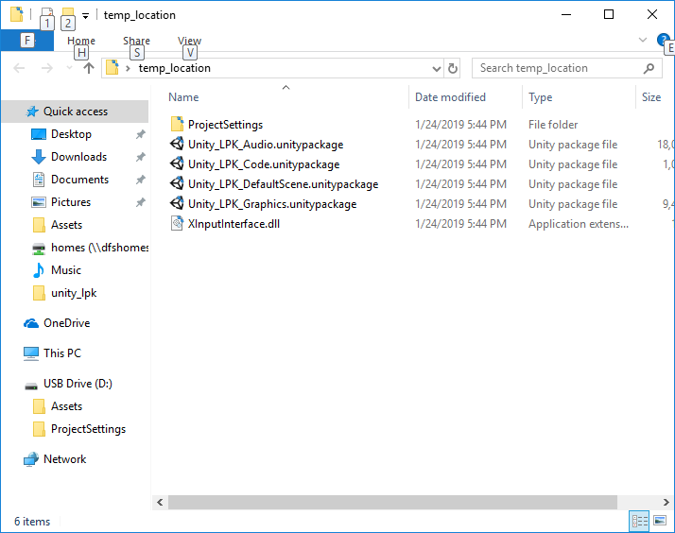

*NOTE: You do not need to copy over this document.*

1. Close the Unity_LPK.zip folder. You may delete the Unity_LPK.zip folder as well, if desired, at this point.

# Importing Unity Packages

1. Launch the Unity Project you wish to import the Unity LPK toolset into. You can do this through the Unity Launcher, or by launching unity via a .unity asset.
2. Once you have launched your project, click on “Assets” found near the top right of the screen by default.
3. On the pop-up menu that appeared when clicking on “Assets”, click on “Import Package”.
4. Select “Custom Package”.

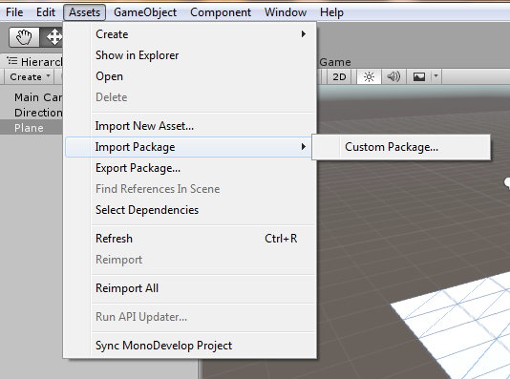

1. A window will pop up at this point. Navigate to the location you have extracted the files found within the Unity_LPK.zip folder. Double click on any of the .unityproject files.

**NOTE: Each package contains separate content.**

* **“Unity_LPK_Code” contains all scripts, shaders, textures, and plugins.**
* **“Unity_LPK_Graphics” contains sprites and tilemaps.**
* **“Unity_LPK_Audio” contains sound effects and musical stingers.**
* **“Unity_LPK_DefaultScene” contains an empty 2D scene.**

# Importing Unity Packages (continued)

1. Once you have selected a Unity Package, a new dialogue box will pop up, asking what contents of the package you wish to add to your project. You may add and remove any of the assets as desired.

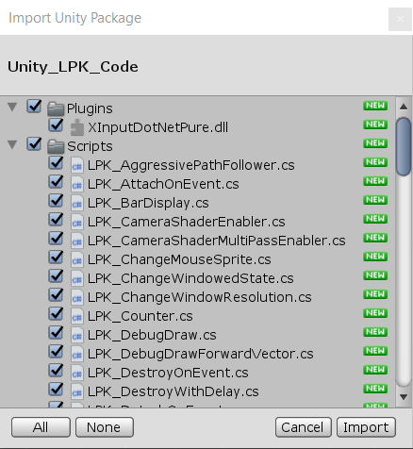

**NOTE: If updating a project with the Unity LPK already in it, Unity will not override files that have no changes between your local copy, and the copy stored within the .unitypackage file.**

**NOTE: LPK_Utilities, LPK_EditorTools, and LPK_EditorAttributes are all required for any of the other LPK scripts to function correctly.**

**NOTE: You can only add a single .unitypackage at a time via this method. Another method to add .unitypackage files into your project is to drag the files onto the Project window found by default at the bottom of the editor.**

# XInputInterface.dll

1. Close the Unity project if it is open.
2. Navigate to the location your project is saved at. If you do not know where your project is saved, you can right click in the Project window within the editor and select “show in explorer”.

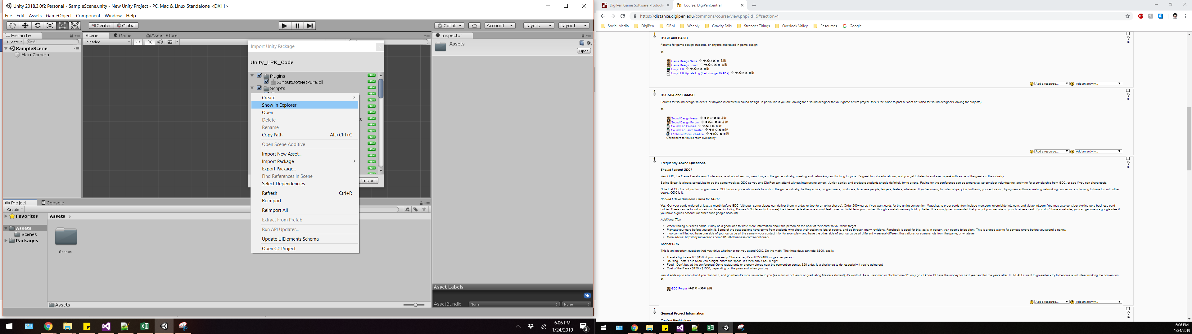

1. Copy the XInputInterface.dll you extracted earlier, and paste it **NEXT TO** the assets folder of your project.

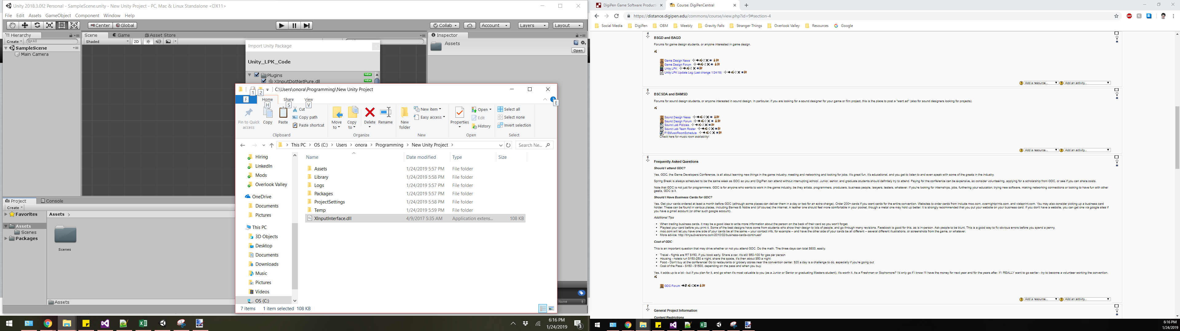

**NOTE: This DLL is used to enable controller vibration, but will make your project windows-exclusive. You do not need to import this .dll if you wish to use the LPK on platforms other than windows.**

# Q/A

**Q:** Can I use the Unity LPK for projects outside of DigiPen?

**A:** The Unity LPK can be used for any project at DigiPen, as long as the instructor for the project approves its use. It can be used for personal projects outside of DigiPen, but you MUST list the credits as found at the end of this document if you do so. For projects done for other companies, or monetized projects, you must get approval from DigiPen (contact Benjamin Ellinger).

**Q:** What versions of Unity will this toolset work for?

**A:** The Unity LPK will work on any version of Unity dating from 2017-2019. This is subject to change as updates are made to the engine/LPK toolset.

**Q:** Can I use the Unity LPK for 2D and 3D games?

**A:** Most of the LPK works for both 2D and 3D games. Some components are restricted to 2D use due to references to colliders and RigidBodies. Users may modify these scripts to work in 3D, if desired.

**Q:** I found a bug! What do I do?

**A:** If you find a bug in the Unity LPK, please contact the author of this document immediately. Before doing so, however, please ensure that you can reproduce the bug.

**Q:** I want a feature added…please!?

**A:** If you have a feature request for the Unity LPK, please contact the author of this document. Please do not request game-specific requests such as specific character controllers, enemy AI, etc.

**Q:** Do I have to credit anyone to use this toolset?

**A:** Yes. Please use the text in “Credits” section of this document below ==EXACTLY== as listed (including the header).

# Credits

DigiPen LPK Development Team

* Christopher Onorati –Lead Programmer
* Victor Cecci – Core Architecture Programmer
* Doug Zwick – Tools Programmer, Quality Assurance
* Aeon Williams – Quality Assurance