# Linux Mint 16 Installation & Configuration

# Configuration

Once Installation Completes, if VM, install VBox Guest Additions

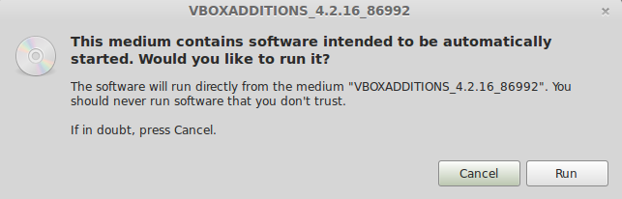

## Install updates

### Error on Update

* Upon Error run this command in terminal to manually clean it up
* sudo dpkg --configure -a
* Run Install Updates now

### 4 broken packages, use filter to locate them

## Samba for Networking

system-config-samba

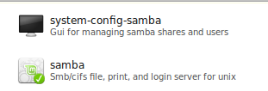

### Samba Server Settings

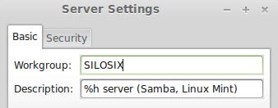

## Users and Groups

* silosix-admin [ silosix setup remote
* silosix-users [ muneca
* silosix-guest [ guest
* silosix-minors [ minor

## Remote Desktop Enable

* vino-preferences
* vino-server
* uses port 5900
* netstat -nl | grep 5900

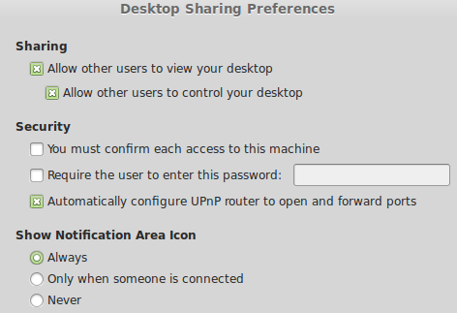

## Personal File Sharing

* May run into missing packages issue, so just go a folder such as ‘Public’ and select ‘Sharing Options’, and share the folder. Looking to force the OS to initialize the sharing components.

