1. Install Nebula

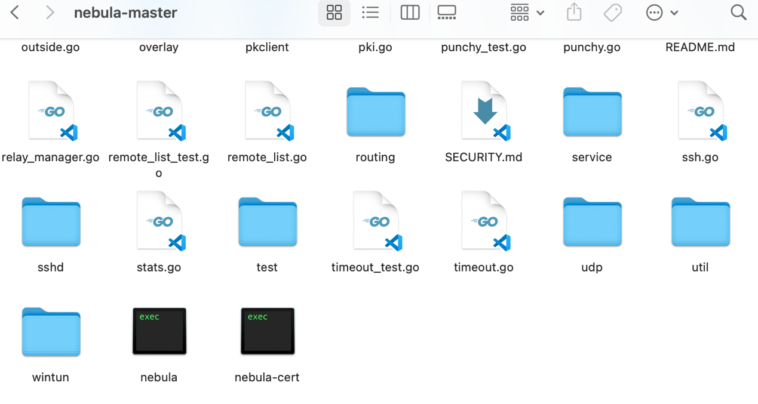

***Figure1. Install Nebula & Nebula-cert***

*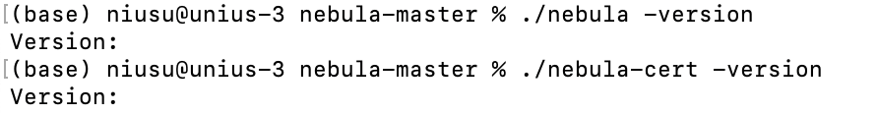****Figure2. Nebula & Nebula-cert version***

2. Configure MBP15.conf.yaml

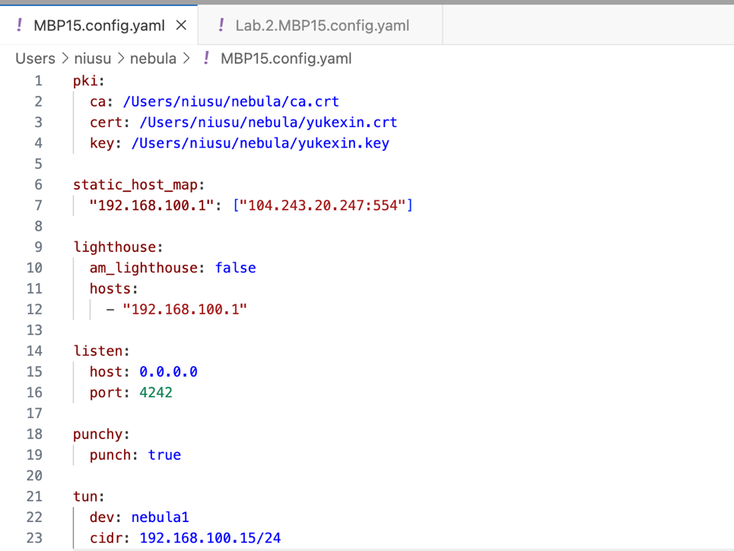

***Figure3. MBP15.conf.yaml***

3. Connect to the lighthouse

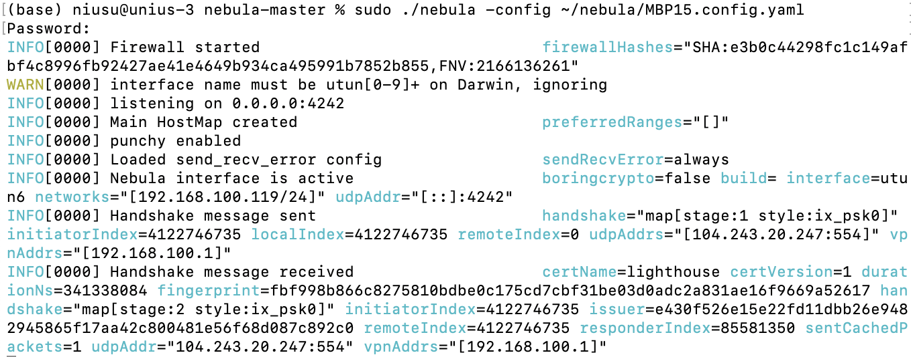

***Figure4. Start local nebula and connect to the lighthouse***

4. Connect to the Nebula network

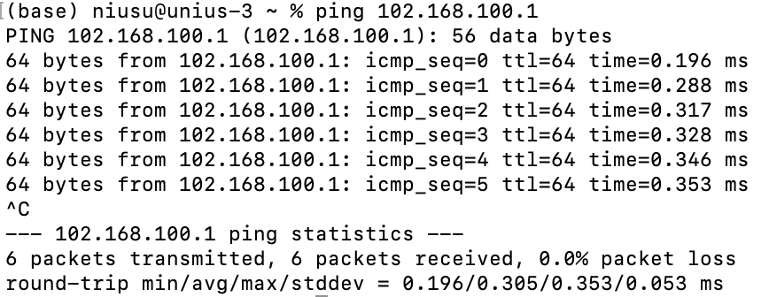

***Figure5. Test the network connectivity***