1. Install docker



***Figure1. Start docker***

2. Insall gitea

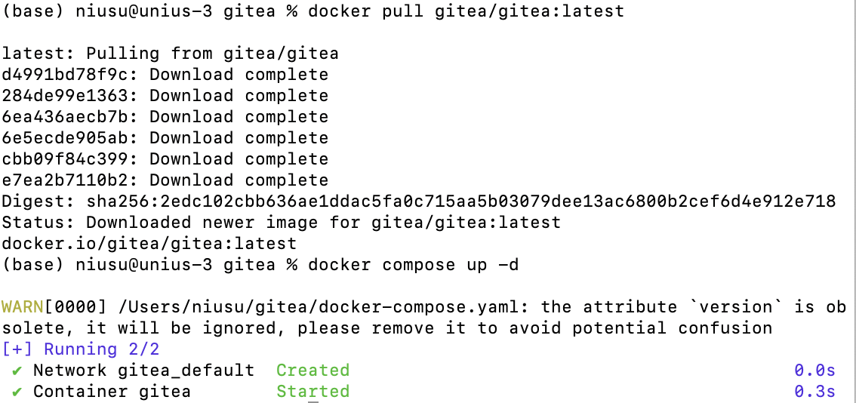

 ***Figure2. Start gitea***

a. Does it support LFS? prove it. ----Yes

The LFS configuration is enabled.

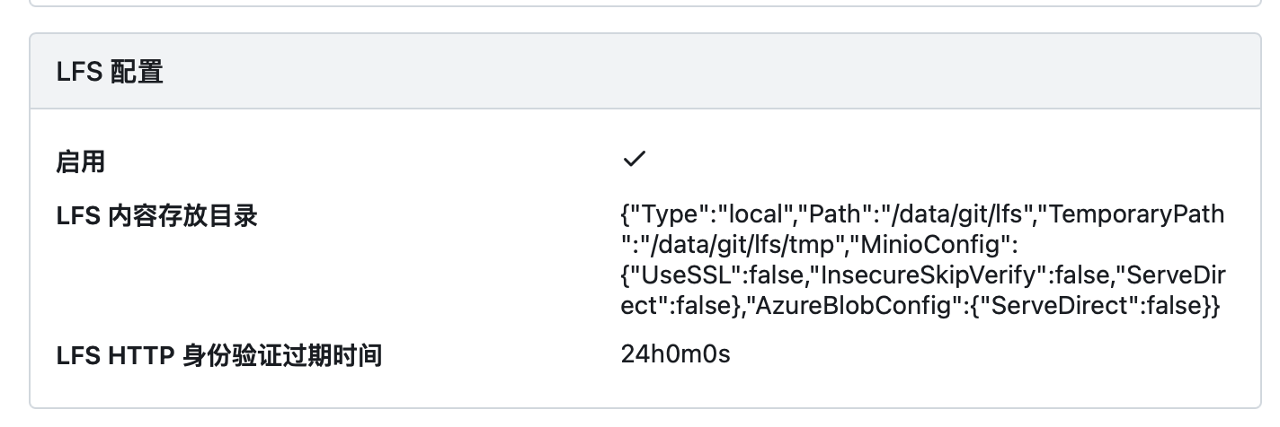

***Figure3. LFS supporting***

b. Create a repo with a large file (1G+)

① Create a repository



***Figure4. Create a repository***

② Create 1GB file

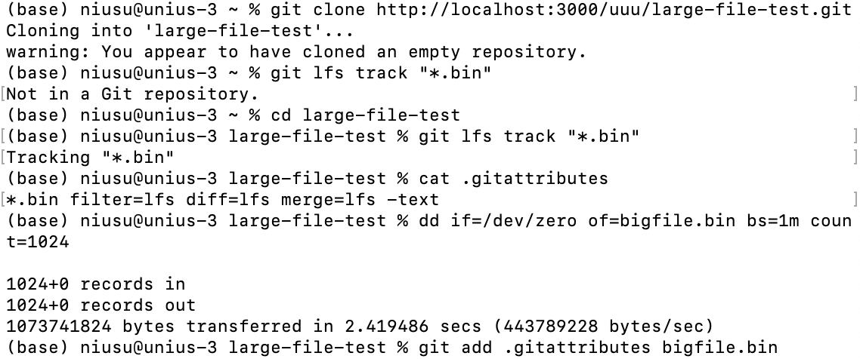

***Figure5. Create 1GB file***

③ Push the file to gitea

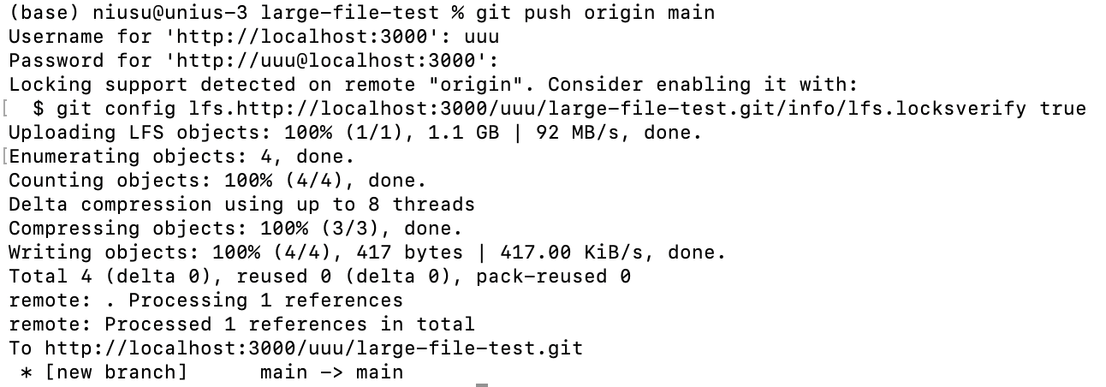

***Figure6. Push the file to gitea***

④ Verify



***Figure7. Git LFS works***