1. Download Istio

**Command:**

curl -L https://istio.io/downloadIstio | sh -

cd istio-1.27.2

export PATH=$PWD/bin:$PATH

**Note:**

Downloads Istio and adds the istioctl binary to your PATH so you can use Istio commands.

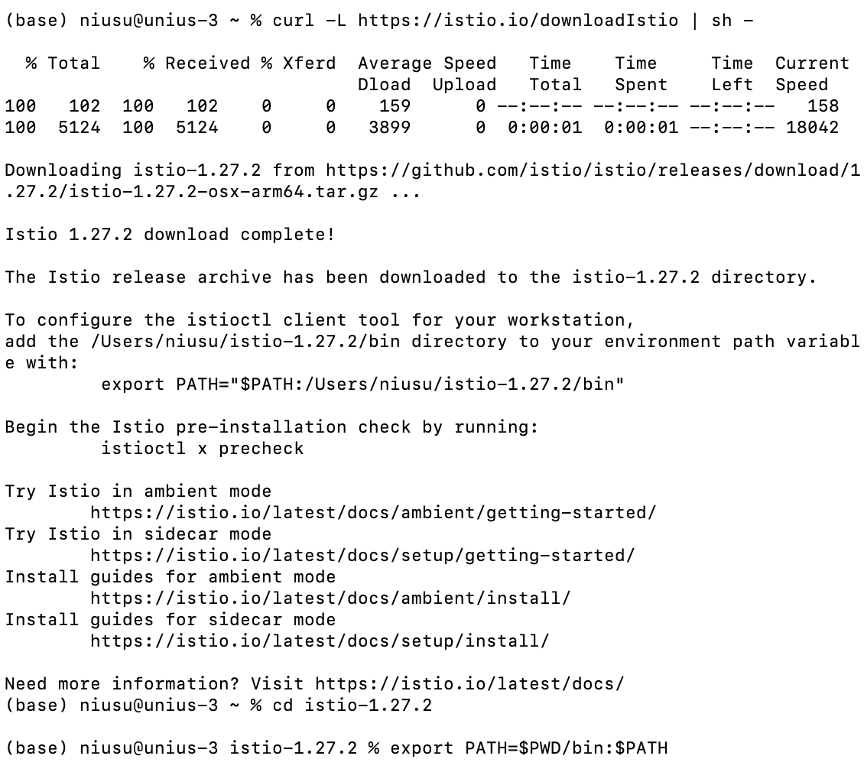

***Figure1: Download Istio***

2. Install Istio

**Command:**

istioctl install -f samples/bookinfo/demo-profile-no-gateways.yaml -y

kubectl label namespace default istio-injection=enabled

**Note:**

Installs Istio using a demo profile without gateways. Labels the default namespace to enable automatic sidecar injection.

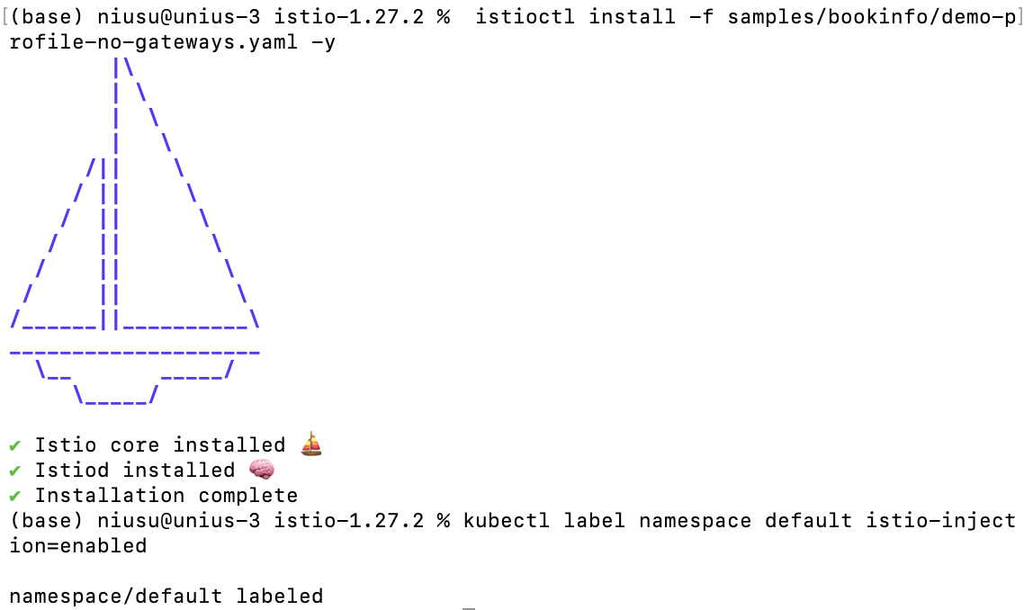

***Figure2: Install Istio***

3. Install the Kubernetes Gateway API CRDs

**Command:**

kubectl get crd gateways.gateway.networking.k8s.io &> /dev/null || \

{ kubectl kustomize "github.com/kubernetes-sigs/gateway-api/config/crd?ref=v1.3.0" | kubectl apply -f -; }

**Note:**

Installs the Gateway API CRDs only if they are not already present in the cluster.

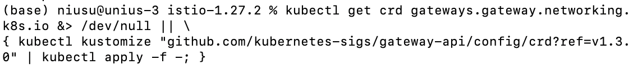

***Figure3:*** ***Kubernetes Gateway API CRDs***

4. Deploy the sample application

**Command:**

(1) Deploy the Bookinfo sample application

kubectl apply -f samples/bookinfo/platform/kube/bookinfo.yaml

kubectl get services

kubectl get pods

**Note:**

Deploys the Bookinfo sample application and checks that all services and pods are running.

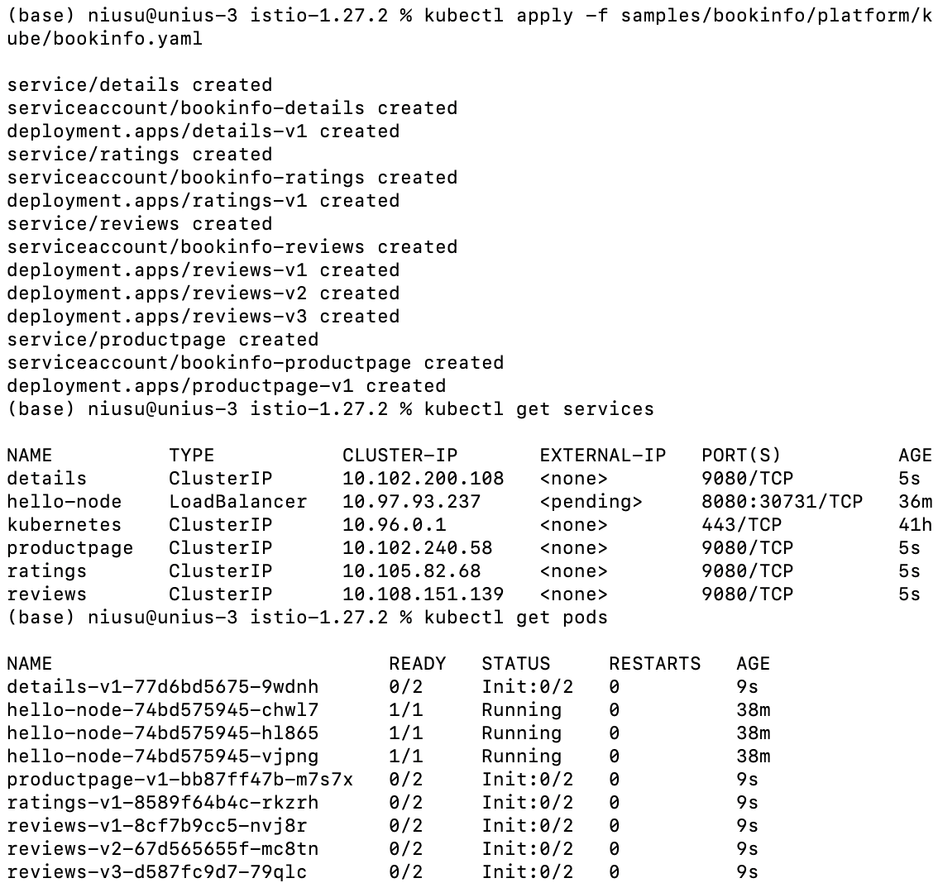

***Figure4: Deploy the sample application***

(2) Validate that the app is running inside the cluster by checking for the page title in the response

**Command:**

kubectl exec "$(kubectl get pod -l app=ratings -o jsonpath='{.items[0].metadata.name}')" -c ratings -- curl -sS productpage:9080/productpage | grep -o "<title>.*</title>"

**Note:**

Confirms the application is running by checking the page title in the response.

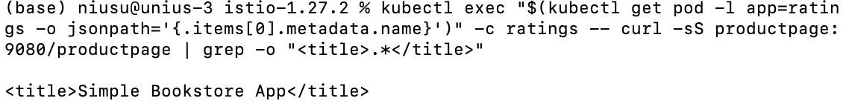

***Figure5: Validate the app***

5. Open the application to outside traffic

**Command:**

kubectl apply -f samples/bookinfo/gateway-api/bookinfo-gateway.yaml

kubectl annotate gateway bookinfo-gateway networking.istio.io/service-type=ClusterIP --kubectl get gateway

**Note:**

Creates a Gateway resource to expose the Bookinfo application to external traffic and annotates it as a ClusterIP service.

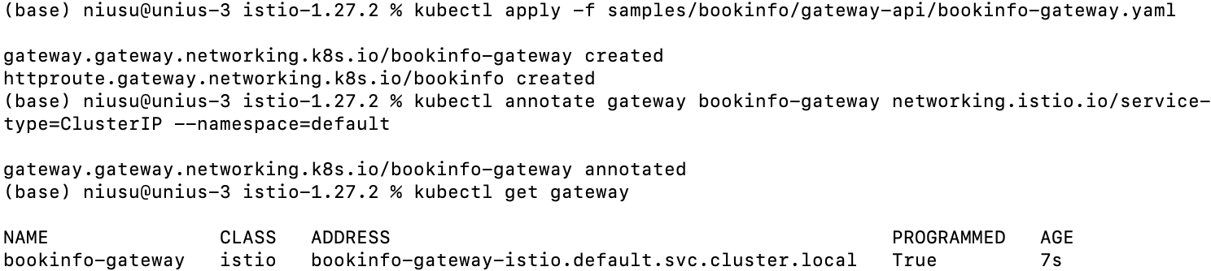

***Figure6: Open the application to outside traffic***

6. Access the application

**Command:**

kubectl port-forward svc/bookinfo-gateway-istio 8080:80

**Note:**

Forwards local port 8080 to the Bookinfo gateway service so you can access the app in a browser.

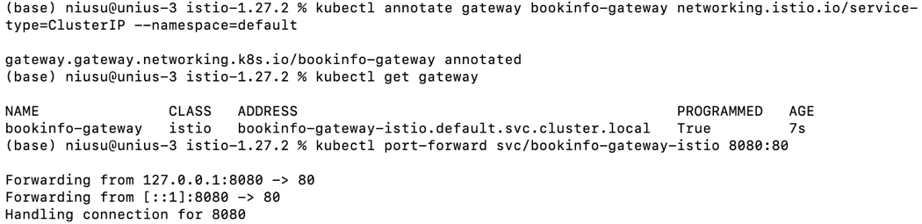

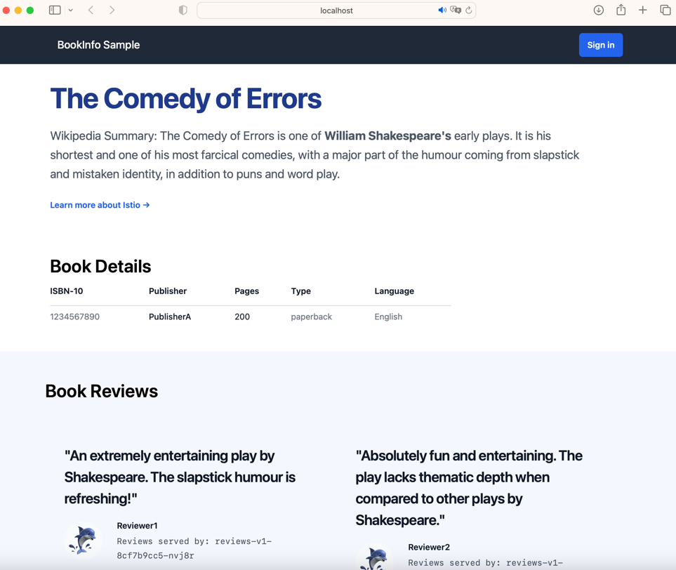

***Figure7: Access the application***

7. View the dashboard

**Command:**

kubectl apply -f samples/addons

kubectl rollout status deployment/kiali -n istio-system

istioctl dashboard kiali

**Note:**

Runs an Nginx container to serve the current directory on port 8081 for viewing dashboards or HTML pages.

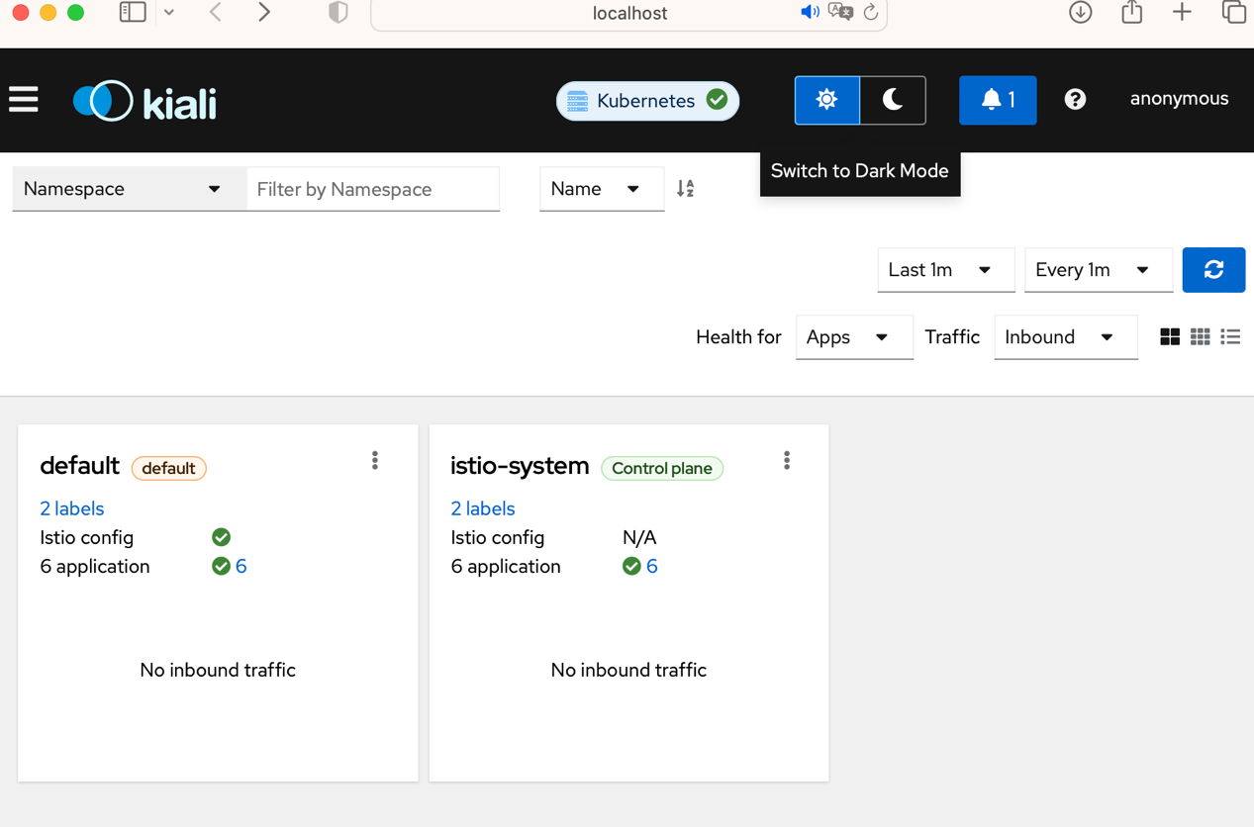

***Figure8: Dashboard***