1. Environment Setup
Command:
kubectl apply -f serving-crds.yaml
kubectl apply -f serving-core.yaml
kubectl apply -f istio.yaml
kubectl apply -f net-istio.yaml
kubectl --namespace istio-system get service istio-ingressgateway
kubectl apply -f cert-manager.yaml
kubectl apply -f eventing.yaml
Note:
The above commands install all necessary components for Knative, including Serving, Eventing, Istio networking, and Cert-Manager. Running kubectl --namespace istio-system get service istio-ingressgateway allows you to confirm that the Istio Ingress Gateway is deployed and running. Once the environment is set up, Knative can deploy and manage serverless services on the Kubernetes cluster. Every pod should be ready & running.
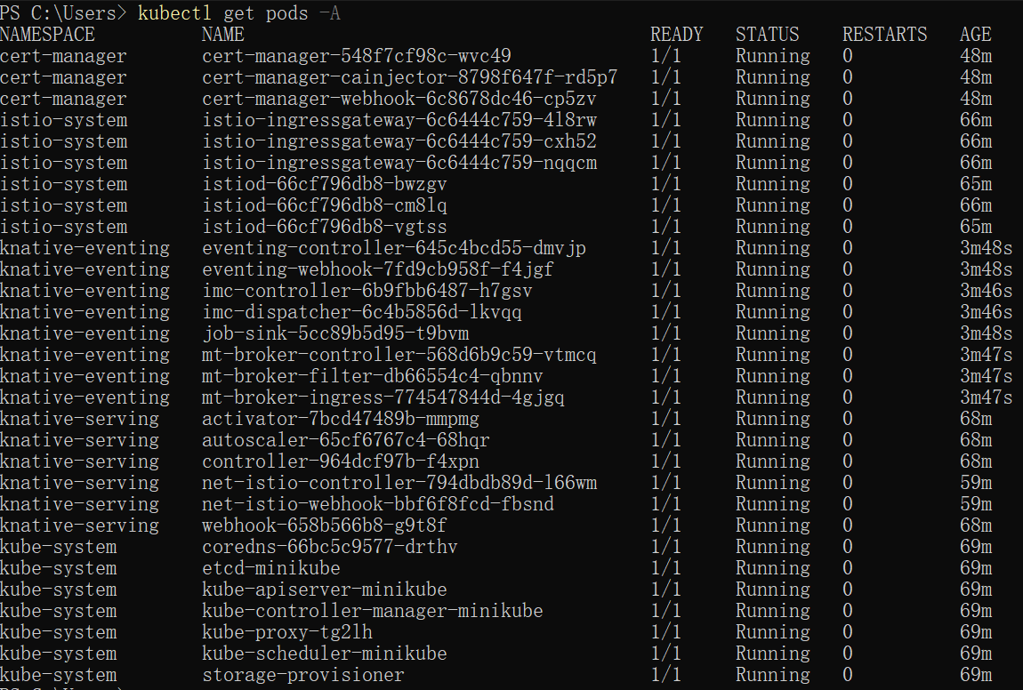
Figure1: Install components for Knative

2. Knative Function
(1) Installing func CLI
Command:
brew tap knative-extensions/kn-plugins
brew install func
func version
Note:
This step sets up the func CLI, which is essential for creating and managing Knative functions. Verifying the installation ensures the tool is ready for development and testing.
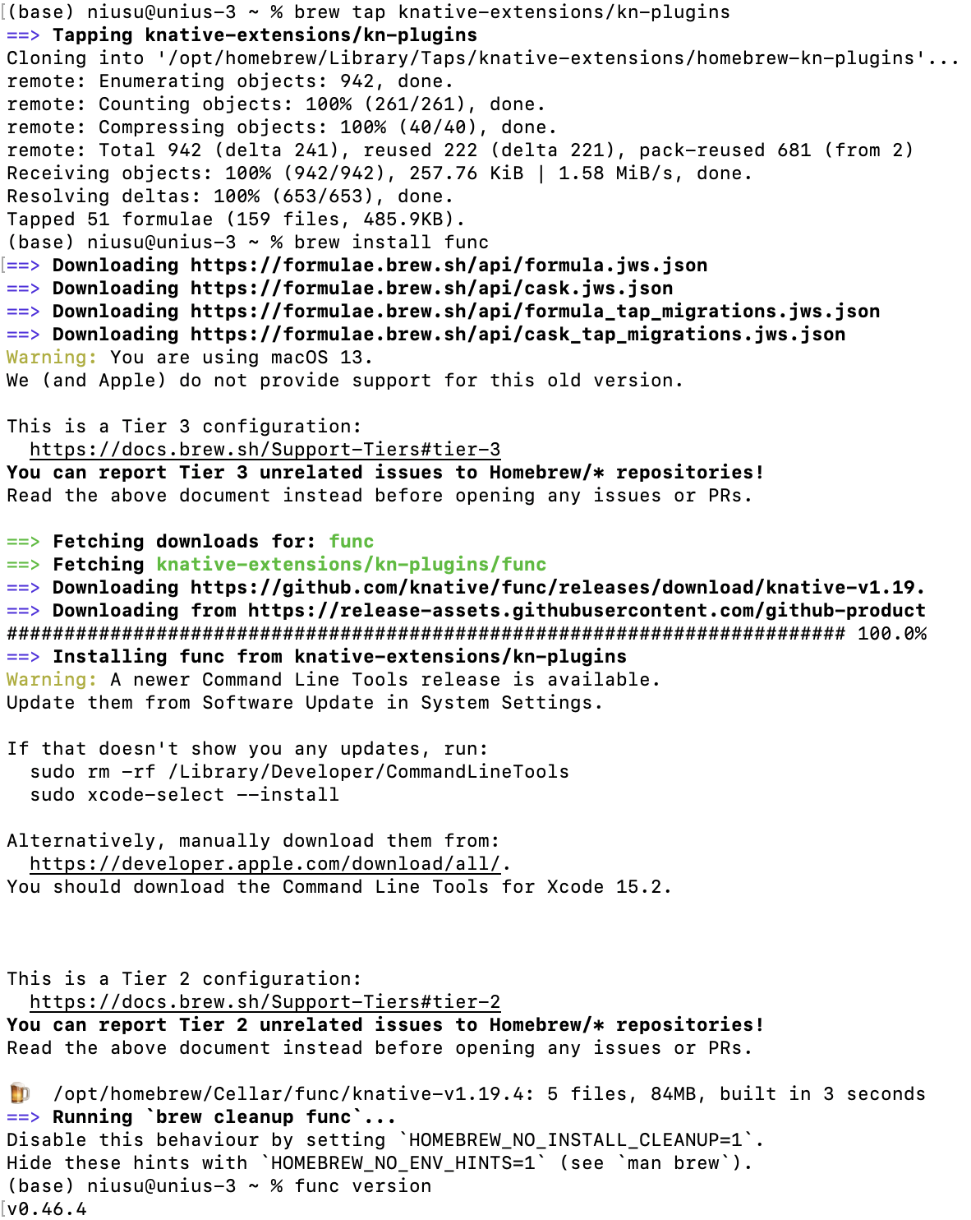
Figure1: Install fuc CLI

(2) Creating & Running a Function
Command:
func create -l go hello
kn func run
docker run -d -p 5001:5000 --name registry registry:2
func run --registry localhost:5001
func invoke
curl http://localhost:8080
Note:
Creating a sample Go function named hello and testing it locally using kn func run. Setting up a local Docker registry allows the function image to be stored and managed. Invoking the function and successfully accessing it via curl demonstrates that the function runs correctly and is accessible, confirming the local development and deployment workflow works as expected.
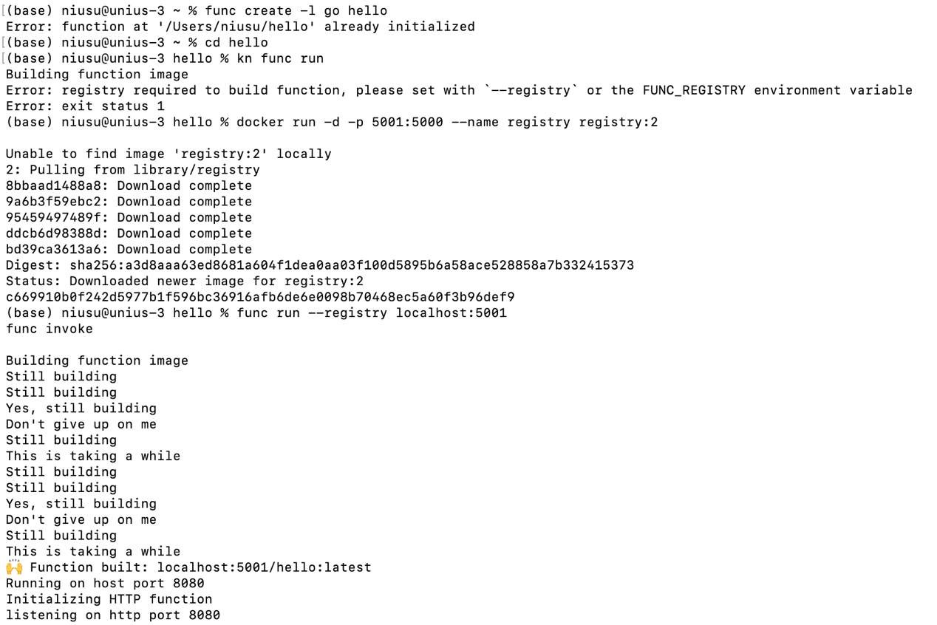
Figure1: Invoke the function
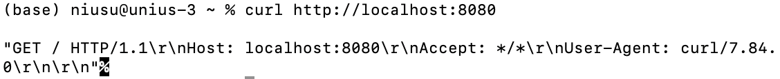
Figure2: Access the function

3. Knative Servings
Command:
kn service create hello --image ghcr.io/knative/helloworld-go:latest --port 8080 --env TARGET=World
kn service list
kubectl run -it --rm busybox --image=busybox --restart=Never -- sh
wget -qO- http://hello.default.svc.cluster.local
Note:
Deploying the hello service illustrates how Knative Serving simplifies deploying a serverless application on Kubernetes. The service is configured with environment variables and automatically exposes the container on the cluster network.
Testing internal access from a BusyBox Pod verifies that: the service is running, the Pod has started successfully, autoscaling works, and internal DNS resolves service names. This confirms that Knative automates much of the infrastructure, making the service easily accessible and scalable within the cluster.
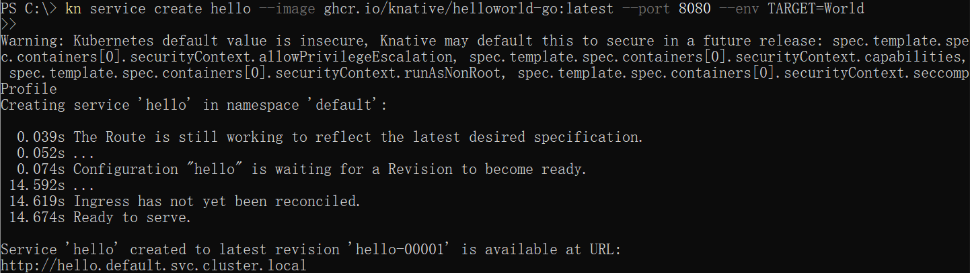
Figure1: Deploy hello service
Figure2: Verify the service
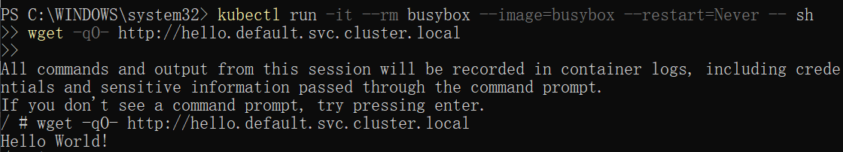
Figure3: Access the service

4. Knative Eventing
(1) Create broker
Command:
kn broker create example-broker
kn broker list
Note:
The Broker acts as a central event bus that manages and routes events. Creating and listing the broker confirms that the eventing system is ready to handle CloudEvents.
Figure1: Create broker

(2) Creating source
Command:
kn service apply -f cloudevents-player.yaml
kn service list
kubectl get pods -n default
kubectl port-forward cloudevents-player-00001-deployment-6979b56d96-64l9f 8080:8080
Note:
Deploying the CloudEvents Player as an event source allows the cluster to generate events. Port-forwarding enables local testing and confirms that the source service is operational.
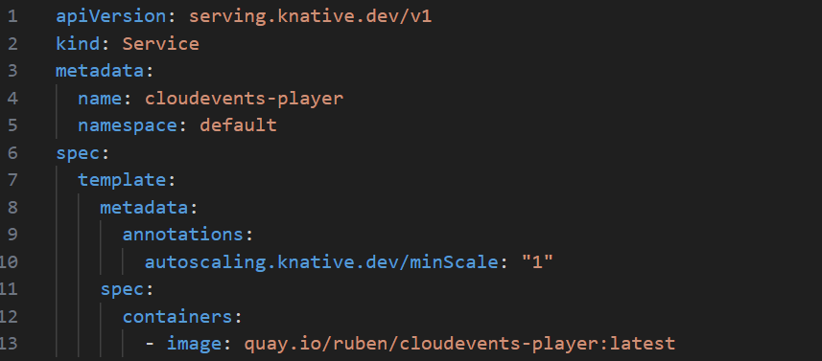
Figure1: Cloudevents - player yaml file
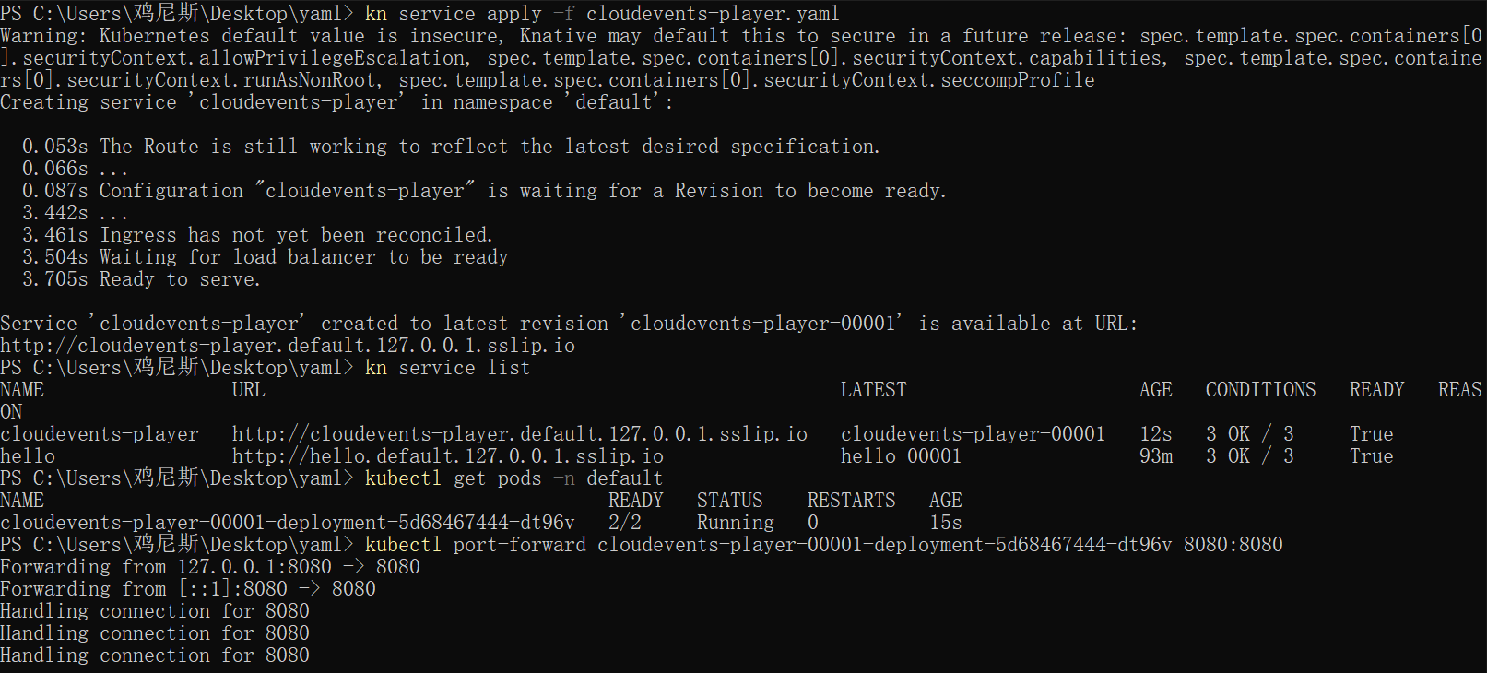
Figure2: Deploy cloudevents player service
(3) Creating binding
Command:
kn source binding create ce-player-binding --subject
"Service:serving.knative.dev/v1:cloudevents-player" --sink broker:example-broker
kubectl get sinkbindings
Note:
Binding the CloudEvents Player to the Broker ensures that events are automatically routed from the source to the broker.
Figure1: Create binding

(4) Examining the CloudEvents Player
http://localhost:8080
Note:
Accessing the CloudEvents Player verifies that the source service is running.
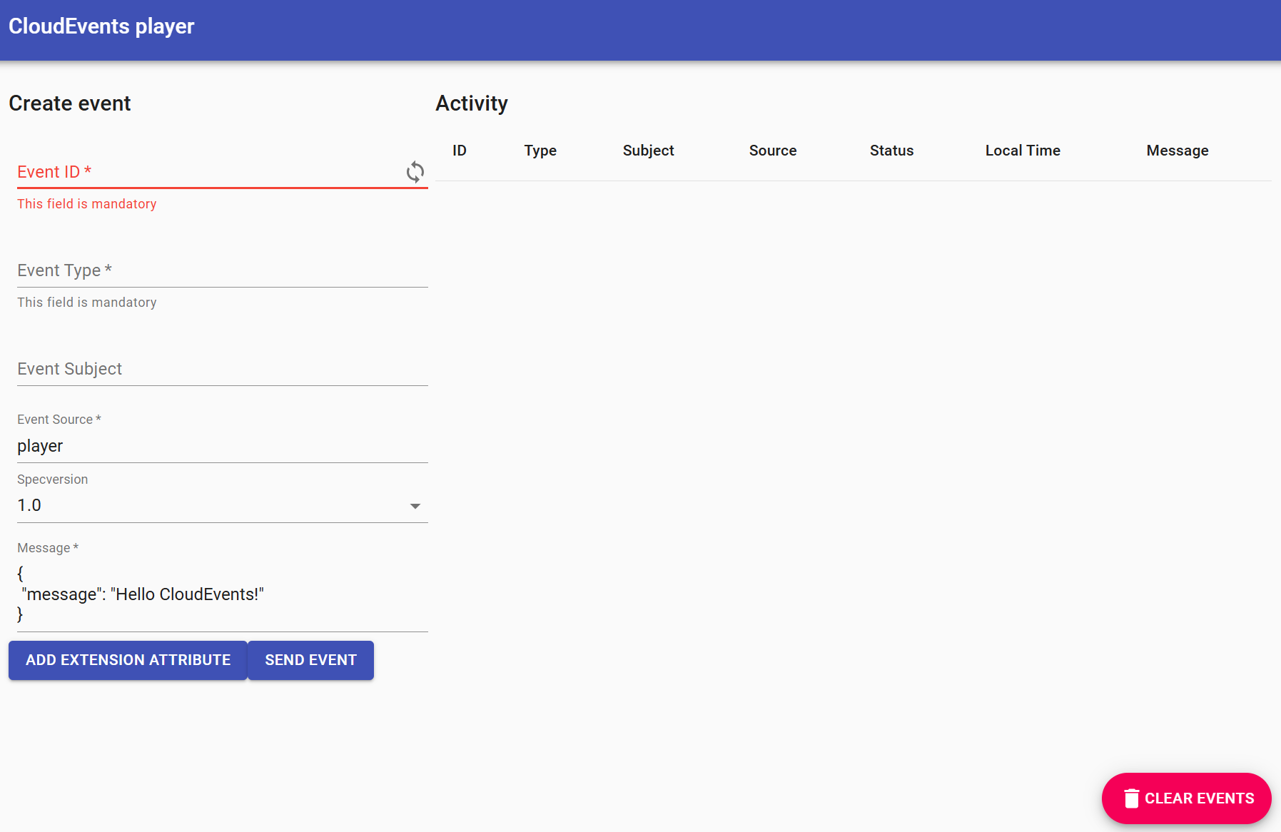
Figure1: CloudEvents plyaer

(5) Sending an event
Note:
The 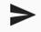 icon in the "Status" column implies that the event has been sent to our Broker.
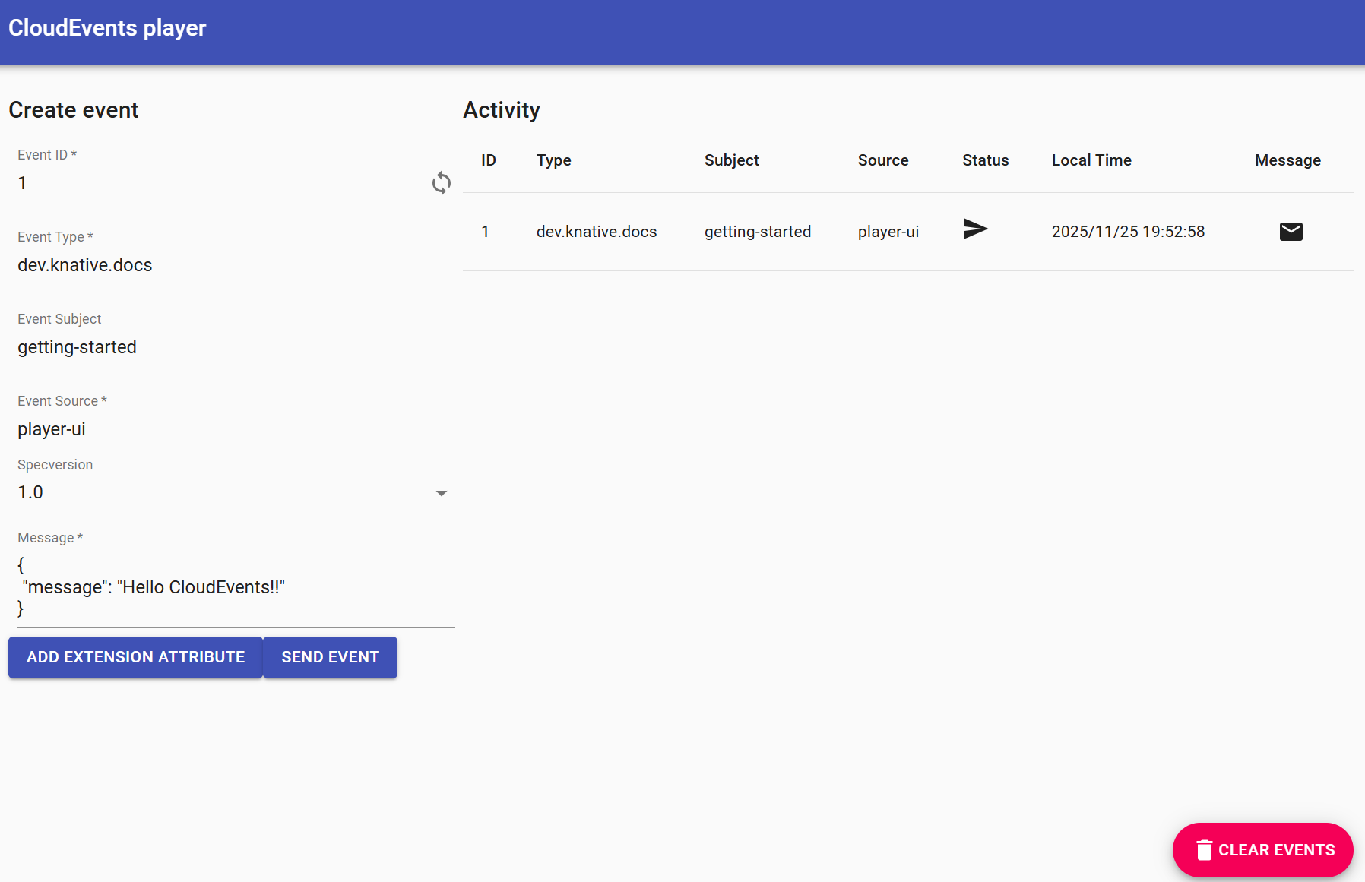
Figure1: Send an event
(6) Creating trigger
Command:
kn trigger create cloudevents-trigger --sink cloudevents-player --broker example-broker
Note:
Creating a Trigger completes the Eventing workflow by routing events from the Broker to the Sink. We see that CloudEvents are both sent and received by the CloudEvents Player
Figure1: Create trigger
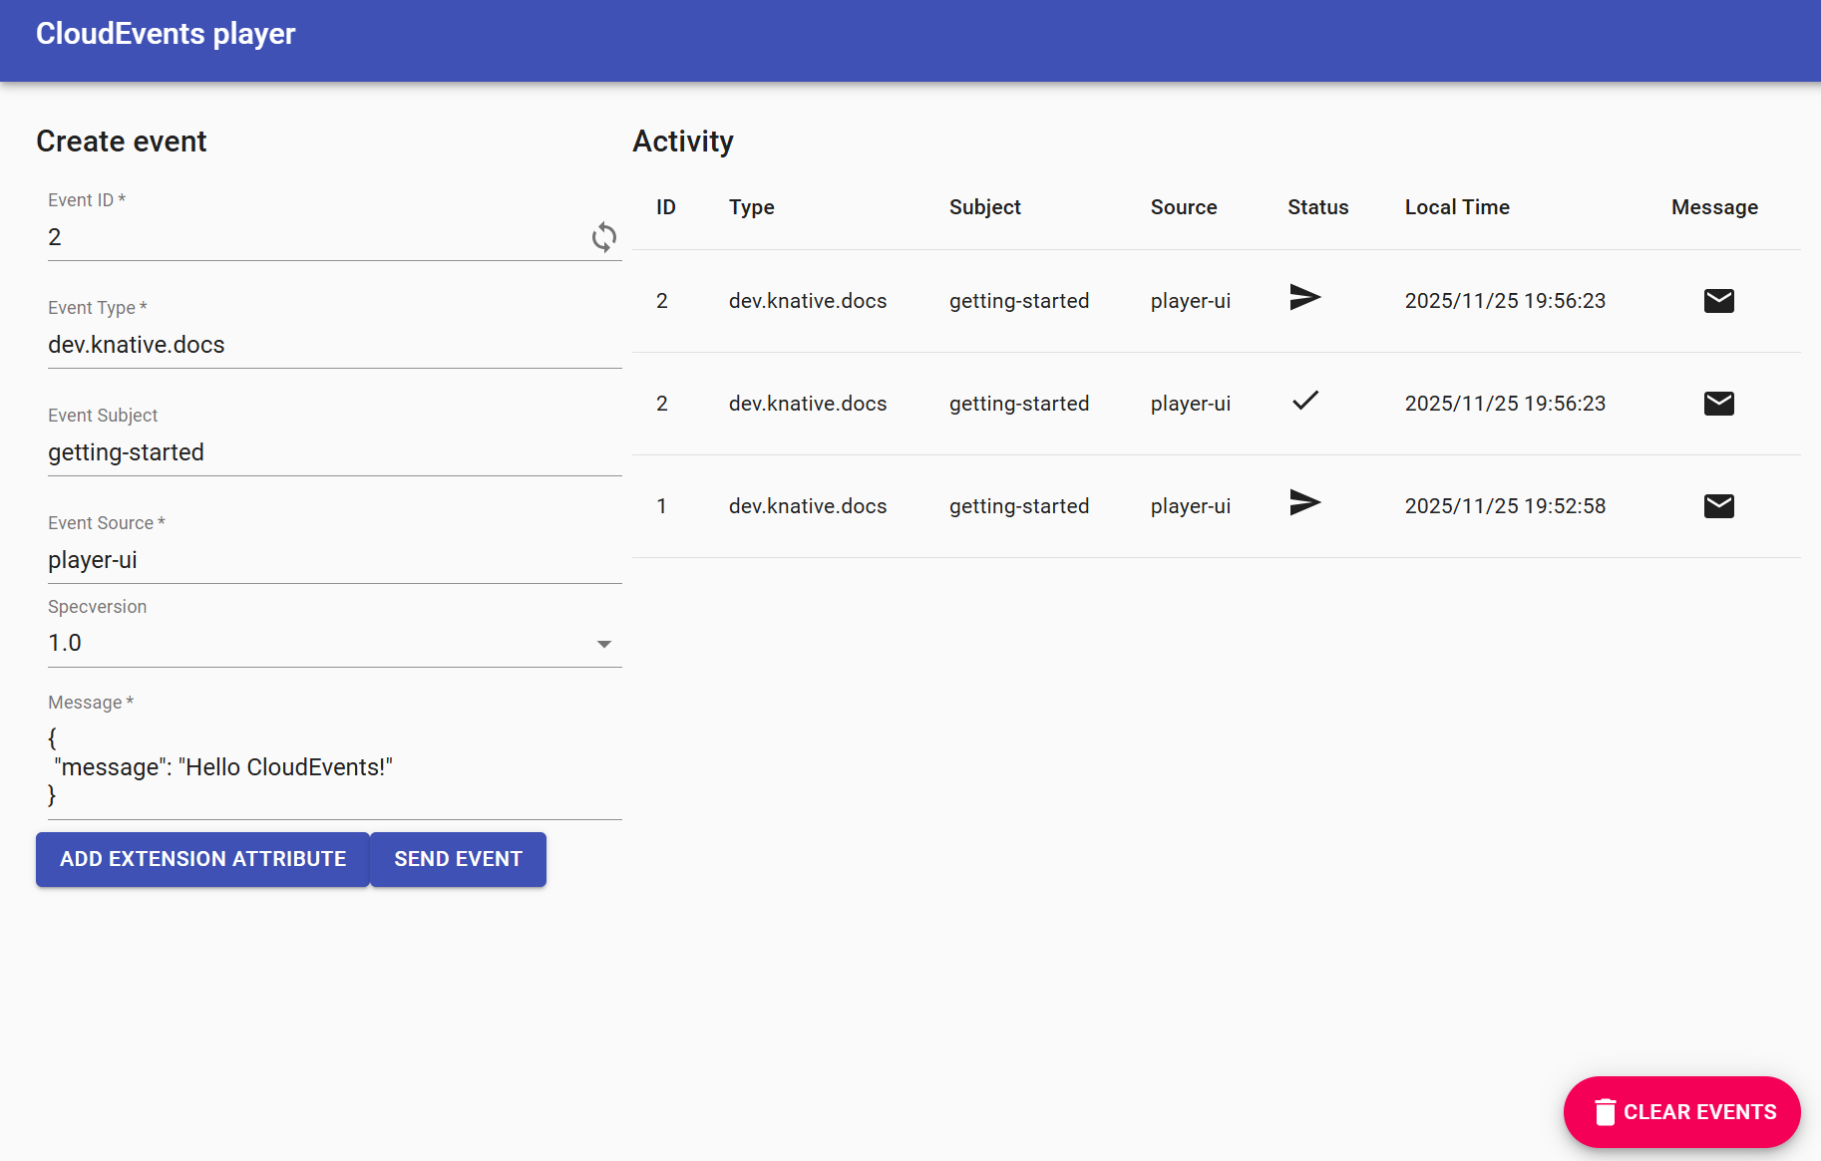
Figure2: Event being sent & received by the CloudEvents Player

