Universal open platform and reference specification for Ambient Assisted Living

Personal Health Devices (x073) and universAAL middleware integration

<< How to for uAAL developers >>

Local device discovery and integration group (LDDI)

Release history

Version | Date | Editors | Reviewers | Comments
0 | July 31, 2012 | Ángel Martínez (TSB) and Luis Gigante (TSB) | Juan-Pablo Lázaro (TSB) | 1st version
1 | September 17, 2012 | Ángel Martínez (TSB) | Thomas Fuxreiter (AIT) and Patrick Stern (AIT) | 2nd version
2 | December 10, 2012 | Ángel Martínez (TSB) | Thomas Fuxreiter (AIT) and Alejandro Medrano (UPM) | 3rd version

Table of contents

Release history 3

Overview 6

Overview 6

Execution environment 8

Hardware requirements 8

Hardware requirements 8

Software requirements 10

Shoulders to the wheel 16

Working without uAAL middleware 17

Working with uAAL middleware 21

Troubleshooting 29

Appendix A 31

Setting up uAAL development environment on GNU/Linux 31

Troubleshooting 39

Overview

The aim of this document is to make available a technical guide to enable universAAL (uAAL) developers community in general and LDDI experts group in particular to start developing Ambient Assisted Living (AAL) services with Continua Health Alliance devices (also called agents or sources).

This technological solution involves two pieces of code:
- libHDPnative.so is a dynamic library fully developed in C code that enables communication between BlueZ Bluetooth stack (C) and uAAL services (Java) through Java Native Interface (JNI) technology and inter-process communication (IPC) DBUS system. Is an isolated file with “.so” extension (similar to DLL files in Microsoft Windows environments).
- X73implementation.jar is the Continua Health Alliance standard (ISO/IEEE 11073) implementation developed in pure Java and without any external dependencies. It is composed by several packages grouped by performance: coder, decoder, DIM, state machine, etc.

Additionally other files or packages will be distributed:
- javadoc.rar file with a short description of methods, attributes, classes and relationships between them. Quite simply for Java developers.
- A sample project (BloodPressureMonitor_x073_Sample) showing how a Continua manager can receive valid and real time measurements through a HDP wireless channel. This example works outside OSGi platforms (no uAAL middleware is needed) so it should just be consider as a proof of concept.
- Some Maven projects showing how a Continua manager can receive weighting scales as well as blood pressure monitor events and publish it inside uAAL context bus is provided. Both sample applications can be followed as a template in order to develop additional managers with more advance features.

Just to put in context the future reader, this guide (text and images) have been elaborated with the following test environment (not relevant at this point):

- Sony Vaio laptop with Ubuntu 11.10 OS (kernel version 3.0.0-19).
- GNU/Linux bluetooth stack blueZ 4.99 version.
- Anycom 2.0 USB-200 bluetooth dongle.
- Real Continua health devices (just for testing): UC-321PBT-C A&D weigh scale and UA-767PBT-C A &D upper arm blood pressure monitor.

Execution environment

As has previously been mentioned, this technological solution relies over the official bluetooth stack (BlueZ) available in GNU/Linux operating systems, so from this point you should continue working with any free and open source OS distribution. Due to its high population and success, we decide work with the version 11.10 of Ubuntu Desktop OS (32 bits) directly downloaded from Ubuntu web page (Ubuntu 12.04 LTS is out now).

First step is ensure that your computer has the minimum technological requirements necessary to run and start developing new AAL services with the aforementioned libraries:

Hardware requirements

As Continua health devices employs bluetooth as transmission system basis, in order to send and receive x073 data frames between agents and managers it is obvious that your PC should support that wireless technology. Developed source code is independent of any bluetooth dongle, so it doesn't matter which model or manufacturer you choose to test the libraries.

In our case, we choose a bluetooth dongle USB-200 model (Bluetooth 2.0 + Enhanced Data Rate (EDR)) manufactured in 2006 by ANYCOM just because it was available for us as free resource in TSB company (please remember: any technical or strategic reason justifies this dongle choice).

In order to verify that your bluetooth dongle works fine in GNU/Linux platforms you can use (for instance) sdptool (interface for performing service queries on bluetooth devices around us) command as follows:

$ sdptool browse

Inquiring ...

Browsing 4C:ED:DE:0B:0D:98 ...

Service Name: Audio Source

Service Provider: TOSHIBA CORPORATION

Service RecHandle: 0x1008e

Service Class ID List:

"Audio Source" (0x110a)

Protocol Descriptor List:

"L2CAP" (0x0100)

PSM: 25

"AVDTP" (0x0019)

uint16: 0x102

Language Base Attr List:

code_ISO639: 0x656e

encoding: 0x6a

base_offset: 0x100

Profile Descriptor List:

"Advanced Audio" (0x110d)

Version: 0x0102 ...

Table 1: Ubuntu console (uAAL developer input/system output)

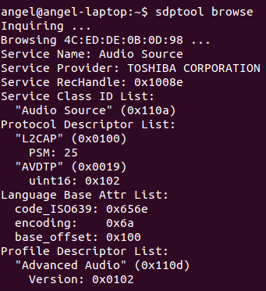Figure 1: Available bluetooth services in our coverage range (checking bluetooth dongle performance)

Important note: sdptool command is part of BlueZ (bluetooth tools and daemons) package so if that package is not available in our PC, we can't use it. Just ensure that bluez is ready to be launched or install it from any software manager (Synaptic, Ubuntu software manager centre, etc) otherwise.

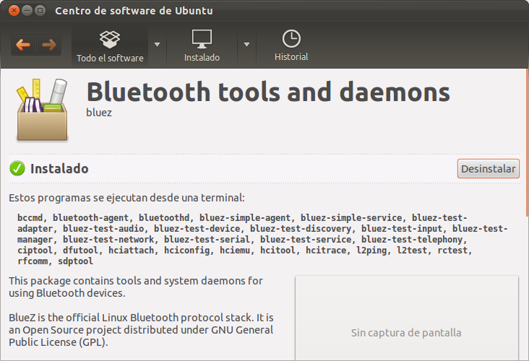Figure 2: Ubuntu software manager with BlueZ package installed

Software requirements

This technical guide assumes that you have some expertise developing uAAL services as well as setting up the required environment and related plug-ins (if not, please carefully read the universAAL Developer Handbook (login required) and come back later), so you will probably have within your reach some generic Java developer tools, namely Maven, SVN client, Pax Runner and Eclipse IDE. Sorry for bothering you again in that case:
- The Java JDK available by default in GNU/Linux systems is a FLOSS (free and open source) alternative named as OpenJDK. This libraries has been developed with one of the latest versions of the official Oracle JDK available for download so it is highly recommended work with the same JDK than us. After completely remove the OpenJDK from our system (if necessary) we can download and install the right version of the Java Development Kit. Next table shows you how install Oracle-jdk7 for 32 bit architecture (Important note: 64 bit Oracle JDK version don't work on 32 bit OS, ensure you are working with the appropriate binaries package).

$ sudo add-apt-repository ppa:webupd8team/java

$ sudo apt-get update

$ sudo apt-get install oracle-jdk7-installer

$ java -version

java version "1.7.0_04"

Java(TM) SE Runtime Environment (build 1.7.0_04-b20)

Java HotSpot(TM) Server VM (build 23.0-b21, mixed mode)

Table 2: Downloading and installing Oracle JDK version 7 (32 bits)
- Eclipse IDE and related plugins suggested to improve and facilitate uAAL development working process. Please, read Appendix A at the end of this document to a better understanding of how to proceed at each case. Summarizing, you will download Eclipse IDE for GNU/Linux OS version 3.5.2 (as recommended in the Developer Handbook of universAAL) and install some additional software tools.

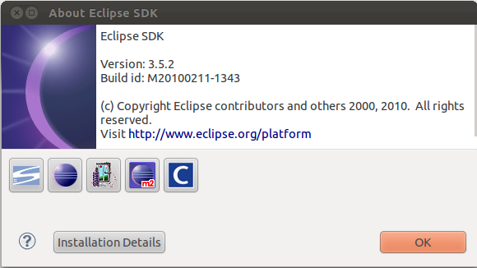Figure 3: Eclipse IDE installed

- As has previously been mentioned, BlueZ is the core of this technological solution and contains tools and system daemons for using Bluetooth devices. BlueZ is the official Linux Bluetooth protocol stack, which has full support of Health Device Profile (HDP) required to exchange data between Continua agents and managers (AAL software services running inside OSGi framework, for instance). Despite of this code is distributed by default in GNU/Linux OS, as developers we need to install next package in order to avoid future dependencies:
  - libbluetooth3 as library to use the bluez linux bluetooth stack.

Our libraries has been developed with 4.96 version (bluez 4.96-0ubuntu4 package) of BlueZ (latest release available for download is 4.101 nowadays). Upper versions of 4.80 is mandatory due to it was the first release where HDP was integrated.
- API of GNU/Linux official bluetooth stack, BlueZ, uses the popular message bus system created by Red Hat company D-Bus. D-Bus is an inter-process communication (IPC) open-source system that enables a reliable way for exchanging data (messages) directly between software applications and between software applications and the operating system (where the operating system would typically include the kernel and any system daemons or processes) over the same desktop session. Although there are some implementations (bindings) of D-Bus in several higher level development languages (Java, Python, Qt, Glib, C#, etc) we decided to base our development over the low level D-Bus implementation which API is written in C code for the following reasons:
  - Low level implementation has no additional dependencies unlike higher level bindings and it is distributed by default in GNU/Linux OS also.
  - Java binding (the closest to uAAL partners interests, for obvious reasons) has a very important lack compared with low level implementation (C code): file descriptor data type is not supported in the latest release available for download (D-Bus works with Unix sockets so a valid file descriptor should be reserved to any HDP channel created prior to send and receive data bytes between agents and managers).

Our libraries has been developed with 1.4.14 D-Bus version (latest release available for download is 1.6.1 nowadays). Please keep in mind that working with low level D-Bus C API is not easy and has a very pronounced learning curve so you should only go deeper just if necessary (main page of D-Bus C API welcomes visitors with a warm: If you use this low-level API directly, you're signing up for some pain). Please, ensure that any version of D-Bus is conveniently installed. Additionally, as developers we need to install some packages related with libdbus library in order to avoid future dependencies:
  - libglib2.0-dev as development files for GLib libraries.
  - libdbus1.0-cil-dev as CLI implementation of D-Bus.
  - libdbus-glib1.0-cil-dev as CLI implementation of D-Bus (Glib mainloop integration).
  - libdbus-1-dev as development headers for simple interprocess messaging system.
  - libdbus-glib-1-dev as Glib interface.

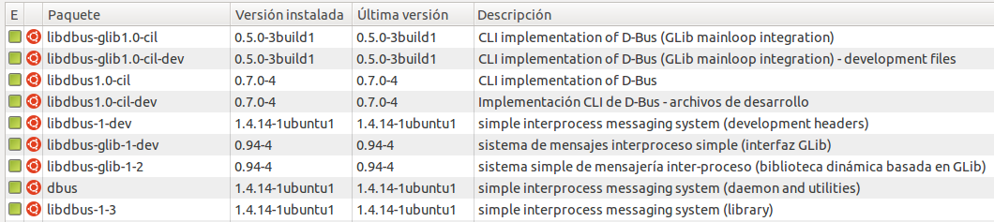Figure 4: Synaptic package manager view with "libdbus" and "installed packages" as quick filters

If everything goes as expected, our local folders (usr/lib/i386-linux-gnu/dbus-1.0/include/dbus and usr/include/dbus-1.0/dbus) should contain some new header files as shown following:

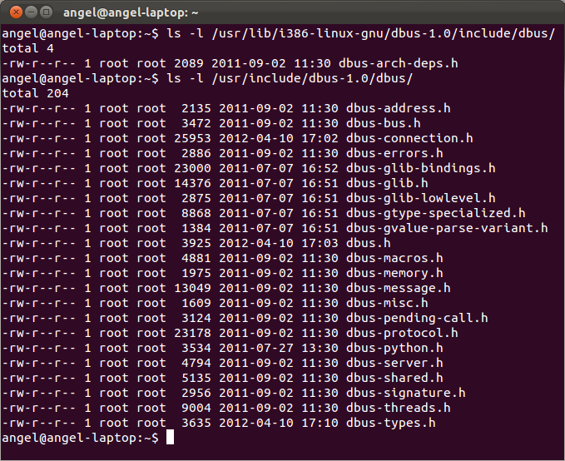Figure 5: D-Bus IPC system header files

At this point, we should ensure that D-Bus, BlueZ and our bluetooth dongle works fine as a whole. In order to verify (again) that your bluetooth adapter is ready to work run hciconfig command (for example) as root.

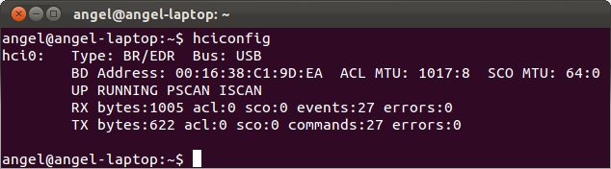Figure 6: Checking availability of local bluetooth adapter

Next, type the following D-Bus command to get your assigned BlueZ D-Bus address:

$ dbus-send --system --type=method_call --print-reply --dest=org.bluez "/" org.bluez.Manager.ListAdapters

Table 3: List of local bluetooth adapters

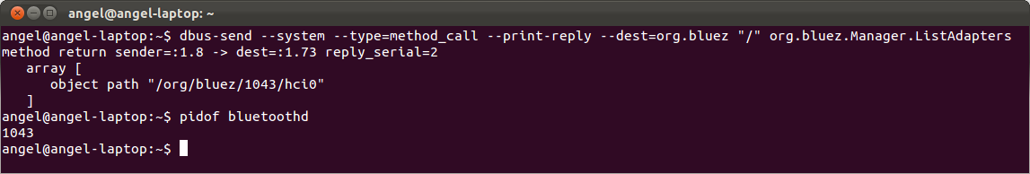Figure 7: Local bluetooth adapter path returned by D-Bus system

The returned object path as string org/bluez/1043/hci0 is our adapter's name where 1043 is the PID (Process ID) bluetooth process at this session (Important note: local bluetooth adapter PID varies after each computer boot so it shouldn't be consider as static value). As next step, we can (for instance) request for local bluetooth adapter properties as follows:

$ dbus-send --system --type=method_call --print-reply --dest=org.bluez "/org/bluez/1043/hci0" org.bluez.Adapter.GetProperties

Table 4: Default local bluetooth adapter properties

If everything goes well, automatically output should be (more or less) similar to:

method return sender=:1.8 -> dest=:1.74 reply_serial=2

array [

dict entry(

string "Address"

variant string "00:16:38:C1:9D:EA"

)

dict entry(

string "Name"

variant string "angel-laptop-0"

)

dict entry(

string "Class"

variant uint32 4849920

)

dict entry(

string "Powered"

variant boolean true

)

dict entry(

string "Discoverable"

variant boolean true

)

dict entry(

string "Pairable"

variant boolean true

)

dict entry(

string "DiscoverableTimeout"

variant uint32 0

)

dict entry(

string "PairableTimeout"

variant uint32 0

)

dict entry(

string "Discovering"

variant boolean false

)

dict entry(

string "Devices"

variant array [

object path "/org/bluez/1043/hci0/dev_00_09_1F_80_0A_E0"

object path "/org/bluez/1043/hci0/dev_00_09_1F_80_04_D6"

]

)

dict entry(

string "UUIDs"

variant array [

string "00001000-0000-1000-8000-00805f9b34fb"

string "00001001-0000-1000-8000-00805f9b34fb"

string "00001112-0000-1000-8000-00805f9b34fb"

string "0000111f-0000-1000-8000-00805f9b34fb"

string "0000110a-0000-1000-8000-00805f9b34fb"

string "0000110c-0000-1000-8000-00805f9b34fb"

string "0000110e-0000-1000-8000-00805f9b34fb"

string "00001103-0000-1000-8000-00805f9b34fb"

]

)

]

Table 5: Default local bluetooth adapter properties returned by D-Bus system

Shoulders to the wheel

Summarizing, for being able to run the libraries, you will have to need a PC with GNU/Linux operating system installed with one of the latest versions of BlueZ library and D-Bus system for managing Bluetooth connections. In our case, we had a 32-bit Ubuntu 11.10 with BlueZ 4.96 and Oracle Java JDK 7 also.

Important note: as prior step to exchange data bytes between Continua agents and managers both should have been paired first. Developed libraries doesn't have an automatic process to manage this task at this release so you should use any bluetooth manager software available for download. We decided to use the software distributed with the OS by default for simplicity. Next figure shows that application with both the weigh scale and the upper arm blood pressure monitor paired with our computer (you will probably need to consult the right instruction manual of chosen Continua device to get the secret PIN required as final step of any pairing process).

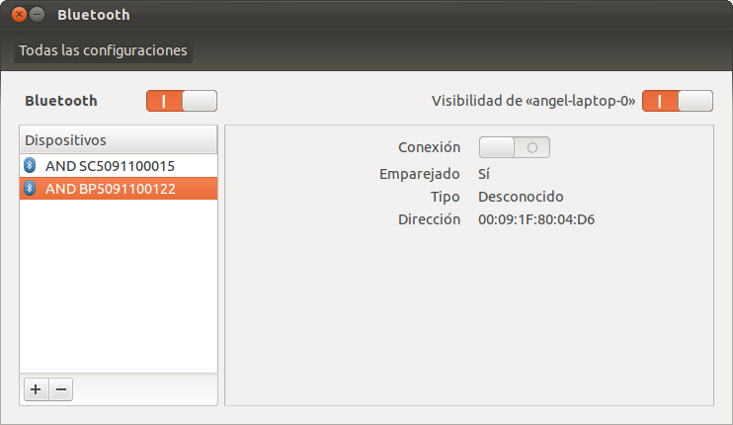Figure 8: Bluetooth software manager with Continua compliant paired devices

Once the Continua agents and our PC (or any smart device with manager role) has been paired, we can continuous with the next steps as detailed below.

Working without uAAL middleware

As uAAL middleware runs inside an OSGi framework and this environment is not too intuitive and easy to integrate third party libraries (at the beginning), a good practice could be start working with the libraries developed in standalone mode as first step. Please, follow next steps:

1. Update your local copy of the uAAL repository with the latest version of the libraries. The contents you must have should be:
- Jar file with the implementation of ISO/IEEE 11073 standard (java pure code, distributed in several packages and without external dependencies): X73implementation.jar
- Native library written in C code (with “.so” extension) with JNI functions for accessing Bluetooth stack with Java through D-Bus IPC system: libHDPnative_NOUAAL.so
- Javadoc documentation for helping uAAL developers creating Continua managers with Bluetooth HDP capabilities: javadoc.rar
- Java code (Eclipse IDE project format) with a manager as sample: BloodPressureMonitor_x073_Sample

With this three elements and the sample of code, you will be able to create your own managers, and obtain measurements from any Continua compliant medical device such as a weighing scale or a blood pressure monitor.

2. Ensure that your Continua device/devices is/are successfully paired with your computer (this step is mandatory, don't forget it).

3. Create a new folder exactly named jni_lib at your home path (Important note: this path must be exact. Otherwise, it won't work).

4. Copy the libHDPnative_NOUAAL.so file into the previously created directory.

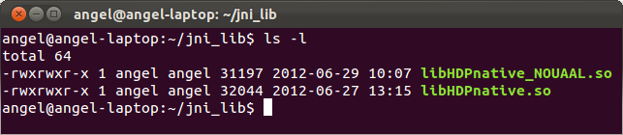Figure 9: Native library inside our local folder

5. Import the sample project (BloodPressureMonitor_x073_Sample) available in uAAL repository in Eclipse IDE or create a new one with the same package structure than the other one. In any case, jar package with ISO/IEEE x073 implementation must be imported into the Java project. So, your software project should contain next classes/imported packages at least:

  - hdpManager.java is the core of the manager application. It should implement hdpManagerListener.java interface.
  - hdpManagerListener.java is an interface that only defines three self- explanatory methods: onChannelConnected, onChannelDisconnected and onDataReceived. Please, refer the aforementioned Javadoc file to get more detailed information.
  - X73implementation.jar is the ISO/IEEE 11073 standard implementation in Java code. It is responsible for processing and managing x073 received data frames.

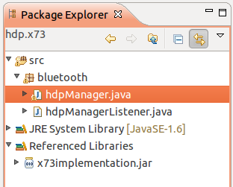Figure 10: Package explorer of Eclipse IDE

Important note: package name that contains hdpManager.java and hdpManagerListener.java classes must be bluetooth. Otherwise, native library will return an error (this file is, more or less, auto-generated by the javah tool included in the JDK so this value is the right expected).

6. Since the output text messages from the C functions at libHDPnative.so file seems not to be showing in the console of the Eclipse IDE platform, we recommend to execute the software from the GNU/Linux OS console terminal as follows:

  - In hdpManager.java file change the macAddressRemoteDevice attribute with the corresponding MAC value (line 76) of your blood pressure device.
  - If your project is built automatically by Eclipse IDE (Project → Build automatically option checked) go to the bin folder inside the sample project directory (workspace) and execute java bluetooth.hdpManager command (where hdpManager is the manager main class and bluetooth the name of the container package). Next table shows some properties about the local bluetooth adapter, its valid PID and how an HDP channel is waiting for Continua agent frames to start the exchange data process.

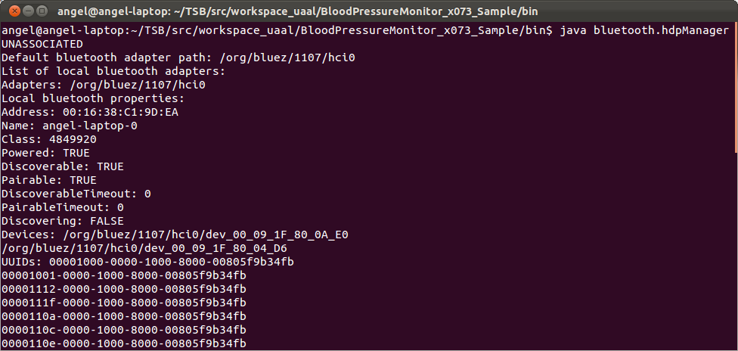Figure 11: Blood pressure manager successfully launched

7. Start getting measurements from the Continua devices in our area of coverage is the actual step. Next images shows an example of a blood pressure measurement:

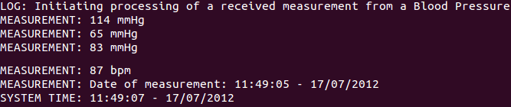

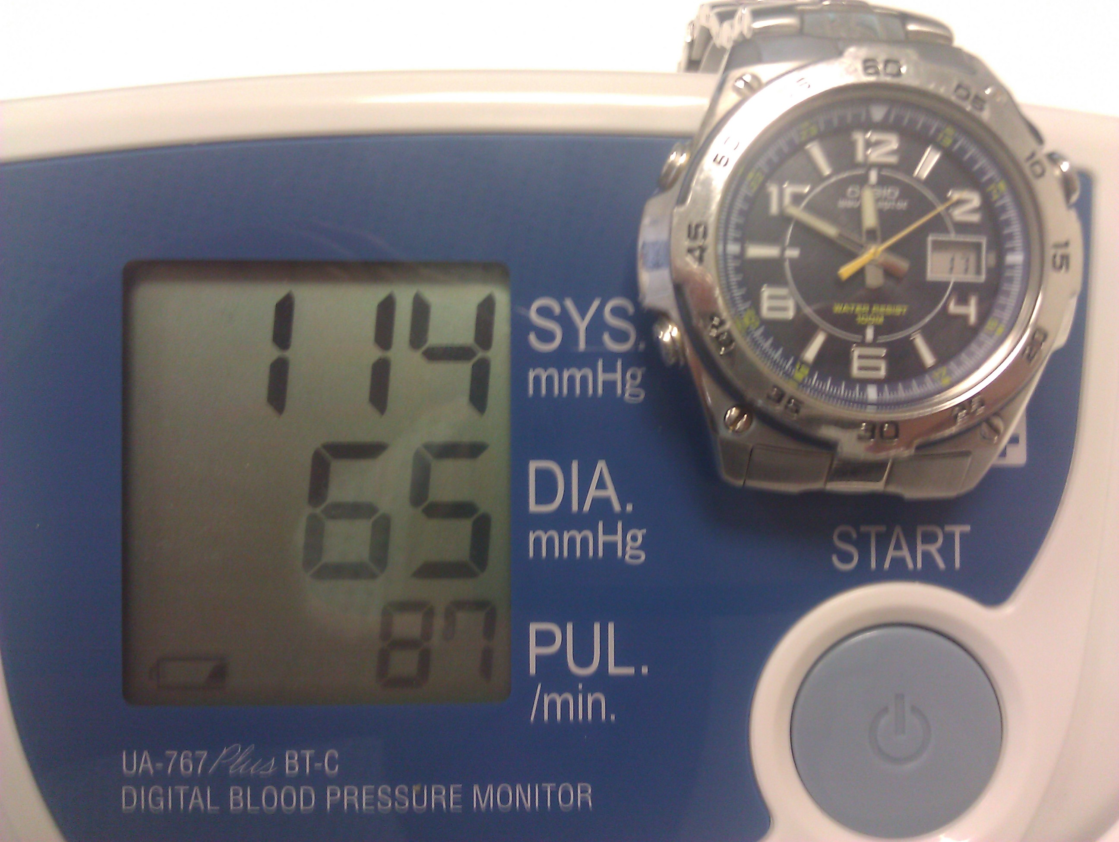Figure 12: Measurements done with a real Continua blood pressure monitor

$ pwd

/.../workspace_uaal/BloodPressureMonitor_x073_Sample/bin

/.../workspace_uaal/BloodPressureMonitor_x073_Sample/bin$ java bluetooth.hdpManager

UNASSOCIATED

Default bluetooth adapter path: /org/bluez/1107/hci0

List of local bluetooth adapters:

Adapters: /org/bluez/1107/hci0

Local bluetooth properties:

Address: 00:16:38:C1:9D:EA

Name: angel-laptop-0

Class: 4849920

Powered: TRUE

Discoverable: TRUE

Pairable: TRUE

DiscoverableTimeout: 0

PairableTimeout: 0

Discovering: FALSE

Devices: /org/bluez/1107/hci0/dev_00_09_1F_80_0A_E0

/org/bluez/1107/hci0/dev_00_09_1F_80_04_D6

UUIDs: 00001000-0000-1000-8000-00805f9b34fb

00001001-0000-1000-8000-00805f9b34fb

00001112-0000-1000-8000-00805f9b34fb

0000111f-0000-1000-8000-00805f9b34fb

0000110a-0000-1000-8000-00805f9b34fb

0000110c-0000-1000-8000-00805f9b34fb

0000110e-0000-1000-8000-00805f9b34fb

00001103-0000-1000-8000-00805f9b34fb

Remote bluetooth adapter path: /org/bluez/1107/hci0/dev_00_09_1F_80_04_D6

Remote device properties (BEFORE):

Address: 00:09:1F:80:04:D6

Name: AND BP5091100122

Alias: AND BP5091100122

Class: 2308

Paired: TRUE

Trusted: TRUE

Blocked: FALSE

Connected: FALSE

UUIDs: 00001200-0000-1000-8000-00805f9b34fb

00001401-0000-1000-8000-00805f9b34fb

Services:

Adapter: /org/bluez/1107/hci0

Property Trusted successfully changed

Remote device properties (AFTER):

Address: 00:09:1F:80:04:D6

Name: AND BP5091100122

Alias: AND BP5091100122

Class: 2308

Paired: TRUE

Trusted: TRUE

Blocked: FALSE

Connected: FALSE

UUIDs: 00001200-0000-1000-8000-00805f9b34fb

00001401-0000-1000-8000-00805f9b34fb

Services:

Adapter: /org/bluez/1107/hci0

HDP application identifier: /org/bluez/health_app_3

HDP application (/org/bluez/health_app_3) successfully closed

HDP application identifier: /org/bluez/health_app_4

DBUS sytem status: Up

CONNECTED UNASSOCIATED

Waiting for source connections...

Table 6: Continua manager waiting for input source connections (agents)

Working with uAAL middleware

Once we were able to get real time measurements from Continua devices in standalone mode as has shown before we need to migrate that technological solution inside OSGi environments due to this framework is the basis of uAAL middleware. Please, follow next steps and be patient:

1. Update your local copy of the uAAL repository with the latest version of the libraries. The contents you must have should be:
- Maven project with the implementation of ISO/IEEE 11073 standard (java pure code, distributed in several packages and without external dependencies): ieee.x73.std
- Native library written in C code (with “.so” extension) with JNI functions for accessing Bluetooth stack with Java through D-Bus IPC system (please, choose the most appropriate version according your OS): libHDPnative.so
- Javadoc documentation for helping uAAL developers creating Continua managers with Bluetooth HDP capabilities: javadoc.rar
- Some Maven projects as code samples:
  - weighingScalePublisher_x073_Sample: simple app without GUI.
  - ContinuaManager: advanced app with GUI enabled.
  - “UniversAALized” sample: more advanced app following uAAL design patterns. It is composed by four components:
- continua manager ontology: ont.continuahealthmanager
- continua manager service: continua.hdp.manager
- continua manager caller:

continua.hdp.manager.caller.test
- continua manager subscriber:

continua.hdp.manager.subscriber.test

With this three elements and the samples of code, you will be able to create your own managers, obtain measurements from any Continua compliant medical device such as a weighing scales or a blood pressure monitors and send data received to uAAL context bus.

2. Ensure that your Continua device/devices is/are successfully paired with your computer (this step is mandatory, don't forget it).

3. Create a new folder exactly named jni_lib at your home path (Important note: this path must be exact. Otherwise, it won't work).

4. Copy the libHDPnative.so file into the previously created directory (please, review figure 9).

5. Import one of the sample Maven projects from your local copy of the uAAL repository to your Eclipse IDE. In order to work with our more realistic sample we need to import four Maven projects:

- File → Import → Existing Maven Projects → ont.continuahealthmanager
- File → Import → Existing Maven Projects → continua.hdp.manager
- File → Import → Existing Maven Projects → continua.hdp.manager.caller.test
- File → Import → Existing Maven Projects → continua.hdp.manager.subscriber.test}

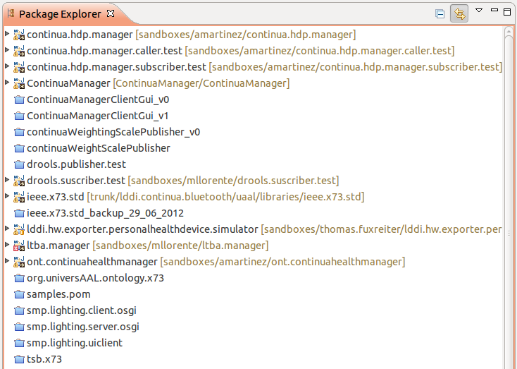

What should be expected by each Maven project imported:
  - Continua.hdp.manager is a Continua Health manager service working as a whole (you could switch on and off it). It is the main responsible for managing secure connections between agents and managers and for processing low level frames. A new independent and isolated Continua manager is created when an uAAL caller message is received.
  - Continua.hdp.manager.caller.test is an uAAL caller class. Just for testing.
  - Continua.hdp.manager.subscriber.test is an uAAL subscriber class. Just for testing.
  - Ont.continuahealthmanager is the Continua Health Alliance Manager ontology. It is used by the Continua Health manager service.

Important note: (1) don't change packages names. Otherwise, native library will return an error (this file is, more or less, auto-generated by the javah tool included in the JDK so this value is the right expected. In conclusion: if thoses package are renamed, functions in native library should be renamed too. Otherwise, both names will not match and an error will be return as output) (2) manage possible external dependencies with the pom file (pom.xml). There are some ontologies specifically created to model Continua agents and managers. Please, check them before launching the service. as weighing scales and blood pressures. Please review org.universAAL.ontology.x73 package in uAAL SVN repositories (3) Delete (if proceed) the x073implementation.jar JAR file previously copied inside your local path folder (/usr/lib/jvm/java-7-oracle/jre/lib/ext) to force maven project get the library from the right source.

6. In GUI.java file (Continua.hdp.manager.caller.test project) you should change the remoteMacAddress attribute with the corresponding MAC value (lines 189 and 216) of your weighing scale device and blood pressure monitor.

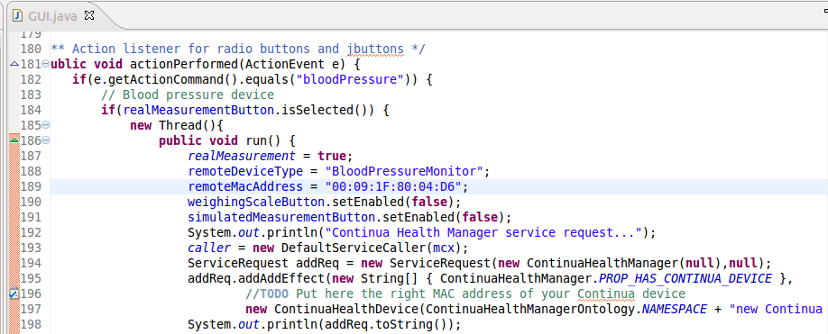

6. Launch this application with an appropriate Run Configurations. Please, check that all previously installed bundles are Active less than our Caller bundle. (remember: output text messages from the C functions at libHDPnative.so file seems not to be showing in the console of the Eclipse IDE platform, this bug will be solved ASAP by TSB team):

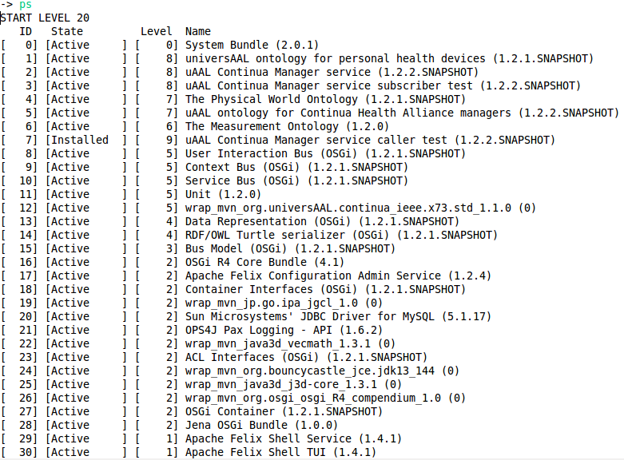

Important note: VM arguments at Arguments tab in the Run Configurations window should contain the path where native library has been stored as follows: -Djava.library.path=/home/user/jni_lib

-Dosgi.noShutdown=true -Dfelix.log.level=4 -Dorg.universAAL.middleware.peer.is_coordinator=true -Dorg.universAAL.middleware.peer.member_of=urn:org.universAAL.aal_space:test_env -Dbundles.configuration.location=${workspace_loc}/rundir/confadmin -Djava.library.path=/home/angel/jni_lib

- Start the Caller bundle with the appropriate ID number. If all goes as expected a simple GUI should be shown in your screen.
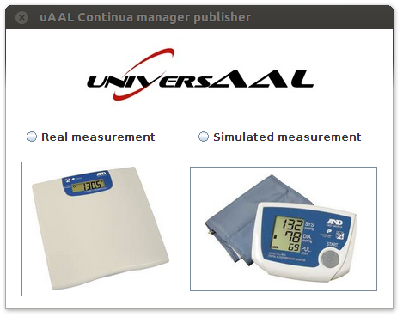

- If you have access to real Continua devices, press the appropriate combination of checkbox/button and wait for agents events. If not, you can send simulated and randomized measures to the uAAL context bus. At any case, when the measurement is published in the context bus, the subscriber is able to get the data and show it in another application.
  - Subscriber for simulated measurements (blood pressure monitor, for instance).
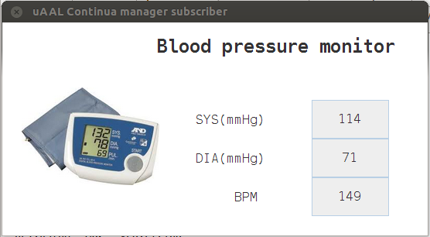
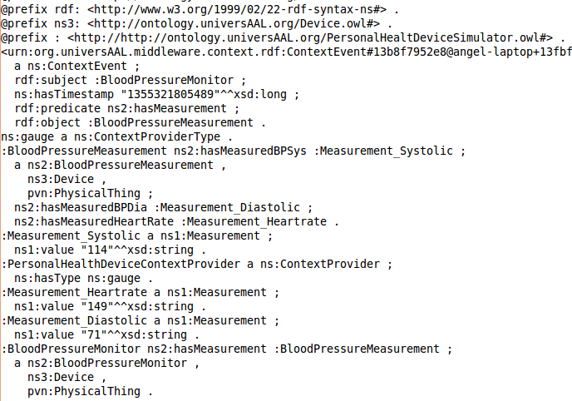
  - Subscriber for real measurements (weighing scale, for instance).

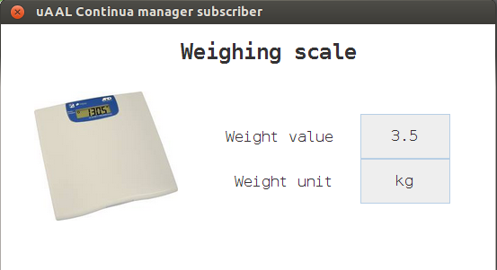
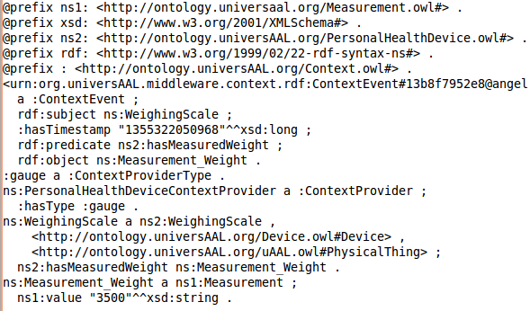

Important note: When the Caller application is closed an Invalid BundleContext exception is thrown. It seems that is a well known problem inside uAAL developers community so we assume it as normal response. Any advice, suggestion to avoid it would be appreciated.

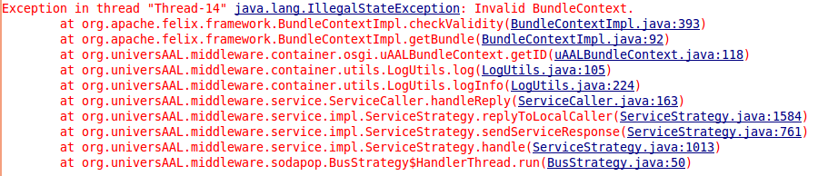

Troubleshooting

1. Error: compiling any source class always returns a java.lang.UnsupportedClassVersion. Possible solution: Change your JDK to the official Oracle Java JDK or update its version.

$ java -version

java version "1.7.0_04"

Java(TM) SE Runtime Environment (build 1.7.0_04-b20)

Java HotSpot(TM) Server VM (build 23.0-b21, mixed mode)

Table 7: UnsupportedClassVersion error

2. Error: launching manager application with x073implementation.jar file imported always returns a java.lang.NoClassDefFoundError. Possible solution: Check the classpath or directly copy the jar file inside /usr/lib/jvm/java-7-oracle/jre/lib/ext path folder.

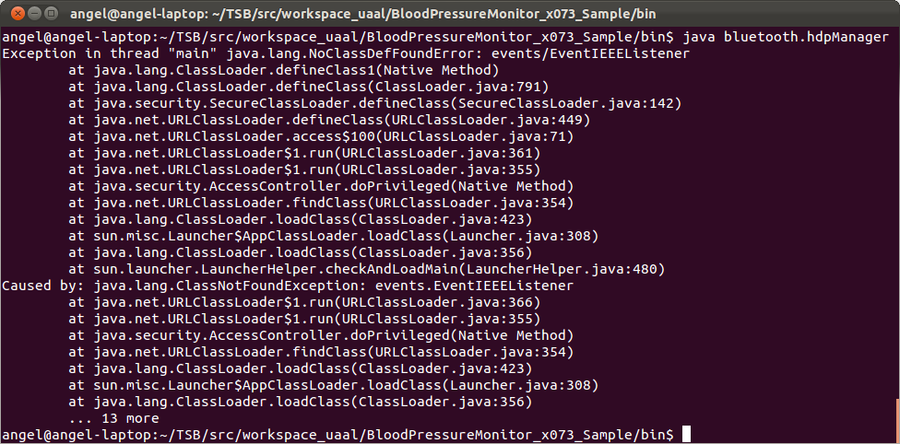Figure 13: NoClassDefFoundError error

3. Error: launching manager application always returns an undefined symbol error. Possible solution: Execute ldd -d command (print shared library dependencies) in the OS console in the folder where native libraries (remember: .so files) where stored. If these libraries has successfully been linked in your system, you should get an output similar as follows:

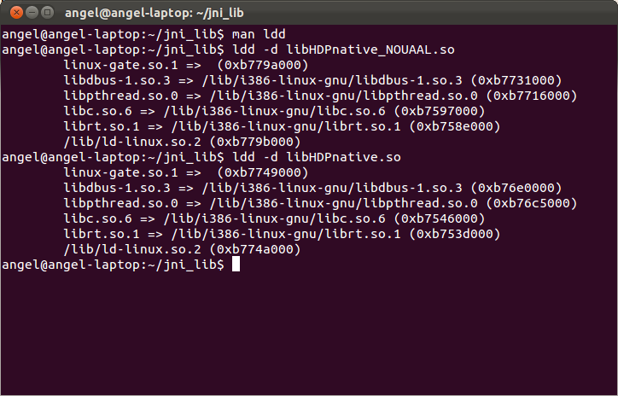Figure 14: Native libraries successfully linked

4. Error: launching manager application always returns a java.lang.UnsatisfiedLinkError. Possible solution: Check the classpath or update your LD_LIBRARY_PATH global variable.

Appendix A

Setting up uAAL development environment on GNU/Linux

Important note: this guidelines are not official documentation supported and maintained by universAAL Consortium. This document has been elaborated (of our own necessity) in order to help any GNU/Linux user starting setting up the minimum required environment to run and develop AAL services based on uAAL middleware. Official information available in the universAAL Developer Handbook only covers this process in Microsoft Windows environments so due to this lack we decide to create this simple guide from scratch. As any first release it isn't exempt from errors, so we apologize for any inconvenience. Please, feel free to comment or modify anything of this appendix. Any suggestion will be appreciated.

We will assume that you are using a 32-bit Linux Ubuntu 11.10 operating system.

1. Install an appropriate JDK. We recommend Oracle-jdk7.

2. Create directory tree. For example, we will use as root of universaal environment a folder in home directory.

- Create ~/universAAL folder. Please note that ~ symbol refers to home directory.

3. Install maven software:

- Download the latest version package from the official URL
- Extract the files in ~/universAAL/maven. This will as seen in screenshot:

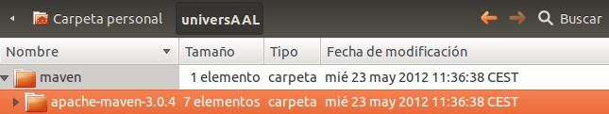

- Set up the proper environment variables. For doing this permanent, we will have to edit the .bashrc file in home folder. In console terminal, write gedit ~/.bashrc (at the end of that text file, add next lines):

export M2_HOME=/home/username/universAAL/maven/apache-maven-3.0.4

export M2=$M2_HOME/bin

export MAVEN_OPTS="-Xms256m -Xmx512m"

export PATH=$M2:$PATH

export JAVA_HOME=/usr/lib/jvm/java-7-oracle

export PATH=$JAVA_HOME/bin:$PATH

- Check if it is working correctly. Enter the mvn --version in console terminal. If everything is okay, we have to see information about our computer and the version of maven software just installed:

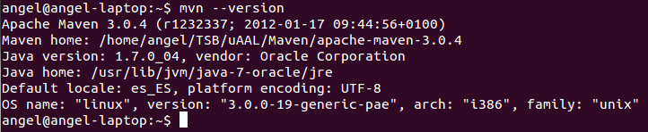

- Once we have maven software running in our machine, it is time to install a SVN client and to obtain the universAAL resources (source code). This guidelines will assume that you are registered in universAAL GForce web page and you have been granted access to Middleware, Ontologies and Support projects.

- Install any SVN client which can be retrieved from Ubuntu Software Center or similar (for instance: RabbitVCS or SVN Workbech).

- Create the folders (for instance):
  - ~/universAAL/svn/middleware/
  - ~/universAAL/svn/ontologies/
  - ~/universAAL/svn/support/

- Get uAAL source code from universAAL repository accordingly with SVN client previously chosen. Wait until all files are downloaded.
  - SVN source: http://forge.universaal.org/svn/middleware
  - SVN source: http://forge.universaal.org/svn/ontologies
  - SVN source: http://forge.universaal.org/svn/support

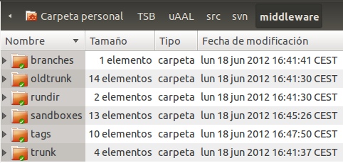

5. Download Eclipse IDE for GNU/Linux OS. As recommended in the Developer Handbook of universAAL, we will get the 3.5.2 version from Eclipse repositories.

- Extract the files on (for instance) ~/universAAL/eclipse/ (create the folder).

- As a recommendation, create a new (clean) workspace folder. For example, ~/universAAL/uAAL_workspace/. Each universAAL project will be a sub-folder of this one.

- Start Eclipse IDE and select ~/universAAL/uAAL_workspace/ as workspace for this session (this name is not important now, since we are only adding plugins to Eclipse but is a good practice).

8. Install Eclipse required plugins:

- Install Subversion plugin for Eclipse IDE using the normal procedure.

  - Following the recommendation from the universAAL Developer Handbook, install a svn command line client. In terminal console with root privileges, enter the command sudo apt-get install subversion.

- Install M2Eclipse plugin for Eclipse IDE.

- Install Pax Runner plugin for Eclipse IDE.

9. After installing all the additional software for Eclipse, the Installed Software window should look like this:

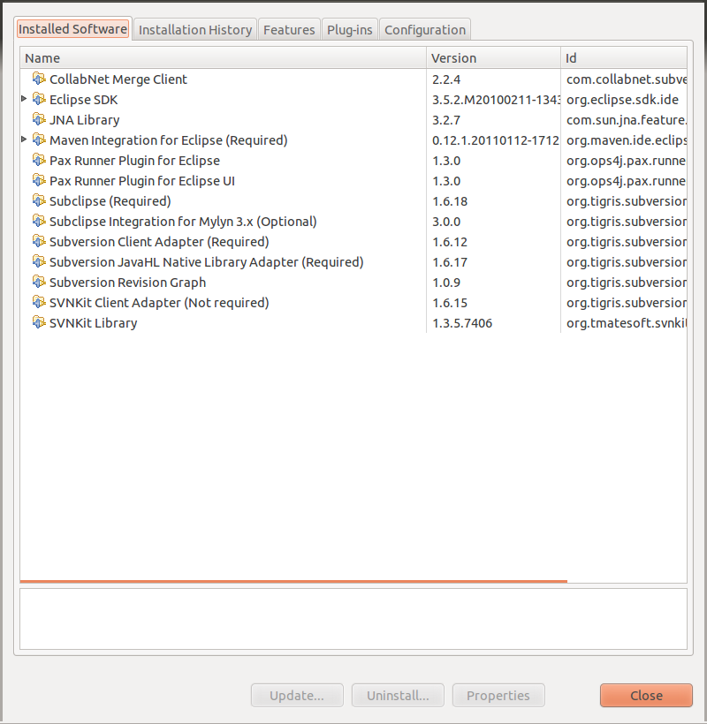

10. Configure Eclipse to look for the Java JDK.

- Open the file eclipse.ini in ~/universAAL/eclipse/ folder.

- Look for -vmargs line. Above it, write two lines (please keep in mind that the previous two lines have to be added as two lines, not one). Save and exit.

-vm

/usr/lib/jvm/java-7-oracle/jre/bin/java

11. Configure Maven options in the local system checking that the folder ~/.m2 is present.

- Copy the settings.xml file available in Resources folder (recently created at your computer) to your local .m2 folder.

12. Restart Eclipse. You may see a warning message saying that “Subversion 1.6 has a bug with GNOME keyring via the Subversion JavaHL API”. Just press OK button.

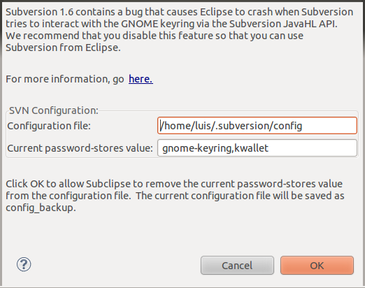

13. Probably, you will have problems in order to have the JavaHL library working properly. This is used by Subversion as a high level API and serve as the JNI bridge between Java code and native libraries. You can check if the problem is present going to Window → Preferences → Team → SVN (inside Eclipse IDE). If SVN Interface menu option shows “Not available”, follow the next steps. If it shows JavaHL(JNI) 1.6.x, you should go without problems to the point number 14.

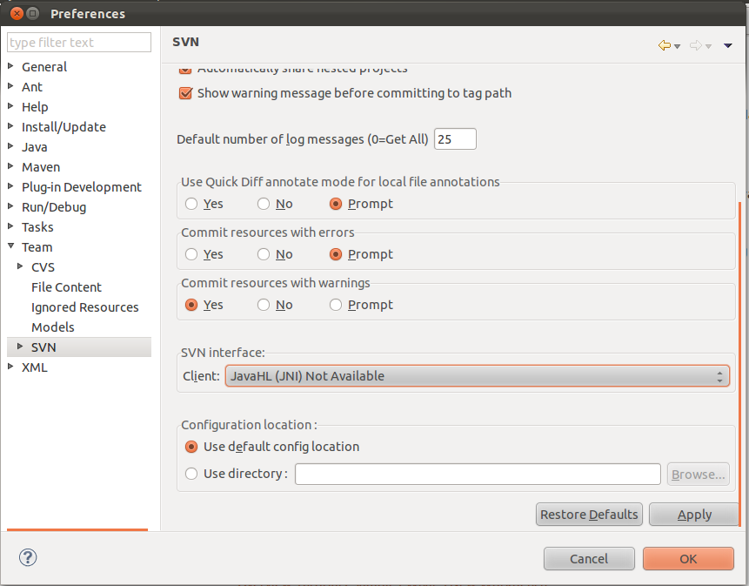

- In GNU/Linux OS, the JavaHL library is in a separate package dependent on the main subversion package. To get it launch the command console and follow next steps:

sudo apt-get install libsvn-java

find / -name libsvnjavahl-1.so > ~/pathJavaHL

- Open the file eclipse.ini in ~/universAAL/eclipse/ folder.
- After -vmargs line, add the following line: -Djava.library.path=/usr/lib/jni/ (without quotes). This will create a file text with the path of the JavaHL library inside it. This information will be used in the next steps (typically, it will be /usr/lib/jni). Save and exit.

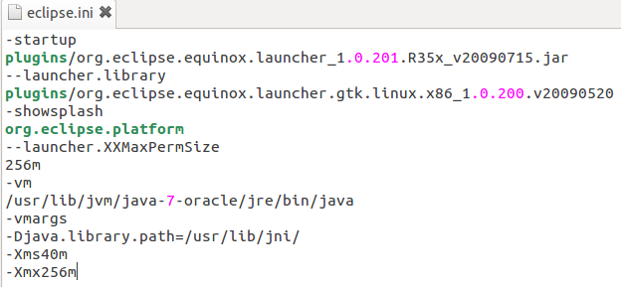

- Open again Eclipse IDE, and check if the SVN Interface option described before has a correct value.

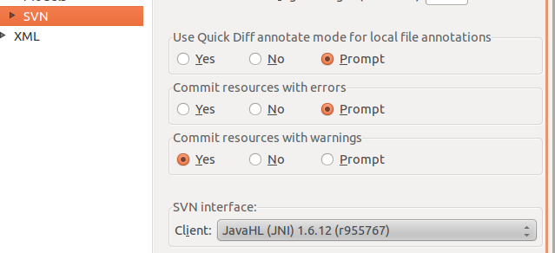

14. At this point, you should be able to import any uAAL project as well as run it correctly.

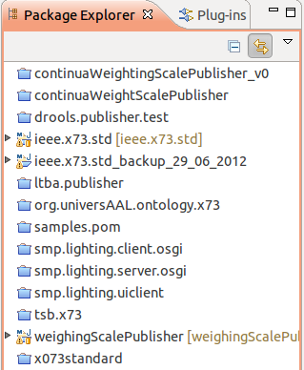

Troubleshooting

1. The examples (and any universAAL bundle) will not run if the file sodapop.key is not in the proper folder. For solving this problem, look for any sodapop.key file in the ~/universAAL/svn/support/trunk/samples local folder, and copy it into [workspace_folder]/rundir/mw.bus.model. If any of the folders in the later path does not exist, just create them.

ANDROID DEVELOPMENT SUPPORT

Setting up a real device for development/debbugging

http://developer.android.com/tools/device.html

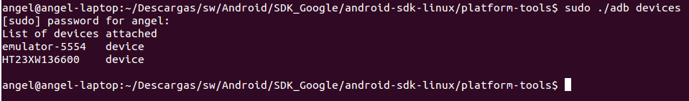

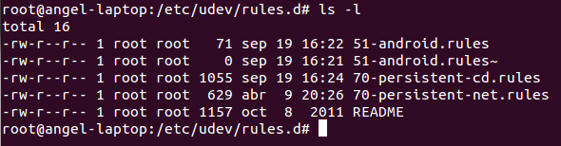

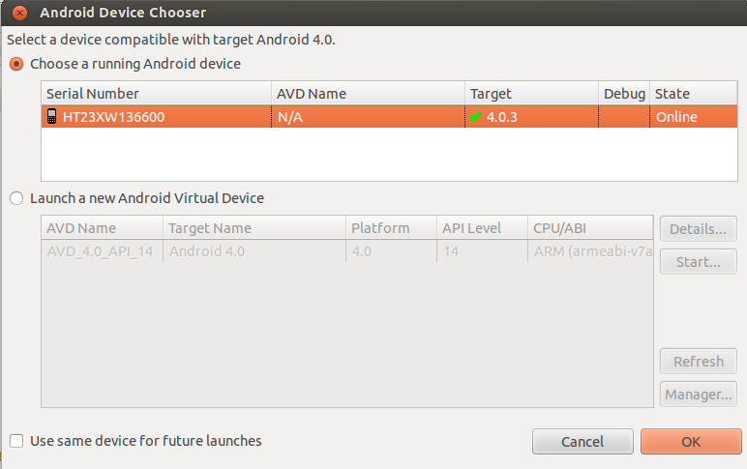

OS had successfully been updated to ubuntu 12.04 LTS in August 2012.
http://www.bluez.org
http://www.aandd.jp/products/medical/bluetooth/uc_321pbt_c.html
http://www.aandd.jp/products/medical/bluetooth/ua_767pbt_c.html
http://www.ubuntu.com/download/desktop
http://forge.universaal.org/gf/
http://www.bluez.org/download/
http://www.freedesktop.org/wiki/Software/dbus
http://www.freedesktop.org/wiki/Software/DBusBindings
http://dbus.freedesktop.org/doc/api/html/index.html
http://forge.universaal.org/gf/
http://maven.apache.org/download.html
http://forge.universaal.org/gf/
http://rabbitvcs.org/
http://pysvn.tigris.org/docs/WorkBench.html
http://archive.eclipse.org/eclipse/downloads/drops/R-3.5.2-201002111343/download.php?dropFile=eclipse-SDK-3.5.2-linux-gtk.tar.gz
http://subclipse.tigris.org/update_1.6.x
http://m2eclipse.sonatype.org/sites/m2e
http://www.ops4j.org/pax/eclipse/update/
~/universAAL/svn/support/trunk/resources/maven-repo-settings

