To reset the browser we do a simple reset using the universal selector.
Universal selector will select each and every element of the page and then apply the declarations to it .
We add a margin of 0 pixels and also a padding of 0 pixels

* {
margin: 0;
padding: 0;
box-sizing: border-box;
}

By default browsers apply certain margins and certain padding to some elements like for example an h1 element
box-sizing border box; changes the box model so that the box model are never added to the total width or the total height that is specified for the box.

If we want to add some font property to the entire web page we do in the body element because the property related to fonts are usually inherited. If we put font family on the body element which it the parent element for all other element this font family will get inherited to all the child elements of the body. Doing it this way if more efficient that to put all of this in universal selector.
body {
font-family: "Lato", sans-serif;
font-weight: 400;
font-size: 16px;
line-height: 1.7;
color: #777;
}

height: 95vh; we say that at every point height of this element should be 95% of the viewport height.

To specify the background image we write background-image: url(../img/hero.jpg);
../img/hero.jpg is the path relative to the current file ie style.css.

background-size: cover; scales the image, while preserving its intrinsic aspect-ratio (if any) , to the smallest size such that both its width and its height can completely cover the background positioning area.

background-position: top; it insures that whatever the viewport size the top of the image always stays at the top of the container. Bottom of the image may get cropped but top of the image always stays the same.

background-image: linear-gradient(
to right,
rgba(128, 214, 113, 0.803),
hsla(160, 64%, 43%, 0.802)
),
url(../img/hero.jpg);

For the green gradient all over the image we use background image again because to specify gradient we always use background image property.
Here we already have the background-image property and we want the gradient to stay on top so we specify before the image
to right specifies that it should start on the left side and go to the right.

clip-path: polygon(0 0, 100% 0, 100% 70%, 0 100%);
If we want to clip a part of image for the styling we use clic-path where we specify an image or a polygon in which the image will be still be visible
clic-path uses a polygon function where we define a bunch of coordinates which define its polygon
Starting at the top left we define the coordinates with xy property.

Properties used

margin

syntax
[ <length> | <percentage> | auto ]{1,4}

Values
<length>
The size of the margin as a fixed value.
<percentage>
The size of the margin as a percentage, relative to the width of the containing block.
auto
The browser selects a suitable margin to use. For example, in certain cases this value can be used to center an element.

Description
This property can be used to set a margin on all four sides of an element. Margins create extra space around an element, unlike padding, which creates extra space within an element.
The top and bottom margins have no effect on non-replaced inline elements, such as <span> or <code>.

Initial value | as each of the properties of the shorthand:  - margin-bottom: 0  - margin-left: 0  - margin-right: 0  - margin-top: 0
Applies to | all elements, except elements with table display types other than table-caption, table and inline-table. It also applies to ::first-letter and ::first-line.
Inherited | no
Percentages | refer to the width of the containing block
Computed value | as each of the properties of the shorthand:  - margin-bottom: the percentage as specified or the absolute length  - margin-left: the percentage as specified or the absolute length  - margin-right: the percentage as specified or the absolute length  - margin-top: the percentage as specified or the absolute length
Animation type | a length

The margin property may be specified using one, two, three, or four values. Each value is a <length>, a <percentage>, or the keyword auto. Negative values draw the element closer to its neighbors than it would be by default.

When one value is specified, it applies the same margin to all four sides.
When two values are specified, the first margin applies to the top and bottom, the second to the left and right.
When three values are specified, the first margin applies to the top, the second to the right and left, the third to the bottom.
When four values are specified, the margins apply to the top, right, bottom, and left in that order (clockwise).

Example
/* Apply to all four sides */
margin: 1em;
margin: -3px;

/* vertical | horizontal */
margin: 5% auto;

/* top | horizontal | bottom */
margin: 1em auto 2em;

/* top | right | bottom | left */
margin: 2px 1em 0 auto;

/* Global values */
margin: inherit;
margin: initial;
margin: revert;
margin: unset;

margin-top

The margin-top CSS property sets the margin area on the top of an element. A positive value places it farther from its neighbors, while a negative value places it closer.
This property has no effect on non-replaced inline elements, such as <span> or <code>.

<length> | <percentage> | auto

Values
<length>
The size of the margin as a fixed value.
<percentage>
The size of the margin as a percentage, relative to the width of the containing block.
auto

Initial value | 0
Applies to | all elements, except elements with table display types other than table-caption, table and inline-table. It also applies to ::first-letter and ::first-line.
Inherited | no
Percentages | refer to the width of the containing block
Computed value | the percentage as specified or the absolute length
Animation type | a length

For example
margin-top: 10px; /* An absolute length */
margin-top: 1em; /* relative to the text size */
margin-top: 5%; /* relative to the nearest block container's width */

/* Keyword values */
margin-top: auto;

/* Global values */
margin-top: inherit;
margin-top: initial;
margin-top: revert;
margin-top: unset;

font-weight

The font-weight CSS property sets the weight (or boldness) of the font. The weights available depend on the font-family that is currently set.

<font-weight-absolute> | bolder | lighter
where
<font-weight-absolute> = normal | bold | <number [1,1000]>

Values
normal
Normal font weight. Same as 400.
bold
Bold font weight. Same as 700.
lighter
One relative font weight lighter than the parent element.
bolder
One relative font weight heavier than the parent element.
<number>
A <number> value between 1 and 1000, inclusive. Higher numbers represent weights that are bolder than (or as bold as) lower numbers.
CSS Fonts Level 4 extends the syntax to accept any number between 1 and 1000 and introduces Variable fonts, which can make use of this much finer-grained range of font weights.

Initial value | normal
Applies to | all elements. It also applies to ::first-letter and ::first-line.
Inherited | yes
Computed value | the keyword or the numerical value as specified, with bolder and lighter transformed to the real value
Animation type | a font weight
/* Keyword values */
font-weight: normal;
font-weight: bold;

/* Keyword values relative to the parent */
font-weight: lighter;
font-weight: bolder;

/* Numeric keyword values */
font-weight: 100;
font-weight: 200;
font-weight: 300;
font-weight: 400;// normal
font-weight: 500;
font-weight: 600;
font-weight: 700;// bold
font-weight: 800;
font-weight: 900;

/* Global values */
font-weight: inherit;
font-weight: initial;
font-weight: revert;
font-weight: unset;

font-size

<absolute-size> | <relative-size> | <length-percentage>
where
<absolute-size> = xx-small | x-small | small | medium | large | x-large | xx-large | xxx-large
<relative-size> = larger | smaller
<length-percentage> = <length> | <percentage>

Description
There are several ways to specify the font size, including keywords or numerical values for pixels or ems. Choose the appropriate method based on the needs of the particular web page.

Keywords
eg medium

Pixels
Setting the font size in pixel values (px) is a good choice when you need pixel accuracy.
Font sizing settings can also be used in combination. For example, if a parent element is set to 16px and its child element is set to larger, the child element displays larger than the parent element on the page.

Ems
p {
font-size: 2em;
}
the font size of <p> elements will be double the computed font-size inherited by <p> elements. If a font-size has not been set on any of the <p>'s ancestors, then 1em will equal the default browser font-size, which is usually 16px.
em = desired element pixel value / parent element font-size in pixels

One important fact to keep in mind: em values compound.

Rems
rem values were invented in order to sidestep the compounding problem. rem values are relative to the root html element, not the parent element.
it lets us specify a font size in a relative fashion without being affected by the size of the parent, thereby eliminating compounding.

Initial value | medium
Applies to | all elements. It also applies to ::first-letter and ::first-line.
Inherited | yes
Percentages | refer to the parent element's font size
Computed value | as specified, but with relative lengths converted into absolute lengths
Animation type | a length
/* <absolute-size> values */
font-size: xx-small;
font-size: x-small;
font-size: small;
font-size: medium;
font-size: large;
font-size: x-large;
font-size: xx-large;
font-size: xxx-large;

/* <relative-size> values */
font-size: smaller;
font-size: larger;

/* <length> values */
font-size: 12px;
font-size: 0.8em;

/* <percentage> values */
font-size: 80%;

/* Global values */
font-size: inherit;
font-size: initial;
font-size: revert;
font-size: unset;

line-height
The line-height CSS property is used to set the distance between lines of text. On block-level elements, it specifies the minimum height of line boxes within the element. On non-replaced inline elements, it specifies the height that is used to calculate line box height.

normal | <number> | <length> | <percentage>
Values
normal
Depends on the user agent. Desktop browsers (including Firefox) use a default value of roughly 1.2, depending on the element's font-family.

<number> (unitless)
The used value is this unitless <number> multiplied by the element's own font size. The computed value is the same as the specified <number>. In most cases, this is the preferred way to set line-height and avoid unexpected results due to inheritance.

<length>
The specified <length> is used in the calculation of the line box height. Values given in em units may produce unexpected results (see example below).

<percentage>
Relative to the font size of the element itself. The computed value is this <percentage> multiplied by the element's computed font size. Percentage values may produce unexpected results (see the second example below).
Use a minimum value of 1.5 for line-height for main paragraph content. This will help people experiencing low vision conditions, as well as people with cognitive concerns such as Dyslexia. If the page is zoomed to increase the text size, using a unitless value ensures that the line height will scale proportionately.
Initial value | normal
Applies to | all elements. It also applies to ::first-letter and ::first-line.
Inherited | yes
Percentages | refer to the font size of the element itself
Computed value | for percentage and length values, the absolute length, otherwise as specified
Animation type | either number or length

/* Keyword value */
line-height: normal;

/* Unitless values: use this number multiplied
by the element's font size */
line-height: 3.5;

/* <length> values */
line-height: 3em;

/* <percentage> values */
line-height: 34%;

/* Global values */
line-height: inherit;
line-height: initial;
line-height: revert;
line-height: unset;

Color
<color>
where
<color> = <rgb()> | <rgba()> | <hsl()> | <hsla()> | <hex-color> | <named-color> | currentcolor | <deprecated-system-color>

where
<rgb()> = rgb( <percentage>{3} [ / <alpha-value> ]? ) | rgb( <number>{3} [ / <alpha-value> ]? ) | rgb( <percentage>#{3} , <alpha-value>? ) | rgb( <number>#{3} , <alpha-value>? )
<rgba()> = rgba( <percentage>{3} [ / <alpha-value> ]? ) | rgba( <number>{3} [ / <alpha-value> ]? ) | rgba( <percentage>#{3} , <alpha-value>? ) | rgba( <number>#{3} , <alpha-value>? )
<hsl()> = hsl( <hue> <percentage> <percentage> [ / <alpha-value> ]? ) | hsl( <hue>, <percentage>, <percentage>, <alpha-value>? )
<hsla()> = hsla( <hue> <percentage> <percentage> [ / <alpha-value> ]? ) | hsla( <hue>, <percentage>, <percentage>, <alpha-value>? )

where
<alpha-value> = <number> | <percentage>
<hue> = <number> | <angle>

Initial value | Varies from one browser to another
Applies to | all elements. It also applies to ::first-letter and ::first-line.
Inherited | yes
Computed value | If the value is translucent, the computed value will be the rgba() corresponding one. If it isn't, it will be the rgb() corresponding one. The transparent keyword maps to rgba(0,0,0,0).
Animation type | a color
/* Keyword values */
color: currentcolor;

/* <named-color> values */
color: red;
color: orange;
color: tan;
color: rebeccapurple;

/* <hex-color> values */
color: #090;
color: #009900;
color: #090a;
color: #009900aa;

/* <rgb()> values */
color: rgb(34, 12, 64, 0.6);
color: rgba(34, 12, 64, 0.6);
color: rgb(34 12 64 / 0.6);
color: rgba(34 12 64 / 0.3);
color: rgb(34.0 12 64 / 60%);
color: rgba(34.6 12 64 / 30%);

/* <hsl()> values */
color: hsl(30, 100%, 50%, 0.6);
color: hsla(30, 100%, 50%, 0.6);
color: hsl(30 100% 50% / 0.6);
color: hsla(30 100% 50% / 0.6);
color: hsl(30.0 100% 50% / 60%);
color: hsla(30.2 100% 50% / 60%);

/* Global values */
color: inherit;
color: initial;
color: revert;
color: unset;

Padding

The padding CSS shorthand property sets the padding area on all four sides of an element at once.

[ <length> | <percentage> ]{1,4}

Values
<length>
The size of the padding as a fixed value.

<percentage>
The size of the padding as a percentage, relative to the width of the containing block.

The padding property may be specified using one, two, three, or four values. Each value is a <length> or a <percentage>. Negative values are invalid.

When one value is specified, it applies the same padding to all four sides.
When two values are specified, the first padding applies to the top and bottom, the second to the left and right.
When three values are specified, the first padding applies to the top, the second to the right and left, the third to the bottom.
When four values are specified, the paddings apply to the top, right, bottom, and left in that order (clockwise).

Initial value | as each of the properties of the shorthand:  - padding-bottom: 0  - padding-left: 0  - padding-right: 0  - padding-top: 0
Applies to | all elements, except table-row-group, table-header-group, table-footer-group, table-row, table-column-group and table-column. It also applies to ::first-letter and ::first-line.
Inherited | no
Percentages | refer to the width of the containing block
Computed value | as each of the properties of the shorthand:  - padding-bottom: the percentage as specified or the absolute length  - padding-left: the percentage as specified or the absolute length  - padding-right: the percentage as specified or the absolute length  - padding-top: the percentage as specified or the absolute length
Animation type | a length
/* Apply to all four sides */
padding: 1em;

/* vertical | horizontal */
padding: 5% 10%;

/* top | horizontal | bottom */
padding: 1em 2em 2em;

/* top | right | bottom | left */
padding: 5px 1em 0 2em;

/* Global values */
padding: inherit;
padding: initial;
padding: revert;
padding: unset;

padding-top

<length> | <percentage>
Values
<length>
The size of the padding as a fixed value. Must be nonnegative.
<percentage>

The size of the padding as a percentage, relative to the width of the containing block. Must be nonnegative.
The padding-top CSS property sets the height of the padding area on the top of an element.
An element's padding area is the space between its content and its border.
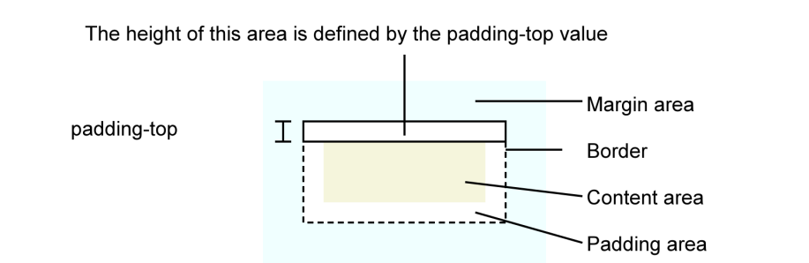
Initial value | 0
Applies to | all elements, except table-row-group, table-header-group, table-footer-group, table-row, table-column-group and table-column. It also applies to ::first-letter and ::first-line.
Inherited | no
Percentages | refer to the width of the containing block
Computed value | the percentage as specified or the absolute length
Animation type | a length
/* <length> values */
padding-top: 0.5em;
padding-top: 0;
padding-top: 2cm;

/* <percentage> value */
padding-top: 10%;

/* Global values */
padding-top: inherit;
padding-top: initial;
padding-top: revert;
padding-top: unset;

height
The height CSS property specifies the height of an element. By default, the property defines the height of the content area. If box-sizing is set to border-box, however, it instead determines the height of the border area.

auto | <length> | <percentage> | min-content | max-content | fit-content | fit-content(<length-percentage>)
where
<length-percentage> = <length> | <percentage>

Values
<length>
Defines the height as an absolute value.

<percentage>
Defines the height as a percentage of the containing block's height.

auto
The browser will calculate and select a height for the specified element.

max-content
The intrinsic preferred height.

min-content
The intrinsic minimum height.

fit-content(<length-percentage>)
Uses the fit-content formula with the available space replaced by the specified argument, i.e. min(max-content, max(min-content, <length-percentage>)).
Initial value | auto
Applies to | all elements but non-replaced inline elements, table columns, and column groups
Inherited | no
Percentages | The percentage is calculated with respect to the height of the generated box's containing block. If the height of the containing block is not specified explicitly (i.e., it depends on content height), and this element is not absolutely positioned, the value computes to auto. A percentage height on the root element is relative to the initial containing block.
Computed value | a percentage or auto or the absolute length
Animation type | a length, percentage or calc();
/* <length> values */
height: 120px;
height: 10em;

/* <percentage> value */
height: 75%;

/* Keyword values */
height: max-content;
height: min-content;
height: fit-content(20em);
height: auto;

/* Global values */
height: inherit;
height: initial;
height: revert;
height: unset;

background-image
The background-image CSS property sets one or more background images on an element.
The background images are drawn on stacking context layers on top of each other. The first layer specified is drawn as if it is closest to the user.
The borders of the element are then drawn on top of them, and the background-color is drawn beneath them. How the images are drawn relative to the box and its borders is defined by the background-clip and background-origin CSS properties.

Syntax
<bg-image>#
where
<bg-image> = none | <image>

where
<image> = <url> | <image()> | <image-set()> | <element()> | <paint()> | <cross-fade()> | <gradient>

where
<image()> = image( <image-tags>? [ <image-src>? , <color>? ]! )
<image-set()> = image-set( <image-set-option># )
<element()> = element( <id-selector> )
<paint()> = paint( <ident>, <declaration-value>? )
<cross-fade()> = cross-fade( <cf-mixing-image> , <cf-final-image>? )
<gradient> = <linear-gradient()> | <repeating-linear-gradient()> | <radial-gradient()> | <repeating-radial-gradient()> | <conic-gradient()>

where
<image-tags> = ltr | rtl
<image-src> = <url> | <string>
<color> = <rgb()> | <rgba()> | <hsl()> | <hsla()> | <hex-color> | <named-color> | currentcolor | <deprecated-system-color>
<image-set-option> = [ <image> | <string> ] [ <resolution> || type(<string>) ]
<id-selector> = <hash-token>
<cf-mixing-image> = <percentage>? && <image>
<cf-final-image> = <image> | <color>
<linear-gradient()> = linear-gradient( [ <angle> | to <side-or-corner> ]? , <color-stop-list> )
<repeating-linear-gradient()> = repeating-linear-gradient( [ <angle> | to <side-or-corner> ]? , <color-stop-list> )
<radial-gradient()> = radial-gradient( [ <ending-shape> || <size> ]? [ at <position> ]? , <color-stop-list> )
<repeating-radial-gradient()> = repeating-radial-gradient( [ <ending-shape> || <size> ]? [ at <position> ]? , <color-stop-list> )
<conic-gradient()> = conic-gradient( [ from <angle> ]? [ at <position> ]?, <angular-color-stop-list> )

where
<rgb()> = rgb( <percentage>{3} [ / <alpha-value> ]? ) | rgb( <number>{3} [ / <alpha-value> ]? ) | rgb( <percentage>#{3} , <alpha-value>? ) | rgb( <number>#{3} , <alpha-value>? )
<rgba()> = rgba( <percentage>{3} [ / <alpha-value> ]? ) | rgba( <number>{3} [ / <alpha-value> ]? ) | rgba( <percentage>#{3} , <alpha-value>? ) | rgba( <number>#{3} , <alpha-value>? )
<hsl()> = hsl( <hue> <percentage> <percentage> [ / <alpha-value> ]? ) | hsl( <hue>, <percentage>, <percentage>, <alpha-value>? )
<hsla()> = hsla( <hue> <percentage> <percentage> [ / <alpha-value> ]? ) | hsla( <hue>, <percentage>, <percentage>, <alpha-value>? )
<side-or-corner> = [ left | right ] || [ top | bottom ]
<color-stop-list> = [ <linear-color-stop> [, <linear-color-hint>]? ]# , <linear-color-stop>
<ending-shape> = circle | ellipse
<size> = closest-side | farthest-side | closest-corner | farthest-corner | <length> | <length-percentage>{2}
<position> = [ [ left | center | right ] || [ top | center | bottom ] | [ left | center | right | <length-percentage> ] [ top | center | bottom | <length-percentage> ]? | [ [ left | right ] <length-percentage> ] && [ [ top | bottom ] <length-percentage> ] ]
<angular-color-stop-list> = [ <angular-color-stop> [, <angular-color-hint>]? ]# , <angular-color-stop>

where
<alpha-value> = <number> | <percentage>
<hue> = <number> | <angle>
<linear-color-stop> = <color> <color-stop-length>?
<linear-color-hint> = <length-percentage>
<length-percentage> = <length> | <percentage>
<angular-color-stop> = <color> && <color-stop-angle>?
<angular-color-hint> = <angle-percentage>

where
<color-stop-length> = <length-percentage>{1,2}
<color-stop-angle> = <angle-percentage>{1,2}
<angle-percentage> = <angle> | <percentage>

Values
none
Is a keyword denoting the absence of images.

<image>
Is an <image> denoting the image to display. There can be several of them, separated by commas, as multiple backgrounds are supported.
Initial value | none
Applies to | all elements. It also applies to ::first-letter and ::first-line.
Inherited | no
Computed value | as specified, but with url() values made absolute
Animation type | discrete
background-image:
linear-gradient(to bottom, rgba(255,255,0,0.5), rgba(0,0,255,0.5)),
url('catfront.png');

/* Global values */
background-image: inherit;
background-image: initial;
background-image: revert;
background-image: unset;

background-position
The background-position CSS property sets the initial position for each background image. The position is relative to the position layer set by background-origin.

<bg-position>#
where
<bg-position> = [ [ left | center | right | top | bottom | <length-percentage> ] | [ left | center | right | <length-percentage> ] [ top | center | bottom | <length-percentage> ] | [ center | [ left | right ] <length-percentage>? ] && [ center | [ top | bottom ] <length-percentage>? ] ]

where
<length-percentage> = <length> | <percentage>

Values
<position>
A <position>. A position defines an x/y coordinate, to place an item relative to the edges of an element's box. It can be defined using one to four values. If two non-keyword values are used, the first value represents the horizontal position and the second represents the vertical position. If only one value is specified, the second value is assumed to be center. If three or four values are used, the length-percentage values are offsets for the preceding keyword value(s).

1-value syntax: the value may be:
The keyword value center, which centers the image.
One of the keyword values top, left, bottom, right. This specifies an edge against which to place the item.
The other dimension is then set to 50%, so the item is placed in the middle of the edge specified.
A <length> or <percentage>. This specifies the X coordinate relative to the left edge, with the Y coordinate set to 50%.

2-value syntax: one value defines X and the other defines Y. Each value may be:
One of the keyword values top, left, bottom, right. If left or right are given here, then this defines X and the other given value defines Y. If top or bottom are given, then this defines Y and the other value defines X.
A <length> or <percentage>. If the other value is left or right, then this value defines Y, relative to the top edge. If the other value is top or bottom, then this value defines X, relative to the left edge.
If both values are <length> or <percentage> values, then the first defines X and the second Y.
Note that: If one value is top or bottom, then the other value may not be top or bottom. If one value is left or right, then the other value may not be left or right.
This means, e.g., that top top and left right are not valid.
The default value is top left or 0% 0%.

3-value syntax: Two values are keyword values, and the third is the offset for the preceding value:

The first value is one of the keyword values top, left, bottom, right, or center. If left or right are given here, then this defines X. If top or bottom are given, then this defines Y and the other keyword value defines X.
The <length> or <percentage> value, if it is the second value, is the offset for the first value. If it is the third value, it is the offset for the second value.
The single length or percentage value is an offset for the keyword value that precedes it. The combination of one keyword with two <length> or <percentage> values is not valid.

4-value syntax: The first and third values are keyword value defining X and Y. The second and fourth values are offsets for the preceding X and Y keyword values:
The first value and third values one of the keyword values top, left, bottom, right. If left or right are given here, then this defines X. If top or bottom are given, then this defines Y and the other keyword value defines X.
The second and fourth values are <length> or <percentage> values. The second value is the offset for the first keyword. The fourth value is the offset for the second keyword.
Regarding Percentages:
The percentage offset of the given background image's position is relative to the container. A value of 0% means that the left (or top) edge of the background image is aligned with the corresponding left (or top) edge of the container, or the 0% mark of the image will be on the 0% mark of the container. A value of 100% means that the right (or bottom) edge of the background image is aligned with the right (or bottom) edge of the container, or the 100% mark of the image will be on the 100% mark of the container. Thus a value of 50% horizontally or vertically centers the background image as the 50% of the image will be at the 50% mark of the container. Similarly, background-position: 25% 75% means the spot on the image that is 25% from the left and 75% from the top will be placed at the spot of the container that is 25% from the container's left and 75% from the container's top.

Essentially what happens is the background image dimension is subtracted from the corresponding container dimension, and then a percentage of the resulting value is used as the direct offset from the left (or top) edge.

(container width - image width) * (position x%) = (x offset value)
(container height - image height) * (position y%) = (y offset value)
Using the X axis for an example, let's say we have an image that is 300px wide and we are using it in a container that is 100px wide, with background-size set to auto:

100px - 300px = -200px (container & image difference)
So that with position percentages of -25%, 0%, 50%, 100%, 125%, we get these image-to-container edge offset values:

-200px * -25% = 50px
-200px * 0% = 0px
-200px * 50% = -100px
-200px * 100% = -200px
-200px * 125% = -250px
So with these resultant values for our example, the left edge of the image is offset from the left edge of the container by:

+ 50px (putting the left image edge in the center of the 100-pixel-wide container)
0px (left image edge coincident with the left container edge)
-100px (left image edge 100px to the left of the container, in this example that means the middle 100px image area is centered in the container)
-200px (left image edge 200px to the left of the container, in this example that means the right image edge is coincident with the right container edge)
-250px (left image edge 250px to the left of the container, in this example that puts the right edge of the 300px-wide image in the center of the container)
It's worth mentioning that if our background-size is equal to the container size for a given axis, then a percentage position for that axis will have no effect because the "container-image difference" will be zero. You will need to offset using absolute values.

Initial value | 0% 0%
Applies to | all elements. It also applies to ::first-letter and ::first-line.
Inherited | no
Percentages | refer to the size of the background positioning area minus size of background image; size refers to the width for horizontal offsets and to the height for vertical offsets
Computed value | as each of the properties of the shorthand:  - background-position-x: A list, each item consisting of: an offset given as a combination of an absolute length and a percentage, plus an origin keyword  - background-position-y: A list, each item consisting of: an offset given as a combination of an absolute length and a percentage, plus an origin keyword
Animation type | repeatable list of simple list of length, percentage, or calc

/* Keyword values */
background-position: top;
background-position: bottom;
background-position: left;
background-position: right;
background-position: center;

/* <percentage> values */
background-position: 25% 75%;

/* <length> values */
background-position: 0 0;
background-position: 1cm 2cm;
background-position: 10ch 8em;

/* Multiple images */
background-position: 0 0, center;

/* Edge offsets values */
background-position: bottom 10px right 20px;
background-position: right 3em bottom 10px;
background-position: bottom 10px right;
background-position: top right 10px;

/* Global values */
background-position: inherit;
background-position: initial;
background-position: revert;
background-position: unset;

background-size
The background-size CSS property sets the size of the element's background image. The image can be left to its natural size, stretched, or constrained to fit the available space.

<bg-size>#
where
<bg-size> = [ <length-percentage> | auto ]{1,2} | cover | contain

where
<length-percentage> = <length> | <percentage>

The background-size property is specified in one of the following ways:

- Using the keyword values contain or cover.
- Using a width value only, in which case the height defaults to auto.
- Using both a width and a height value, in which case the first sets the width and the second sets the height. Each value can be a <length>, a <percentage>, or auto.
To specify the size of multiple background images, separate the value for each one with a comma.

Values

contain
Scales the image as large as possible within its container without cropping or stretching the image. If the container is larger than the image, this will result in image tiling, unless the background-repeat property is set to no-repeat.

cover
Scales the image as large as possible to fill the container, stretching the image if necessary. If the proportions of the image differ from the element, it is cropped either vertically or horizontally so that no empty space remains.

auto
Scales the background image in the corresponding direction such that its intrinsic proportions are maintained.

<length>
Stretches the image in the corresponding dimension to the specified length. Negative values are not allowed.

<percentage>
Stretches the image in the corresponding dimension to the specified percentage of the background positioning area. The background positioning area is determined by the value of background-origin (by default, the padding box). However, if the background's background-attachment value is fixed, the positioning area is instead the entire viewport. Negative values are not allowed.

Working with gradients
If you use a <gradient> as the background and specify a background-size to go with it, it's best not to specify a size that uses a single auto component, or is specified using only a width value (for example, background-size: 50%). Rendering of <gradient>s in such cases changed in Firefox 8, and at present is generally inconsistent across browsers, which do not all implement rendering in full accordance with the CSS3 background-size specification and with the CSS3 Image Values gradient specification.

.gradient-example {
width: 50px;
height: 100px;
background-image: linear-gradient(blue, red);

/* Not safe to use */
background-size: 25px;
background-size: 50%;
background-size: auto 50px;
background-size: auto 50%;

/* Safe to use */
background-size: 25px 50px;
background-size: 50% 50%;
}
Note that it's particularly not recommended to use a pixel dimension and an auto dimension with a <gradient>, because it's impossible to replicate rendering in versions of Firefox prior to 8, and in browsers not implementing Firefox 8's rendering, without knowing the exact size of the element whose background is being specified.

Initial value | auto auto
Applies to | all elements. It also applies to ::first-letter and ::first-line.
Inherited | no
Percentages | relative to the background positioning area
Computed value | as specified, but with relative lengths converted into absolute lengths
Animation type | repeatable list of simple list of length, percentage, or calc

/* Keyword values */
background-size: cover;
background-size: contain;

/* One-value syntax */
/* the width of the image (height becomes 'auto') */
background-size: 50%;
background-size: 3.2em;
background-size: 12px;
background-size: auto;

/* Two-value syntax */
/* first value: width of the image, second value: height */
background-size: 50% auto;
background-size: 3em 25%;
background-size: auto 6px;
background-size: auto auto;

/* Multiple backgrounds */
background-size: auto, auto; /* Not to be confused with `auto auto` */
background-size: 50%, 25%, 25%;
background-size: 6px, auto, contain;

/* Global values */
background-size: inherit;
background-size: initial;
background-size: revert;
background-size: unset;

When we have to work with image we normally put them inside a div as img is an inline element. To position the image we can have that image inside the container and then position that container to position the image

<div class="logo-box">
<img src="img/logo-white.png" alt="logo" class="logo" />
</div>

We have logo-box and logo to style our image

Here we want to set the position of the logo-box to absolute but without a reference point with all its parent set to default static the reference will default to the root element
Therefore we will set the position of the header to be relative.

Heading
H1 is the single most important heading on the page for google to figure out what our web page is all about. There fore we should put the title of the web page in there.
We can use the span element inside of the h1 to divide the text. Span is simply to style some text differently.
Span element is just inline element so to make them into block element we can change the display to block
This can make the divided heading in different lines

If heading contain other elements like buttons icons or an image. We can put it in other box. And the we can style this box for the position distribution and other stuff instead of worrying about position each element separately with respect to the header.
To center this box we can use absolute positioning.
Then we set the top to 50% and left 50%. this will position it 50% to the left of parent element and 50% from the top the parent element.
Then we translate the entire box. By using transform property of css and specify how much we want to translate on x and y that in our case is -50% each
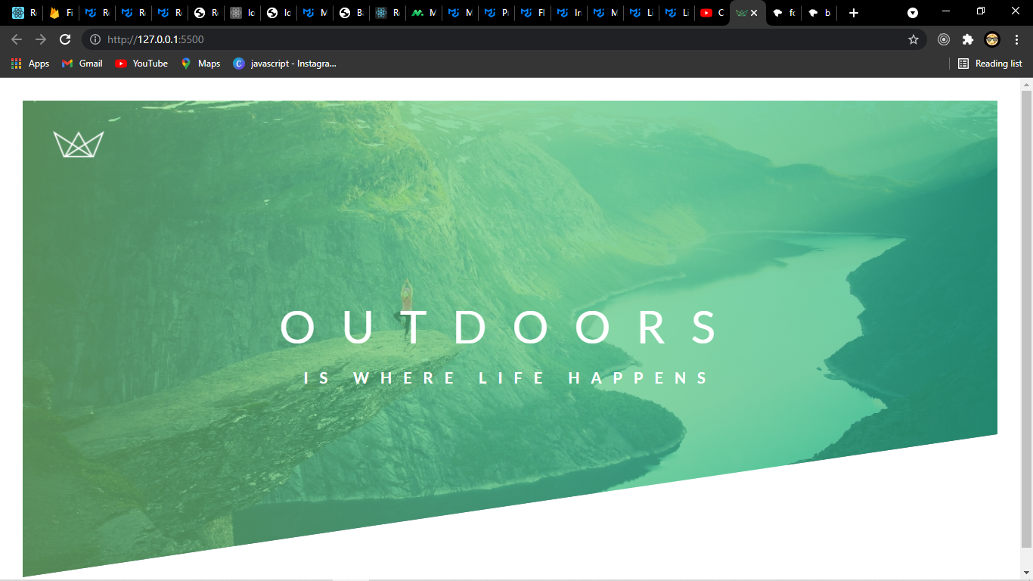
.text-box {
position: absolute;
top: 50%;
left: 50%;
transform: translate(-50%, -50%);
text-align: center;
}

.heading-primary {
color: #fff;
text-transform: uppercase;
}
.heading-primary-main {
display: block;
font-size: 60px;
font-weight: 400;
letter-spacing: 34px;
}
.heading-primary-sub {
display: block;
font-size: 20px;
font-weight: 700;
letter-spacing: 15px;
text-align: center;
}

Properties used

position
The position CSS property sets how an element is positioned in a document. The top, right, bottom, and left properties determine the final location of positioned elements.

Syntax
static | relative | absolute | sticky | fixed

Values
Static
The element’s box is generated as normal. Block-level elements generate a rectangular box that is part of the document’s flow,
This is the default position that all our HTML elements will have when they enter onto the page it says that it should follow the other elements in the document flow whatever comes first in our HTML will above what comes later.
The inline-level boxes generate one or more line boxes that flow within their parent element.

Relative
The element’s box is offset by some distance. Its containing block can be considered to be the area that the element would occupy if it were not positioned. The element retains the shape it would have had were it not positioned, and the space that the element would otherwise have occupied in the normal flow is preserved.
Relative allows to change the position of the element relative to normally it would be in the document flow if statically positioned. To specify the relative position we use top, left, right, bottom and assign it to the value by which we pant to relatively position the element. Bot this is not often used for top left right bottom.

Absolute
The element’s box is completely removed from the flow of the document and positioned with respect to its containing block, which may be another element in the document or the initial containing block.
Whatever space the element might have occupied in the normal document flow is closed up, as though the element did not exist.
The positioned element generates a block box, regardless of the type of box it would generate if it were in the normal flow.
This allows us to do top, left, right, bottom to it. Not like relative positioning it will not position relative to itself but it will position itself relative to its parent element which is also positioned any of relative absolute, sticky or fixed but not static.
If the parent is positioned static the absolute positioned element will look up the DOM tree to find that case until it gets relative to the HTML element.
This is where relative is really useful its when we want to position any thing inside of it we make the element position relative other wise the absolute positioned element will fall back to the next relatively (or all other other than static )positioned element or all the back to the HTML element.

Fixed
The element’s box behaves as though set to absolute, but its containing block is the viewport itself. And they stay in same place when we scroll

Sticky
The element’s box stays in the normal flow until it reaches a sticky edge of the containing box, at which time it “sticks” there as if absolutely positioned.
The space that the element would otherwise have occupied in the normal flow is preserve

Initial value | static
Applies to | all elements
Inherited | no
Computed value | as specified
Animation type | discrete
Creates stacking context | yes

position: static;
position: relative;
position: absolute;
position: fixed;
position: sticky;

/* Global values */
position: inherit;
position: initial;
position: revert;
position: unset;

transform
The transform CSS property lets you rotate, scale, skew, or translate an element. It modifies the coordinate space of the CSS visual formatting model.

Syntax
none | <transform-list>
where
<transform-list> = <transform-function>+

where
<transform-function> = <matrix()> | <translate()> | <translateX()> | <translateY()> | <scale()> | <scaleX()> | <scaleY()> | <rotate()> | <skew()> | <skewX()> | <skewY()> | <matrix3d()> | <translate3d()> | <translateZ()> | <scale3d()> | <scaleZ()> | <rotate3d()> | <rotateX()> | <rotateY()> | <rotateZ()> | <perspective()>

where
<matrix()> = matrix( <number>#{6} )
<translate()> = translate( <length-percentage> , <length-percentage>? )
<translateX()> = translateX( <length-percentage> )
<translateY()> = translateY( <length-percentage> )
<scale()> = scale( <number> , <number>? )
<scaleX()> = scaleX( <number> )
<scaleY()> = scaleY( <number> )
<rotate()> = rotate( [ <angle> | <zero> ] )
<skew()> = skew( [ <angle> | <zero> ] , [ <angle> | <zero> ]? )
<skewX()> = skewX( [ <angle> | <zero> ] )
<skewY()> = skewY( [ <angle> | <zero> ] )
<matrix3d()> = matrix3d( <number>#{16} )
<translate3d()> = translate3d( <length-percentage> , <length-percentage> , <length> )
<translateZ()> = translateZ( <length> )
<scale3d()> = scale3d( <number> , <number> , <number> )
<scaleZ()> = scaleZ( <number> )
<rotate3d()> = rotate3d( <number> , <number> , <number> , [ <angle> | <zero> ] )
<rotateX()> = rotateX( [ <angle> | <zero> ] )
<rotateY()> = rotateY( [ <angle> | <zero> ] )
<rotateZ()> = rotateZ( [ <angle> | <zero> ] )
<perspective()> = perspective( <length> )

where
<length-percentage> = <length> | <percentage>

Values
<transform-function>
One or more of the CSS transform functions to be applied. The transform functions are multiplied in order from left to right, meaning that composite transforms are effectively applied in order from right to left.

none
Specifies that no transform should be applied.

Initial value | none
Applies to | transformable elements
Inherited | no
Percentages | refer to the size of bounding box
Computed value | as specified, but with relative lengths converted into absolute lengths
Animation type | a transform
Creates stacking context | yes

translate()
The translate() CSS function repositions an element in the horizontal and/or vertical directions. Its result is a <transform-function> data type.
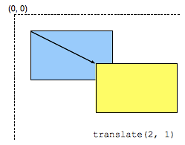
Values
Single <length-percentage> values
This value is a <length> or <percentage> representing the abscissa (horizontal, x-coordinate) of the translating vector. The ordinate (vertical, y-coordinate) of the translating vector will be set to 0. For example, translate(2px) is equivalent to translate(2px, 0). A percentage value refers to the width of the reference box defined by the transform-box property.

Double <length-percentage> values
This value describes two <length> or <percentage> values representing both the abscissa (x-coordinate) and the ordinate (y-coordinate) of the translating vector. A percentage as first value refers to the width, as second part to the height of the reference box defined by the transform-box property.

/* Single <length-percentage> values */
transform: translate(200px);
transform: translate(50%);

/* Double <length-percentage> values */
transform: translate(100px, 200px);
transform: translate(100px, 50%);
transform: translate(30%, 200px);
transform: translate(30%, 50%);

display

Syntax
[ <display-outside> || <display-inside> ] | <display-listitem> | <display-internal> | <display-box> | <display-legacy>
where
<display-outside> = block | inline | run-in
<display-inside> = flow | flow-root | table | flex | grid | ruby
<display-listitem> = <display-outside>? && [ flow | flow-root ]? && list-item
<display-internal> = table-row-group | table-header-group | table-footer-group | table-row | table-cell | table-column-group | table-column | table-caption | ruby-base | ruby-text | ruby-base-container | ruby-text-container
<display-box> = contents | none
<display-legacy> = inline-block | inline-list-item | inline-table | inline-flex | inline-grid
Initial value | inline
Applies to | all elements
Inherited | no
Computed value | as the specified value, except for positioned and floating elements and the root element. In both cases the computed value may be a keyword other than the one specified.
Animation type | Not animatable

/* legacy values */
display: block;
display: inline;
display: inline-block;
display: flex;
display: inline-flex;
display: grid;
display: inline-grid;
display: flow-root;

/* box generation */
display: none;
display: contents;

/* two-value syntax */
display: block flow;
display: inline flow;
display: inline flow-root;
display: block flex;
display: inline flex;
display: block grid;
display: inline grid;
display: block flow-root;

/* other values */
display: table;
display: table-row; /* all table elements have an equivalent CSS display value */
display: list-item;

/* Global values */
display: inherit;
display: initial;
display: revert;
display: unset;

text-align
The text-align CSS property sets the horizontal alignment of the content inside a block element or table-cell box. This means it works like vertical-align but in the horizontal direction.

Values
start
The same as left if direction is left-to-right and right if direction is right-to-left.

end
The same as right if direction is left-to-right and left if direction is right-to-left.
start | end | left | right | center | justify | match-parent
left
The inline contents are aligned to the left edge of the line box.

right
The inline contents are aligned to the right edge of the line box.

center
The inline contents are centered within the line box.

justify
The inline contents are justified. Text should be spaced to line up its left and right edges to the left and right edges of the line box, except for the last line.

justify-all
Same as justify, but also forces the last line to be justified.

match-parent
Similar to inherit, but the values start and end are calculated according to the parent's direction and are replaced by the appropriate left or right value.

<string>
When applied to a table cell, specifies the alignment character around which the cell's contents will align.

The text-align property is specified in one of the following ways:

Using the keyword values start, end, left, right, center, justify, justify-all, or match-parent.
Using a <string> value only, in which case the other value defaults to right.
Using both a keyword value and a <string> value.

Initial value | start, or a nameless value that acts as left if direction is ltr, right if direction is rtl if start is not supported by the browser.
Applies to | block containers
Inherited | yes
Computed value | as specified, except for the match-parent value which is calculated against its parent's direction value and results in a computed value of either left or right
Animation type | discrete
/* Keyword values */
text-align: start;
text-align: end;
text-align: left;
text-align: right;
text-align: center;
text-align: justify;
text-align: justify-all;
text-align: match-parent;

/* Character-based alignment in a table column */
text-align: ".";
text-align: "." center;

/* Block alignment values (Non-standard syntax) */
text-align: -moz-center;
text-align: -webkit-center;

/* Global values */
text-align: inherit;
text-align: initial;
text-align: revert;
text-align: unset;

There are two types of animations in CSS.
First is to use the transition property and then change the properties that we want to animate on an event like when we hover over the element.
Second is the key @keyframes rule.

@keyframes
We write @keyframes and then we give animation a name and inside of the curly braces we specify what we want to happen in each moment of time of animation
We start at 0% when the animation start and at the finish when the animation finish, we can put another steps in the middle as we want the animation to behave.
For browser performance its best only ever animate two properties one is the opacity and other is transform.
For animation to work there is only two property that we want to specify
animation-name and the animation duration and we use it the declaration of that particular element
Animation-timing-function: will define how the animation will proceed

.heading-primary-main {
display: block;
font-size: 60px;
font-weight: 400;
letter-spacing: 34px;
animation-name: moveInLeft;
animation-duration: 1s;
animation-delay: 1s;
animation-timing-function: ease-out;
}
.heading-primary-sub {
display: block;
font-size: 20px;
font-weight: 700;
letter-spacing: 15px;
text-align: center;
animation-name: moveInRight;
animation-duration: 1s;
animation-delay: 1s;
animation-timing-function: ease-out;
}
@keyframes moveInLeft {
0% {
opacity: 0;
transform: translate(-100px);
}
80% {
transform: translate(13px);
}
100% {
opacity: 1;
transform: translate(0);
}
}
@keyframes moveInRight {
0% {
opacity: 0;
transform: translate(100px);
}
80% {
transform: translate(-13px);
}
100% {
opacity: 1;
transform: translate(0);
}
}

Properties used

@keyframes
The @keyframes CSS at-rule controls the intermediate steps in a CSS animation sequence by defining styles for keyframes (or waypoints) along the animation sequence. This gives more control over the intermediate steps of the animation sequence than transitions.

Syntax
@keyframes <keyframes-name> {
<keyframe-block-list>
}
where
<keyframes-name> = <custom-ident> | <string>
<keyframe-block-list> = <keyframe-block>+

where
<keyframe-block> = <keyframe-selector># {
<declaration-list>
}

where
<keyframe-selector> = from | to | <percentage>

Values
<custom-ident>
A name identifying the keyframe list. This must match the identifier production in CSS syntax.

from
A starting offset of 0%.

to
An ending offset of 100%.

<percentage>
A percentage of the time through the animation sequence at which the specified keyframe should occur.

@keyframes slidein {
from {
transform: translateX(0%);
}

to {
transform: translateX(100%);
}
}

animation-timing-function
The animation-timing-function CSS property sets how an animation progresses through the duration of each cycle.

Syntax
<easing-function>#
where
<easing-function> = linear | <cubic-bezier-timing-function> | <step-timing-function>

where
<cubic-bezier-timing-function> = ease | ease-in | ease-out | ease-in-out | cubic-bezier(<number [0,1]>, <number>, <number [0,1]>, <number>)
<step-timing-function> = step-start | step-end | steps(<integer>[, <step-position>]?)

where
<step-position> = jump-start | jump-end | jump-none | jump-both | start | end

Values
<easing-function>
The easing function that corresponds to a given animation, as determined by animation-name.

The non-step keyword values (ease, linear, ease-in-out, etc.) each represent cubic Bézier curve with fixed four point values, with the cubic-bezier() function value allowing for a non-predefined value.
The step timing functions divides the input time into a specified number of intervals that are equal in length. It is defined by a number of steps and a step position.

ease
Equal to cubic-bezier(0.25, 0.1, 0.25, 1.0), the default value, increases in velocity towards the middle of the animation, slowing back down at the end.

linear
Equal to cubic-bezier(0.0, 0.0, 1.0, 1.0), animates at an even speed.

ease-in
Equal to cubic-bezier(0.42, 0, 1.0, 1.0), starts off slowly, with the speed of the transition of the animating property increasing until complete.

ease-out
Equal to cubic-bezier(0, 0, 0.58, 1.0), starts quickly, slowing down the animation continues. •

ease-in-out
Equal to cubic-bezier(0.42, 0, 0.58, 1.0), with the animating properties slowly transitioning, speeding up, and then slowing down again.

cubic-bezier(p1, p2, p3, p4)
An author defined cubic-bezier curve, where the p1 and p3 values must be in the range of 0 to 1.

steps(n, <jumpterm>)
Displays an animation iteration along n stops along the transition, displaying each stop for equal lengths of time. For example, if n is 5, there are 5 steps. Whether the animation holds temporarily at 0%, 20%, 40%, 60% and 80%, on the 20%, 40%, 60%, 80% and 100%, or makes 5 stops between the 0% and 100% along the animation, or makes 5 stops including the 0% and 100% marks (on the 0%, 25%, 50%, 75%, and 100%) depends on which of the following jump terms is used:

jump-start
Denotes a left-continuous function, so that the first jump happens when the animation begins;

jump-end
Denotes a right-continuous function, so that the last jump happens when the animation ends;

jump-none
There is no jump on either end. Instead, holding at both the 0% mark and the 100% mark, each for 1/n of the duration.

jump-both
Includes pauses at both the 0% and 100% marks, effectively adding a step during the animation iteration.

start
Same as jump-start.

end
Same as jump-end.

step-start
Equal to steps(1, jump-start)

step-end
Equal to steps(1, jump-end)

Initial value | ease
Applies to | all elements, ::before and ::after pseudo-elements
Inherited | no
Computed value | as specified
Animation type | discrete
/* Keyword values */
animation-timing-function: ease;
animation-timing-function: ease-in;
animation-timing-function: ease-out;
animation-timing-function: ease-in-out;
animation-timing-function: linear;
animation-timing-function: step-start;
animation-timing-function: step-end;

/* Function values */
animation-timing-function: cubic-bezier(0.1, 0.7, 1.0, 0.1);
animation-timing-function: steps(4, end);

/* Steps Function keywords */
animation-timing-function: steps(4, jump-start);
animation-timing-function: steps(10, jump-end);
animation-timing-function: steps(20, jump-none);
animation-timing-function: steps(5, jump-both);
animation-timing-function: steps(6, start);
animation-timing-function: steps(8, end);

/* Multiple animations */
animation-timing-function: ease, step-start, cubic-bezier(0.1, 0.7, 1.0, 0.1);

/* Global values */
animation-timing-function: inherit;
animation-timing-function: initial;
animation-timing-function: revert;
animation-timing-function: unset;

To style the button inside of our button since it is a link we use :link pseudo class. Pseudo classes are special states of selectors
.btn:link{} here link is a state of a button selector like user hovers an element or a check-box is clicked or if we want to select a lastchild we use pseudo classes to style element under special conditions.
link is a special state of a selector when it is an anchor element.
Similarly we have the visited state this is a state when user has already clicked on a button once before and sees the button again.
As we don’t style a link at all it will appear blue in the beginning and once it click it once it becomes purple that’s the default styling of links in most of the browser.

Anchor element is an inline element we should display it as a inline block so the block model can work in this element. We should always do this if we want to do some padding or height or width to elements.
And as if it is an inline block element it is treated as if it was some text therefor to center it inside the box we can use text align.

btn can also have the hover state so we can use the :hover pseudo class.
Similarly it can have an active state for which we have :active pseudo class

The transition property can also be used for animation
We write transform and then we specify which property we have to animate if we are not sure we write all then we specify the duration .
Now the transform on hover and the as well on the active will be animated in relation to the initial state.
Transition property needs to be on the initial state where we say that there will be a transition we specify the duration and then in the hover and the active state we specify how it should look like.
.btn:link,
.btn:visited {
text-transform: uppercase;
text-decoration: none;
padding: 16px 40px;
display: inline-block;
border-radius: 100px;
transition: all 0.2s;
}

.btn:hover {
transform: translateY(-3px);
box-shadow: 0 10px 20px rgba(0, 0, 0, 0.2);
}
.btn:active {
transform: translateY(-1px);
box-shadow: 0 10px 20px rgba(0, 0, 0, 0.2);
}

Properties Used

transition
The transition CSS property is a shorthand property for transition-property, transition-duration, transition-timing-function, and transition-delay.

Syntax
<single-transition>#
where
<single-transition> = [ none | <single-transition-property> ] || <time> || <easing-function> || <time>

where
<single-transition-property> = all | <custom-ident>
<easing-function> = linear | <cubic-bezier-timing-function> | <step-timing-function>

where
<cubic-bezier-timing-function> = ease | ease-in | ease-out | ease-in-out | cubic-bezier(<number [0,1]>, <number>, <number [0,1]>, <number>)
<step-timing-function> = step-start | step-end | steps(<integer>[, <step-position>]?)

where
<step-position> = jump-start | jump-end | jump-none | jump-both | start | end

The transition property is specified as one or more single-property transitions, separated by commas.

Each single-property transition describes the transition that should be applied to a single property (or the special values all and none).
It includes:

- zero or one value representing the property to which the transition should apply. This may be any one of:
-the keyword none
-the keyword all
-a <custom-ident> naming a CSS property.
- zero or one <easing-function> value representing the easing function to use
zero, one, or two <time> values. The first value that can be parsed as a time is assigned to the transition-duration, and the second value that can be parsed as a time is assigned to transition-delay.

Initial value | as each of the properties of the shorthand:  - transition-delay: 0s  - transition-duration: 0s  - transition-property: all  - transition-timing-function: ease
Applies to | all elements, ::before and ::after pseudo-elements
Inherited | no
Computed value | as each of the properties of the shorthand:  - transition-delay: as specified  - transition-duration: as specified  - transition-property: as specified  - transition-timing-function: as specified
Animation type | discrete
/* Apply to 1 property */
/* property name | duration */
transition: margin-right 4s;

/* property name | duration | delay */
transition: margin-right 4s 1s;

/* property name | duration | easing function */
transition: margin-right 4s ease-in-out;

/* property name | duration | easing function | delay */
transition: margin-right 4s ease-in-out 1s;

/* Apply to 2 properties */
transition: margin-right 4s, color 1s;

/* Apply to all changed properties */
transition: all 0.5s ease-out;

/* Global values */
transition: inherit;
transition: initial;
transition: revert;
transition: unset;

box-shadow
The box-shadow CSS property adds shadow effects around an element's frame. You can set multiple effects separated by commas. A box shadow is described by X and Y offsets relative to the element, blur and spread radius, and color.

Syntax

none | <shadow>#
where
<shadow> = inset? && <length>{2,4} && <color>?

where
<color> = <rgb()> | <rgba()> | <hsl()> | <hsla()> | <hex-color> | <named-color> | currentcolor | <deprecated-system-color>

where
<rgb()> = rgb( <percentage>{3} [ / <alpha-value> ]? ) | rgb( <number>{3} [ / <alpha-value> ]? ) | rgb( <percentage>#{3} , <alpha-value>? ) | rgb( <number>#{3} , <alpha-value>? )
<rgba()> = rgba( <percentage>{3} [ / <alpha-value> ]? ) | rgba( <number>{3} [ / <alpha-value> ]? ) | rgba( <percentage>#{3} , <alpha-value>? ) | rgba( <number>#{3} , <alpha-value>? )
<hsl()> = hsl( <hue> <percentage> <percentage> [ / <alpha-value> ]? ) | hsl( <hue>, <percentage>, <percentage>, <alpha-value>? )
<hsla()> = hsla( <hue> <percentage> <percentage> [ / <alpha-value> ]? ) | hsla( <hue>, <percentage>, <percentage>, <alpha-value>? )

where
<alpha-value> = <number> | <percentage>
<hue> = <number> | <angle>

Values
inset
If not specified (default), the shadow is assumed to be a drop shadow (as if the box were raised above the content). The presence of the inset keyword changes the shadow to one inside the frame (as if the content was depressed inside the box). Inset shadows are drawn inside the border (even transparent ones), above the background, but below content.

<offset-x> <offset-y>
These are two <length> values to set the shadow offset. <offset-x> specifies the horizontal distance. Negative values place the shadow to the left of the element. <offset-y> specifies the vertical distance. Negative values place the shadow above the element. See <length> for possible units. If both values are 0, the shadow is placed behind the element (and may generate a blur effect if <blur-radius> and/or <spread-radius> is set).

<blur-radius>
This is a third <length> value. The larger this value, the bigger the blur, so the shadow becomes bigger and lighter. Negative values are not allowed. If not specified, it will be 0 (the shadow's edge is sharp).

<spread-radius>
This is a fourth <length> value. Positive values will cause the shadow to expand and grow bigger, negative values will cause the shadow to shrink. If not specified, it will be 0 (the shadow will be the same size as the element).

<color>
See <color> values for possible keywords and notations. If not specified, it defaults to currentcolor.

Interpolation
Each shadow in the list (treating none as a 0-length list) is interpolated via the color (as color) component, and x, y, blur, and (when appropriate) spread (as length) components. For each shadow, if both input shadows are or are not inset, then the interpolated shadow must match the input shadows in that regard. If any pair of input shadows has one inset and the other not inset, the entire shadow list is uninterpolated. If the lists of shadows have different lengths, then the shorter list is padded at the end with shadows whose color is transparent, all lengths are 0, and whose inset (or not) matches the longer list.

Initial value | none
Applies to | all elements. It also applies to ::first-letter.
Inherited | no
Computed value | any length made absolute; any specified color computed; otherwise as specified
Animation type | a shadow list
/* Keyword values */
box-shadow: none;

/* offset-x | offset-y | color */
box-shadow: 60px -16px teal;

/* offset-x | offset-y | blur-radius | color */
box-shadow: 10px 5px 5px black;

/* offset-x | offset-y | blur-radius | spread-radius | color */
box-shadow: 2px 2px 2px 1px rgba(0, 0, 0, 0.2);

/* inset | offset-x | offset-y | color */
box-shadow: inset 5em 1em gold;

/* Any number of shadows, separated by commas */
box-shadow: 3px 3px red, -1em 0 0.4em olive;

/* Global keywords */
box-shadow: inherit;
box-shadow: initial;
box-shadow: revert;
box-shadow: unset;

Pseudo elements allow us to style certain parts of elements.
For example ::after pseudo element acts like a virtual element right after the element that we are selecting and we can then style the element.
So using this after pseudo element power’s us to do some cool effects.
For example .btn::after will add an element that looks exactly like button element but we put it behind the button. And when we hover or click we can add css to do some trick by this pseudo btn.

First in order for an after pseudo element to appear on the page we need to specify its content property. Doesn’t matter what its content is it can be empty but we have to specify other wise it’s not going to appear and
Same thing with display property and here we set it to inline block as the btn that we have to which we are creating the pseudo is also set to inline block.

And if we want to look it the same we can just style it same as the original element to do that we set height to 100% and width to 100%, this works because ::after pseudo element is basically treated as child of the btn here, width of 100% is the 100 % of the width of the btn.

And as we want the btn to be white this time we make other pseudo element for the button white.

.btn:hove::after puts the pseudo element only when we hover over the btn and it puts the same element and we can do some transition in the pseudo for cool effects.

.btn::after {
display: inline-block;
content: "";
height: 100%;
width: 100%;
border-radius: 100px;
position: absolute;
top: 0;
left: 0;
z-index: -1;
transition: all 0.4s;
}
.btn-white::after {
background-color: #fff;
}
.btn:hover::after {
transform: scale(1.4, 1.6);
opacity: 0;
}
.btn-animated {
animation: moveInBottom 0.5s ease-out 0.75s;
animation-fill-mode: backwards;
}

Properties Used

::after
In CSS, ::after creates a pseudo-element that is the last child of the selected element. It is often used to add cosmetic content to an element with the content property. It is inline by default.
/* CSS3 syntax */
::after

scale()
The scale() CSS function defines a transformation that resizes an element on the 2D plane. Because the amount of scaling is defined by a vector, it can resize the horizontal and vertical dimensions at different scales. Its result is a <transform-function> data type.
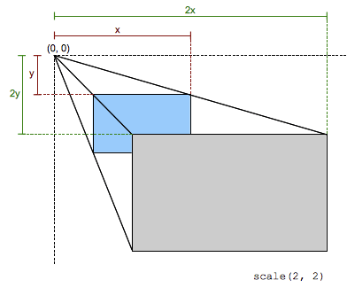
This scaling transformation is characterized by a two-dimensional vector. Its coordinates define how much scaling is done in each direction.
If both coordinates are equal, the scaling is uniform (isotropic) and the aspect ratio of the element is preserved

When a coordinate value is outside the [-1, 1] range, the element grows along that dimension; when inside, it shrinks. If it is negative, the result a point reflection in that dimension. A value of 1 has no effect.

Values
sx
A <number> representing the abscissa of the scaling vector.

sy
A <number> representing the ordinate of the scaling vector. If not defined, its default value is sx, resulting in a uniform scaling that preserves the element's aspect ratio.

Cartesian coordinates on ℝ^2 | Homogeneous coordinates on ℝℙ^2 | Cartesian coordinates on ℝ^3 | Homogeneous coordinates on ℝℙ^3
sx 0 0 sy | sx 0 0 0 sy 0 0 0 1 | sx 0 0 0 sy 0 0 0 1 | sx 0 0 0 0 sy 0 0 0 0 1 0 0 0 0 1
 | [sx 0 0 sy 0 0]
scale(sx)

scale(sx, sy)

animation-fill-mode
The animation-fill-mode CSS property sets how a CSS animation applies styles to its target before and after its execution.

Syntax
<single-animation-fill-mode>#
where
<single-animation-fill-mode> = none | forwards | backwards | both

Values
none
The animation will not apply any styles to the target when it's not executing. The element will instead be displayed using any other CSS rules applied to it. This is the default value.

forwards
The target will retain the computed values set by the last keyframe encountered during execution. The last keyframe depends on the value of animation-direction and animation-iteration-count:
animation-direction | animation-iteration-count | last keyframe encountered
normal | even or odd | 100% or to
reverse | even or odd | 0% or from
alternate | even | 0% or from
alternate | odd | 100% or to
alternate-reverse | even | 100% or to
alternate-reverse | odd | 0% or from

backwards
The animation will apply the values defined in the first relevant keyframe as soon as it is applied to the target, and retain this during the animation-delay period. The first relevant keyframe depends on the value of animation-direction
animation-direction | first relevant keyframe
normal or alternate | 0% or from
reverse or alternate-reverse | 100% or to

both
The animation will follow the rules for both forwards and backwards, thus extending the animation properties in both directions.

Initial value | none
Applies to | all elements, ::before and ::after pseudo-elements
Inherited | no
Computed value | as specified
Animation type | discrete
/* Single animation */
animation-fill-mode: none;
animation-fill-mode: forwards;
animation-fill-mode: backwards;
animation-fill-mode: both;

/* Multiple animations */
animation-fill-mode: none, backwards;
animation-fill-mode: both, forwards, none;

/* Global values */
animation-fill-mode: inherit;
animation-fill-mode: initial;
animation-fill-mode: revert;
animation-fill-mode: unset;

Three pillars of HTML and CSS

- Responsive Design
- Maintainable and Scalable Code
- Web Performance

Responsive Design
- Fluid layouts
- Media queries
-Responsive images
-Correct units
-Desktop first vs Mobile first

Maintainable and Scalable code
- Clean
- Easy to understand
- Growth
- Reusable
- How to organize files
- How to name classes
- How to structure HTML

Web Performance
- Less HTTP requests
- Less Code
- Compress Code
- Use a CSS pre- processor
- Less Images
- Compress Images

What happens to CSS code when we actually load up the browser.
Many things happen behind the scenes of the internet until the browser can start loading the website we requested.
Things like HTTP request figuring our domain names and servers etc.
But what important in the context is what happens in the browser on a computer when the user opens the page.

Our starting point is when the browser starts to load the initial HTML file.
It takes the HTML code and then parses it which means that it decodes the code line by line.
And with this process the browser builds the Document Object Model DOM.
DOM describes the web document like a family tree the parents children and sibling elements.

Now when the browser parses the HTML it also finds the style sheet included in the HTML head and it starts loading them as well.
And just like HTML CSS is also parsed.
During the CSS parsing phase there are two main steps.
First resolving conflict in CSS declaration through a process known as cascade
Second is to parse final CSS values like converting the margin defined in %age unit into pixels. Imagine we define a left margin in percentage unit but that 50% on a smart phone is completely different 50% on large screen and that’s why the percentages and other relative units can only be calculated on the users device in the parsing phase.
The final CSS is also stored in a tree like structure called CSS Object Model similar to the DOM.

The DOM and COM together form the Render tree. And with that we finally have every thing to render the page.

To render the page the browser uses something called Virtual Formatting Model.
This algorithm calculates many thing such as box model floats and positioning.
Only after the Visual Formatting model has done its work, the website is finally rendered or painted to the screen and the process is finished.

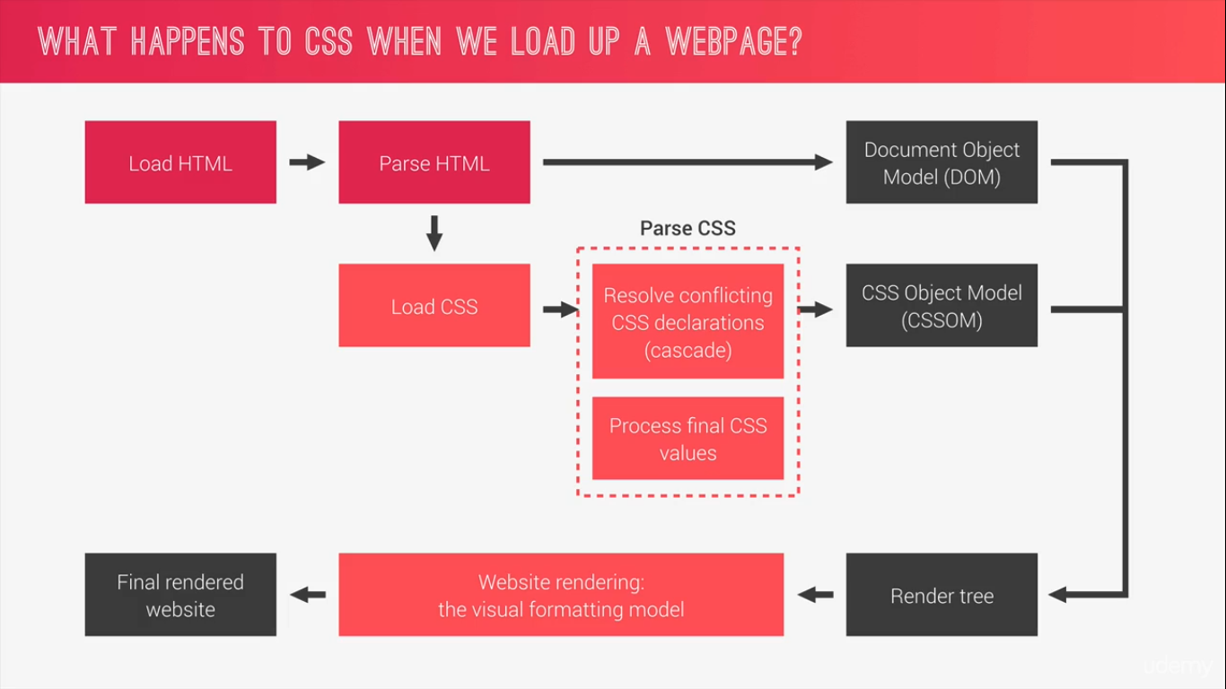

How CSS is parsed.

A CSS rule consists of a selector and a declaration Block

.heading-primary-main {
display: block;
font-size: 60px;
font-weight: 400;
letter-spacing: 34px;
animation-name: moveInLeft;
animation-duration: 1s;
animation-delay: 1s;
animation-timing-function: ease-out;
}
We use the selector to select one or more HTML element that we want to style
And the declaration block is where we write the actual styles to style the selected element on the page. We can write one or more CSS declarations in the declaration block.
Each declaration consists of a CSS property and it’s corresponding value which is the value that we assign to the property.
This value we assign to property is called the declared value.
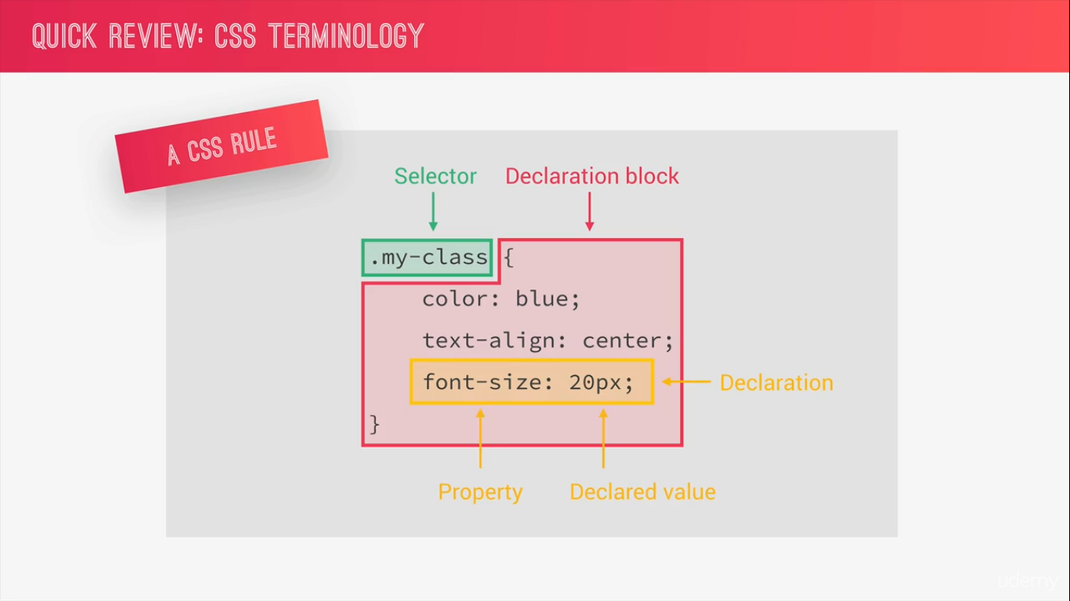

Cascade
Cascade is a process of combining different style sheets and resolving conflict between different CSS rules and declarations, when more that one rule applies to a certain element.
Because declaration for a certain style property like font-size can appear in several style sheets and several time inside single style sheet.
CSS can also come from different sources one which we write are called author declarations
Another source can be the user declaration which is the CSS coming from the users. For an instance when an user changes a default font-size in the browser then that is user CSS.
And then we have the default browser declaration. For an instance if we put an anchor tag in an HTML for link then don’t style it at all it is usually rendered with blue text and underlined that’s called the user agent CSS.

To resolve the conflict cascade looks at the following.
Importance
Specificity
Source order .

Importance
First up the cascade starts with giving importance to the conflicting declaration based on where they are declared.
- User! Important declaration
- Author! Important declaration
- Author declaration
- User Declaration
- Default Browser declarations

Specificity
Lot of times we have bunch of conflicting rules in the author style sheet without important keyword and in this case all the declarations have the exact same importance.
Here the cascade calculates the specificity and compare of the declaration selectors.
- Inline styles
- IDs
- Classes, pseudo-classes, attribute
- Elements pseudo elements
Specificity is not just only one number but one number for each of the above values inline styles, IDs, classes pseudo classes and attributes and finally elements.
And for each or this we count the number of occurrences in the selector.

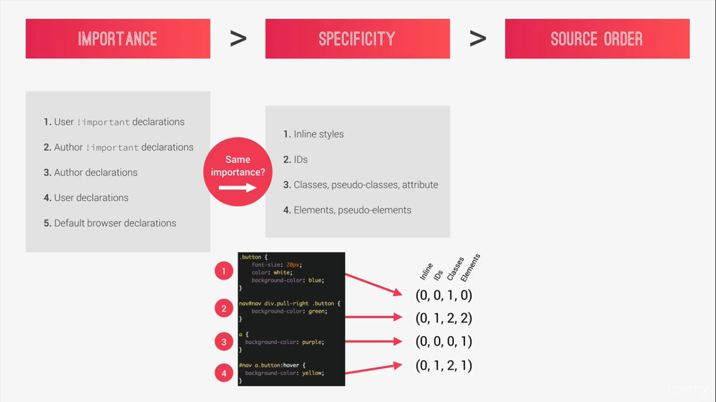
In the selector 1 we don’t have any inline styles because an inline style has to be written in the HTML which is not the case here.
Inline is 0, we also no IDs here so 0, but we do have one class button class therefor the classes category we have 1 and finally there is no element selector here so 0 for that as well. For this selector specificity is 0010.

Next one is also not an Inline style so 0 for inline, we have an id selector #nav ID so 1 for the ID, we have 2 classes .pull-right and button so 2 for the classes and finally we have nav and div so 2 for element so specificity is 0122

Selector number 3 only has an element selector so the specificity is 0001

Last one has a $nav Id so 1 for ID, next we have a button class and a pseudo class hover which makes it to 2 for the classes
And one element selector makes the final specificity 0121

To use the above number to find out which of the selectors applies we start to look for the numbers from left to right starting with the most specific category the inline styles if there is selector it would have won against the most of the selectors.
Next We see that the selector in 2 and 4 have 1 here while others have 0 so 1 and 4 are out of game.
Further both 2 and 4 have 2 classes so its a tie
But in the elements category the selector 2 has a 2 while 4 only has 1 so the style rule of selector 2 is applied to the element.

Source Order
If both 2 and 4 had the same value at element category also from the above example then specificity of both would have been the same and then the last CSS declaration will apply.
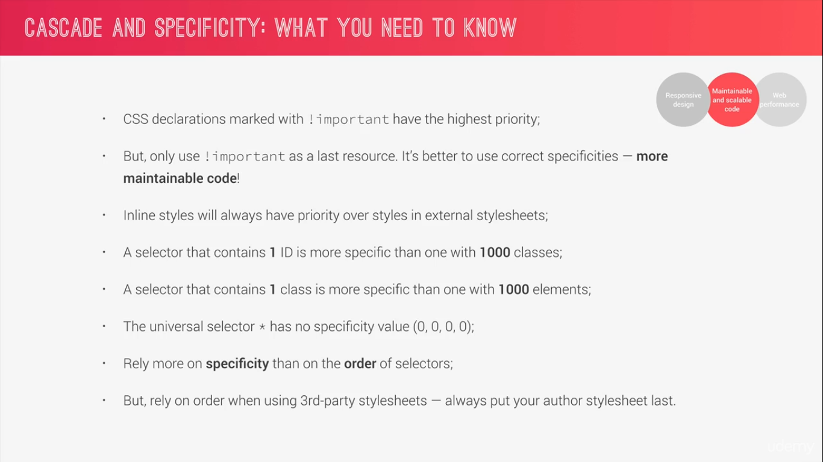

Note: when working with hovers not only we have to make sure that we have hovers pseudo class in place if we want hover effect also the selector should have higher specificity than the original one.

How CSS values are replaced.

Declared values are processed in 6 different steps to final actual value.
-Declared value when we have conflicting declared values to determine which one will apply CSS uses cascade thus we get the cascaded value
-Cascaded value the value which we get after the cascade.
-Specified value this one is the default value of certain CSS property if there is no cascaded value this value is used
-Computed value in this step values with relative units are converted to pixels also CSS key words like orange, auto, bolder etc are computed and replaced in this step, A percentage value is technically not a unit.
-Used Value In this calculation step CSS engine uses rendered layout to figure out some of the remaining values for example the percentage values that depend on the layout are converted into the px.
A percentage value is in relation to its parent element width, parser needs to know that width. Then the used value is calculated, this step only happens in the rendering phase of the page.
-Actual value: if the used value is not what the browser can exactly display for eg 188.8px the it would be rounded to 189 pixels, this becomes our actual value which is used in the layout

If we don’t declare a property it has no declare value so no cascaded value then we have specified value or inherited value.

How units are converted from relative to absolute

percentages

There is a distinction for using percentages for fonts and distance measurements. Its relative to the font-size of its parent
For the length the reference is always the parent elements width.

em
ems use parent element font-size as the reference
If we want to use ems for font sizes then references is simply the parents computed font sizes
For length use the font size of the current element as reference

rems
rems use root element font size as the reference.
It actually works in a same way for both font sizes and length because it just uses the root font size as a reference. That means a 10rem padding will result in 160px because root font size is 16px.

By using font sizes we can build more robust responsive layouts because just by changing the font sizes we will automatically change length as it depends on the font size.

vh/vw
1 vh is 1% of the viewport height and 1vw is just 1% of the viewport width
We actually don’t know always what the viewport width or height is but the browser which is painting the page knows it.
These are very handy in building hero sections with 100% of viewport height.

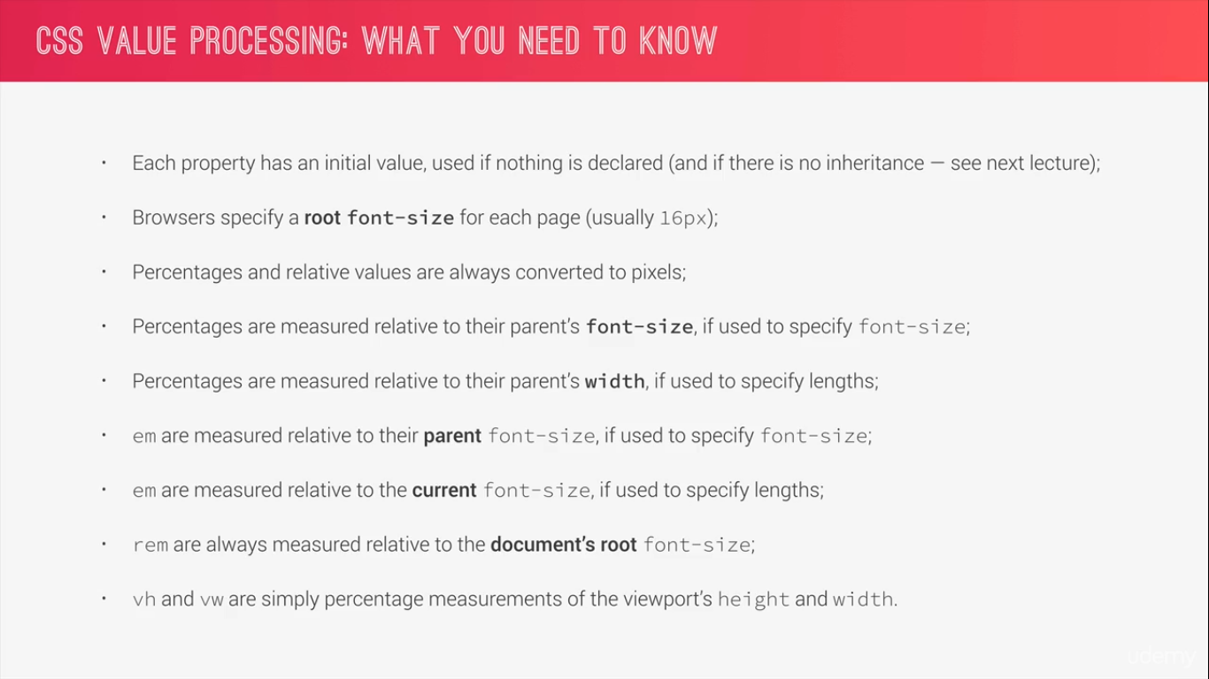

Inheritance
Inheritance is way of propagating property values from parent element to the child element.

When processing a certain property for certain element for example line-height the first question that the CSS engine asks is if there is a cascaded value and if so then of-course that’s the value that is used.
If there is no cascaded value is if that property can be inherited and that depends on each property their are some property that are inherited and others are not.
line-height gets inherited.
If a property gets inherited then the value of that property becomes the computed value of its parent element.
Value that gets inherited is the computed value and not the relative value.

If the property is not inherited like padding then the specified value will become initial value which is also specific to each property in the case of padding its 0px
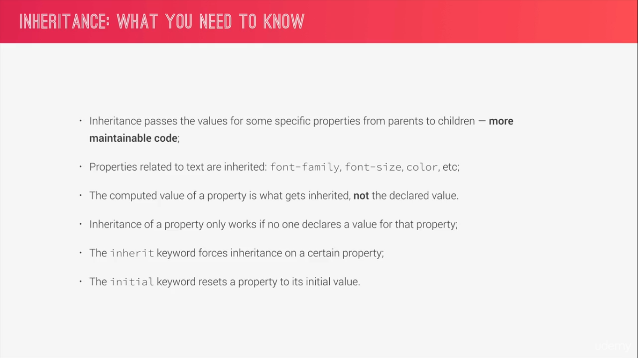

root font size is set in the HTML selector.
And we change it to 10px so that we know that 1rem is equal to . actually we set to 62.5 percent to allow the users to change the scale or zoom in or zoom out on text.

We can use inherit keyword to force inheritance box-sizing property is not inherited by setting the box-sizing property to each an every element on the entire page to inherit to automatically put in the box-sizing
In the element and we put border-box.

And also we set all the ::after pseudo elements and the ::before pseudo elements in the root to get the reset behaviour.

Visual formatting model.
Algorithm that calculates boxes and determines the layout of these boxes for each element in the render tree in order to determine the final layout of the page.

In order to this the algorithm takes into account factors like
- Dimensions of the boxes: which is calculated by the box model.
- Box type: which can be inline block or inline block.
- Positioning scheme which includes concepts like floats, absolute or relative positioning
- Stacking contexts
- Other element that are present in the render tree such as sibling or parents.
- Viewport size, dimension of images, etc..

By considering all the above factors browser figures out how the final website will look to the user

Box Model
Box model is one of the fundamental part of CSS and something we really have to master to layout a web page..
The box model is one of the factors that how elements are displayed on the web page and how they are sized.

According to the box model each an every element on a web page can be seen as rectangular box.
And each box can have.
Width
Height
Padding
Margin
Border
Note: they are all optional.

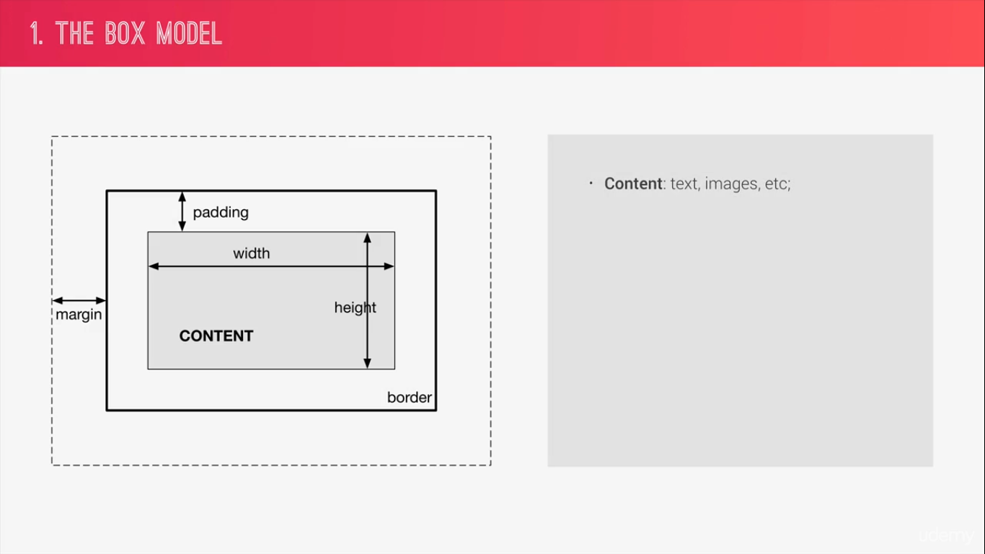
Content: All the text, images or other context that we specify go in the content of the box. We can easily define
It’s height, width using the corresponding CSS properties.
Padding: Transparent area around the content but still inside of the box. We use padding to generate white
Space inside of the box, and we can define the padding by specifying the padding property in CSS.
Border: Border goes around the padding and the content.
Margin: Similar to padding we have the margin but instead of inside of the box margin is white spaced outside
of the box , margin can be thought to be the space between the boxes.
Fill area: The text content and images go inside the content box but same doesn’t apply for background images
or the background color of the box, these properties will be applied not only to the content box but
to the entire fill area which also includes the padding and the border not the margin.

If we choose not to specify the height width of a certain element, the visual formatting model will just use the content of the box to determine its size.
Total width = right border + right padding + specified width + left padding + left border.
Total height = top border + top padding + specified height + bottom padding + bottom border.
Eg:
Suppose we define the height for an element of 100 px and padding to the top and bottom of 20px so the final height as displayed on the website will be 140 px.
Whenever we define the width or height of the box the padding and the border gets added to what we define.
But that sounds impractical to solve this issue we use the box-sizing property to border box.
So if we set the box-sizing to border-box the height and the width will be defined for the entire box including the padding and the border and not just for the content area. Padding and border will reduce the inner w and h or the content area.

With box-sizing property set to border box. the actual total width = specified width and the same goes for the height.

Box types:

Block level box
The type of the box is always defined by the display property
For a block level element the display property is usually set to block. Values flex for the flex-box layout list-item and table also produce block level boxes

All the HTML element have default display property, elements such as paragraphs or divs which are usually formatted visually as blocks there display property is set to block by default we can of-course change the properties manually.
Being a block level box , the box will occupy as much space as possible which is usually 100% of its parent width .
And will create line-breaks before and after it meaning that blocks are formatted vertically one after another.

Inline level
Content is distributed in line meaning that an inline box only occupies the space that it’s content actually needs, therefore they also don’t cause line breaks after or before of them.
They just sit inside their block level parent element.

Box model things work different in inline boxes .
First the height and the width property do not apply
And we can only specify horizontal padding and margin on inline elements. So only on the left and the right side.

Inline Block
They are technically also inline boxes but simply work as a block level box on the inside.
Since they are inline boxes they only use their content space and cause no line breaks.
But since they work as block level box on the inside the box model applies to the just like any other regular block level box..

Positioning Scheme
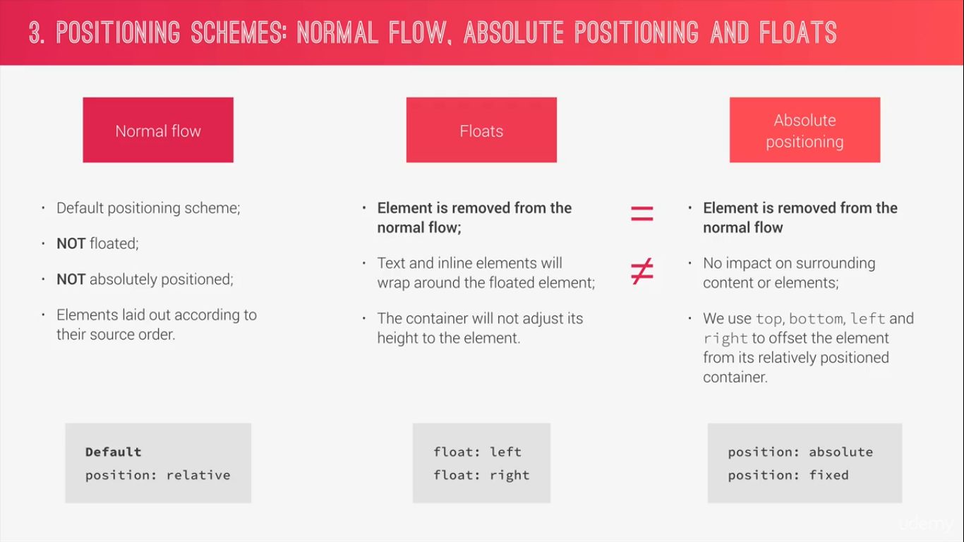

Stacking Context
Stacking contexts are what determine in which order elements are rendered on the page.
A new stacking context can be created by different CSS properties like z-index.
There are other properties that also create new stacking contexts. Stacking context are layers that form a stack.
Layers at the bottom of the stack are painted first and higher and elements higher up on the stack appear on top overlapping the elements below them.

One with the higher z-index appear on top and one with the low z-index appear at bottom.
Opacity value different from 1 a transform, a filter or other properties will also create new stacking context.
That’s why sometimes event with z-index set on a positioned element, the stacking order doesn’t work as expected.

Architect Mindset
Think: We need to think about the layout of our web page or web app even before writing the code.
Build: After having a layout figured out we should build in HTML and CSS with consistent structure for naming our classes.
Architect: Create a logical CSS architecture by using multiple files and folders.

Think
Component driven design: in CSS we try to divide our page in modular components.
Components are the building blocks that we use to construct interfaces so we can basically think of our interface as a collection of components held together by the overall layout of the page.
Probably the most important thing about the component is that they should be re-usable across the project and also between different project.
So we can build a library of components and then use them across project.
Components should be independent so that we can use them completely on their own no matter where on the page.
What that means that component should not depend on their parent elements.
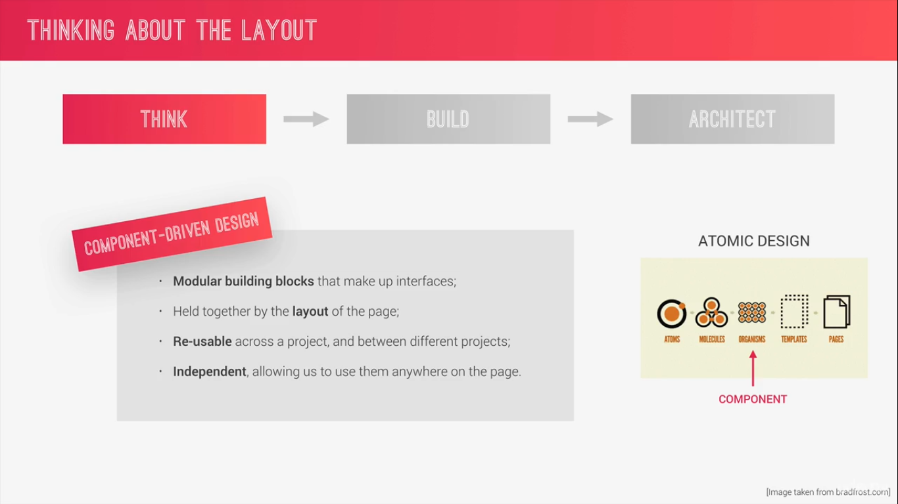
Build
BEM: Block Element Modifier
Block is a stand alone component that is meaning full on its own.
Element is a part of a block that has no meaning of it’s own.
Modifier is flag that we can put on a block or an element in order to make it different from the regular blocks or elements to make it different version lets say.
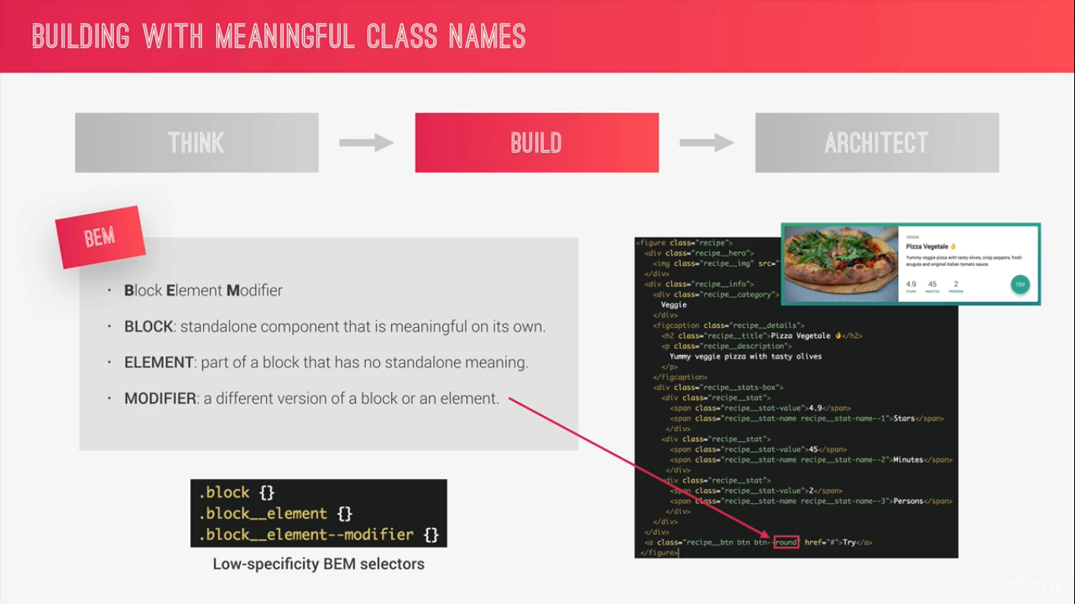

Architect
The 7-1 pattern: All it means that we have 7 different folders where we put partial sass files and 1 main sass files in which we import all partial sass files into one final compiled CSS style sheet.
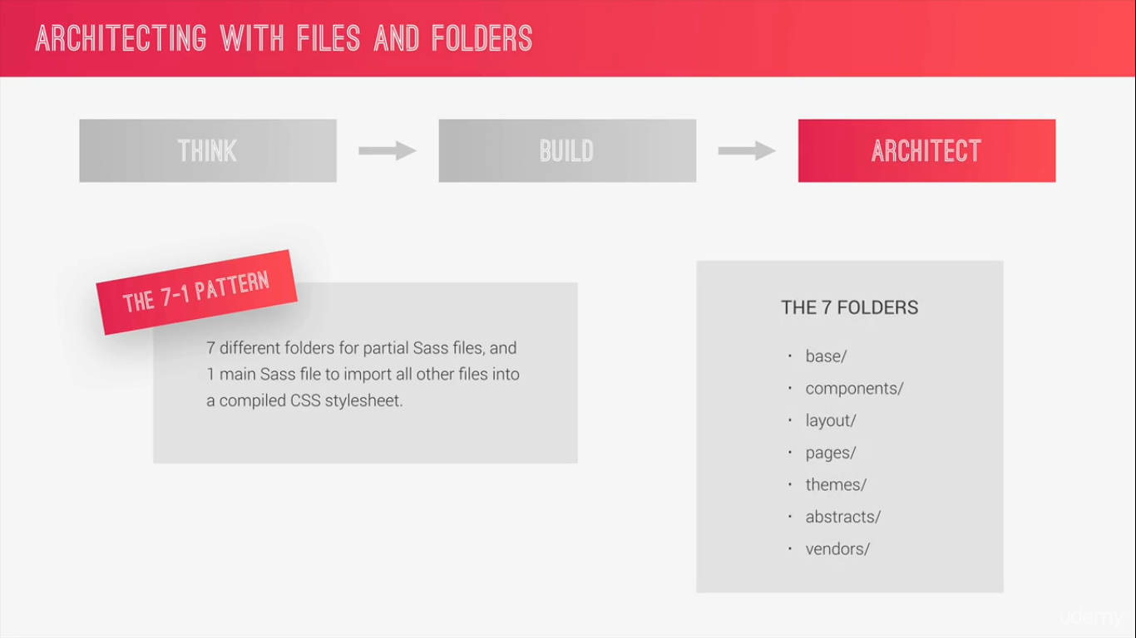

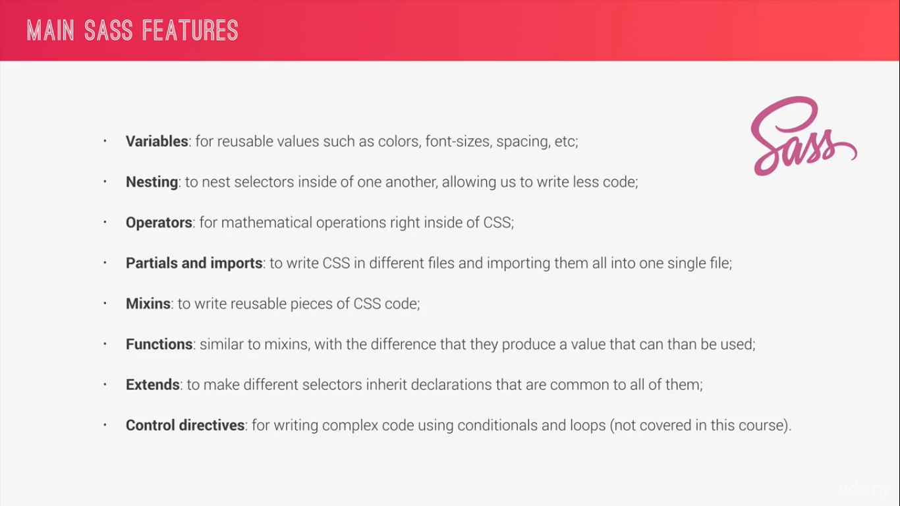

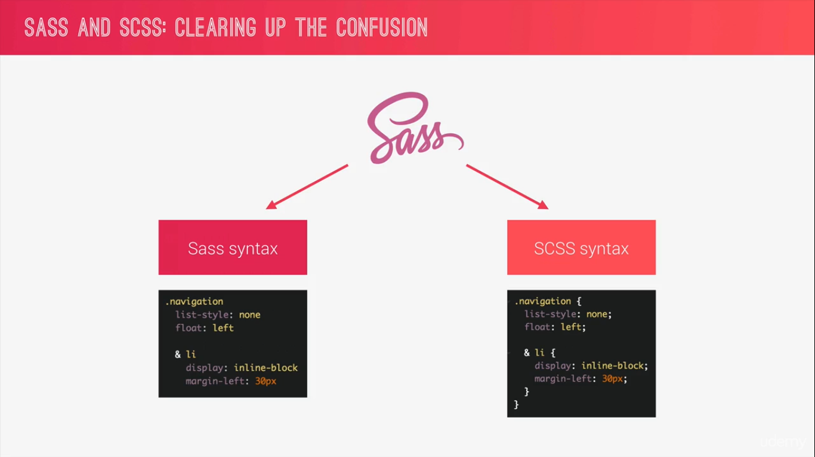

Sass indentation sensitive
SCSS preserves the way the original CSS looks like.
/*
COLORS:

Light green: #7ed56f
Medium green: #55c57a
Dark green: #28b485

we set the variables
*/
// Variables
$color-primary: #7ed56f;
$color-primary-light: #55c57a;
$color-primary-dark: #28b485;
$color-grey-dark: #777;
$color-white: #fff;
$color-black: #000;

//------------------Styles---------------//

*,
*::after,
*::before {
margin: 0;
padding: 0;
box-sizing: inherit;
}
html {
font-size: 62.5%;
}
body {
font-family: "Lato", sans-serif;
font-weight: 400;
font-size: 16px;
line-height: 1.7;
color: $color-grey-dark;
padding: 3rem;
box-sizing: border-box;
}

/*------------------- Header ------------------------*/
.header {
height: 95vh;
background-image: linear-gradient(
to right,
rgba($color-primary-light, 0.6),
rgba($color-primary-dark, 0.7)
),
url(../img/hero.jpg);
background-size: cover;
background-position: top;
clip-path: polygon(0 0, 100% 0, 100% 75%, 0 100%);
position: relative;

&__logo-box {
position: absolute;
top: 4rem;
left: 4rem;
}
&__logo {
height: 3.5rem;
}
&__text-box {
position: absolute;
top: 50%;
left: 50%;
transform: translate(-50%, -50%);
text-align: center;
}
}

/*------------------- Heading ------------------------*/
.heading-primary {
color: $color-white;
text-transform: uppercase;
backface-visibility: hidden;
margin-bottom: 4rem;

&--main {
display: block;
font-size: 6rem;
font-weight: 400;
letter-spacing: 3.4rem;
animation-name: moveInLeft;
animation-duration: 1s;
animation-timing-function: ease-out;
}
&--sub {
display: block;
font-size: 2rem;
font-weight: 700;
letter-spacing: 1.5rem;
text-align: center;
animation: moveInRight 1s ease-out;
}
}

/*------------------- Animation Header ------------------------*/
@keyframes moveInLeft {
0% {
opacity: 0;
transform: translate(-10rem);
}
80% {
transform: translate(1.3rem);
}
100% {
opacity: 1;
transform: translate(0);
}
}
@keyframes moveInRight {
0% {
opacity: 0;
transform: translate(10rem);
}
80% {
transform: translate(-1.3rem);
}
100% {
opacity: 1;
transform: translate(0);
}
}
@keyframes moveInBottom {
0% {
opacity: 0;
transform: translateY(3rem);
}

100% {
opacity: 1;
transform: translate(0);
}
}
/*------------------- Btn pseudo class ------------------------*/
.btn {
&:link,
&visited {
text-transform: uppercase;
text-decoration: none;
padding: 1.6rem 4rem;
display: inline-block;
border-radius: 10rem;
transition: all 0.2s;
position: relative;
animation: moveInBottom 1s ease-out;
}

&:hover {
transform: translateY(-0.3rem);
box-shadow: 0 1rem 2rem rgba($color-black, 0.2);
&::after {
transform: scale(1.4, 1.6);
opacity: 0;
}
}
&:active {
transform: translateY(-0.1rem);
box-shadow: 0 1rem 2rem rgba($color-black, 0.2);
}

&--white {
background-color: $color-white;
color: $color-grey-dark;
&::after {
background-color: $color-white;
}
}
&::after {
display: inline-block;
content: "";
height: 100%;
width: 100%;
border-radius: 10rem;
position: absolute;
top: 0;
left: 0;
z-index: -1;
transition: all 0.4s;
}

&--animated {
animation: moveInBottom 0.5s ease-out 0.75s;
animation-fill-mode: backwards;
}
}

Basic Responsive Design Principles
- FLUID GRIDS AND LAYOUTS: Use %ages rather than px for all layout related length and specially width.
- FLEXIBLE AND RESPONSIVE IMAGES: Usually we make them flexible by defining their dimensions in percentages rather than fixed units like px and we should also optimize the images for different width.
- MEDIA QUERIES: Allows to change styles on certain viewport width which are called breakpoints.

Fluid Grids and Layouts aspect of design also has the concept of layouts other than Fluid Grids.
In modern web design there are 3 major ways of laying out web page or an app.

Floats
FlexBox
CSS Grids

max-width the difference between width and max-width if we have enough available space then it will have the with that we specified but id if there is not enough width if the view port is smaller then it will simply fill 100% of the available space
To center the row in the viewport we set margin:0 auto; that’s the trick to center any block element inside of another block element. The browser will automatically figure the margin at the left and the right side and with this we have set both to auto

The :not() property in CSS is a negation pseudo class and accepts a simple selector or a selector list as an argument. It matches an element that is not represented by the argument. The passed argument may not contain additional selectors or any pseudo-element selectors.
.row {
max-width: $grid-width;
background-color: #eee;
margin: 0 auto;

&:not(:last-child) {
margin-bottom: $gutter-vertical;
margin-right: $gutter-horizontal;
}
}

CSS has a special calc() function for doing basic math. In this guide, let’s cover just about everything there is to know about this very useful function.
We can do mathematical calculation and can actually mix units here.
.col-1-of-2 {
width: calc((100% - #{$gutter-horizontal}) / 2);
background-color: orangered;
float: left;
&:not(:last-child) {
margin-right: $gutter-horizontal;
}
}

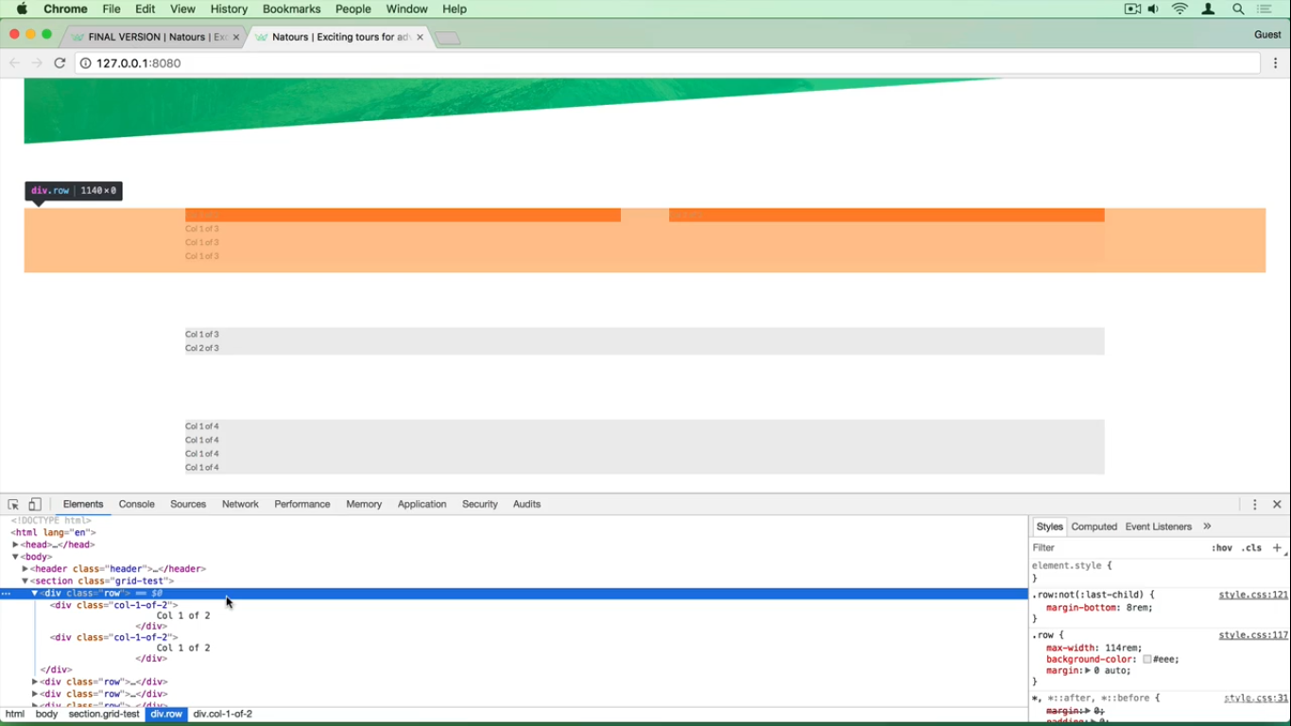

The row has 0px height because all all of the child element of the row element are floated. Do they go out of the normal flow and the height of the container collapses becomes 0.
To fix this we use clear-fix hack

We use a mixin for that as we have to use this in multiple location.

A clear fix appends a pseudo element after the element which will then clear these floats.
We need to specify the content property other wise a pseudo element will not appear on the page
Then we need to display standard to table
And finally the property that performs that clear-fix the clear property which we set to both to clear both left and write.

Now we get the height as its not set so by default its auto so it is taking the height of the content which is in our case the line-height 1.7X1.6= 27.2 rounded to 27.
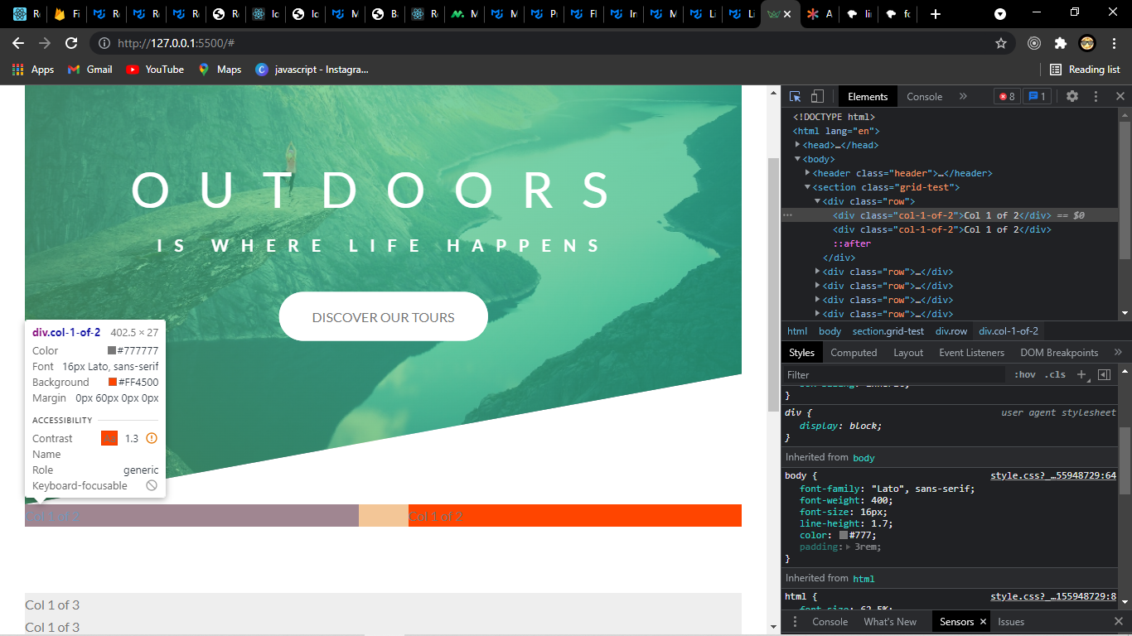

We use attribute selector if we want to select all the divs whose class start with col.
[class^="col-"] {
}
Above syntax select all the elements where all the class attributes starts with col-
If we use * instead of ^ then it will select all the elements with class attributes having col-
If we use $ then it will select all the elements with class attributes that ends with col-

If we want to select all the direct child of a parent we can use &>*

& > * {
transform: skewY(7deg);
}
}

text-shadow

p {
text-shadow: 1px 1px 1px #000;}
You can apply multiple text shadows by comma separating
p {
text-shadow: 1px 1px 1px #000,
3px 3px 5px blue; }
The first two values specify the length of the shadow offset. The first value specifies the horizontal distance and the second specifies the vertical distance of the shadow. The third value specifies the blur radius and the last value describes the color of the shadow:
1. value = The X-coordinate
2. value = The Y-coordinate
3. value = The blur radius
4. value = The color of the shadow
Using positive numbers as the first two values ends up with placing the shadow to the right of the text horizontally (first value) and placing the shadow below the text vertically (second value).
The third value, the blur radius, is an optional value which can be specified but don’t have to. It’s the amount of pixels the text is stretched which causes a blur effect. If you don’t use the third value it is treated as if you specified a blur radius of zero.
Also, remember you can use RGBa or HSLa values for the color, for example, a 40% transparency of white:

background-image: linear-gradient(
to right,
$color-primary-light,
$color-primary-dark
);
-webkit-background-clip: text;
color: transparent;

We use here webkit-background-clip to clip the background color with the text in front
And then we set the color of the text to transparent to use the background gradient as the text color.

outline
The outline property in CSS draws a line around the outside of an element. It’s similar to border except that:

It always goes around all the sides, you can’t specify particular sides
It’s not a part of the box model, so it won’t affect the position of the element or adjacent elements (nice for debugging!)
Other minor facts include that it doesn’t respect border-radius (makes sense I suppose as it’s not a border) and that it isn’t always rectangular. If the outline goes around an inline element with different font-sizes, for instance, Opera will draw a staggered box around it all.

It is often used for accessibility reasons, to emphasize a link when tabbed to without affecting positioning and in a different way than hover.

outline: [ <outline-width> || <outline-style> || <outline-color> ] | inherit
It takes the same properties as border, but with “outline-” instead. The above shorthand could have been written:
a:focus {
outline-width: 1px;
outline-style: dashed;
outline-color: red;}

Notes
You can’t set an outline on just one (or two, or three) sides of an elements. All sides only. There is no such thing as outline-top, outline-right, outline-bottom, or outline-left like there is with border.
Try opening up the console on any website and running document.head.insertAdjacentHTML("beforeend", "<style>* { outline: 1px solid red; }</style>"); – you’ll see a lot of the sites structure that way.
outline is used for :focus styles by default. Remember if you ever remove outline styles, like a:focus { outline: 0; }, you need to add them back in using some other kind of visually distinct style.

outline-offset
The outline-offset property in CSS offsets a defined outline from an element’s border edge by a specified amount. An outline, which is different from a border, does not take up any space on the page (like an absolutely positioned element) so the outline can be offset in any amount and it will not affect the position or layout of surrounding elements.
.example {
outline: solid 2px blue;
outline-offset: 10px;}
Outlines defined using the outline property are often used as focus rings, for accessibility. Thus, the outline-offset property allows you to change the position of the focus ring.

Values
outline-offset accepts one kind of value, a length, which can be:
- 0 (the default)
- Any other valid length with a specified unit (including negative values)
Note that outline-offset, like outline-width, does not accept percentage values.

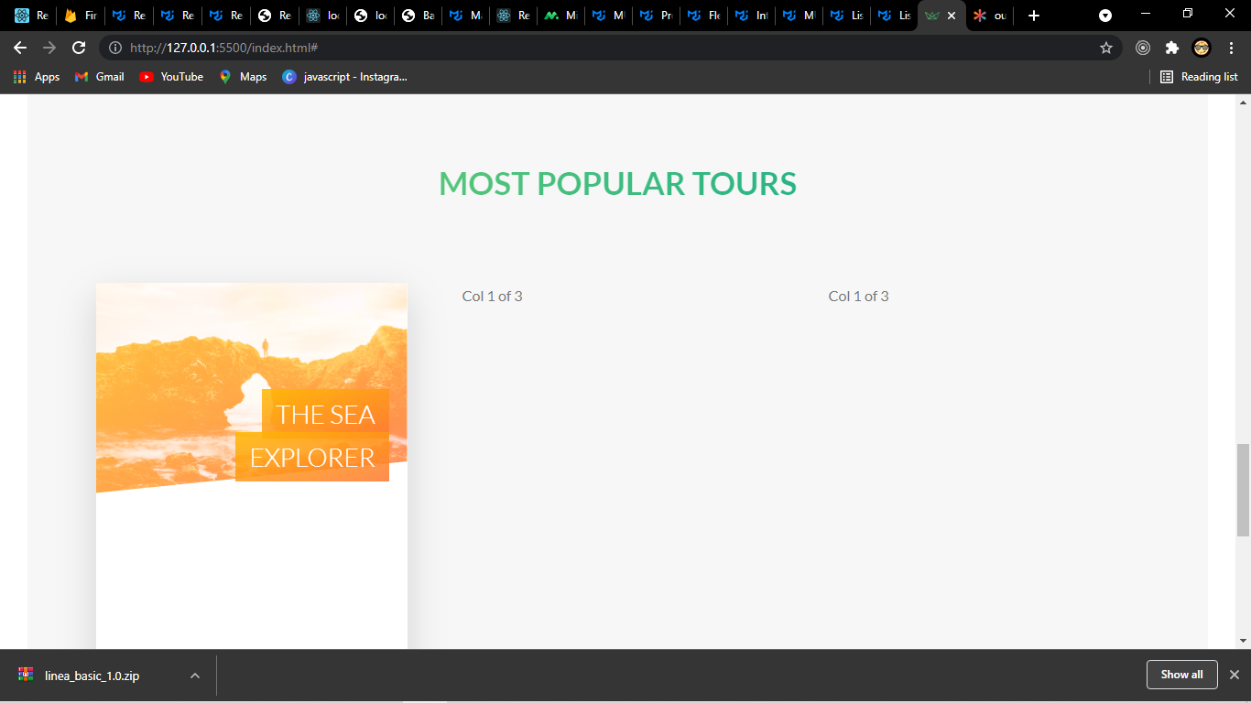

To treat the sea explorer as two separate box
The sea and explorer and adjust the padding so that the right margin is consistent.
We use -webkit-box-decoration-break: clone;
&_heading-span {
padding: 1rem 1.5rem;
-webkit-box-decoration-break: clone;
&--1 {
background-image: linear-gradient(
to right bottom,
rgba($color-secondary-light, 0.85),
rgba($color-secondary-dark, 0.85)
);
}
}
What clone does to apply all the declarations that we have in this selector which in this case only the padding to all of the boxes that are created by an element.

perspective
The perspective CSS property gives an element a 3D-space by affecting the distance between the Z plane and the user.

The strength of the effect is determined by the value. The smaller the value, the closer you get from the Z plane and the more impressive the visual effect. The greater the value, the more subtle will be the effect.

Important: Please note the perspective property doesn’t affect how the element is rendered; it simply enables a 3D-space for children elements. This is the main difference between the transform: perspective() function and the perspective property. The first gives element depth while the later creates a 3D-space shared by all its transformed children.

.parent {
perspective: 1000px;
}

.child {
transform: rotateY(50deg);
}

backface-visibility

The backface-visibility property relates to 3D transforms. With 3D transforms, we can manage to rotate an element so what we think of as the “front” of an element no longer faces the screen. For instance, this would flip an element away from the screen:
.flip {
transform: rotateY(180deg);}
It will look as if you picked it up with a spatula and flipped it over like a pancake. That’s because the default for backface-visibility is visible. Instead of it being visible, you could hide it.
.flip {
transform: rotateY(180deg);
backface-visibility: hidden;}

Syntax
backface-visibility: visible | hidden;

Values
visible
The back face is visible when turned towards the user.

hidden
The back face is hidden, effectively making the element invisible when turned away from the user.

Initial value | visible
Applies to | transformable elements
Inherited | no
Computed value | as specified
Animation type | discrete
/* Keyword values */
backface-visibility: visible;
backface-visibility: hidden;

/* Global values */
backface-visibility: inherit;
backface-visibility: initial;
backface-visibility: revert;
backface-visibility: unset;

Overflow

The overflow property controls what happens to content that breaks outside of its bounds: imagine a div in which you’ve explicitly set to be 200px wide, but contains an image that is 300px wide. That image will stick out of the div and be visible by default. Whereas if you set the overflow value to hidden, the image will cut off at 200px.

Syntax
[ visible | hidden | clip | scroll | auto ]{1,2}

Values
visible
Content is not clipped and may be rendered outside the padding box.

hidden
Content is clipped if necessary to fit the padding box. No scrollbars are provided, and no support for allowing the user to scroll (such as by dragging or using a scroll wheel) is allowed. The content can be scrolled programmatically (for example, by setting the value of a property such as offsetLeft), so the element is still a scroll container.

clip
Similar to hidden, the content is clipped to the element's padding box. The difference between clip and hidden is that the clip keyword also forbids all scrolling, including programmatic scrolling. The box is not a scroll container, and does not start a new formatting context. If you wish to start a new formatting context, you can use display: flow-root to do so.

scroll
Content is clipped if necessary to fit the padding box. Browsers always display scrollbars whether or not any content is actually clipped, preventing scrollbars from appearing or disappearing as content changes. Printers may still print overflowing content.

auto
Depends on the user agent. If content fits inside the padding box, it looks the same as visible, but still establishes a new block formatting context. Desktop browsers provide scrollbars if content overflows.

overlay
Behaves the same as auto, but with the scrollbars drawn on top of content instead of taking up space. Only supported in WebKit-based (e.g., Safari) and Blink-based (e.g., Chrome or Opera) browsers.

Mozilla extensions
-moz-scrollbars-none
Use overflow: hidden instead.

-moz-scrollbars-horizontal
Use overflow-x: scroll and overflow-y: hidden, or overflow: scroll hidden instead.

-moz-scrollbars-vertical
Use overflow-x: hidden and overflow-y: scroll, or overflow: hidden scroll instead.

-moz-hidden-unscrollable
Use overflow: clip instead.

Initial value | visible
Applies to | Block-containers, flex containers, and grid containers
Inherited | no
Computed value | as each of the properties of the shorthand:  - overflow-x: as specified, except with visible/clip computing to auto/hidden respectively if one of overflow-x or overflow-y is neither visible nor clip  - overflow-y: as specified, except with visible/clip computing to auto/hidden respectively if one of overflow-x or overflow-y is neither visible nor clip
Animation type | discrete

/* Keyword values */
overflow: visible;
overflow: hidden;
overflow: clip;
overflow: scroll;
overflow: auto;
overflow: hidden visible;

/* Global values */
overflow: inherit;
overflow: initial;
overflow: revert;
overflow: unset;
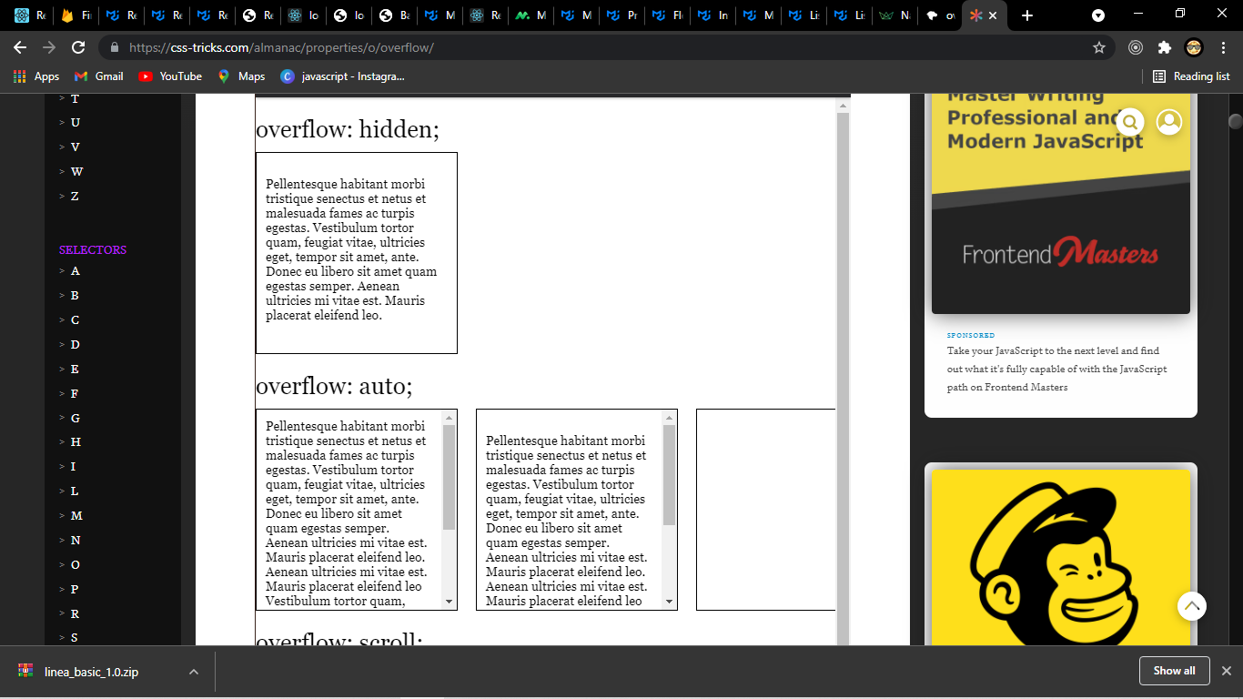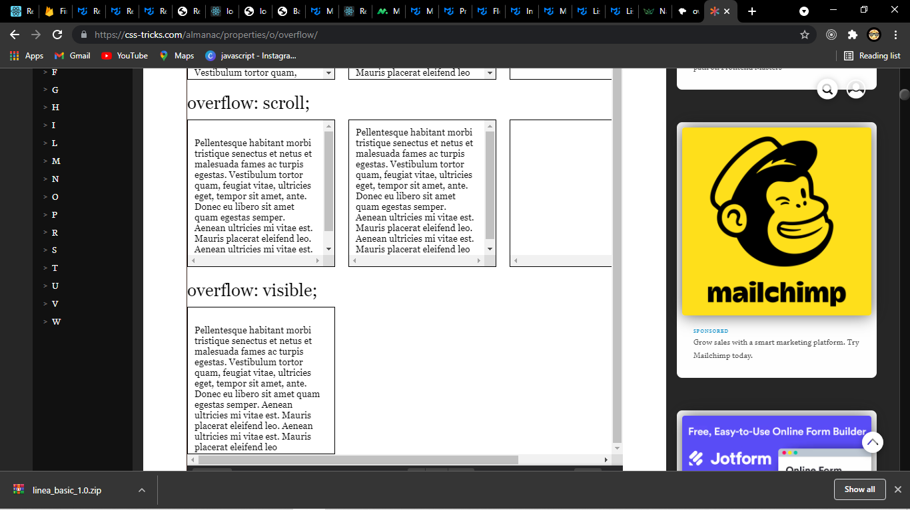

filter
CSS Filters are a powerful tool that authors can use to achieve varying visual effects
.filter-me {
filter: blur(3px);
filter: grayscale(1);
filter: saturate(2.2);

filter: none; /* remove existing filter */
}

There are a number of functions to use for the value:

blur()
brightness()
contrast()
drop-shadow()
grayscale()
hue-rotate()
invert()
opacity()
saturate()
sepia()
url() – for applying SVG filters
custom() – “coming soon”

Filter Functions
To use the CSS filter property, we specify a value for one of the following functions listed above. If the value is invalid, the function returns “none.” Except where noted, the functions that take a value expressed with a percent sign (as in 34%) also accept the value expressed as decimal (as in 0.34).

grayscale()
filter: grayscale(20%)
filter: grayscale(0.2);
Converts the input image to grayscale. The value of “amount” defines the proportion of the conversion. A value of 100% is completely grayscale. A value of 0% leaves the input unchanged. Values between 0% and 100% are linear multipliers on the effect. If the “amount” parameter is missing, a value of 100% is used. Negative values are not allowed.

sepia()
filter: sepia(0.8);
filter: sepia(80%);
Converts the input image to sepia. The value of “amount” defines the proportion of the conversion. A value of 100% is completely sepia. A value of 0 leaves the input unchanged. Values between 0% and 100% are linear multipliers on the effect. If the “amount” parameter is missing, a value of 100% is used. Negative values are not allowed.

saturate()
filter: saturate(2);
filter: saturate(200%);
Saturates the input image. The value of “amount” defines the proportion of the conversion. A value of 0% is completely un-saturated. A value of 100% leaves the input unchanged. Other values are linear multipliers on the effect. Values over 100% are allowed, providing super-saturated results. If the “amount” parameter is missing, a value of 100% is used. Negative values are not allowed.

hue-rotate()
filter: hue-rotate(180deg);
filter: hue-rotate(0.5turn);
Applies a hue rotation on the input image. The value of “angle” defines the number of degrees around the color circle the input samples will be adjusted. A value of 0deg leaves the input unchanged. If the “angle” parameter is missing, a value of 0deg is used. The maximum value is 360deg.

invert()
filter: invert(100%);
Inverts the samples in the input image. The value of “amount” defines the proportion of the conversion. A value of 100% is completely inverted. A value of 0% leaves the input unchanged. Values between 0% and 100% are linear multipliers on the effect. If the “amount” parameter is missing, a value of 100% is used. Negative values are not allowed.

opacity()
filter: opacity(0.5);
filter: opacity(50%);
Applies transparency to the samples in the input image. The value of “amount” defines the proportion of the conversion. A value of 0% is completely transparent. A value of 100% leaves the input unchanged. Values between 0% and 100% are linear multipliers on the effect. This is equivalent to multiplying the input image samples by amount. If the “amount” parameter is missing, a value of 100% is used. This function is similar to the more established opacity property; the difference is that with filters, some browsers provide hardware acceleration for better performance. Negative values are not allowed.

brightness()
filter: brightness(0.5);
filter: brightness(50%);
Applies a linear multiplier to input image, making it appear more or less bright. A value of 0% will create an image that is completely black. A value of 100% leaves the input unchanged. Other values are linear multipliers on the effect. Values of an amount over 100% are allowed, providing brighter results. If the “amount” parameter is missing, a value of 100% is used.

contrast()
filter: contrast(4);
filter: contrast(400%);
Adjusts the contrast of the input. A value of 0% will create an image that is completely black. A value of 100% leaves the input unchanged. Values over the amount over 100% are allowed, providing results with less contrast. If the “amount” parameter is missing, a value of 100% is used.

blur()
filter: blur(5px);
filter: blur(1rem);
Applies a Gaussian blur to the input image. The value of ‘radius’ defines the value of the standard deviation to the Gaussian function, or how many pixels on the screen blend into each other, so a larger value will create more blur. If no parameter is provided, then a value 0 is used. The parameter is specified as a CSS length, but does not accept percentage values.

drop-shadow()
filter: drop-shadow(2px 2px 5px rgb(0 0 0 / 0.5));
filter: drop-shadow(4px 4px red); /* no blur */
Applies a drop shadow effect to the input image. A drop shadow is effectively a blurred, offset version of the input image’s alpha mask drawn in a particular color, composited below the image. The function accepts a parameter of type (defined in CSS3 Backgrounds), with the exception that the ‘inset’ keyword is not allowed.

This function is similar to the more established box-shadow property; the difference is that with filters, some browsers provide hardware acceleration for better performance.

Drop-shadow also mimics the intended objects outline naturally unlike box-shadow that treats only the box as its path.

Implementing background video HTML CSS.

HTML
<div class="bg-video">
<video class="bg-video_content" autoplay muted loop>
<source src="img/video.mp4" type="video/mp4" />
<source src="img/video.webm" type="video/webm" />
</video>
</div>

CSS
.bg-video {
position: absolute;
top: 0;
left: 0;
height: 100%;
width: 100%;
z-index: -1;
opacity: 0.15;
overflow: hidden;
&_content {
height: 100%;
width: 100%;
object-fit: cover;
}
}

object-fit
The object-fit property defines how an element responds to the height and width of its content box. It’s intended for images, videos and other embeddable media formats in conjunction with the object-position property. Used by itself, object-fit lets us crop an inline image by giving us fine-grained control over how it squishes and stretches inside its box.

object-fit can be set with one of these five values:

fill: this is the default value which stretches the image to fit the content box, regardless of its aspect-ratio.
contain: increases or decreases the size of the image to fill the box whilst preserving its aspect-ratio.
cover: the image will fill the height and width of its box, once again maintaining its aspect ratio but often cropping the image in the process.
none: image will ignore the height and width of the parent and retain its original size.
scale-down: the image will compare the difference between none and contain in order to find the smallest concrete object size.

This is how we might set that property:

<div class="form_radio-group">
<input
type="radio"
class="form_radio-input"
id="large"
name="size"
/>
<label for="large" class="form_radio-label">
<span class="form_radio-button"></span>Large tour
group</label
>
</div>

&_radio-input:checked ~ &_radio-label &_radio-button::after {
opacity: 1;
}

As soon as we hit the label element the radio input becomes checked and we have the checked pseudo class available to us
and what we do then to simply select the sibling of the input then the child because that’s the on we want to change each time the radio input is selected.

Hamburger menu
When we click the hamburger the navigation should open and the it should turn into a cross.
Above we had a radio button connected to label when we clicked on the label the radio button got selected.
Same logic we apply for this hamburger but instead of radio button we use check-boxes.
- we will have a check box that we will hide after the logic is complete and
-we have a level connected to the check box where we click that will be our hamburger.
-reveal the entire navigation in the background as soon as the check-box becomes checked and we can check the pseudo class to style that.

// MEDIA QUERY MANAGER
/*
0 - 600px: Phone
600 - 900px Tablet portrait
900 - 1200px Tablet landscape
[1200 -1800px] Normal style
1800px + : Big desktop
$breakpoint argument choices:
- phone
- tab-port
- tab-land
- big-desktop

1em - 16px

ORDER Base -> typography -> general layout -> grid -> page layout -> components

*/

@mixin respond($breakpoint) {
@if $breakpoint==phone {
@media (max-width: 37.5rem) {
//600px
@content;
}
}
@if $breakpoint==tab-port {
@media (max-width: 56.25rem) {
//900px
@content;
}
}
@if $breakpoint==tab-land {
@media (max-width: 75rem) {
//1200px
@content;
}
}
@if $breakpoint==big-desktop {
@media (max-width: 112.5rem) {
//1800px
@content;
}
}
}

In our mixins we create a respond mixin for the different breakpoints as shown with if statements so that the respond mixin can be used through our or css as it takes breakpoint as argument and sets the content if the that we would specify of the particular break point.

For example we set the different font-size of the HTML document
html {
font-size: 62.5%;
@include respond(big-desktop) {
font-size: 75%;
}
@include respond(tab-land) {
font-size: 56.25%;
}
@include respond(tab-port) {
font-size: 50%;
}
@include respond(phone) {
font-size: 34%;
}
}

Order of media queries
Imagine that we have a width of 700px for the screen in that case both the below queries will apply as
600 - 900px Tablet portrait
900 - 1200px Tablet landscape
And 700 is less than 900 and 1200 and the condition is max-width in our mixin since the both the media queries apply then simply it will be the last declaration that will apply
That 50% thats what we want if the tab_land was ordered after the tab-port the font-size for 700 screen would have been 56.25% and that’s not what we want.
@include respond(tab-land) {
font-size: 56.25%;
}
@include respond(tab-port) {
font-size: 50%;
}

Flexbox

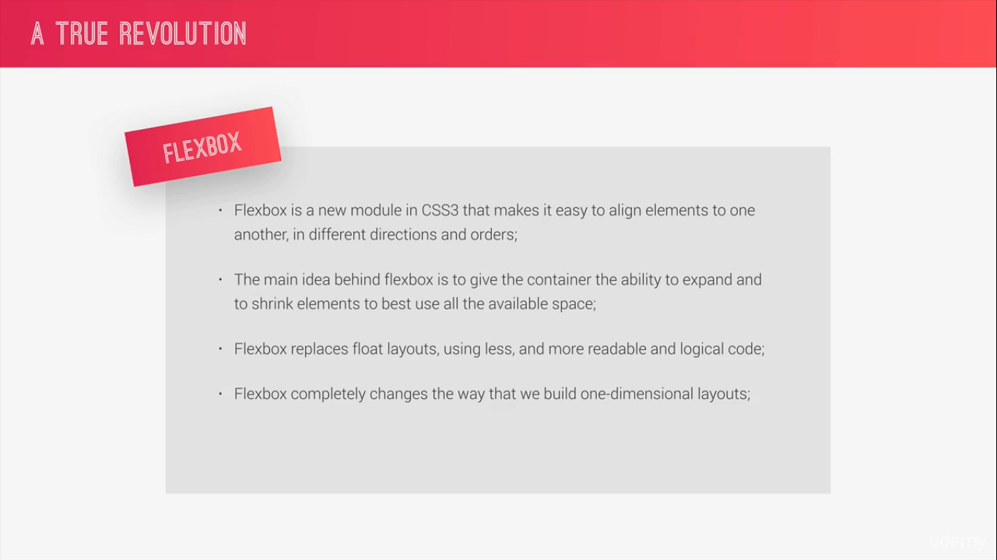

Concept
The element on which we use flex-box is called flex-container.
To set a flex container set its display property to flex.
We can also set it to flex-inline which will then creates a flex-container that behaves like an inline element.

All the direct children flex container are called flex items.
The direction in which the flex containers are laid out is called main axis.
The perpendicular to main axis is called the cross axis.
We can change the direction of the main axis as there are different ways of aligning element both across the mains axis and the cross axis

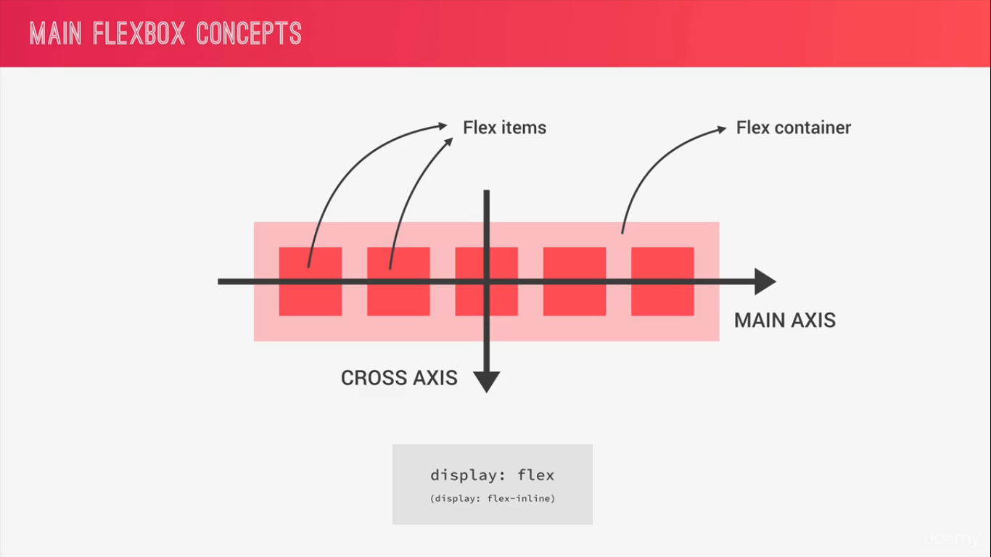

Flex-box specification has certain properties that we can use on the flex container in-order to position in-line all the all the flex-item
And also some other properties that we use directly on the flex-item themselves.

Container properties
- flex-direction: row| row-reverse | column|column-reverse
Specifies in which direction the main axis goes the default is row that is left to right. row-reverse is right to left. column is top to bottom. column-reverse is bottom to top.

- flex-wrap: no-wrap | wrap | wrap-reverse
Which defines if the flex-items should wrap into new line if there is not enough space.
nowrap
The flex container is single-line.
wrap (top to bottom distribution of lines)
The flex container is multi-line.
wrap-reverse ( bottom to top distribution of lines)
Same as wrap.
For the values that are not wrap-reverse, the cross-start direction is equivalent to either the inline-start or block-start direction of the current writing mode (whichever is in the cross axis) and the
cross-end direction is the opposite direction of cross-start. When flex-wrap is wrap-reverse, the cross-start and cross-end directions are swapped.

- justify-content |flex-start| flex-end|center|space-between|space-around|space-evenly
This defines how the flex-items will align along the main axis,
The justify-content property aligns flex items along the main axis of the current line of the flex container. This is done after any flexible lengths and any auto margins have been resolved. Typically it helps distribute extra free space leftover when either all the flex items on a line are inflexible, or are flexible but have reached their maximum size. It also exerts some control over the alignment of items when they overflow the line.

flex-start
Flex items are packed toward the start of the line. The main-start margin edge of the first flex item on the line is placed flush with the main-start edge of the line, and each subsequent flex item is placed flush with the preceding item.

flex-end
Flex items are packed toward the end of the line. The main-end margin edge of the last flex item is placed flush with the main-end edge of the line, and each preceding flex item is placed flush with the subsequent item.

center
Flex items are packed toward the center of the line. The flex items on the line are placed flush with each other and aligned in the center of the line, with equal amounts of space between the main-start edge of the line and the first item on the line and between the main-end edge of the line and the last item on the line. (If the leftover free-space is negative, the flex items will overflow equally in both directions.)

space-between
Flex items are evenly distributed in the line. If the leftover free-space is negative or there is only a single flex item on the line, this value is identical to flex-start. Otherwise, the main-start margin edge of the first flex item on the line is placed flush with the main-start edge of the line, the main-end margin edge of the last flex item on the line is placed flush with the main-end edge of the line, and the remaining flex items on the line are distributed so that the spacing between any two adjacent items is the same.

space-around
Flex items are evenly distributed in the line, with half-size spaces on either end. If the leftover free-space is negative or there is only a single flex item on the line, this value is identical to center. Otherwise, the flex items on the line are distributed such that the spacing between any two adjacent flex items on the line is the same, and the spacing between the first/last flex items and the flex container edges is half the size of the spacing between flex items.

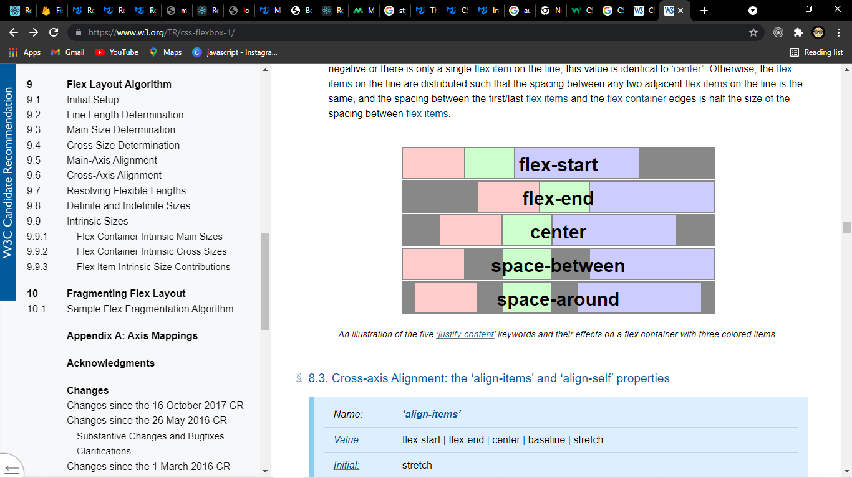

- align-items: |stretch | flex-start | flex-end | center | baseline
Defines how the flex-items will be align along the cross axis
stretch
If the cross size property of the flex item computes to auto, and neither of the cross-axis margins are auto, the flex item is stretched. Its used value is the length necessary to make the cross size of the item’s margin box as close to the same size as the line as possible, while still respecting the constraints imposed by min-height/min-width/max-height/max-width.

flex-start
The cross-start margin edge of the flex item is placed flush with the cross-start edge of the line.

flex-end
The cross-end margin edge of the flex item is placed flush with the cross-end edge of the line.

center
The flex item’s margin box is centered in the cross axis within the line. (If the cross size of the flex line is less than that of the flex item, it will overflow equally in both directions.)

baseline
The flex item participates in baseline alignment: all participating flex items on the line are aligned such that their baselines align, and the item with the largest distance between its baseline and its cross-start margin edge is placed flush against the cross-start edge of the line. If the item does not have a baseline in the necessary axis, then one is synthesized from the flex item’s border box.
In short items are aligned such as their baselines align

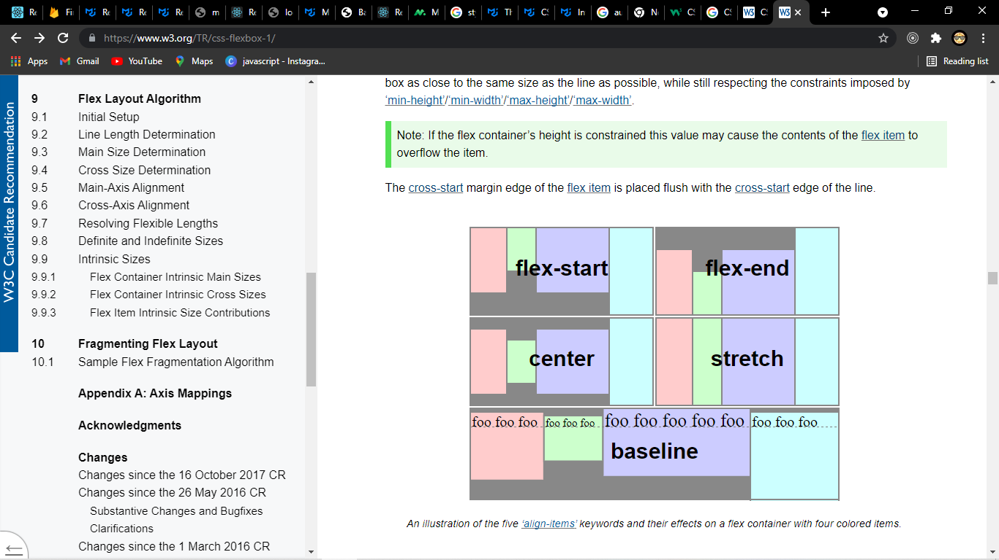

align-content: |stretch|flex-start | flex-end | center | space-between | space-around
Only applies when their is more than one row of flex items in that case align content controls how the rows are aligned along the cross axis if there is some empty space
The align-content property aligns a flex container’s lines within the flex container when there is extra space in the cross-axis, similar to how justify-content aligns individual items within the main-axis. Note, this property has no effect on a single-line flex container. Values have the following meanings:
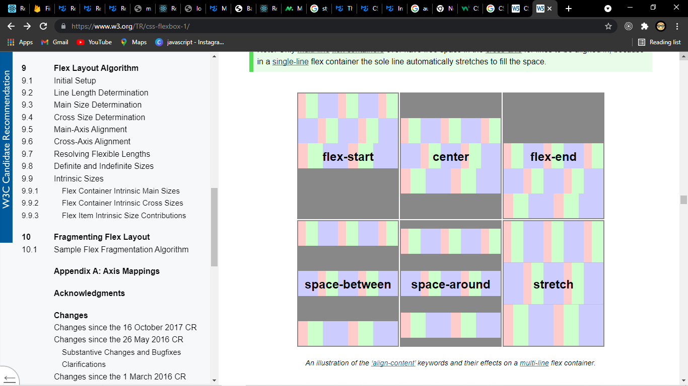
flex-start
Lines are packed toward the start of the flex container. The cross-start edge of the first line in the flex container is placed flush with the cross-start edge of the flex container, and each subsequent line is placed flush with the preceding line.
flex-end
Lines are packed toward the end of the flex container. The cross-end edge of the last line is placed flush with the cross-end edge of the flex container, and each preceding line is placed flush with the subsequent line.
center
Lines are packed toward the center of the flex container. The lines in the flex container are placed flush with each other and aligned in the center of the flex container, with equal amounts of space between the cross-start content edge of the flex container and the first line in the flex container, and between the cross-end content edge of the flex container and the last line in the flex container. (If the leftover free-space is negative, the lines will overflow equally in both directions.)
space-between
Lines are evenly distributed in the flex container. If the leftover free-space is negative or there is only a single flex line in the flex container, this value is identical to flex-start. Otherwise, the cross-start edge of the first line in the flex container is placed flush with the cross-start content edge of the flex container, the cross-end edge of the last line in the flex container is placed flush with the cross-end content edge of the flex container, and the remaining lines in the flex container are distributed so that the spacing between any two adjacent lines is the same.
space-around
Lines are evenly distributed in the flex container, with half-size spaces on either end. If the leftover free-space is negative this value is identical to center. Otherwise, the lines in the flex container are distributed such that the spacing between any two adjacent lines is the same, and the spacing between the first/last lines and the flex container edges is half the size of the spacing between flex lines.
stretch
Lines stretch to take up the remaining space. If the leftover free-space is negative, this value is identical to flex-start. Otherwise, the free-space is split equally between all of the lines, increasing their cross size.

Item properties

align-self: auto | flex-start | flex-end | center | baseline | stretch
Same as align-item but for one individual flex-item. For example if we set align-item to center and then we want one of the item to be aligned to the bottom in that case we can use align self.
order: 0| <integer>
Defines the order in which on specific flex-item should appear in side the container. This is helpful to reorder item for smaller screens and other stuff.

Then we have 3 properties that help us decide upon the width of the flex-items
flex-grow: 0| <integer>
Defines how much an item can grow.
flex-shrink: 0| <integer>
How much an item can shrink.
flex-basis: auto|<length>
We define its base width
And we have shorthand properties for above which is called flex:0 1 auto

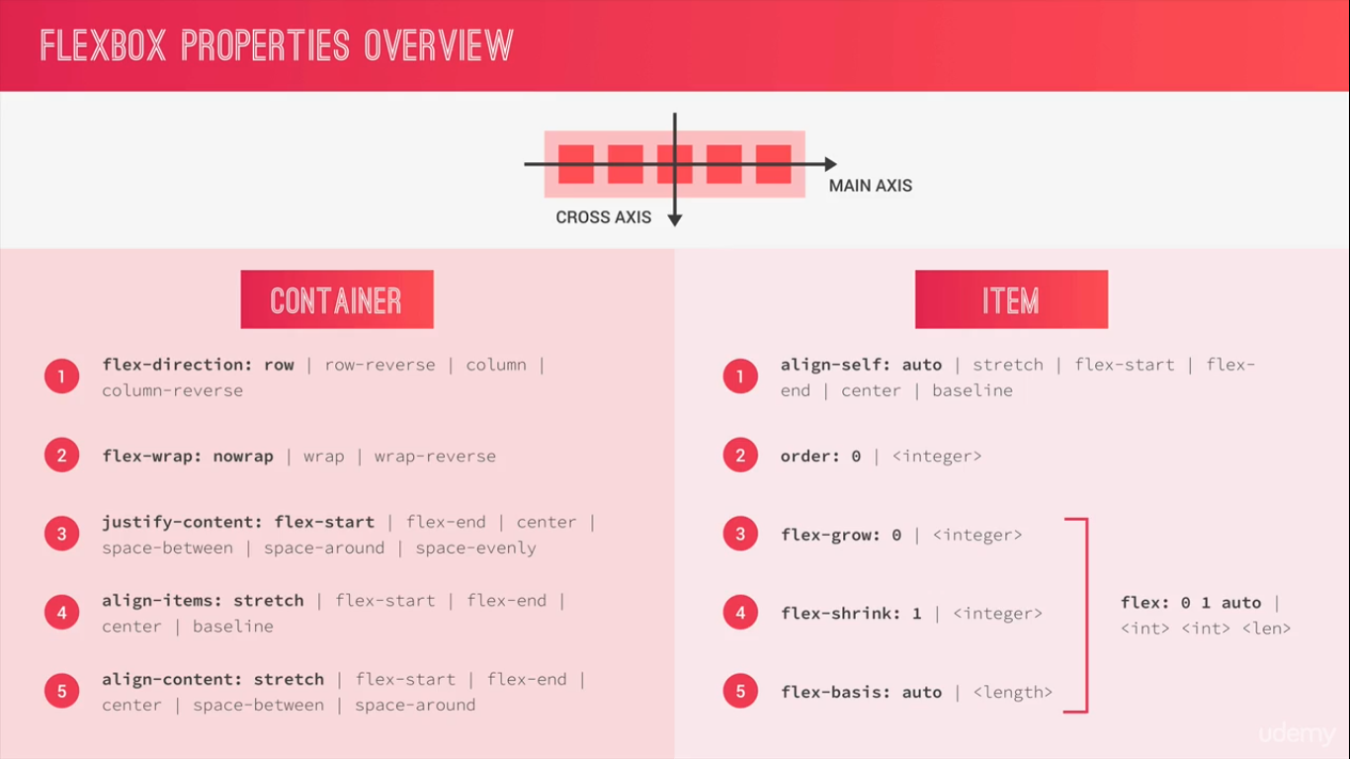

Grids

We create a new grid container by setting the display property of the element to grid.
All the direct children of the grid container are grid item.

We also have axis
But here we call them row axis in X direction and column axis in Y direction.
And these axis are always the same we cannot change where they are like we do in the flex-box.
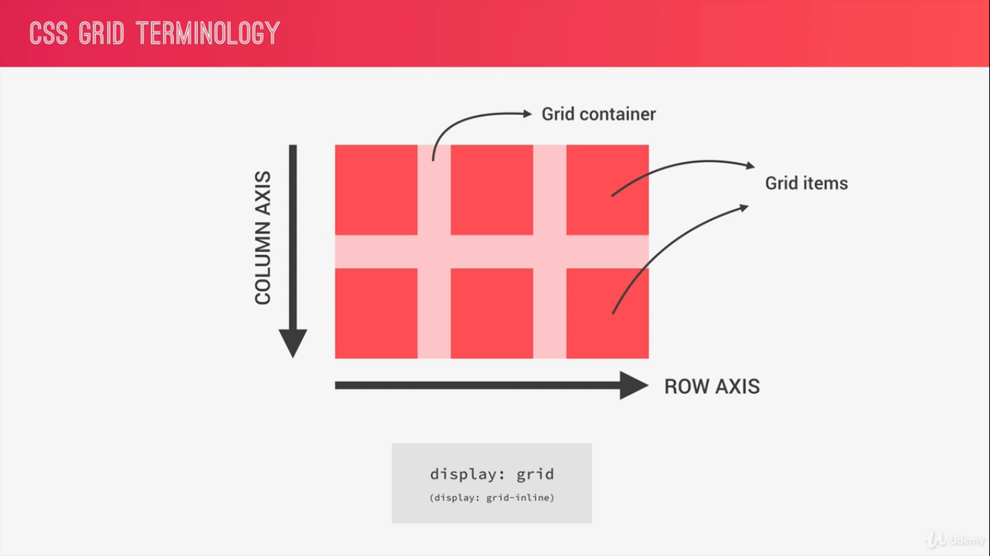

The vertical and the horizontal line that divide the grids and separate the columns are called grid lines.
They are automatically numbered for the columns as well as the for the rows, starting from 1 to no of rows +1 and as well as the no of columns +1.
That space between the rows and the columns is called the gutter.

The space between two grid-lines is called track no matter if it’s vertical or horizontal. If its horizontal it’s called a row and if its vertical it’s called column.

The area between two horizontal and two vertical grid-lines is called grid area, and if that area is between two adjacent grid lines and two adjacent columns line then that area is just called a grid cell.
