UNIVERSITY OF DAR ES SALAAM
COLLEGE OF INFORMATION AND COMMUNICATION TECHNOLOGIES (CoICT)
DEPARTMENT OF COMPUTER SCIENCE AND ENGINEERING

PRACTICAL TRAINING REPORT

REPORT TITLE
FIBRE OPTIC CABLE SPLICING AND BASIC NETWORK TROUBLESHOOTING AT TTCL MOSHI

Student Name: | IGNATUS NICHOLAUS KULAYA
Registration Number: | 04291-04-2025
Practical Training: | PT I
Company/Organization: | Tanzania Telecommunications Corporation (TTCL) – Moshi
Training Officer: | ____________________________
Academic Supervisor: | ____________________________

2026

ABSTRACT
This report presents the Practical Training (PT I) experience undertaken at Tanzania Telecommunications Corporation (TTCL), Moshi. The training focused on introductory Computer Engineering and Information Technology activities relevant to a first-year student, particularly fibre optic cable handling and splicing, identification of network equipment, basic network troubleshooting, and observation of wired network operations. The main task selected for this report is fibre optic cable splicing and basic troubleshooting because reliable fibre connections are essential for communication services and network availability.
The report identifies common problems that can affect a fibre connection, including poor fibre preparation, incorrect alignment, contamination of fibre ends and physical damage to cables. The proposed solution is a systematic procedure involving inspection, stripping, cleaning, cleaving, fusion splicing and testing. The report also compares fusion splicing with mechanical splicing and cable replacement. Relevant fieldwork photographs are included without alteration.
The training improved practical awareness of telecommunications equipment, safety practices and the relationship between physical network infrastructure and service reliability. Challenges included limited time for hands-on practice, the need for careful handling of sensitive equipment and the requirement to work under technical supervision. The report concludes with recommendations for continued practical exposure and further training in fibre testing and network maintenance.

ACKNOWLEDGEMENTS
I thank God for the strength and good health that enabled me to undertake my Practical Training. I sincerely thank the management and staff of Tanzania Telecommunications Corporation (TTCL), Moshi, for providing a practical learning environment and for sharing their technical knowledge and experience during the training period.
I also express my appreciation to my Training Officer and all technical staff who guided me through the activities, demonstrated equipment and procedures, and helped me understand the importance of safety and accuracy in telecommunications work. I am grateful to the University of Dar es Salaam, College of Information and Communication Technologies, for organizing the Practical Training programme and providing the academic guidelines for this report. Finally, I thank my family, fellow students and everyone who contributed to the successful completion of my Practical Training.

DECLARATION
I, IGNATUS NICHOLAUS KULAYA, Registration Number 04291-04-2025, declare that this Practical Training Report titled “Fibre Optic Cable Splicing and Basic Network Troubleshooting at TTCL Moshi” is based on my learning and activities during the Practical Training period. The report has been prepared for academic purposes in accordance with the Practical Training requirements of the University of Dar es Salaam.
Student Signature: ____________________________
Date: ____________________________
Training Officer’s Signature: ____________________________
Official Stamp: ____________________________

TABLE OF CONTENTS
ABSTRACT
ACKNOWLEDGEMENTS
DECLARATION
LIST OF ABBREVIATIONS
LIST OF TABLES
LIST OF FIGURES
CHAPTER ONE: COMPANY/ORGANIZATION PROFILE
CHAPTER TWO: MAIN TASK
REFERENCES
2.11 Year I CEIT Activities Covered in this Report
The activities described in this report were selected to match the level of a first-year CEIT student. They include identifying computer and network components, learning about different network cables and connections, observing network troubleshooting and configuration, learning basic hardware and software support, and observing the testing and maintenance of communication equipment. Some activities were performed through direct participation under supervision, while others were learned through demonstration and observation.
APPENDICES
Note: Page numbers can be updated after opening the editable document in Microsoft Word or LibreOffice.

LIST OF ABBREVIATIONS
Abbreviation | Meaning
CoICT | College of Information and Communication Technologies
ICT | Information and Communication Technology
IP | Internet Protocol
LAN | Local Area Network
OLT | Optical Line Terminal
ONT | Optical Network Terminal
PT | Practical Training
TTCL | Tanzania Telecommunications Corporation

LIST OF TABLES
Table 1: Examples of technical/ICT job responsibilities at the training environment
Table 2: Comparison of alternative solutions for fibre connection problems

LIST OF FIGURES
Figure 1: Simplified organizational structure relevant to telecommunications operations
Figure 2: Fibre optic splicing process flow
Figure 3: Telecommunications router/network equipment used for connectivity
Figure 4: Fibre optic fusion splicing equipment during fieldwork
Figure 5: Fibre optic fusion splicer prepared for a splicing operation

CHAPTER ONE: COMPANY/ORGANIZATION PROFILE

1.1 Introduction and Background
Tanzania Telecommunications Corporation (TTCL) is a telecommunications organization that provides communication and related ICT services. During my Practical Training at TTCL Moshi, I was exposed to a working environment involving telecommunications infrastructure, network equipment and fibre optic technology. The placement provided an opportunity to connect classroom concepts with practical activities performed under the guidance of technical personnel.
The organization’s operations require coordination between technical staff, network support personnel, customer service staff and management. In the technical environment, reliable infrastructure is important because faults in cables, connectors or network equipment can interrupt communication services. My PT I activities therefore concentrated on observing, identifying and learning basic procedures used in maintaining telecommunications and network infrastructure.

1.2 Organizational Structure
The organization structure of Tanzania Telecommunications Corporation (TTCL) is shown in Figure 1 below. It presents the main leadership and directorates of the organization, including the Technical and Operations Directorate, where most of the technical activities related to my practical training are found.
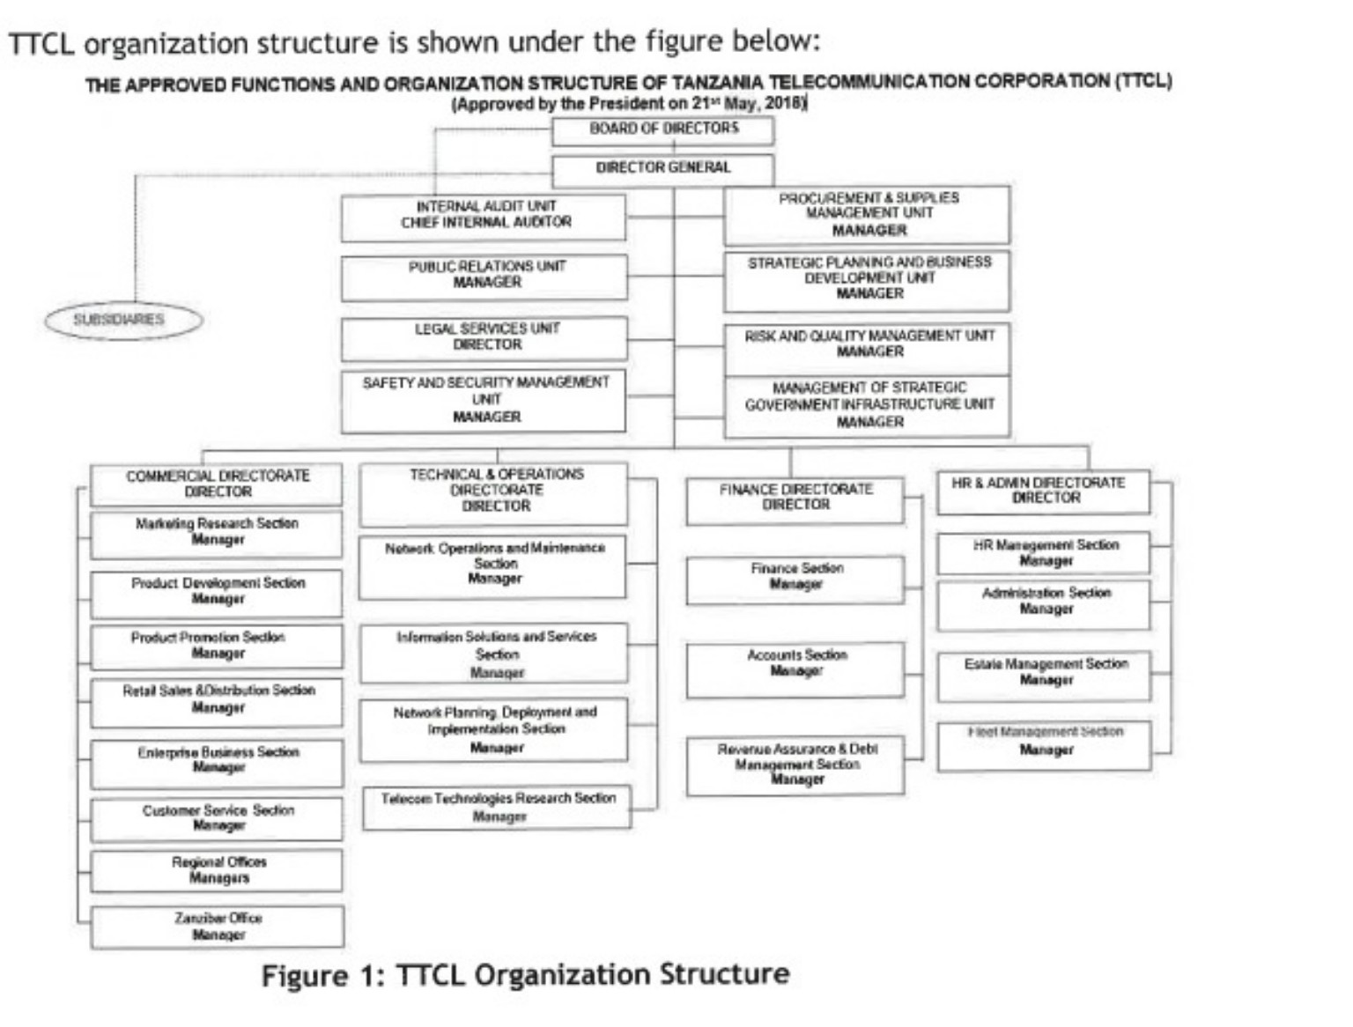
Figure 1: TTCL Organization Structure
The exact internal reporting structure may differ by office or department. A simplified structure relevant to the training environment is shown below:
Management / Regional Leadership
│
Technical and Network Operations
├───────────────┬────────────────┬───────────────┤
Network Support Field Technicians Customer/Service Support
Figure 1: Simplified organizational structure relevant to telecommunications operations

1.3 Job Descriptions of Technical/ICT Workers
Role | Main Work | Knowledge/Skills Required
Network Technician | Supports installation, configuration and troubleshooting of network equipment and connections. | Basic networking, IP concepts, cable identification, troubleshooting and documentation.
Fibre Technician | Prepares, splices, protects and assists in testing fibre optic cables. | Fibre handling, cleaning, cleaving, fusion splicing, safety and use of testing equipment.
ICT Support Personnel | Assists users and maintains computer-based systems and peripherals. | Computer hardware, software installation, configuration and communication skills.
Field Technician | Performs supervised field installation and maintenance activities. | Technical safety, use of tools, fault identification and teamwork.

1.4 Safety Regulations and General Welfare
Telecommunications and ICT work requires attention to safety, particularly when handling electrical equipment, optical fibres and field tools. During practical activities, equipment should be used according to instructions and under the supervision of qualified personnel. Fibre fragments should be handled carefully because they can cause injury. Work areas should be kept clean, and tools should be returned after use.
General welfare is also supported through cooperation, proper communication, appropriate working hours and guidance from supervisors. Students should follow workplace rules, maintain punctuality and report any unsafe condition or equipment problem to the responsible officer.

1.5 Recruitment and Training Practices
Technical organizations require personnel with relevant education, practical competence and the ability to follow professional procedures. Training is important because telecommunications technologies and equipment continue to change. During Practical Training, students benefit from demonstrations, observation, supervised participation and explanations from experienced workers. This approach helps a first-year student gradually develop practical confidence while remaining within an appropriate level of responsibility.

1.6 Strategic Role of the Organizational Structure
The separation of management, technical operations and support functions helps the organization coordinate its core services. Technical teams can focus on infrastructure and fault handling, while customer and administrative functions support service delivery and communication. Cooperation between these units is important because a network problem may require technical diagnosis, field intervention and communication with service users.

CHAPTER TWO: MAIN TASK

2.1 Main Task: Fibre Optic Cable Splicing and Basic Network Troubleshooting
The main task selected for this report is the learning and observation of fibre optic cable splicing together with basic troubleshooting of network connections. This task is relevant to PT I because it involves identification of system components, network cables, maintenance procedures and the use of available technical equipment. It also provided direct exposure to a physical communication medium used in modern telecommunications networks.

2.2 Problem Identification and Justification
A communication service can be interrupted or degraded when a fibre optic path develops a fault. Possible causes include cable damage, poor preparation of fibre ends, contamination, incorrect alignment or a weak connection. Because fibre carries data using light, small imperfections at a connection point can affect signal transmission.
The problem addressed in this report is therefore the restoration of a reliable fibre connection after a cable discontinuity or faulty joint. The task is justified because a correct splicing procedure helps restore continuity while reducing signal loss and the possibility of repeated faults.

2.3 Proposed Solution
The proposed solution is a systematic fibre splicing procedure using appropriate equipment and supervision. The procedure begins with identifying the suspected fault and preparing the work area. The fibre cable is then prepared by exposing the fibre, stripping the protective coating, cleaning the fibre and making a precise cleave. The prepared fibre ends are aligned in a fusion splicer, which joins them using a controlled electric arc. The completed joint is protected and the connection is checked using the available testing method.
Where a network problem is suspected to involve equipment rather than the fibre itself, basic troubleshooting includes checking physical connections, observing device status indicators, confirming that cables are properly seated and reporting persistent faults for further diagnosis.

2.4 Fibre Splicing Procedure Flow
Identify Fault
↓
Prepare Work Area and Equipment
↓
Strip and Clean Fibre
↓
Cleave Fibre Ends
↓
Align and Fusion Splice
↓
Protect the Joint
↓
Test / Verify Connection
Figure 2: Fibre optic splicing process flow

2.5 Functional and Technical Requirements
- A fibre optic fusion splicer or another approved joining method.
- Fibre stripping and cleaning tools.
- A cleaver for preparing clean fibre end faces.
- Appropriate fibre protection materials.
- Power supply and safe working conditions.
- Available testing or verification equipment.
- Qualified technical supervision, especially for a first-year trainee.

2.6 Advantages and Disadvantages of the Proposed Solution

Advantages
- Fusion splicing can provide a strong and reliable permanent connection.
- A systematic procedure helps reduce errors caused by poor preparation.
- Testing after the work helps confirm whether the connection has been restored.
- The task develops practical skills in handling network infrastructure.

Disadvantages
- The equipment requires careful handling and trained operation.
- The process can be affected by contamination or poor fibre preparation.
- Specialized equipment and maintenance may be required.
- Hands-on work must be supervised to maintain safety and quality.

2.7 Alternative Solutions and Comparison
Alternative | Description | Advantages | Limitations
Fusion splicing | Joins fibre ends using a controlled fusion process. | Reliable, low-loss connection when correctly performed. | Requires specialized equipment and skill.
Mechanical splicing | Uses a mechanical device to hold aligned fibre ends. | Can be quicker and may require less complex equipment. | May be less suitable where the highest connection quality is required.
Cable replacement | Replaces a damaged cable section. | Useful for severe or repeated physical damage. | May require more materials, time and field work.
Table 2: Comparison of alternative solutions for fibre connection problems

2.8 Fieldwork Photographs
The following photographs were provided from the Practical Training activities. They are included as original fieldwork photographs and have not been modified.
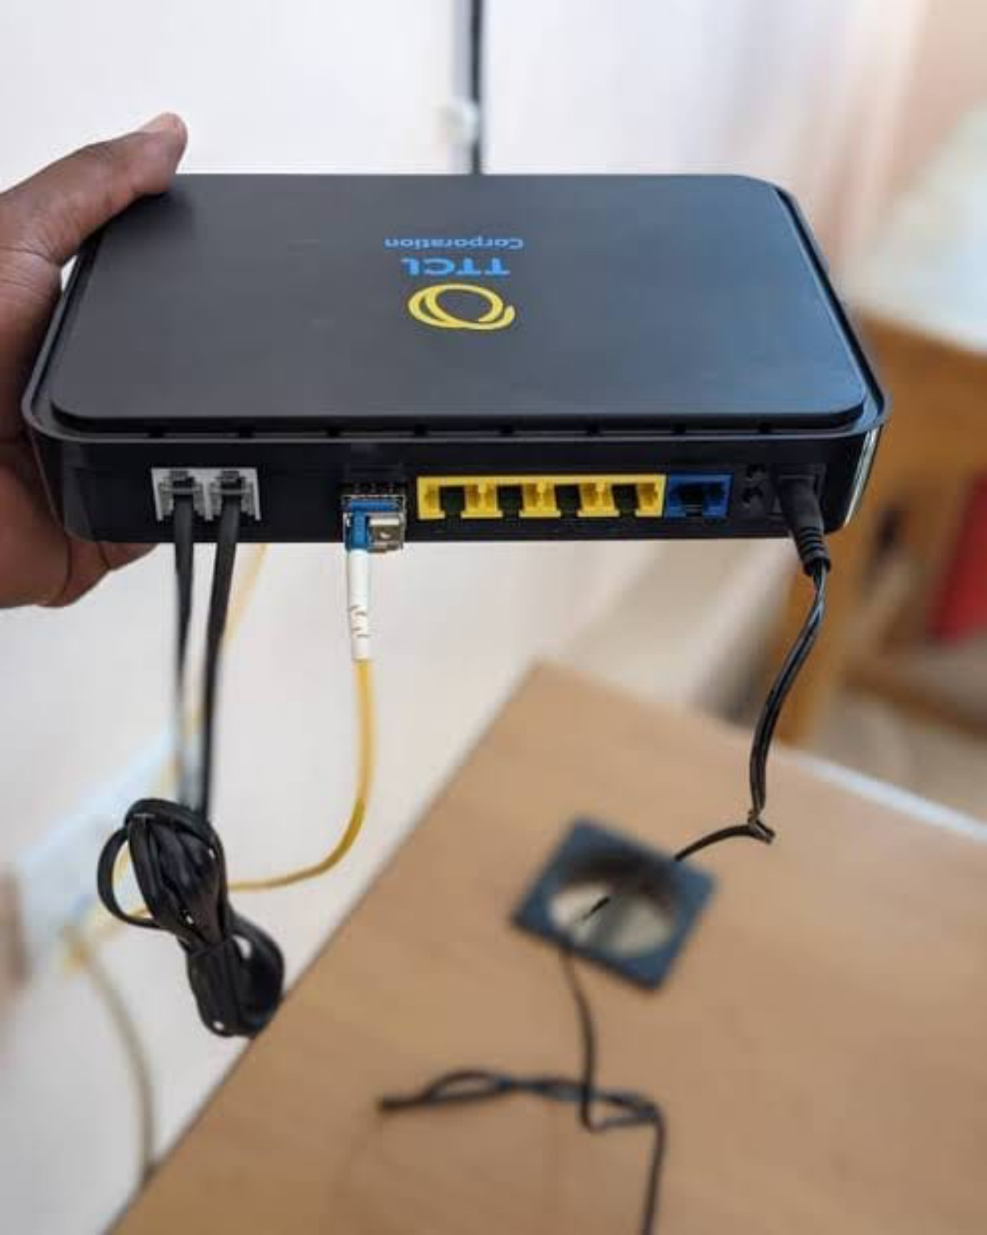
Figure 3: Telecommunications router/network equipment used for connectivity
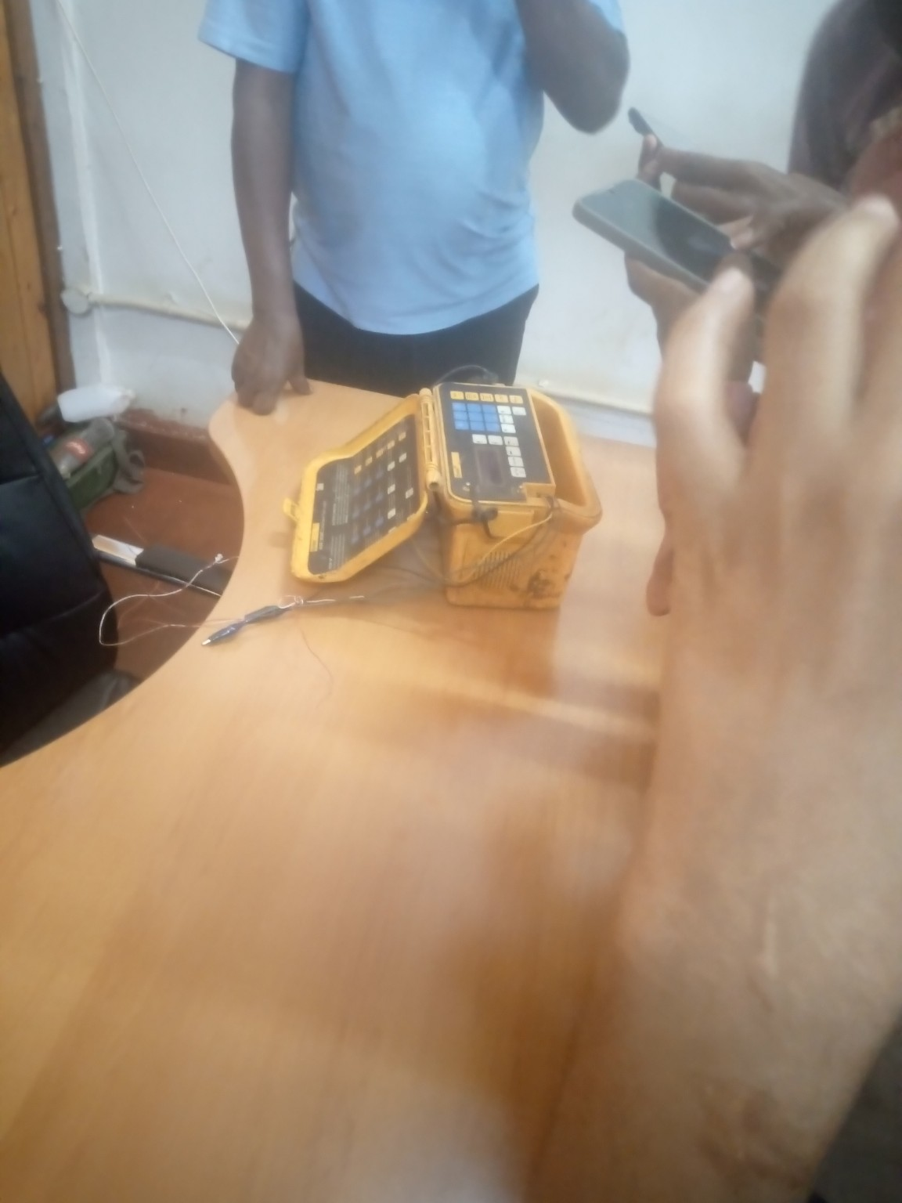
Figure 4: Fibre optic fusion splicing equipment during fieldwork
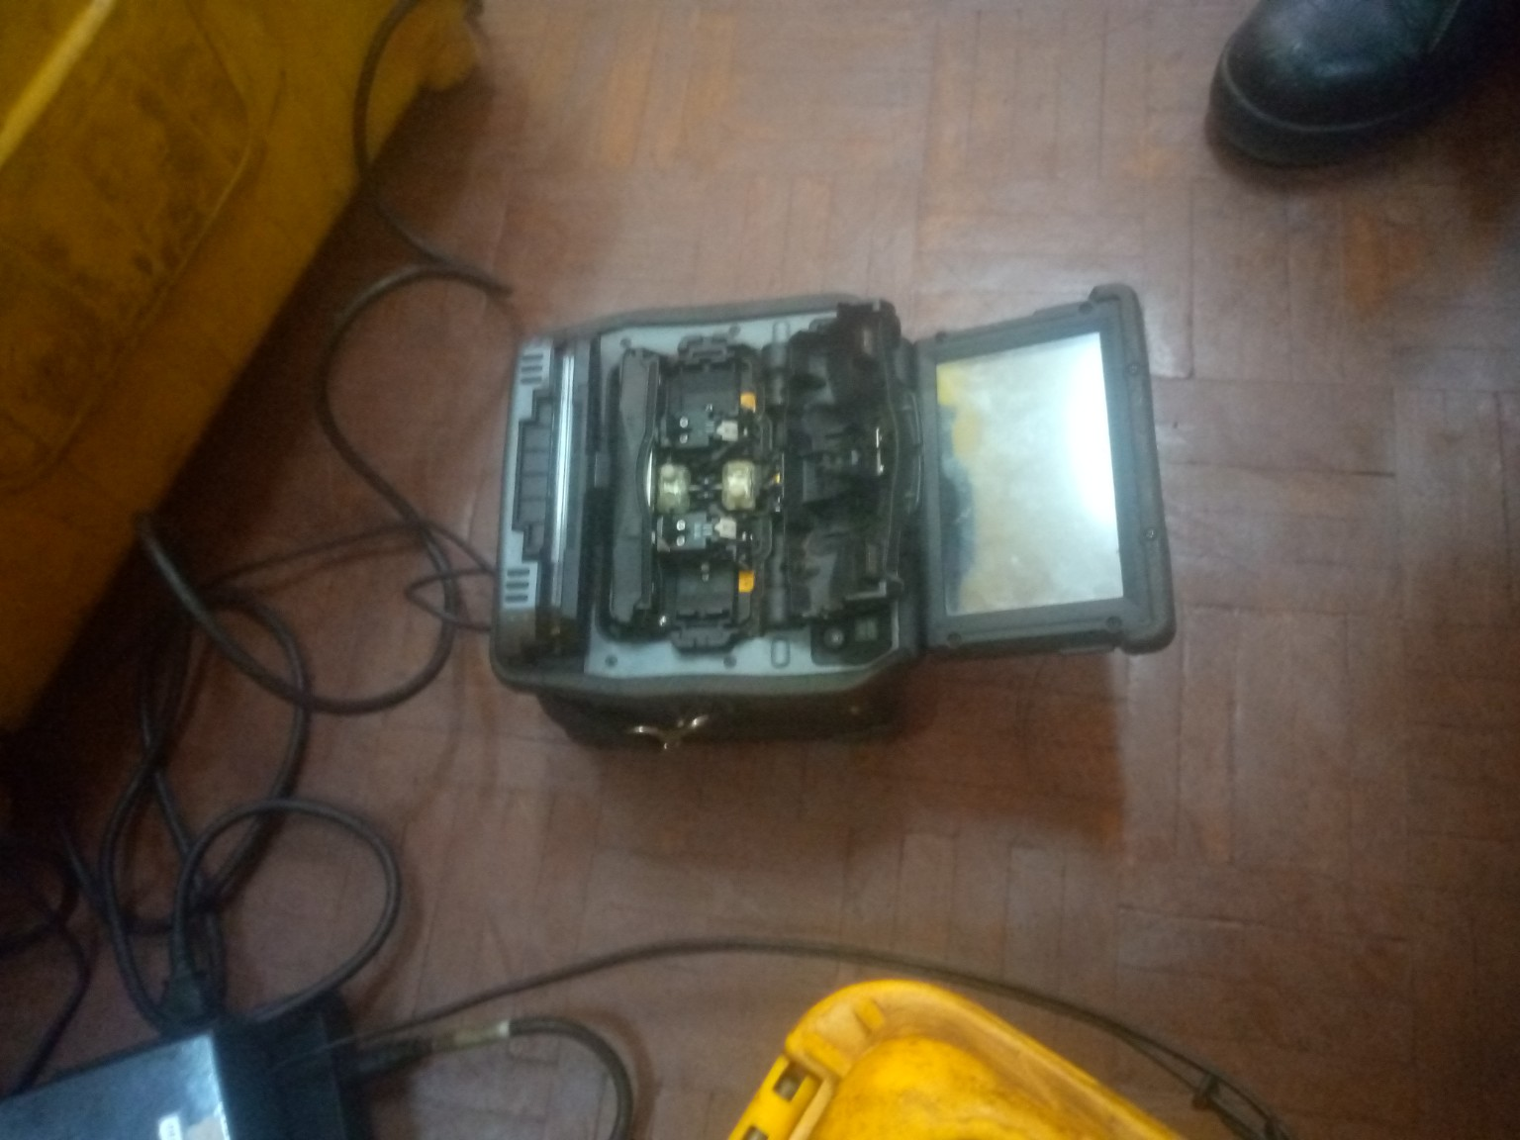
Figure 5: Fibre optic fusion splicer prepared for a splicing operation
The following diagrams are included from the provided sample report as visual learning materials. They are placed according to the practical activities learned during training.
2.8.1 Additional Telecommunications Diagrams
Figure 6: TTCL Copper Cable Connection
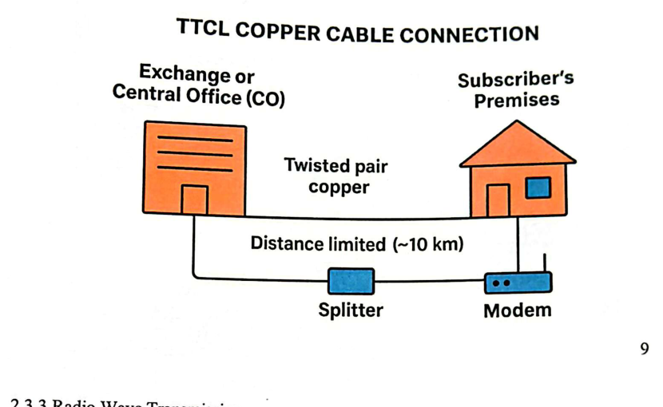
TTCL Copper Cable Connection
Figure 7: Radio Wave Transmission
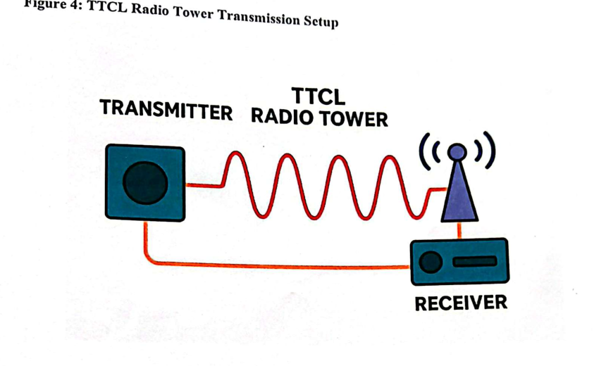
Radio Wave Transmission
Figure 8: Microwave Transmission and Line of Sight
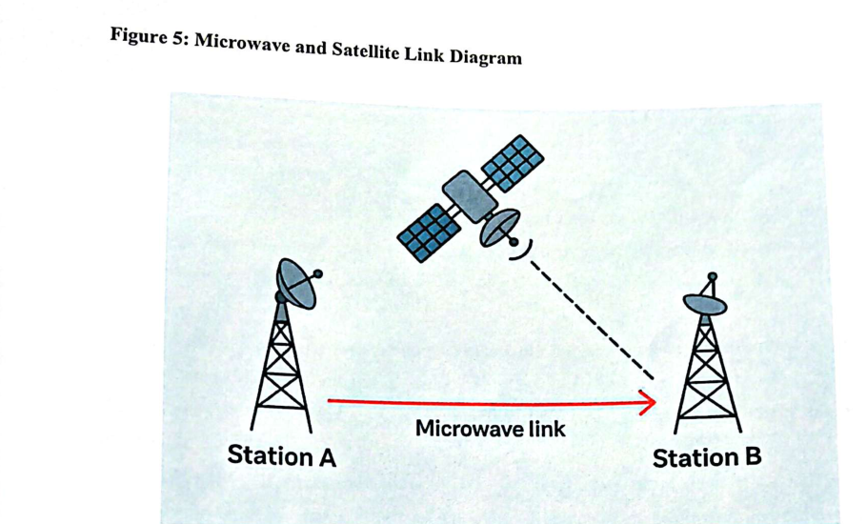
Microwave Transmission and Line of Sight
Figure 9: Telecommunications Network Distribution
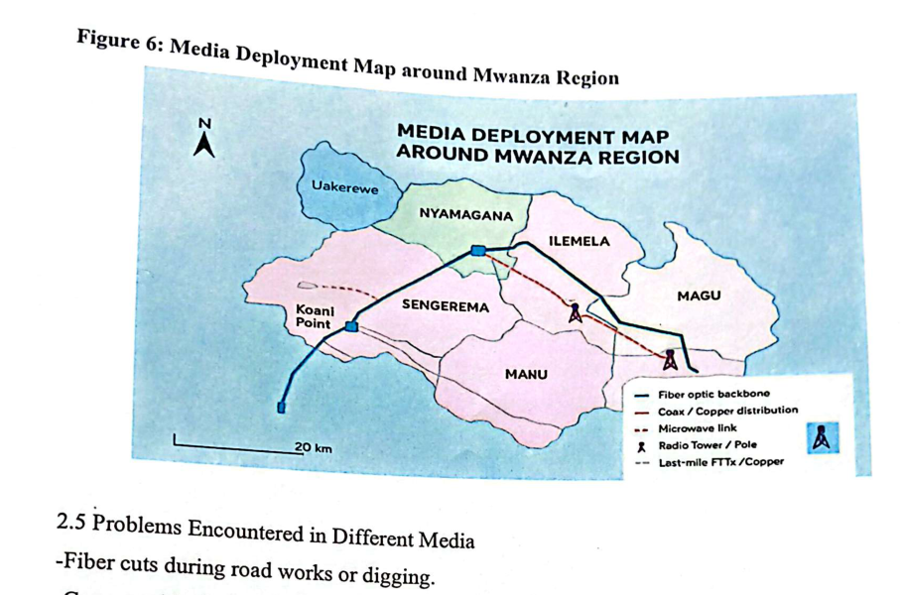
Telecommunications Network Distribution

2.9 Challenges Encountered
Several challenges were encountered during the Practical Training. First, as a first-year student, some equipment and procedures required close guidance before their operation could be understood. Second, practical time was limited, so not every technical procedure could be repeated many times. Third, fibre work requires precision because small errors in cleaning, cleaving or handling can affect the quality of a connection. Finally, some tasks involve equipment and infrastructure that must be handled only by authorized technical personnel, which limited independent experimentation.

2.10 Conclusion and Recommendations
The Practical Training at TTCL Moshi provided useful exposure to telecommunications and ICT working practices. The practical activities in network support, cable identification, computer systems and fibre optic work demonstrated the importance of properly maintained infrastructure in reliable communication services. The experience improved my understanding of technical equipment identification, network connections, cable handling, basic troubleshooting, workplace safety and the value of following a systematic procedure.
It is recommended that future PT I students continue to receive guided exposure to practical tasks that match their level of study. Additional demonstrations of fibre testing and fault localization would further strengthen the learning experience. The University may also continue preparing students with introductory networking and workshop skills before PT so that they can understand workplace demonstrations more effectively.

REFERENCES
College of Information and Communication Technologies. (2020). Practical Training Regulations and Guidelines for Report Writing. University of Dar es Salaam.
College of Information and Communication Technologies. (2022). Logbook Keeping and Report Writing Seminar. University of Dar es Salaam.
College of Information and Communication Technologies. (2020). Scope of PT Activities for CoICT Students: Activities and Tasks for Year I CEIT Students. University of Dar es Salaam.
Kurose, J. F., & Ross, K. W. (2021). Computer Networking: A Top-Down Approach (8th ed.). Pearson.
Stallings, W. (2021). Data and Computer Communications (11th ed.). Pearson.
The Fiber Optic Association. (n.d.). Introduction to Fiber Optics and Fiber Optic Networks. FOA Reference Guide to Fiber Optics.

APPENDICES

Appendix A: Summary of PT I Relevant Activities
The Practical Training activities were aligned with introductory CEIT tasks such as identifying systems' components and installations, network troubleshooting and configuration, identification of network cables, troubleshooting and maintenance of wired and wireless network operations, and testing components using available equipment.

Appendix B: Fieldwork Photo Notes
The photographs in Chapter Two document network and fibre optic equipment observed during the training activities. No location-oriented images were added, and the supplied photographs were used without modification.

Appendix C: Additional Practical Training Activities
The following activities were recorded during the Practical Training at TTCL Moshi. They show the practical exposure received as a first-year CEIT student. The activities included router configuration, fault correction, fibre work, carrier room maintenance, switch configuration and basic telecommunications network learning.
Router configuration and remote access
I learned how customer routers are configured for data and voice services. During the exercise, I observed the use of a VLAN ID, customer service credentials and remote access to customer devices. I also learned how to enable voice service for a client and how to change management settings so that technical staff can access a device when necessary.
Securing customer router access
I was taught how to close web access on a customer router to reduce unauthorized access. The procedure involved accessing the network settings and changing the web access permission. This activity helped me understand why basic security settings are important in network equipment.
Switch configuration and troubleshooting
I participated in learning switch configuration and basic troubleshooting. Commands such as 'display interface brief' and 'display current-configuration' were introduced for checking the condition and configuration of network devices. I also learned that devices with different access levels or settings may cause difficulties when trying to log in or communicate with another switch.
Fibre optic connection and equipment identification
I observed and participated under supervision in connecting fibre cables using a fusion splicer. I also learned about the Optical Distribution Frame (ODF), SFP modules and fibre colour codes. This practical exposure helped me understand how fibre connections are organized and maintained.
Fault correction and field work
I joined technical staff during fault correction activities. These included checking network equipment, working with an access point, investigating a transmission problem and correcting a fibre-related fault. I also observed the replacement of a customer router that had developed a fault.
Carrier room maintenance
I learned about the arrangement of telecommunications equipment in the carrier room. One of the maintenance activities involved removing unused patch cords. This helped me understand the importance of keeping network connections organized and avoiding unnecessary cables.
Telecommunications network learning
I explored how capacity received through the national backbone is distributed to different networks and service areas. I was introduced to network components such as switches, routers, ODFs and patch cords. I also learned through simulation about microwave and radio wave communication and the importance of line of sight between two points.

Appendix D: Additional Fieldwork Photographs
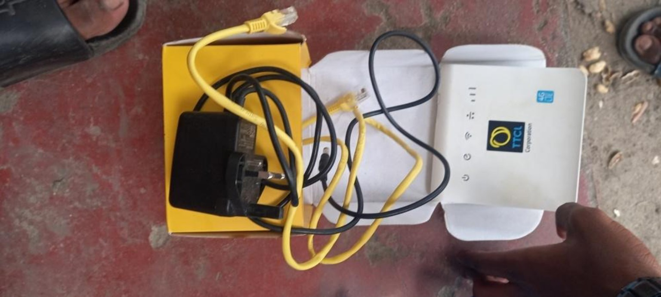
Figure 6: TTCL customer router and Ethernet cables used during router configuration and connectivity activities.
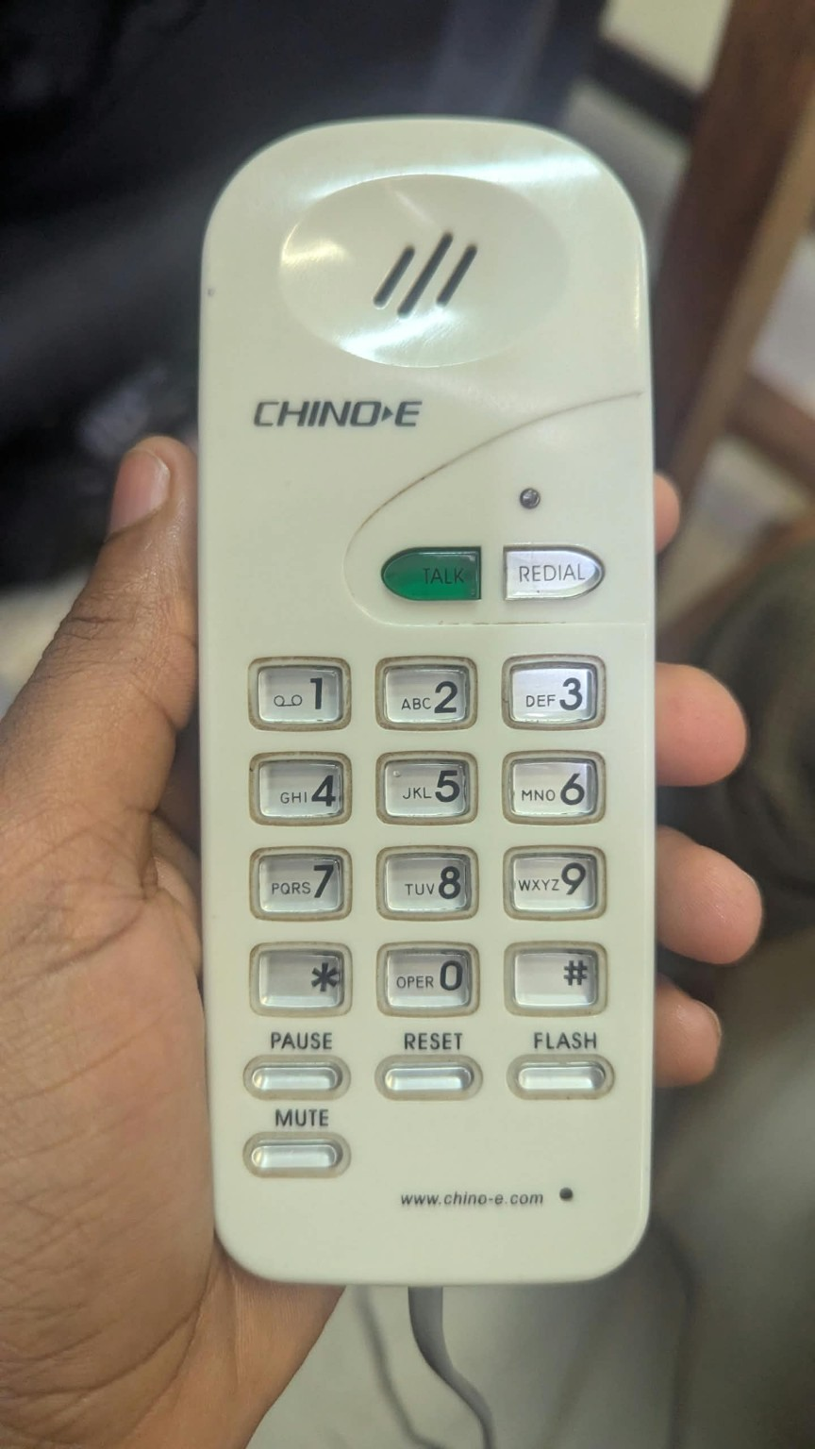
Figure 7: Telephone handset observed during telecommunications equipment identification.
Note: The photographs above are original fieldwork photographs supplied by the student and were not edited. The location-oriented photograph was not included because it does not directly show a technical PT activity.

