How to Run the Continued Fraction Regression Program

Source Code

The source code of the program is written using C++. The program requires C++ 11 and make to compile and execute. You can access the source code from GitHub repository at: <https://github.com/MohammadNHaque/ContinuedFractionRegression-V2>

# Setup Required Software and IDE

If you are using a Windows operating system, then you can use Cygwin (for C++11 and Make) and NetBeans to compile and execute the program. In Ubuntu/Unix like operating system, Netbeans, Make and C++ can be be used. Detail instruction about how to install the system in Unix OS can be found in the Readme of the project on GitHub.

## Installing C++, OpenMP, gdb and Make from Cygwin for Windows

Cygwin is a Unix-like environment for Windows OS. It is a vast collection of Unix tools and Utilities. We will use GNU C++ (GCC) compiler, OpenMP, GNU Debugger (gdb) and Make form it. Download Cygwin from <https://cygwin.com/install.html> . Run the [setup-x86_64.exe](https://cygwin.com/setup-x86_64.exe) (for the 64-bit version of Windows) or [setup-x86.exe](https://cygwin.com/setup-x86.exe) for the 32-bit Windows.

* Run the Cygwin Installer.
* Select default options at the installer until the “Select Packages” option arrives.
* At the “Select Packages” Click the + next to Devel, to expose the developer packages/ search for following packages:
  + Scroll down until you see the gcc-g++ C++ compiler package and select it.
  + Scroll down until you see the gdb GNU debugger package and select it
  + Scroll down until you see the GNU version of the make package and select it
  + Scroll down until you see the OpenMP package and select it

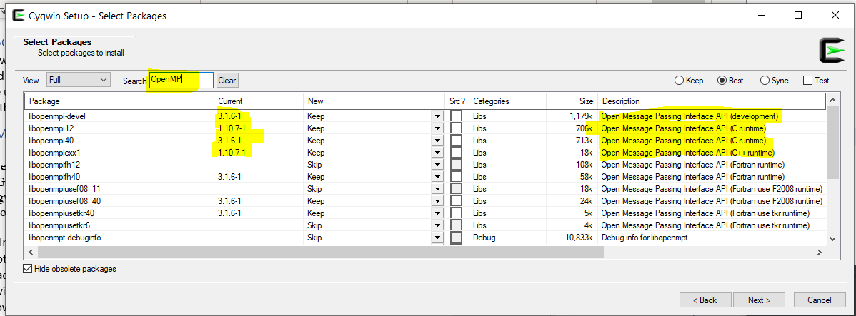

* We have selected our required packages, so click the Next button. The installer will then begin installing the packages.
* Congratulations! You've just installed g++, OpenMP, gdb, and make!

Check the versions of your Cygwin compilers and tools:

1. After completing the installation, we have to check the version of Cygwin in the Windows command Prompt:

C:\Users\moham>**cygcheck -c cygwin**

Cygwin Package Information

Package Version Status

cygwin 3.1.4-1 OK

1. Now check the versions of the g++, gdb and make in the command prompt:

C:\Users\moham>**g++ --version**

g++ (tdm64-1) 9.2.0

C:\Users\moham>**gdb --version**

GNU gdb (GDB) 8.3.1

C:\Users\moham>**make --version**

GNU Make 3.82.90

If you have the correct versions, then no further setup is necessary.

## Download and Install Netbeans IDE

Apache NetBeans is a cross-platform Integrated Development Environment (IDE) for C++, Java, PHP and many other languages. We will use NetBeans as our IDE for the Progam. Download the Netbeans from <https://netbeans.apache.org/download/index.html> . I suggest using the **Apache NetBeans 12 LTS** version. After you install the Netbeans, we have to configure it for using C++.

Now go to Tools 🡪 Plugins 🡪 Settings and add “NetBeans 8.2 Plugin Portal” with url: <http://updates.netbeans.org/netbeans/updates/8.2/uc/final/distribution/catalog.xml.gz>

Form the available plugins install the one for C/C++.

Configure C++ Build tools in NetBeans

Now go to NetBean’s Tools🡪 Options window and select the C/C++ and Create “Build Tool” with the proper path in your computer, as shown in Figure 1.

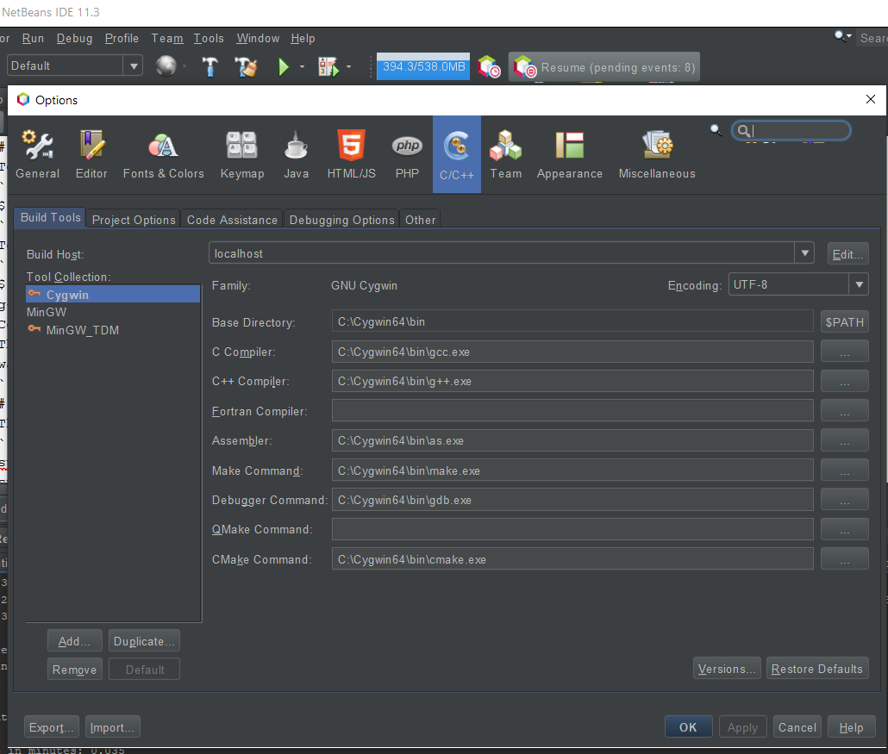

Figure 1: Build Tool for C++ Projects in NetBeans 12

# Run The Program

This section will illustrate how to run the program. The parameters of the program can be specified in the Project’s Run Property, as shown in Figure 2.

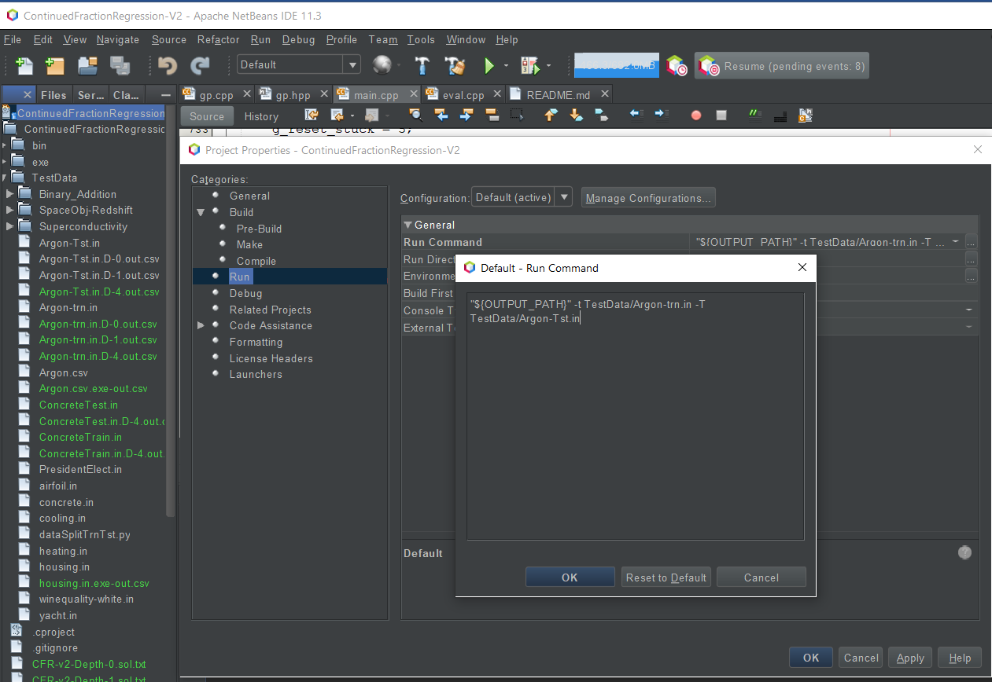

Figure : Setting the Command Line Parameter of the program

Run Example 1:

An Example of how to run the program for Argon data:

"${OUTPUT_PATH}" -t TestData/Argon-trn.in -T TestData/Argon-Tst.in

Run in NetBeans

./bin/main -t TestData/Argon-trn.in -T TestData/Argon-Tst.in

Unix Environment

The output shows the values of all parameters in the program

======================== PARAMETER VALUE =====================

-t --train TestData/Argon-trn.in

-T --Test TestData/Argon-Tst.in

-o --obj mse

-d --delta 0.35

-g --num-gen 200

-m --mut-rate 0.2

-f --frac-depth 4

-r --reset-root 5

-p --pop-init Random

-l --ls-gen 1

-nm --nelder-mead 3:250:5

-n --norm 0

-S --is-serial true

-s --seed random_device

-ld --ls-data 100

-sw --samp-weight Not Present

-loo --loo-cv false

-prec --out-prec 6

-v --verbose 0

============================================================

Then it will start showing the best fitness obtained (so far) for each of the generations. Finally, it shows the best fitness achieved for the solution. Then it shows the solution in LaTeX, Mathematica (in verbose mode >=2) and Excel format. The error metric for train and test are then displayed. The error metric used in the fitness function is highlighted with an * mark.

==================================================

Solution in LaTeX format

BestFitness 6.86101 Solution_Size 1

${10.9815+76.5324v0}+\cfrac{{-1-32.1863v0}}{{0.990555-0.0892841v0}+\cfrac{{-2.52729+0.775669v0}}{{-0.0326047+1.38879v0}+\cfrac{{-0.588104+13.702v0}}{{3.62593+2.91453v0}+\cfrac{{2.52588+70.2236v0}}{{-0.102985-3.10377v0}}}}}$

(10.9815+76.5324*B2)+(-1-32.1863*B2)/((0.990555-0.0892841*B2)+(-2.52729+0.775669*B2)/((-0.0326047+1.38879*B2)+(-0.588104+13.702*B2)/((3.62593+2.91453*B2)+(2.52588+70.2236*B2)/((-0.102985-3.10377*B2)))))

Solution in Excel format

Error Metric

Score **\*mse** nmse pearson theil med.err med.ae mase

Train 5.08223 0.000757177 0.999609 0.994379 2.15799 2.15799 0.11278

Test 1.15378e+07 1.81891 -0.969125 -0.0286502 2030.19 2030.19 1.07619

Solution is written at: CFR-v2-Depth-4.sol.txt

Run Example 2 : with some Parameters

Another Example: running the program with parameters used in CEC 2020 paper: [obj=mse, gen=200, muRate=0.10 penalty=0.1 nelder-mead:4:250:10 depth=4]:

"${OUTPUT_PATH}" TestData/Argon-trn.in -T TestData/Argon-Tst.in -g 200 -m 0.1 -d 0.1 -nm 4:250:10 -f 4 -v 2

Run in NetBeans

./bin/main TestData/Argon-trn.in -T TestData/Argon-Tst.in -g 200 -m 0.1 -d 0.1 -nm 4:250:10 -f 4 -v 2

Unix Environment

More Detail about the program, data format and some data for testing it can be found in the Readme file at the Github Page: <https://github.com/MohammadNHaque/ContinuedFractionRegression-V2/>