This article appeared as “Information Operations in the Information Age” in the “Journal of Electronic Defense.” It was published in two parts in the April and May 2004 editions.

Operations in the Information Age: A U.S. Air Force Perspective

INTRODUCTION: THE POWER OF INFORMATION
“There is a war out there, old friend - a World War. And it’s not about who’s got the most bullets; it’s about who controls the information. What we see and hear, how we work, what we think. It’s all about the information.”
Cosmo
Universal Studio’s movie “Sneakers”™

As the 20th Century drew to a close, strategists began to understand how informational power might affect future military operations. The world was introduced to the so-called “CNN factor,” a term used to describe real-time, global broadcast television’s impact on national policy and diplomacy. The first twenty-four hour media coverage of war generated new concerns over Operations Security (OPSEC) and made some question whether large-scale military deception operations would ever be possible again given the ubiquitous media coverage of military operations. The world witnessed the considerable changes in warfare resulting from the technological revolution of the Information Age. With the Information Age came Information Operations (IO), an ostensibly new way of conducting military operations. This paper examines operations in the Information Age from a U.S. Air Force perspective, illustrating how the Air Force approach is making IO a core competency. Part I sets the stage by providing a summary of the application of IO by the Department of Defense (DOD) in recent joint operations. Part II discusses the evolution of IO doctrine in the U.S. Air Force and examines some of the Air Force’s most pertinent IO issues today. It also addresses the direction in which Air Force IO is headed and offers suggestions for the future of Air Force IO in the 21st Century.

PART I: THE GENESIS AND EVOLUTION OF JOINT IO
In Operation Desert Storm, the art and science of Command and Control warfare was applied to near perfection. Command and Control warfare, or C2W, targets an adversary’s Command and Control (C2) systems. Military commanders use C2 systems to coordinate and synchronize virtually every aspect of their planning and operations. Applying C2W, the Allied coalition in Desert Storm systematically bombarded Iraq’s frontline troops with psychological operations (PSYOP); crippled Iraq’s integrated air defenses; blinded its target acquisition; shut down its propaganda machine; and totally disrupted military communications from the national to the operational level. These actions were supported by the most massive military deception operation since the Normandy invasion. Iraq’s military forces, psychologically exhausted and rendered electronically deaf and blind, were subsequently defeated in detail by relentless aerial attack combined with a lightning-swift ground campaign. The image of the crushed Iraqi forces surrendering by the thousands remains vivid today. C2W was the genesis of the joint Information Operations (IO) doctrine employed by the U.S. military today.
Information Operations, or IO, has yet to be fully understood or embraced by the U.S. military. Yet they have applied IO doctrinally at least since 1998, when the Department of Defense (DOD) first published Joint Publication (JP) 3-13, Joint Doctrine for Information Operations. The military applied IO tactics, techniques and procedures operationally as early as the end of 1995, when the U.S. first introduced ground troops into Bosnia. The Unified Combatant Commanders have all formed IO cells on their staffs and the military services have each developed unique approaches to applying IO in their daily operations and planning. Joint Doctrine defines IO as, “Actions taken to affect adversary information and information systems while defending one’s own information and information systems.” The vagueness of this definition to a large degree reflects the inability of the military services to agree on a definition for IO, even though it has been over three years since the publication of JP 3-13. They have only recently agreed on what will be come a consensus definition of IO. Joint IO doctrine divides IO into offensive and defensive capabilities and related activities. These include the capabilities of psychological operations (PSYOP), operations security (OPSEC), military deception, physical attack, electronic warfare (EW), and computer network attack (CNA). Additionally, there are two related activities that directly support IO: civil affairs (CA) and public affairs (PA). In virtually every joint combat operation, U.S. military forces employ EW against enemy air defenses. Other IO capabilities are employed as the situation warrants.

Somalia
Although there was no DOD IO doctrine in 1992, the U.S. military made extensive use of a number of IO capabilities during its ill-fated operations in Somalia. Somalia began as a humanitarian mission to end a famine resulting from years of civil war, exacerbated by unprecedented flooding across large portions of the country. Any technological infrastructure Somalia might have had was long destroyed when the U.S. intervened. For that reason, the “soft science” of perception management operations prevailed during the operation. The U.S. used a combination of PSYOP and public affairs to pass selected messages and themes to the Somali people and leaders. The persuasive words were reinforced by the actions of Civil Affairs teams whose coordination of relief projects did much to ease the massive human suffering. The humanitarian crisis was essentially relieved during the first days of the mission.
Virtually all of the perception management success in Somalia was negated when the military mission changed from humanitarian relief to peace enforcement. The new mission included a requirement to capture the warlord Mohammed Farah Aideed. This resulted in armed engagements between U.S. and Somali forces, an act that erased any semblance of American neutrality and virtually destroyed the credibility of subsequent perception management efforts by the military. Aideed himself was a master of perception management. His forces filmed themselves dragging the dead body of a U.S. pilot through the streets of Mogadishu and then passed the video to the international news media. The film aired across the globe and ultimately precipitated a withdrawal of U.S. forces from Somalia and a reversal of U.S. national policy in the Horn of Africa. The “CNN factor,” in this instance clearly demonstrated that information had become an element of national power that, when properly employed, could prove as effective as military, economic, and diplomatic power.

Haiti
Perception management operations were employed extensively in Haiti prior to the 1994 U.S. introduction of ground forces in operation Uphold Democracy. The aim of the United Nations-backed operation was enforcement of the Governors Island Accords, which laid the framework for the return to power of the democratically elected Jean Bertrand Aristide. Aristide had been overthrown by a coup in 1991, the same year he was elected. A government led by the parliamentary majority party and the Haitian military replaced him. General Raul Cedras led the Haitian military. The U.S. Atlantic Command had created Joint Task Force Haiti Assistance Group (JTF HAG) to lead the movement of U.S. forces into Haiti. The JTF was embarked aboard the USS Harlan County, an amphibious transport ship. It was structured for an assistance mission to help restore stability to Haiti, not for peace enforcement. Upon arriving at Port-au-Prince harbor, the Harlan County’s commander discovered a Cuban tanker blocking his assigned berth, an angry, drunken mob at the piers, and Haitian Navy gunboats with an aggressive attitude. Already gun shy from the Somalia experience, the Clinton administration was reluctant to enter into a peacekeeping effort with a show of force. The Harlan County eventually was recalled and CNN broadcast its departure, which it described as the Harlan County being “thrown out of Haiti.” The Haitians interpreted the departure as a lack of American resolve…and once again, the CNN factor had influenced American national policy.
Planning for the introduction of forces into Haiti included both permissive and forcible entry operations. Prior to the introduction of forces, Military aircraft broadcast PSYOP messages by radio and TV directly to the Haitian People. One theme discouraged the Haitians from attempting to flee to the United States during the upcoming operations. Other messages from deposed President Jean-Bertrand Aristide explained the situation and declared that the mission of U.S. soldiers was to restore democracy. The U. S. dropped 10,000 portable radios to enable the Haitian citizens to monitor the Commando Solo broadcasts by the 193 Special Operations Group, Pennsylvania Air National Guard. Other perception management operations were aimed directly at the Haitian military leader General Raul Cedras and top civilian leaders. The messages urged the Haitian civilian and military leadership to peacefully relinquish power. They eventually succumbed to the immense pressure. Cedras and other top military leaders were allowed to depart the country to live in exile in Panama.
Operation Uphold Democracy succeeded in restoring democracy and stemming the massive flow of illegal immigrants to the United States. However, the U.S. military was caught unprepared for the Harlan County incident and suffered an initial loss in the perception management effort from which it had difficulty recovering. The military must be able to respond to unfavorable events before the adversary can use it for his own propaganda. The U.S. military planners did not anticipate the Harlan County incident and the Haitians were quick to claim that they had defeated the U.S. Navy. This fact was not lost on the Haitian military leadership.
In reality, serendipity may have played as big a role in the eventual peaceful entry of forces into Haiti as did planning. While every effort was made to maintain OPSEC throughout planning and executing the deployment of U.S. forces, it proved impossible to hide the fact that the U.S. Army’s 10th Mountain Division had embarked on the aircraft carrier U.S.S. Eisenhower. Television coverage of this event was readily available to the Haitian leadership. The clear threat of force might have been just what was needed to convince them not to resist. Unfortunately, this consideration had not been factored into the perception management operations. The U.S. was just lucky to have avoided the necessity for a forcible entry.
After the introduction of forces, the perception management effort continued. Public Affairs continued to explain the presence of U.N. forces and sought to prevent any hostile acts against those forces. Civil Affairs led the efforts to restore electricity and other infrastructure. Civil Affairs also served as expert advisors to as many as twelve government ministries.

Bosnia
The first large-scale application of IO as a U.S. military doctrine was in Bosnia-Herzegovina. NATO’s mission in Bosnia was peace operations, i.e. enforcing the agreements of the Dayton Peace Accords. The Bosnian Serbs had been driven to the negotiating table as a direct result of the NATO air operation Deliberate Force, conducted from 29 August to 14 September 1995. Deliberate Force focused on eliminating the Serb integrated air defenses and the Bosnian Serb Army’s operational command and control. The operation was so successful that afterwards the combined Croat and Muslim forces of the Bosnian Federation were able to rout the shaken Serb forces in central and western Bosnia.
NATO’s peacekeeping force, called the Implementation Force (IFOR), begin entering Bosnia in December 1995 as part of operation Allied Force. Their entrance was preceded by an extensive PSYOP campaign to inform and prepare the former warring factions for their arrival. The Air Force’s Commando Solo was the primary means of disseminating the PSYOP messages. The peacekeepers made extensive use of Civil Affairs and Public Affairs to support their perception management operations. The aim of the Civil Affairs projects was to restore order to the daily lives of the Bosnian citizens and to win their support for NATO’s presence in their country. Public Affairs informed the Bosnian public about NATO’s intent and emphasized the positive influences caused by NATO’s presence in Bosnia.
The U.S. Army, as a long-term, stay-behind force relies heavily upon perception management to support its operations, particularly to enhance force protection. NATO’s U.S. Army-led Multinational Division North (MND-N) made extensive use of IO. The Army published Field Manual 100-6, Information Operations in August 1996, some two years before joint IO doctrine was published. MND-N’s IO planning capability was augmented by a Field Support Team (FST) from the Army’s then new IO center of excellence, the Land Information Warfare Activity (LIWA), based in Fort Belvoir, Virginia. The IO executed by MND-N focused heavily on perception management using the PSYOP and OPSEC supported by CA and PA operations. The LIWA FST was organized to provide a full-spectrum of offensive and defensive IO planning and execution support. This is the first instance we find of a military structure developed specifically to support the application of full-spectrum IO in operations. Even NATO eventually joined in, forming the first NATO IO Cell in the Stabilization Force (SFOR) headquarters in Sarajevo in late 1996.
Operations in Bosnia revealed the potential value of the integrated and coordinated application of IO. Perhaps the most important lesson learned was the utility of PA, CA, and PSYOP as non-lethal weapons. Civil Affair played a tremendous role in Bosnia, with CA troops coordinating the massive humanitarian relief effort and assisting in the establishment of government functions and services in the newly formed Bosnian government. Civil Affairs and PSYOP troops engaged in a massive public information effort aimed at mine awareness and reducing the number of casualties from the thousands of mines that had been spread across the country during the years of civil war. Public Affairs supported these efforts and worked in parallel with the PSYOP efforts to convince the former warring factions to refrain from further fighting amongst themselves or from attacking coalition forces. Radio IFOR and later Radio SFOR broadcast entertainment, public information and narrowly focused PSYOP messages to the Bosnian citizens and leadership. The SFOR continues to employ IO in Bosnia today.

Kosovo
Unfortunately, the NATO peacekeeping efforts in Bosnia-Herzegovina did not resolve the wider regional crisis in the Balkans. Serbia’s leader Slobodan Milosevic was, determined to crush a separatist movement by the majority ethnic Albanians in Serbia’s autonomous southern region of Kosovo, in order to prevent further break-up of the former Yugoslavia. Kosovo is the traditional Seat of Serbia’s Orthodox Church and the site of the “Field of Blackbirds,” where outnumbered Serbs refused to surrender to the invading Ottomans in 1389 and suffered a crushing defeat. This site has been called Serbia’s Alamo and is a symbol of extreme Nationalistic pride amongst Serbs.
“The Kosovo crisis began in early 1998 when large-scale fighting broke out, resulting in the displacement of some 300,000 people. A ceasefire was agreed to in October 1998, which enabled refugees to find shelter, averting a massive humanitarian crisis over the winter. A Verification Mission was deployed under the auspices of the Organization for Security and Cooperation in Europe (OSCE). However, violence continued and the situation worsened significantly in January 1999. A peace conference, held in Paris, broke up on 19 March with the refusal of the Yugoslav delegation to accept a peaceful settlement.” Milosevic, who controlled the news media with an iron fist, would prove a formidable adversary in the realm of information warfare.
Operation Noble Anvil was the U.S. portion of NATO’s larger operation Allied Force, in which the NATO allies determined to quell the Kosovo crisis by expelling Serb forces from Kosovo. Some have called Kosovo the first “net war.” “Besides using the Internet for public affairs and propaganda purposes, Serbs also used it to conduct information attacks against NATO countries. In the first week of the bombing, one Serbian individual sent over 2000 virus-laden emails a day into the NATO computer system. The Alliance’s web page also came under cyber attack during the second week, as Serbian computer users managed to temporarily disable the site by bombarding it with ping-attacks, which overwhelmed the system with more queries than it could handle simultaneously.”
The U.S. European Command (EUCOM) made use of the Internet for its own purposes. The Balkan Information Exchange was a EUCOM sponsored website established to provide a source of unbiased, world news reporting on the Balkans region as a means of countering Serbian propaganda. EUCOM hired the Rendon Group, an international media marketing firm to develop the website. The website offered Balkan news in nine regional languages and still exists under EUCOM sponsorship as the Southeast European Times.
Although many of the details still remain classified, Noble Anvil revealed the new possibilities technology offers in the realm of perception management. In an effort to weaken support from Milosevic’s closest followers, direct, personalized PSYOP messages were delivered to them by electronic means, including telephone, cell phone, fax, and email. In the Information Age, a list of adversary telephone numbers, fax numbers, or email addresses can be a goldmine.
President Clinton’s decision not to employ ground forces to reject the Serb army from Kosovo limited the possibility for employing military deception at the operational level. It also meant that air power became the focus of the operation. The formidable Serb integrated air defense threat meant that bombing would be conducted from high altitude, making both targeting and battle damage assessment (BDA) more difficult. It also limited the utility of Commando Solo broadcasts, as the aircraft was forced to operate at a safe standoff distance from the Serb air defense umbrella.
The IO lessons learned from our experience in Kosovo were many. Allied operations security (OPSEC) was less than adequate during Noble Anvil. As Lieutenant General Michael C. Short, NATO's Air Component Commander, noted, "NATO placed its own air crews at increased risk by taking certain steps to reduce civilian casualties, such as bombing bridges only on week nights between 10 p.m. and 4 a.m.—a regular schedule that made NATO planes more vulnerable to antiaircraft fire."
A draft briefing circulated on the Internet and attributed to Admiral James Ellis, the Commander of Allied Force and JTF Noble Anvil describes IO as, “at once a great success…and perhaps the greatest failure of the war.” It cites many IO successes, including the formation of the first IO Cell at the JTF level, effective employment of PSYOP, and the availability of IO tools. On the other hand, it cites missed IO opportunities, a general lack of IO understanding by warfighters, and a resounding defeat in the public affairs “battle.” Ellis observed that, “the enemy was much better at this [public affairs] than we were . . . and far more nimble. The enemy deliberately and criminally killed innocents by the thousands, but no one saw it. . . . we accidentally killed innocents, sometimes by the dozens, and the world watched on the evening news. We were continuously reacting, investigating, and trying to answer ‘how could this happen?’”¹² Ellis cautioned the military to ignore public affairs at its own peril.
Admiral Ellis also warned us of the perils of information saturation and staffs being controlled by information rather than vice versa. He failed however, to mention the susceptibility NATO forces displayed to Serb deception and denial (D&D) activities. The Serbs employed the old Soviet art of “maskirova,” or tactical deception with great success in Kosovo. Aviation Week and Space Technology in July 1999 reported that NATO had dropped 3,000 precision-guided munitions, had hit 500 decoys, but had only destroyed 50 tanks. The actual number of Serb combat vehicles destroyed is still a matter of considerable debate and controversy, with some claiming that the massive U.S. aerial bombardment did little damage to the Serb Army’s combat vehicles. This controversy attests to the success of the Serb D&D operations. The Serbs made extensive use of combat vehicle decoys, as had Saddam Hussein during the Gulf War when he employed inflatable SCUD missile look-alikes. The Serbs used smoke pots to degrade laser-designation of targets and feign damage in order to deceive NATO’s attempts at battle damage assessment. We must learn from the many hard lessons of Kosovo.
The Global War on Terrorism
After the September 11 attacks on the World Trade Center and the Pentagon, the United States began a Global War on Terrorism (GWOT). One of President Bush’s first efforts was to begin seizing terrorist’ financial assets and electronically tracing their cash flow in order to disrupt their logistics network. By all reckoning, the GWOT is still in its early stages. After a short time, it became evident that the Al-Qaida is a sophisticated enemy, using the Internet and encrypted communications to plan and command and control its operations and having a sophisticated financial network backing it. Poor OPSEC combined with the relatively open communications infrastructure of the United States and other Western nations provide fertile ground for Al Qaeda information gathering and target acquisition. While there has been much speculation about Al-Qaida’s potential to employ cyber warfare against the United States, the capability has yet to be confirmed. That is not to say that the potential threat has been taken lightly. Given Al-Qaida’s goal of severely damaging the U. S. economy, cyber threats, particularly those against critical infrastructure, must be constantly evaluated. This became very evident in the wake of the large electricity blackout in the northeast U.S. on August 14, 2003.
The enemy faced by U.S. forces in Afghanistan was technologically unsophisticated, so IO focused on non-technical capabilities. Early in the war, the United States moved to establish a public information office in Islamabad, Pakistan, to present the American side of the military action in Afghanistan — to counter the spin put out by Arab television news. The influence of the Qatar-based Al Jazeera, which has been called the “Arab CNN,” cannot be overstated. Al Jazeera beams its message across the Middle East and is reported to reach 35 to 40 million viewers. It has been accused by some of being a mouthpiece for Osama bin Laden, airing recorded messages from Bin Laden that some believe are used to pass cryptic messages to his followers. Regardless of its motives, Al Jazeera is a market competitor for U.S. PSYOP and public affairs broadcasts in the region.
Some have argued that the United States’ inability to win the United Nations’ approval for military operations to oust Saddam Hussein was a direct result of losing the international media campaign. In addition to the “Al Jazeera factor,” at least part of this problem can be attributed to the failure of the Pentagon’s “Office of Strategic Influence,” or OSI. The office was formed to plant so-called “black propaganda,” i.e. disinformation, in foreign media. The OSI was formed as a direct result of the GWOT. The Pentagon may not place black propaganda in U.S. media, but it is not prohibited from doing so in foreign media, including in allied countries. The office was controversial from the beginning, with some fearing that even hinting at black propaganda would ruin the U.S. military’s credibility. The controversial office was dismantled nearly as quickly as it was established, but Secretary of Defense Rumsfeld has suggested that its programs remain essentially intact.
Afghanistan’s ruling Taliban maintained a stranglehold on printed media and broadcast radio, their primary means of information dissemination. During the early operations in Afghanistan, U.S. bombing destroyed the Taliban's radio broadcast capability. The information vacuum was then filled with PSYOP and public affairs messages using Commando Solo aircraft and ground-based transmitters. These were augmented with leaflets drops. The themes were simple, telling the Afghan people the truth about Osama bin Laden and the Taliban and letting them judge for themselves. Drops of humanitarian rations along with the leaflets aimed to further muster public support for U.S. operations. Once the Taliban had been forced from the populated areas, CA teams on the ground began coordinating the massive humanitarian relief efforts in the most populated areas and helped increase the flow of relief supplies to levels five-times those prior to the September 11th attacks.
All in all, the United States still has an incredible IO task ahead in the GWOT. The problem is exacerbated by the fact that much of the conflict is being waged on U.S. soil. The Posse Comitatus Act immediately comes into play. How much involvement may the U.S. military have on the domestic scene? Furthermore, law has yet to catch up with the technology of the Information Age. The Title 50 authorities of the Intelligence Community do not fully address new, domestic intelligence collection requirements. Many things need to change. Many of the required changes will stir considerable debate and controversy.

Gulf War II
It is difficult to assess the effectiveness of IO just prior to and during the major combat operations in Iraq during in Gulf War II. Many of the details are still under close hold by the Department of Defense. Much of the outcome of IO has yet to be determined. However, from what information is available it is evident that much of what occurred followed the classic C2W pattern of Operation Desert Storm. There was extensive use of EW against the Iraqi integrated air defenses and of PSYOP leaflets and broadcasts targeting their ground forces. Each of these capabilities was augmented with large doses of high explosives aimed at the same targets. As occurred in the war in Kosovo, direct PSYOP appeals to high-level Iraqis were made by telephone, email, and facsimile. It appears that the extensive use of cyber warfare, as many armchair generals had anticipated, never materialized. This may have been due to the remarkable speed with which the major combat operations were concluded. Lieutenant General David D. McKiernan, the Land Component Commander for Operation Iraqi Freedom, expressed his opinion that the effectiveness of the IO campaign may have been responsible for the fact that the Iraqis did not employ weapons of mass destruction against coalition forces. As in the GWOT operations in Afghanistan, the Al Jazeera news service proved troubling to the United States, broadcasting scenes of dead and captured American and British soldiers. They also continue to air audio messages purported to be from the missing Iraqi dictator Saddam Hussein.
An interesting aspect of Gulf War II was President Bush’s direct appeal to the Iraqi people and the Iraqi military in the days preceding the war. Bush’s Iraq policy address on March 18, 2003 was translated into Arabic and beamed to the Iraqi populace and military via Commando Solo and terrestrial-based broadcasts. Bush’s message assured the Iraqi people that America’s fight was with Saddam’s regime and not the Iraqi people; he warned Saddam’s Ba’ath Party loyalists about possible prosecution for war crimes; and he implored the Iraqi military not to fight and waste their lives for a dying regime.
Now that Gulf War II has reached the difficult stabilization phase, much of the IO burden will fall on PSYOP, supported by CA and PA, to help promote a return to normalcy. The complexity of the problem is immense and will likely require years of commitment as in post-war Bosnia and Kosovo. However, achieving stability and a return to normalcy in Iraq is even more critical than in the Balkans due the greater instability in the Middle East and the ties to the ongoing GWOT. The IO tasks ahead are monumental. Fortunately, the United States ability to conduct IO has improved considerably since the Balkans crisis. Since the end of the Kosovo War, the DOD has given the Commander of the U.S. Strategic Command responsibility for DOD IO. This includes responsibility for computer network operations and integrated, full-spectrum IO. The Secretary of Defense has declared that IO will become a core competency for the DOD. The military services have finally agreed on a common definition for IO. The DOD is establishing an IO Roadmap that will guide IO policy, planning, and modernization in the coming years. The future of DOD IO is appears bright.
Thus far this paper has attempted to summarize and scrutinize the development of Joint IO in the U. S. Department of Defense. Part II will focus on the future of IO, specifically in the U. S. Air Force.

PART II: IO IN THE U.S. AIR FORCE

WHAT IS THE IO THREAT TO AIR FORCE IO TODAY?
“Know your enemy and know yourself and you will be successful in a hundred battles.”
Sun Tzu
Today as in the past, it pays to know one’s enemies. In fact, it is impossible to fully understand the U.S. Air Force’s approach to IO without understanding the IO threat that exists today. While knowing one’s enemies is good, it is even better to know one’s adversaries. Why the distinction? It’s because an adversary may be an economic or ideological competitor rather than a traditional military enemy. So what do the United States’ adversaries know about IO? To answer this question we first have to establish what an “information” adversary is. In the information age, potential adversaries come in a thousand shapes: they may take the form of traditional military enemies, like North Korea or Iraq; or perhaps malicious hackers who wish to steal from or harm the United States Government or military; they might be terrorists; or they could be economic competitors. To make matters more difficult, a military ally of the U.S. might also be an information adversary, such as France which has openly declared that it practices economic espionage against its competitors.
Some of the United States’ potential adversaries have well-developed IO doctrine. Russia and China in particular have published volumes on the subject. The Russians have fundamentally focused on Psychological Operations (PSYOP), disinformation, and less conventional concepts such as mind control. Over the years they have also favored Radio Electronic Combat (REC), an operational concept similar to U.S. electronic warfare. Russia also remains keen on “maskirova,” the old Soviet art of deception.
Recent Chinese writings have focused on asymmetric warfare as a means of defeating a militarily superior enemy. In 1999, Qiao Liang and Wang Xiangsui, two colonels in China’s Peoples’ Liberation Army (PLA), published a treatise titled Unrestricted Warfare. While not an official document, the PLA publishing house published Unrestricted Warfare, demonstrating at lease some degree of acceptance. It contains a chilling description of how to defeat an enemy using asymmetric attacks in such a manner that the enemy may not even realize they are under attack until it is too late to respond effectively. The techniques they describe include cyber warfare, attacks against financial institutions and critical infrastructure, terrorism, manipulating the media, and a variety of other methods. While these tactics do not necessarily conform to international law or the Laws of Armed Conflict, the United States should have learned on September 11th, 2001 that not all of its adversaries care about such restrictions.

THE EVOLUTION OF AIR FORCE IO
Over the years, the Air Force has employed numerous systems with tremendous IO and IO-related capabilities, including the Airborne Warning and Control System (AWACS), U-2, Joint Surveillance Target Attack Radar System (Joint STARS), Rivet Joint, and a variety of Electronic Warfare (EW) systems. With all of these, the Air Force approach to IO thus far has been largely centered on targeting and enhancing the kinetic kill chain. Likewise, the Air Force has focused on developing offensive and defensive information warfare (IW) capabilities in cyberspace, but has not focused on integrating these capabilities with each other and with other IO capabilities. Because air forces do not occupy terrain in the same way ground forces do, perception management has hardly played an important role in Air Force IO at all. This situation is rapidly changing however, and the Air Force is beginning to shift towards integrated, full-spectrum IO.
The U.S. Air Force published Air Force Doctrine Document (AFDD) 2-5, Information Operations, in August 1998, just prior to publication of the DOD’s joint IO doctrine. Its IO doctrine is inextricably linked to Air Force Vision 2010 and the quest for Information Superiority. Information Superiority is a recognized core competency in the Air Force. The following is extracted from the forward to AFDD 2-5, which is currently undergoing a significant revision:
“The Air Force recognizes the importance of gaining a superior information advantage—an advantage obtained through information operations (IO). Information operations are those operations that achieve and maintain information superiority—a critical part of air and space superiority. The Air Force defines information superiority as that degree of dominance in the information domain which allows friendly forces the ability to collect, control, exploit, and defend information without effective opposition.
Air Force IO includes two distinct, but interrelated, sets of information functions: information-in-warfare and information warfare. Information-in-warfare includes the “gain” and “exploit” information functions of IO. Information warfare, on the other hand, includes “attack” and “defend” functions. It is also important for Airmen to understand that Air Force information services—the Air Force’s piece of the global information grid that helps create and sustain the information operations medium—underpins our ability to conduct both information-in-warfare and information warfare.
Air Force doctrine recognizes a fully integrated spectrum of military operations. Information operations, like air and space operations, are effects-based. Both air and space operations can support and leverage information operations, just as information operations can support both air and space operations. Through the horizontal integration of manned, unmanned and space assets we will enable the machine-level digital conversations that result in actionable, exploitable information for our commanders.”
Successful IO requires a high degree of situational awareness such as can only be achieved through real-time fusion of information between sensors, shooters, and command centers.
CONTINUED ON NEXT PAGE

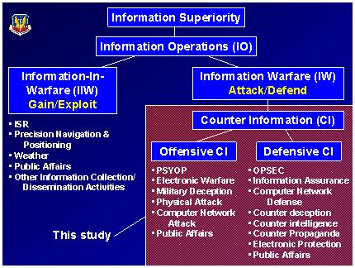

Air Force IO Doctrinal Framework

Quite early the Air Force recognized it needed to organize the force to conduct IO. This resulted in the formation of a number of organizations dedicated to supporting Air Force IO. Much of the Air Force’s IO capability has been consolidated under the Air Combat Command (ACC), based at Langley AFB in Hampton, Virginia. This includes the 8th Air Force, the Air Intelligence Agency, and Air Force Information Warfare Center. The role of each of these organizations in Air Force IO is discussed below.
The 8th Air Force (8 AF), based at Barksdale AFB, Mississippi, provides combat-ready information operations, command and control, intelligence, surveillance and reconnaissance, and strike forces to Combatant Commanders around the world. With its bomber and IO capabilities, it is the Air Force’s first operational force designed to achieve and maintain Information Superiority. The 8AF units include the 67th Information Operations Wing, Lackland AFB, Texas; the 70th Intelligence Wing, Fort Meade, Maryland; the 116th Air Control Wing (E-8C JSTARS), Robins AFB, Georgia; the 552nd Air Control Wing (E-3B/C), Tinker AFB, Oklahoma; the 819th RED HORSE Squadron, Malmstrom AFB, Montana; and the 3rd Air Support Operations Group, Fort Hood, Texas. The unique structure of 8 AF makes it uniquely organized to conduct full spectrum IO in support of the Joint Force Air Component Commander (JFACC).
The Air Intelligence Agency (AIA), based at Lackland AFB in San Antonio, Texas, is aligned under Air Combat Command and Eighth Air Force and serves as their primary information operations (IO) force provider normalizing and synchronizing IO capabilities into the warfighter’s arsenal. Under a recent force realignment, the AIA Commander serves as the Eighth Air Force deputy commander for information operations. The AIA Commander also serves as commander of the Joint Information Operations Center, a subordinate unit of U.S. Strategic Command.
The Air Force Information Warfare Center (AFIWC), also based at Lackland AFB, is the Air Force’s warfare center creating IW capabilities to meet requirements for aerospace and joint forces. The AFIWC produces IW analyses/data for combat operations, targeting, and acquisition programs. It also explores, demonstrates, and exercises IW capabilities, tests weapons, develops tactics, trains forces, and assesses IW vulnerabilities of units and systems for offensive and defensive counterinformation missions. The AFIWC is subordinate to the Air Intelligence Agency.
AFIWC’s 39th IO Squadron (IOS) is the Air Force’s “School House” for IO. The 39 IOS, based at Hurlburt Field, Florida is subordinate to the 318 IO Group. The 39 IOS maintains and executes advanced IO and IW training for the Air Force. The squadron also acts as the Air Intelligence Agency's time-sensitive, single focal point to the Air Force Command and Control Training and Innovation Group, All-Service Combat Identification and Evaluation Team and 53rd Wing for information operations capabilities. The squadron applies and migrates these capabilities to combatant forces through transitioning technology, strategy, tactics, knowledge and skills to control the information battlespace. They meet this challenge by delivering the Information Operation Integration Course (IOIC). The 39 IOS represents a crucial step in the evolving field of information superiority for the Air Force and continues to advance the expertise enabling information warriors to fight and win.
Since the time the Air Force developed its own IO doctrine it has strived to fully integrate IO in all warfare areas. One manifestation of this integration effort is the Information Warfare Flight (IWF). The IW Flights were envisioned to exist in every Numbered Air Force to serve as the focal point for integrating IO in Air Force operations. The graphic below shows an early concept for the basic structure and manning of an IWF, with the core elements shown in light blue and combat augmentation shown in purple.
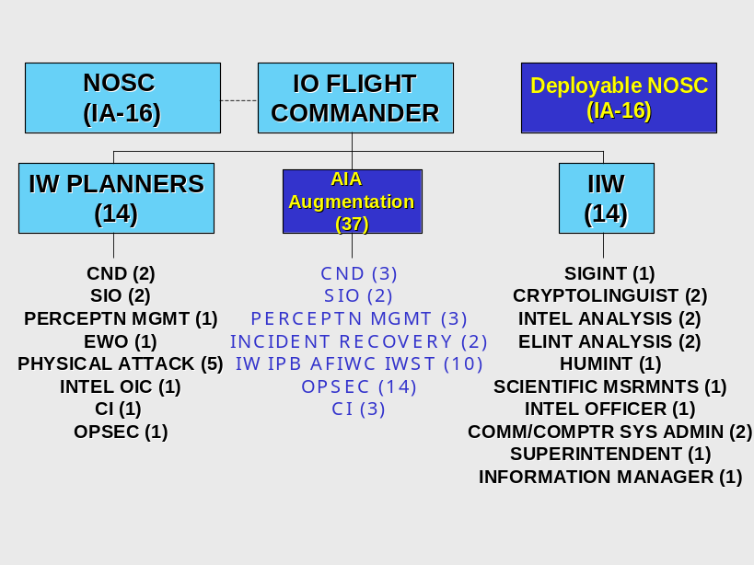
An Early Concept for an IW Flight
The Network Operations and Security Center (NOSC) shown is not part of the IWF, but was envisioned as working under the overall coordination of the IWF. The organization and mission of the IWF is an area of much discussion today. So where is the Air Force headed with IO?

AIR FORCE IO TOMORROW AND BEYOND
“If a man does not know to what port he is steering, no wind is favorable”
Seneca

While many of the individual capabilities of IO have been individually integrated into air, space, land, and maritime operations, IO as an integrated whole has yet to be fully realized. Total integration requires the development of programs, policies and doctrine; tactics, techniques and procedures (TTP); information systems; education and training; organizational structures; and a personnel system that supports all of these. To realize the full potential of IO, the Air Force must address all of these areas.
General Hal M. Hornburg, Commander of the Air Combat Command (COMACC), has a clear vision for the future of Air Force IO. One requirement for achieving his vision is that non-kinetic weapons must achieve an equal status with kinetic weapons. This will, in turn, require that the kinetic and non-kinetic targeting processes be merged into a single process. Achieving this will fulfill many of today’s requirements to limit collateral damage and limit non-combatant casualties.
General Hornburg is engaged in a quest to “operationalize” and normalize IO in the Air Force, thus truly establishing IO as a true core competency. Part of his concern for IO stems from the less-than-satisfactory ratings Air Force IW received in a Rand Study published in September 2002. (Recall that IW is a subset of IO according to Air Force doctrine.) The Rand study noted Air Force IW problems in integrating IO capabilities, centralizing IO responsibility/authority, unrealistic cyber expectations, and an investment strategy that was inadequate to meet projected IO requirements.
General Hornburg ‘s vision for Air Force IO addresses each of these shortcomings in detail. In November 2002 he established the ACC IW Working Group (IWWG) to oversee efforts to operationalize and normalize Air Force IO. This body evolved into the Air Force IO Steering Group (SG). The IWWG focused on IO strategy, doctrine, and vision. One of the main efforts of the IWWG was to develop a draft IO Concept of Operations (CONOPS) describing an IO vision and charting a roadmap for the future. The CONOPS, approved in February 2004, is transformational in nature and establishes a new Air Force IO doctrinal framework that enhances the seamless integration of IO capabilities into all operations. The framework appears in the next graphic.
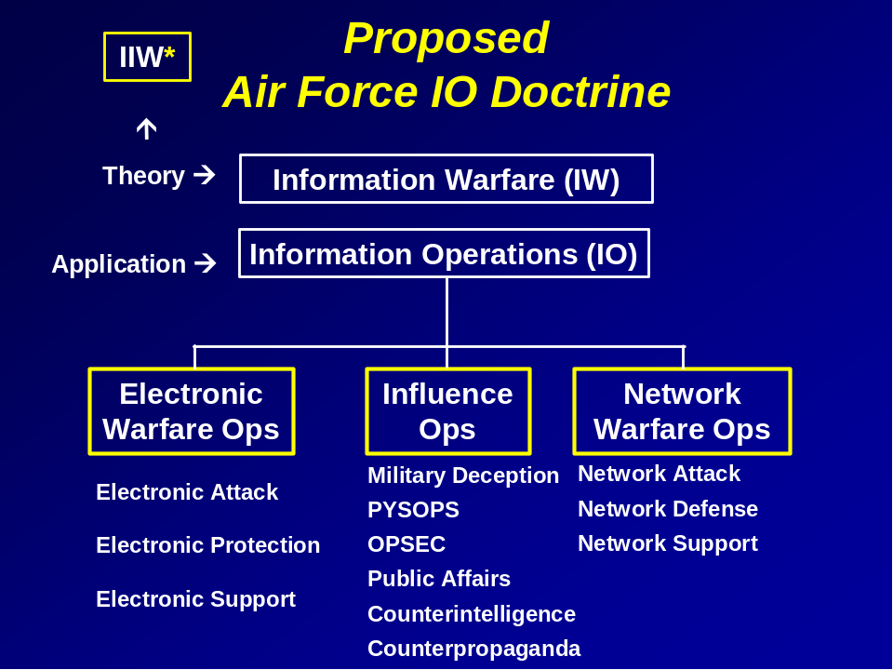
IO Doctrinal Framework in the AF IO CONOPS
The new framework will be reflected in the next edition of Air Force Doctrine Document (AFDD) 2-5 which is currently under revision. This change in the doctrinal framework aligns IO doctrine with other Air Force doctrine by placing IW theory at the top of the doctrinal hierarchy, just as Air Warfare theory and Space Warfare theory sit at the top of their respective doctrinal hierarchies. The framework recognizes the importance of public affairs in “influence operations,” something the military has previously called “perception management operations.” The IO CONOPS envisions the Air Operations Center (AOC) as the focal point where Air Force IO capabilities are integrated. One key to ensuring proper IO integration in the AOC is the total integration of an IW Flight (IWF) into the AOC structure. Currently, the IWF is a separate AIA entity that augments the AOC. However, the Air Force has decided that the IWF will be fully integrated into the AOC Weapon System in the future. The Air Force has had difficulty manning, educating, and formulating the exact mission of the IWFs. How to best accomplish this integration is a topic of extensive study today. One proposed solution is shown in the next graphic. This solution not only integrates the IWF into the AOC, but also creates an A-39 on the AOC staff to help coordinate IO planning at the joint level.
CONTINUED ON NEXT PAGE
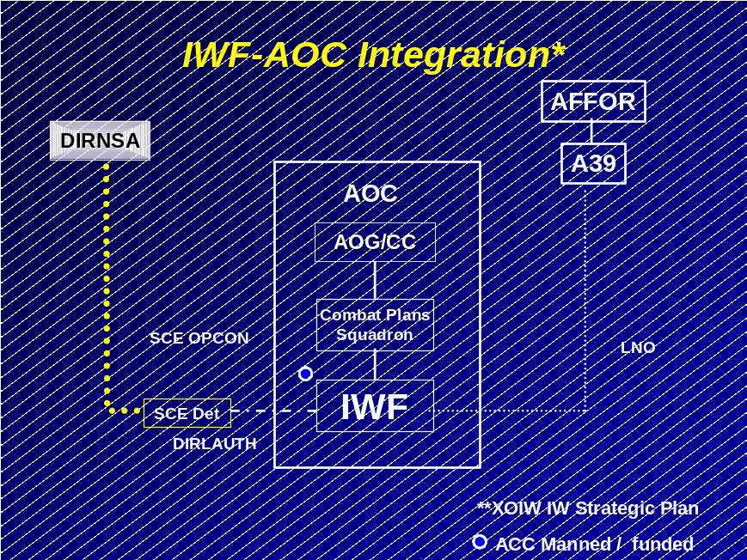
A Proposed Solution for Integrating the IWF in the AOC
Another consideration to help operationalize and normalize IO is the creation of an IO Career Force, which was mandated by the Department of Defense IO Roadmap signed by the Secretary of Defense in October 2003. Developing the IO career force is described in the Air Force IO Strategic Plan, produced by the Air Force Deputy Chief of Staff for Air and Space Operations (AF/XO) in March 2003. Developing a career force will create a career path for IO operators that will include education, training and career progression that mirrors standards used throughout the Air Force today. Given the highly technical nature of many IO capabilities today and the perishable skills required to operate and maintain many IO systems, creating an IO career force is an urgent need.
CONCLUSIONS
Today’s Air Force is clearly on the way to making IO a core competency. Of all the transformational areas in the Air Force, IO may be the most likely to succeed. This is because the Air Force leadership had developed the vision and made the investment in personnel and fiscal resources to transform IO into a warfare area that has the potential to equal or surpass space and air warfare.
The Air Force is uniquely structured to provide full-spectrum IO support for a Joint Force Commander (JFC). Under the Air Combat Command—8 Air Force—Air Intelligence Agency framework, the Air Force has organized to provide the warfighter a wide array of integrated IO capabilities for electronic warfare operations, influence operations, and network warfare operations. The Air Force has already demonstrated a tremendous ability to employ individual IO capabilities, but the key requirement is an ability to seamlessly integrate these capabilities and achieve decision superiority over future adversaries.
The future of Air Force IO looks bright, but the work is far from done. Success will require sustaining resources at today’s high levels or higher. The Air Force must develop an acquisition system that facilitates rapid research and prototyping, rapid assessment of new technologies, and the integration of the best technologies for military use. This will require IO ranges that allow realistic testing, evaluation, and training with the new technologies that are developed. The training ranges must allow the exercise of full spectrum IO, where both kinetic and non-kinetic effects are exercised. Accomplishing this will require developing measures of effectiveness for all IO capabilities, including influence operations. It will also require the development of a seamless targeting process that incorporates kinetic and non- kinetic weapons—lethal and non-lethal fires. Finally, the Air Force must integrate IO into the AOC common operational picture to facilitate the command and control of IO. The future promises to be challenging, but it will ultimately lead to the transformation of the Air Force and its sister military services into a force that will surpass anything imaginable today.

Selected Bibliography

Blackington, Robert E., “Air Force IO Doctrine: Consistent with Joint IO Doctrine?” Air University, Maxwell AFB, Alabama, April 2001.

Department of the Air Force, “AFDD 2-5: Information Operations,” Washington D.C., 04 January 2002.

Department of the Air Force, “AFDD 2-5.1: Electronic Warfare Operations,” Washington D.C., 19 November 1999.

Department of the Air Force, “AFDD 2-5.3: Psychological Operations,” Washington D.C., 27 October 1999.

Department of the Air Force, “AFPAM 14-118: Aerospace Intelligence Preparation of the Battlespace,” Washington D.C., 5 June 2001.

Department of the Air Force, “AFPD 20-10: Air Force Defensive Counterinformation Operations,” Washington D.C., 1 October 1998.

Department of the Air Force, “Global Engagement: A Vision for the 21st Century air Force,” Washington, D.C., 1996.

Department of the Air Force, “Information Operations Concept of Operations (CONOPS)” Headquarters, Air Combat Command, Langley AFB, Virginia; Version 2, (draft), February 2003.

Holmes, H. Allen, “Civil Affairs: Reflections of the Future,” speech by the Assistant Secretary of Defense for Special Operations and Low-Intensity Conflict [ADS (SOLIC)], at the Worldwide Civil Affairs Conference, Chicago, June 6, 1997.

Joint Chiefs of Staff, “Joint Publication 3-13: Joint Doctrine for Information Operations,” Washington D.C., October 1998.

Joint Chiefs of Staff, “Joint Publication 3-13.1: Joint Doctrine for Command and Control Warfare,” Washington D.C., 7 February 1996.

Joint Chiefs of Staff, “Joint Publication 3-53: Doctrine for Joint Psychological Operations,” Washington D.C., 10 July 1996

Joint Chiefs of Staff, “Joint Publication 3-54: Joint Doctrine for Operations Security,” Washington D.C., 24 January 1997.

Joint Chiefs of Staff, “Joint Publication 3-57: Joint Doctrine for Civil-Military Operations,” Washington D.C., 8 February 2001.

Joint Chiefs of Staff, “Joint Publication 3-58: Joint Doctrine for Military Deception,” Washington D.C., 31 May 1996.

Joint Forces Staff College, “Information Operations: The Hard Reality of Soft Power,” Norfolk, Virginia, 2002.

Larsen, Wayne A., “Serb Information Operations During Operation Allied Force,” Air University, Maxwell AFB, Alabama, April 2002.

Lasley, Jennifer, “Denial and Deception: A Serious Threat to Information Superiority?” National Defense University, Washington D.C., 19 April 2000.

Liang, Qiao and Wang, Xiangsui, “Unrestricted Warfare,” PLA Literature and Arts Publishing House, Beijing, February 1999, (FBIS Translation).

Rand Corporation, “Air Force Information Warfare Perspectives: A Summary of PROJECT AIR FORCE Perspectives,” Washington, D.C. September 2002.

Riehm, Peter J.A., “The Harlan County Affair,” Military Review, Fort Leavenworth, Kansas July-August 1997 edition.

Seinwill, Jeffrey D., “Organizing Joint Forces for Information Operations: The Viability of a Joint Information Operations Component Commander,” Air University, Maxwell AFB, Alabama, April 1999.

About the Author
Zachary P. Hubbard, Lieutenant Colonel, U.S. Army (Retired), directed the Information Warfare faculty at the Joint Forces Staff College in Norfolk, Virginia from April 1998 to June 2001, where he earned distinction as a Master Faculty Member. He is currently employed by Zel Technologies, LLC and serves as the Senior Information Operations Analyst at the Air Force Command and Control & Intelligence, Surveillance, and Reconnaissance Center (AF2SIRC) on Langley Air Force Base in Hampton, Virginia. Commissioned in the Field Artillery, Mr. Hubbard was also a credentialed Counterintelligence and HUMINT officer. His career included service in operations Desert Shield and Desert Storm in the Kuwaiti Theater of Operations; JTF Andrew, Florida; CJTF Kismayo, Somalia; Operations Sharp Guard and Deny Flight, Italy; and with the NATO Implementation Force (IFOR) and Stabilization Force (SFOR) in Sarajevo, Bosnia-Herzegovina. In Somalia he served as a staff Civil-Military Operations Officer (CJ5) where he directed Civil Affairs and PSYOP operations for a joint and combined US-Belgian task force. In Bosnia he served as Chief of Intelligence Assessments in the CJ2, IFOR/SFOR and supported the first NATO Information Operations cell. He has written and lectured extensively on Department of Defense Information Operations and Information Warfare. Mr. Hubbard is a contributing author of “Information Operations: Warfare and the Hard Reality of Soft Power,” a book published Brassey’s Inc., in the May 2004. This article represents the author’s opinion and in no way reflects the official position of Zel Technologies, LLC, the U.S. Department of Defense, or the U.S. Air Force.

Joint Command and Control Warfare doctrine is established in Joint Publication (JP) 3-13.1. It defines C2W as, “The integrated use of operations security, military deception, psychological operations, electronic warfare, and physical destruction, mutually supported by intelligence, to deny information to, influence, degrade or destroy adversary command and control capabilities, while protecting friendly command and control capabilities against such actions.
Joint Publication 3-13, Oct 98, Glossary, pg. GL-7.
The author was the Civil-Military Operations Officer (CJ5) for CJTF Kismayo. As such, he coordinated and controlled the efforts of the Civil Affairs and PSYOP teams supporting the force, which was based in the southern port city of Kismayo, near Somalia’s Jubba River valley.
LCDR Peter J.A. Riehm, “The Harlan County Affair,” Military Review, U.S. Army Command And General Staff College, July-August 97 edition. Web version taken from: http://www-cgsc.army.mil/milrev/english/JulAug97/Riehm.htm on 24 March 2003.
“PSYOP in Haiti,” taken from: http://www.psywarrior.com/haiti2.html , 12 March 2003.
“Civil Affairs: Reflections of the Future,” from a speech by Mr. H. Allan Holmes, ASD (SOLIC), given at the Worldwide Civil Affairs Conference, Chicago, June 6, 1997, taken from http://www.defenselink.mil/speeches/1997/s19970606-holmes.html on 24 March 2003.
“Operation Deliberate Force,” taken from: http://www.globalsecurity.org/military/ops/deliberate_force.htm, 18 March 2003.
Lieutenant Colonel Stephen W. Shanahan, US Army, Retired, and Lieutenant Colonel Garry J. Beavers, U.S. Army, “Information Operations in Bosnia,” Military Review, Vol. LXXVII, No. 6, pg. 56; U.S. Army Command and General Staff College, Ft. Leavenworth, KS.
The author participated in this IO Cell.
Bill Blakemore, “The Field of Blackbirds,” taken from: http://abcnews.go.com/onair/WorldNewsTonight/wnt990324_blackbird_story.html on 19 March 2003.
“Operation Noble Anvil,” taken from: http://www.globalsecurity.org/military/ops/allied_force.htm, on 18 March 2003.
Amy Harmon, “Serbs’ Revenge: NATO Web Site Zapped.” New York Times, 1 April 1999, pg. A14.
“Balkan Information Exchange, Kosovo,” found at: http://abcnews.go.com/onair/WorldNewsTonight/wnt990324_blackbird_story.html, 19 March 2003.
See http://www.balkan-info.com/ and click on the link “About this site.”
“The Other Kosovo War,” taken from: http://www.msnbc.com/news/607032.asp, 19 March 2003.
Dana Priest, "Air Chief Faults Kosovo Strategy," The Washington Post, 22 October 1999, pg. 14.
ADM James K. Ellis, “A View from the Top,” draft briefing, September 1999, taken from: http://www.d-n-i.net/fcs/ppt/ellis_kosovo_aar.ppt, 19 March 2003.
David A. Fulghum, "Pentagon Dissecting Kosovo Combat Data," Aviation Week and Space Technology, 26 July 1999, pg. 68.
Timothy L. Thomas, “Al Qaeda and the Internet: The Danger of ‘Cyberplanning’,” Parameters, Spring 2003, U.S. Army Command and General Staff College, Ft. Leavenworth, KS, taken from http://call.army.mil/fmso/fmsopubs/ISSUES/alqaedainternet.HTM , 19 March 2003.
Helle Dale, “Information Warfare,” The Washington Times,3 March 2002. Web version taken from: http://asp.washtimes.com/printarticle.asp?action=print&ArticleID=20020313-4505720, 19 March 2003.
Terrence Smith, “Window on the War,” 8 October 2001, taken from: http://www.pbs.org/newshour/bb/media/july-dec01/jazeera_10-8.html, 19 March 2003.
Tom Carver, “Pentagon Plans Propaganda War,” BBC News, 20 Feb 2002, taken from: http://news.bbc.co.uk/1/hi/world/americas/1830500.stm, 19 March 2003.
Taken from a DOD transcript on DARPA’s Total Information Awareness Program, found at: http://www.fas.org/sgp/news/2002/11/dod111802.html, 19 March 2003.
Sgt. William Patterson, “Civil Affairs Teams Reestablish Afghan Relief,” taken from: http://www.dtic.mil/armylink/news/Dec2001/a20011221cateams.html, 19 March 2003.
“Waging Cyber Warfare,” CBS News.com, taken from: http://www.cbsnews.com/stories/2003/03/05/tech/main542884.shtml, 4 June 2003.
David D. McKiernan, Lieutenant General, Commander, Third U.S. Army and U.S. Army Forces Central Command and the Coalition Forces Land Component Command. Live Briefing from Baghdad on 23 April 2003, DOD transcript taken from: http://216.239.57.100/search?q=cache:WDWeQ95jStcJ:www.dod.mil/transcripts/2003/tr20030423-0122.html+%22Operation+Iraqi+Freedom%22+%22Information+Operations%22&hl=en&ie=UTF-8, 5 June 2003.
“Bush Address Underscores the Importance of Radio PSYOP,” Radio Netherlands, taken from: http://www.rnw.nl/realradio/features/html/iraq-analysis030318.html, 3 June 2003.
A good collection of writings on Russian and Chinese IO is available on the website of the Foreign Military Studies Office (FMSO) of the US Army Command and General Staff College at: http://fmso.leavenworth.army.mil/fmsopubs/fmsopubs.htm#Info
A FBIS translation of “Unrestricted Warfare” in Adobe pdf format is available at: www.terrorism.com/documents/unrestricted.pdf.
Condensed from the Forward to AFDD 2-5, Information Operations, 4 January 2002, pp. iii-iv.
U.S. Air Force, http://www.barksdale.af.mil/8af/history/facts.doc, 18 March 2003.
U.S. Air Force, http://aia.lackland.af.mil/homepages/pa/missionvision.cfm, 18 March 2003.
U.S. Air Force, https://afiwcmil.lackland.af.mil/organization/factsheet.cfm, 18 March 2003.
U.S. Air Force, https://www.hurlburt.af.mil/milonly/tenantunits/39ios/index.htm, 18 March 2003.

