Formando palavras

Complete as palavras de acordo com a imagem:

1)



|  |  |  |  |  |  |  |  |  |
| --- | --- | --- | --- | --- | --- | --- | --- | --- |
|  | H |  | R |  | A |  |  |  |

2)

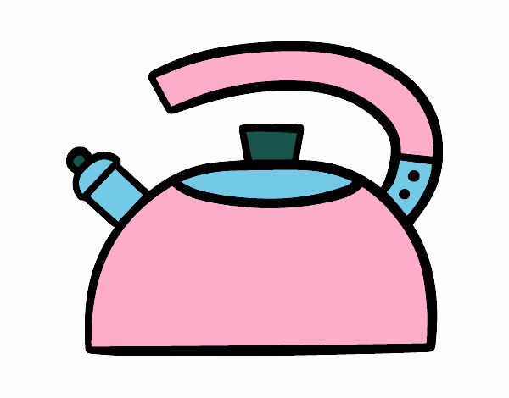

|  |  |  |  |  |  |  |  |
| --- | --- | --- | --- | --- | --- | --- | --- |
| C |  | A |  | E |  |  |  |

3)

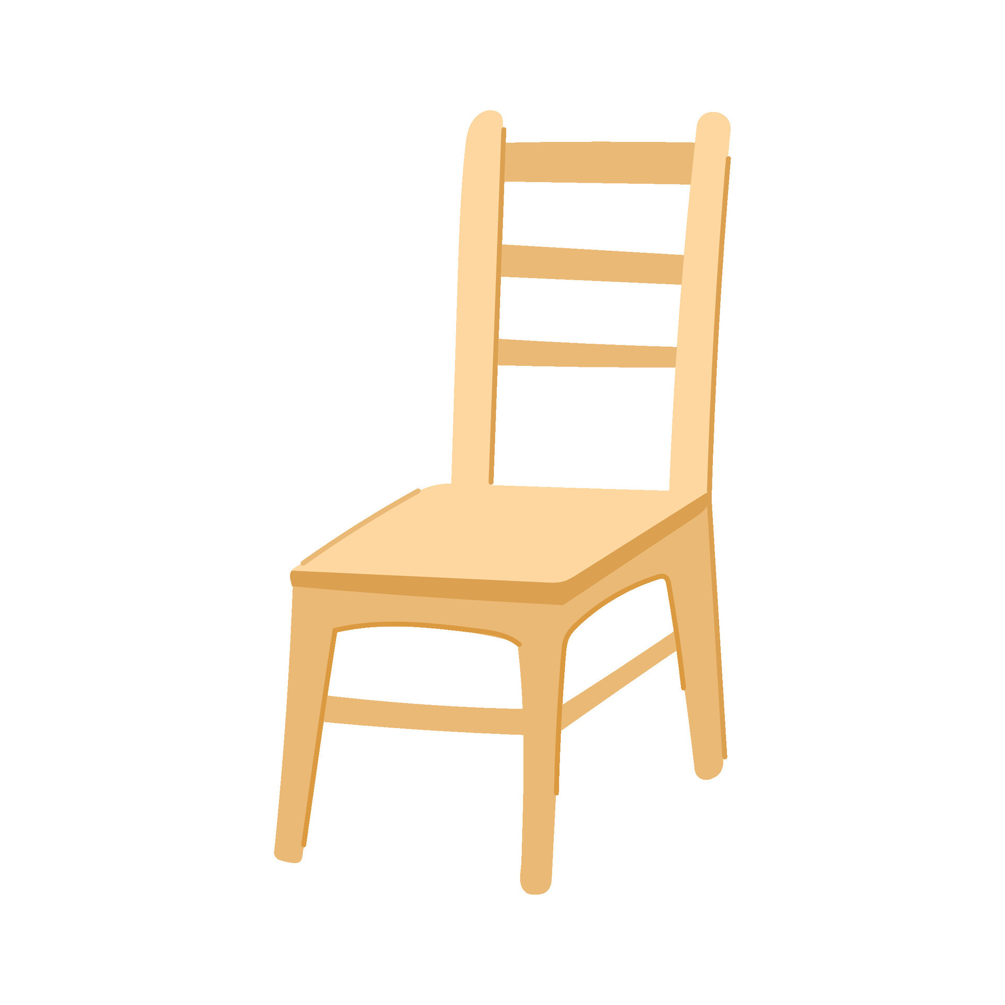

|  |  |  |  |  |  |  |
| --- | --- | --- | --- | --- | --- | --- |
|  |  | D |  |  |  | A |