Nama : Moch Lutfi Hilmi Fathurohman
NPM : 2414101066
DOKUMENTASI CAPSTONE
Screenshoot 1
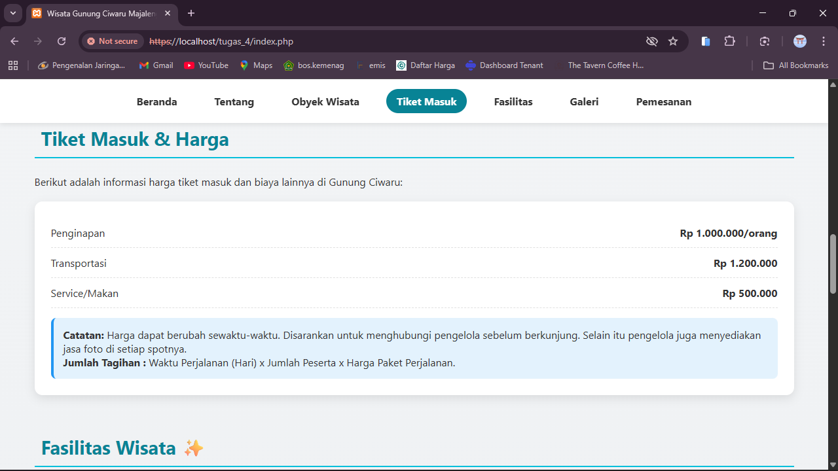
Screenshoot 2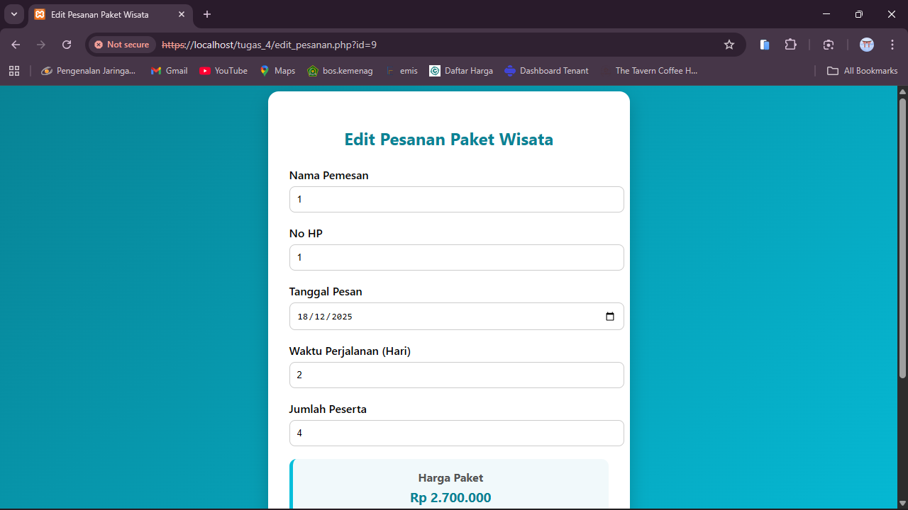

Screenshoot 3
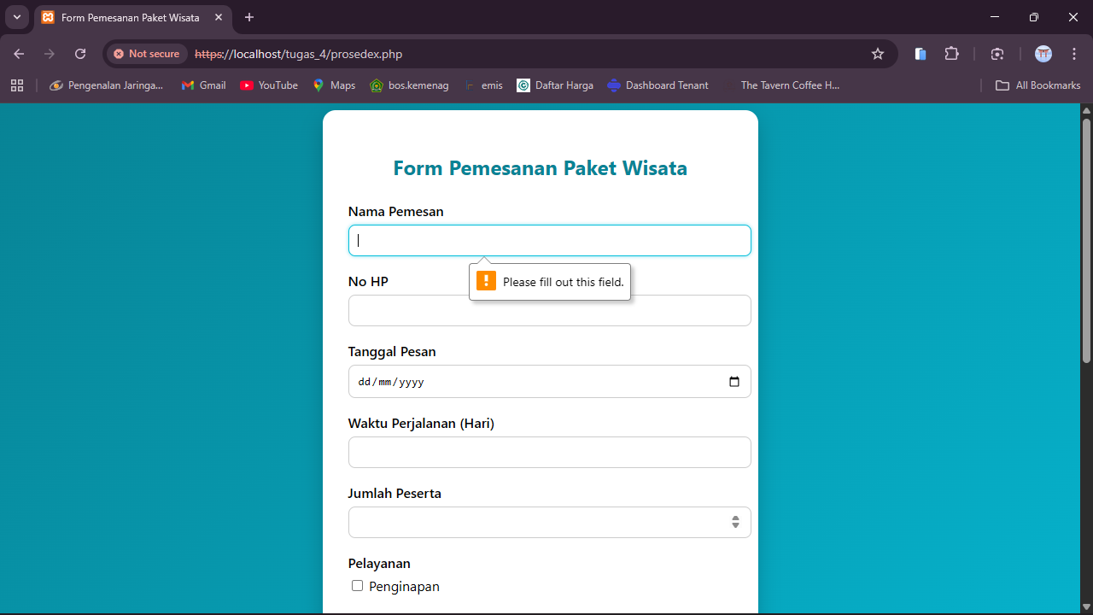
Screenshoot 4
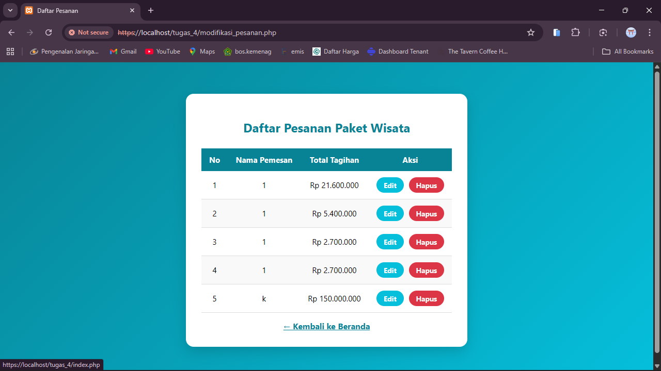

Screenshoot 5
