
15/10/2017
CA400
Functional Specification
ASDN Platform
Filip Nikolic – ID: 14470852
Supervisor – Mr. Brian Stone
School of Computing, DCU

Table of Contents

1 Introduction 1
1.1 Overview 1
1.2 Business Context 1
1.3 available solutions 1
1.4 Glossary 2
2. General Description 3
2.1. System Funcionality 3
2.2. User Characteristics and Objectives 3
2.3. Operational Scenarios 5
2.4. Constraints 6
3. Functional Requirements 7
4. System Architecture 11
5. High-Level Design 12
Application Architecture Diagram 13
Data Flow Diagram – Deployment Module 14
6. Preliminary Schedule 15
6.1. GANTT chart 16
7. Appendices 18

Introduction

Overview
The project being developed is a network automation platform which will initially aid and eventually replace network engineers in configuring and making changes on a live network. This will subsequently reduce operating costs as well as the possibility of human introduced errors. The devices this platform will communicate with include, but are not limited to switches, routers and firewalls.

The system will use a variety of technologies to accomplish the above outlined goals. It will adopt a client-server architecture and is intended to run on a wide range of devices and operating systems which can display web-pages. The platform consists of several separate modules, each being used by a different aspect of the system. The two main ones will be the Software Defined Networking and Assisted Machine Learning Module.

Business Context
I will be developing this project with help from Agile Networks, as they will provide me with access to high-end network devices and servers to develop and test the project.
They are a Network Engineering Company, based in Dublin. They build and support IT networks across 1,600 sites and with over 1.8 million end users, despite being a small to medium sized company with around forty employees.
I have calculated that, on average a company such as Agile Networks can decrease engineer time spent making network changes significantly. It would normally take an around thirty minutes for a task that can be done by the ASDN platform in a fraction of that time.

available solutions
One of the most common tasks that a network engineer carries out daily is making changes on networks, whether they are user requested or maintenance based. These repetitive tasks are extremely hard to automate, require specialist software that may not work in many scenarios or an in-house developed solution.

Most solutions available today are vendor specific, meaning that each network device vendor will offer their own automation solution which may cost thousands per month and is limited only to the devices manufactured by the same company. As many enterprise networks use a mix of manufacturers, these solutions are very impractical and only useful for a green field deployment scenario.

Other possible solutions are open-source, however require a lot of programming knowledge to deploy successfully and does not take into consideration version changes on devices. In addition, scalability is another big drawback and is especially important in large enterprise environments.

The time an engineer spends making changes on a network decreases company efficiency as well as revenue. Unlike large multinational companies such as Facebook and Google, most wouldn’t have the resources to develop effective in-house automation solutions.

Glossary
- Network Switch – connects various devices together on a computer network. It uses packet switching to receive, process and forward data to the destination device, operating on the data link layer of the OSI Model.
- Network Router – forwards data packets between different networks. Packets are usually forwarded between routers, until it reaches its destination node. They operate on the Network Layer of the OSI Model.
- Firewall – a network security device that monitors incoming and outgoing traffic, making decisions in real-time whether to allow or block traffic based on a defined set of security rules.
- LLDP – Link Layer Discovery Protocol is a vendor-neutral link layer protocol used by network devices in order to advertise their identity, capabilities and neighbours.
- SNMP – Simple Network Management Protocol is used for collecting information from network devices such as switches, routers, firewalls, etc.
- CDP – Cisco Discovery Protocol is a proprietary protocol that accomplishes a similar goal to LLDP, used to share information over the network about interconnected Cisco equipment.
- SSH – s a cryptographic network protocol for operating network services securely over an unsecured network. The best-known example application is for remote login to computer systems by users.
- XML – is a markup language that defines rules for encoding data in a human-readable and machine-readable code.
- VPN – Virtual Private Network is a way of securely interconnecting networks over the internet, whereby the remote network will appear as if it was located internally, allowing users to securely access protected resources.
- Ansible – Ansible is an open-source automation engine that allows for software provisioning, configuration management, and application deployment.
- VLAN – Virtual local Area Network is a group of devices on one or more local area networks configured to communicate as if they were attached to the same wire
- DHCP – Dynamic Host Configuration Protocol is a network protocol that enables a server to automatically assign IP addresses to hosts on the same network.
- XSS – Cross Site Scripting is a computer security vulnerability normally found in web applications, where the attacker injects malicious data.
- IPSec – Internet Protocol security is a framework of open standards that help to ensure privacy and secure communication over IP.

General Description

System Funcionality

The platform will allow network engineers as well general technical staff to easily make changes on the network. Over time the Assisted Machine Learning Module will aid the system in making the same changes automatically.
Initially changes such as interface address assignment and general Layer 2 functionality, including VLANs, DHCP services will be developed. Support for more complex tasks such as static and dynamic route configuration will be added. Finally, the most challenging feature will be automating network security, such as firewall zones, policies, access control, etc.
The user interface for this system will be easily accessible via a Web Application and gives users access to their network from any remote site. Configuration changes can be easily made by using an intuitive network map and making changes on it in real time.
Unlike many systems in the networking industry, it will be developed and distributed as a subscription model whereby the potential customers will not be investing in any hardware upfront.

User Characteristics and Objectives

The main user group that is most likely to benefit from this network automation platform are network engineers, however general IT personnel would as well. This system is only used to automate the configuration of high-end networking devices, ranging from thousands to hundreds of thousands of euro in value.
No features of the system will directly benefit the end user, however as it eliminates human introduced errors, the likelihood of downtime is reduced, therefore positively impacting user experience.
I am aware that the target market is quite narrow and to further define the most common users I have developed two sample personas.

Edward | Story  Edward is a 40-year-old Network Engineer, with over fifteen years of experience in the industry. Preferring a more hands on approach to interacting with and configuring devices using a CLI instead of Web Interfaces.  He has a lot of networking knowledge, however has no experience scripting or automating network tasks.  He has many certifications from vendors such as Cisco, Juniper Networks, etc.

Demographics  Age 40  Occupation Network Engineer  Tech literacy Very High  Residence Ireland | System expectations and requirements:  - Automate time intensive tasks, which have usually been delegated to other engineers  - Improve the efficiency of manual configuration, by using network maps offered by the system instead of different CLIs for different vendors.  - Push changes to multiple devices at once.

Sean | Story  Sean is a 25-year-old IT Administrator in a finance firm. He has recently been promoted from an IT helpdesk job. He has a diverse knowledge of IT, ranging from enterprise software, server expertise to networking skills, however all are limited.  To carry out any significant changes on the network, he must contact the contracted network support company and wait for up to three days for the change to be implemented.  He finds this very frustrating, as it directly impacts his productivity. He has requested a quicker turnaround from the network support company, however due to a much higher cost, it has been rejected by the finance department.

Demographics  Age 28  Occupation IT Admin  Tech literacy High  Residence UK | System expectations and requirements:  - Easily make changes on the network using the system.  - Take advantage of the automated device reconfiguration.  - Needs a failsafe, to avoid potential network downtime.

Operational Scenarios

The scenarios outlined below, give a brief description of the user’s objective, as well as actions they will have to take. However, it is not an in-depth table, missing more rudimental fields such as source and step number. This would greatly increase the table complexity and size.

Scenario ID | 1
User Objective | To sign up online for the services offered by ASDN and set up the initial VPN connection to their network.
User Action | The user will enter their personal details and receive a confirmation email which will allow them to set up two-factor authentication using the Google Authenticator App.  Thereafter, they will be greeted with a VPN setup screen on their account dashboard. They will fill the form in and a secure connection will be established between their network and our system.
Comments | There are some pre-requisites for this Objective to be successful. Firstly, the user requires to have a valid email address. Secondly, Google’s Authenticator App is needed to complete the two-step verification setup. Finally, the user needs to correctly configure their VPN device in order to establish a successful connection between the two sites.

Scenario ID | 2
User Objective | To make manual network changes using the provided network diagram. For example, change an interface IPv4 address.
User Action | The user will log onto the ASDN dashboards and click on the device on their network map they wish to configure.  Then, enter the address they wish and click on the commit button.  They will be notified within seconds whether the configuration change has been approved and applied by the system.
Comments | There main assumption made here is that the user has some networking knowledge, however even if they make a mistake, the system will prevent this action.

Scenario ID | 3
User Objective | To monitor the changes that the system automatically applies to the network.
User Action | The user will log onto the ASDN dashboards and look at recent changes the system has made.  If some of them are incorrectly applied there will be a rollback option available.
Comments | The platform can be used as a monitoring tool, even though that is not its main intended purpose. There will be very little user input required when the fully autonomous mode is operational.

Constraints

There are many constraints related to this approach of developing a network automation system. I will elaborate further on the most impactful ones below:
- The user must have some pre-requisite networking knowledge to take full advantage of the system functionality offered.
- A VPN capable firewall is also needed on the user side to ensure the most secure possible connection technology is used to accommodate communication between the two networks.
- As mentioned previously, a limitation of the system is that it will initially support only the largest network device manufacturers, however this is an addressable issue in future software releases.
- Some of the more niche tasks that are very vendor specific and do not directly impact network operation will not be supported.
- The system will not be able to operate correctly without a constant connection to the remote customer network.

Functional Requirements
The functional requirements shown below give a general description of each requirement, as well as issues that are very likely to be encountered during development.
Requirement ID | 1
Description | The web application must allow the user to securely create an account and log in using two-factor authentication. In addition, an email validation token needs to be confirmed by the user.
Criticality | This is the key requirement of the system, as without this feature the user would not be able to access the application UI.
Technical Issues | This involves deploying a web-server, a mail server and implementing two factor authentication libraries to securely log the user in. Additionally, all the dependencies will have to be deployed, such as a web, mail, database server, etc. Most of the work will be spent making the registration and login process secure, with SSL other technologies and by preventing XSS and other similar attacks.
Dependencies | N/A

Requirement ID | 2
Description | A back-end system will be needed that will configure a local VPN capable firewall. The user will enter VPN connection details as soon as they initially log into the web app. This information will be used to enable the back-end of the system to communicate with the remote devices on the customer network.
Criticality | This is also a curtail requirement, as the system would not operate at any capacity without being able to communicate with network devices.
Technical Issues | This requires a program to be developed that can automatically configure a site to site IPSec VPN between the local and remote customer site. This is challenging as if the automated configuration malfunctions a user will need to fix it.
Dependencies | This depends on requirement 1 as if there is no web server, the system has no remote network details and cannot be set up.  In addition, there is another pre-requisite, whereby the customer is required to configure a VPN connection on their side. This might look complex. However, most larger companies have staff capable of accomplishing such a task or can outsource it relatively cheaply.

Requirement ID | 3
Description | The system must be able to connect to and communicate with devices located on a customer’s network using a secure protocol such as SSH running over the previously configured VPN connection.
Criticality | This is a very important requirement, as without the ability to communicate with devices, the system cannot operate.
Technical Issues | This involves developing a formatted I/O stream between the system and the network devices. The data will most likely be in an XML format. It will also need to be able to parse output of many different device vendors such as Cisco, HP and Juniper Networks.
Dependencies | This depends heavily on requirement 1 and 2 as there is nothing to send or receive from the device if we can’t make a connection.

Requirement ID | 4
Description | System must be able to update necessary data stores.
Criticality | This is less important than establishing a connection as any data collected needs to be stored for future use.
Technical Issues | One of the main challenges is ensuring the database is used correctly, as well as formatted and accessible. It must conform to the 3rd normal form. In addition, security is paramount, as the database will contain very sensitive customer network details There might also be a need for two different database technologies, SQL and NoSQL. The former will be used for general data storage, whereas the later for the Assisted Machine Learning System.
Dependencies | This depends heavily on requirement 2 and 3, as there no data available for storage if connection to the remote network isn’t hade and no data was transmitted.

Requirement ID | 5
Description | A Networking Module will have to be developed to carry out several important tasks. The main ones include, network mapping, network translation and monitoring. There are many sub-requirements of this module, for example, to recognise device type, it’s neighbouring nodes, translate a configuration of a device of any brand into a standardised format, etc.
Criticality | This module is very important as it is a core part of how the system operates. There would be no possibility of automation without it.
Technical Issues | There will be a variety of challenges tied to the Networking Module, however the main ones include the following:  - Standardisation of network device configurations and operational states.  - Creating a network status feature, that will be able to tell whether a neighbour device is up, traffic is transmitted successfully, etc. This will most likely be done with a variety of protocols, such as CDP, LLDP, SNMP, etc.  - Mapping a network infrastructure for it to be visually represented in the Web UI.
Dependencies | This depends heavily on requirement 2, 3 and 4.

Requirement ID | 6
Description | This is the requirement encompassing the Assisted Machine Learning Module. It will be used to automate the process of reconfiguring the devices on the network as well as checking the validity of human requested changes. It will use a variety of technologies and many sub-systems to accomplish this task.
Criticality | This module is the main differentiator between this system and its competitors. While being very important, the platform would still be very usable and useful even without it.
Technical Issues | Changing a device configuration requires the system to take many different parameters into consideration. For this it will require two rulebooks, one containing network specific rules, such as IP addressing best practices, VLAN numbering and device type consideration, etc. Whereas the second will contain the rules which the system must follow to change and adapt the first network specific rulebook. This will be the most challenging aspect of this project.  This is due to it being able to damage very expensive devices, therefore any errors must be caught quickly and dealt with gracefully. This can be achieved by constantly monitoring the effects of the changes and allowing for configuration rollbacks.
Dependencies | This depends heavily on requirement 2, 3, 4 and 5 to operate correctly.
Requirement ID | 7
Description | Cross-platform client support and multi-vendor nature are necessary for this platform to be commercially viable. However, as my access to devices from most vendors is somewhat limited, I will attempt to cover as many with a large market share as possible. Initially I will concentrate on Juniper Networks and Cisco and will further expand to devices from HP, Palo Alto and Extreme Networks.
Criticality | This is not a critical feature, however the larger the vendor support portfolio, the more usable the system is in an actual deployment scenario.
Technical Issues | This will be somewhat challenging, as some vendors do not employ a hierarchical configuration structure which is what the system will be leveraging to build a tree-set of possible command completions.
Dependencies | This requirement is independent of any previous as it can be developed separately with only requirement being access to different brands of networking equipment.

System Architecture

This section describes a high-level overview of the anticipated system architecture showing the distribution functions across (potential) system modules. Architectural components that are reused or 3rd party should be highlighted.

High-Level Design
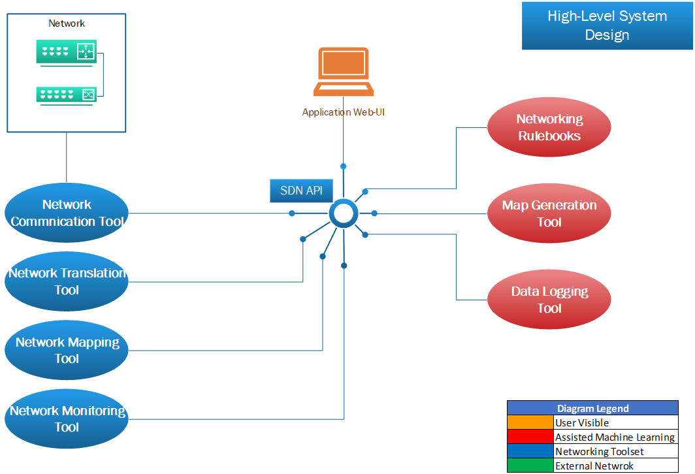

Application Architecture Diagram
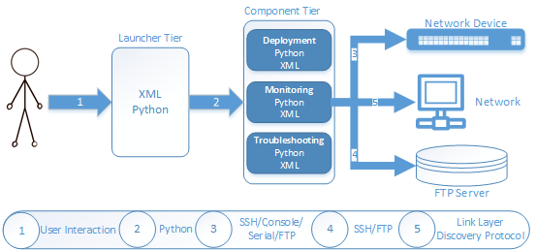

Data Flow Diagram – Deployment Module
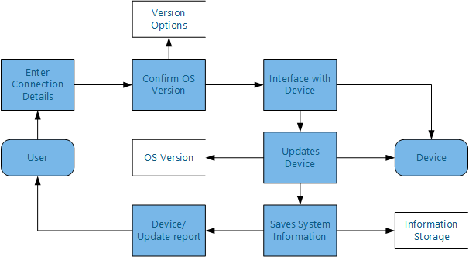
This section should set out the high-level design of the system. It should include one or more system models showing the relationship between system components and the systems and its environment. These might be object-models, DFD, etc.

Preliminary Schedule
This section provides an initial version of the project plan, including the major tasks to be accomplished, their interdependencies, and their tentative start/stop dates. The plan also includes information on hardware, software, and wetware resource requirements. The project plan should be accompanied by one or more PERT or GANTT charts.
- We have structured the order of project activities using the Critical Path Method. Allowing the shortest time possible to complete the project, as well as working on as many activities in parallel. Finally, we have also allowed for some slack in activities that might be harder to develop.
- Scrum/agile development methodology to allow for flexibility and easy changes to the direction we’re taking. Meetings will take place weekly with our supervisor Brian Stone (where permitting) and by ourselves in person and over skype.

GANTT chart

Starting 02/10/17 | W 1 | W 2 | Week 3 | Week 4 | Week 5 | Week 6 | Week 7 | Week 8 | Week 9 | Week 10 | Week 11
Requirements Analysis
Design Analysis
Project Planning
Project Proposal
Deployment Prototype
GUI Prototype
Functional Specification
Maintenance Prototype
Troubleshooting Prototype
Launcher Prototype
Overall Prototype Build
User Testing
Testing unit/code/coverage
Testing/Code Review
Documentation
Project Minutes

Starting 02/10/17 | W 12 | W 13 | Week 14 | Week 15 | Week 16 | Week 17 | Week 18 | Week 19 | Week 20 | Week 21 | Week 22
Deployment Build
Maintenance Build
Troubleshooting Build
GUI Build
Launcher Build
Overall Build
User Testing
Test Planning
Test Development
Boundary Value Testing
Equivalence Testing
Decision Tables
Functional Testing
Structural Testing
Path Testing
Data Dependence
Integration Testing
Testing Review & Write-up
Code Review
Documentation
Project Minutes

7. Appendices
Specifies other useful information for understanding the requirements.

