**Hardware installation Safe-power (all versions of Raspberry Pi)**

1. Install the shutdown script as per <http://safe-power.appspot.com/setup>
2. Turn off the Raspberry and disconnect USB power
3. insert the AA size LiPo battery, negative pole goes side of the spring
4. wait until the red LED switches to blinking every 2s

5. connect safe-power, Pin1 of Safe-power connects to Pin1 of the Raspberry

6. connect USB power to the Raspberry

Pin 1 Pin1 Raspberry (all models)

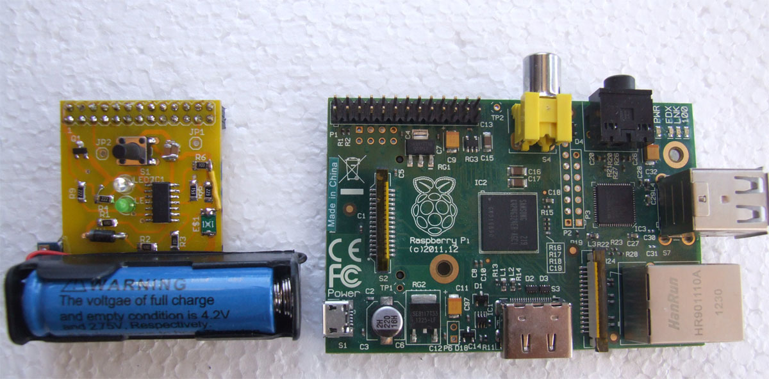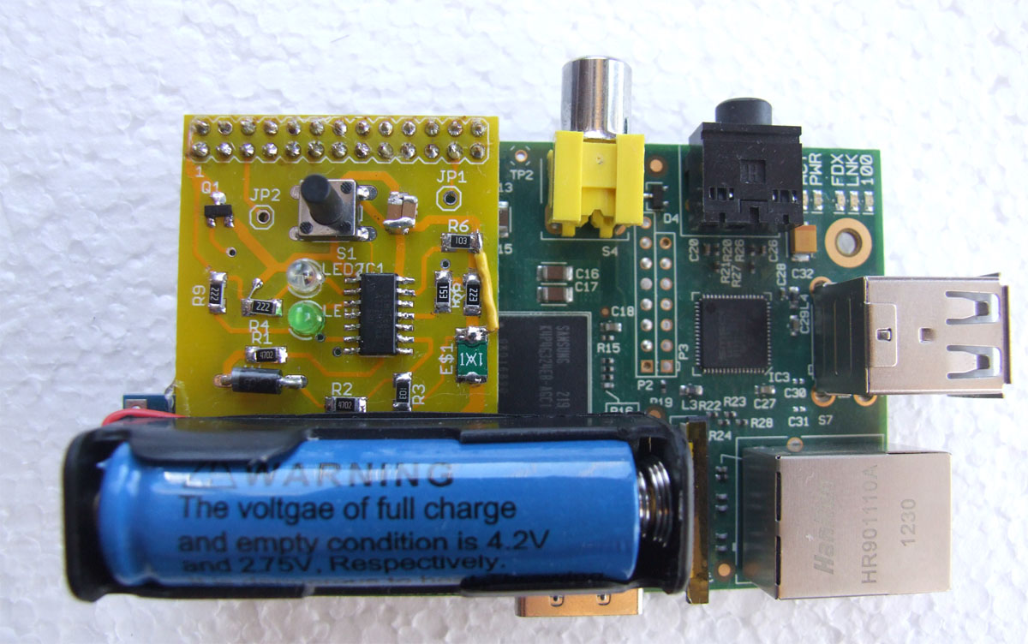

**Operation of Safe-power**

Safe-power monitors constantly the power provided by USB. In case power fails, there is no delay, and your Raspberry is immediately powered by the LiPo battery.

On Raspberry version 1 the USB ports and network will cease to work when on battery power.

If the power cut on USB takes longer than 10 seconds, Safe-power will send a shutdown signal to the Operating System. This operation will finish after 30 seconds, the red LED will be on. Battery power will be cut, and only the microcontroller of Safe-power continues to operate. This state is indicated by a flash of the red LED every 2 seconds.

When USB power is restored the Raspberry switches back on.

The LiPo battery has it’s own charging circuit with 2 LEDs (the small blue PCB underneath).

Red – the battery is charging, blue- the battery is full.

**Warning:** DO NOT replace the provided battery with any other rechargeable battery, except Lithium Polymer which has a charging voltage of 4.2V.

**LED blink codes**

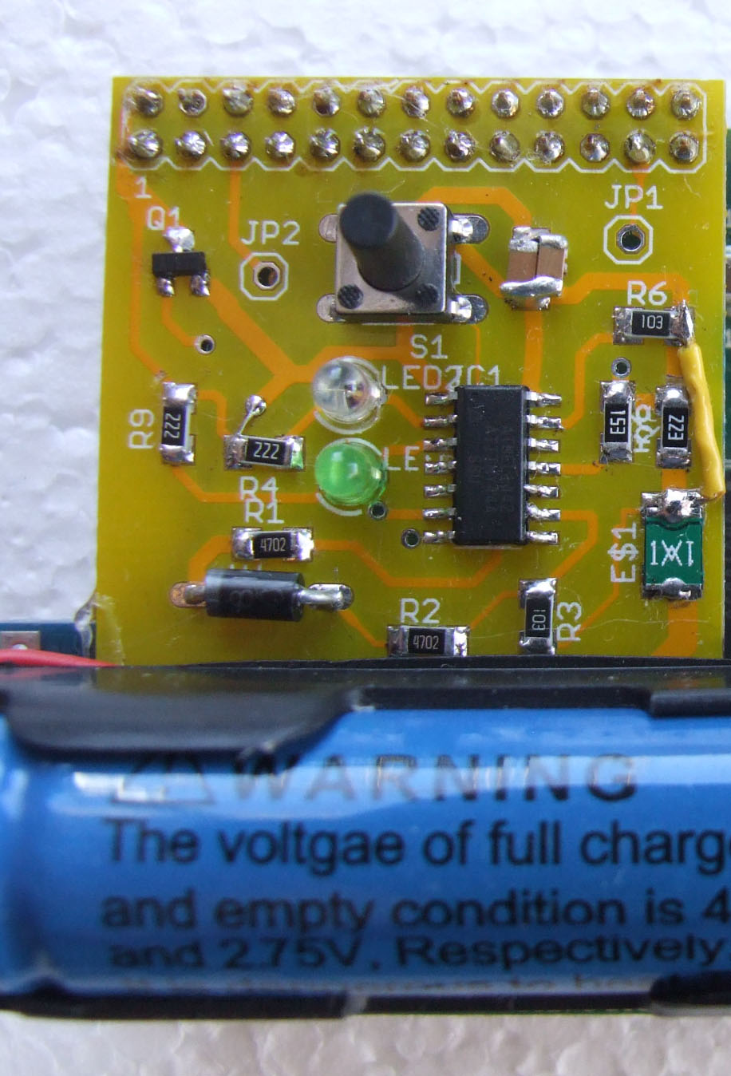

Button for manual shutdown

LED red

LED green

**Steady green** – power has been applied, Raspberry boots

**Blinking green** 2 seconds – normal operation power ok

**Blinking red fast** – power failure detected

**Steady red** – shutdown initiated (manual or after power failure)

**Blinking red** 2 seconds – power failure, Raspberry is shutdown

**Blinking red** **and green** 2 seconds – system in shutdown after

manual shutdown by button

**Red and green alternating 5 times** – Safe-power

Microcontroller boots

**Manual shutdown**

Manual shutdown can be initiated by pressing the button once. The red LED will turn on for 35 seconds and your Raspberry will shut down the operating System.

After completed shutdown, red and green will blink. You can now restart the Operating system by pressing the button.