Contents

1. CMIS architecture: 2

2. Services by CMIS 3

**Repository Services** 3

**Navigation Services** 3

**Discovery Services** 3

**Object Services** 3

**Versioning Services** 3

**Relationship Services** 4

**Multi-Filing Services** 4

**ACL Services** 4

**Policy Services** 4

3. Mobile Client Architecture 5

4. Apendix 5

# CMIS architecture:

We build mobile client integrated with CMIS **(Content Management Interoperability Service)** to work with Alfresco.

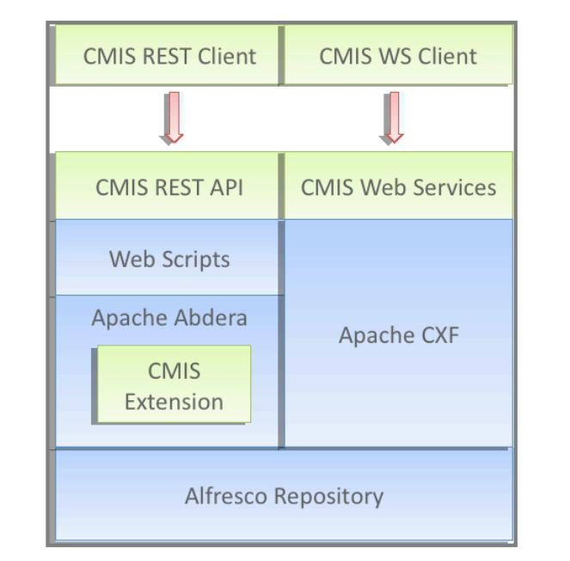

Figure : CMIS Architecture

As we can see, CMIS uses two protocols Web Services(SOAP) and Restful Atom Pub to work with Alfresco system.

Easy explanation for Restful Atom Pub:

What is Atom? Atom is in XML format and useful to display web content.

What is Atom pub? Atom publishing protocol, based on REST.

What is REST? Consider everything as resource and reference by name with simple operations are GET, POST, PUT and DELETE.

***Client send URL request to Alfresco and Alfresco will response in form of Atom. We must parse it to get information.***

# Services by CMIS

The following services are available to the client. Some of these services may provide optional functionality and therefore not be supported in all repositories.

**Repository Services**

* Get Repositories: Get a list of repositories that can be accessed from this service endpoint
* Get Repository Info: Get information about the specified repository
* Get Type Children, Get Type Descendants: Various ways to discover the object types in a repository
* Get Type Definition: Get the definition (list of properties) of the specified type

**Navigation Services**

* Get Folder Tree, Get Descendants, Get Children: Retrieve descendant objects (each one has slightly different nuances)
* Get Folder Parent, Get Object Parents: Retrieve an object's parent folder(s)
* Get Checkedout Docs: Retrieve list of checked out documents

**Discovery Services**

* Query: Execute a CMIS query
* Get Content Changes: Gets a list of changes to the repository; the client can provide an optional change log token that specifies the first event to be included in the list.

**Object Services**

* Get Object, Get Object By Path: Retrieve objects
* Get Properties, Get Allowable Actions, Get Renditions: Get information about objects
* Get Content Stream: Retrieve an object's content stream
* Create Relationship, Create Document, Create Document From Source, Create Policy, Create Folder: Create objects
* Update Properties, Move Object: Update objects
* Delete Object, Delete Tree: Remove objects
* Set Content Stream, Delete Content Stream: Update content streams

**Versioning Services**

* Get Properties Of Latest Version, Get Object Of Latest Version: Get information about latest version of object
* Get All Versions: Retrieve an object's version history
* Check Out, Check In, Cancel Check Out: Control locking/unlocking of an object for the purpose of updating
* Delete All Versions: Remove version history

**Relationship Services**

* Get Object Relationships: Get the relationships associated with an object

**Multi-Filing Services**

* Add Object To Folder, Remove Object From Folder: File and un-file objects;
  + If multi-filing is supported in the repository, then an object can be added to multiple folders
  + If un-filing is supported in the repository, then an object can be removed from all folders that it is filed in without deleting the object

**ACL Services**

* Get ACL: Get the permissions associated with an object
* Apply ACL: Set the permissions associated with an object

**Policy Services**

* Get Applied Policies: Get the policies that are applied to an object
* Apply Policy, Remove Policy: Apply and remove policies to/from an object

# Mobile Client Architecture

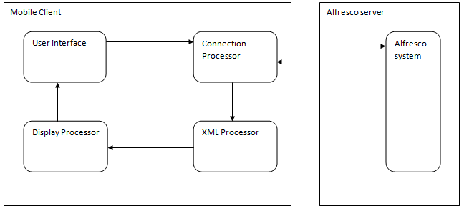

Figure : Mobile Client Architecture

**General mobile client contains four main components:**

* **User interface:** Process user input.
* **Connection Processor:** Encrypt user input into URL request and send to Alfresco system. Receive response and pass to XML processor.
* **XML process:** Parse XML to get elements and pass to Display processor.
* **Display processor:** Display content to users.

# Apendix

References:

[http://wiki.vfossa.vn](http://wiki.vfossa.vn/)

[www.giaiphapmo.org](http://www.giaiphapmo.org)

<http://www.alfresco.com/resources/>

[http://developer.android.com](http://developer.android.com/)