**Describe all the functions of Alfresco Mobile Client**

1. Introduction 2

2. Manage account 2

a. Register 2

b. Log in 2

c. Log out 2

d. Forgot password 2

e. Edit profile 2

f. Share status 3

g. Change password 4

h. View associated information 4

i. Notification 4

j. Account setting 4

k. Record activities 4

3. Manage Site 5

a. Create site 5

b. Edit site 5

c. Leave site 5

d. Delete site 5

e. Add a site to favorites 5

f. Invite people to member 5

g. Remove member 5

4. Manage Documents 6

a. Upload documents 6

b. Download documents 6

c. View in browser 6

d. Edit properties 6

e. Upload new version 6

f. Edit offline 7

g. Copy to 7

h. Move to 7

i. Delete documents 7

j. Manage permission 7

k. Add to favorite documents 7

l. Like documents 7

m. Comment documents 7

n. Add tag documents 7

5. Manage Task 8

a. Create task 8

b. Edit task 8

c. View task 8

d. View history 8

e. Cancel Task 8

# Introduction

Alfresco Client helps users to control four services of Alfresco system: account, site, documents, and tasks.

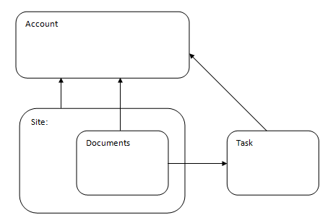

Figure : Alfresco service summary

From account, we can control personal information, and view related information of user’s site, documents and task.

Site contains documents. Each site has a documents library. Each site can have many members, including managers, collaborators, contributors, consumers (required at least one manager). This provide work environment for members.

Documents belong to a site. Users can assign documents to a task.

Tasks include making a task to users (you or other members) or request send documents to review (require approval from other members).

# Manage account

## Register

You input your email, and then Alfresco system will send an invitation email to you. After active your account, you can log in and use Alfresco service. You should complete your registration process by web browser.

## Log in

Use your email and password to log in.

## Log out

Log out when stop using Alfresco service.

## Forgot password

Recover password when you forgot it.

## Edit profile

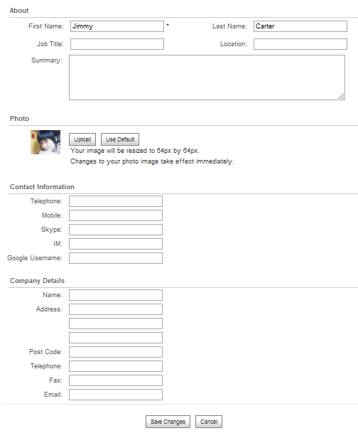

Figure : Edit profile interface

## Share status

Users can share status.

## Change password

Users can change password.

## View associated information

When people want to view profile, they can see all associated information.

* + Personal information
  + Site
  + Content
    - Recent add
    - Recent modified
  + I’m following
  + Following me

## Notification

Users use notification to follow important information. They can select to receive notification email.

## Account setting

* + Account summary
  + Manage users (upgrade account required)
  + Application (upgrade account required)
  + Trashcan (upgrade account required)

## Record activities

This function allows users to control activities.

# Manage Site

## Create site

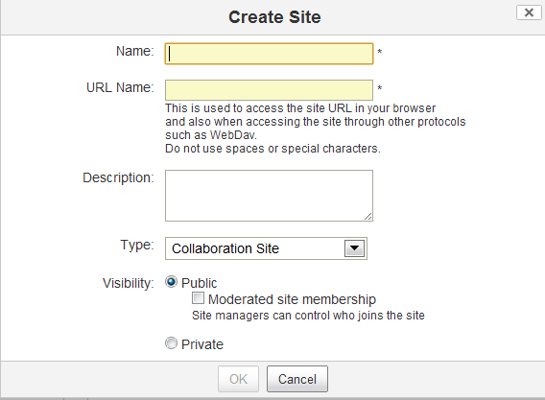

Figure : Create Site Interface

## Edit site

Mangers can edit Site details.

## Leave site

Users can leave a site they do not continue following.

## Delete site

Managers of site can delete the site.

## Add a site to favorites

User can add a site to favorites.

## Invite people to member

Managers can invite people to a site.

## Remove member

Managers can remove members from a site.

# Manage Documents

## Upload documents

Users can upload documents to a site.

## Download documents

Users can download documents.

## View in browser

Users can view documents in a browser.

## Edit properties

Users can edit documents properties.

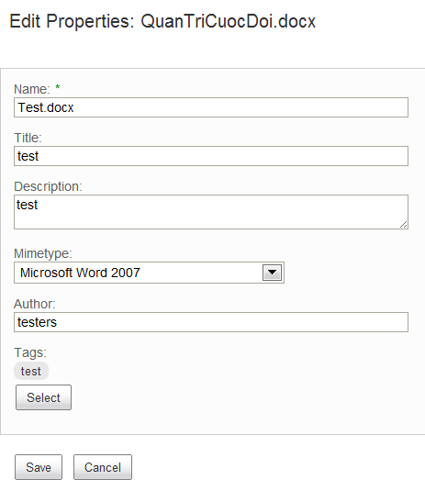

Figure : Edit Document Properties Interface

## Upload new version

Users can upload newer version of documents.

## Edit offline

Users can edit offline. When users are editing offline, system will block editing online.

## Copy to

Users can copy documents from a folder of a site to folder of another site.

## Move to

Users can move documents from a folder of a site to folder of another site.

## Delete documents

Users can delete documents from a site.

## Manage permission

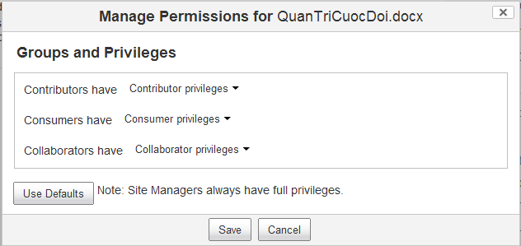

Figure : Manage Document Permission Interface

## Add to favorite documents

Users can add document to favorites.

## Like documents

User can like documents.

## Comment documents

User can comment documents.

## Add tag documents

Users can add a tag to document for search.

# Manage Task

## Create task

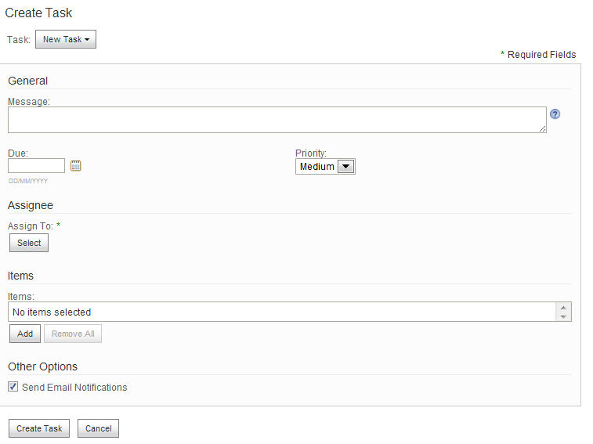

Figure : Create Task Interface

## Edit task

Users can edit task.

## View task

Users can view task.

## View history

Users can view task history.

## Cancel Task

User can view task.

Table 1: All function of alfresco mobile client

| Version | Group of functions | ID | Function | Description |
| --- | --- | --- | --- | --- |
| 1.0 | Manage account |  | Log in |  |
|  | Log out |  |
|  | Forgot password |  |
|  | Edit profile |  |
|  | Share status |  |
|  | Change password |  |
|  | View associated information | 1. Personal information 2. Site 3. Content 4. Recent add 5. Recent modified 6. I’m following 7. Following me |
|  | Notification |  |
|  | Account settings | 1. Account summary 2. Manage users (upgrade account required) 3. Application (upgrade account required) 4. Trashcan (upgrade account required) |
|  | Record activities | 1. ***Users*** 2. My activities 3. Everyone else’s activities 4. Everyone’s activities 5. I’m following 6. ***Items*** 7. Status 8. Comment 9. Content 10. Membership 11. ***Time*** 12. Today 13. Last one week 14. Last two week 15. Last three week |
| Manage site |  | Create site |  |
|  | Edit site |  |
|  | Leave a site |  |
|  | Delete site |  |
|  | Add a site to favorites |  |
|  | Invite people to members | 1. Manager 2. Collaborator 3. Contributor 4. Consumer |
|  | Remove member |  |
| Manage documents |  | Upload documents |  |
|  | Download documents |  |
|  | View in browser |  |
|  | Edit properties |  |
|  | Upload new version |  |
|  | Edit offline |  |
|  | Copy to |  |
|  | Move to |  |
|  | Delete documents |  |
|  | Manage permission |  |
|  | Add to favorite documents |  |
|  | Like documents |  |
|  | Comment documents |  |
|  | Add tag documents |  |
|  | Manage Task |  | Create task |  |
|  |  | Edit task |  |
|  |  | View task |  |
|  |  | View history |  |
|  |  | Cancel task |  |