Homework 2 — CI/CD with Jenkins, GitHub, Docker, ECR & Docker Swarm
Name: SENG Kimoun | Course: Cloud Computing
Repository: https://github.com/unixquantum101/kimoun-hw2.git | Live app: http://47.128.220.36/

1. Architecture overview
A push to GitHub fires a webhook to a Jenkins server running on my local Ubuntu 24.04 machine, made reachable from the internet with ngrok. Jenkins builds a Docker image tagged with the build number and git SHA, authenticates to a private Amazon ECR repository with aws ecr get-login-password, pushes the image, and then connects over SSH to the Docker Swarm manager on EC2 to run docker stack deploy --with-registry-auth. Swarm pulls the new image from ECR on the manager and the worker and performs a rolling update of two replicas.
Component | Details
Source control | GitHub, feature branches + pull requests, webhook to Jenkins
CI/CD | Jenkins (local Ubuntu 24.04) exposed via ngrok; declarative Jenkinsfile in the repo
Registry | Private Amazon ECR repo hw2-flask-app, region ap-southeast-1
Cluster | Docker Swarm on EC2: 1 manager + 1 worker, 2 replicas of the web service
Security | IAM user limited to ECR; security group: 80 public, 22 from my IP, 2377/7946/4789 only inside the group

2. Pipeline
Stages: Checkout → Build → Push to ECR → Deploy to Swarm → Verify. Images are tagged <build number>-<short SHA>, so every running container can be traced to a build and a commit. The stack file sets update_config (parallelism 1, start-first, rollback on failure) and restart_policy, so a redeploy never takes all replicas down at once.

3. Evidence
AWS ECR
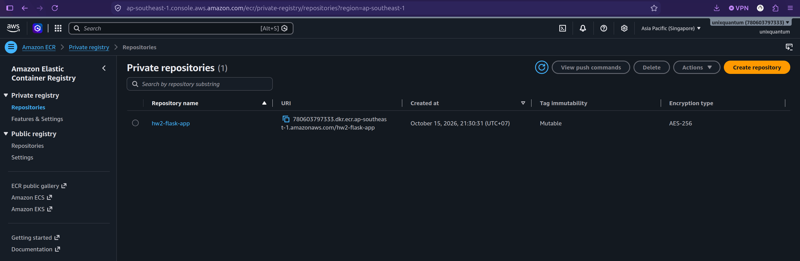
Jenkins Stage View
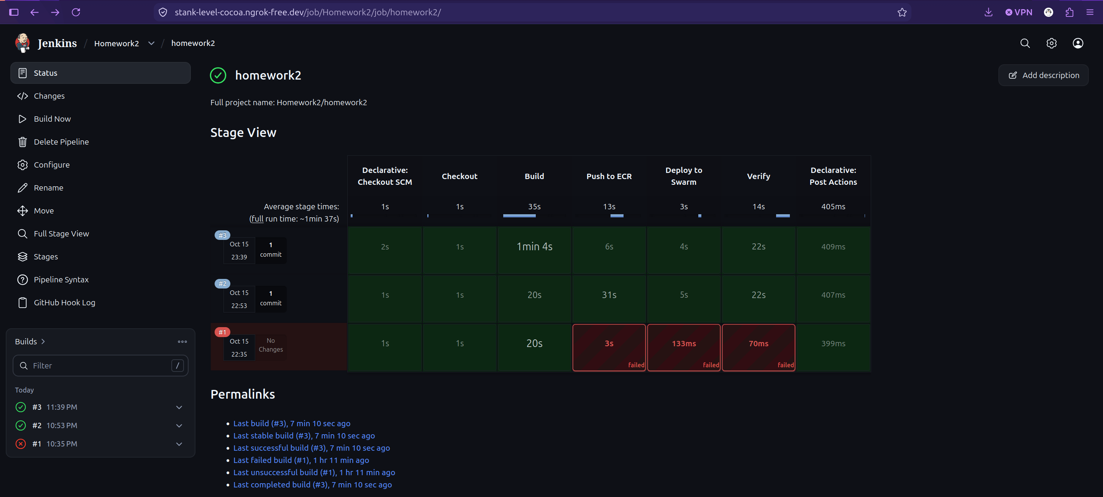
HTTP on Docker Swarm Manager
