Homework 3 — Release Management: GitHub Tags & Jenkins Build/Push/Deploy/Rollback
Name: SENG Kimoun | Course: Cloud Computing | Date: 23-10-2026
Repository: https://github.com/unixquantum101/kimoun-hw3.git | Live app: http://18.143.120.217:8080/ | Running version: v1.2.0

1. Tagging convention and pipeline design
Releases use semantic versioning (vMAJOR.MINOR.PATCH) with annotated Git tags. Pushing a tag sends a GitHub webhook through ngrok to Jenkins on my local Ubuntu machine. A Generic Webhook Trigger filter accepts only refs/tags/vX.Y.Z, so normal branch commits never start a build. One parameterized job handles every action: ACTION = release | build | push | deploy | rollback and VERSION = the target tag.
Step | Behaviour
Build | docker build with the exact Git tag baked in (APP_VERSION), commit SHA and build number
Push | Image tagged hw3-flask-app:<vX.Y.Z> (never latest) to private ECR; ECR tag immutability is on and the pipeline also refuses to push an existing tag
Deploy | docker stack deploy --with-registry-auth on the Swarm manager (manager + worker, 2 replicas)
Rollback | Confirms the version exists in ECR, then docker service update --image <old tag>; no rebuild
No downtime | update_config: parallelism 1, order start-first, failure_action rollback; restart_policy set

2. Release cycle evidence
Tags v1.0.0, v1.1.0 and v1.2.0 were each pushed as a Git tag and the pipeline built, pushed and deployed them without manual steps.
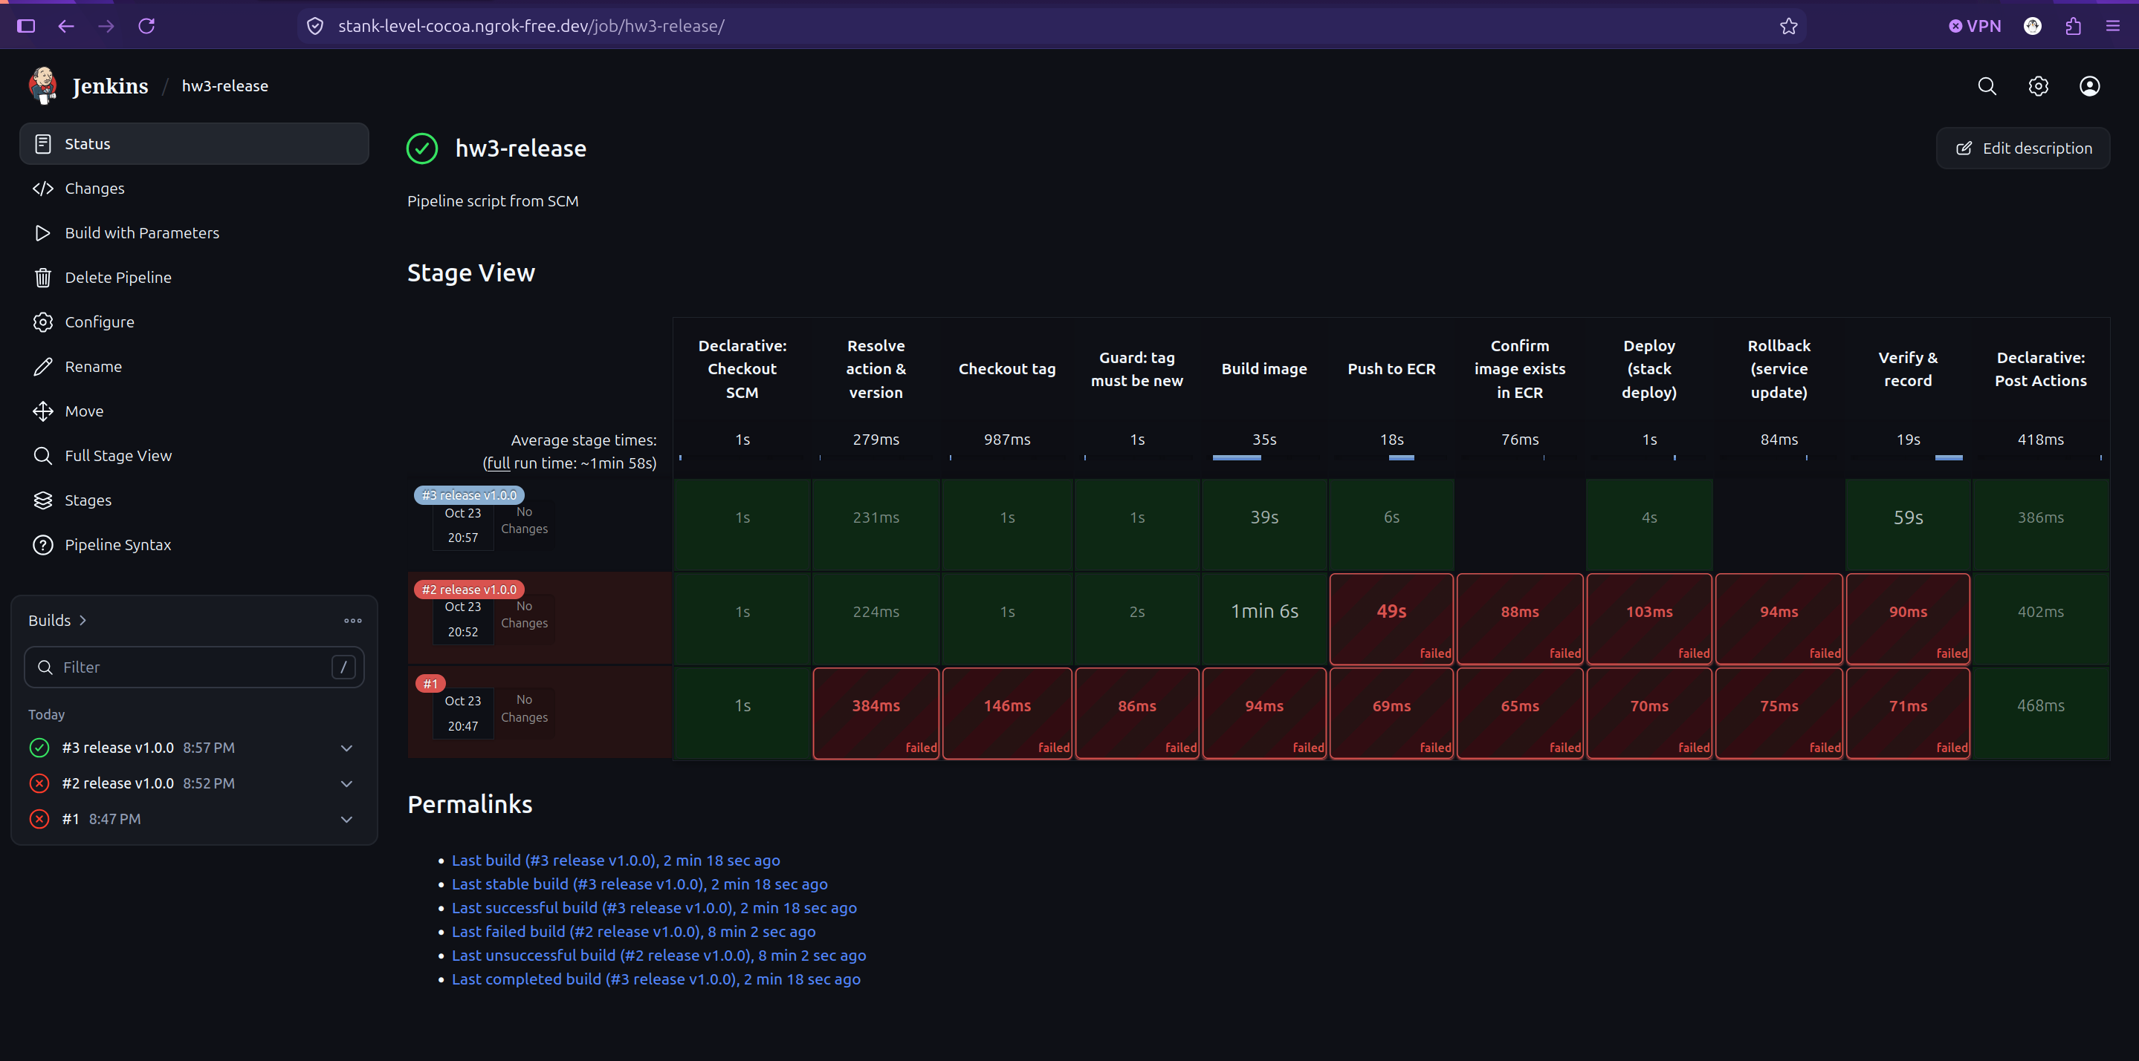
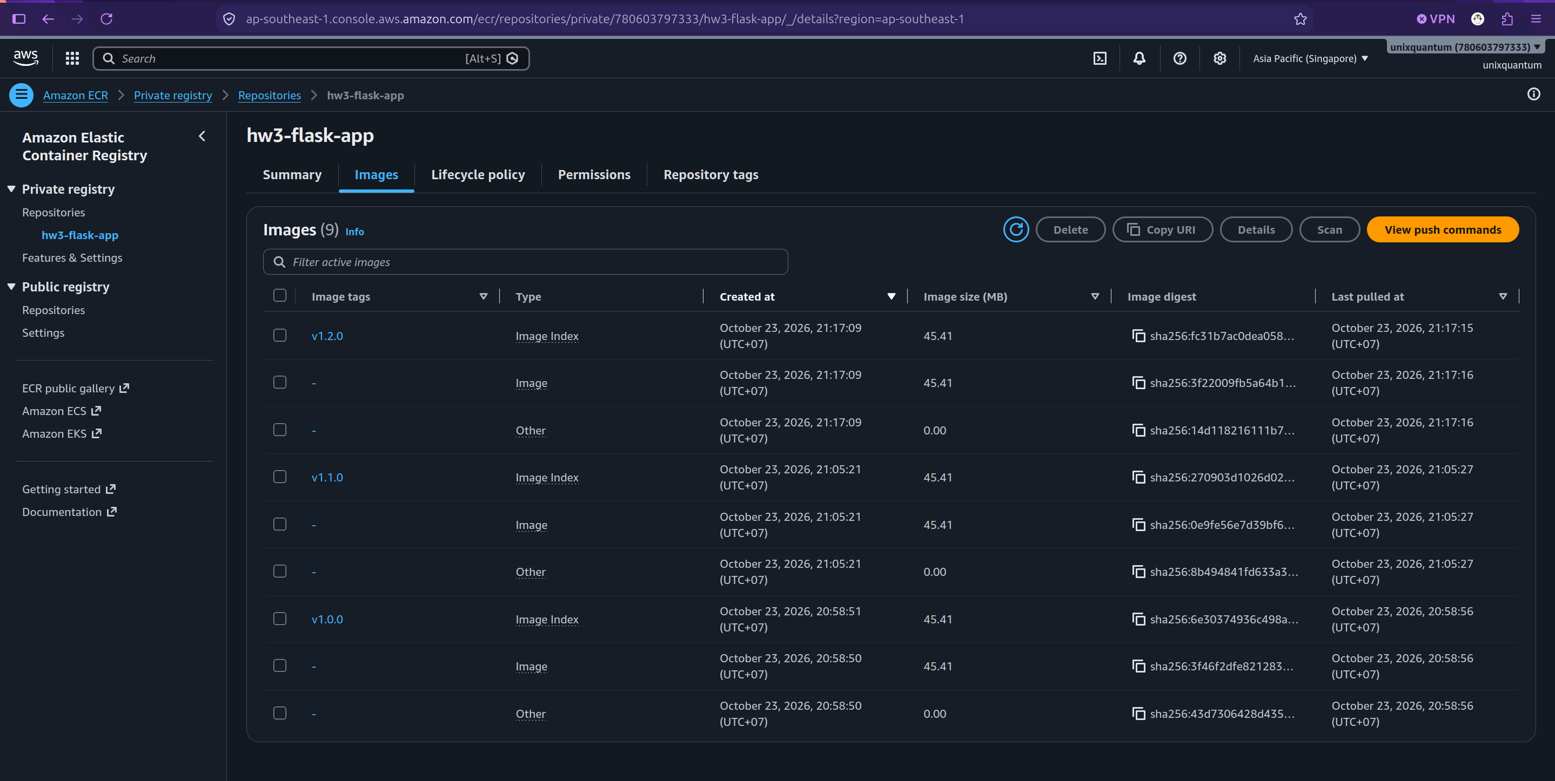

3. Rollback evidence
After v1.2.0 was deployed I rolled back to v1.1.0 by running the job with ACTION=rollback and VERSION=v1.1.0. An uptime check on my laptop polled /health twice a second during the rollback and returned only HTTP 200 while the version changed.
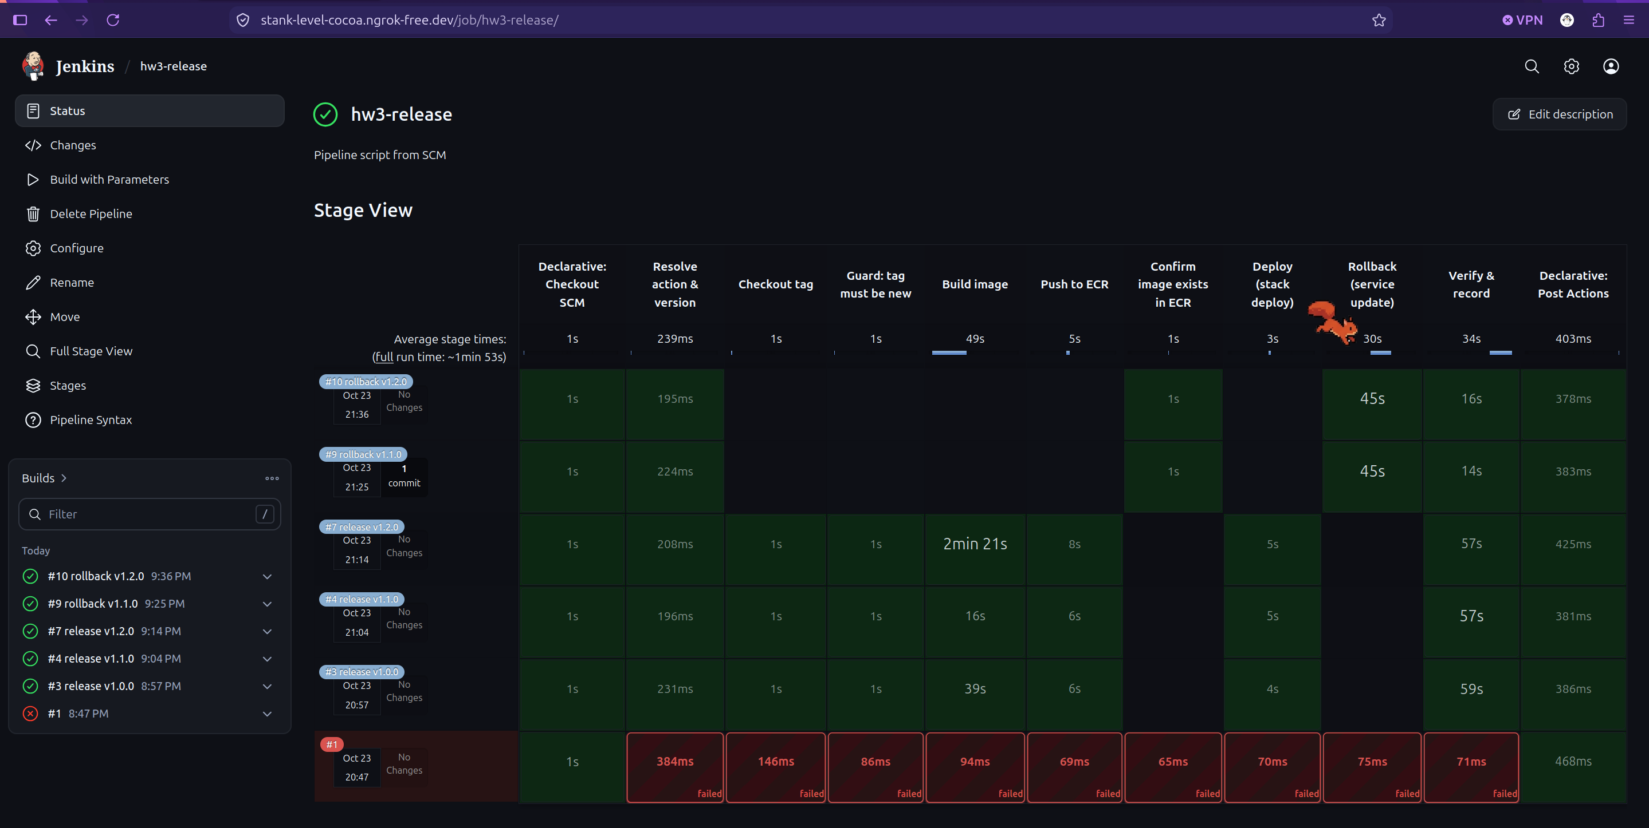

4. Deployment history
Time (UTC) | Action | Version | Build
2026-10-23T13:59:51Z | release | v1.0.0 | jenkins build #3
2026-10-23T14:06:22Z | release | v1.1.0 | jenkins build #4
2026-10-23T14:18:10Z | release | v1.2.0 | jenkins build #7
2026-10-23T14:26:38Z | rollback | v1.1.0 | jenkins build #9

