NETWORK MARKETING COMPANY
MANAGEMENT SYSTEM
DBMS Mini-Project Report
[Student Name]
[USN / Roll Number]
B.Tech CSE

1. Topic Name
Network Marketing Company Management System

2. Frameworks Used
Layer | Technology
Frontend | React (Vite)
Backend | Node.js, Express.js
Database | MySQL

3. Brief Summary
The Network Marketing Company Management System is a web-based application for managing distributors (members), their sponsor-downline network, product sales, order fulfilment, and commission payouts in a direct-selling / multi-level-marketing (MLM) business. Members can register under a sponsor, browse products, place orders, track their downline network, and view commissions they have earned. Administrators can manage the product catalogue and oversee ranks and payouts.
The system uses React.js for the frontend, Node.js with Express.js for the backend, and MySQL for database management — the same stack used in the reference Vehicle Rental Management System project. It demonstrates key DBMS concepts including relational modelling, primary/foreign keys, a self-referencing key for the sponsor hierarchy, constraints, multi-table joins, a trigger, a stored procedure, and a view.

4. Objectives
- Model a distributor network where each member is recruited by a sponsor, using a self-referencing relationship.
- Track product sales and orders placed by members.
- Automatically compute and credit sponsor commissions when an order is completed, using a database trigger.
- Retrieve a member's entire downline (direct and indirect recruits) using a recursive stored procedure.
- Summarise each member's sales and earnings through a database view.
- Provide a web interface for members to register, shop, and monitor their network and earnings.

5. Entity-Relationship Diagram
The system is modelled around eight entities: USER_ACC, MEMBER, RANK_MASTER, PRODUCT, ORDERS, ORDER_ITEM, COMMISSION, and PAYMENT. The MEMBER entity has a recursive one-to-many "SPONSORS" relationship with itself, which is what allows the distributor network/downline tree to be represented in a single table.
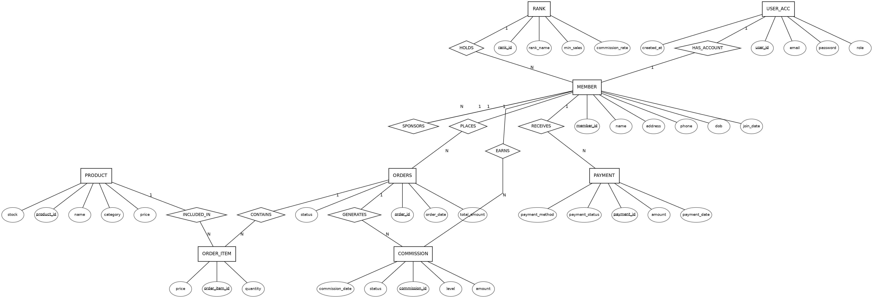

6. Relational Model Schema
Each entity maps to one table. Primary keys are underlined; arrows point from a foreign key column to the primary key it references.
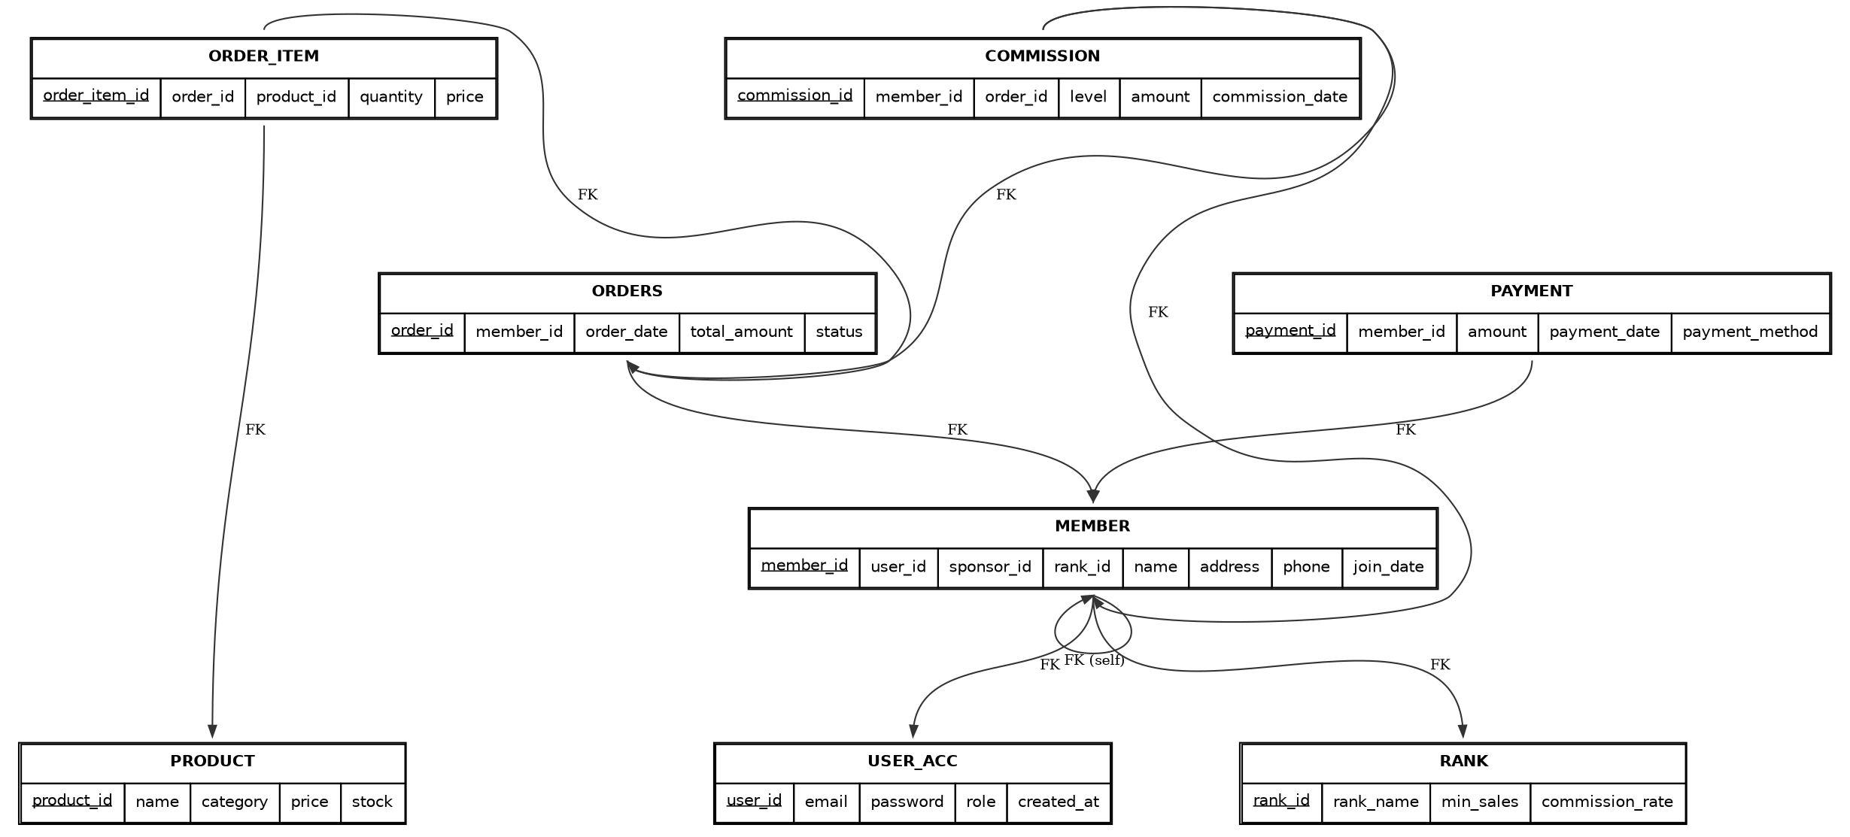

6.1 Table Descriptions
Table | Key Columns | Purpose
USER_ACC | user_id (PK) | Login credentials shared by members and admins
MEMBER | member_id (PK), user_id (FK), sponsor_id (FK, self) | A distributor; sponsor_id builds the downline tree
RANK_MASTER | rank_id (PK) | Distributor rank/level and its commission rate
PRODUCT | product_id (PK) | Product catalogue
ORDERS | order_id (PK), member_id (FK) | A purchase placed by a member
ORDER_ITEM | order_item_id (PK), order_id (FK), product_id (FK) | Line items within an order
COMMISSION | commission_id (PK), member_id (FK), order_id (FK) | Earnings credited to a sponsor
PAYMENT | payment_id (PK), member_id (FK) | Payout transactions to members

7. Normalization
1NF: Every column holds a single atomic value and each table has a primary key (e.g. order_item_id uniquely identifies a row in ORDER_ITEM rather than repeating groups of products within ORDERS).
2NF: All non-key attributes depend on the whole primary key. Composite information such as order line pricing is separated into ORDER_ITEM instead of being partially dependent on ORDERS alone.
3NF: Transitive dependencies are removed — e.g. a member's commission rate is not stored on MEMBER itself but derived through RANK_MASTER via rank_id, so updating a rank's rate does not require touching every member row.

8. DBMS Concepts Implemented

8.1 Trigger — trg_generate_sponsor_commission
Fires after an ORDERS row is updated. When an order's status changes to 'completed', it looks up the ordering member's sponsor and rank commission rate, then automatically inserts a COMMISSION row crediting the sponsor.
DELIMITER $$
CREATE TRIGGER trg_generate_sponsor_commission
AFTER UPDATE ON ORDERS
FOR EACH ROW
BEGIN
DECLARE v_sponsor_id INT;
DECLARE v_rate DECIMAL(5,2);
IF NEW.status = 'completed' AND OLD.status <> 'completed' THEN
SELECT m.sponsor_id, r.commission_rate INTO v_sponsor_id, v_rate
FROM MEMBER m JOIN RANK_MASTER r ON r.rank_id = m.rank_id
WHERE m.member_id = NEW.member_id;
IF v_sponsor_id IS NOT NULL THEN
INSERT INTO COMMISSION (member_id, order_id, level, amount, status)
VALUES (v_sponsor_id, NEW.order_id, 1,
ROUND(NEW.total_amount * v_rate / 100, 2), 'pending');
END IF;
END IF;
END$$
DELIMITER ;

8.2 Stored Procedure — sp_get_downline
Uses a recursive common table expression (CTE) to walk the sponsor_id self-reference and return every member in a given member's downline, along with how many levels deep each one sits.
DELIMITER $$
CREATE PROCEDURE sp_get_downline(IN in_member_id INT)
BEGIN
WITH RECURSIVE downline AS (
SELECT member_id, sponsor_id, name, 1 AS depth
FROM MEMBER WHERE sponsor_id = in_member_id
UNION ALL
SELECT m.member_id, m.sponsor_id, m.name, d.depth + 1
FROM MEMBER m JOIN downline d ON m.sponsor_id = d.member_id
)
SELECT * FROM downline ORDER BY depth, member_id;
END$$
DELIMITER ;

8.3 View — vw_member_sales_summary
Aggregates each member's completed orders and total commission earned, joined with their current rank, for use on the dashboard.
CREATE VIEW vw_member_sales_summary AS
SELECT m.member_id, m.name, r.rank_name,
COUNT(DISTINCT o.order_id) AS total_orders,
COALESCE(SUM(DISTINCT o.total_amount), 0) AS total_purchase_value,
COALESCE((SELECT SUM(c.amount) FROM COMMISSION c
WHERE c.member_id = m.member_id), 0) AS total_commission_earned
FROM MEMBER m
JOIN RANK_MASTER r ON r.rank_id = m.rank_id
LEFT JOIN ORDERS o ON o.member_id = m.member_id AND o.status = 'completed'
GROUP BY m.member_id, m.name, r.rank_name;

9. Sample Queries
Find every product included in a member's orders (multi-table join):
SELECT o.order_id, p.name, oi.quantity, oi.price
FROM ORDERS o
JOIN ORDER_ITEM oi ON oi.order_id = o.order_id
JOIN PRODUCT p ON p.product_id = oi.product_id
WHERE o.member_id = 3;
Top 5 members by total commission earned:
SELECT name, total_commission_earned
FROM vw_member_sales_summary
ORDER BY total_commission_earned DESC
LIMIT 5;

10. Website Modules
Page | Purpose
Register / Login | Create a member account under a sponsor; authenticate
Dashboard | Rank, commission rate, sales & earnings summary
My Downline | Recursive tree of the member's entire network
Products | Browse catalogue and place an order
Orders | Track order status; completing an order fires the commission trigger
Commissions | View earned commissions and trigger payouts

11. Conclusion & Future Scope
This project models the core relational structure of a network-marketing business — members, sponsorship hierarchy, products, orders, and commissions — and demonstrates how database features such as triggers, recursive procedures, and views can automate and simplify multi-level commission logic that would otherwise need to be computed in application code. Future enhancements could include multi-level (not just direct-sponsor) commission cascades, rank auto-promotion based on sales thresholds, and an admin analytics dashboard.

