**SCHOOL BASED MANAGEMENT SYSTEM**

**OF ENGRACIA L. VALDOMAR NATIONAL HIGH SCHOOL**

**A Capstone Project presented to the Faculty of**

**College of Information Technology Education**

**Goldenstate College, General Santos City**

**In partial fulfillment of the Requirements for the degree**

**Bachelor of Science in Information Technology**

**Presented by:**

Dalingding, Aljon

Mission, Arman

Caril, Cedric John

Bisoyo, Niño

Badanoy, Kenneth

Roluos, Kent Anthony

May 8, 2020

**TABLE OF CONTENTS**

* Dedication………………………………………………………………...... 3
* Acknowledgement…………………………………………………………. 4
* Abstract……………………………………………………………………… 5
* Background of the Study………………………………………………… 6

**Chapter 1: Introduction**

* Introduction…………………………………………………………………. 7
* Objectives of the project………………………………………………….. 8
* Scope and Limitation……………………………………………………… 9

**Chapter 2: Review of related literature and studies**

* Local Literature………………………………………………………… 10-12
* Foreign Literature……………………………………………………… 12-13

**Chapter 3: Technical Background**

* Technicality of the Project…………………………………………………. 14
* Details of the technologies to be used…………………………….. 15-17
* How the system would work……………………………………………… 18

**Chapter 4: Methodology**

* Description about Analysis of the Project……………………………… 19
* Importance of SDLC……………………………………………………… 19-21
* Operational Feasibility……………………………………………………… 21
* Technical Feasibility………………………………………………………… 22
* Schedule Feasibility………………………………………………………….

**DEDICATION**

This study is dedicated to our Almighty God, who through the abundance of his grace and love gave us the help, knowledge and wisdom we need that is very crucial for the completion of this study.

To our dear parents, who in their efforts and support provides us the motivation to continue and pursue the completion of the study even the monetary help we need.

To our relatives, siblings, companions and friends who shared their ideas and knowledge for the completion of this study. Thank you!

**ACKNOWLEGDEMENT**

They gave glory and acknowledgement to the Almighty God whom without his help and providence, this study wouldn’t be possible to accomplish.

They would like also to acknowledge their families for giving their help, for providing their needs and who through persistence, encouraged them to achieve their education.

To Mr. Mark Anthony and Mrs. Marjorie Tagarro, who wholeheartedly provide their support and accept to be their grammarian, they would like to express their gratitude for the help and guidance.

To their subject educator, Mr. Elmer Baloyo Jr., MIT and to our capstone consultant, this task would not have been possible without their assistance and direction.

To Ms. Cheska Salipot and Mr. Janz Ryan Mark Buenavesta, who without asking any payments voluntarily accept to help them, they would like to express their sincere thanks.

To Engracia L. Valdomar Nat’l High School principal, Ms. Maylene E. Arzadon and SMB coordinator Mr. Reymark De Arce, they would like also to express their sincere thanks for the help and cooperation.

**ABSTRACT**

This study was created to improve the existing manual SBM system of Engracia L. Valdomar Nat’l High School, in which the processes and procedures in the submission of the documents really takes a lot of efforts, especially given with the current pandemic situation. Considering the government protocols of social distancing, it is difficult for the teachers to submit their reports face to face as work at home is also implemented.

That is why; the primary purpose of this study is to provide an online platform, a website that will help the school specially the teachers, to easily submit their reports to the SBM Coordinator online. This will enable the school head and the SBM coordinator to easily monitor, retrieve and organize the documents based on its categories.

**BACKGROUND OF THE STUDY**

Now a days, report submissions is difficult due to government protocols and the current pandemic Covid-19. Teachers are submitting their reports with the use of Flash Drives, printed copies, online platforms such as facebook messenger, emails and so on. This method of report submission is good but has a lot of disadvantages. It takes time to submit it personally, flash drives are prone to viruses, corruption, printed copies are not editable and can be easily misplaced or stolen, files submitted through online platforms such as facebook messenger, and emails can be stolen and is difficult to locate and categorized. The possibility also of the file to be stolen is huge.

With this in mind, they choose this project to help and assist the school creating opportunity for them continue their activities without hassle. School Based Management System enables the said users, the teachers and the faculty of the said school to submit their reports to their school head and SBM Coordinator directly with the use of the system or the website.

**CHAPTER 1**

**INTRODUCTION**

School Based Management in school is a meeting conducted for decision-making and planning. Its participants are the school teachers and their school head. After the meeting or before the meeting reach its conclusion, teachers according to their SBM indicators start to create reports and submit it to the coordinator according to the time scheduled. It is also a system of administration in which the school is the primary unit of educational decision-making. This includes every primary and secondary levels of educations.

Education system is managed by different methods throughout the world; including centralized, semi centralized and decentralized methods that are administrated through different systems. Among such systems School-Based Management (SBM) based on decentralized method could be mentioned. School-based management considered as a factor to increase education effectiveness and efficiency in school level, but really what factors will support this kind of management in schools? Some intellectuals believe that the essential factors for prosperity of a school in SBM reform include the support of principals, teachers, sufficient financial sources, clarified commitment, responsibilities, skills and qualifications of school officials, precise plan, responsibility and accountability.

Reference: <https://www.sciencedirect.com/science/article/pii/S1877042812056467>

**OBJECTIVES OF THE PROJECT**

**General Objectives:**

This project will help the improvement of the current existing system of SBM, the manual processing of data and manual submission. Our goal is to create a user-friendly website that will help them minimize their time and enables them to submit their reports online. This will create also an opportunity for both of them grow in knowledge and in benefits.

**Specific Objectives:**

* To properly manage and organize the submitted documents.
* To implement fast, easy and systematic way of recording data, data monitoring and data submission.
* File security especially when it comes to plagiarism.
* To provide the need of the school based on the initial interview they had.

**SCOPE AND LIMITATION OF THE STUDY**

The proposed system provides a login for the administrator and for the users. For the administrators accounts, it has the right to control the users, to access every documents submitted and to download them, to modify settings and credentials of the users such as their login information’s like usernames and passwords, to add users and to remove. The administrators also has the right to allow or not allow the users to resubmit a report.

For the user accounts, it is categorized by indicator, indicators are the category of SBM by designation. Upon login of the user, the system will verify its credentials and its category of account and will redirect them based on the verification. The users can change their credentials such as name, username and passwords. They can submit their reports by category under their indicator and can resubmit a report upon the permission of the administrators. The users are limited only in its category or indicators, they cannot access or view the other indicators and the reports in it or even the reports of the users at the same indicator he/she belongs.

They would like also to emphasize that everything in the system and its features is the actual request of the said prospect. Anything that can be added will be added after the implementation of the system and will be regarded as an upgrade.

**CHAPTER 2**

**REVIEW OF RELATED LITERATURE AND STUDIES**

The review of related literature for this thesis involves local and foreign literature, this involves the school history and lessons, websites and other forms of media that helps them to formulate and analyzing the system that fits the need of the prospect. The review focuses on a number of different literatures that are related in the system like inventory systems, school websites, enrollment systems and many more. It helps them generate an idea and basis to conclude the system design and its structure.

**Local Literature**

The School-Based Management (SBM) is a DepEd thrust that decentralizes the decision-making from the Central Office and field offices to individual schools to enable them to better respond to their specific education needs. One way to empower the schools is through the SBM grant.

Know what the SBM grant is for, who is eligible, and just how much an eligible school can receive from the grant, and where the grant can be used.

This paper estimates the effect of school-based management on student performance in the Philippines using the administrative dataset of all public schools in 23 school districts over a three-year period, 2003–2005. The authors test whether schools that received early school-based management interventions (training in school-based management and direct funding for school-based reforms, based on school improvement plans) attained higher average test scores than those that did not receive such inputs. The analysis uses school-level overall composite test scores (comprising all subject areas tested) and test scores in three separate subject areas: English, mathematics, and science. Their preferred estimator, difference-in-difference with propensity score matching, shows that the average treatment effect of participation in school-based management was higher by 1.5 percentage points for overall composite scores, 1.2 percentage points for mathematics scores, 1.4 percentage points for English scores, and 1.8 percentage points for science scores. These results suggest that the introduction of school-based management had a statistically significant, albeit small, overall positive effect on average school-level test scores in 23 school districts in the Philippines. The paper provides a first glimpse of the potential for school-based management in a Southeast Asian context based on available administrative data. The authors suggest that the next order of research is to answer policy-related questions regarding the reforms: what aspects of the reform lead to desired results; are there differential effects across subpopulations; and what are the potential downsides to the reforms? The authors recommend that countries embarking on implementation of school-based management reforms specify their school-based management model and theories of change clearly and advance mechanisms for rigorous evaluations simultaneously. Such evaluations should not only provide more accurate estimates of the effectiveness of the reforms, but also help answer policy-related questions regarding design and implementation of those reforms in different sociocultural contexts.

Reference:

<https://www.tandfonline.com/doi/abs/10.1080/19439342.2012.692389>

**Foreign Literature**

School-Based Management (SBM) was first practiced in Malaysia over two decades ago (Mansor & Suliman, 2018) through the establishment of cluster schools, an effort that was outlined in the Education Development Master Plan (EDMP) 2006-2010 (Ismail & Abdullah, 2011). The selection criteria to be a cluster school include being one of the best performing schools based on the average achievement of at least three consecutive public examinations, a high-grade school average as well as the number of students with A, and having a history of excellence in certain subjects (Kementerian Pendidikan Malaysia, 2006). Schools that have been awarded special awards and achieved regional, national, and overseas co-curricular achievements were also considered. For example, national innovation awards, robotic, arts, and dance competitions organized not only by the Ministry of Education but other government agencies and private sectors too. Principals in cluster schools were given the autonomy to manage five areas within the school, namely resource management, school funds, student recruitment, teaching, and learning as well as examinations and assessments (Suseela & Faizah, 2011). According to Ismail and Abdullah (2014), the creation of autonomous schools was based on a decentralized process involving school empowerment through the provision of independent leadership. This form of autonomy meant that schools must adhere to specific standards despite being given freedom in school-based management.

Reference:

<https://hrmars.com/papers_submitted/7870/school-based-management-sbm-practices-in-malaysia-a-systematic-literature-review.pdf>

**CHAPTER 3**

**TECHNICAL BACKGROUND**

**TECHNICALITY OF THE PROJECT**

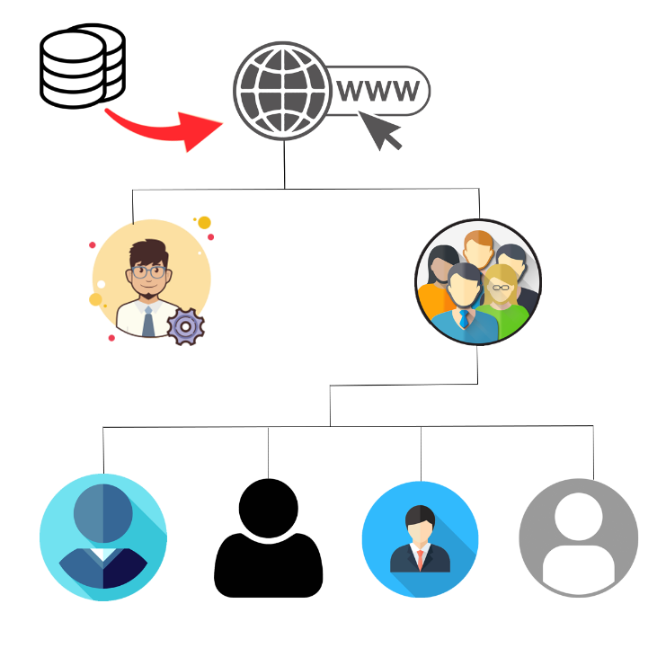Figure 1. System Architecture

Figure 1.

Figure 1 is the system architecture of the SBM System of Engracia L. Valdomar Nat’l High School wherein the users presented are required to login and is categorized by level of authority. The admin accounts and the user accounts in which also is divided into categories named as “Indicators” and the database that serves as the storage of any information and documents from the users.

**DETAILS OF THE TECHNOLOGIES TO BE USED**

The scope of this section is the discussion of the technologies being used in the development of the system.

The required technologies are as follows:

Table 1: **Technologies used for developing the system**

|  |  |
| --- | --- |
| TECHNOLOGIES | DESCRIPTION |
| 1. Software | |
| Sublime Text 3 |  |
| Xampp |  |
| Google Chrome |  |
| 1. Hardware | |
| Desktop / Laptop | An electronic device for storing and processing data, typically in binary form, according to instructions given to it in a variable program. |
| 1. Peopleware | |
| Developers | Maintains workability of the system and provides technical support to the users, they are also the one who upgrades the system into something the users desired. |
| Users | They are the people who are using the system, the administrators and the users. |
| 1. Networks | |
| WAN (Wide Area Network) | A network used to connect and access the site. |

**FRONT END**

**HTML**

**CSS**

**Visual Studio** – It is the program used to develop the system, it provides the users to create and build their own program, sites or any software they like.

**BACK END**

**Java Script**

**MySQL** – This is the database in which the information and any documents are being saved.

**OPERATING SYSTEM REQUIREMENTS**

**Windows 7, 8, 8.1, 10** – Any operating system works and can access the system provided that it has the internet connection.

**Operating System Architecture** – It doesn’t matter if the system is x64-based or x32 based.

**HARDWARE REQUIREMENT**

**Computer** – To access the site easily.

* At least 1gb Ram
* At least 50gb Storage

**Mobile Phone** – To access the site without the use of computer.

**Printer** – For printing

**HOW THE SYSTEM WOULD WORK**

The system is programmed to ask the users to enter their login information. Upon login, the system will verify and will identify the level of authority of the user and the category it belongs. If the user is an administrator, the system will automatically redirect them to the administrators interface and if the user is verified as a user only, the system will identify his/her category named as “indicator” and will redirect them in that indicators user interface.

The administrators will receive the documents submitted by the users, he/she can download them, and can change the information of the users and their login credentials.

The users can change their login credentials, their profile information and can only submit their report but cannot edit, change or download their submitted reports.

**CHAPTER 4**

**METHODOLOGY**

**Description about Analysis of the Project**

The system secures the documents submitted by the teachers of the school. By using the system, they can easily submit their reports based on their designated indicators and the administrators can manage them easily.

**Importance of SDLC**

It is important to have an SDLC in place as it helps to transform the idea of a project into a functional and completely operational structure. In addition to covering the technical aspects of system development, SDLC helps with process development, change management, user experience, and policies.

A system development life cycle helps to lower the complexity of developing a system from scratch. It is important to have an SDLC in place as it helps to transform the idea of a project into a functional and completely operational structure.

* **Step by step method in making the project**
* **Planning**

The group came together as one to share an idea with each other for what the project would do despite this pandemic we face. Even as we face this pandemic, the group still organizes and assigns each of the members for their role as best they can or where they capable of.

* **Analyzing**

The group performed some research in the internet to find some problems and analyze the current method of the system that related for the project plan.

* **Designing**

In order to create a specific design for the project, the group used a user-friendly programming language which could be easy to use by the assigned programmer in the group. And the system should be understandable for the reason that the client user understands the procedure of the system.

* **Software Development**
* **Coding**

For the software development of the project, the group use a programming language that is more familiar to the programmers in the group and easy to use.

* **Testing**

In the testing, after finishing the coding and designing of the system, the group test the system in a different type of browser which is this system created by the group is based in the website by analyzing and check some errors in the system and fix it.

* **Implementation**

After fixing and improving the system of the group, the group make a document papers for the system that they made for how the system works, what is the procedures and process of making the system.

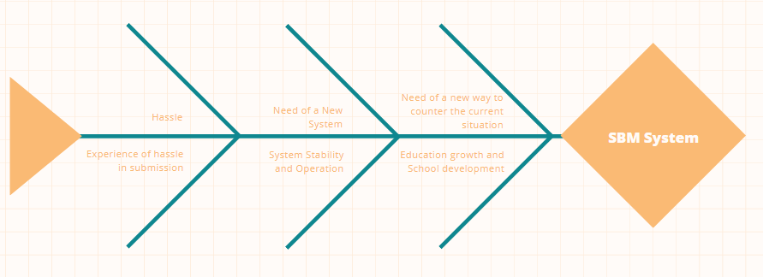**Operational Feasibility**

**Fishbone Diagram**

**Functional Decomposition Diagram**

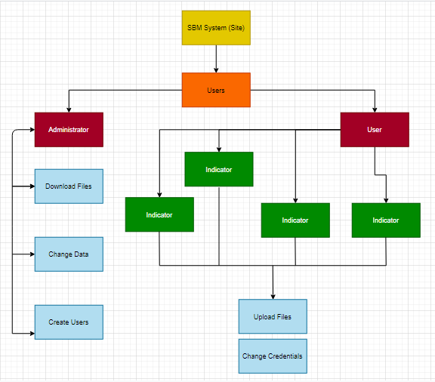

**Technical Feasibility**

**Relevance of the Technology**

The technology or the system itself saves the time and efforts of the users, and on top of that, it enhances the security of the documents submitted by the users. May factors determine the importance of the system in the school, because the role it plays is very important for the operations to run smoothly and proficiently.

**Schedule Feasibility (Ongoing)**

**Gantt Chart**

**Performance Evaluation Review Technique (PERT)**