**ENG101 Midterm Examination**

**Fall 2021**

**Total score: 15 Marks**

**Duration: 80 minutes**

| Name of the Student: | G Suite Email ID: |
| --- | --- |
| Student ID: | Section Number: 11 |

| **Task Instructions:** Do the following **THREE tasks.**  **Task 1:** Create an outline for an Opinion Paragraph on any of the topics from the options below. **(5 marks)**  **Task 2:** Write a complete Opinion Paragraph using the outline. **(10 marks)**  **Task 3:** After completing your writing, you will save it in an MS Word file and submit it in Turnitin. |
| --- |
| **Opinion Paragraph Topics [please highlight your choice]**  **Topic 1:**  Students cannot focus on studies for using smartphones.  Or,  **Topic 2:** Joint families are the best for ensuring a healthy environment for children. |

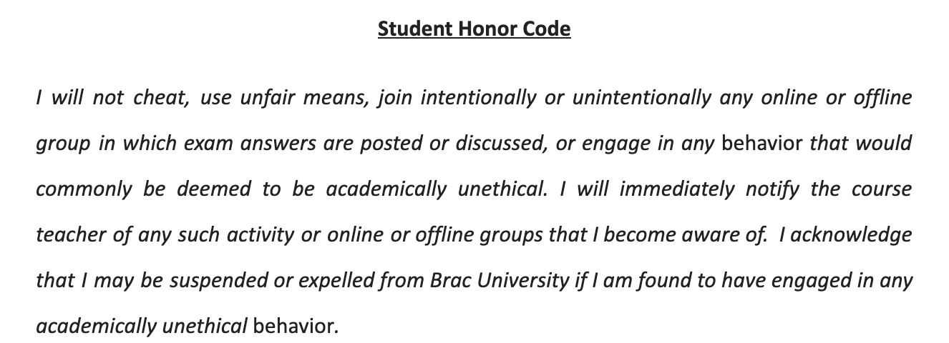

***I agree.***

| ***My Full name*** |  |
| --- | --- |

**Start writing from here.**

**Task 1:**

**Outline (5 marks)**

|  |
| --- |

| **Topic sentence:** In my point of view, I agree that Students cannot focus on studies for using smartphones due to various reasons.  **Supporting Details:**  **Reason 1:** Spends too much time on the phone.  **Evidence:** Students on averagespend 2-7 hours daily on their phone. (Thea-blast.org)  **Reason 2:** They pay more attention to social media.  **Evidence:** More than 98% of the students use social media. (Consumer research from Experian)  **Reason 3:** Increases the tendency of plagiarism or copying.  **Evidence:** 36% of the undergraduate students caught plagiarizing. (Survey by the Psychological Record)  **Concluding sentence:** In conclusion, due to all these reasons, I strongly believe that students cannot focus on studies for using smartphones. |
| --- |

**Task 2:**

**Opinion Paragraph (10 marks)**

In my point of view, I agree that Students cannot focus on studies for using smartphones due to various reasons. Firstly, students spend too much time on their phone’s which reduces their study time. According to the website Thea-blast.org, students on averagespend 2-7 hours daily on their phone. To elaborate, nowadays everyone has a mobile phone but students get more addicted to using their phones, most of them waste their time playing games or watching various videos and the more time they spend on their phone they get more addicted which leads to a bad performance on their study. Secondly, they pay more attention to social media, they focus on showcasing their personalities on social media which is a very bad ideology to have. As reported by a consumer research from Experian, more than 98% of the students use social media and the rate is increasing. Students focus on their social media to gain more popularity. They try to show off their lifestyle to the people which leaves a bad impact on the new generation and kills the focus on their study. Lastly, it increases the tendency of plagiarism or copying. From a survey by the Psychological Record, 36% of the undergraduate students caught plagiarizing. Since in today's date we get everything from the internet, students try to copy from the internet without using their own knowledge. In conclusion, due to all these reasons, I strongly believe that students cannot focus on studies for using smartphones.

**Task 3:**

**After completing your writing, download this document as an MS Word file and submit it in Turnitin.**