CMPS350 Social Media Platform
Phase 2 Report
Course: CMPS350 Web Development
Instructor: Dr. Mucahid Kutlu
Department of Computer Science and Engineering
Qatar University

Team Members
Abdulrahman
Abdulaziz
Yahia
Mohammed
Submission Report

2. Introduction
This project is a social media platform developed for CMPS350 Web Development. In Phase 1, the system was implemented as a frontend-only application using HTML, CSS, JavaScript, and localStorage. In Phase 2, the project was upgraded into a full database-backed web application using Next.js, React, Prisma ORM, and SQLite.
The upgraded system stores real application data in a relational database instead of localStorage. Users can register, log in, create posts, comment, like posts, follow other users, view public profiles, and use a database-backed statistics page. The project also includes API routes, a repository layer, Prisma schema models, database migrations, and a seed script for demo data.

3. Technologies Used
Technology | Purpose
Next.js | Provides the application framework, routing, React page structure, and API routes.
React | Used to build reusable UI components and interactive pages.
JavaScript | Main programming language used across frontend, API routes, repositories, and seed script.
Prisma ORM | Used to define the data model and interact with the SQLite database.
SQLite | Relational database used for local development and Phase 2 data persistence.
CSS | Used to preserve the original social-media-style visual design.
API Routes | Used to connect the React frontend to backend database operations.
Repository Layer | Stores all Prisma database queries in organized repository files.

4. System Features
The completed Phase 2 system includes the following features:
- Login: Existing users can log in using seeded or registered accounts.
- Register: New users can create accounts.
- Create Posts/Messages: Users can publish short messages/posts.
- Delete Posts: Users can delete their own posts using a custom confirmation modal.
- Add Comments: Users can comment on posts.
- Delete Comments: Users can delete their own comments using a custom confirmation modal.
- Like/Unlike Posts: Users can like and unlike posts.
- Follow/Unfollow Users: Users can follow and unfollow other users.
- Search Users: Users can search by username, email, or bio.
- View Profile: Each user has a public profile page.
- Edit Profile: Users can edit their own username, bio, and profile image.
- Public Profile Visibility: Other logged-in users can view public profiles and posts.
- Statistics Page: The /stats page shows database-based statistics that update after actions.

5. Data Model
The database is modeled using Prisma. The main entities are User, Post, Comment, Like, and Follow.

User
Purpose: Stores account information for each user.
Important Fields:
- id: Primary key.
- username: Unique username.
- email: Unique email address.
- password: User password.
- bio: Profile biography.
- avatarData: Uploaded profile image data.
- createdAt, updatedAt: Timestamps.
Relationships:
- A user has many posts.
- A user has many comments.
- A user has many likes.
- A user can follow many users.
- A user can be followed by many users.
Constraints:
- email is unique.
- username is unique.

Post
Purpose: Stores user-created messages/posts.
Important Fields:
- id: Primary key.
- content: Post text.
- imageData: Optional post image data.
- authorId: Foreign key to the user who created the post.
- createdAt, updatedAt: Timestamps.
Relationships:
- A post belongs to one user.
- A post has many comments.
- A post has many likes.

Comment
Purpose: Stores comments written under posts.
Important Fields:
- id: Primary key.
- content: Comment text.
- postId: Foreign key to the post.
- authorId: Foreign key to the user who wrote the comment.
- createdAt, updatedAt: Timestamps.
Relationships:
- A comment belongs to one post.
- A comment belongs to one user.

Like
Purpose: Stores post likes.
Important Fields:
- id: Primary key.
- userId: Foreign key to the user.
- postId: Foreign key to the post.
- createdAt: Timestamp.
Relationships:
- A like belongs to one user.
- A like belongs to one post.
Constraints:
- One user can like a post only once using a unique constraint on userId and postId.

Follow
Purpose: Stores follow relationships between users.
Important Fields:
- id: Primary key.
- followerId: User who follows.
- followingId: User being followed.
- createdAt: Timestamp.
Relationships:
- A follow relationship connects two users.
Constraints:
- One follow relationship per follower/following pair.
- The application prevents a user from following themselves.
Data Model Diagram:
Figure 1. Data model diagram showing User, Post, Comment, Like, and Follow relationships.
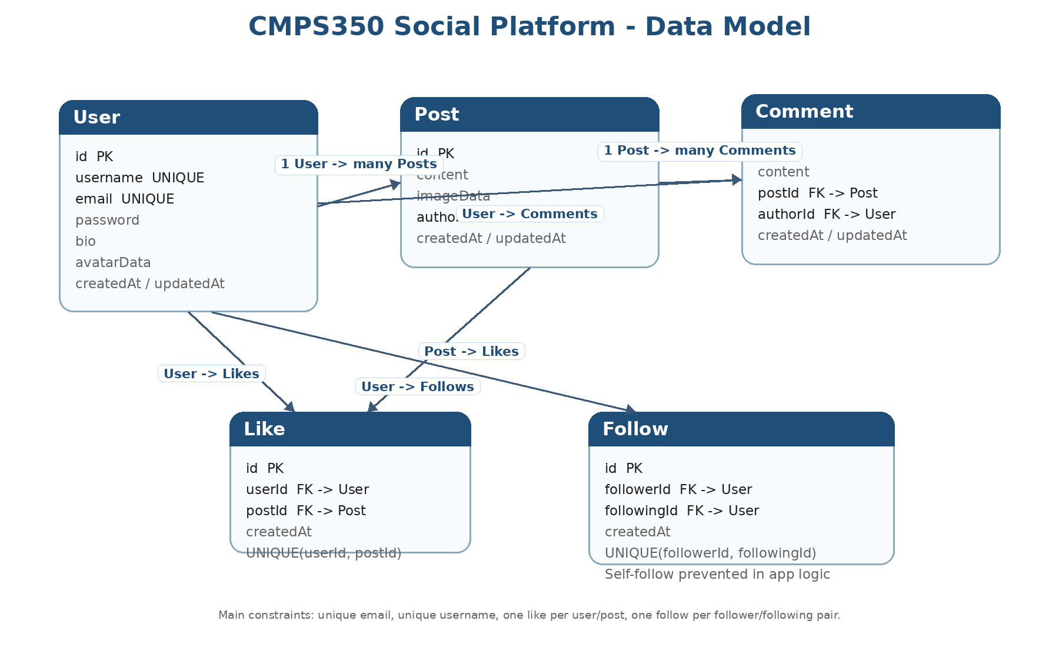

6. Database Initialization Using seed.js
The project includes prisma/seed.js, which populates the SQLite database with realistic demo data. This is important because the instructor needs to run the project from zero and immediately see meaningful users, posts, comments, likes, follows, and statistics.
The seed script creates:
Data Type | Count
Users | 10
Posts/Messages | 30
Comments | 45
Likes | 98
Follow relationships | 23

Important test accounts include:
User | Email | Password
Yahia | yahia@example.com | Passw0rd!
Abdulaziz | abdulaziz@example.com | Passw0rd!
Noura | noura@example.com | Passw0rd!
Saleh | saleh@example.com | Passw0rd!

The seed data was designed to support the demo video. For example, Yahia does not initially follow Abdulaziz, so Abdulaziz’s posts do not appear in Yahia’s feed until Yahia follows him. This makes the follow/unfollow feed behavior easy to demonstrate.

7. Repository Layer
The project uses a repository layer in lib/repositories/. This means Prisma queries are not placed directly inside React components or API routes. Instead, database logic is organized into repository files.
Repository files include:
File | Purpose
userRepository.js | User creation, login lookup, user search, profile retrieval, and profile updates.
postRepository.js | Create, retrieve, feed, profile posts, and delete post operations.
commentRepository.js | Create and delete comments.
likeRepository.js | Like and unlike posts.
followRepository.js | Follow and unfollow users.
statsRepository.js | Database queries used for the statistics page.

This structure improves maintainability, code reuse, and organization. It also follows the Phase 2 requirement that database operations should be separated from the UI and API route files.

8. API Routes
The application uses Next.js API routes to connect the React frontend to the database. API routes are kept thin and call repository functions.
Main API groups:
API Group | Purpose
auth | Login.
users | Register users, search users, get profile data, update profile.
posts | Get feed/profile posts, create posts, delete posts.
comments | Add and delete comments.
likes | Like and unlike posts.
follows | Follow and unfollow users.
stats | Return database statistics for /stats.

Passwords are not returned in API responses. The project uses a serializer function that removes the password field before sending user objects to the frontend.

9. Statistics Page
The /stats page displays database-backed statistics. Each statistic is designed to be easy to demonstrate during the video by showing the current value, performing an action, and returning to the statistics page.
Statistic | What It Measures | Repository Function | How It Changes During Demo
Total users | Number of registered users | getStatistics | Register a new user.
Total posts | Number of posts/messages | getStatistics | Create or delete a post.
Average posts per user | Total posts divided by total users | getStatistics | Create/delete a post or register a user.
Total comments | Number of comments | getStatistics | Add or delete a comment.
Total likes | Number of likes | getStatistics | Like or unlike a post.
Total follows | Number of follow relationships | getStatistics | Follow or unfollow a user.
Average followers per user | Total follows divided by total users | getStatistics | Follow/unfollow a user or register a user.
Most frequent post word | Most common non-stop-word in post content | getStatistics | Create a post with a repeated unique word.

10. Database Queries
The statistics page uses Prisma queries inside statsRepository.js.

Total Users
Query Purpose: Counts all users in the database.
Prisma Query Summary: prisma.user.count()
Explanation: This returns the number of records in the User table. It changes when a new user registers.

Total Posts
Query Purpose: Counts all posts/messages.
Prisma Query Summary: prisma.post.count()
Explanation: This returns the number of records in the Post table. It changes when users create or delete posts.

Average Posts Per User
Query Purpose: Calculates the average number of posts per user.
Prisma Query Summary: The repository counts users and posts, then divides posts by users.
Explanation: This value changes when users create/delete posts or when new users register.

Total Comments
Query Purpose: Counts all comments.
Prisma Query Summary: prisma.comment.count()
Explanation: This returns the number of records in the Comment table. It changes when users add or delete comments.

Total Likes
Query Purpose: Counts all post likes.
Prisma Query Summary: prisma.like.count()
Explanation: This returns the number of records in the Like table. It changes when users like or unlike posts.

Total Follows
Query Purpose: Counts all follow relationships.
Prisma Query Summary: prisma.follow.count()
Explanation: This returns the number of records in the Follow table. It changes when users follow or unfollow other users.

Average Followers Per User
Query Purpose: Calculates average followers/follow relationships per user.
Prisma Query Summary: The repository counts users and follow relationships, then divides follows by users.
Explanation: This statistic changes when users follow/unfollow or when new users are registered.

Most Frequent Post Word
Query Purpose: Finds the most common meaningful word in post content.
Prisma Query Summary: The repository selects only the content field from posts using prisma.post.findMany({ select: { content: true } }).
Explanation: SQLite and Prisma do not provide a simple built-in word-frequency aggregation for free text. Therefore, the repository selects post content only, then tokenizes the text and counts non-stop-words in JavaScript. This statistic can change if a user creates a post with a repeated unique word such as orbitdemo.

11. UI Design
The interface keeps the same social-media-inspired visual identity from the original project. It uses a three-column layout with navigation on the left, content in the center, and supporting cards on the right.
Main UI design elements:
- Social media style feed.
- Profile pages with user information and posts.
- User search page.
- Post cards with comments, likes, and delete actions.
- Statistics cards on /stats.
- Custom notices and custom confirmation modals.
- No browser alert(), confirm(), or prompt() popups.

Screenshots of the Working Implementation:
Figure 2. Login page with test accounts.
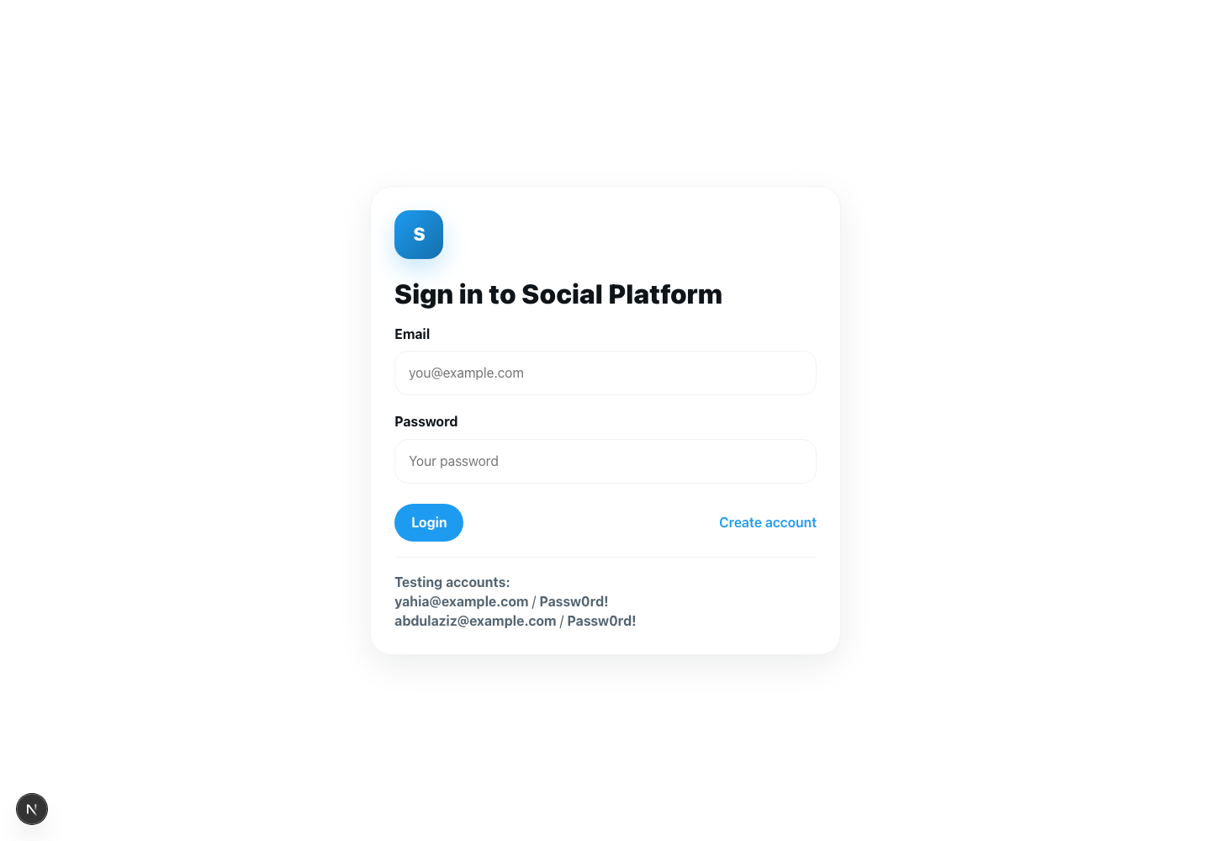

Figure 3. Home feed showing database-backed posts and feed layout.
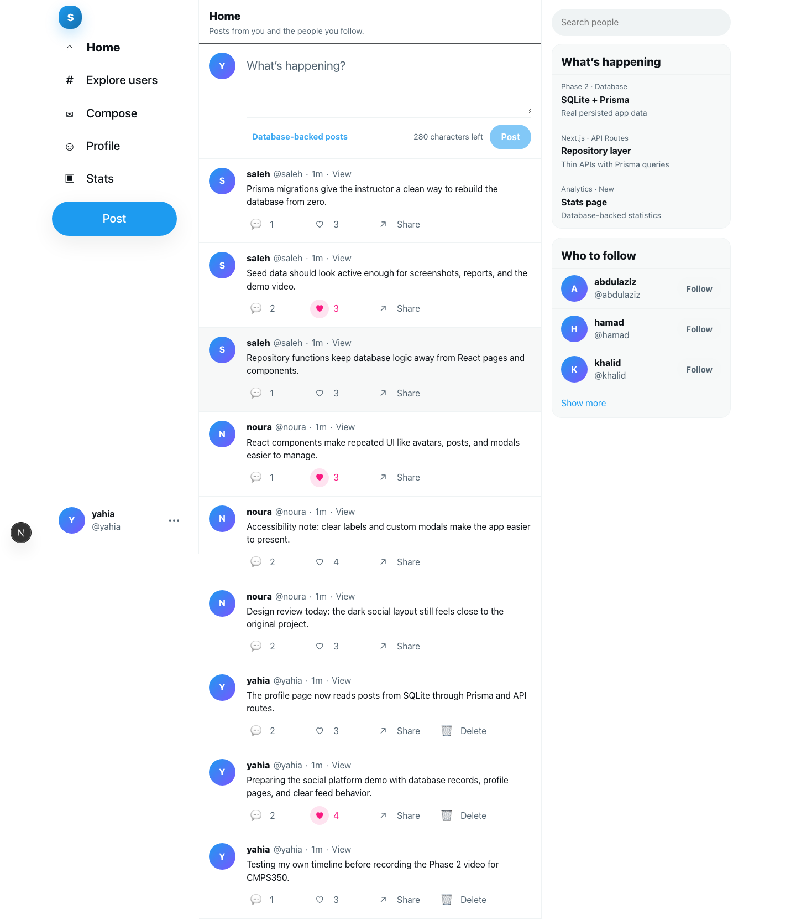

Figure 4. Explore users page with follow/unfollow controls.
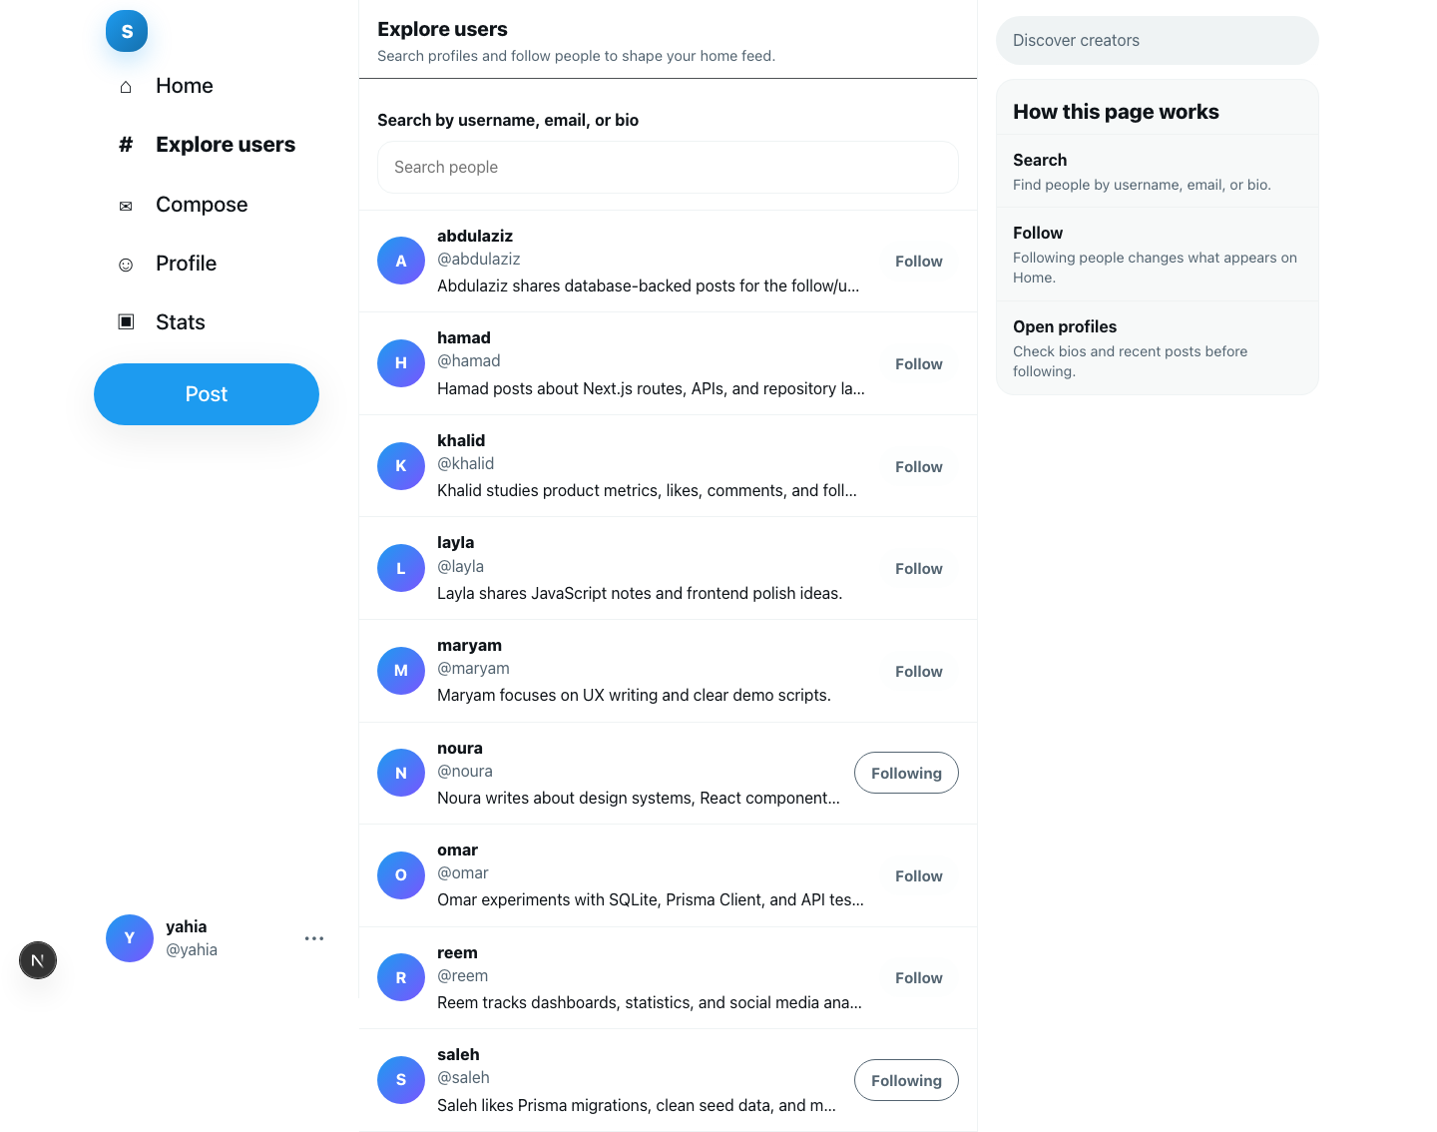

Figure 5. Profile page showing editable profile information and user posts.
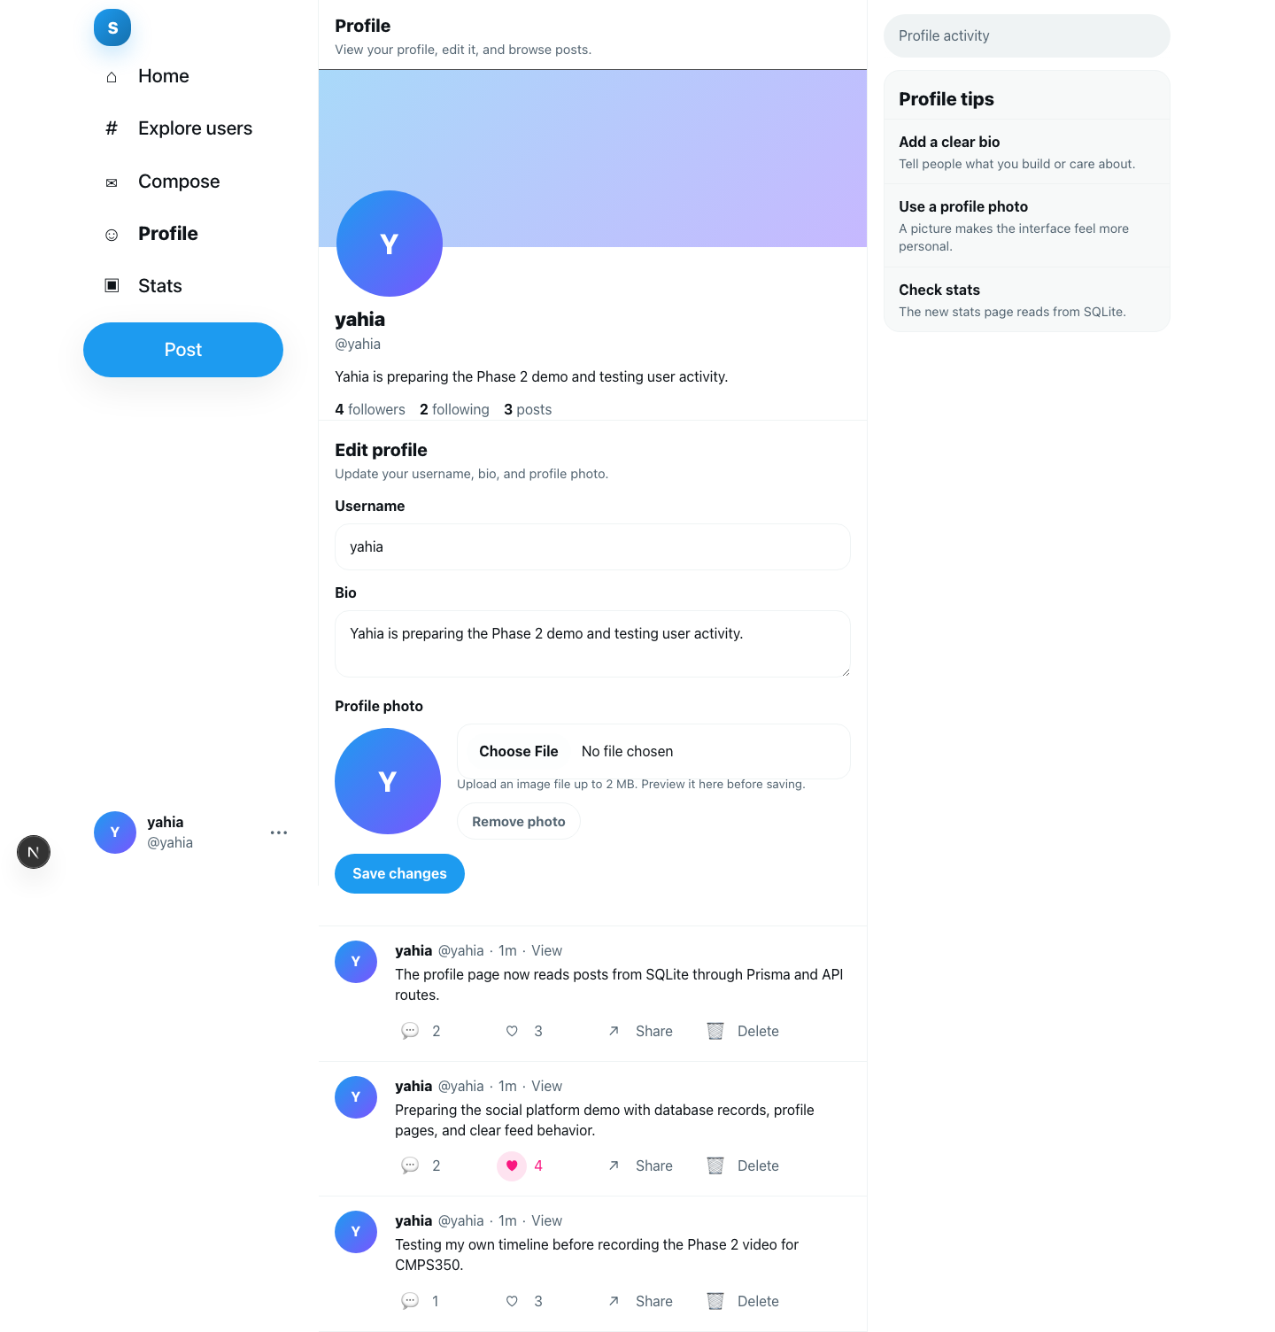

Figure 6. Single-post page with comments and reply form.
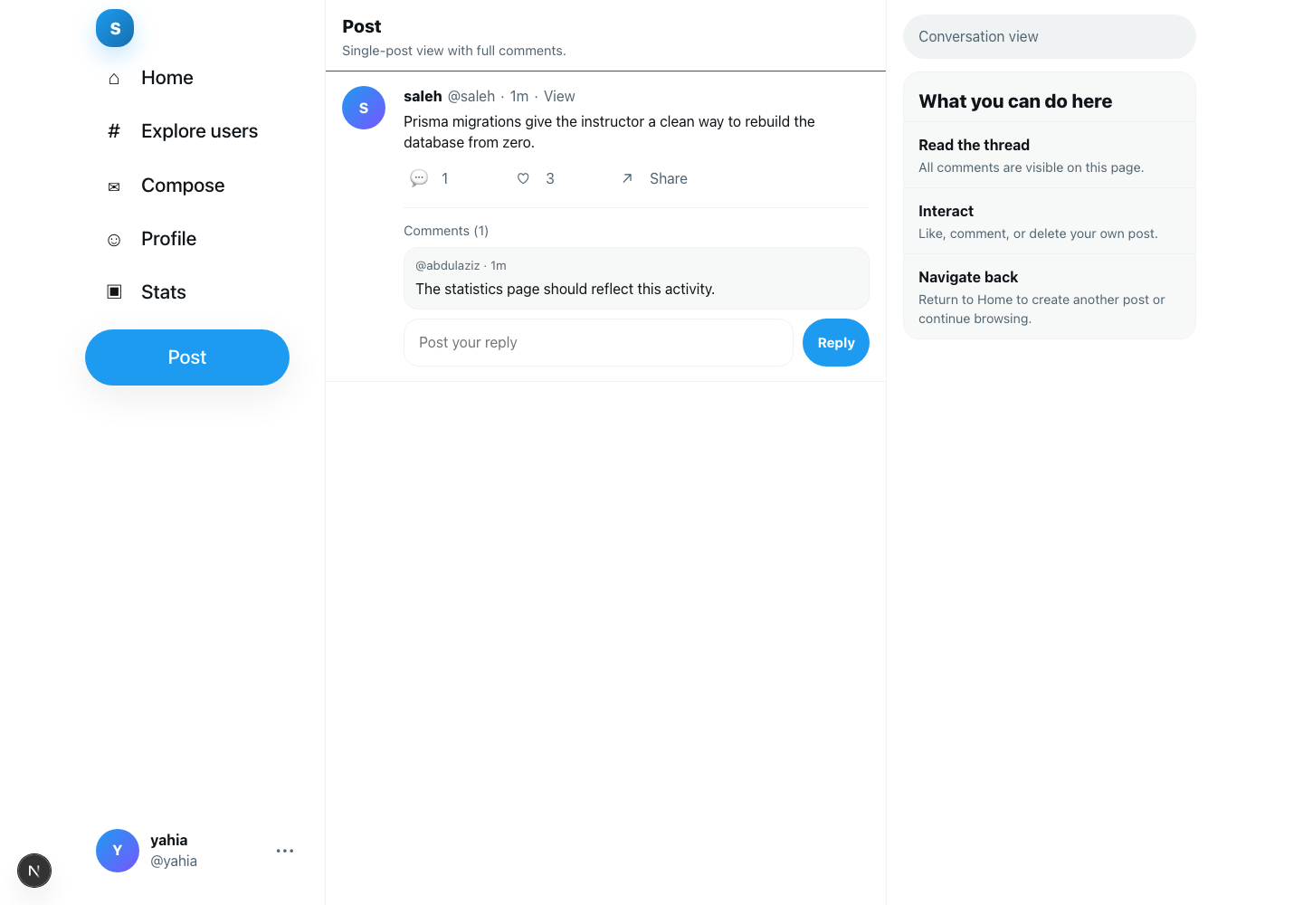

Figure 7. Statistics page showing database-backed demo-friendly statistics.
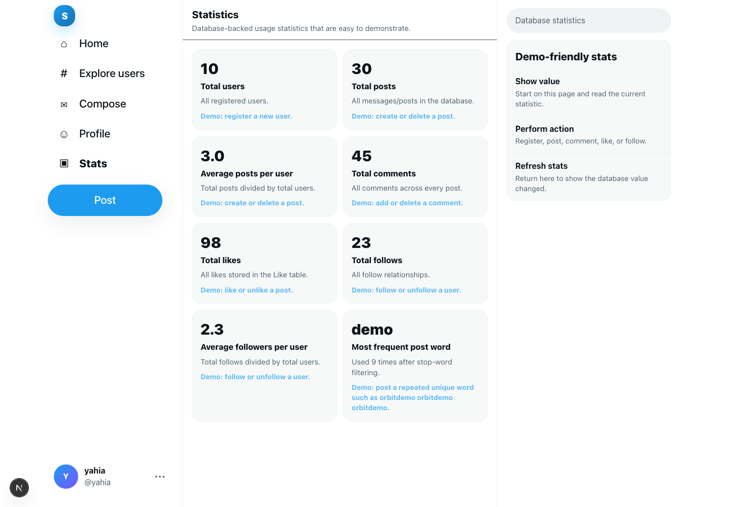

12. Testing
Test Case | Steps | Expected Result | Actual Result | Status
Login | Open /login, enter seeded account credentials. | User logs in and is redirected to home feed. | Works as expected. | Pass
Register | Open /register, create a new account. | New user is stored in SQLite and can log in. | Works as expected. | Pass
Create Post | Log in and create a post from /. | Post appears in feed and database. | Works as expected. | Pass
Delete Post | Delete own post using custom modal. | Post is removed from feed and database. | Works as expected. | Pass
Add Comment | Open a post and add a comment. | Comment appears and is stored in database. | Works as expected. | Pass
Delete Comment | Delete own comment using custom modal. | Comment is removed from database. | Works as expected. | Pass
Like/Unlike | Like a post, then unlike it. | Like count updates; one like per user/post is enforced. | Works as expected. | Pass
Follow/Unfollow | Follow a user, then unfollow. | Follow relationship is created and removed. | Works as expected. | Pass
Feed Update | Yahia follows Abdulaziz, checks feed, then unfollows. | Abdulaziz posts appear after follow and disappear after unfollow. | Works as expected. | Pass
Cross-Account Visibility | Log in as Abdulaziz and open Yahia’s profile. | Yahia’s public posts are visible. | Works as expected. | Pass
Statistics Update | Perform actions that change users, posts, comments, likes, follows, and word frequency. | /stats values update after actions. | Works as expected. | Pass
Data Persistence | Refresh after creating data. | Data remains because it is stored in SQLite. | Works as expected. | Pass

13. Setup and Running Instructions
These instructions assume the instructor is running the code for the first time.

Step 1: Install Node.js
Install Node.js if it is not already installed.

Step 2: Unzip the Project
Unzip the submitted project folder.

Step 3: Open Terminal Inside the Project Folder
Open a terminal or command prompt in the root project directory. For example:
cd CMPS350-Social-Platform-Phase2

Step 4: Install Dependencies
npm install

Step 5: Create the Database and Run Migrations
npm run migrate

Step 6: Populate the Database With Seed Data
npm run seed

Step 7: Run the Application
npm run dev

Step 8: Open the Browser
http://localhost:3000

Step 9: Optional Build Verification
Before final submission, run the build command to verify that the project compiles successfully:
npm run build
Important notes:
- Do not run the project by double-clicking HTML files.
- This is a Next.js project and must be started with npm run dev.
- Real application data is stored in SQLite through Prisma.
- localStorage is used only for the current session user id, not as the main database.

14. Demo Video Plan

Scenario A — User Activity & Following
- Log in as Yahia.
- Create message 1.
- Create message 2.
- Open Yahia’s profile.
- Show both messages.
- Delete one message.
- Follow Abdulaziz.
- Open the news feed.
- Show Abdulaziz’s messages appearing.
- Unfollow Abdulaziz.
- Open the news feed again.
- Show Abdulaziz’s messages disappearing.

Scenario B — Cross-Account Visibility
- Log out.
- Log in as Abdulaziz.
- Open Yahia’s profile.
- Show Yahia’s remaining undeleted message.

Scenario C — Statistics Features
For each statistic:
- Open /stats.
- Show the current value.
- Perform an action that changes the value.
- Return to /stats.
- Show the updated value.
Examples:
- Register a user to change total users.
- Create/delete a post to change total posts.
- Add/delete a comment to change total comments.
- Like/unlike a post to change total likes.
- Follow/unfollow a user to change total follows.
- Create a repeated-word post to change the most frequent word statistic.

15. Team Contributions
Team Member | Contribution
Abdulrahman | Worked on project planning, testing, report preparation, and demo scenario organization.
Abdulaziz | Worked on user features, follow/unfollow behavior, feed testing, and cross-account visibility testing.
Yahia | Worked on Next.js conversion, React pages, UI consistency, profile features, and statistics demo preparation.
Mohammed | Worked on Prisma schema, seed data, repository layer organization, API route testing, and documentation support.

16. Limitations
- Passwords are stored as plain text for course/demo simplicity. In a production system, passwords should be hashed securely.
- SQLite is used for local development and demonstration. A larger production application may use PostgreSQL or MySQL.
- localStorage is used only to store the current session user id in the browser. It is not used as the main database.
- The authentication system is simplified for the course project.

17. Conclusion
This Phase 2 project successfully upgrades the original frontend/localStorage social media prototype into a full database-backed web application. The system now uses Next.js, React, Prisma, SQLite, API routes, and a repository architecture. Application data is persistent and stored in a relational database, while the UI preserves the original social-media design and features.
The project supports user registration, login, posts, comments, likes, follows, public profiles, profile editing, search, and database-backed statistics. The seed script creates rich demo data, and the setup instructions allow the instructor to run the project from zero. Overall, the project satisfies the Phase 2 requirements by moving from a frontend-only prototype to a structured full-stack web application with persistent data and meaningful statistics.

