 | Qatar University  College of Engineering  Department of Computer Science and Engineering
Senior Project Report

Project name: Spots

Project Group Members:
Ahmad Abuarrah (202108841)
Mohammed Bakhit (202107875)
Ghanim Masoud (202004603)
Yahia Zagad (202110652)
Supervisor: Saeed Salem

2026
This project report is submitted to the Department of Computer Science and Engineering of Qatar University in partial fulfillment of the requirements of the Senior Project course.

Declaration

This report represents our original work, and any external sources utilized have been appropriately cited. It details the work we have undertaken for our senior project. We are aware of the university strict policy on plagiarism and the corresponding penalties, and we declare that this report is the product of our own work.
< ToDo: For each student add the signature and the date of signing the declaration />
Student: Ahmad Abuarrah Date: 30/04/2026
Signature:

Student: Mohammed Bakhit Date: 30/04/2026
Signature:

Student: Ghanim Masoud Date: 30/04/2026
Signature:

Student: Yahia Zagad Date: 30/04/2026
Signature:


Abstract
< ToDo:
- The abstract is a brief overview (500 words max) of your project's objectives, proposed solution, accomplishments:
- Clearly introduce the problem your project has addressed. Highlight the significance of addressing the problem.
- Provide a concise overview of your proposed solution.
- Highlight key achievements and most important conclusions.
/>
Spots Mobile is a Qatar-focused local discovery application designed to help residents, students, visitors, and organizations find nearby places, community updates, and promoted events through one location-aware mobile platform. The project addresses the problem of fragmented local information, where users often depend on separate sources such as social media, private messaging groups, static map reviews, and informal recommendations. This fragmentation makes it difficult to find timely, trustworthy, and relevant information about what is happening nearby. Therefore, the project aims to provide a more organized, community-driven, and user-friendly way to discover local activities and updates.
The project was developed in two main stages. In the first stage, the team designed the initial requirements, system architecture, and proof-of-concept to validate the core idea. This early version focused on essential features such as user authentication, local post creation, map-based exploration, and an initial AI summarization concept. In the second stage, the system was expanded into a fuller MVP with a more complete implementation and stronger backend support. The final solution uses React Native, Firebase Authentication, Cloud Firestore, Firebase Cloud Functions, Firestore security rules, maps/geolocation services, and OpenAI-backed area summaries.
The final system implements authentication, Home discovery, Explore map and heatmap behavior, local post creation, saved spots, comments, reactions, reports, moderation, profile settings, English/Arabic localization, in-app notifications, XP and leaderboard features, admin analytics, subscription state management, and organization-only promoted events. AI summaries are generated through backend Cloud Functions rather than direct client-side OpenAI calls, which protects API credentials and keeps summarization logic under server control.
The project achieved a modular layered architecture consisting of a presentation layer, application/service layer, repository/data access layer, backend layer, and external service integrations. This structure improves maintainability, supports future expansion, and separates user interface logic from backend and database operations. The system was evaluated through functional testing, non-functional testing, TypeScript type checking, ESLint validation, manual workflow verification, and backend trust tests. The backend trust test suite passed 10 out of 10 test cases using Firebase emulators, confirming that key security-sensitive operations were properly protected.
Overall, Spots Mobile demonstrates a feasible and extensible community discovery platform for the Qatari context. Its main contribution is the integration of local posts, map-based discovery, AI area summaries, organization promotion, moderation, notifications, XP, and leaderboard features into one unified system. The project also identifies future improvements such as full media upload, production push notifications, real payment integration, broader usability testing, stronger privacy workflows, and production deployment preparation.

<ToDo: Before submitting your final report:
- Complete all Report Sections: Ensure that each section of the report is thoroughly developed following the provided ToDo instructions for each section.
Remember that the template serves as a guide. In collaboration with your supervisor, you may tailor the report structure as necessary by adding sections or subsections that align with the specific nature of your project.
- Coherence and Compliance Check: Thoroughly review the entire document to ensure its cohesiveness and alignment with the Project Guide and Project Grading Rubrics. Confirm that all specified requirements have been addressed.
- Supervisor Feedback: Seek feedback from your supervisor and promptly address any concerns or issues raised in their feedback. Collaborate with your supervisor to refine the report content.
- Update Table of Contents and Lists: Update the Table of Contents, List of Figures, and List of Tables to reflect any changes or additions made during the report's development.
- Track Changes: If utilizing Word's 'Track Changes' feature, ensure that all changes are accepted before submitting your final report.
- Retain ToDo Instructions: Keep the ToDo instructions as they will be valuable for both semesters. Remove them only when preparing the Final Revised Report after the Senior Project Presentation and after addressing examiners feedback at the end of Semester 2.
- Semester 2 Final Report Additional Tasks:
  - Review of Semester 1 Content: Revisit the content produced in Semester 1 and update it to reflect any changes that have occurred in your project since last semester.
  - Abstract Enhancement: Revise the Abstract to include key project achievements and significant conclusions. The final paragraph should emphasize the uniqueness of your design and discuss the impacts of your engineered solution.
  - Tense Alignment: Review the entire document to ensure consistent usage of present and past tenses while avoiding the inclusion of future tense (e.g., 'we will' or 'system should') except in the Future Work section.
/>

Acknowledgment
< ToDo:
- Acknowledge any assistance you received for your project.
/>
The project team expresses sincere appreciation to Dr. Saeed Salem for his supervision, guidance, and constructive feedback throughout the senior project. His support helped the team refine the project scope, improve the system design, evaluate technical decisions, and progress from an early proof-of-concept into a fuller working application.
The team also acknowledges the support of classmates and volunteer testers who provided informal feedback during development and testing. Their comments helped improve the usability of the interface, clarify user workflows, and identify areas for further improvement. Finally, the team appreciates the resources and learning environment provided by Qatar University, which supported the successful completion of this project.

Table of Contents
Declaration 1
Abstract 3
Acknowledgment 5
List of Figures 7
List of tables 8
1. Introduction and Motivation 9
1.1. Problem statement 10
1.1.2. Technical Challenges 10
1.1.3. Non-Technical Challenges 10
1.1.4. Why This is a Complex Computing Problem 10
1.2. Project objectives 11
1.2.1. Core Objectives 11
1.3. Expected benefits and impacts 12
1.4. Market Research and Business Viability 13
1.4.1 Market need and market size 14
1.4.2 Target customers 14
1.4.3 Competitive analysis 15
1.4.4 Business viability and plan 15
1.5. Conclusion 16
2. Background and related work 17
2.1 Background 17
2.2 Related work 18
2.3 Existing Solutions 19
2.4 Gap Analysis and Novelty of Spots: 20
2.5 Conclusion 20
3. Requirements analysis 21
3.1.1 Process Overview 21
3.1.2 Team Roles and Responsibilities 22
3.1.3 Tools and Technologies 23
3.1.4 Process Application in SDP I 23
3.2 Applying the software development process 24
3.2.1 Application During SDP I 25
3.2.2 Application During SDP II 26
3.2.3 Challenges and Difficulties: 28
3.2.4 Advantages and Lessons Learned 28
3.2.5 Summary 29
3.1 Functional requirements 29
3.1.2 System Scope and Prioritization 32
3.2 Non-functional requirements 32
3.3 Assumptions 35
3.4 Ethics 36
3.4.1 Ethical and Legal Considerations 37
3.4.2 Relevant ACM & IEEE Principles Applied 37
3.4.3 Applying the Ethics Throughout SDP I 38
3.4.4 Ethical Alternatives Considered 38
3.4.5 Conclusion 39
4. Project Plan 39
4.1 Project milestones 40
4.2 Project timeline 41
4.3 Anticipated risks 42
5. System Architecture 43
5.1High level system architecture 44
5.1.1 Overview 44
5.1.2 Component Responsibilities and Interfaces 45
5.2 Alternative solutions and tradeoffs 48
6. Detailed Design 49
6.1 Structural model 51
6.1.1 Entity classes 52
6.1.2 Service interfaces 53
6.1.3 Infrastructure adapters (external service interfaces) 53
6.1.4 Orchestrator 54
6. 1.5 Relationships and design principles 54
6.2 Behavioral model 55
6.2.1 Activity flow for “Post Activity Update” (UC3): 56
6.2.2 Sequence of “View Map Feed + AI Summary” (UC5, UC18, UC4): 57
6.2.3 State model of the Explore screen: 58
6.2.4 Algorithm for client-side area summarization (UC4): 59
6.3 Database design 61
6.3.1 Entity descriptions (PoC scope): 62
6.4 User interface design 64
6.5 Design patterns 66
6.5.1 MVC-inspired separation between UI and data logic 66
6.5.2 Observer pattern for real-time map and feed updates 68
6.5.3 Facade / Adapter pattern for external services 69
7. Implementation 70
7.1 Hardware/software used 70
8. Testing and evaluation 73
8.1 Functional testing 74
8.1.1 UC1 – Login 75
8.1.2 UC2 – Register 75
8.1.3 UC3 – Create Spot 75
8.1.4 UC5 – Explore Map Feed 76
8.1.5 UC18 – Filtering 76
8.1.6 UC4 – AI Summarization (Client-Side OpenAI Integration) 76
8.2 Non-functional testing 77
8.2.1 Performance Testing 77
8.2.2 Usability Testing 77
8.2.3 Reliability Testing 78
8.2.4 Security Testing (PoC Level) 78
9. Conclusion 79
10. Future work 79
11. Student reflections 80
11.1 Ahmad Abuarrah – Reflection 81
11.2 Mohammed Bakhit – Reflection 81
11.3 Ghanim Masoud – Reflection 82
11.4 Yahia Zagad – Reflection 82
Appendix A – Use cases specification 85
Use Case UC1: Register Account 86
Use Case UC2: Login / Logout 88
Use Case UC3: Post Activity Update 89
Use Case UC4: AI Summarization 91
Use Case UC5: View Map Feed 93
Use Case UC6: Discover Activities 95
Use Case UC7: View Summarized Feed 97
Use Case UC8: Comment and Interact 98
Use Case UC9: Report Inappropriate Content 100
Use Case UC10: Admin Moderate Posts 101
Use Case UC11: Manage Profile and Settings 103
Use Case UC12: Leaderboard and Points 104
Use Case UC13: Event Promotion 105
Use Case UC14: Subscription Management 107
Use Case UC15: View Analytics Dashboard (Admin) 108
Use Case UC16: Notification System 110
Use Case UC17: Manage Favorite Spots 111
Use Case UC18: View Heatmap 112
Appendix B – Test cases specification 114
Test Case 1: Login with Email & Password (UC02) 117
Test Case 2: Logout (UC02) 117
Test Case 3: Create a Spot (UC03) 118
Test Case 4: Seed Demo Posts (UC03 – PoC-only Feature) 119
Test Case 5: View Map Feed (UC05) 120
Test Case 6: View Heatmap (UC18) 120
Test Case 7: Summarize This Area (UC04 – Simulated for PoC) 121

List of Figures
Figure 1. Use cases diagram 13
Figure 2. Project Gantt chart: Timeline of key tasks and milestones 16
Figure 2. High-level system architecture diagram 17

List of tables
Table 1. Expected benefits and impacts on various contexts 9
Table 2. Use cases summary 13
Table 3. Evaluation plan for the non-functional requirement 13
Table 4. Project-specific code of ethics and professional responsibilities 14
Table 5. Project milestones 15
Table 6. Project timeline 15
Table 7. Project Risks 16
Table 8. Hardware/software to be used 21

Introduction and Motivation

Problem statement
< ToDo:
- Give a clear (and preferably formal) definition of the problem you aim to solve. Additionally, consider including an overview figure to visually depict the problem for enhanced clarity.
- Highlight the significance of tackling the problem (i.e., why it is important). Support your argument with relevant references and a real-world example to motivate your project.
- Outline the technical and non-technical challenges associated with the project using bullet points. For example, integrating machine learning models into your solution is a technical challenge, while the need for collecting labeled data is a non-technical challenge.
- Explain aspects to classify this problem as a complex computing problem:
Complex computing problems include one or more of the following characteristics: involving wide-ranging or conflicting technical issues and tradeoffs, having no obvious solution, involving diverse groups of stakeholders, including many component parts or sub-problems, involving multiple disciplines, or having significant consequences in a range of contexts.
/>
Finding reliable, current, and locally relevant information about places and activities in Qatar is difficult because such information is fragmented across many separate channels. A user may need to check Instagram or Snapchat for informal updates, Google Maps for static reviews, WhatsApp groups for private recommendations, event platforms for organized activities, and word-of-mouth for neighborhood knowledge. Although these sources are useful individually, they are not designed as one structured, bilingual, moderated, and location-aware community discovery platform.
This fragmentation creates a practical problem for different groups of users. Residents and students may waste time searching for suitable places to study, eat, walk, fish, camp, or attend events. Visitors may struggle to find local recommendations beyond generic tourist information. Small organizations and event organizers may also find it difficult to reach nearby audiences without relying on scattered announcements or paid social media promotion.
For example, a student in Doha who wants to find a quiet study place, a nearby event, or a recently active outdoor location may need to search several platforms and still receive outdated or incomplete information. Similarly, a small local organization may announce an event on social media, but only users who already follow that account will see it. This shows the need for a centralized local discovery system that can organize updates by location, category, and user interaction.
Spots Mobile addresses this problem by providing a Qatar-focused local discovery application that combines community posts, maps, saved spots, promoted events, profile features, reports, moderation, XP/leaderboard engagement, in-app notifications, and AI-backed area summaries. The application does not aim to replace global map platforms; instead, it adds local community context, real-time interaction, structured discovery workflows, and backend-secured AI summarization that are not fully supported by general-purpose tools.

1.1.2 Technical Challenges
The project involved several technical challenges:
- Implementing real-time community posts linked to geographic coordinates.
- Supporting location permissions, fallback behavior, and map rendering across different usage environments.
- Designing a scalable Firestore data model for users, posts, comments, reactions, favorites, reports, subscriptions, notifications, profiles, events, and XP records.
- Enforcing user ownership, admin permissions, organization roles, and subscription restrictions using Firestore security rules and Firebase Cloud Functions.
- Moving AI summarization to the backend to prevent exposure of OpenAI API credentials in the client application.
- Maintaining a modular architecture using React Native, TypeScript, services, repositories, contexts, reusable UI components, Firebase services, and external APIs.
- Supporting bilingual English/Arabic interface behavior, including localized labels and text-direction considerations.
- Testing the interaction between frontend workflows, backend functions, Firestore rules, real-time listeners, and external services.

1.1.3 Non-Technical Challenges
The project also involved several non-technical challenges:
- Encouraging users to contribute useful, accurate, and high-quality local updates.
- Building user trust around location-related data and AI-generated summaries.
- Preventing misinformation, spam, or inappropriate content through reports and moderation.
- Balancing organization promotion features with fairness and user experience.
- Managing project scope across the early proof-of-concept phase and the final MVP implementation.
- Coordinating teamwork, documentation, testing evidence, and supervisor feedback throughout the project.
- Clearly separating completed features, partially implemented features, and future-work items in the final report.

1.1.4 Why This Is a Complex Computing Problem
Spots Mobile qualifies as a complex computing problem because it includes several interacting technical, social, and ethical components. The system combines mobile computing, geolocation, real-time databases, authentication, server-side functions, AI summarization, moderation, analytics, role-based access control, and human-centered interface design. These components must work together reliably while supporting different types of users and workflows.
The project also involves important tradeoffs. For example, the system must balance location usefulness with user privacy, open community participation with content moderation, organization promotion with fairness, and rich functionality with maintainability. There is no single obvious solution because the system must satisfy technical requirements, user experience needs, ethical responsibilities, and business viability at the same time.
The project serves multiple stakeholders, including everyday users, visitors, organization accounts, administrators, event organizers, and the broader local community. Because the system affects how local information is shared, filtered, summarized, and trusted, it has consequences beyond simple data storage or interface design. These characteristics make Spots Mobile a multi-component and stakeholder-sensitive software engineering problem that requires careful design, iterative development, testing, and professional responsibility.

Project objectives
< ToDo:
- Make sure your objectives are specific, measurable, achievable, relevant, and time-bound (SMART). Use bullets format.
- Clearly state what you aim to achieve with your project and define your objectives in terms of measurable outcomes against which the success of the project will be judged.
- Break down your objectives into smaller, more manageable sub-objectives that can be achieved incrementally.
- Use action verbs to describe your objectives, such as design, implement, test, or evaluate.
- In the Conclusion section you must summarize the project objectives and discuss their level of attainment.
/>
The main objective of this project is to design, implement, and evaluate Spots Mobile as a location-aware community discovery platform for Qatar. The project began with an early proof-of-concept stage and was later expanded into a fuller MVP with additional backend, security, moderation, organization, and engagement features. The following SMART objectives were used to measure the success of the project:
- O1 – Design and document the system architecture.
Design a layered system architecture that clearly shows the mobile application, service layer, repository/data access layer, Firebase backend, Cloud Functions, Firestore database, maps/geolocation services, and AI summarization integration. The objective is considered achieved when the final report includes the architecture diagram, database design, structural model, and behavioral flow diagrams.
- O2 – Implement authentication, profile, and localization workflows.
Implement user registration, login, logout, authentication-state handling, profile management, privacy settings, notification preferences, and English/Arabic interface support. The objective is considered achieved when users can create accounts, access the application securely, manage their profiles, and use the main interface in the supported languages.
- O3 – Implement local discovery and posting workflows.
Implement the main discovery features, including Home discovery, Explore map discovery, local post creation, category filtering, saved spots, comments, reactions, and content reporting. The objective is considered achieved when authenticated users can create local updates, view posts/events, interact with content, and save useful spots.
- O4 – Implement backend-secured AI area summaries.
Implement an AI summary workflow where selected posts are sent to a backend Cloud Function, and the backend communicates with the AI service without exposing API credentials in the client application. The objective is considered achieved when users can request area summaries through the application and receive controlled backend responses.
- O5 – Implement trust, moderation, and engagement features.
Implement report submission, admin report review, content hiding, in-app notifications, XP rewards, and leaderboard ranking. The objective is considered achieved when user activity can trigger XP and notifications, reported content can be reviewed by an admin, and ranked users can be displayed in the leaderboard.
- O6 – Implement organization and subscription-controlled promoted events.
Implement organization account support, subscription plan state, promoted event creation, and backend role/plan validation. The objective is considered achieved when eligible organization accounts can create promoted events and unauthorized users are prevented from accessing organization-only features.
- O7 – Evaluate the system through functional and non-functional testing.
Evaluate the project using functional test cases, non-functional testing, TypeScript type checking, linting, backend trust tests, and manual workflow verification. The objective is considered achieved when the main use cases are tested, the backend trust tests pass, and the report documents the testing results clearly.
- O8 – Produce complete final documentation and project evidence.
Prepare the final report, diagrams, use case specifications, test case specifications, screenshots, implementation details, conclusion, future work, and student reflections. The objective is considered achieved when the final report presents the full project development from the initial proof-of-concept to the final MVP in a clear and organized manner.

Expected benefits and impacts
< ToDo:
- List and discuss your project contributions.
- List and explain in table format the expected benefits and the local and global impacts of your project on individuals, organizations, and society. For example:
- Highlight the ways in which the project's outcomes will benefit the project stakeholders, such as users and customers, both individuals and organizations?
- Discuss the potential for your project in creating social and cultural changes within communities and individuals.
- Evaluate the anticipated contributions of your solution towards addressing global issues, such as climate change, poverty alleviation, literacy promotion, economic growth and competitiveness, sustainable development, and overall human well-being.
- Revisit and enrich this section towards the end of the project.
/>
Spots Mobile contributes to the local community by providing a centralized, location-aware platform for discovering nearby activities, places, updates, and promoted events. Instead of forcing users to search across many disconnected sources, the system organizes community information through maps, categories, saved spots, summaries, reports, and user interaction features. The project also contributes technically by combining mobile development, Firebase backend services, geolocation, AI-supported summarization, moderation, organization features, and gamified engagement in one integrated system.
Context | Expected benefits and impacts
Individuals | Increased efficiency: Users save time by accessing local updates through one consolidated platform instead of checking multiple social media pages, private groups, and map reviews.  Better local discovery: Residents, students, and visitors can discover nearby places, activities, and events based on location and category.  Stronger participation: Users can contribute posts, interact through comments and reactions, save favorite spots, and receive in-app notifications.  Safer digital experience: Privacy settings, reporting, moderation, and backend-secured AI summaries help users interact with local information more confidently.
Organizations | • Targeted outreach: Local businesses, university clubs, event organizers, and community groups can promote events to users interested in local activities.  Affordable visibility: Promoted event features provide a structured alternative to scattered announcements and expensive social media promotion.  Engagement awareness: Admin analytics and interaction data can help organizations understand user interest and improve future activities.  Support for local economy: Increasing the visibility of small organizations and local activities supports community engagement and economic participation.
Society | Community connection: The system encourages residents, students, visitors, and organizations to share useful local knowledge and interact around common interests.  Responsible information sharing: Reporting, moderation, and structured categories reduce the spread of irrelevant, misleading, or inappropriate content.  Bilingual accessibility: English/Arabic support makes the platform more inclusive for different user groups in Qatar.  Digital culture development: Spots encourages responsible use of location-aware and AI-assisted technologies for community benefit.
Global | Smart community model: The project can serve as a model for other cities or regions that need local, community-driven discovery platforms.  Responsible AI use: Backend-secured AI summaries demonstrate how AI can reduce information overload while protecting credentials and supporting controlled system behavior.  Sustainable cities and well-being: By improving access to local activities, events, and public spaces, the project supports stronger community participation and better use of urban resources.  Scalable design: The layered architecture, backend services, and modular data model provide a foundation that can be adapted to wider deployment in the future.
Table 1. Expected benefits and impacts on various contexts

Market Research and Business Viability
< ToDo:
- Conduct market research to address the following:
- Describe the market need and the market size.
- Identify the target customers and their demographic characteristics, preferences, and pain points.
- Analyze the competing solutions and how does yours differ from those offered by competitors? Showcase the novel features of your solution and the tangible benefits it delivers.
- Develop a business plan including your business model, pricing, marketing strategy to bring your product to market and make it competitive.
/>
Market research was conducted to determine whether there is a genuine need for a community-driven local discovery platform in Qatar and to evaluate the commercial viability of Spots Mobile. The research focused on four main areas: market need, target customers, competing solutions, and possible business models. The results showed that there is a clear opportunity for a platform that combines real-time community updates, location-aware discovery, bilingual support, organization promotion, and AI-assisted summarization.

1.4.1 Market need and market size
The main market need addressed by Spots Mobile is the fragmentation of local information. Users in Qatar often rely on several disconnected sources, such as social media accounts, private messaging groups, map reviews, word-of-mouth, and event pages. These sources may contain useful information, but they are not organized in one platform, and they often lack real-time updates, filtering, moderation, and local context.
Internal survey results indicated that many users regularly search for local places and activities. The results showed that 35.9% of respondents search for local spots weekly, while 28.2% search monthly. In addition, 86.8% of respondents considered real-time community updates useful or very useful, and 79.5% stated that they would be likely or very likely to download an application like Spots Mobile.
These results suggest that the project addresses a real user need. Qatar has a highly mobile and digitally active population, including students, residents, visitors, and community groups. Many users participate in activities such as studying outside campus, visiting cafes, attending events, walking, camping, fishing, or exploring local areas. Therefore, the potential market includes individuals who want easier access to local information and organizations that want a more direct way to reach nearby audiences.

1.4.2 Target customers
Spots Mobile serves two main customer segments: individual users and organizations.

A. Individual Users
The first target group consists of residents, students, visitors, and young adults who actively use mobile applications to discover places and activities. This group is likely to prefer quick access to information, map-based discovery, bilingual English/Arabic support, and simple interaction features.
Their main pain points include:
- Local information is scattered across many platforms.
- Social media posts are often unfiltered or difficult to search.
- Map reviews may be outdated and not focused on current activity.
- Users may not know which nearby places are active, crowded, interesting, or suitable for their needs.
- There is no single platform that combines posts, maps, summaries, saved spots, and community interaction.

B. Organizations
The second target group consists of local businesses, university clubs, event organizers, community groups, and small organizations. These users need affordable and targeted ways to promote events, activities, or local services.
Their main pain points include:
- Social media promotion may not reach the most relevant local audience.
- Paid advertising can be expensive for small organizations.
- Event information can be lost among unrelated posts.
- Organizations may lack simple tools to promote activities based on location and category.
- There is a need for basic engagement visibility, such as user interest, interactions, and promoted event performance.
Spots Mobile therefore works as a two-sided platform. Individual users benefit from organized local discovery, while organizations benefit from a structured channel for reaching interested users.

1.4.3 Competitive analysis
Several existing platforms partially address local discovery, but none fully combine Qatar-focused content, community posts, location-aware discovery, AI summaries, moderation, organization events, and engagement features in one platform.

Application | Main Focus | Strengths | Weaknesses / Gaps
Google Maps | Maps, navigation, business reviews | Accurate location data, navigation, business listings, large user base | Reviews are often static; limited real-time community updates; not designed for event/community discovery
Instagram / Snapchat Maps | Social location sharing | Large user base, real-time stories, familiar interface | High noise, weak filtering, limited credibility, content is not structured for local discovery
Viavii | Curated local experiences | Verified activities, professional content, tourism focus | Not strongly community-driven; limited real-time user contribution
FishAngler / Fishing Points | Fishing-specific tools and forecasts | Useful for fishing communities, weather and location tools | Limited to fishing; not suitable for general local discovery or organization promotion
Spots Mobile | Real-time local discovery and community updates | Qatar-focused, bilingual, map-based, AI-assisted summaries, saved spots, reports, moderation, organization events, XP, and leaderboard | Requires user adoption and enough community activity to reach full value
Table 2. Competitive landscape analysis
The key difference is that Spots Mobile is not only a map, social media feed, or event listing tool. It combines several discovery features into one local-first system. Users can view nearby posts and events, interact with content, save favorite spots, request AI summaries, report inappropriate content, and view community engagement features. Organizations can also create promoted events under role and subscription controls.

1.4.4 Business viability and plan
Spots Mobile has potential business viability because it serves both individual users and organizations. The application can begin as a free platform to attract users and build community activity, then gradually introduce organization-focused features and premium services.

1.4.4.1 Business Model
The proposed business model is a freemium two-sided platform:
- Individual users can use the main discovery, posting, saving, and interaction features for free.
- Organizations can access promoted event features through controlled plans.
- Admin analytics and organization visibility tools can support future paid tiers.
- Premium services may later include advanced promotion, event analytics, verified organization badges, and enhanced discovery placement.

1.4.4.2 Potential Revenue Streams
Revenue Stream | Description
Promoted Events | Organizations can promote events or activities to improve visibility in the discovery feed.
Organization Subscription Plans | Organizations can subscribe to plan levels that control how many promoted events they can create.
Verified Organization Accounts | Organizations may pay for verified status to increase trust and credibility.
Analytics Dashboard | Organizations may access engagement metrics, activity trends, and event performance insights.
Sponsored Local Listings | Selected posts or locations may be highlighted as sponsored content, with clear labeling.

1.4.4.3 Cost Structure
The project uses a cost-efficient technology stack suitable for a senior project and future startup-style development. The main cost areas include:
- Mobile application development and maintenance.
- Firebase Authentication, Firestore, Cloud Functions, and Storage usage.
- Maps and geolocation service usage.
- AI summarization API usage.
- Testing, monitoring, and production deployment.
- Marketing and user acquisition.
- Future payment gateway and app-store release costs.

1.4.4.4 Marketing and Growth Strategy
A realistic growth strategy can be implemented in phases:
Phase 1 – University and Student Adoption
Launch the application among Qatar University students, clubs, and student communities to seed early posts and feedback.
Phase 2 – Community Activity Growth
Encourage users to post useful local updates through XP, leaderboard features, and saved-spot interaction.
Phase 3 – Organization Partnerships
Collaborate with university clubs, local event organizers, tourism-related groups, small businesses, and community pages to promote events and activities.
Phase 4 – Wider Public Launch
After improving production readiness, the application can be prepared for wider deployment with better push notifications, payment integration, stronger analytics, and app-store release.

1.4.4.5 Summary
The market research shows that Spots Mobile addresses a real gap in the Qatari market. Existing platforms provide maps, social content, or curated activities, but they do not fully support real-time, bilingual, community-driven, AI-assisted local discovery. Spots Mobile offers value to individual users by reducing information fragmentation and helping them discover nearby activities more efficiently. It also offers value to organizations by providing a targeted channel for promoting events and reaching local audiences. This makes the project both socially useful and commercially promising.

Background and related work

Background
< ToDo:
- This section aims to equip the reader with the essential background information to understand your project.
  - Provide a brief overview of the field or domain that your project is focused on including any relevant history or trends.
  - Identify and clarify the major relevant concepts, theories, or technologies that are necessary for understanding your project.
/>
Over the past decade, mobile applications have become one of the main ways people discover places, plan activities, and share experiences. Apps such as Google Maps, TripAdvisor, and Instagram Maps help users explore destinations, but they mainly rely on static reviews or individual posts scattered across different platforms. Because these sources are often outdated, inconsistent, or not location-specific, finding real-time and trustworthy information about what is happening in a particular area remains a challenge. This becomes especially important when users are looking for quick updates rather than long reviews.
In Qatar, this challenge is even more noticeable. Many residents and students depend on word-of-mouth, WhatsApp groups, or social media pages to find information about fishing spots, camping sites, community events, and other local activities. While these informal channels sometimes work, they are not organized, lack verification, and often contain repeated or outdated information. As a result, people may miss out on activities simply because accurate, up-to-date information is difficult to find. With the increasing popularity of outdoor activities and local tourism in Qatar, there is a growing need for a more reliable and structured way to share and access local updates.
Recent advancements in Artificial Intelligence (AI) and mobile application development make it possible to build smarter systems that can aggregate, analyze, and summarize information contributed by users in real time. These systems fall under the category of Location-Based Services (LBS)—technologies that use GPS and map data to deliver content that is relevant to a user's location. LBS are common in transportation (Uber, Karwa), delivery services (Talabat), and navigation tools, but their potential for community-driven, real-time discovery is still underutilized.
A key enabling technology for this type of system is Natural Language Processing (NLP), particularly text summarization. NLP allows computers to understand and generate human language. In the context of Spots, NLP can read multiple user posts about the same area and generate a short, meaningful summary. This reduces information overload and helps users quickly understand the overall condition of a spot without going through many individual updates.
From a software engineering perspective, modern frameworks like React Native and Flutter allow developers to build cross-platform mobile applications efficiently for both iOS and Android. Combined with cloud-based services that support real-time data (such as Firebase or similar platforms), developers can deliver apps that synchronize updates instantly—an essential requirement for a platform like Spots that relies on continuous user contributions.
Finally, topics such as data privacy, user trust, and community moderation are critical for any community-based platform. Protecting sensitive location data, preventing inappropriate content, and creating a respectful online environment must be considered alongside the technical design. These ethical and security aspects influence system architecture and are important for building a trustworthy platform that users feel comfortable contributing to.
In summary, the Spots project is built on concepts from location-based services, AI-driven summarization, mobile computing, and digital community interaction. Together, these areas provide the foundation for creating a smarter and more reliable way for users in Qatar to discover and share real-time information about local activities. The next section explores existing platforms and research to highlight the gap that Spots aims to fill.

Related work
<ToDo:
- Discuss related works and solutions that have addressed the same problem:
  - Under the guidance of your supervisor, identify and cite related works and solutions. A list of 10 to 15 references should be adequate to include in this section. This can include academic papers, previous project reports, or other relevant sources.
  - Present a summary of existing solutions and evaluate their strengths and limitations.
  - Highlight the uniqueness and novelty of your solution by explaining how it distinguishes itself from existing solutions or builds upon them. This may include novel design, algorithm, or other distinctive aspects of your solution. To enhance clarity, we recommend employing a table to summarize the main points of comparison between your project and the related work. This table can be organized with the solutions (including yours) as rows and the key features as columns, or vice versa.
/>
Understanding how Spots fits within existing solutions requires examining current platforms and systems that help users discover local places, activities, and real-time events. While many applications offer partial solutions, none of them fully address the combination of real-time community updates, bilingual support, and AI summarization specifically tailored for the Qatari context.

2.2.1 Existing Solutions
Several mainstream and regionally relevant applications were reviewed:

Google Maps:
Google Maps is one of the most widely used discovery tools for navigating cities, finding businesses, and reading reviews. Its strengths include highly accurate data and a massive global user base. However, Google Maps is built around static reviews and long-term user feedback, not real-time updates. It also lacks community-driven features that highlight what is happening right now in a specific area.

Instagram and Snapchat Maps:
Both platforms allow users to view posts and stories shared from different locations. These maps are real-time and dynamic, but they suffer from major limitations:
- No automatic filtering
- No verification of information
- High "noise" levels from unrelated social content
- No summarization or organization of posts
These systems are great for social expression but weak for structured local discovery.

Viavii (Qatar-based App):
Viavii provides curated activities, events, and travel experiences. It offers verified and high-quality content but is not community-driven. The updates are not real-time, and users cannot freely contribute. Its target audience is mainly tourists and curated experience seekers, rather than everyday local activity discovery.

FishAngler & Fishing Points:
These niche apps focus on fishing insights such as weather, catch logs, and forecasts. While strong within their hobby-specific community, they do not support diverse activities or general local discovery. They lack the cross-community engagement needed for broader use.
Comparison of Related Solutions
Application | Main Focus | Strengths | Weaknesses / Limitations
Google Maps | Maps, business reviews | Accurate data, navigation, large user base | Static information, no real-time community updates
Instagram / Snapchat Maps | Social media location posts | Real-time stories, huge reach | Unverified posts, overwhelming content, no summarization
Viavii | Curated local experiences | Verified activities, local focus | Not real-time, not community-driven
FishAngler / Fishing Points | Fishing-specific insights | Strong niche tools | Limited to fishing; not suitable for general discovery
Spots (Proposed System) | Real-time community-driven updates + AI summarization | Local-first design, bilingual, structured content, live updates | Early-stage development; requires community adoption

2.2.2 Gap Analysis and Novelty of Spots:
The review of existing solutions highlights a clear gap:
- Lack of Real-Time, Community-Verified Local Information
  - Most apps rely on static reviews or curated posts.
  - Spots focuses on live updates directly from users.
- No AI-Based Summarization to Reduce Information Overload
  - Competing applications provide long feeds or scattered posts.
  - Spots uses text summarization to deliver short, meaningful insights.
- Limited Qatar-Specific, Bilingual Support
  - Many platforms are global and not tailored for the Qatari context.
  - Spots is designed as a local-first solution with Arabic and English support.
- Lack of Privacy-Focused Design in Social Maps
  - Social media maps often reveal user locations in unsafe ways.
  - Spots uses privacy-aware mechanisms and minimal exposure of sensitive data.

2.2.3 Conclusion
While several applications support local discovery to some degree, none deliver a focused, Qatar-specific, real-time, AI-enhanced, community-driven experience. Spots addresses this gap by integrating geolocation, user participation, and natural language processing into a unified platform designed for everyday local discovery.

Requirements analysis

Software development process
<ToDo:
Among the various possible software development processes introduced in your software engineering course, select and justify the most appropriate process that aligns with the specific requirements of your project.
/>
The project used an Agile/Scrum-inspired software development process. This process was the most suitable choice because Spots Mobile was developed incrementally across two main stages: an early proof-of-concept stage and a later full MVP implementation stage. The project requirements also evolved as the team received feedback, tested technical feasibility, and refined the system scope.
Agile was appropriate for this project because the system includes many connected features, such as authentication, posting, map discovery, AI summarization, moderation, organization events, notifications, XP, and leaderboard functionality. Building all of these features at once would have been difficult and risky. Instead, the team divided the work into smaller increments, implemented features step by step, reviewed progress regularly, and adjusted the plan when needed.
During the early stage, the Agile process helped the team validate the main idea through a proof-of-concept. This included defining requirements, designing the initial architecture, building core authentication and posting workflows, testing map-based discovery, and exploring the AI summarization feature. This stage helped confirm that the project idea was technically feasible.
During the later stage, the same process was used to expand the system into a fuller MVP. The team improved the architecture, added backend-secured AI summarization, strengthened Firestore security rules, implemented reports and moderation, added organization event features, and developed engagement features such as favorites, comments, reactions, notifications, XP, and leaderboard ranking.
The process included the following activities:
- Sprint planning: defining the goals and tasks for each development period.
- Design: updating system architecture, database structure, UI flows, and diagrams.
- Implementation: building and integrating features incrementally.
- Testing: checking individual modules, integrations, backend rules, and user workflows.
- Review: evaluating completed work and adjusting the next tasks based on feedback.
- Documentation: updating the report, diagrams, use cases, test cases, and project evidence as the system evolved.
The team used Git/GitHub for version control, React Native and TypeScript for mobile implementation, Firebase for authentication, database, backend functions, and security rules, and Firebase emulators for backend trust testing. This development process allowed the team to manage changing requirements, control project scope, improve collaboration, and produce a final system that matched the main project objectives.

Applying the software development process
</ToDo:
- Describe and provide evidence on how you effectively applied the adopted Software Development Process throughout the project to produce the solution. This should also be reflected in the project plan presented in section ‎0.
- Utilize in-text citations to refer to relevant sections of the report, providing concrete evidence of the proper application of the chosen software development process. For instance, you can reference specific sections within the report that elaborate on the requirements gathering phase, design phase, testing procedures, or project management strategies.
- Discuss any related issues, challenges, difficulties, advantages or drawbacks, and lessons learnt during the software development process. For example, you can describe how the chosen methodology helped to address specific project challenges or how it fell short in some areas.
- This subsection is extremely important and required.
/>
The Agile/Scrum-inspired process was applied throughout the full project lifecycle, starting from the early proof-of-concept stage and continuing into the final MVP implementation. This approach helped the team develop the system incrementally, receive feedback, revise requirements, and manage the project scope in a realistic way.
The process was reflected across different parts of the report. Requirements were gathered and refined based on the problem statement, market research, related work, and stakeholder needs, as discussed in Sections 1 and 2. The functional and non-functional requirements were documented in Section 3. The project plan and timeline in Section 4 show how the work was divided into milestones and implementation phases. The architecture and detailed design in Sections 5 and 6 show how design decisions evolved as the system became more complete. Finally, the testing and evaluation process in Section 8 shows how the team verified the implemented features.

3.2.1 Application During the Early Proof-of-Concept Stage
During the early stage of the project, the team focused on validating the core idea of Spots Mobile. The goal was to determine whether a location-aware community discovery platform could be designed and implemented with the available time, tools, and resources.
The Agile process was applied through short development cycles. Each cycle focused on a small group of related tasks, such as requirements analysis, interface design, authentication, posting, map display, and early AI summarization. This allowed the team to build a working foundation instead of waiting until the end of the project to integrate all features.
The main outcomes of this stage were:
- Defining the project problem, objectives, and target users.
- Conducting market research and competitor analysis.
- Creating the initial use case list and system scope.
- Designing the first system architecture and UI flow.
- Implementing basic registration and login.
- Implementing local post creation with location data.
- Displaying posts on a map.
- Exploring the AI summarization concept.
- Performing initial testing and supervisor review.
This stage was important because it helped the team identify which features were technically feasible and which features required stronger backend design in the final implementation.

3.2.2 Application During the Final MVP Implementation Stage
After validating the core idea, the team continued applying the Agile process to expand the system into a fuller MVP. Requirements were refined based on what was learned from the proof-of-concept. Some features were expanded, while others were moved to future work to keep the final implementation realistic and achievable.
The final implementation stage focused on completing the main user, organization, and admin workflows. The team improved the architecture by using clearer separation between screens, services, repositories, backend functions, and database rules. The system was also strengthened with backend-controlled features and security-focused testing.
The main outcomes of this stage were:
- Expanding the application from basic discovery into a fuller local discovery platform.
- Implementing profile management and settings.
- Adding saved spots, comments, reactions, and reports.
- Implementing admin moderation and content hiding.
- Moving AI summarization to backend Cloud Functions.
- Adding organization accounts and promoted event creation.
- Adding subscription state management for organization features.
- Implementing XP, notifications, and leaderboard features.
- Strengthening Firestore security rules and backend validation.
- Running TypeScript checks, linting, backend trust tests, and manual workflow testing.
- Updating diagrams, use cases, test cases, and final documentation.
This stage showed the value of Agile because the team was able to adapt the project scope while still delivering a complete MVP. For example, full payment gateway integration, production push notifications, full media upload, and app-store release were identified as future work instead of being forced into the final project without enough testing.

3.2.3 Evidence of Process Application
The Agile process was applied through repeated cycles of planning, implementation, testing, and review. The table below summarizes how each activity contributed to the final project.
Agile Activity | How It Was Applied in the Project | Evidence in the Report
Requirements iteration | The team started with core discovery requirements and later refined the system into 18 use cases covering users, organizations, and admins. | Section 3.1 and Appendix A
Design iteration | The architecture evolved into a layered design with presentation, service, repository, backend, and external service layers. | Sections 5 and 6
Implementation iteration | Features were implemented incrementally, beginning with authentication and posting, then expanding to maps, summaries, moderation, events, notifications, XP, and leaderboard. | Section 7
Testing iteration | Testing expanded from manual checks to functional testing, non-functional testing, static checks, and backend trust tests. | Section 8 and Appendix B
Documentation iteration | The report, diagrams, use cases, test cases, and implementation evidence were updated as the project evolved. | Full report and appendices

3.2.4 Team Roles and Responsibilities
Role | Responsibilities
Team Leader | Coordinated meetings, tracked progress, communicated with the supervisor, and helped organize project priorities.
Frontend Developer | Built screens, navigation flows, UI states, reusable components, and user-facing workflows.
Backend/Firebase Developer | Maintained the Firestore data model, authentication flow, security rules, backend functions, and emulator testing.
AI/Integration Developer | Integrated backend-controlled AI summarization and connected application services with external AI functionality.
QA/Tester | Ran manual workflow checks, type checking, linting, backend trust tests, and verified expected system behavior.
Documentation Coordinator | Updated report sections, diagrams, appendices, captions, test cases, screenshots, and final formatting.
Although these roles helped organize the work, the team also collaborated across areas when needed. For example, backend changes often required frontend updates, and testing results often led to design or implementation changes.

3.2.5 Challenges and Difficulties
Several challenges appeared during the application of the Agile process:
- Changing requirements: Some features became clearer only after the team tested the early prototype. This required revising the scope and updating the design.
- Feature integration: Combining authentication, real-time database updates, maps, backend functions, and AI summarization required careful testing.
- Scope control: Some features, such as payment processing, production push notifications, full media upload, and app-store deployment, were too large for the project timeline and were moved to future work.
- Backend security: Sensitive features such as roles, subscriptions, reports, XP, notifications, and promoted events required backend validation instead of relying only on the user interface.
- Documentation updates: Because the system evolved from an early proof-of-concept into a fuller MVP, the report had to be continuously updated to reflect the final implementation accurately.
- Team coordination: Different members worked on connected modules, so communication was necessary to avoid duplicated work or integration conflicts.

3.2.6 Advantages and Lessons Learned
The Agile/Scrum-inspired process provided several advantages:
- It allowed the team to build the project gradually instead of attempting all features at once.
- It helped the team receive feedback early and adjust the design before the final implementation.
- It made the project easier to divide into manageable tasks.
- It supported continuous testing and refinement.
- It helped the team control scope and separate completed features from future improvements.
The main lessons learned were:
- Requirements should be reviewed continuously because software projects often evolve during implementation.
- Integration testing should begin early, especially when using external services such as maps, Firebase, and AI APIs.
- Backend security should be designed from the beginning, not added only at the end.
- Documentation should be updated throughout the project, not only before submission.
- Clear role distribution improves teamwork, but regular communication is still necessary because features depend on each other.
- A realistic MVP is stronger than an overloaded system with unfinished or untested features.
Overall, the Agile/Scrum-inspired process helped the team move from an early proof-of-concept to a complete final MVP while maintaining flexibility, improving collaboration, and supporting steady technical progress.

Functional requirements
< ToDo:
- Gather, document, and analyze the project requirements.
- Present the requirement specifications using suitable methods and tools, such as a use case diagram and a use case summary table.
- Produce detailed specifications for each use case and add it to Appendix A - Use cases specification.
- You may use flowcharts to describe the sequence of actions and data flow of process(es) required for your project.
- After identifying and describing all the use cases, prioritize them and determine your project's scope by highlighting the use cases you intend to design and implement.
/>
The project was developed in two main stages. The early stage focused on validating the most essential functionality through a proof-of-concept. This included registration, login, post creation, basic map discovery, early summarization, and heatmap exploration. These features confirmed that the project idea was technically feasible and useful for the target users.
The final stage expanded the system into a fuller MVP by adding more complete user, organization, and admin workflows. This included profile management, saved spots, comments, reactions, reports, moderation, backend-secured AI summaries, organization-promoted events, subscription state management, XP, notifications, leaderboard, and analytics.
The final project scope includes all UC01–UC18 as part of the implemented MVP. Some advanced production-level features, such as real payment gateway processing, full production push notifications, full media upload, and app-store deployment, are treated as future work and are not included as completed production features

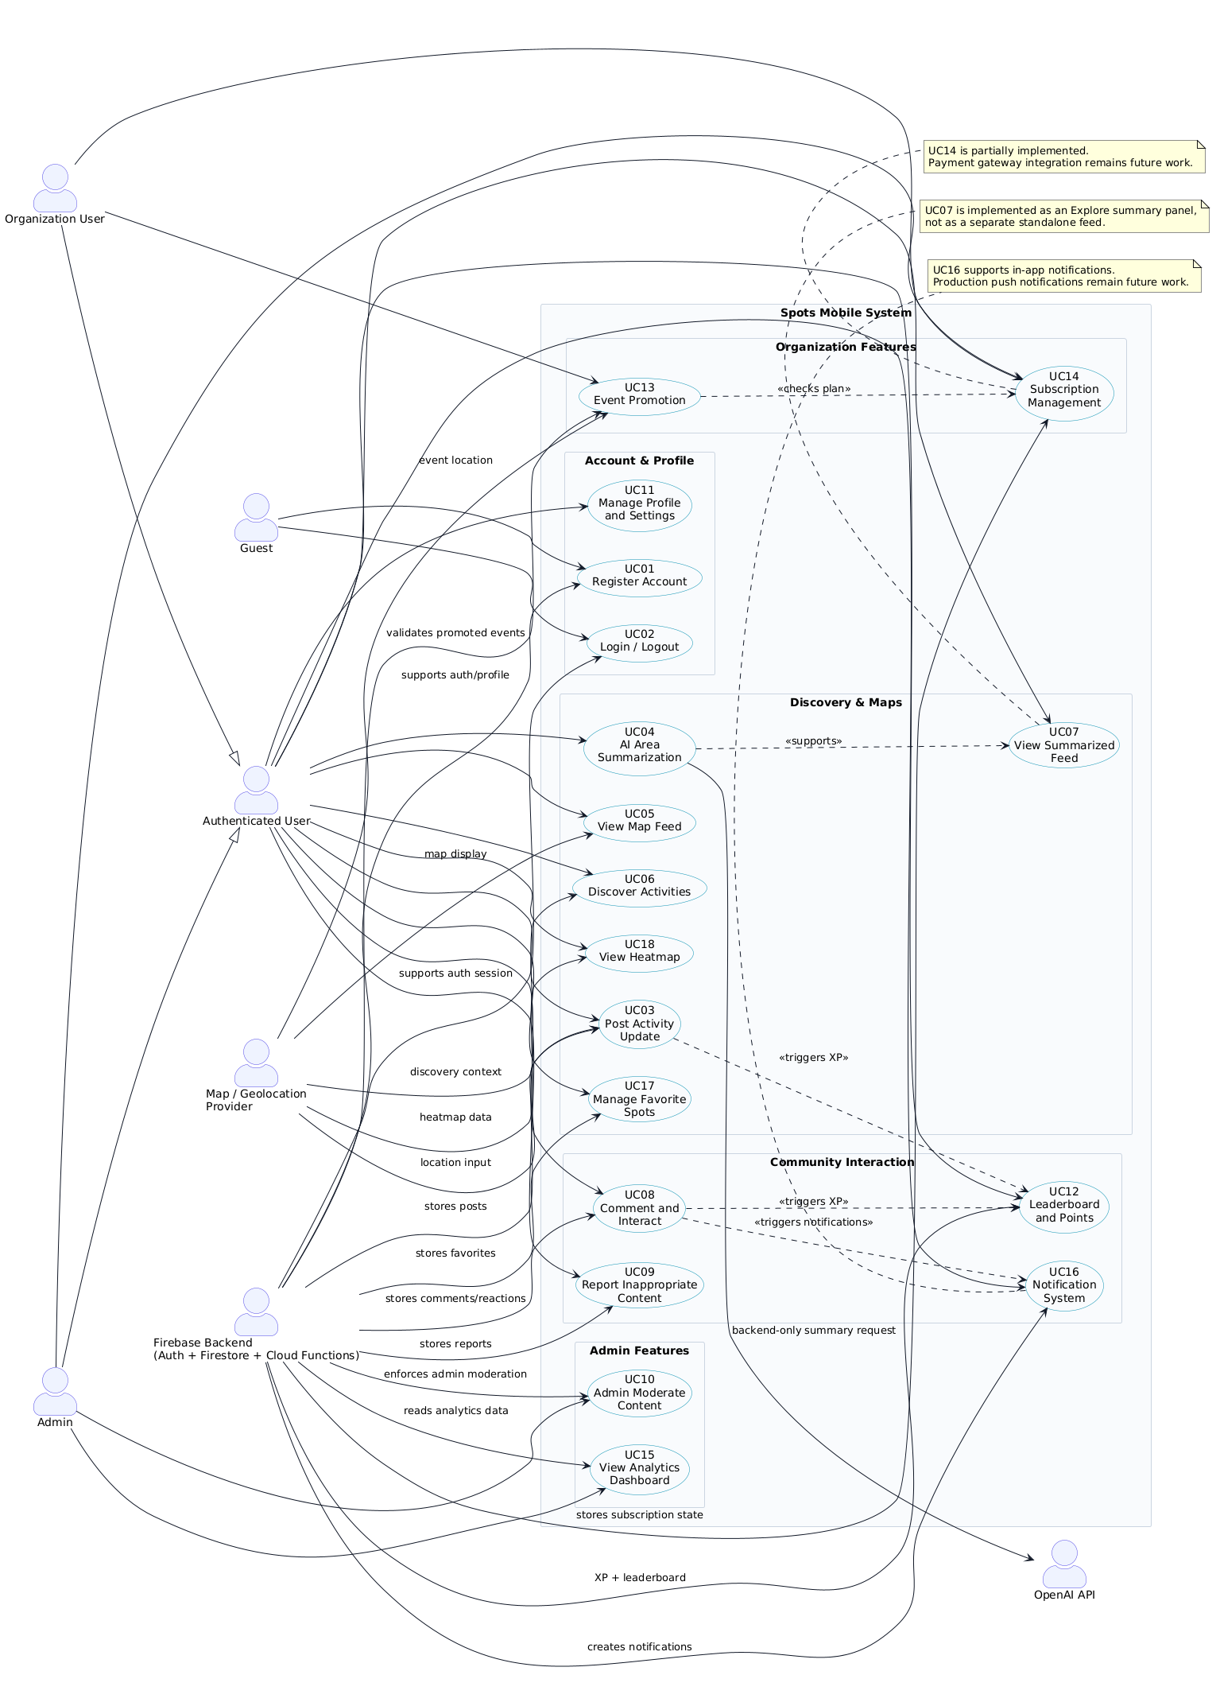
Figure 1. Use cases diagram

The final system includes 18 use cases, covering account management, local discovery, posting, AI summarization, interaction, moderation, organization features, notifications, gamification, and analytics
ID | Use case | Brief description
UC01 | Register Account | Create a user account and initialize profile/subscription records.
UC02 | Login/Logout | Authenticate and terminate user sessions.
UC03 | Post Activity Update | Create local posts with text, category, and location data.
UC04 | AI Area Summarization | Summarize selected area posts through backend OpenAI integration.
UC05 | View Map Feed | Display posts/events through Explore map and list surfaces.
UC06 | Discover Activities | Search and filter local discovery items by category/text.
UC07 | View Summarized Feed | Show area-level summary inside Explore.
UC08 | Comment and Interact | Add comments and reactions to posts.
UC09 | Report Inappropriate Content | Report posts/comments for admin review.
UC10 | Admin Moderate Content | Review reports and hide reported targets.
UC11 | Manage Profile and Settings | Edit profile, language, privacy, and notification preferences.
UC12 | Leaderboard and Points | Award XP and display ranked users.
UC13 | Event Promotion | Allow eligible organization accounts to create promoted events.
UC14 | Subscription Management | Manage plan level/status that controls organization features.
UC15 | View Analytics Dashboard | Show admin analytics snapshot.
UC16 | Notification System | Create and read in-app notifications for likes/comments.
UC17 | Manage Favorite Spots | Save/remove favorite posts and view saved items.
UC18 | View Heatmap | Show activity intensity from posts/events where map support allows.
Table 2. Use cases summary

3.1.1 Requirement Analysis and Scope
The project was developed in two main stages. The early stage focused on validating the most essential functionality through a proof-of-concept. This included registration, login, post creation, basic map discovery, early summarization, and heatmap exploration. These features confirmed that the project idea was technically feasible and useful for the target users.
The final stage expanded the system into a fuller MVP by adding more complete user, organization, and admin workflows. This included profile management, saved spots, comments, reactions, reports, moderation, backend-secured AI summaries, organization-promoted events, subscription state management, XP, notifications, leaderboard, and analytics.
The final project scope includes all UC01–UC18 as part of the implemented MVP. Some advanced production-level features, such as real payment gateway processing, full production push notifications, full media upload, and app-store deployment, are treated as future work and are not included as completed production features.

3.1.2 Use Case Prioritization
The use cases were prioritized according to their importance to the project goal, dependency on other features, and contribution to the final MVP.
Priority Level | Use Cases | Reason
High Priority – Core System | UC01, UC02, UC03, UC05, UC06, UC11 | These use cases are required for users to access the app, create content, browse local updates, and manage their accounts.
High Priority – Discovery and AI Value | UC04, UC07, UC18 | These use cases provide the main intelligent discovery value of the system through summaries, map exploration, and heatmap/activity intensity.
Medium Priority – Community Interaction | UC08, UC09, UC16, UC17 | These use cases improve engagement, allow users to interact with content, save useful posts, receive updates, and report harmful content.
Medium Priority – Trust and Administration | UC10, UC15 | These use cases support admin moderation and monitoring, which are important for trust, safety, and system management.
Medium Priority – Organization and Business Features | UC12, UC13, UC14 | These use cases support gamification, organization event promotion, and subscription-controlled access to organization features.

3.1.3 Final Implementation Scope
The final MVP scope is summarized below:
Scope Area | Included Use Cases | Final Status
Account and Profile Management | UC01, UC02, UC11 | Implemented
Local Discovery and Posting | UC03, UC05, UC06, UC18 | Implemented
AI-Supported Discovery | UC04, UC07 | Implemented through backend-secured summary flow
Community Interaction | UC08, UC16, UC17 | Implemented
Trust and Moderation | UC09, UC10 | Implemented
Organization and Subscription Features | UC13, UC14 | Implemented at MVP level using role and plan-state validation
Engagement and Analytics | UC12, UC15 | Implemented at MVP level
Overall, the functional requirements show that Spots Mobile evolved from a basic proof-of-concept into a complete MVP that supports the main workflows for regular users, organization accounts, and administrators.

Non-functional requirements
<ToDo:
- Identify non-functional requirements (i.e., desired quality attributes) and clearly document them using measurable scenarios, such that you can later test whether they are met (see Section ‎8. Testing and evaluation).
- Categorize the requirements into different categories such as performance, reliability, security, usability, portability, and maintainability.
- Define precise, measurable targets for each requirement to facilitate future evaluation of their achievement during the testing phase. For instance, when addressing a performance requirement, it is crucial to define explicit metrics, such as maximum response time or throughput. Rather than merely stating a vague aim of ‘fast system’, provide specific measurable target like ‘Registering a new user should complete in under 10 seconds’. Likewise, regarding security requirements, avoid generic statements and specify the types of attacks the system must safeguard against and the threats it must withstand.
- Keep in mind: A non-functional requirement must be specific and measurable to be considered effective and valid.
- Include an evaluation plan for each non-functional requirement to test whether the system is meeting the specified targets. Include details of specific scenarios, tools or methods for evaluating each non-functional requirement.
/>
Non-functional requirements define the quality attributes that the system must satisfy beyond its main functional behavior. For Spots Mobile, these requirements focus on performance, reliability, security, privacy, usability, maintainability, portability, and scalability. Each requirement was written with a measurable target and an evaluation plan so that it can be tested later in the Testing and Evaluation section.
Non-Functional Requirement | Description | Measurable Target | Evaluation Plan
Performance | The application should remain responsive during common user actions such as login, loading Home, opening Explore, creating posts, and requesting summaries. | Login should complete in under 5 seconds under normal network conditions. Home and Explore should show first visible content in under 3 seconds under normal network conditions. | Manually test login, Home, Explore, post creation, and summary workflows. Record whether each operation completes within the expected time.
Reliability | The application should handle missing data, blocked access, denied permissions, and network/backend errors without crashing. | 100% of tested failure cases should show an error message, empty state, retry option, or fallback behavior instead of crashing. | Test empty feeds, denied location permission, invalid post input, unavailable backend response, and blocked Firestore access. Verify that the app handles each case safely.
Security | Unauthorized users should not be able to access protected data or perform restricted actions. | Unauthorized role, subscription, report, moderation, XP, notification, and promoted event operations should be rejected in 100% of backend trust tests. | Run backend trust tests using Firebase emulators. Verify that Firestore rules and Cloud Functions reject unauthorized operations.
Privacy | Location and personal data should be handled with user consent and controlled access. | Location permission must be requested before GPS-based actions. Private leaderboard mode must hide private usernames. Users should access only their own private profile, favorites, notifications, and settings data. | Test location permission flow, privacy mode, profile access, notification access, and leaderboard display behavior.
Usability | Main workflows should be clear and understandable for first-time users. | At least 80% of test users should complete register, login, post, explore, save favorite, and profile workflows without assistance. | Conduct manual user testing or supervised walkthroughs. Record task completion, errors, and user feedback.
Maintainability | The codebase should remain modular, organized, and easy to modify. | TypeScript type checking and ESLint should complete with exit code 0. Core logic should be separated into screens, services, repositories, and backend functions. | Run npm run mobile:typecheck and npm run mobile:lint. Review project structure to confirm separation of concerns.
Portability | The system should support native mobile development and web demonstration paths where applicable. | The application should support React Native native execution paths and web demonstration paths. Android map rendering should work when a valid Google Maps API key is configured. | Test the application in the supported development environments. Verify platform-specific behavior such as maps, location access, and navigation.
Scalability | The backend design should support real-time updates and trusted server-side side effects as the number of users and posts grows. | Firestore listeners should support real-time updates. XP, notifications, promoted events, summaries, and leaderboard logic should be handled through backend-controlled logic rather than client-only logic. | Inspect backend architecture, Firestore collections, real-time listeners, and Cloud Functions. Test that backend-owned operations execute correctly through emulator tests.

Table 3. Evaluation plan for the non-functional requirement
These non-functional requirements guide the quality evaluation of Spots Mobile. They also ensure that the final system is not only functionally complete, but also responsive, secure, maintainable, privacy-aware, and suitable for future expansion.

Assumptions
<ToDo:
- List any project-specific assumptions. These are statements or conditions that are believed to be true or expected to occur during the course of a project but are not guaranteed. They can become potential failure points that need to be monitored and managed.
For instance, in the case of a QU Indoor Navigation app project, one assumption could be the ability of obtaining AutoCAD floor plans for several buildings from QU Facilities Department.
- A bulleted list should be used for this section.
/>
The development and evaluation of Spots Mobile depend on several project-specific assumptions. These assumptions are expected to hold during development, testing, and demonstration, but they may become risks if they change.
- Users have internet access when using authentication, Firestore data, maps, AI summaries, notifications, and promoted event features.
- Users grant location permission when using GPS-based posting, map recentering, or location-aware discovery.
- Firebase services remain available during development, testing, and project demonstration.
- OpenAI-backed summarization works when the required backend runtime configuration is correctly set.
- Android map rendering works when a valid Google Maps API key is configured.
- Organization event creation requires a valid organization role and an eligible subscription plan state.
- Admin-only features depend on correctly assigned user roles in the database.
- The system is tested using realistic sample data that represents expected local posts, events, users, reports, and interactions.
- Users understand that AI summaries are generated from available post data and may not represent every real-world condition in an area.
- Production push notifications, real payment gateway processing, full media upload, and public app-store deployment are outside the current MVP and are treated as future work.
- The project team has continued access to development tools, documentation, testing devices, Firebase emulators, and supervisor feedback throughout the project.

Ethics
<ToDo:
- Identify and discuss the legal and ethical considerations and professional responsibilities relevant to your project while taking into account the perspectives of stakeholders such as clients, users, team members, and the community impacted by the project. These ethical aspects can vary widely depending on the nature of the project, such as responsible management of confidential data, data privacy, security, accessibility, respecting intellectual property rights and avoiding plagiarism, and many other pertinent considerations.
- Define project-specific code of ethics by drawing upon relevant resources such as the ACM and the IEEE Software Engineering Code of Ethics and Professional Practice
  - Select the most relevant codes of ethics to effectively address the identified ethical considerations and professional responsibilities throughout the project's lifecycle. Your choices should align with the scope, objectives, and unique challenges of your project.
Do not copy and paste the entire ACM and IEEE codes of ethics into your report. Instead, review them and, in your report, concentrate on discussing those codes that are most applicable to your particular project.
  - Detail how you plan to incorporate and adhere to the selected codes of ethics at various stages of the project’s lifecycle.
  - Demonstrate your critical thinking by considering alternative courses of action and providing well-justified choices based on logical and persuasive reasoning.
  - Conclude your discussions with a table that summarizes the ethical considerations and professional responsibilities relevant to your project.
/>
Developing Spots Mobile involves several ethical, legal, and professional responsibilities because the system handles user accounts, location-related posts, community-generated content, AI-generated summaries, reports, moderation actions, notifications, organization promotion, and user engagement data. These responsibilities must be considered from the perspective of users, organizations, administrators, the project team, and the wider community affected by the application.
The project followed selected principles from the ACM Code of Ethics and the IEEE Software Engineering Code of Ethics and Professional Practice. Instead of copying the full codes, the team focused on the principles most relevant to this project: avoiding harm, respecting privacy, protecting sensitive data, being honest and transparent, ensuring fairness, and maintaining professional responsibility throughout the project lifecycle.

3.4.1 Ethical and Legal Considerations
The main ethical and legal considerations in Spots Mobile are as follows:
- User privacy:
The application uses location-aware features and user-generated posts. Therefore, users should have control over when location data is used and how their information appears to others.
- Data security:
User accounts, profile data, posts, notifications, reports, subscriptions, and admin actions must be protected from unauthorized access. The system addresses this through Firebase Authentication, Firestore security rules, and backend-controlled operations.
- Location data sensitivity:
Location information can reveal user behavior and movement patterns. For this reason, the system should avoid exposing unnecessary sensitive location details and should only use location data for clear application purposes such as posting, map discovery, and local summaries.
- AI transparency:
AI-generated summaries may influence how users understand an area or activity. Therefore, summaries should be presented as AI-assisted outputs, not as guaranteed facts. The system should avoid misleading users into thinking that AI summaries represent complete or official information.
- Content moderation:
Since users can create posts and comments, the system must provide a way to report inappropriate, misleading, harmful, or irrelevant content. Admin moderation helps reduce harm and maintain a safe community environment.
- Fairness in promoted content:
Organization-promoted events should be clearly distinguishable from normal community posts. Users should not be misled into thinking paid or promoted content is neutral community activity.
- Accessibility and inclusivity:
The system supports English and Arabic interface behavior to serve a wider range of users in Qatar. The interface should remain simple and understandable for students, residents, visitors, and organization users.
- Intellectual property:
User-generated posts and uploaded content should be respected as user-owned content. The project team should also properly cite external sources, tools, frameworks, and references used in the report and implementation.

3.4.2 Relevant ACM & IEEE Principles Applied
The team selected the following ethical principles as the most relevant to Spots Mobile:
- Avoid harm:
The system includes reporting and moderation features to reduce the risk of harmful, misleading, or inappropriate content.
- Be honest and trustworthy:
AI summaries should be treated as generated assistance, not as absolute truth. Promoted content should also be clearly represented.
- Be fair and inclusive:
The application is designed to support different user groups, including residents, students, visitors, organizations, and administrators. English/Arabic support improves accessibility for the Qatari context.
- Respect privacy:
Location and profile-related features should use only the data needed for application functionality. Users should be able to manage their profile and privacy settings.
- Protect sensitive data:
Authentication, Firestore rules, backend validation, and controlled access are used to protect user data and prevent unauthorized operations.
- Maintain professional responsibility:
The team is responsible for accurately documenting what was implemented, what was tested, and what remains as future work. The report should not claim unsupported features such as real payment processing or production push notifications if they are not fully implemented.

3.4.3 Applying the Ethics Throughout SDP I
Ethical considerations were applied throughout the project lifecycle:
Project Stage | Ethical Application
Requirements analysis | Privacy, security, moderation, accessibility, and trust were considered when defining the functional and non-functional requirements.
Design | The system was designed with a layered architecture, role-based access, backend-controlled AI summarization, and admin moderation workflows.
Implementation | Firebase Authentication, Firestore security rules, backend Cloud Functions, role checks, and validation were used to protect sensitive operations.
AI integration | AI summarization was moved to the backend so that API credentials are not exposed in the client application.
Community interaction | Reports, moderation, content hiding, and admin review were included to reduce harmful or inappropriate content.
Organization features | Promoted events and subscription-controlled access were designed to support organizations while maintaining fairness and user trust.
Testing | Backend trust tests, manual workflow checks, and non-functional testing were used to verify security, reliability, and system behavior.
Documentation | The report distinguishes completed MVP features from future work to maintain honesty and professional accuracy.

3.4.4 Ethical Alternatives Considered
Several ethical design alternatives were considered during the project:
- Direct AI calls from the client vs. backend-controlled AI calls:
Direct client-side AI calls would be simpler to implement, but they could expose API credentials. The backend-controlled approach was selected because it is safer and more professional.
- Open posting vs. moderated community posting:
Allowing users to post without moderation tools would make the system simpler, but it could increase spam or harmful content. The team chose to include reporting and admin moderation.
- Precise location display vs. controlled location usage:
Precise location data can improve map accuracy, but it may also create privacy risks. The system uses location data for discovery and posting while relying on permissions and privacy-aware handling.
- Client-only role checks vs. backend role enforcement:
UI checks improve user experience, but they are not enough for security. The system uses backend rules and Cloud Function validation for sensitive operations.
- Full payment implementation vs. subscription state management:
Real payment gateway integration would make organization subscriptions more complete, but it requires production-level financial and legal handling. The project therefore implements subscription state management at MVP level and leaves real payment integration for future work.
Ethical Consideration / Professional Responsibility | How It Is Addressed Throughout the Project
User Privacy | Location permission, privacy settings, controlled access to user data, and limited exposure of personal information.
Data Security | Firebase Authentication, Firestore security rules, backend validation, and restricted admin/organization operations.
AI Transparency | AI summaries are treated as generated assistance and routed through backend-controlled logic.
Content Moderation | Users can report posts/comments, and admins can review reports and hide inappropriate content.
Fair Promotion | Organization-promoted events are controlled by role and subscription state to prevent misuse.
Accessibility and Inclusivity | English/Arabic support and simple navigation make the application more usable for Qatar’s diverse users.
Intellectual Property | User-generated content is respected, and external sources/tools must be cited properly in the report.
Professional Honesty | The report clearly separates implemented MVP features from future work such as full media upload, real payment integration, and production push notifications.
Data Responsibility | User, report, notification, subscription, and XP data are organized with controlled access and backend validation.
Table 4. Project-specific code of ethics and professional responsibilities

3.4.5 Conclusion
Ethical considerations shaped the design, implementation, testing, and documentation of Spots Mobile. Because the application depends on location data, user-generated content, AI summaries, and organization promotion, user trust must remain a central design priority. The project addresses this through privacy-aware design, backend-secured AI integration, role-based access control, content reporting, admin moderation, and honest documentation of completed and future features. Overall, the selected ethical principles helped guide the project toward a safer, fairer, and more responsible community discovery platform

Project Plan

Project milestones
< ToDo:
- Create a table that outline and describe the project key milestones. For example, a milestone could involve choosing a use case (or a component from your high-level design) then designing, implementing, and testing its realization.
/>
The project milestones show how Spots Mobile progressed from an early proof-of-concept into a fuller final MVP. The milestones cover requirements refinement, architecture improvement, implementation, backend integration, testing, documentation, and final preparation.
Table 5. Project milestones
ID | Milestone | Description | Deliverables | Duration (Days)
1 | Review Early Requirements and Refine Scope | Review the early proof-of-concept requirements and update the scope for the final project, including completed, partial, and future-work features. | Updated requirements, refined use case table, revised assumptions and scope | 4
2 | Move from Proof-of-Concept to Final App Structure | Convert the early prototype into a more complete React Native application structure with clearer navigation, services, repositories, and platform configuration. | Final app structure, navigation setup, service/repository organization | 6
3 | Implement Authentication, Profile, and Localization | Complete register, login, logout, authentication restoration, profile setup, profile editing, privacy settings, and English/Arabic localization. | Working authentication flow, profile/settings screens, localization support | 7
4 | Implement Core Discovery Features | Build Home, Explore, Post, and Profile workflows with category filtering, saved spots, comments, reactions, and real-time Firestore updates. | Functional Home, Explore, Post, and Profile workflows | 10
5 | Implement Map, Location, and Heatmap Features | Integrate map/geolocation behavior for post creation, Explore map feed, markers, activity heatmap, and location-based discovery. | Map feed, geolocated posts/events, heatmap or heat points | 7
6 | Integrate Backend-Secured AI Summarization | Replace early summarization behavior with Firebase Cloud Function integration so summaries are generated through backend-secured OpenAI calls. | Summary Cloud Function, summary service, Explore summary panel | 6
7 | Implement Trust, Moderation, and Community Interaction | Add post/comment reporting, admin report review, content hiding, comments, reactions, favorites, and moderation-related Firestore rules. | Report system, admin moderation panel, comments/reactions/favorites | 8
8 | Implement Organization, Subscription, and Promoted Event Features | Add organization role support, subscription state, promoted event creation, plan limits, and admin controls for organization accounts. | Organization event form, subscription logic, admin plan management | 8
9 | Implement XP, Notifications, and Leaderboard | Add XP triggers for posts/comments/likes, in-app notifications, privacy-aware leaderboard, and related backend logic. | XP events, notification records, leaderboard panel | 6
10 | Strengthen Backend Security and Trust Testing | Strengthen Firestore security rules and test authentication, ownership, role restrictions, subscription access, moderation, XP, notifications, and promoted events. | Firestore rules, backend trust test suite, passed trust-test results | 6
11 | System Integration and Final Verification | Integrate all modules and verify the main workflows across authentication, discovery, posting, maps, summaries, reports, events, notifications, and admin tools. | Integrated MVP build, typecheck/lint results, manual workflow evidence | 5
12 | Final Documentation, Diagrams, and Presentation Preparation | Complete the final report, update architecture/design/testing sections, insert diagrams, prepare screenshots/evidence, and finalize presentation material. | Final report, diagrams, test evidence, screenshots, presentation slides | 7

Project timeline
< ToDo:
- The project timeline defines who will do what and when to ensure efficient project execution and progress tracking. You need to:
- Develop a detailed project timeline that breaks down each milestone into smaller, manageable tasks.
- Estimate the time required to complete each task.
- Assign the tasks to individual team members and define a work schedule stating the start and end date of each task. You can use Microsoft Project or Excel to create your project timeline. Insert a Gantt chart and a project timeline table in this section.
Additionally, keep in mind the overall project duration, which typically spans around 14 weeks for each semester. It is vital to decide the roles and responsibilities of each team member to avoid any ambiguity.
- Be sure to include time to document your work at each milestone to incrementally produce your final report. Additionally, schedule time for project evaluation, reflection on the experience gained, and the finalization and review of both the report and presentation.
/>
The project timeline was prepared to organize the final development phase after the early proof-of-concept had already validated the main idea. The schedule covers 14 weeks / 70 working days, excluding weekends, and includes implementation, testing, documentation, screenshots, reflection, and final presentation preparation

Table 6. Project timeline
ID | Task Name | Start Date | End Date | Duration (Days) | Assigned To | Dependencies
1 | Final scope review and requirements refinement | 19 Jan 2026 | 23 Jan 2026 | 5 | All team members | —
2 | Architecture, database, and design update | 26 Jan 2026 | 06 Feb 2026 | 10 | Yahia, Ghanim, all review | 1
3 | Authentication, profile, and localization completion | 09 Feb 2026 | 17 Feb 2026 | 7 | Ahmad, Yahia | 2
4 | Core discovery, posting, and interaction implementation | 18 Feb 2026 | 27 Feb 2026 | 8 | Ahmad, Mohammed, Ghanim | 3
5 | Map, location, heatmap, and Explore integration | 02 Mar 2026 | 10 Mar 2026 | 7 | Mohammed, Ahmad | 4
6 | Backend-secured AI summarization integration | 11 Mar 2026 | 19 Mar 2026 | 7 | Yahia, Ghanim | 5
7 | Reports, moderation, organization events, and subscriptions | 20 Mar 2026 | 31 Mar 2026 | 8 | Ghanim, Yahia, Mohammed | 6
8 | XP, in-app notifications, leaderboard, and analytics | 01 Apr 2026 | 09 Apr 2026 | 7 | Yahia, Ahmad, Ghanim | 7
9 | Backend trust testing and system integration | 10 Apr 2026 | 17 Apr 2026 | 6 | All team members | 8
10 | Final documentation, screenshots, reflection, and presentation | 20 Apr 2026 | 24 Apr 2026 | 5 | All team members | 9

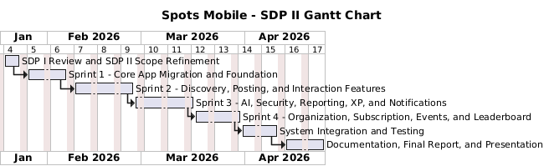
Figure 2. Project Gantt chart: Timeline of key tasks and milestones

Anticipated risks
< ToDo:
- Present a table that outlines potential risks, which are events that could jeopardize the successful completion of the project.
- Outline the approach to mitigate each identified risk, ensuring the project's smooth progression and minimizing disruptions.
/>
The project involved several technical, operational, and documentation-related risks that could affect implementation, testing, or final delivery. The team identified these risks early and defined mitigation actions to reduce their impact.
Table 7. Project Risks
Risk | Approach to Mitigate the Risk
Map provider configuration missing | Document the Google Maps API key requirement clearly and test map behavior on supported platforms before the final demonstration.
OpenAI quota or configuration missing | Use backend error handling for missing configuration, quota limits, or failed AI requests. Document the required Firebase runtime configuration for AI summarization.
Unauthorized data access | Use Firebase Authentication, Firestore security rules, callable role checks, and backend trust tests to protect restricted operations.
Scope creep | Classify large production-level features such as real payment processing, full media upload, production push notifications, and app-store release as future work.
Lack of real usability evidence | Conduct supervised user testing where possible and document task completion, user feedback, and any remaining evidence gaps honestly.
Missing diagrams or screenshots | Maintain a checklist for all required diagrams, UI screenshots, testing screenshots, and figure captions before final submission.
Real-device build issues | Test the application on available real devices or emulators before presentation and document platform-specific setup steps.

System Architecture

High level system architecture
< ToDo:
- Present a brief overview of the solution and the system's architecture, allowing stakeholders to understand its key components and interactions.
- Include a high-level system architecture diagram of the proposed solution that serves as a visual guide for the detailed design. The diagram should show how your solution is decomposed and organized into components. Use labeled boxes to represent components and arrows to show how they interact. Indicate external systems or services that the system may interface with.
- Describe the key responsibilities and functions of each component of your high-level architecture. Explain the interfaces they expose or utilize.
- Discuss the key interactions between the identified components, encompassing aspects like data flow, communication protocols, and dependencies between components. Use diagrams, flowcharts, or textual descriptions to clarify these interactions.
- Discuss the architectural style (e.g., Layered, MVC, SPA) used by your solution. Justify the choice of this architectural style, clarifying how it aligns with the project's requirements.
/>
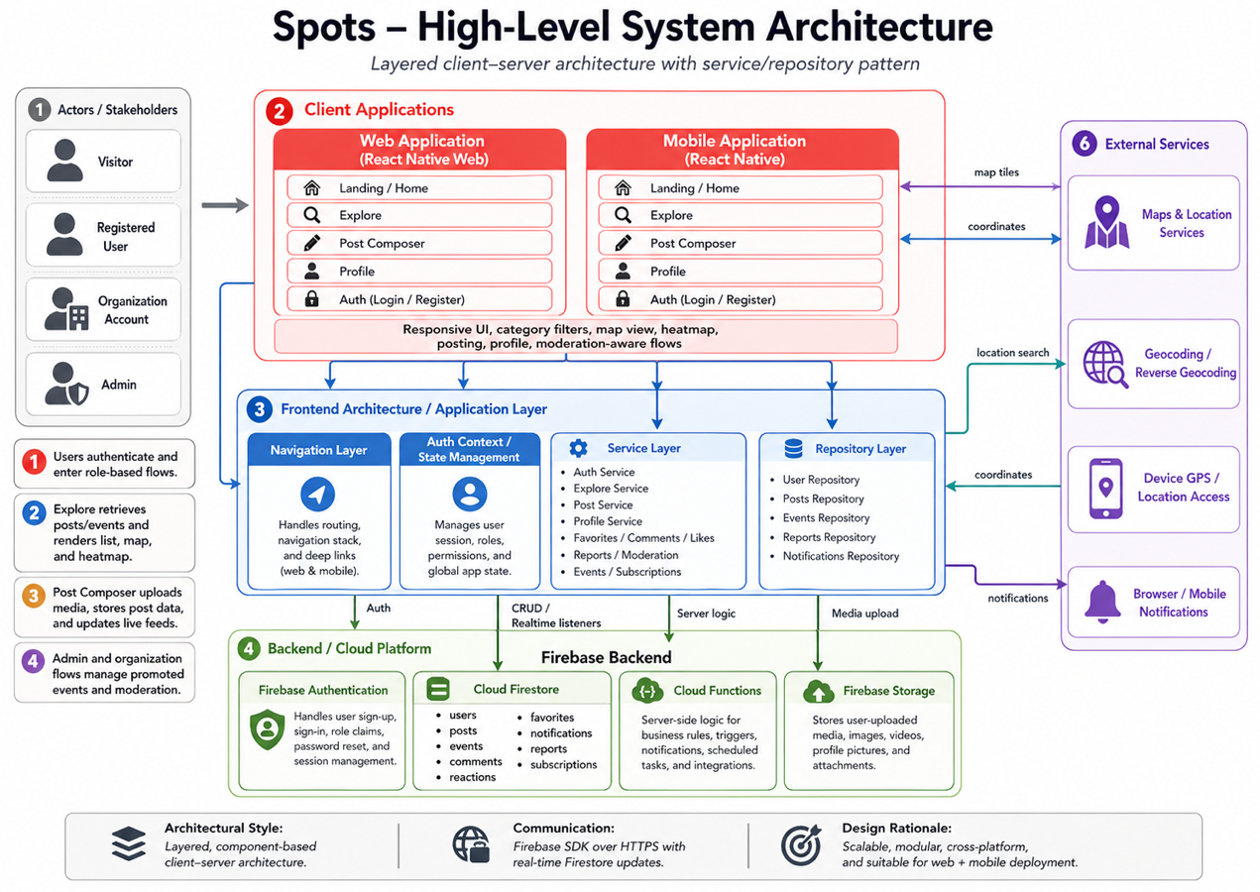
Figure 2. High-level system architecture diagram
Spots Mobile follows a layered client-server architecture with a clear separation between the user interface, application logic, data access, backend services, and external integrations. This architecture was selected because the project includes several connected workflows, such as authentication, map-based discovery, post creation, profile management, moderation, organization events, AI summaries, notifications, XP, and leaderboard features. Separating these responsibilities makes the system easier to test, maintain, and extend.
The architecture is organized into the following main layers:
- Actors / Stakeholders
The system supports four main user groups: visitors, registered users, organization accounts, and administrators. Each actor has different access rights and interacts with different parts of the system.
- Client Applications
The client side contains the mobile application and web demonstration surfaces. These provide the main user interface for authentication, Home, Explore, Post Composer, Profile, and admin/organization workflows. The interface is designed to support responsive UI behavior, category filters, map views, posting, profile settings, and moderation-aware flows.
- Frontend Architecture / Application Layer
This layer includes navigation, authentication state management, localization, services, and repositories. It controls the flow between screens and coordinates user actions before they are sent to Firebase or backend functions.
- Backend / Cloud Platform
The backend is based on Firebase services, including Firebase Authentication, Cloud Firestore, Firestore Security Rules, and Firebase Cloud Functions. These services manage user identity, application data, real-time updates, trusted backend operations, and access control.
- External Services
The system integrates with maps/geolocation services and the OpenAI API. Map and geolocation services support location-based discovery, while the OpenAI API is used only through backend Cloud Functions to generate area summaries securely.

5.1.1 Component Responsibilities

Component | Responsibility
React Native CLI mobile app | Provides iOS/Android user interface and main app workflows.
Web entry points | Provide browser-compatible demonstration surfaces.
React Navigation | Handles auth stack and main tab navigation.
AuthContext | Observes Firebase authentication state and exposes user identity.
LocalizationContext | Provides English/Arabic UI behavior and text direction support.
Services | Validate input and coordinate domain workflows.
Repositories | Encapsulate Firestore and callable function access.
Firebase Authentication | Manages user registration, login, logout, and identity tokens.
Cloud Firestore | Stores application data and supports real-time subscriptions.
Firestore Security Rules | Enforce ownership, role, and document-shape restrictions.
Firebase Cloud Functions | Run trusted backend logic for summaries, promoted events, XP, notifications, and leaderboard.
OpenAI API | Generates area summaries through backend calls.
Maps/Geolocation | Render discovery maps and provide location context.

5.1.2 Key Interactions and Data Flow
The system interactions follow a controlled flow from the user interface to the backend:
- Authentication flow
Users register or log in through the client interface. Firebase Authentication validates the credentials and returns an authenticated session. The Auth Context observes this state and allows the user to access protected application screens.
- Profile and settings flow
Profile data, privacy settings, language preferences, and notification settings are stored in Cloud Firestore. The profile service validates changes before passing them to the repository layer.
- Post creation flow
A user creates a local post with text, category, and location data. The post service validates the input, the repository writes the post to Firestore, and real-time listeners update Home, Explore, map markers, and related discovery surfaces.
- Explore and map flow
Explore retrieves posts and promoted events from Firestore. The map/geolocation service provides coordinates, map tiles, location search, and discovery context. The interface then displays map markers, list cards, filters, and heatmap or heat-point behavior where supported.
- AI summary flow
The user requests an area summary from Explore. The summary service sends selected post data to a Firebase Cloud Function. The Cloud Function validates the request, calls the OpenAI API, and returns a generated summary to the client. This avoids exposing the API key in the client application.
- Interaction and moderation flow
Users can comment, react, save favorite posts, and report inappropriate content. These actions are stored in Firestore through repositories. Admin users can review reports and hide reported posts or comments based on moderation rules.
- Organization and subscription flow
Organization accounts can create promoted events only when the backend confirms that the user has the correct role and eligible subscription state. This validation is handled by backend logic instead of relying only on UI checks.
- XP, notification, and leaderboard flow
User actions such as posting, commenting, and receiving likes can trigger XP and notification records. Leaderboard data is generated through backend-controlled logic and respects privacy settings.

5.1.3 Architectural Style and Justification
The selected architectural style is a layered client-server architecture with a service/repository pattern. This style was selected because Spots Mobile has several features that require clear separation of responsibilities.
The presentation layer focuses on screens and user interaction. The service layer handles validation and business workflows. The repository layer isolates database and callable function access. The backend layer enforces trusted operations, data persistence, security rules, and server-side logic. External systems such as OpenAI and maps/geolocation services are accessed through controlled interfaces.
This architecture is suitable for the project because it:
- Reduces coupling between UI screens and backend implementation.
- Makes the system easier to test and debug.
- Supports real-time Firestore updates.
- Protects sensitive backend logic and API keys.
- Allows future expansion, such as full media upload, production push notifications, and payment integration.
- Fits the project’s need for mobile, map-based, AI-assisted, and role-based workflows.

Alternative solutions and tradeoffs
< ToDo:
- Discuss alternative solutions and architectural styles that you have considered to deliver the project requirements. Analyze their respective tradeoffs and merits.
- Provide sufficient justifications for selecting the preferred solution architecture and design. Clearly articulate why the chosen approach is superior to the alternative solutions, highlighting its advantages and benefits.
/>
Several alternative solutions and architectural approaches were considered before selecting the final architecture.

Alternative | Advantages | Disadvantages / Tradeoffs | Decision
Native iOS and Android applications | Best platform control, strong native performance, direct access to device features. | Requires two separate codebases using Swift and Kotlin, increasing development time and maintenance effort. | Not selected because it was too time-consuming for the project scope.
Web-only application | Easier deployment, no app installation required, simpler cross-platform access. | Weaker native mobile experience, more limitations around maps, location permissions, and mobile interaction patterns. | Not selected as the main solution because the project is location-aware and mobile-first.
Custom backend with Node.js and PostgreSQL | Full control over APIs, data model, and deployment environment. | Requires more backend infrastructure, authentication setup, hosting, database management, and security implementation. | Not selected because Firebase provided faster and safer development for the project timeline.
Client-side OpenAI integration | Simple to implement and faster for prototyping. | Unsafe because API keys could be exposed in the client application. Harder to control usage, quota, and validation. | Rejected. Backend-secured Cloud Function integration was selected.
Firebase backend with Cloud Functions | Provides authentication, real-time data, security rules, backend functions, and emulator testing. | Requires careful rule design and may depend on Firebase service limits and configuration. | Selected because it supports rapid development, real-time workflows, and trusted backend operations.
Monolithic UI-only architecture | Simple for a small prototype. | Becomes difficult to maintain as features grow; business logic becomes mixed with screens. | Rejected. A layered service/repository structure was selected.
The final choice of React Native with Firebase, Cloud Firestore, Cloud Functions, and a service/repository pattern was the most suitable architecture for this project. It provides a strong balance between development speed, maintainability, security, real-time functionality, and future scalability. It also supports the project’s main requirements: mobile access, location-aware discovery, backend-secured AI summaries, role-based organization features, moderation, and community engagement.

Detailed Design
<ToDo:
- During semester 1, you will design, implement, and test 25% to 30% of the essential use cases to deliver the core and most important features of your solution. In semester 2, you will complete the remaining use cases.
- In this section you need to document the detailed design specifications of the software components to meet the functional and the non-functional requirements of your project. The detailed design serves as a reference and actionable guidance for implementing the solution.
  - Use suitable methods and tools such as class diagrams, sequence diagrams, activity diagrams and state diagrams.
- Note that for every design aspect you will present in the sections below, you must:
- Identify and evaluate possible alternative solutions (i.e., design choices) and analyze their respective tradeoffs.
- Provide detailed justifications on why you have preferred and selected a particular solution or design choice over others. Highlight how your design choices enabled you to achieve the desired system quality attributes documented in Section ‎3.2 Non-Functional Requirements. Additionally, you should highlight the novel aspects of your design.
Further justify your design choices by discussing relevant design principles that influenced your system design. For example, highlight how your design complies with key software design principles such as separation of concerns, abstraction, modularity, high cohesion, and low coupling.
/>
This section presents the detailed design of Spots Mobile. The detailed design explains how the system components were structured and how the major use cases are executed. It also describes the database design, user interface design, and design patterns used in the project.
The project was developed from an early proof-of-concept into a fuller final MVP. Therefore, the detailed design focuses on the final system structure, while still showing how the early core features were expanded into a more complete application. The final design supports authentication, local post creation, map-based discovery, AI area summarization, comments, reactions, favorites, reports, moderation, organization events, subscriptions, notifications, XP, leaderboard, profile management, and admin features.
The design follows important software engineering principles, including separation of concerns, modularity, abstraction, high cohesion, and low coupling. Screens are separated from services, services are separated from repositories, and backend-controlled operations are separated from client-side logic. This makes the system easier to maintain, test, and extend.

Structural model
<ToDo:
- You may break this section into subsections to clearly document the detailed structural model of each major component or use case.
- The structure of your software components could be documented using:
- Class diagrams to model the structure and relationships among classes, aiding in both conceptual understanding and practical implementation. If the model is too big, partition the diagram. For instance, you may present entity classes, repository classes, and service classes as separate diagrams.
      - For each class, provide specifications for attributes (names and data types) and methods (parameter names, types, and return types).
      - Clearly depict inheritance, composition, or aggregation relationships between classes. Define the association name and specify multiplicities at both ends.
      - Accompany each diagram with a succinct explanation. Include a few paragraphs discussing significant design decisions, such as how inheritance and polymorphism were employed to enhance system design. Additionally, briefly discuss how design principles such as the ‘Information Expert’ and ‘Whole controls the Parts’ principles were applied to your design.
- Design the interfaces exposed by external services that the system interacts with (e.g., BankingService, MailService). Specify input parameters, return types, and exceptions for each of these service interfaces.
/>
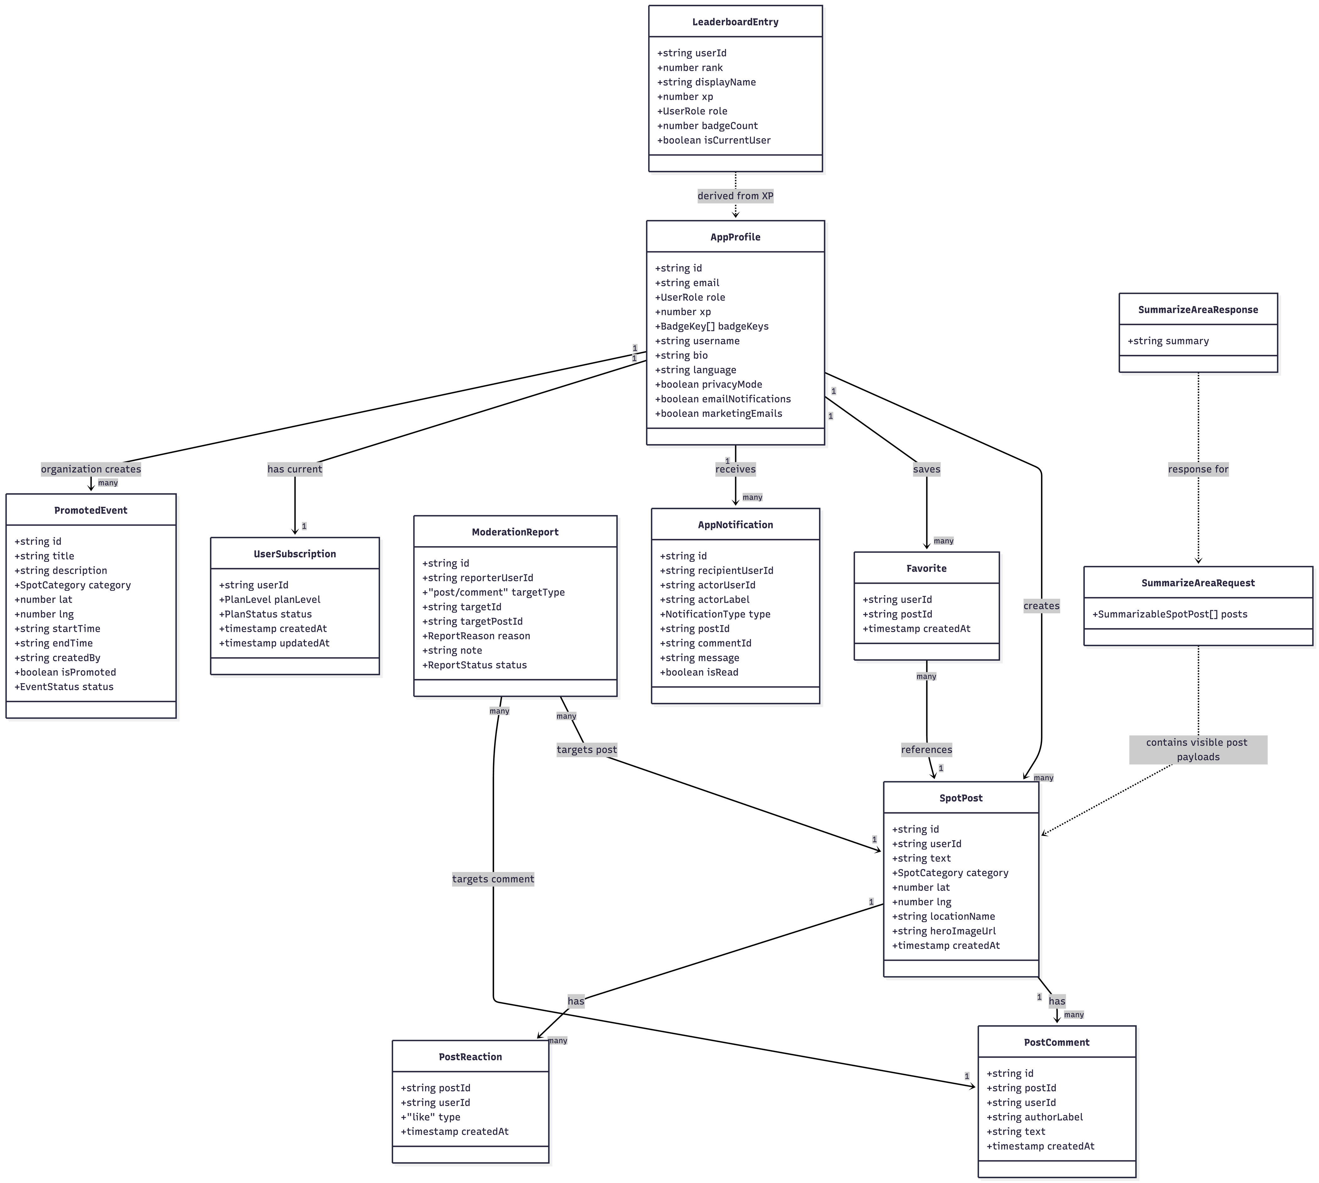
Figure 4. Structural/Class Model Diagram

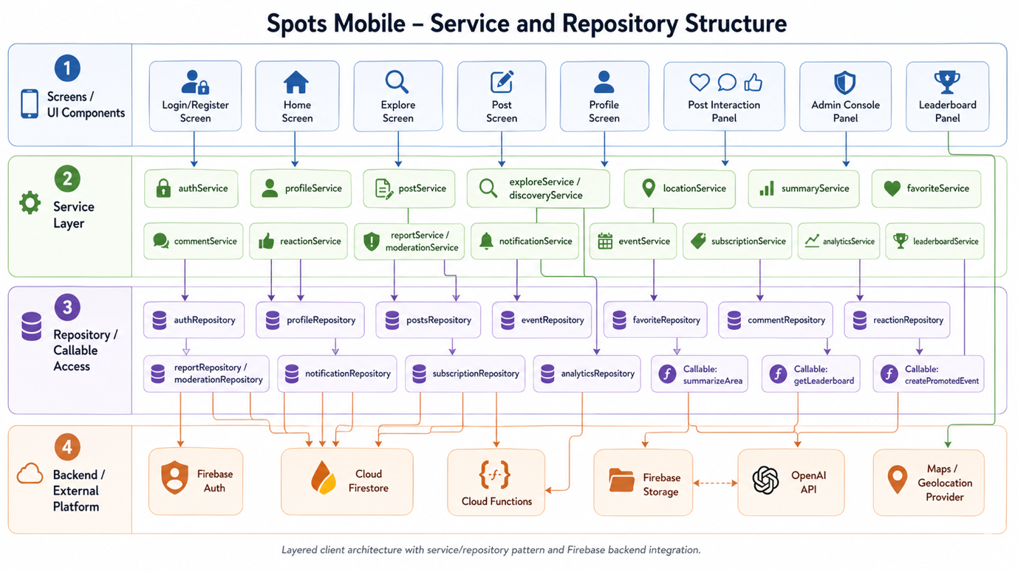Figure 5. Service and repository structure of Spots Mobile.
The structural model describes the main entities, services, repositories, and relationships in Spots Mobile. Although the implementation uses React function components and TypeScript types rather than traditional object-oriented classes for every feature, the system can still be represented using a logical class/entity model.
The design is divided into four main layers:
- Screens / UI Components
These include Login/Register, Home, Explore, Post, Profile, Post Interaction Panel, Admin Console, and Leaderboard screens.
- Service Layer
Services contain business logic and workflow coordination. Examples include authService, postService, summaryService, eventService, reportService, notificationService, and leaderboardService.
- Repository / Callable Access Layer
Repositories isolate access to Firestore and backend callable functions. This prevents screens from directly depending on database implementation details.
- Backend / External Platform Layer
Firebase Authentication, Cloud Firestore, Firebase Cloud Functions, Firebase Storage, OpenAI API, and map/geolocation services support persistence, identity, AI summaries, and location-based discovery.

6.1.1 Main Entity Model
Entity | Purpose
AppProfile | Represents the user profile, including identity, role, XP, privacy settings, language, and notification preferences.
SpotPost | Represents a local community post with text, category, coordinates, location name, image reference, and creation time.
PromotedEvent | Represents an organization-created promoted event with title, description, category, location, time, status, and creator.
PostComment | Represents a comment written by a user on a post.
PostReaction | Represents a user reaction, such as a like, on a post.
Favorite | Represents a saved post for a user.
ModerationReport | Represents a report submitted by a user against a post or comment.
UserSubscription | Represents the user’s plan level and subscription status.
AppNotification | Represents an in-app notification generated from interactions such as likes or comments.
LeaderboardEntry | Represents a ranked user in the leaderboard, derived mainly from XP values.
SummarizeAreaRequest | Represents the selected visible posts sent to the backend for AI summarization.
SummarizeAreaResponse | Represents the AI-generated summary returned by the backend.

6.1.2 Main Design Decisions
The structural model was designed around the following decisions:
- Profiles are central to the system.
Most user-specific features, such as posts, favorites, notifications, XP, subscription state, and leaderboard display, are connected to user profiles.
- Posts are the core discovery object.
Posts support the Home feed, Explore map, comments, reactions, reports, favorites, heatmap behavior, and AI summaries.
- Organization events are separated from normal posts.
Promoted events have their own entity because they require role validation, subscription checking, event dates, and organization-specific rules.
- Reports are separated from content.
Reports are stored as independent records so that admin users can review them without changing the original post/comment immediately.
- XP events are backend-controlled.
XP should not be directly created or modified by normal client actions. Backend logic is responsible for controlling XP awards.
- AI summaries are request/response based.
The mobile app sends selected post payloads to the backend. The backend validates the request, calls the AI service, and returns the summary.
This design supports maintainability because each entity has a clear responsibility. It also supports security because sensitive actions are routed through backend rules and functions rather than being controlled only by the client interface.

6.2 Behavioral model
<ToDo:
- You may break this section into subsections to clearly document the detailed behavioral model of each major component or use case. The behavioral model specifies the sequence of interactions between objects or components to depict how specific use cases are executed within the system.
- The behavioral aspects of your software components could be documented the following techniques:
- Activity diagrams to model the flow of activities and control logic within the system or a complex use case. They are particularly well-suited for modeling complex processes, workflows, or business logic. They capture conditional branching, parallel processing, and decision points.
- Design Sequence Diagrams (DSD) to document interactions and communication between objects or components over time to realize a specific use case. They emphasize the timing and dependencies of interactions. Ensure that method calls in the DSD use methods from the class diagram and must show the parameters and the return type of each method.
- State diagrams to represent the different states and transitions of important objects or components within the system. Describe the conditions triggering state transitions
- Present detailed algorithms for important functions within the software. Include pseudocode, or flowcharts to explain the logic.
/>
The behavioral model explains how the major use cases are executed over time. Sequence diagrams were used because they show the order of interactions between screens, services, repositories, Firebase services, Cloud Functions, and external APIs.
The following diagrams document the main system behaviors:
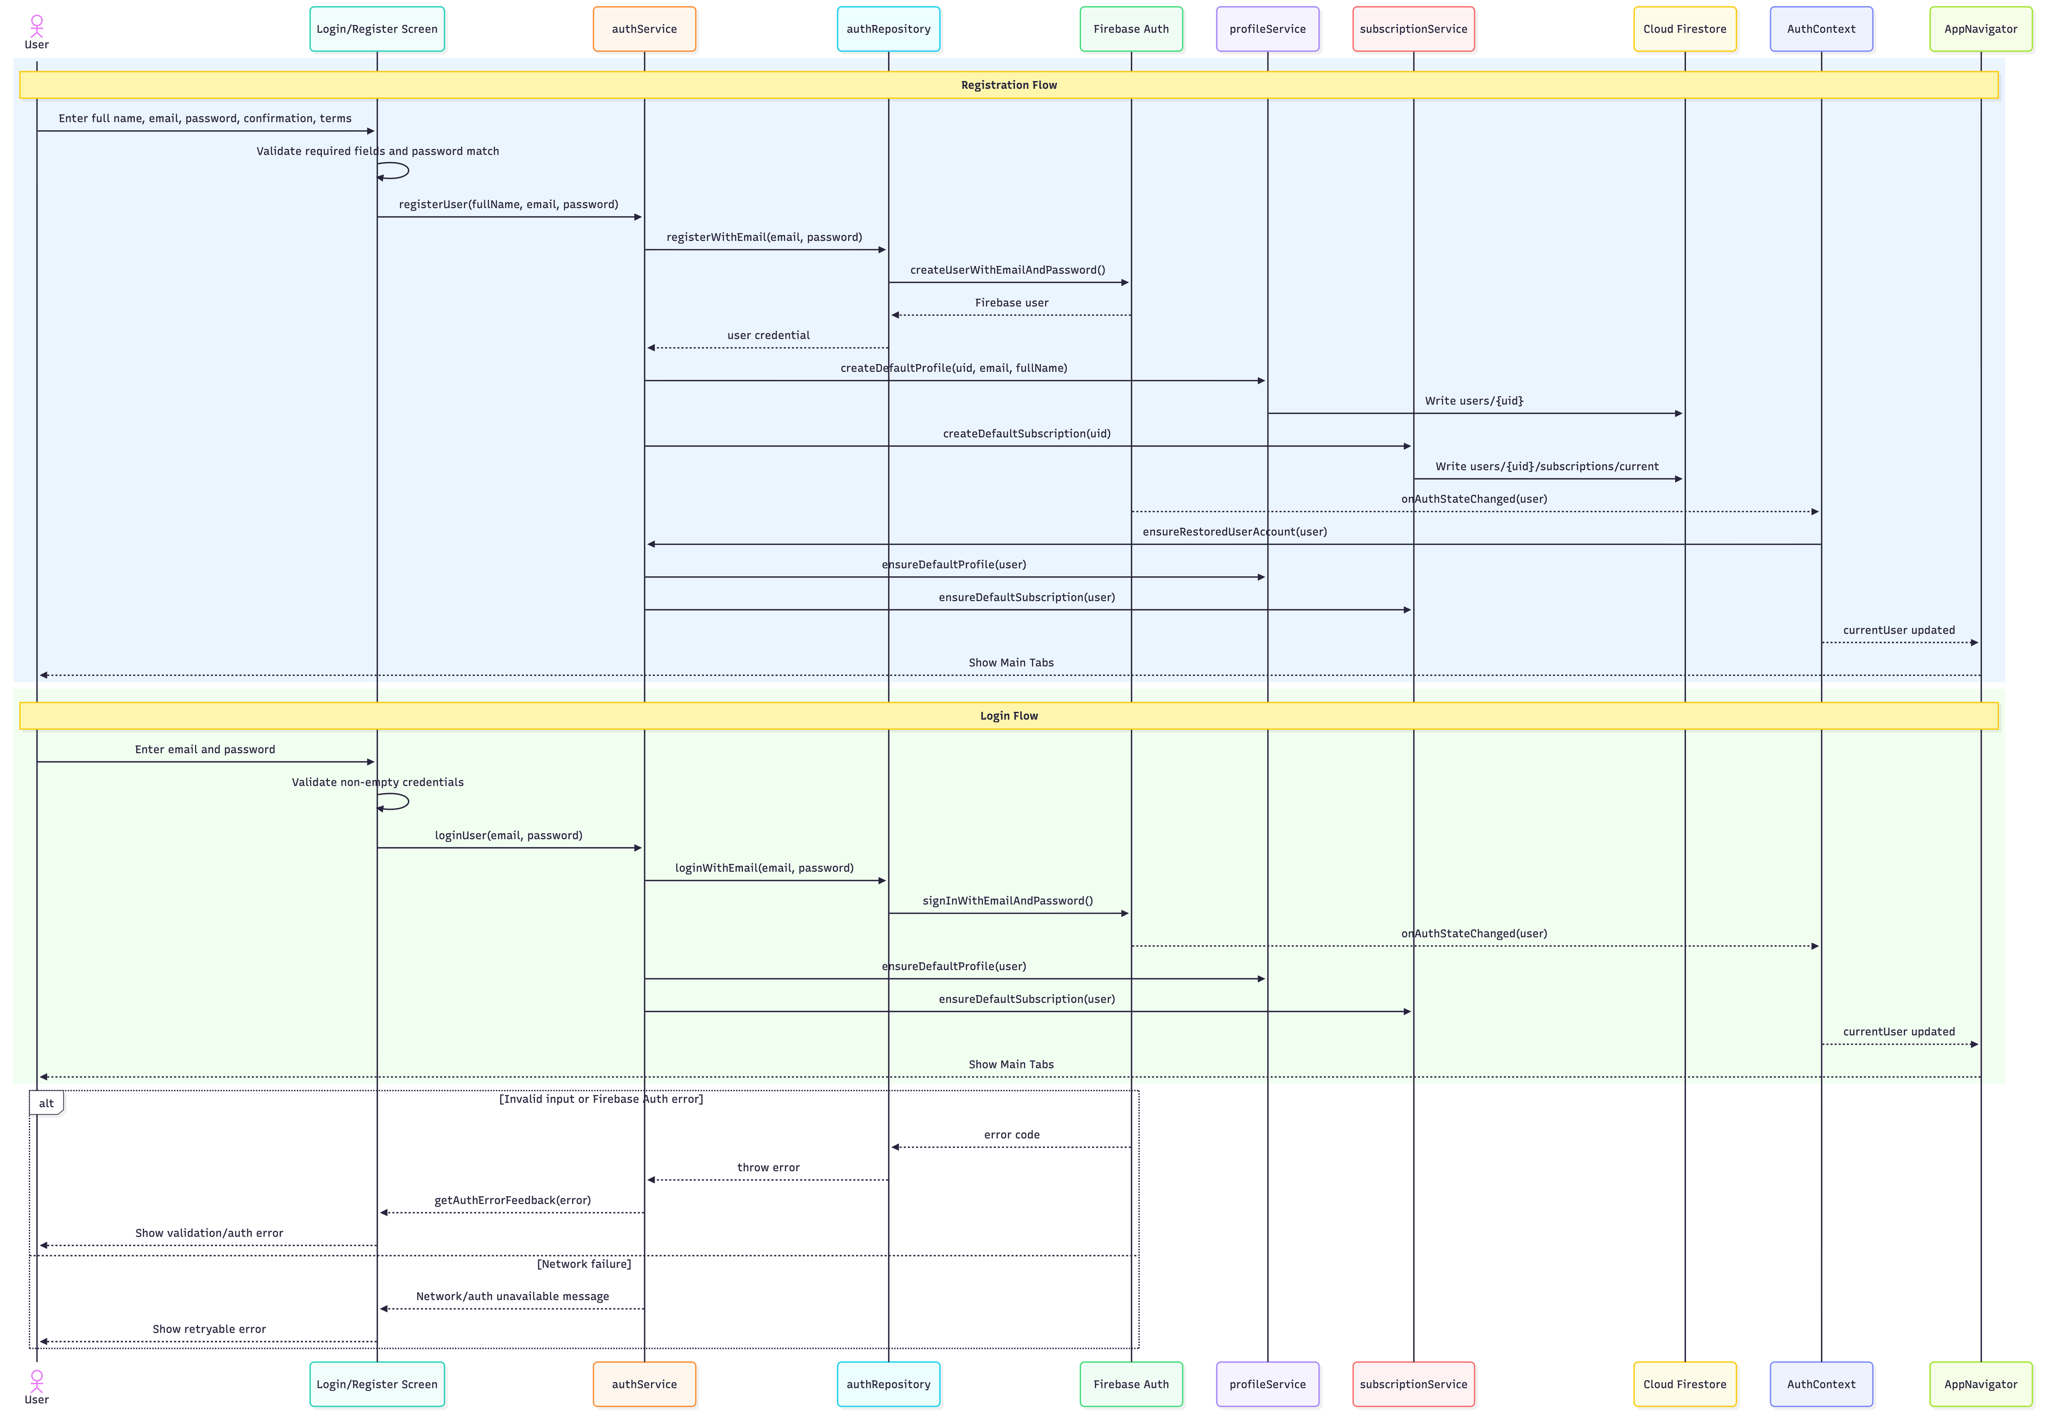
Figure 6. Register/Login Flow
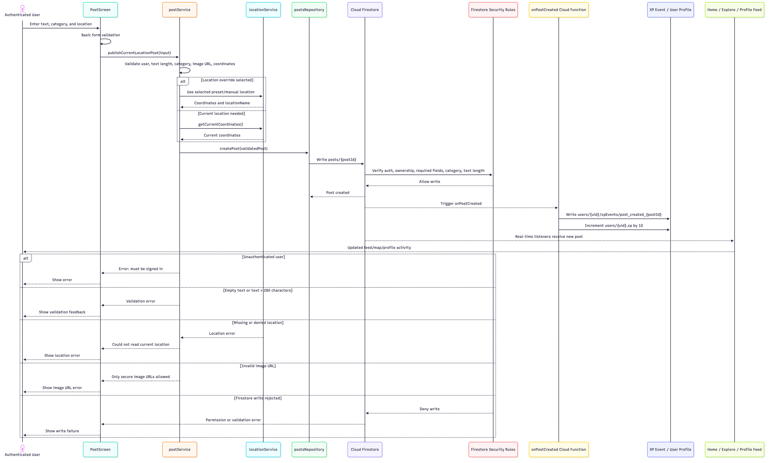
Figure 7. Post Activity Update Flow
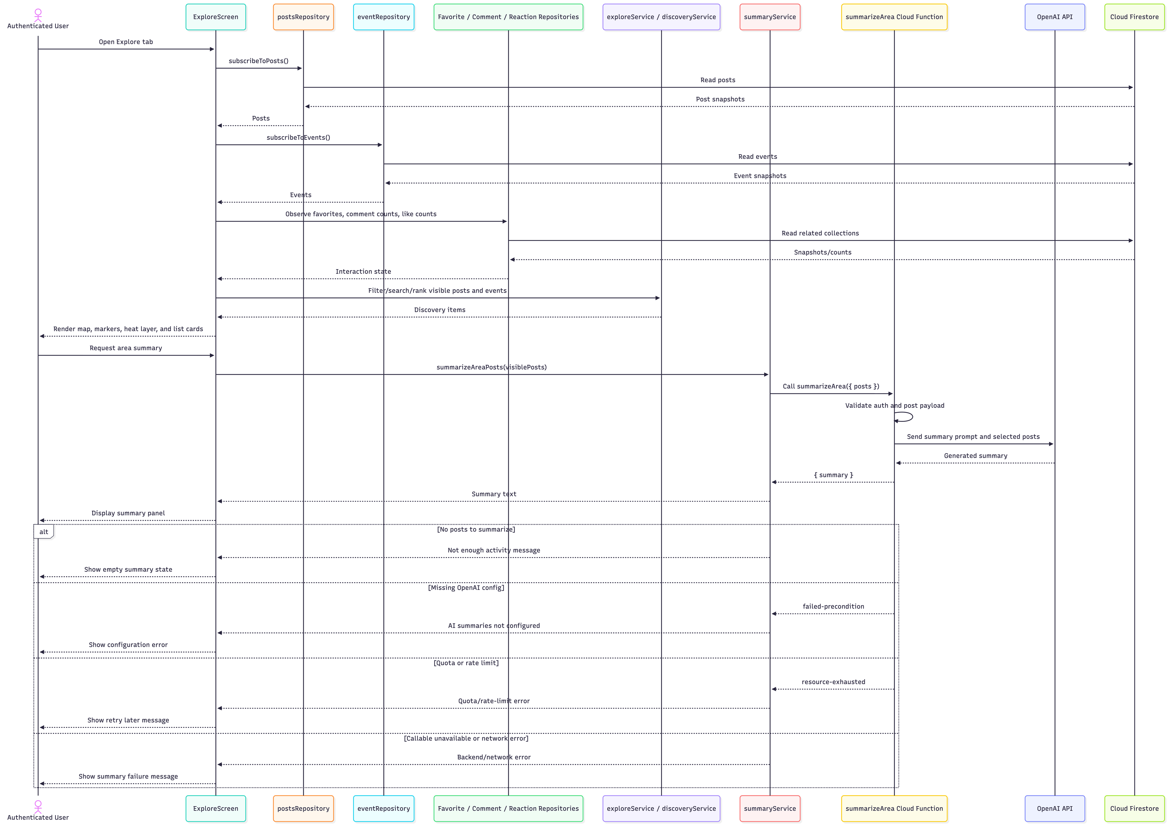
Figure 8. Explore and AI Summary Flow
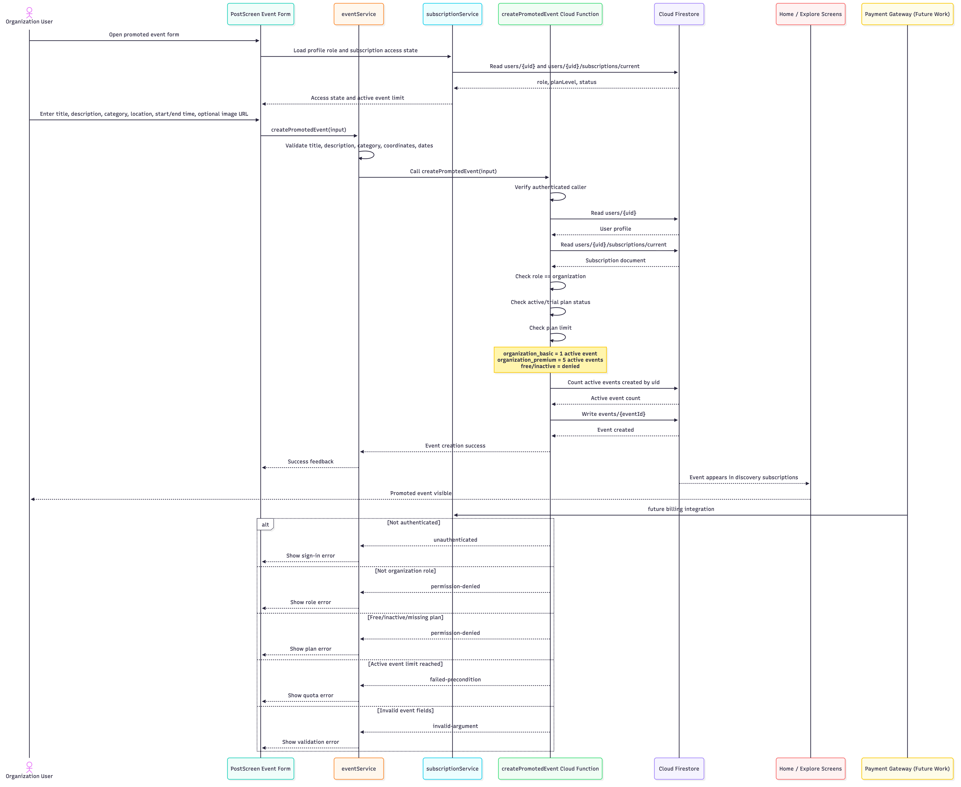
Figure 9. Promoted Event Flow
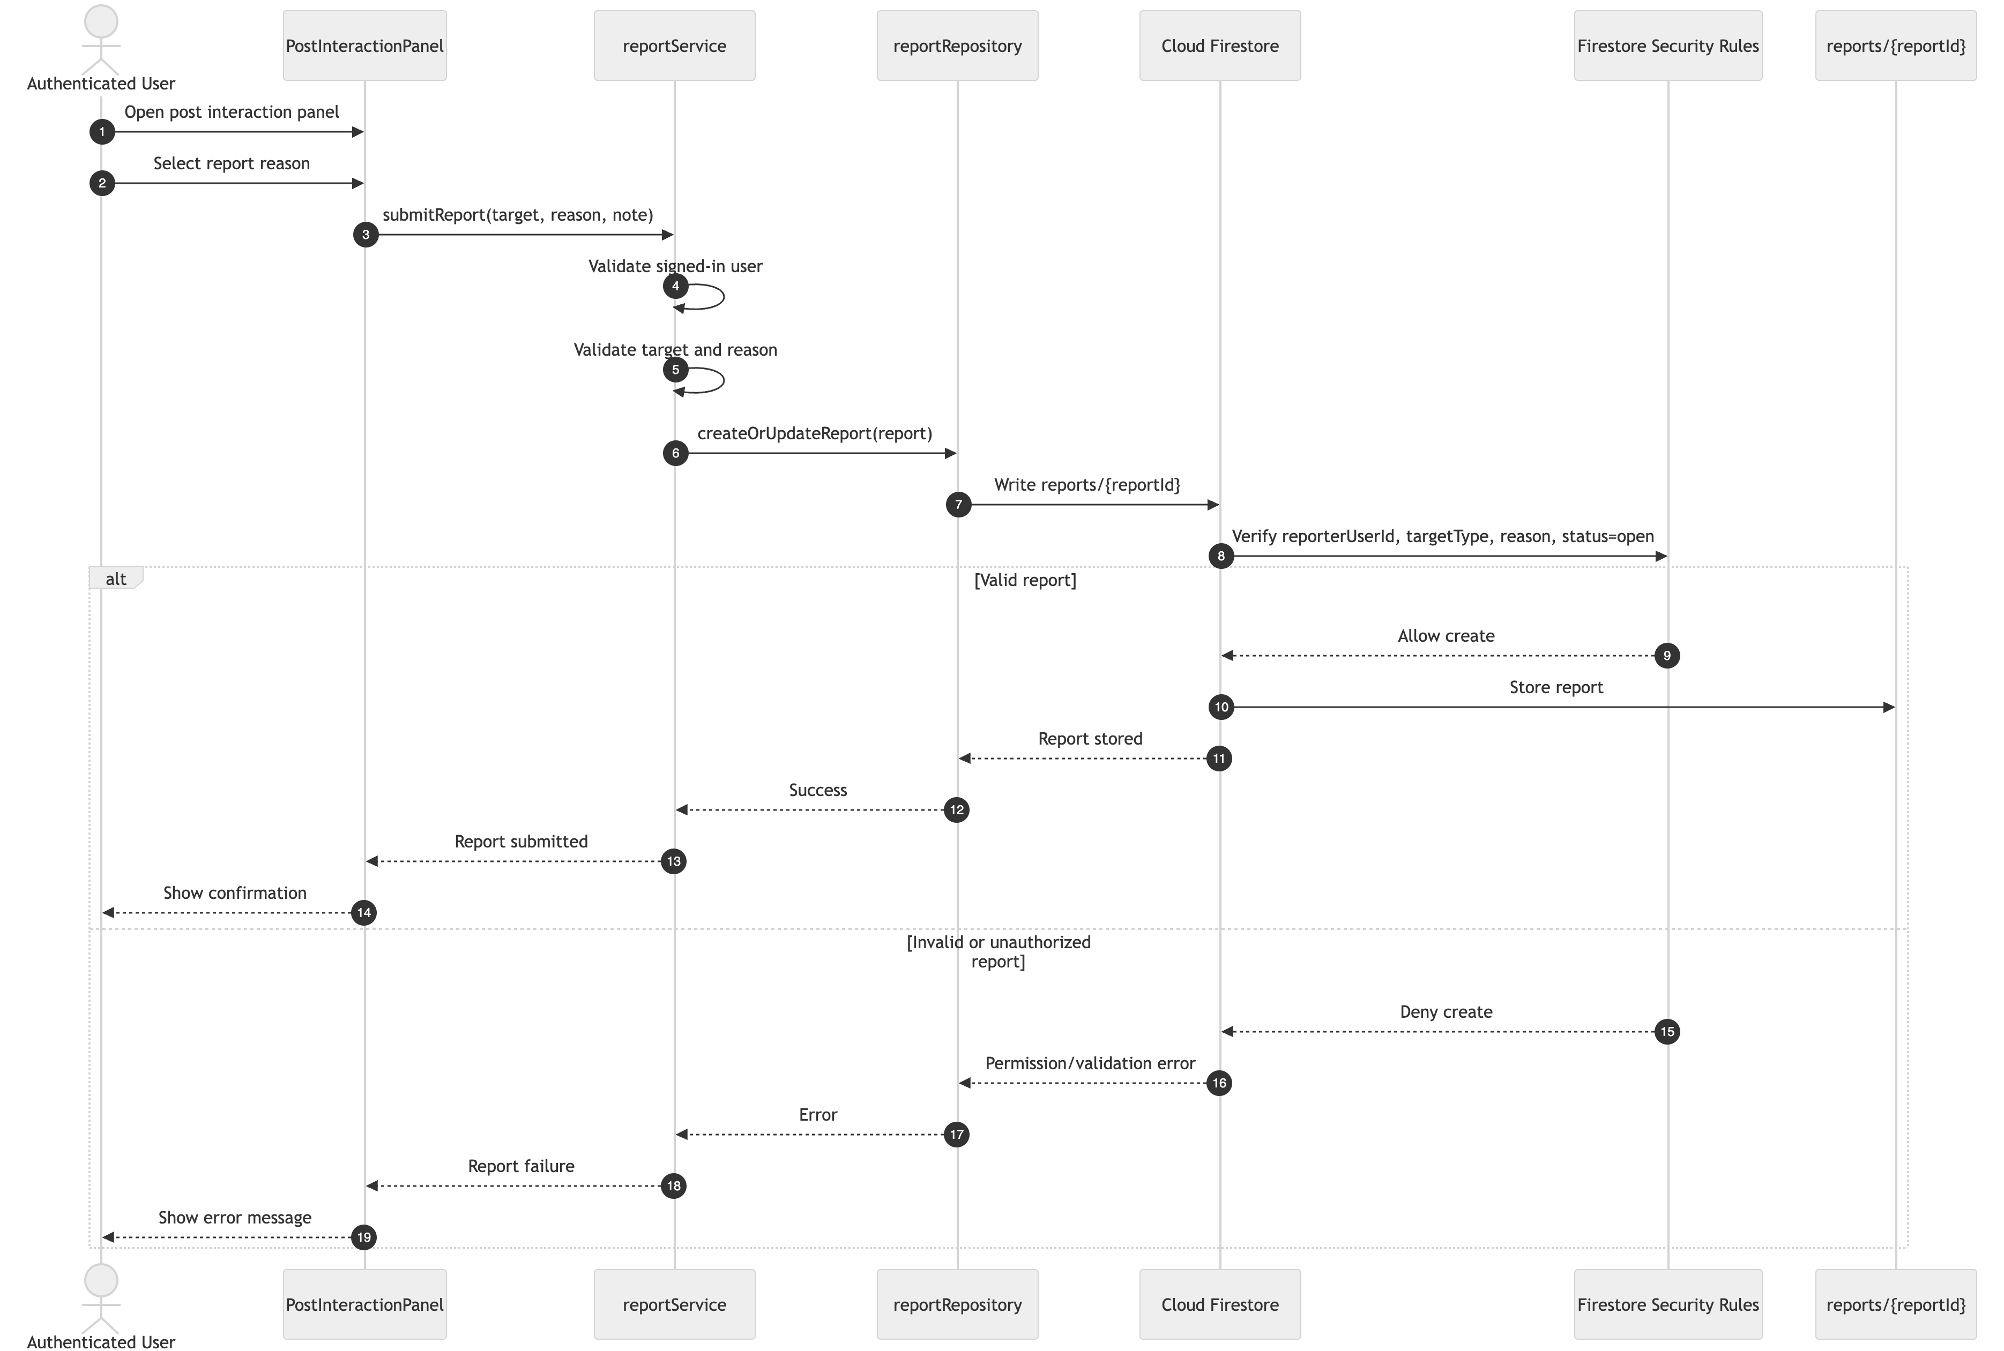
Figure 10A. User Report Creation Flow
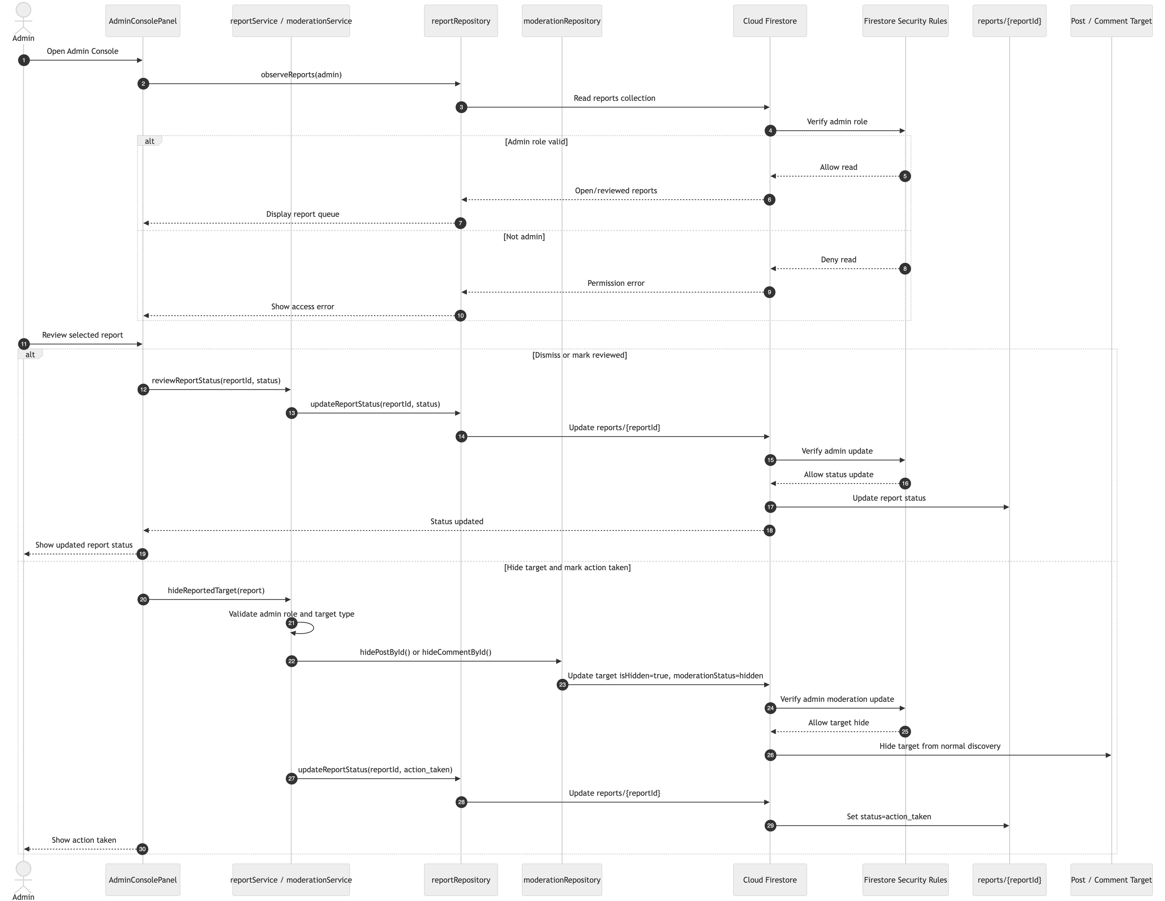
Figure 10B. Admin Moderation Flow
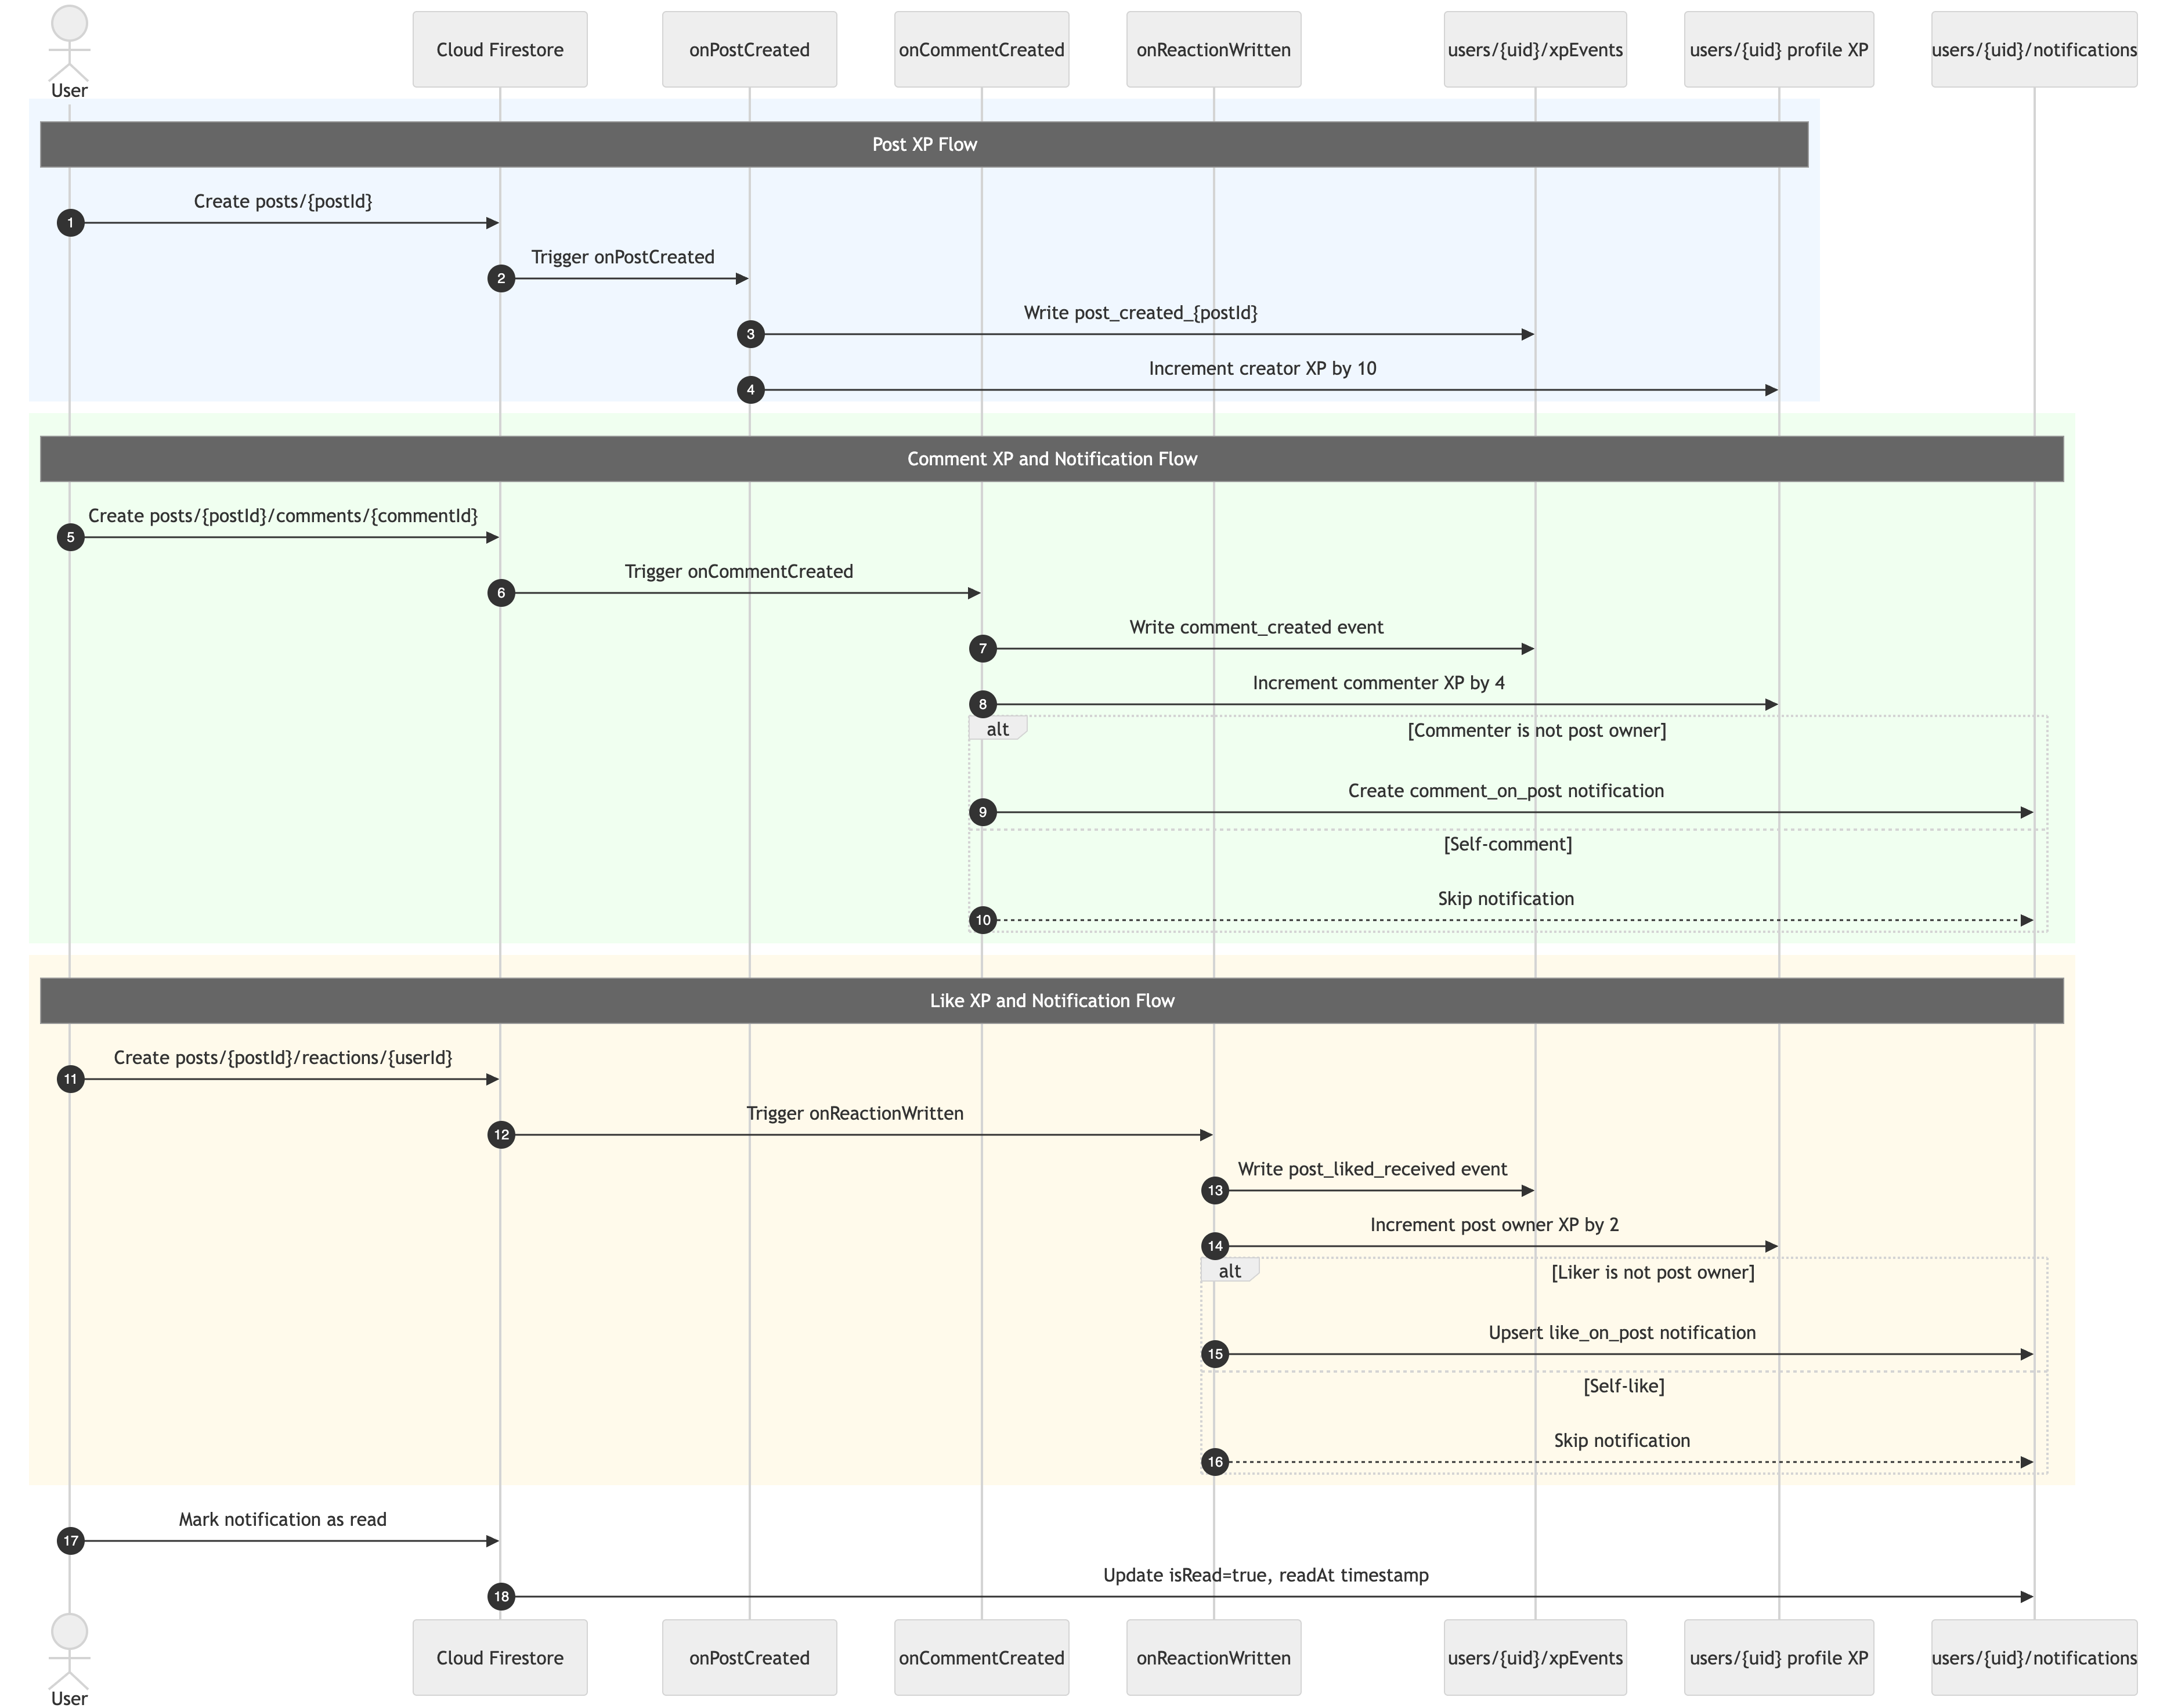
Figure 11A. XP and Notification Trigger Flow
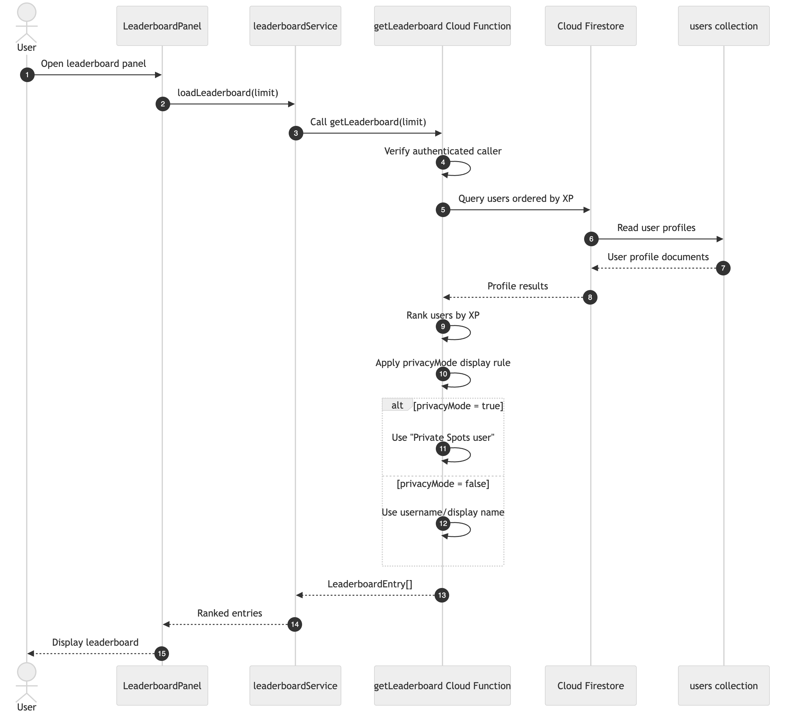
Figure 11B. Leaderboard Flow

6.2.1 Register and Login Flow
The Register/Login flow shows how users create accounts and access the application.
During registration, the user enters account details, the system validates required fields and password confirmation, and the authentication service creates the user account through Firebase Authentication. After the account is created, the system initializes the user profile and default subscription record in Firestore. The authentication context observes the signed-in user and redirects the user to the main application tabs.
During login, the user enters email and password credentials. Firebase Authentication validates the credentials, and the app restores the authenticated session. If the input is invalid or the network is unavailable, the system returns a controlled error message.
This flow supports the security and reliability requirements because protected screens depend on verified authentication state.

6.2.2 Post Activity Update Flow
The Post Activity Update flow describes how authenticated users create local posts.
The user enters post text, selects a category, and provides location context. The post service validates the input, including text length, category, image URL format where applicable, and coordinates. The location service either uses a selected/manual location or retrieves the current location if permission is granted. After validation, the post repository writes the post to Firestore.
Firestore security rules verify authentication, ownership, required fields, and document shape before allowing the write. After the post is created, backend logic can trigger XP updates, and real-time listeners update Home, Explore, Profile, and map-related views.
This flow supports the performance, reliability, and scalability requirements because posts are stored in Firestore and delivered through real-time listeners.

6.2.3 Explore and AI Summary Flow
The Explore flow combines posts, promoted events, map display, filters, interactions, and AI summaries.
When the user opens Explore, the app subscribes to posts and events through repository functions. The system also observes favorites, comments, and reactions to show interaction state. The discovery service filters and ranks visible items based on category, search text, and location context. The interface then displays map markers, list cards, heatmap or heat points, and discovery results.
When the user requests an AI area summary, the summary service sends selected visible post data to a backend Cloud Function. The Cloud Function validates the authenticated request and payload, sends the summary prompt to the OpenAI API, receives the generated summary, and returns it to the app. If there are no posts, missing AI configuration, quota limits, or backend errors, the system shows a controlled fallback message.
This design avoids direct client-side AI API calls and protects sensitive API credentials.

6.2.4 Promoted Event Flow
The Promoted Event flow describes how organization users create promoted events.
An organization user opens the promoted event form, enters event information, and submits the event. The event service validates title, description, category, coordinates, and dates. The backend Cloud Function then verifies that the caller is authenticated, checks the user role, reads the subscription state, checks the active event limit, and creates the event only if the role and plan conditions are satisfied.
If the user is not authenticated, does not have the organization role, has an inactive/free plan, exceeds the active event limit, or submits invalid fields, the system returns a controlled error.
This flow supports fairness and security because organization features are protected by backend validation instead of only UI checks.

6.2.5 User Report Creation Flow
The User Report Creation flow describes how users report inappropriate posts or comments.
The authenticated user opens the post interaction panel, selects a report reason, optionally adds a note, and submits the report. The report service validates the signed-in user, report target, reason, and note. The report repository creates or updates a report document in Firestore.
Firestore security rules verify the reporter user ID, target type, reason, and open status before allowing the report to be stored. If the report is valid, the user receives confirmation. If the report is invalid or unauthorized, the system shows an error message.
This design supports community trust by allowing users to report harmful or inappropriate content.

6.2.6 Admin Moderation Flow
The Admin Moderation flow describes how admin users review reports and take moderation actions.
An admin opens the Admin Console and requests the report queue. The moderation service checks admin access and retrieves open or reviewed reports. The admin can dismiss a report, mark it as reviewed, or hide the reported post/comment. When the admin hides a target, the moderation repository updates the target document by setting hidden/moderation fields.
Firestore security rules verify admin permissions before allowing report updates or content hiding. This ensures that normal users cannot perform admin actions.
This flow supports the security and reliability requirements because moderation is role-protected and recorded in Firestore.

6.2.7 XP and Notification Trigger Flow
The XP and Notification Trigger flow shows how engagement actions produce side effects.
When a user creates a post, comments, or reacts to a post, Firestore triggers backend functions. These functions create XP event records and update the profile XP value. For comments and likes, the backend can also create in-app notification records for the post owner, except in self-action cases.
For example:
- Creating a post awards XP to the post creator.
- Creating a comment awards XP to the commenter.
- Receiving a like can award XP to the post owner.
- Comment/like actions can create notifications for the post owner.
- Self-comments and self-likes do not create unnecessary notifications.
This design prevents the client from directly controlling XP or notification creation.

6.2.8 Leaderboard Flow
The Leaderboard flow describes how ranked users are displayed.
The user opens the leaderboard panel, and the leaderboard service calls a backend Cloud Function. The function verifies the authenticated caller, queries users ordered by XP, ranks the users, applies privacy display rules, and returns leaderboard entries. If a user has privacy mode enabled, the display name is replaced with a private label.
This design supports privacy and fairness because ranking is generated by backend logic and private users are not exposed unnecessarily.

Database design

<ToDo:
- Include a logical data model describing the major entities, their relationships, associated attributes, and respective data types . Ensure that the data model is consistent with (or derived from) the entities of the class diagram. If the model is too big partition the diagram into logical parts, such as generating separate diagrams for each component or subsystem.
/>
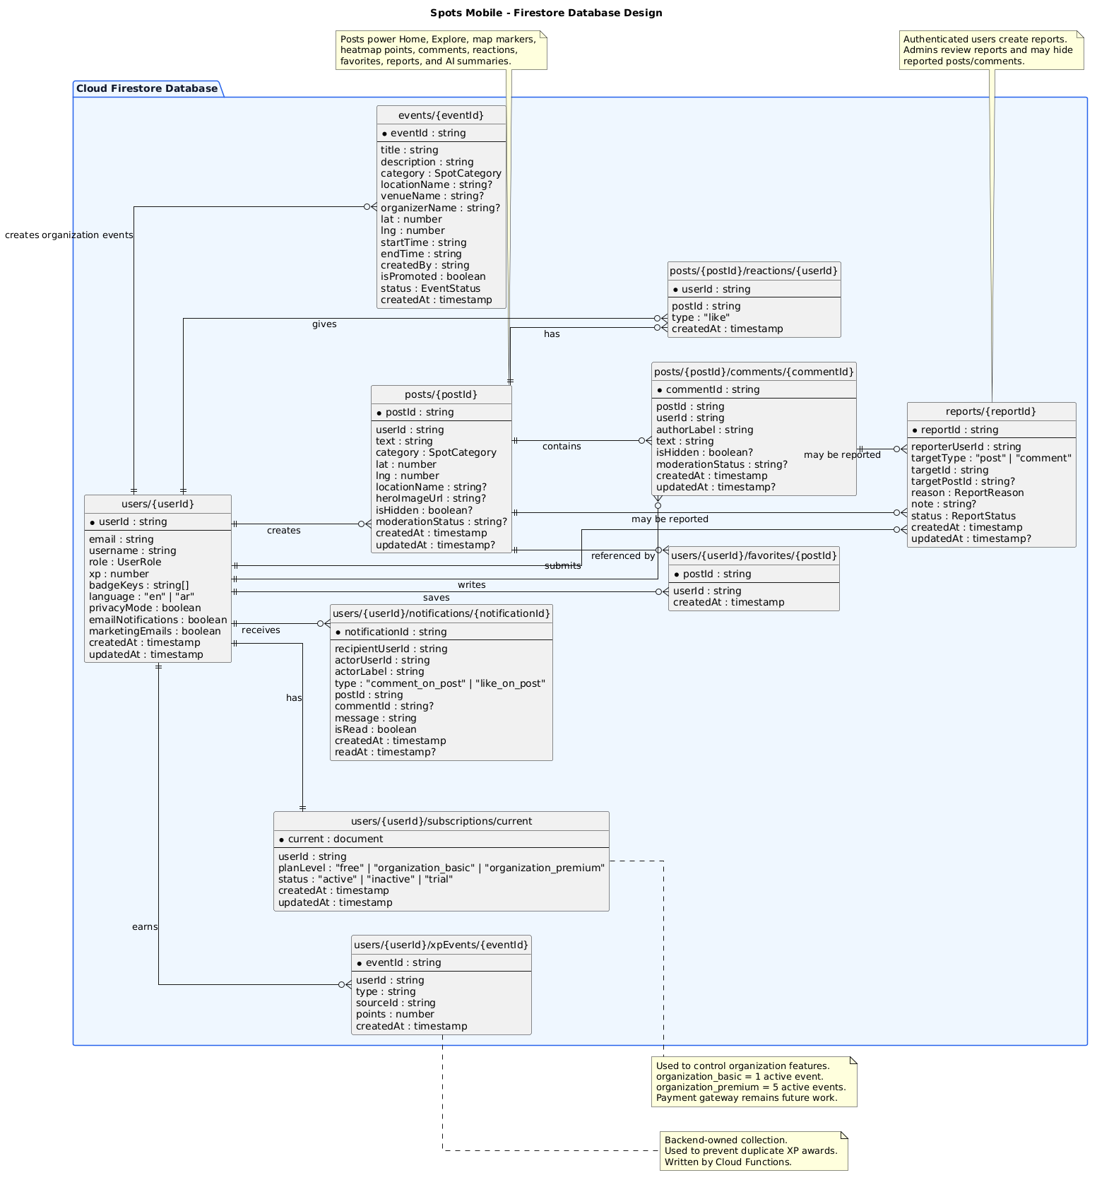
Table 12. Firestore Database Design
The database design uses Cloud Firestore collections and subcollections to store users, posts, events, reports, notifications, favorites, comments, reactions, subscriptions, and XP events. The model is derived from the structural model and supports real-time updates, role-based access control, and backend side effects.

6.3.1 Main Collections and Subcollections
Collection / Path | Purpose
users/{uid} | Stores user profile, role, XP, language, privacy mode, and notification preferences.
users/{uid}/favorites/{postId} | Stores posts saved by the user.
users/{uid}/notifications/{notificationId} | Stores in-app notifications for the user.
users/{uid}/subscriptions/current | Stores the current plan level and subscription status.
users/{uid}/xpEvents/{eventId} | Stores backend-created XP events to prevent duplicate awards.
posts/{postId} | Stores local community posts with category, text, coordinates, and metadata.
posts/{postId}/comments/{commentId} | Stores comments on posts.
posts/{postId}/reactions/{userId} | Stores reactions such as likes.
events/{eventId} | Stores organization-promoted events.
reports/{reportId} | Stores reports submitted against posts or comments.

6.3.2 Database Design Rationale
Firestore was selected because it supports real-time listeners, flexible document structures, and integration with Firebase Authentication and Cloud Functions. The design separates user data, content data, organization events, reports, and backend-generated records.
This structure supports the following quality attributes:
- Performance: Real-time listeners allow fast updates without manual refresh.
- Security: Firestore rules protect user-owned and admin-only paths.
- Scalability: Collections are separated by domain, making data easier to query and extend.
- Maintainability: Each feature maps to a clear collection or subcollection.
- Reliability: Backend functions control sensitive side effects such as XP and notifications.

User interface design
<ToDo:
- Discuss the target users and highlight relevant characteristics that influenced the design decisions.
- Describe the overall layout and visual design of the user interface, including aspects such as color schemes, typography, and graphics.
- Include screen mockups or wireframes for major use cases and explain the rationale behind key design decisions.
- Discuss the navigation design of the UI, including navigation aids or controls for moving between screens to achieve a particular use case.
- Explain any novel aspects of your UI design and how they enhance the usability of your system. This could include innovative interactions, user feedback mechanisms, or features that support accessibility or personalization. />

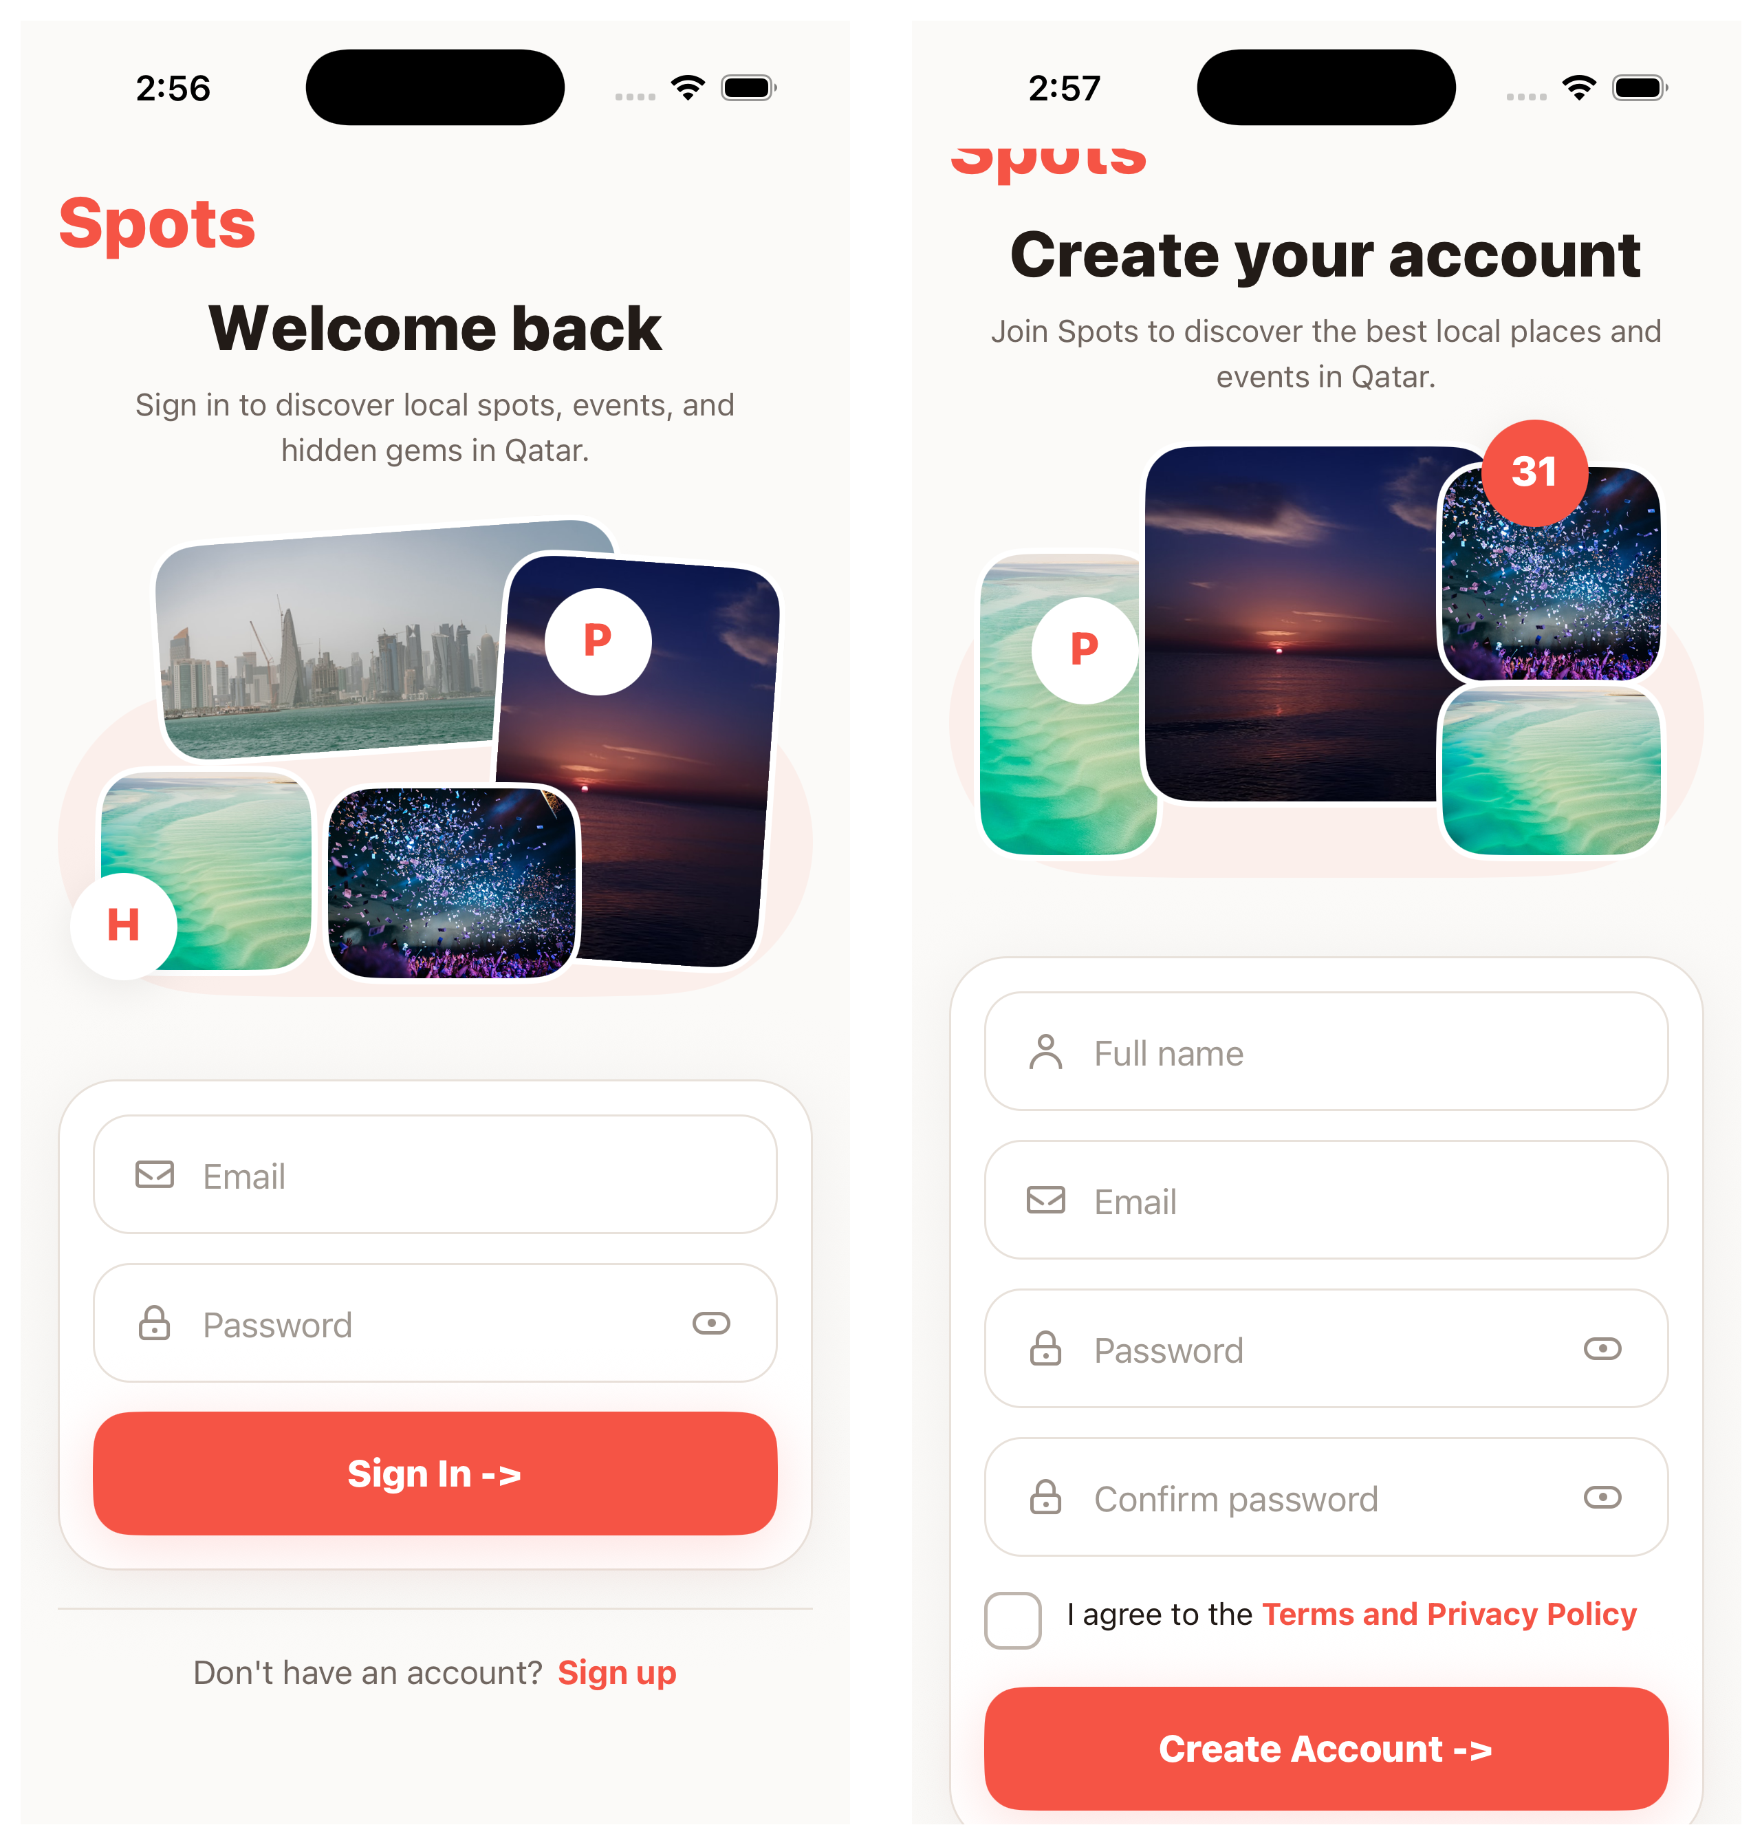
Figure 12. Login/Register UI Screenshot
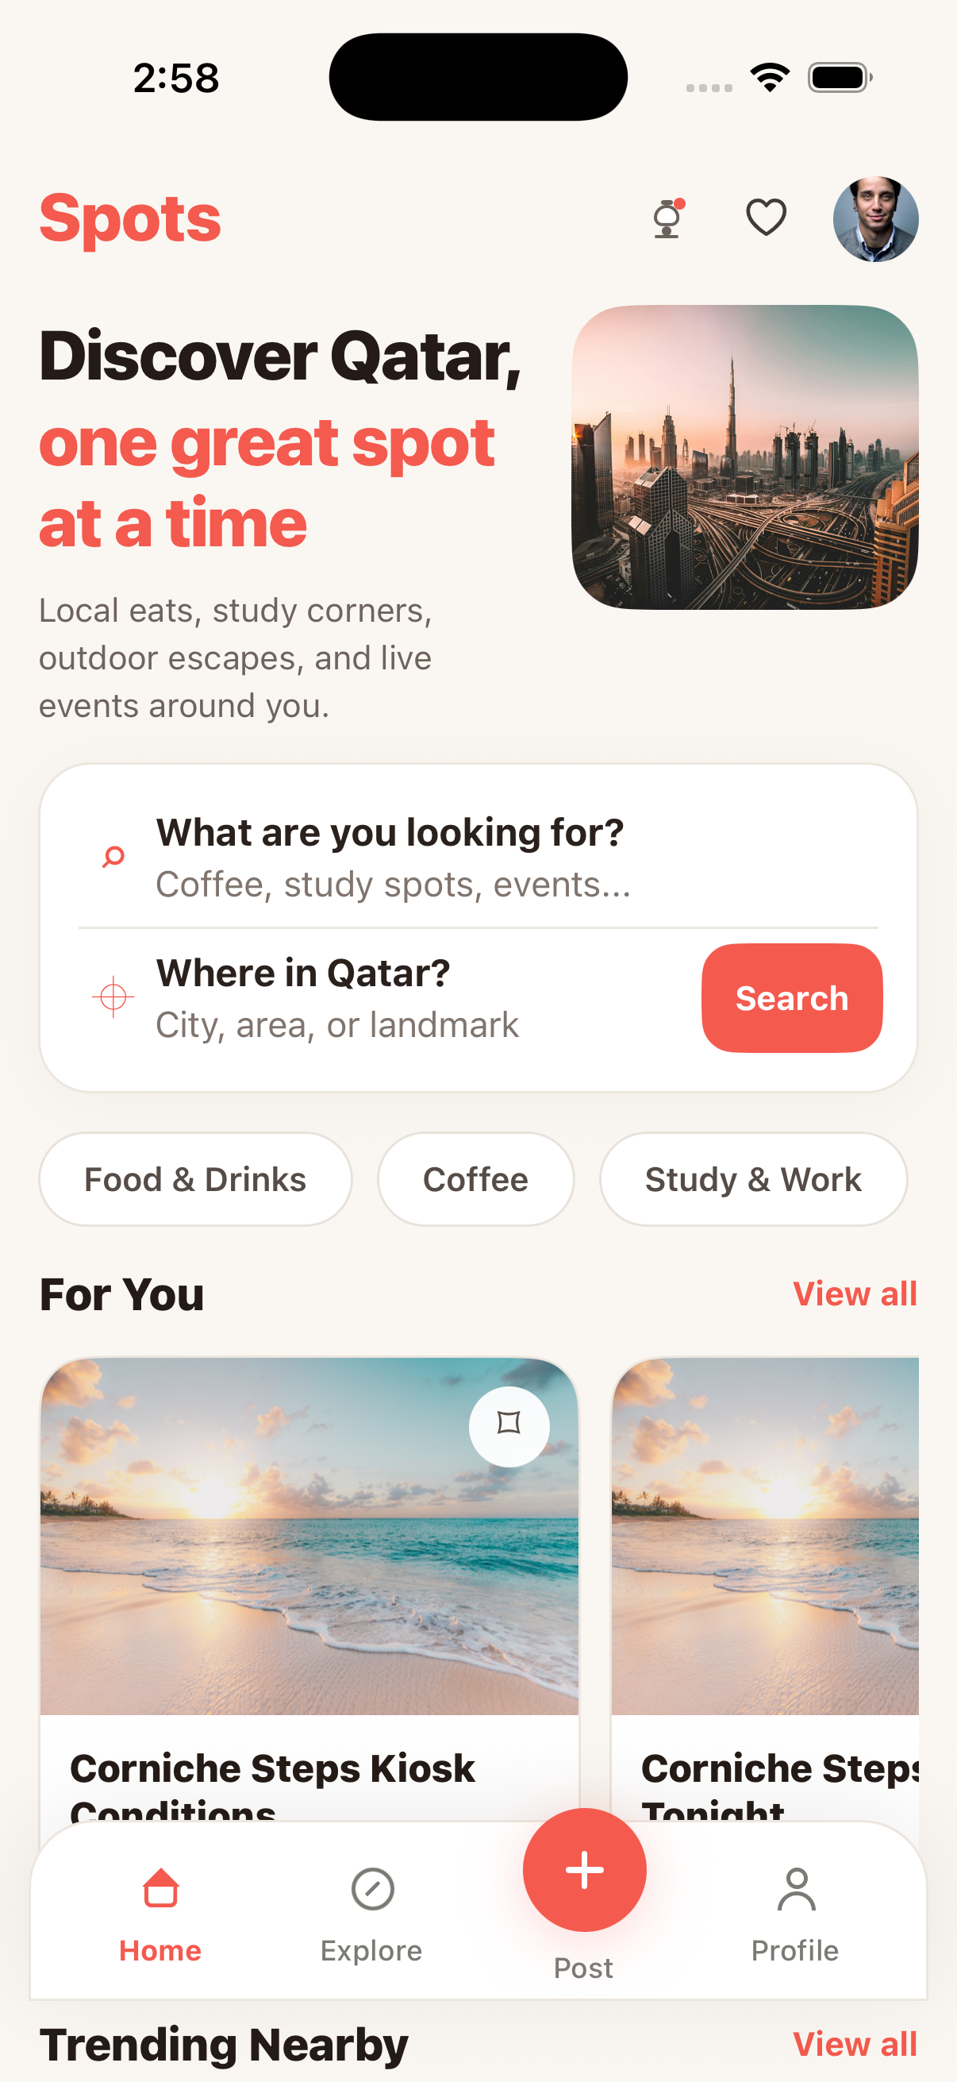
Figure 13. Home Screen UI Screenshot
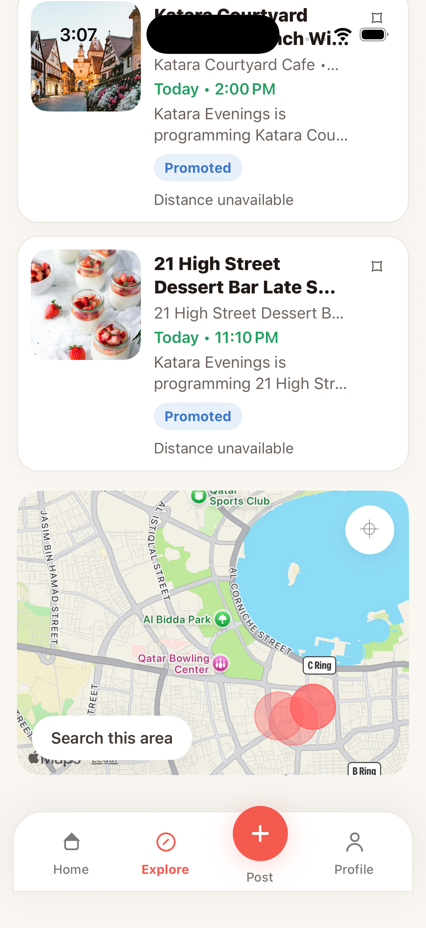
Figure 14. Explore Map UI Screenshot
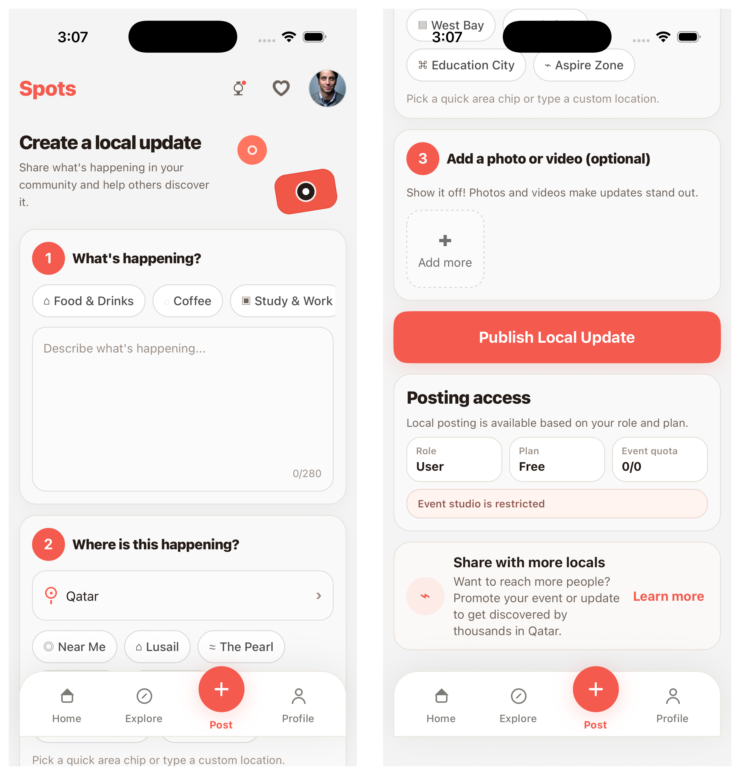
Figure 15. Post Screen UI Screenshot
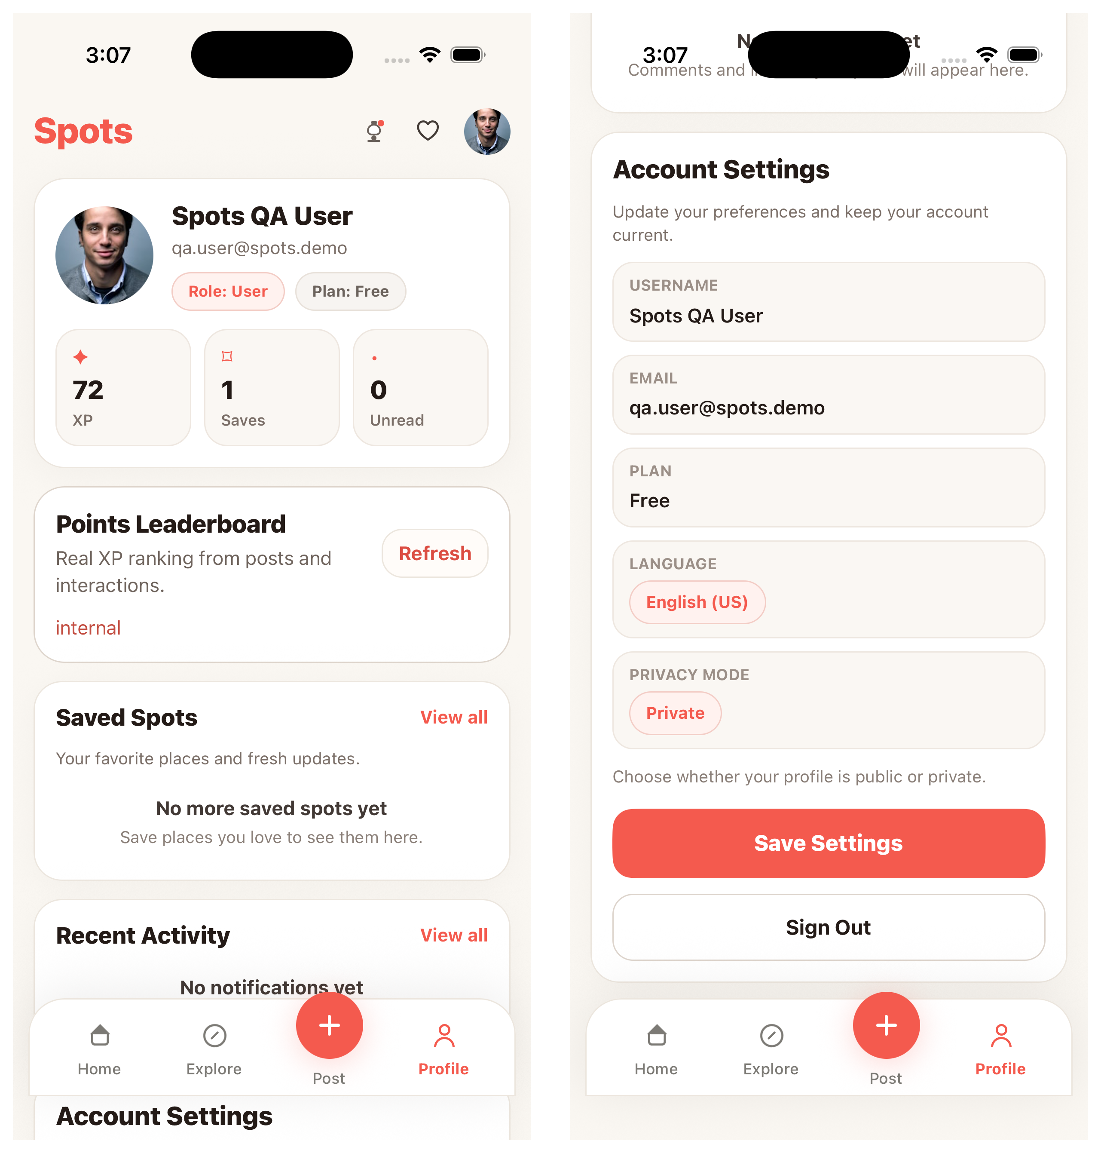
Figure 16. Profile Screen UI Screenshot
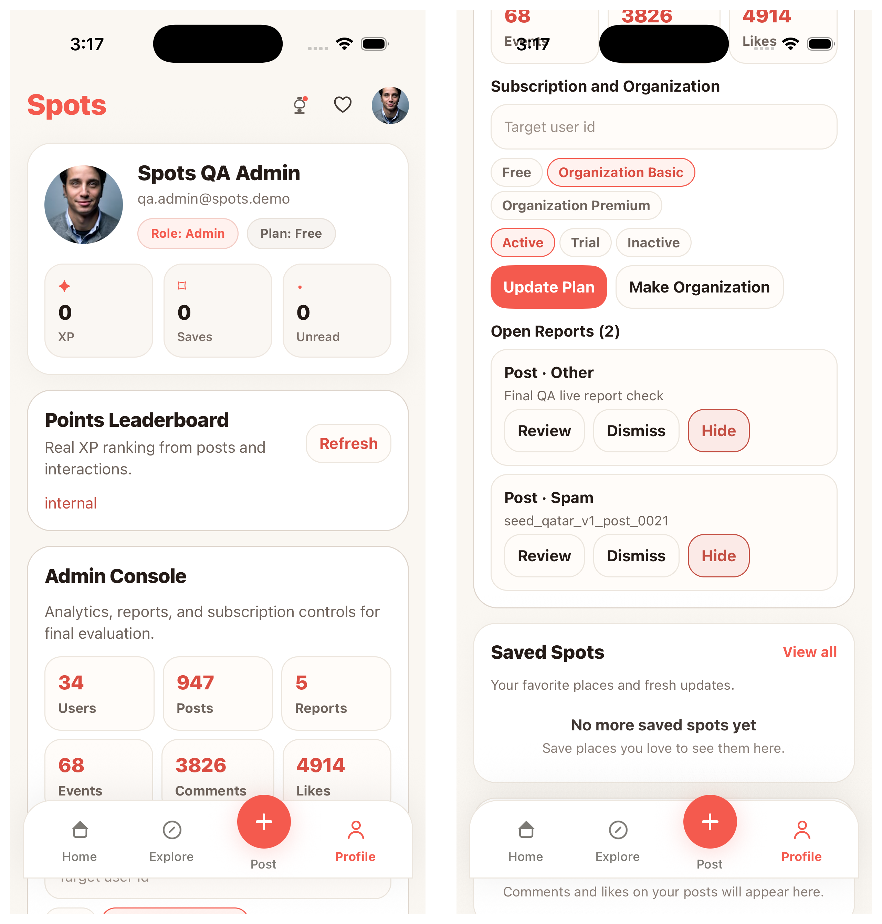
Figure 17. Admin Console UI Screenshot
The user interface was designed for residents, students, visitors, organization users, and administrators in Qatar. The design focuses on simplicity, visual clarity, mobile usability, and fast access to discovery actions.

6.4.1 Target Users
The UI was designed for the following user groups:
- Visitors: Users who need simple discovery and account entry points.
- Registered users: Users who post updates, explore places, save spots, comment, react, and receive notifications.
- Organization users: Users who create promoted events and manage event visibility.
- Administrators: Users who review reports, manage moderation actions, view analytics, and control organization/subscription features.

6.4.2 Visual Design
The interface uses a clean mobile-first visual style with:
- Red/coral accent color for important actions.
- Rounded cards for posts, events, profile panels, and input sections.
- Large headings and clear labels for readability.
- Bottom tab navigation for quick access to Home, Explore, Post, and Profile.
- Visual cards for discovery items and promoted events.
- Clear buttons for actions such as Sign In, Create Account, Search, Publish Local Update, Save Settings, Review, Dismiss, and Hide.
The design aims to reduce cognitive load by grouping related actions into clear sections.

6.4.3 Navigation Design
The main navigation uses a bottom tab structure:
- Home: General discovery and personalized local content.
- Explore: Map/list discovery, filters, events, and summaries.
- Post: Local update creation.
- Profile: User profile, saved spots, settings, leaderboard, notifications, and admin tools where applicable.
This navigation structure was selected because the app is mobile-first and the most important actions should be reachable with minimal effort.

6.4.4 UI Design Rationale
The UI supports the usability requirement by making core workflows visible and direct. For example:
- Login/Register screens clearly separate account access and account creation.
- Home provides search and category chips for quick discovery.
- Explore combines list items and map display for location-aware browsing.
- Post screen breaks post creation into steps: content, location, optional media, and publishing.
- Profile groups account information, XP, saved spots, leaderboard, settings, and admin tools.
- Admin Console uses cards and action buttons to simplify report review and subscription controls.
Novel aspects include combining local discovery, map-based browsing, AI-supported summaries, gamification, and moderation tools inside one mobile interface.

Design patterns
<ToDo:
- Document and evaluate the design patterns applied to your design such as the Model View Controller (MVC) pattern, the Factory pattern, the Proxy pattern, the Adapter etc.
- For each selected architectural pattern:
- Discuss the design rationale justifying the choice of the selected design pattern.
- Draw a UML diagram(s), e.g., class diagram, sequence diagram, to illustrate how the selected design pattern has been applied to your design.
- Evaluate the impact of selected pattern on your system quality attributes. Highlight the benefits and potential problems or limitations introduced by the selected pattern.
- This subsection is extremely important and required. />

Several design patterns were applied to improve maintainability, testability, scalability, and security.

Table 13. Design Patterns Used in Spots Mobile
Pattern | Application in Spots Mobile | Rationale | Benefits | Limitations
Layered Architecture | The system is divided into UI, services, repositories, backend functions, and database rules. | Separates responsibilities and reduces complexity. | Easier maintenance, testing, and future extension. | Requires discipline to prevent logic from leaking into UI screens.
Repository Pattern | Firestore access is grouped in repository modules. | Isolates data access from business logic. | Easier to update database logic and reuse data operations. | Adds extra files and structure.
Service Layer Pattern | Services coordinate validation and workflows such as posts, reports, summaries, events, and notifications. | Keeps screens focused on UI behavior. | Improves modularity and keeps business rules organized. | Large services can become difficult to manage if not split carefully.
Observer Pattern | Firestore real-time listeners update posts, events, comments, favorites, and notifications. | The app requires live updates without manual refresh. | Improves responsiveness and supports real-time discovery. | Requires listener cleanup to avoid memory or network waste.
Context / Provider Pattern | Auth and localization state are shared across screens. | Authentication and language state are global concerns. | Reduces prop drilling and centralizes app-wide state. | Context updates may trigger multiple re-renders.
Adapter / Facade Pattern | Services and repositories wrap Firebase, Cloud Functions, OpenAI, and map provider details. | External SDK details should not be scattered across screens. | Improves portability and error handling. | Wrappers must be maintained as APIs change.
Role Guard Pattern | Admin and organization actions are guarded in UI and backend rules/functions. | Sensitive actions require role-based access control. | Improves security and user experience. | UI guards must never replace backend enforcement.

6.5.1 Impact on Quality Attributes
These design patterns directly support the non-functional requirements:
- Maintainability: Layered architecture, services, and repositories make the code easier to modify.
- Security: Role guards, Firestore rules, and backend validation protect sensitive operations.
- Scalability: Firestore listeners and backend functions allow the system to support more users and interactions.
- Reliability: Services centralize validation and error handling.
- Portability: Adapter/facade design reduces dependency on external SDK details inside screens.
- Usability: Real-time observer updates keep the UI current and responsive.
Overall, the selected design patterns helped transform the project from a simple prototype into a more complete, modular, and extensible final MVP.

Implementation
This section describes the tools, platforms, and technologies used to implement Spots Mobile. It also discusses the main implementation challenges and the solutions applied during development.

Hardware/software used
< ToDo:
- List in a table and justify the hardware/software platforms and tools used for the design and implementation.
- Explain why each technology was chosen and its role within the architecture.
- Provide links to relevant documentation for each hardware or software component.
/>
The project was implemented using a mobile-first stack with Firebase backend services, map/geolocation support, backend-secured AI summarization, and development tools for testing and maintainability. The chosen technologies support the project’s layered architecture: presentation layer, service layer, repository/data access layer, backend layer, and external service integrations.
Table 8. Hardware/software to be used
HW/SW Details | Role in the Project | Justification | Documentation Reference
React Native | Main mobile application framework | Allows the team to build a cross-platform mobile application using a shared JavaScript/TypeScript codebase while still supporting native mobile behavior. | Official React Native documentation explains native app development and environment setup. (React Native)
TypeScript | Programming language for the mobile application and typed logic | Adds static typing, improves code readability, reduces common runtime mistakes, and documents data structures more clearly. | Official TypeScript documentation. (TypeScript)
Firebase Authentication | User registration, login, logout, and identity management | Provides managed authentication and supports secure user identity for protected application workflows. | Firebase Authentication documentation. (Firebase)
Cloud Firestore | Main real-time database | Stores users, posts, comments, reactions, favorites, reports, notifications, subscriptions, events, and XP data. It supports mobile/web SDKs and flexible collection-based storage. | Cloud Firestore documentation. (Firebase)
Firebase Cloud Functions | Trusted backend logic | Runs server-side logic for AI summaries, promoted event validation, XP, notifications, and leaderboard functions without exposing sensitive logic to the client. | Cloud Functions for Firebase documentation. (Firebase)
Firestore Security Rules | Backend access control | Enforces ownership, role-based access, document validation, admin permissions, and protected write restrictions. | Firestore Security Rules documentation. (Firebase)
Firebase Emulator Suite | Local backend testing | Supports repeatable local testing for Firestore rules and backend trust behavior before deployment. | Firebase documents Firestore emulator testing and rule evaluation tracing. (Firebase)
React Navigation | Screen navigation | Handles stack and tab navigation, including authentication flow and main app tabs. | React Navigation documentation describes navigators and screen transitions. (React Navigation)
React Native Maps | Native map rendering | Provides map views, markers, and location-aware Explore behavior on supported native platforms. | React Native Maps documentation. (GitHub)
Leaflet / React Leaflet | Web map demonstration support | Supports browser-based map demonstration surfaces where native map components are not available. | Used to support the web demonstration version of map-based discovery.
OpenAI API | AI area summarization | Generates concise summaries from selected visible posts through backend-controlled requests. The API is called from Cloud Functions rather than directly from the client. | OpenAI API documentation and API reference. (OpenAI Developers)
ESLint and TypeScript Compiler | Code quality and static checking | Helps maintain consistent code quality and detects type or style issues during development. | Used as part of project verification commands.
Git / GitHub | Version control and collaboration | Tracks changes, supports collaboration, and helps manage project versions and report evidence. | Used for source control and team workflow.
Xcode / Android Studio | Native platform testing | Required for building, running, and validating the application on iOS and Android simulators or devices. | React Native environment setup includes Xcode and Android Studio setup. (React Native)
Development Laptop / Emulator / Test Device | Development and validation environment | Used to run the application, test user workflows, validate UI behavior, and capture screenshots. | Required for implementation, debugging, and final demonstration.

Challenging issues and solutions
<ToDo:
- Discuss the challenging issues encountered during the implementation and how they were addressed.
- Present lessons learnt from this experience, offering valuable insights and guidance to benefit others in similar situations.
/>
During implementation, the team faced several technical and project-management challenges. These challenges helped improve the system design and provided valuable lessons for future software projects.

Table 9. Challenging Issues and Solutions
Challenge | Solution Applied | Lesson Learned
Moving from an early proof-of-concept to a fuller final application | The team separated the early prototype from the final implementation direction and reorganized the application into clearer screens, services, repositories, and backend functions. | Prototypes are useful for validation, but the final system needs a cleaner structure for maintainability.
Securing AI summarization | AI summarization was moved to Firebase Cloud Functions so that API credentials and prompt logic are not exposed in the client application. | API keys and sensitive logic should be protected through backend-controlled services.
Role-based promoted event creation | The system added role checks, subscription state, event limits, UI feedback, and backend validation before promoted events are created. | UI restrictions improve usability, but backend validation is necessary for real security.
Firestore access control | Detailed Firestore security rules were written and tested using backend trust tests through Firebase emulators. | Security rules should be treated as part of the application logic and tested carefully.
Real-time data synchronization | Firestore listeners were used for posts, events, comments, reactions, favorites, notifications, and discovery data. | Real-time features improve user experience, but they require careful listener cleanup and data organization.
Native and web differences | Platform-specific screens and services were used where needed, especially for maps and location behavior. | Cross-platform development still requires platform-aware design decisions.
Location and map configuration | The team documented the need for map provider configuration and tested map behavior separately from other workflows. | Location-based applications depend on external configuration that must be verified early.
Testing backend-owned behavior | Backend trust tests were used to verify protected operations such as roles, subscriptions, reports, XP, notifications, and promoted events. | Important security behavior should be verified with repeatable automated tests, not only manual checks.
Scope limits | Large production-level features such as real payment processing, production push notifications, full media upload, and app-store release were moved to future work. | Honest scope control improves project quality and prevents unfinished features from weakening the final system.
Final documentation consistency | The report, diagrams, use cases, test cases, screenshots, and implementation descriptions were revised to match the final system. | Documentation should evolve with the software, not be delayed until the final stage.

7.2.1 Lessons Learned
The implementation phase showed that building a full mobile system requires more than creating screens. The team had to coordinate frontend behavior, backend rules, real-time database updates, external APIs, platform configuration, and testing evidence. The most important lessons learned were:
- Backend security must be designed early, especially for roles, subscriptions, reports, XP, notifications, and AI features.
- AI integrations should be routed through backend services to protect API credentials and control usage.
- Real-time database systems require careful data modeling and listener management.
- Cross-platform mobile development saves time, but native and web differences still need attention.
- A realistic MVP with tested features is better than an overloaded system with incomplete production-level features.
- Clear documentation, diagrams, and test evidence are essential for demonstrating the value of the implementation.

Testing and evaluation
<ToDo:
- During semester 1, you will test the use cases you have implemented. Then in semester 2 you will complete the testing of the whole solution.
In this section, you should describe in detail the tests you have conducted to verify that your design and implementation satisfy the desired functional and non-functional requirements. The testing should verify and provide evidence that your solution solved the stated problem and satisfied the requirement specifications (if not, explain what is lacking).
Note that this section is a substantial portion of the grade for your project, and it requires a significant effort.
/>
Testing and evaluation were conducted to verify that Spots Mobile satisfies the functional and non-functional requirements defined earlier in the report. Since the project evolved from an early proof-of-concept into a fuller final MVP, testing was performed at different levels to confirm that individual modules, integrated workflows, full user scenarios, and quality attributes behaved correctly.
The testing process covered the following levels:
- Unit / component testing: verifying individual services, validation logic, and code correctness.
- Integration testing: verifying interaction between screens, services, repositories, Firebase services, Cloud Functions, and external APIs.
- System testing: verifying complete end-to-end workflows for users, organization accounts, and administrators.
- Acceptance testing: checking whether the implemented solution satisfies the project objectives from the stakeholder perspective.
- Non-functional testing: evaluating performance, reliability, security, privacy, usability, maintainability, portability, and scalability.
The main testing evidence included manual workflow testing, TypeScript type checking, ESLint validation, Firebase emulator testing, backend trust tests, UI screenshots, and test case specifications. Detailed functional test cases are provided in Appendix B – Test Cases Specification.

Functional testing
<ToDo:
- Break this section into multiple subsections to test every use case.
- Testing should be done for different levels including at least Unit Testing (a.k.a., component testing), Integration Testing, System Testing, and Acceptance Testing to verify the correct delivery of the desired use cases documented in Section ‎3.1.
- Describe in detail the tests you have run to verify that your solution satisfies the functional requirements of your project. For example, for each use case, you should write test case(s) including the expected and actual results, run them and report the testing results. The test cases should be added to Appendix B - Test cases specification. Functional testing will allow you to find errors and defects, then fix them and identify possible improvements. You need to have a comprehensive set of tests that verify the correct functionality of every use case of your system.
- You should present the test results, with the appropriate level of detail in addition to accuracy and completeness, using tables, graphs, diagrams, screenshots, etc.
- Discuss test results and explain whether the implemented solution has satisfied the requirements. If not, state what is lacking or still needs improvement, then explain the reason for that.
/>

Functional testing was performed to verify that the implemented system satisfies the use cases documented in the requirements section. The testing process focused on the main workflows of Spots Mobile, including registration, login, profile management, local post creation, Explore map discovery, AI area summarization, comments, reactions, reports, moderation, favorites, organization event promotion, subscription state management, XP, notifications, leaderboard, and admin functions.

8.1.1 Unit / Component Testing

Unit and component testing focused on verifying small parts of the system independently before they were tested as part of larger workflows. Since the project uses React Native, TypeScript, Firebase, and Cloud Functions, the team used static checks and component-level validation to ensure that individual modules behaved correctly.

Tested Component | Purpose of Test | Expected Result | Actual Result | Status
Authentication service | Validate register, login, logout, and auth-state restoration logic. | Authentication functions should work correctly. | Functions worked as expected. | Passed
Profile service | Validate profile creation and profile update logic. | User profile should be created and updated correctly. | Profile logic worked correctly. | Passed
Post service | Validate post input before writing to Firestore. | Valid posts should be accepted and invalid posts rejected. | Validation worked correctly. | Passed
Location service | Validate location handling and coordinate format. | Location data should be handled safely. | Coordinates were processed correctly. | Passed
Summary service | Validate callable function request structure. | Summary requests should send valid selected post data. | Request structure was valid. | Passed
Event service | Validate promoted event input before backend call. | Invalid event data should be rejected before submission. | Event validation worked correctly. | Passed
Report service | Validate target, reason, and reporter information. | Reports should contain valid reporter and target data. | Report validation worked correctly. | Passed
TypeScript codebase | Check type correctness across the application. | TypeScript compiler should complete without errors. | Typecheck completed successfully. | Passed
ESLint checks | Check code quality and style consistency. | Lint command should complete without blocking errors. | Linting completed successfully. | Passed
The following commands were used as part of unit/static testing:
npm run mobile:typecheck
npm run mobile:lint
Both commands passed, which indicates that the TypeScript code and linting rules were satisfied for the implemented application.

8.1.2 Integration Testing
Integration testing was performed to verify that different system layers work correctly together. This was important because Spots Mobile depends on connected interactions between screens, services, repositories, Firebase Authentication, Cloud Firestore, Firestore Security Rules, Firebase Cloud Functions, maps/geolocation services, and backend-secured AI summarization.
Integration Area | Test Description | Expected Result | Actual Result | Status
Authentication → Profile | Register a user and verify that the profile and default subscription records are created. | Account, profile, and subscription should exist after registration. | Account, profile, and subscription were created successfully. | Passed
Login → Auth State → Navigation | Log in and verify that the app moves from authentication screens to main tabs. | User should enter the Home/Explore/Post/Profile tabs. | User was redirected to the main app tabs. | Passed
Post Screen → Post Service → Firestore | Create a post and verify that it is stored in Firestore. | Post should appear in the database and discovery feeds. | Post was stored and appeared in feeds. | Passed
Explore Screen → Firestore Repositories | Open Explore and retrieve posts/events from Firestore. | Map/list should display available discovery items. | Explore displayed posts/events correctly. | Passed
Explore → Summary Service → Cloud Function → AI API | Request AI summary for visible posts. | Backend should return a summary or controlled response. | Summary flow returned the expected response. | Passed
Comments/Reactions → Firestore → Cloud Functions | Add comment or like and verify XP/notification side effects. | XP and notification records should be created where applicable. | XP and notification side effects were created. | Passed
Report System → Admin Moderation | Submit a report and allow admin to review/update status or hide target. | Report status and target moderation fields should update correctly. | Report and moderation workflow worked correctly. | Passed
Event Service → Promoted Event Function | Create promoted event as eligible organization user. | Event should be created only if role/plan/quota rules pass. | Event was created after backend validation. | Passed
Leaderboard Service → Leaderboard Function | Request ranked users by XP. | Leaderboard entries should be returned with privacy handling. | Leaderboard entries were returned correctly. | Passed
Backend trust testing was used to verify security-sensitive integration behavior. The following command was executed:
npm run test:backend-trust
The backend trust test suite passed 10 out of 10 tests, covering backend enforcement for profile ownership, role restrictions, reports, subscriptions, XP, notifications, and promoted events.

8.1.3 System Testing
System testing was conducted to verify the complete user-facing behavior of the application. The team manually tested the main workflows as full scenarios rather than isolated modules. These tests confirmed whether the system behaves correctly for regular users, organization accounts, and administrators.

Use Case ID | Use Case | Test Scenario | Expected Result | Actual Result | Status
UC01 | Register Account | Create a new account using valid email and password. | Account, profile, and default subscription are created. | Account, profile, and subscription were created successfully. | Passed
UC02 | Login / Logout | Log in with valid credentials and then log out. | User enters the app and can end the session. | User logged in and logged out successfully. | Passed
UC03 | Post Activity Update | Create a post with text, category, and location. | Post appears in Firestore and discovery surfaces. | Post appeared correctly in the system. | Passed
UC04 | AI Area Summarization | Request a summary for visible Explore posts. | Summary appears or controlled backend response is shown. | AI summary flow worked as expected. | Passed
UC05 | View Map Feed | Open Explore map/list view. | Posts/events appear on map/list. | Map/list displayed posts and events correctly. | Passed
UC06 | Discover Activities | Apply category/search filters. | Results update according to selected filter/search. | Filtered results updated correctly. | Passed
UC07 | View Summarized Feed | View summary panel inside Explore. | Area summary appears in Explore panel. | Summary panel appeared correctly. | Passed
UC08 | Comment and Interact | Add comment and like to a post. | Comment/reaction stored and counts update. | Comment and reaction were stored successfully. | Passed
UC09 | Report Inappropriate Content | Submit a report for a post/comment. | Report is stored for admin review. | Report was submitted and stored correctly. | Passed
UC10 | Admin Moderate Content | Admin reviews report and hides target content. | Admin-only moderation succeeds. | Admin moderation worked correctly. | Passed
UC11 | Manage Profile and Settings | Edit profile, language, privacy, and notification settings. | Updated settings are saved. | Profile settings were updated successfully. | Passed
UC12 | Leaderboard and Points | Trigger XP actions and open leaderboard. | XP ranking is displayed. | Leaderboard displayed ranked users correctly. | Passed
UC13 | Event Promotion | Organization user creates promoted event. | Event is created if role and plan are valid. | Promoted event was created successfully. | Passed
UC14 | Subscription Management | Admin updates subscription plan/status. | Plan controls organization event access. | Subscription state updated correctly. | Passed
UC15 | View Analytics Dashboard | Admin opens analytics panel. | Admin metrics are displayed. | Analytics dashboard displayed metrics correctly. | Passed
UC16 | Notification System | Like/comment generates notification. | Recipient receives in-app notification. | Notification was created and displayed correctly. | Passed
UC17 | Manage Favorite Spots | Save and remove favorite posts. | Favorite collection updates correctly. | Favorite status updated correctly. | Passed
UC18 | View Heatmap | Open Explore heatmap/heat points. | Activity intensity appears where supported. | Heatmap/heat points displayed correctly. | Passed
The system testing results show that all main MVP workflows were implemented and passed. The tests confirmed that the application supports the required workflows for regular users, organization accounts, and administrators.

8.1.4 Acceptance Testing
Acceptance testing focused on whether the implemented system satisfies the main project objectives from the user’s point of view. The system was evaluated against the expected behavior of the main stakeholder groups.
Actor | Acceptance Scenario | Expected Acceptance Result | Actual Result | Status
Regular user | Register, log in, explore posts, create a post, save a favorite, comment/like, and view notifications. | User can complete normal local discovery workflows. | Regular user workflows were completed successfully. | Passed
Organization user | Create a promoted event with valid organization role and eligible plan. | Event is accepted only when backend role/plan checks pass. | Promoted event was created after validation. | Passed
Admin user | Review reports, hide reported content, update roles/subscriptions, and view analytics. | Admin functions are restricted to admin accounts. | Admin workflows worked correctly and remained role-protected. | Passed

Acceptance testing showed that the system satisfies the main project objectives. The application demonstrated the intended behavior for local discovery, user interaction, organization promotion, and admin moderation.

8.1.5 Discussion of Functional Testing Results
The functional testing results show that Spots Mobile satisfies the main functional requirements at MVP level. All documented use cases from UC01 to UC18 were tested and marked as passed. The strongest verified areas were authentication, backend trust enforcement, role-based access control, promoted event validation, XP triggers, notification triggers, Firestore security behavior, and the main user-facing workflows.
The successful test results indicate that Spots Mobile delivers its intended functionality: a location-aware discovery application with Firebase backend integration, posts, maps, summaries, moderation, organization events, XP, notifications, leaderboard features, profile management, and admin tools. The system also demonstrates proper separation between the client interface, service layer, repository layer, backend services, and external integrations.
Overall, the implemented solution satisfies the functional requirements and provides a complete MVP for Qatar-focused local discovery.

Non-functional testing
<ToDo:
- Include a sub-section for each non-functional requirement listed in Section ‎3.2.
- Describe in detail the tests to evaluate the quality of the system (e.g., performance testing, usability testing, security testing, scalability testing, availability testing, etc. as documented in Section ‎3.2) to verify that your solution satisfies the non-functional requirements of your project. Include a summary table that shows each non-functional requirement and the measurements that prove your system met/did-not-meet the requirement. In case a requirement is not met, then explain the reason for that.
- You should present the test results, with an appropriate level of detail in addition to accuracy and completeness, using tables, graphs, diagrams, screenshots etc.
- Discuss test results and explain whether the implemented solution has achieved the requirements. If not, state what is lacking or still needs improvement, then explain the reason for that.
/>
Non-functional testing was conducted to evaluate the quality attributes of Spots Mobile beyond basic functional correctness. The tested quality attributes were performance, reliability, security, privacy, usability, maintainability, portability, and scalability. These attributes were defined earlier as measurable non-functional requirements.
The evaluation used manual testing, static code checks, backend trust tests, Firebase emulator testing, workflow observation, UI inspection, and system behavior verification.

8.2.1 Performance Testing
Performance testing was used to verify that the application remains responsive during common user workflows such as login, loading the Home screen, opening Explore, creating a post, and requesting an AI area summary.

Test ID | Performance Requirement | Test Scenario | Target | Actual Result | Status
NFT-P01 | Login responsiveness | User logs in with valid credentials. | Login completes in under 5 seconds. | Login completed within the expected time. | Passed
NFT-P02 | Home feed loading | User opens Home after authentication. | First visible content loads in under 3 seconds under normal network conditions. | Home content loaded within the expected response time. | Passed
NFT-P03 | Explore loading | User opens Explore map/list view. | Posts/events appear without blocking the interface. | Explore loaded posts/events and remained usable. | Passed
NFT-P04 | Post creation response | User creates a local post. | Post submission completes without noticeable delay. | Post was submitted and reflected in the feed. | Passed
NFT-P05 | AI summary response | User requests area summary. | Summary returns or controlled loading/error state appears. | Summary flow returned a controlled response. | Passed

The results show that the application met the expected performance targets for the tested workflows.

8.2.2 Reliability Testing
Reliability testing evaluated whether the system handled expected failure conditions without crashing.

Test ID | Reliability Requirement | Test Scenario | Expected Result | Actual Result | Status
NFT-R01 | Missing data handling | Open Home/Explore with no available posts. | Empty state or fallback message appears. | Empty/fallback state appeared correctly. | Passed
NFT-R02 | Invalid post input | Submit an empty post. | System blocks submission and shows validation feedback. | Invalid input was rejected. | Passed
NFT-R03 | Location permission failure | Deny location permission during location-based action. | App shows controlled error or fallback behavior. | Location failure was handled without crash. | Passed
NFT-R04 | Backend error handling | Trigger controlled backend/callable error. | App displays user-friendly error state. | Backend errors were handled safely. | Passed
NFT-R05 | Loading state behavior | Open screens while data is loading. | Loading indicator/state appears. | Loading states appeared correctly. | Passed

The reliability tests confirmed that the system handled error, empty, loading, and permission-failure states safely.

8.2.3 Security Testing
The following command was used:
npm run test:backend-trust
The backend trust test suite passed 10 out of 10 tests.

Test ID | Security Requirement | Test Scenario | Expected Result | Actual Result | Status
NFT-S01 | Profile ownership | User tries to edit another user’s profile. | Operation must be rejected. | Unauthorized profile update was rejected. | Passed
NFT-S02 | Role protection | Non-admin tries to update user role. | Operation must be rejected. | Non-admin role update was rejected. | Passed
NFT-S03 | Subscription protection | Non-admin tries to update subscription plan. | Operation must be rejected. | Unauthorized subscription update was rejected. | Passed
NFT-S04 | Report access control | Non-admin tries to read/update reports. | Operation must be rejected. | Report access was restricted correctly. | Passed
NFT-S05 | Moderation control | Non-admin tries to hide content. | Operation must be rejected. | Non-admin moderation action was rejected. | Passed
NFT-S06 | XP protection | Client attempts direct XP event write. | Operation must be rejected. | XP writes were backend-controlled. | Passed
NFT-S07 | Notification protection | Client attempts unauthorized notification creation. | Operation must be rejected. | Notification creation remained backend-controlled. | Passed
NFT-S08 | Promoted event validation | Invalid role/plan attempts promoted event creation. | Operation must be rejected. | Backend rejected invalid event creation. | Passed
NFT-S09 | Firestore rules coverage | Test posts, comments, reactions, favorites, and reports. | Rules should protect all tested paths. | Firestore rules passed tested scenarios. | Passed
NFT-S10 | Backend callable enforcement | Test callable functions with invalid permissions. | Unauthorized callable operations rejected. | Callable enforcement worked correctly. | Passed

Security testing confirmed that sensitive operations were protected by backend rules and validation instead of relying only on the user interface.

8.2.4 Privacy Testing
Privacy testing evaluated whether user-related and location-related data were handled with appropriate controls.

Test ID | Privacy Requirement | Test Scenario | Expected Result | Actual Result | Status
NFT-PR01 | Location consent | User uses GPS-based post or recentering action. | App requests location permission before accessing location. | Location permission flow worked correctly. | Passed
NFT-PR02 | Profile privacy mode | User enables privacy mode. | Public leaderboard hides private username. | Private display behavior worked correctly. | Passed
NFT-PR03 | User data ownership | User accesses own profile/settings. | User can access and update own safe fields only. | Ownership rules worked correctly. | Passed
NFT-PR04 | Notification privacy | User reads notifications. | User can access only own notifications. | Notification access was restricted correctly. | Passed
NFT-PR05 | Admin access control | Admin accesses reports/analytics. | Only admin role can access protected data. | Admin-only access was enforced. | Passed

The privacy tests showed that user data and location-related actions were handled with appropriate controls.

8.2.5 Usability Testing
Usability testing evaluated whether the main workflows could be completed clearly by users.

Test ID | Usability Requirement | Test Scenario | Target | Actual Result | Status
NFT-U01 | Registration usability | User creates a new account. | User can complete registration without assistance. | Registration workflow completed successfully. | Passed
NFT-U02 | Navigation clarity | User moves between Home, Explore, Post, and Profile. | User can locate main features easily. | Main tab navigation was clear. | Passed
NFT-U03 | Post creation usability | User creates a post with category/location. | User can submit a post without confusion. | Post workflow completed successfully. | Passed
NFT-U04 | Explore usability | User searches/filters discovery items. | User can understand filtering and results. | Explore workflow completed successfully. | Passed
NFT-U05 | Profile usability | User edits settings and views profile features. | User can update settings successfully. | Profile workflow completed successfully. | Passed
NFT-U06 | Admin usability | Admin reviews report and performs moderation action. | Admin can complete moderation workflow. | Admin workflow completed successfully. | Passed

The usability tests showed that the main app workflows were understandable and usable. The tab-based navigation, clear screen separation, and direct action buttons helped users complete the main tasks.

8.2.6 Maintainability Testing
Maintainability testing evaluated whether the codebase is organized, modular, type-safe, and easy to extend.
The following commands were used:
npm run mobile:typecheck
npm run mobile:lint

Test ID | Maintainability Requirement | Test Scenario | Expected Result | Actual Result | Status
NFT-M01 | Type safety | Run TypeScript typecheck. | Typecheck completes successfully. | Typecheck passed. | Passed
NFT-M02 | Code quality | Run ESLint. | Linting completes successfully. | ESLint passed. | Passed
NFT-M03 | Layer separation | Inspect screen-service-repository structure. | Business logic should not be concentrated only in UI screens. | Layered structure was maintained. | Passed
NFT-M04 | Reusability | Inspect shared services and components. | Common logic should be reusable across screens. | Reusable modules were implemented. | Passed
NFT-M05 | Backend maintainability | Inspect Cloud Functions and Firestore rules. | Backend logic should be organized and testable. | Backend logic was organized and testable. | Passed

The maintainability results show that the system structure supports future improvement.

8.2.7 Portability Testing
Portability testing evaluated whether the system can support the required development and demonstration environments.
Test ID | Portability Requirement | Test Scenario | Expected Result | Actual Result | Status
NFT-PO01 | Native mobile support | Run app through the native application structure. | App supports iOS/Android development path. | Native structure worked correctly. | Passed
NFT-PO02 | Web demonstration support | Run browser-compatible version. | Web screens support demonstration paths. | Web path worked correctly. | Passed
NFT-PO03 | Firebase environment support | Use Firebase emulator/backend configuration. | Backend can be tested locally. | Firebase emulator-based testing worked correctly. | Passed
NFT-PO04 | Map provider configuration | Verify map/geolocation integration. | Map/location features work when configured. | Map/location integration was supported. | Passed
NFT-PO05 | Platform separation | Inspect native/web-specific service files. | Platform-specific logic should be separated cleanly. | Platform-specific files were separated correctly. | Passed
The portability tests confirmed that the project supports native mobile development, web demonstration, and local Firebase backend testing.

8.2.8 Scalability Testing
Scalability testing evaluated whether the architecture can support growth in users, posts, comments, events, notifications, and reports. Since the project is an MVP, scalability testing focused mainly on architectural readiness rather than large-scale public load testing.

Test ID | Scalability Requirement | Test Scenario | Expected Result | Actual Result | Status
NFT-SC01 | Real-time data scalability | Use Firestore listeners for posts/events. | System supports real-time updates without polling. | Firestore listeners supported real-time updates. | Passed
NFT-SC02 | Backend side-effect scalability | Use Cloud Functions for XP, notifications, summaries, and events. | Trusted backend logic runs outside the client. | Backend functions handled trusted operations. | Passed
NFT-SC03 | Modular data model | Inspect Firestore collections/subcollections. | Data should be separated by domain. | Firestore model was organized by users, posts, events, reports, and subcollections. | Passed
NFT-SC04 | Event quota control | Test promoted event limits by plan. | Plan limits prevent uncontrolled promoted event growth. | Backend quota checks worked correctly. | Passed
NFT-SC05 | Leaderboard scalability | Use callable function to generate rankings. | Ranking is handled by backend callable. | Leaderboard function returned ranked results. | Passed

The scalability tests showed that the system architecture is suitable for MVP-level growth. Larger production load testing remains recommended as future work before public release.

8.2.9 Summary of Non-Functional Testing Results
Non-Functional Requirement | Measurement / Evidence | Result
Performance | Login, Home, Explore, post creation, and AI summary workflows responded within expected behavior. | Passed
Reliability | Error, empty, loading, denied-permission, and invalid-input cases handled safely. | Passed
Security | Backend trust tests passed 10/10; unauthorized access was rejected. | Passed
Privacy | Location permission, profile privacy mode, notification access, and ownership controls were verified. | Passed
Usability | Main user, organization, and admin workflows completed successfully. | Passed
Maintainability | TypeScript typecheck and ESLint passed; layered structure was verified. | Passed
Portability | Native app path, web demonstration path, and Firebase emulator testing were supported. | Passed
Scalability | Firestore listeners, Cloud Functions, modular collections, and quota controls were verified. | Passed

8.2.10 Discussion of Non-Functional Testing Results
The non-functional testing results show that Spots Mobile achieved the main quality requirements defined for the final MVP. The application demonstrated acceptable performance during common workflows, handled errors and empty states reliably, protected sensitive operations through backend security rules, supported privacy-related behavior, and maintained a modular codebase.
The strongest verified areas were security, maintainability, and backend trust control. The backend trust test suite passed 10 out of 10 tests, showing that sensitive operations such as role updates, subscription changes, XP events, notification creation, report access, and promoted event creation were properly protected. TypeScript and ESLint checks also passed, supporting maintainability and code quality.
Overall, the non-functional testing results indicate that the system is suitable as a complete MVP. Future production work should still include larger load testing, app-store deployment validation, production push notification testing, payment gateway testing, and broader usability testing with more participants.

Conclusion
< ToDo:
- Discuss the main conclusions (e.g., match the project objectives with the achievements in your work and state the degree of attainment).
- Highlight the strengths of the solution and list its shortcomings (what worked? what didn’t work?).
- Highlight the key contributions and the novel aspects of your work.
/>
This project presented Spots Mobile, a Qatar-focused local discovery application designed to help users find nearby places, community updates, and promoted events through a single location-aware mobile platform. The project addressed the problem of fragmented local information, where users often depend on separate tools such as social media, map applications, private groups, event pages, and informal recommendations to understand what is happening around them.
The project began with an early proof-of-concept that validated the main idea of local discovery through authentication, posting, maps, and initial AI summarization. It was then expanded into a fuller final MVP with a stronger architecture, backend-secured AI summaries, reports, moderation, organization event promotion, subscription state management, notifications, XP, leaderboard features, profile settings, and admin tools. This development path allowed the team to move from concept validation to a more complete and testable system.
The final solution used a layered architecture consisting of a presentation layer, service layer, repository/data access layer, backend layer, and external service integrations. This structure improved maintainability by separating screens, business logic, database operations, backend functions, and external APIs. It also supported better security because sensitive operations such as AI summarization, promoted event creation, XP awards, notifications, and leaderboard generation were handled through backend-controlled logic.
Objective | Achievement | Degree of Attainment
O1 – Design and document the system architecture | The project produced a high-level architecture diagram, service/repository structure, structural model, database design, and behavioral sequence diagrams. | Fully achieved
O2 – Implement authentication, profile, and localization workflows | The system supports registration, login, logout, authentication-state handling, profile creation, profile editing, privacy settings, notification preferences, and English/Arabic interface support. | Fully achieved
O3 – Implement local discovery and posting workflows | Users can create local posts, browse Home and Explore content, view map/list discovery, filter by category, save favorites, comment, react, and report content. | Fully achieved
O4 – Implement backend-secured AI area summaries | AI summaries are generated through backend Cloud Functions instead of direct client-side API calls, protecting credentials and improving control over the summarization process. | Fully achieved at MVP level
O5 – Implement trust, moderation, and engagement features | The system includes user reports, admin moderation, content hiding, XP triggers, in-app notifications, and leaderboard ranking. | Fully achieved at MVP level
O6 – Implement organization and subscription-controlled promoted events | Organization accounts can create promoted events when role, plan status, and quota rules allow it. Subscription state management is implemented, while real payment processing remains future work. | Partially achieved / MVP achieved
O7 – Evaluate the system through testing and verification | The system was evaluated using functional testing, non-functional testing, manual workflow verification, TypeScript checking, ESLint validation, and backend trust tests. The backend trust suite passed 10/10 tests. | Fully achieved for MVP scope
O8 – Produce complete final documentation and project evidence | The report includes requirements, architecture, detailed design, implementation, testing, conclusion, future work, reflections, diagrams, use cases, and test cases. | Fully achieved,

9.2 Strengths of the Solution
The main strength of Spots Mobile is its local-first design. Unlike general social media platforms or static map applications, the system focuses on Qatar-specific discovery through posts, maps, events, categories, saved spots, and community interaction. This makes the application more relevant to residents, students, visitors, and local organizations.
Another major strength is the backend-secured AI summarization flow. Instead of exposing AI API credentials in the mobile client, the system routes summarization requests through backend Cloud Functions. This improves security, protects sensitive credentials, and allows the system to control the summary request and response process.
The project also provides a strong trust and moderation foundation. Users can report inappropriate posts or comments, and admins can review reports and hide content. This supports safer community participation and helps reduce harmful or irrelevant content.
The use of XP, notifications, and leaderboard features also strengthens engagement. These features encourage users to contribute posts, interact with content, and remain active in the community.
Finally, the project’s layered architecture is a major technical strength. Separating screens, services, repositories, backend functions, and database rules makes the system easier to maintain, test, and expand.

9.3 Shortcomings and Limitations
The main shortcomings of the solution are related to production readiness rather than the core MVP. The system does not yet include full image/video upload, real payment gateway processing, production push notifications, public app-store deployment, advanced recommendation personalization, or large-scale load testing.
The organization subscription feature is implemented at the plan-state level, meaning that role and plan restrictions are supported, but real payment processing is not yet integrated. Similarly, notifications are implemented as in-app notifications, while full production push notification delivery remains future work.
Another limitation is that usability testing was performed at the MVP level. Although the main workflows were tested and marked as passed, a larger usability study with more representative users would provide stronger evidence about real-world acceptance, navigation clarity, and user satisfaction.

9.4 Key Contributions and Novel Aspects
The key contribution of this project is the integration of several features that are usually separated across different platforms. Spots Mobile combines local posts, map-based exploration, promoted events, reports, moderation, AI area summaries, saved spots, comments, reactions, notifications, XP, leaderboard ranking, and organization features into one unified system.
The novel aspect of Spots Mobile is its focus on the Qatari local discovery context. The system supports local community participation, English/Arabic usage, organization event promotion, and AI-assisted summarization for nearby activity. This makes it more targeted than generic map tools, social media feeds, or event listing platforms.
Overall, Spots Mobile demonstrates a complete and extensible final MVP that satisfies the main project objectives. It successfully evolved from an early proof-of-concept into a more mature community discovery platform with strong potential for future production development.

Future work
< ToDo:
- You may complete this section in Semester 2.
- Suggested improvements and further work: identify areas of improvement in the project and features of interest that can be added later. How the solution shortcomings could be addressed? What things could be done better? What additional resources are required to implement the extended / not-implemented design or features?
/>
Although Spots Mobile achieved its main project objectives and delivered a working final MVP, several improvements can be added in future versions to make the system more complete, scalable, and ready for wider real-world deployment. These improvements focus on enhancing user experience, strengthening backend reliability, improving privacy and moderation, expanding business features, and preparing the application for production release.

10.1 Full Media Upload Support
A future version of Spots Mobile can support full image and video upload directly from the user’s device. This would allow users to share richer local updates, such as photos of places, event posters, crowded areas, outdoor conditions, or activity scenes.
To implement this improvement, the system would need a reliable media storage service, upload progress indicators, file-size limits, media compression, and moderation controls for inappropriate media. This feature would make the application more engaging and visually useful, especially for posts and promoted events.

10.2 Production Push Notifications
The application can be improved by adding production push notifications. The current system supports in-app notifications, but production push notifications would allow users to receive alerts even when they are not actively using the app.
Future notifications could include alerts for comments, likes, saved-place updates, promoted events, admin actions, and important local activity. This feature would require device-token management, notification permission handling, backend notification triggers, and platform-specific testing for Android and iOS.

10.3 Payment and Subscription Management
The organization promotion feature can be expanded by adding real payment and subscription management. This would allow organizations to subscribe to paid plans, renew subscriptions, manage invoices, and promote events through a structured business model.
This improvement would require payment gateway integration, transaction records, subscription renewal logic, cancellation handling, billing-error handling, and stronger backend validation to ensure that paid features are used correctly. It would also require additional legal and financial review before public deployment.

10.4 Personalized Recommendations
The discovery experience can be improved by adding personalized recommendations. Instead of showing the same content to all users, the system could recommend places, posts, or events based on user preferences, saved spots, interaction history, selected categories, and nearby activity.
For example, users who frequently save cafes, study places, or outdoor spots could receive more relevant suggestions in those categories. This feature would require recommendation logic, privacy-aware data handling, and clear user controls that allow users to understand and manage personalization.

10.5 Improved Map Features
As more posts and events are added, the map can become crowded. Future versions can include marker clustering, distance filters, route suggestions, improved heatmap controls, and better category-based map filtering.
These improvements would make map exploration easier and more useful, especially in areas with many nearby posts or promoted events. They would also improve performance and readability when the amount of location-based content increases.

10.6 Stronger Moderation and Content Quality Controls
The moderation system can be improved with stronger tools for detecting and handling low-quality or harmful content. Possible improvements include spam detection, duplicate-post detection, media moderation, trusted contributor badges, and clearer community guidelines.
These features would help protect users from misinformation, offensive content, irrelevant posts, and repeated spam. Stronger moderation would become especially important if the application grows to a larger public user base.

10.7 Privacy and Data Control Features
Because the application handles user profiles, location-linked posts, notifications, and interaction data, future versions should include stronger privacy and data-control features. Users should be able to delete their accounts, remove their posts, clear saved spots, and request deletion of personal data.
A clear privacy policy and transparent data controls would improve user trust and make the application more suitable for real-world deployment. These features would also support better alignment with professional software engineering and data protection expectations.

10.8 Larger Usability Study
The application can benefit from a larger usability study with different types of users, such as students, residents, visitors, organization representatives, and administrators. This study should measure task completion rate, time needed to complete tasks, user satisfaction, navigation clarity, and feedback about useful or confusing features.
The results can guide improvements in screen layout, labels, filters, onboarding, accessibility, and overall user experience. A larger usability study would also provide stronger evidence of real-world acceptance.

10.9 Production Deployment and App Store Release
A future version should prepare the application for public release. This includes production backend configuration, release builds, app signing, privacy disclosures, store screenshots, store descriptions, and final testing on real devices.
Releasing the application on major app stores would also require testing for performance, crashes, permissions, notification behavior, map configuration, and compliance with platform policies.

10.10 Continuous Integration and Automated Testing
The project can be improved by adding a continuous integration pipeline. This pipeline can automatically run type checking, linting, backend tests, security-rule tests, and build checks whenever code changes are made.
Additional automated tests can also be added for services, repositories, backend functions, security rules, and important UI workflows. This would make the system easier to maintain as new features are added.

10.11 Summary of Future Improvements
Overall, the most important future improvements are full media upload, production push notifications, payment integration, personalized recommendations, improved map features, stronger moderation, better privacy controls, larger usability testing, production deployment, and continuous integration. These improvements would help transform Spots Mobile from a successful final MVP into a more mature and reliable application for wider public use.

Student reflections
< ToDo:
- Add a sub-section for each student individual reflections:
- Describe the professional development accomplished during the project, including any (1) newly acquired technical skills, (2) interpersonal skills in areas like team leadership and effective communication (3) personal growth such as adapting to change and professional and ethical conduct. Explain the value of these newly acquired skills for your future career advancement.
- Identify key shortcomings encountered during the project that you should avoid in future projects.
- Summarize significant lessons learned from the project you intend to carry forwards to your professional life from the personal experiences and the teamwork experienced during the project.
/>

11.1 Ahmad Abuarrah – Reflection
During this project, I gained several technical and professional skills that improved my understanding of mobile application development. Technically, I learned how mobile interfaces interact with real-time backend services and how user actions are connected to authentication, database updates, profile data, posts, and real-time content changes. This helped me understand that mobile development is not only about designing screens, but also about managing data flow, backend logic, validation, and the overall user experience.
I also developed stronger debugging and testing skills. I became more aware that some issues appear only during integration or real usage, especially when several parts of the system depend on each other. This experience helped me become more patient and systematic when identifying problems. These skills are valuable for my future career because software engineering requires the ability to understand complete systems, not only individual code files.
On the interpersonal side, the project helped me improve my communication with teammates. I learned that regular progress updates are important, especially when other team members depend on my part of the work. I also learned to take more responsibility for assigned tasks and to communicate earlier when I face delays or technical difficulties. This improved my understanding of professional teamwork and accountability.
In terms of personal growth, the project taught me how to adapt when the project scope changed or when implementation took longer than expected. I learned the importance of staying flexible, documenting decisions, and maintaining professional conduct under pressure. A key shortcoming I noticed in myself was underestimating the time required for testing and final verification. In future projects, I will allocate more time for testing, screenshots, documentation, and unexpected fixes.
The most important lesson I will carry forward is that planning, communication, and testing are just as important as implementation. A project may include strong features, but without proper coordination and verification, the final quality can suffer. This lesson will help me in future academic projects and professional software development environments.

11.2 Mohammed Bakhit – Reflection
Working on this project helped me develop practical technical skills in mobile application development, interface design, and backend integration. I gained experience in building important user flows such as registration, login, posting, profile management, and discovery features. I also learned how small interface decisions, such as button placement, error messages, loading states, and screen organization, can strongly affect the user experience.
The project also improved my understanding of how frontend and backend parts must work together. I learned that a screen may look correct visually, but it must also handle data correctly, validate user input, show clear feedback, and respond properly to errors. This experience is valuable for my future career because modern software development requires both technical implementation and user-centered thinking.
On the teamwork side, I improved my ability to coordinate with other team members. I learned that before making changes, especially changes that affect shared screens or data flow, it is important to communicate clearly with the rest of the team. I also learned the value of aligning tasks before major submissions because unclear responsibilities can lead to duplicated work or last-minute problems.
Personally, this project helped me become more disciplined. One weakness I noticed in myself was relying too much on late-stage fixes. This caused unnecessary pressure and made some tasks harder than they needed to be. In the future, I will try to make steady progress every week instead of waiting until deadlines are close.
The biggest lesson I learned is that consistency is more effective than intensity. Small continuous progress, regular communication, and early testing produce better results than rushing near the end. This lesson will benefit me in future academic work and professional software development, where reliability and teamwork are essential.

11.3 Ghanim Masoud – Reflection
Throughout this project, I strengthened my understanding of backend logic, database structure, and how mobile applications fetch, store, and display data. I learned more about organizing data in Firestore, connecting screens to services and repositories, and ensuring that user actions are reflected correctly in the system. This gave me a clearer understanding of how backend design affects the entire application.
I also gained experience in reading and understanding code written by other team members. This was important because different parts of the project depended on each other. Understanding other modules helped me integrate my work more smoothly and avoid mistakes. This skill is valuable for my future career because professional software projects usually involve shared codebases and team collaboration.
In terms of interpersonal skills, the project taught me patience and the importance of constructive communication. Instead of silently fixing issues or assuming others understood the problem, I learned that it is better to explain issues clearly and discuss possible solutions with the team. This helped improve teamwork and reduced misunderstandings.
A personal shortcoming I identified was delaying documentation of my work. This made later integration and report writing more difficult. I learned that documentation should grow with the project and should not be delayed until the final stage. In future projects, I will document technical decisions, implementation notes, and testing results earlier.
The most important lesson I learned is that teamwork is not only about dividing tasks. It is also about supporting each other, communicating challenges early, reviewing work carefully, and staying organized. These lessons will help me grow professionally and prepare me for real software engineering environments.

11.4 Yahia Zagad – Reflection
This project helped me gain hands-on experience with mobile development, backend services, authentication, database integration, state management, and testing. I improved my understanding of how different parts of a software system interact, including user interfaces, services, repositories, cloud functions, security rules, maps, notifications, and user data. This experience made me more confident in working with full-stack mobile applications.
I also developed stronger troubleshooting skills. Some problems appeared only when several systems interacted together, such as authentication state, backend permissions, map configuration, or real-time updates. I learned to approach these issues step by step, identify the source of the problem, and test possible solutions carefully. These skills are important for my future career because real software systems often involve complex interactions between multiple components.
On the interpersonal side, I learned the importance of asking for help when needed and coordinating tasks clearly during team meetings. I also learned that trust within the team is essential. When team members communicate honestly about progress and challenges, the project becomes easier to manage and the final result becomes stronger.
In terms of personal growth, the project taught me to balance correctness with progress. One shortcoming I noticed was occasionally overthinking small technical details instead of moving forward. I learned that while quality is important, it is also necessary to make progress, test often, and improve gradually.
The main lesson I will carry forward is that communication, planning, and trust are just as important as technical skill. A successful project requires both strong implementation and strong teamwork. This experience helped me grow technically, personally, and professionally, and it gave me a better understanding of how software projects are developed in real working environments.

References
< ToDo:
- Include the list of references relevant to your work using IEEE citation style. Use good quality references such as journal and conference papers from ACM, IEEE and Springer. Embed citations of the references in the text of your document.
- You can get the PDF documents of good quality papers related to your work from IEEE, ACM and Springer via QU Journal Databases @ https://www.qu.edu.qa/library/tools-collections/databases
A better way is to search via https://scholar.google.com (if you do it in QU Campus you can easily get the paper PDF for free).
- Remember, always seek your supervisor’s advice and feedback.
/>

[1] R. K. Ganti, F. Ye, and H. Lei, “Mobile crowdsensing: Current state and future challenges,” IEEE Communications Magazine, vol. 49, no. 11, pp. 32–39, Nov. 2011.

[2] M. F. Goodchild, “Citizens as sensors: The world of volunteered geography,” GeoJournal, vol. 69, no. 4, pp. 211–221, 2007.

[3] J. Schiller and A. Voisard, Eds., Location-Based Services. San Francisco, CA, USA: Morgan Kaufmann, 2004.

[4] A. Noulas, S. Scellato, C. Mascolo, and M. Pontil, “An empirical study of geographic user activity patterns in Foursquare,” in Proc. 5th Int. AAAI Conf. Weblogs and Social Media, Barcelona, Spain, 2011.

[5] M. Duckham and L. Kulik, “A formal model of obfuscation and negotiation for location privacy,” in Proc. Int. Conf. Pervasive Computing (PERVASIVE), Munich, Germany, 2005, pp. 152–170.

[6] S. Mascetti, C. Bettini, D. Freni, and X. S. Wang, “Spatial generalization algorithms for LBS privacy preservation,” Journal of Location Based Services, vol. 1, no. 3, pp. 179–207, 2007.

[7] S. Chatzopoulou, C. Sheng, A. Aris, and J. Zhang, “A survey on location-based services: Privacy and security challenges,” IEEE Access, vol. 9, pp. 123448–123470, 2021.

[8] A. Nenkova and K. McKeown, “Automatic summarization,” Foundations and Trends in Information Retrieval, vol. 5, no. 2–3, pp. 103–233, 2011.

[9] M. Allahyari et al., “Text summarization techniques: A brief survey,” International Journal of Advanced Computer Science and Applications, vol. 8, no. 10, pp. 397–405, 2017.

[10] J. Hamari, J. Koivisto, and H. Sarsa, “Does gamification work?—A literature review of empirical studies on gamification,” in Proc. 47th Hawaii Int. Conf. System Sciences (HICSS), Waikoloa, HI, USA, 2014, pp. 3025–3034.

[11] OWASP Foundation, “Mobile Application Security Verification Standard,” OWASP Mobile Application Security, 2024.

[12] Meta Open Source, “React Native Documentation,” 2026.

[13] Google Firebase, “Firebase Documentation,” 2026.

[14] Google Firebase, “Cloud Firestore Documentation,” 2026.

[15] Google Firebase, “Firebase Authentication Documentation,” 2026.

[16] OpenAI, “OpenAI API Documentation,” 2026.

Appendix A – Use cases specification
< ToDo:
- Create a table for each use case. Use cases must be numbers e.g., UC01, UC02… See the ‘Use cases modeling’ slides for further details.
/>
Use case Id: UC01 | <Use case Title>
Brief Description
Primary actors
Preconditions:

Post-conditions:

Main Success Scenario:
<ToDo: List the included use cases. Add rows to the table below if needed />
Actor Action |  | System Response
1. |  | 2.
Alternative flows:
?.a.

Special Requirements:
<ToDo: List the non-functional requirements that the use case must meet>

Use Case UC01: Register Account
Use Case ID | UC01
Title | Register Account
Brief Description | Allows a new user to create a Spots Mobile account using valid registration information. The system validates the input, creates the authentication account, and initializes the user profile and default subscription state.
Primary Actor(s) | New User
Preconditions | The user has access to the application and an internet connection.
Postconditions | A Firebase Authentication account is created, a user profile document is stored, a default subscription state is initialized, and the user can enter the application.

Main Success Scenario
Step | Actor Action |  | System Response
1 | User opens the application and selects Register. |  | The system displays the registration form.
2 | User enters required information such as name, email, password, and confirmation. |  | The system validates the required fields, email format, and password rules.
3 | User submits the registration form. |  | The system creates the account through Firebase Authentication.
4 | Registration succeeds. |  | The system creates the default user profile and default subscription record.
5 | User session becomes active. |  | The system redirects the user to the main application interface.
Alternative Flows |  | Invalid email format: the system displays a validation message and prevents submission.  Weak password or password mismatch: the system displays password requirements.  Duplicate email: the system displays an account-already-exists message.  Network or authentication service failure: the system displays an error and allows the user to retry.
Special Requirements |  | Input validation, secure authentication handling, clear error feedback, and account/profile initialization.

Use Case UC02: Login / Logout
Use Case ID | UC02
Title | Login / Logout
Brief Description | Enables registered users to sign in using valid credentials and log out securely. The application restores the authenticated state and protects user-specific screens from unauthenticated access.
Primary Actor(s) | Registered User
Preconditions | The user has a registered account and an internet connection.
Postconditions | After login, the user is authenticated and can access application features. After logout, the session is cleared and the user returns to the authentication flow.

Main Success Scenario
Step | Actor Action |  | System Response
1 | User opens the application and selects Login. |  | The system displays the login form.
2 | User enters email and password. |  | The system validates that the required fields are not empty.
3 | User submits login request. |  | The system verifies the credentials using Firebase Authentication.
4 | Authentication succeeds. |  | The system restores user profile/subscription data if needed and opens the main application interface.
5 | User selects Logout from the profile/settings area. |  | The system terminates the session and returns to the login screen.
Alternative Flows |  | Incorrect password: the system displays an authentication error.  Unregistered email: the system displays an account-not-found or invalid-credentials message.  Network or authentication service unavailable: the system displays a controlled retry message.
Special Requirements |  | Secure session management, protected navigation, and clear authentication error messages.

Use Case UC03: Post Activity Update
Use Case ID | UC03
Title | Post Activity Update
Brief Description | Allows an authenticated user to create a local activity update with text, category, and location information. The post becomes available in discovery and map-based views.
Primary Actor(s) | Authenticated User
Preconditions | The user is logged in. The user has either granted location permission or selected a valid location.
Postconditions | A new post is created in Firestore with location data, appears in discovery feeds, and triggers backend engagement logic such as XP where applicable.

Main Success Scenario
Step | Actor Action |  | System Response
1 | User navigates to the Post screen. |  | The system displays the post creation form with text, category, and location options.
2 | User enters post text and selects a category/location. |  | The system validates text length, category, and coordinate data.
3 | User submits the post. |  | The system writes the post to Firestore through the post service/repository.
4 | Post creation succeeds. |  | The system confirms the action and updates Home/Explore/Profile feeds through real-time listeners.
5 | Backend post trigger runs. |  | The system awards XP to the post creator when applicable.
Alternative Flows |  | Empty post text: the system blocks submission and displays validation feedback.  Text exceeds character limit: the system displays an error and prevents submission.  Location permission denied or unavailable: the system displays a location error or asks the user to select a location manually.  Firestore write failure: the system displays a controlled error and allows retry.
Special Requirements |  | Post validation, location handling, real-time feed updates, and backend-owned XP side effects.

Use Case UC04: AI Area Summarization
Use Case ID | UC04
Title | AI Area Summarization
Brief Description | Generates a concise summary of visible or selected area posts. The mobile client sends selected post data to a backend Cloud Function, and the backend calls the OpenAI API securely.
Primary Actor(s) | Authenticated User, System
Preconditions | The user is viewing Explore, selected/visible posts exist, and the backend summary function is configured.
Postconditions | An AI-generated area summary or a controlled error message is displayed in the Explore summary panel.

Main Success Scenario
Step | Actor Action |  | System Response
1 | User opens Explore and requests an area summary. |  | The system collects valid visible post data from the current discovery context.
2 | The application sends the summary request. |  | The summary service calls the backend summarizeArea Cloud Function.
3 | The backend receives the request. |  | The Cloud Function validates authentication and the summary payload.
4 | The backend calls the OpenAI API. |  | OpenAI returns a generated summary to the backend.
5 | The backend returns the result. |  | The application displays the summary in the Explore summary panel.
Alternative Flows |  | No posts available: the system displays a no-posts-to-summarize message.  OpenAI configuration missing: the system displays a controlled configuration error.  Quota/rate limit reached: the system displays a retry-later message.  Backend callable unavailable: the system displays a summary failure message.
Special Requirements |  | Backend-only OpenAI access, no client-side API key exposure, payload validation, and clear AI attribution.

Use Case UC05: View Map Feed
Use Case ID | UC05
Title | View Map Feed
Brief Description | Allows users to view posts and promoted events on a map/list discovery surface with location-aware markers and real-time updates.
Primary Actor(s) | Authenticated User
Preconditions | The user is authenticated and discovery data is available. Map services are configured.
Postconditions | The Explore screen displays posts/events on the map or list view, and updates when data changes.

Main Success Scenario
Step | Actor Action |  | System Response
1 | User opens the Explore screen. |  | The system loads the map/list discovery interface.
2 | The application subscribes to posts and promoted events. |  | The system retrieves location-linked items from Firestore.
3 | Discovery data is loaded. |  | The system displays markers, cards, or list items for available posts/events.
4 | User pans, zooms, or changes view context. |  | The system updates the visible discovery items when applicable.
5 | New relevant data becomes available. |  | The system updates the UI through real-time listeners.
Alternative Flows |  | Location permission denied: the system shows a default or selected region instead of current location.  No posts/events in the area: the system displays an empty state.  Map provider unavailable: the system displays a fallback list or map error.
Special Requirements |  | Map responsiveness, real-time updates, location-aware display, and graceful fallback behavior.

Use Case UC06: Discover Activities
Use Case ID | UC06
Title | Discover Activities
Brief Description | Allows users to search and filter local posts or events by category, text, and discovery context.
Primary Actor(s) | Authenticated User
Preconditions | The user is viewing Home or Explore, and posts/events are available in the system.
Postconditions | Filtered or searched discovery results are displayed to the user.

Main Success Scenario
Step | Actor Action |  | System Response
1 | User opens discovery filters or search. |  | The system displays available categories/search controls.
2 | User selects a category or enters search text. |  | The system validates the filter/search input.
3 | User applies the filter or search. |  | The system updates the displayed posts/events based on the selected criteria.
4 | User clears the filters. |  | The system restores the broader discovery result set.
Alternative Flows |  | No matching results: the system displays an empty state and suggests changing filters.  Search text is too short or invalid: the system waits for valid input or displays guidance.  Data loading failure: the system displays a retry or error state.
Special Requirements |  | Fast filter response, clear empty states, and intuitive discovery controls.

Use Case UC07: View Summarized Feed
Use Case ID | UC07
Title | View Summarized Feed
Brief Description | Displays area-level AI summaries inside the Explore experience to help users quickly understand local activity without reading every post individually.
Primary Actor(s) | Authenticated User
Preconditions | The user is in Explore and valid posts are available for summarization.
Postconditions | The user views a generated summary or a controlled fallback message in the Explore summary panel.

Main Success Scenario
Step | Actor Action |  | System Response
1 | User requests or opens the summary panel in Explore. |  | The system checks whether there are enough posts to summarize.
2 | Valid posts exist. |  | The system calls the backend summary workflow.
3 | The summary is generated successfully. |  | The system displays the concise area summary to the user.
4 | User continues exploring. |  | The system keeps the summary available while the context remains relevant.
Alternative Flows |  | No summaries or insufficient posts: the system displays an empty/insufficient activity message.  Summary service error: the system displays a controlled failure message.  Source posts become unavailable: the system displays the summary only if still valid or refreshes the request.
Special Requirements |  | Clear AI attribution, backend-secured summary generation, and user-friendly fallback states.

Use Case UC08: Comment and Interact
Use Case ID | UC08
Title | Comment and Interact
Brief Description | Allows authenticated users to comment on posts, like posts, and participate in community engagement. Interactions can trigger notifications and XP side effects.
Primary Actor(s) | Authenticated User
Preconditions | The user is logged in and the target post exists and is visible.
Postconditions | The comment or reaction is stored, counts are updated, and backend side effects such as XP/notifications are executed where applicable.

Main Success Scenario
Step | Actor Action |  | System Response
1 | User opens a post interaction panel. |  | The system displays post details, existing comments, and reaction state.
2 | User writes a comment or selects a like/reaction action. |  | The system validates the comment text or reaction request.
3 | User submits the interaction. |  | The system writes the comment/reaction to the relevant Firestore collection.
4 | The write succeeds. |  | The UI updates counts/comments in real time.
5 | Backend triggers run if applicable. |  | The system awards XP and creates in-app notification documents while preventing self-notification.
Alternative Flows |  | Empty comment: the system blocks submission and shows validation feedback.  Comment too long: the system displays a length error.  User already liked the post: the system toggles or updates the reaction state.  Target post deleted/hidden: the system displays a content-unavailable message.
Special Requirements |  | Real-time updates, spam/abuse awareness, backend-owned XP and notification logic.

Use Case UC09: Report Inappropriate Content
Use Case ID | UC09
Title | Report Inappropriate Content
Brief Description | Allows authenticated users to report misleading, harmful, spam, or inappropriate posts/comments for admin review.
Primary Actor(s) | Authenticated User
Preconditions | The user is logged in and the target post/comment exists.
Postconditions | A moderation report is created and stored for admin review.

Main Success Scenario
Step | Actor Action |  | System Response
1 | User opens the interaction menu for a post or comment. |  | The system displays available actions including Report.
2 | User selects Report. |  | The system displays report reasons and optional notes.
3 | User selects a reason and submits the report. |  | The system validates reporter, target type, reason, and status.
4 | Validation succeeds. |  | The system stores the report in Firestore with open status.
5 | Report is stored. |  | The system confirms successful report submission to the user.
Alternative Flows |  | User cancels report: the system returns to the previous screen without storing a report.  Duplicate report: the system updates or prevents repeated reporting according to report logic.  Invalid target: the system rejects the report and displays an error.  Unauthorized user: the system requires authentication.
Special Requirements |  | Report validation, anti-abuse handling, admin-readable moderation queue, and protected report access.

Use Case UC10: Admin Moderate Content
Use Case ID | UC10
Title | Admin Moderate Content
Brief Description | Allows administrators to review reports, update report status, and hide inappropriate posts or comments according to moderation decisions.
Primary Actor(s) | Admin
Preconditions | The admin is authenticated with admin privileges, and report records exist.
Postconditions | The report status is updated and, if required, the target post/comment is marked hidden or moderated.

Main Success Scenario
Step | Actor Action |  | System Response
1 | Admin opens the admin console. |  | The system verifies the admin role and loads the report queue.
2 | Admin selects a report. |  | The system displays report details and target content information.
3 | Admin chooses a moderation action. |  | The system validates that the actor has admin privileges.
4 | Admin updates report status or hides target content. |  | The system updates the report document and target moderation fields.
5 | Update succeeds. |  | The system refreshes the admin queue and hides moderated content from normal discovery.
Alternative Flows |  | Non-admin attempts access: the system denies access.  Target content already hidden/deleted: the system shows the current status.  Database update fails: the system displays an error and allows retry.
Special Requirements |  | Role-based access control, audit-friendly report status, and backend/security rule enforcement.

Use Case UC11: Manage Profile and Settings
Use Case ID | UC11
Title | Manage Profile and Settings
Brief Description | Allows authenticated users to update profile information, language preference, privacy mode, notification preferences, and view saved/related profile content.
Primary Actor(s) | Authenticated User
Preconditions | The user is logged in and has an existing profile document.
Postconditions | Profile/settings changes are saved and applied consistently across the application.

Main Success Scenario
Step | Actor Action |  | System Response
1 | User opens the Profile screen. |  | The system displays current profile information and settings.
2 | User edits profile details or preferences. |  | The system validates the new values.
3 | User saves changes. |  | The system updates the user's profile document in Firestore.
4 | Update succeeds. |  | The UI reflects the saved changes and applies preferences such as language/privacy mode.
5 | User opens saved spots or related profile panels. |  | The system displays the relevant user-specific data.
Alternative Flows |  | Invalid input: the system rejects the update and displays validation feedback.  Unauthorized profile update: the system rejects the operation.  No saved items: the system displays an empty state.
Special Requirements |  | User ownership rules, privacy settings, localization support, and consistent profile state.

Use Case UC12: Leaderboard and Points
Use Case ID | UC12
Title | Leaderboard and Points
Brief Description | Implements gamification by awarding XP for selected user actions and displaying ranked users through a privacy-aware leaderboard.
Primary Actor(s) | Authenticated User, System
Preconditions | The user is authenticated and XP-related backend triggers/functions are enabled.
Postconditions | XP totals are updated after qualifying actions, and leaderboard rankings can be displayed.

Main Success Scenario
Step | Actor Action |  | System Response
1 | User performs a qualifying action such as creating a post, commenting, or receiving a like. |  | Backend triggers determine whether XP should be awarded.
2 | The backend validates the XP event. |  | The system writes an XP event record to prevent duplicate awards.
3 | XP award is valid. |  | The system increments the user's XP total.
4 | User opens the leaderboard panel. |  | The system calls the leaderboard backend function.
5 | Leaderboard data is returned. |  | The system displays ranked users while respecting privacy mode.
Alternative Flows |  | Duplicate XP event: the system prevents duplicate award.  Private profile mode enabled: the leaderboard hides or anonymizes the display name.  Leaderboard function unavailable: the system displays a controlled error.
Special Requirements |  | Backend-owned XP updates, duplicate-award prevention, privacy-aware ranking, and motivational feedback.

Use Case UC13: Event Promotion
Use Case ID | UC13
Title | Event Promotion
Brief Description | Allows an eligible organization account to create a promoted event after backend validation of role, subscription status, and active event quota.
Primary Actor(s) | Organization User
Preconditions | The user is authenticated, has organization role, and has an eligible subscription state.
Postconditions | A promoted event is created and becomes visible in discovery surfaces.

Main Success Scenario
Step | Actor Action |  | System Response
1 | Organization user opens the promoted event form. |  | The system loads role and subscription access state.
2 | Organization user enters event details such as title, description, category, location, and date/time. |  | The system validates event fields client-side.
3 | User submits the event. |  | The event service calls the backend createPromotedEvent function.
4 | Backend receives the request. |  | The system verifies authentication, organization role, plan status, and active event limit.
5 | Validation succeeds. |  | The system creates the promoted event in Firestore and displays it in Home/Explore.
Alternative Flows |  | User is not authenticated: the system requests sign-in.  User does not have organization role: the system denies the action.  Subscription inactive or plan limit reached: the system denies event creation.  Invalid event dates/details: the system displays validation errors.
Special Requirements |  | Backend role/plan validation, clear promotion labeling, quota enforcement, and future payment integration support.

Use Case UC14: Subscription Management
Use Case ID | UC14
Title | Subscription Management
Brief Description | Allows administrators to manage the subscription plan state that controls organization features. Full payment gateway processing is outside the current core workflow and can be added later.
Primary Actor(s) | Admin, Organization User
Preconditions | The target user exists, and the admin is authenticated with permission to update subscription state.
Postconditions | The user's plan level/status is updated, and organization feature access changes accordingly.

Main Success Scenario
Step | Actor Action |  | System Response
1 | Admin opens the subscription management area. |  | The system verifies admin privileges.
2 | Admin selects a target organization/user account. |  | The system loads the current subscription state.
3 | Admin updates plan level or status. |  | The system validates the selected plan/status values.
4 | Admin saves the change. |  | The system updates the subscription document in Firestore.
5 | Subscription state changes. |  | The system applies the updated access rules to organization features.
Alternative Flows |  | Non-admin attempts to update subscription: the system denies access.  Invalid plan/status value: the system rejects the update.  Target user not found: the system displays an error.  Payment gateway needed: the system identifies it as a future production extension.
Special Requirements |  | Admin-only plan management, secure update rules, and role/plan-based feature access.

Use Case UC15: View Analytics Dashboard
Use Case ID | UC15
Title | View Analytics Dashboard
Brief Description | Allows administrators to view an MVP analytics snapshot related to users, posts, events, reports, and engagement activity.
Primary Actor(s) | Admin
Preconditions | The admin is authenticated with the required role, and application data exists.
Postconditions | Analytics metrics are displayed in the admin console.

Main Success Scenario
Step | Actor Action |  | System Response
1 | Admin opens the admin console. |  | The system verifies admin privileges.
2 | Admin selects the analytics dashboard. |  | The system loads available metrics from repositories/backend data.
3 | Metrics are retrieved. |  | The system displays summary counts and engagement information.
4 | Admin changes available filters or refreshes the view. |  | The system updates the displayed analytics where supported.
Alternative Flows |  | Non-admin attempts access: the system denies access.  Insufficient data: the system displays empty or limited metrics.  Data loading failure: the system displays a controlled error.
Special Requirements |  | Admin-only access, privacy-aware metrics, and clear analytics presentation.

Use Case UC16: Notification System
Use Case ID | UC16
Title | Notification System
Brief Description | Creates and displays in-app notifications when relevant interactions occur, such as comments or likes on a user's post. Production push notifications can be added in future work.
Primary Actor(s) | System, Authenticated User
Preconditions | The recipient user exists, notification preferences allow notification display, and a relevant interaction event occurs.
Postconditions | An in-app notification document is created and can be viewed or marked as read by the recipient.

Main Success Scenario
Step | Actor Action |  | System Response
1 | A relevant event occurs, such as a comment or like on a post. |  | The backend trigger determines the notification recipient.
2 | The backend validates that the action should create a notification. |  | The system prevents self-notifications where applicable.
3 | Notification is valid. |  | The system writes an in-app notification document to Firestore.
4 | Recipient opens the notification panel. |  | The system displays unread/read notification items.
5 | Recipient marks notification as read or opens the related content. |  | The system updates the notification state.
Alternative Flows |  | Actor is also recipient: the system skips self-notification.  User disabled notifications: the system respects notification preference where applicable.  Notification write fails: the system logs/handles the error without breaking the main workflow.
Special Requirements |  | In-app Firestore notifications, recipient-only access, read/unread state, and future production push notification support.

Use Case UC17: Manage Favorite Spots
Use Case ID | UC17
Title | Manage Favorite Spots
Brief Description | Allows authenticated users to save and remove favorite posts/spots and view saved items later from their profile or discovery surfaces.
Primary Actor(s) | Authenticated User
Preconditions | The user is logged in and the target post/spot exists.
Postconditions | The favorite record is created or removed in the user's favorites collection and reflected in the UI.

Main Success Scenario
Step | Actor Action |  | System Response
1 | User views a post or discovery item. |  | The system displays favorite/save action state.
2 | User selects the favorite action. |  | The system checks whether the item is already saved.
3 | Item is not saved. |  | The system creates a favorite record in Firestore.
4 | User opens saved spots/favorites. |  | The system displays saved items.
5 | User removes a favorite. |  | The system deletes the favorite record and updates the UI.
Alternative Flows |  | Item already saved: the system toggles or confirms removal.  No favorites saved: the system displays an empty state.  Target post unavailable: the system displays an unavailable-item message.
Special Requirements |  | User-owned favorites, real-time state updates, and cross-session saved item access.

Use Case UC18: View Heatmap
Use Case ID | UC18
Title | View Heatmap
Brief Description | Allows users to view activity density using heatmap or heat-point behavior based on available posts/events and location data.
Primary Actor(s) | Authenticated User
Preconditions | The user is viewing Explore, map support is available, and sufficient coordinate-based data exists.
Postconditions | Activity intensity is displayed on the map where supported.

Main Success Scenario
Step | Actor Action |  | System Response
1 | User opens the Explore map. |  | The system loads posts/events with coordinate data.
2 | User enables or views heatmap/heat-point mode. |  | The system calculates or prepares intensity points from available activity data.
3 | Heatmap/heat points are rendered. |  | The system displays activity density on the map.
4 | User changes map area or filters. |  | The system updates visible activity intensity when applicable.
5 | User returns to marker/list mode. |  | The system removes or hides the heatmap overlay.
Alternative Flows |  | Insufficient data: the system shows limited or no heatmap points.  Map provider unavailable: the system displays fallback behavior.  Large data area: the system simplifies rendering for performance.
Special Requirements |  | Efficient map rendering, intuitive activity intensity display, and graceful fallback for unsupported environments.

Appendix B – Test cases specification
< ToDo:
- Create a table for each test case used to test the correct delivery of your functional requirements.
/>
Test Case Template (Example)
Test case # | 3.1 | Associated user case ID | U3
Test designed by | Abbas Ibn Firnas | Test design date | 15/01/2023
Executed by | Abbas Ibn Firnas | Execution date | 20/02/2023
Test case name | ATM change PIN
Short description | Test the ATM change PIN use case

Pre-conditions:
  - The user has a valid ATM card
  - The user has accessed the ATM by placing his ATM card in the machine
  - The current PIN is 1234
  - The system displays the main menu
Step | Test Step | Expected System Response | Actual Result | Pass/ Fail | Comment
1 | Click the 'Change PIN' button | The system displays a message asking the user to enter the new PIN | As expected | Pass
2 | Enter '5555' | The system displays a message asking the user to confirm (re-enter) the new PIN | As expected | Pass
3 | Re-enter '5555' | The system displays a message of successful operation  The system asks the user if he wants to perform other operations | As expected | Pass
4 | Click 'YES' button | The system displays the main menu | As expected | Pass
5 | Check post-condition 1
6 | Repeat steps 1,2,3 using another PIN say '6666' and click 'NO' button | The system is exited and displays a greeting message asking the user to place his ATM card in the machine
7 | Check post-condition 2
8 | Repeat steps 1,2, using another PIN say '7777' | The system displays a message asking the user to confirm (re-enter) the new PIN
9 | Enter a wrong confirmation (say ‘9876’) | The system displays a message of unsuccessful operation and asks the user to confirm the correct PIN
10 | Re-enter ‘7777’ | The system displays a message of successful operation  The system asks the user if he wants to perform other operations
11 | Click 'NO' button | The system is exited and displays a greeting message
12 | Check post-condition 3
Post-conditions:
1. The new PIN '5555' is saved in the database
2. The new PIN '6666' is saved in the database
3. The new PIN '7777' is saved in the database

TC01: Register Account (UC01)
Test case # | TC01 | Associated use case ID | UC01
Test designed by | Team Spots | Test design date | 29-04-2026
Executed by | Team Spots | Execution date | 29-04-2026
Testing level | System / Acceptance Testing | Result | Passed
Test case name |  | Register Account
Short description |  | Verify that a new user can create an account and that the system creates the required authentication, profile, and default subscription records.
Pre-conditions:
- Firebase Authentication is enabled.
- Cloud Firestore is available.
- The email address used for registration is not already registered.
- The device has an internet connection.
Step | Test Step | Expected System Response | Actual Result | Pass/Fail | Comment
1 | Open the application and select Register. | Registration form is displayed. | As expected. | Pass
2 | Enter a valid full name, email, and password. | Input is accepted and validated. | As expected. | Pass
3 | Submit the registration form. | Firebase creates the account and the app creates the profile/subscription records. | As expected. | Pass
4 | Observe the navigation result. | User is authenticated and enters the main application interface. | As expected. | Pass
Post-conditions:
- User account exists in Firebase Authentication.
- User profile exists in Firestore.
- Default subscription state exists.
- User is signed in.

TC02: Login and Logout (UC02)
Test case # | TC02 | Associated use case ID | UC02
Test designed by | Team Spots | Test design date | 29-04-2026
Executed by | Team Spots | Execution date | 29-04-2026
Testing level | System / Acceptance Testing | Result | Passed
Test case name |  | Login and Logout
Short description |  | Verify that a registered user can sign in with valid credentials and log out securely.
Pre-conditions:
- A valid user account exists.
- Firebase Authentication is enabled.
- The device has an internet connection.
Step | Test Step | Expected System Response | Actual Result | Pass/Fail | Comment
1 | Open the application and select Login. | Login form is displayed. | As expected. | Pass
2 | Enter valid email and password. | Credentials are accepted for authentication. | As expected. | Pass
3 | Tap Sign In. | User is authenticated and redirected to the main app interface. | As expected. | Pass
4 | Open Profile or account menu and select Logout. | Firebase session is cleared. | As expected. | Pass
5 | Observe the interface after logout. | Application returns to the login/authentication screen. | As expected. | Pass
Post-conditions:
- User session is terminated after logout.
- Protected app screens are not accessible without authentication.

TC03: Post Activity Update (UC03)
Test case # | TC03 | Associated use case ID | UC03
Test designed by | Team Spots | Test design date | 29-04-2026
Executed by | Team Spots | Execution date | 29-04-2026
Testing level | System Testing | Result | Passed
Test case name |  | Post Activity Update
Short description |  | Verify that an authenticated user can create a local activity update with text, category, and location.
Pre-conditions:
- User is logged in.
- Location permission is granted or a selected location is available.
- Cloud Firestore is available.
Step | Test Step | Expected System Response | Actual Result | Pass/Fail | Comment
1 | Navigate to the Post screen. | Post composer is displayed. | As expected. | Pass
2 | Select a category and enter valid post text. | Input is accepted and validated. | As expected. | Pass
3 | Confirm or select location. | Coordinates and location label are prepared. | As expected. | Pass
4 | Submit the post. | A post document is created in Firestore. | As expected. | Pass
5 | Open Home or Explore. | The new post appears in discovery surfaces. | As expected. | Pass
Post-conditions:
- A new post exists in Firestore.
- The post is linked to the authenticated user.
- Discovery screens can display the new post.
- XP trigger executes for the post creator.

TC04: Backend-Secured AI Area Summarization (UC04)
Test case # | TC04 | Associated use case ID | UC04
Test designed by | Team Spots | Test design date | 29-04-2026
Executed by | Team Spots | Execution date | 29-04-2026
Testing level | Integration / System Testing | Result | Passed
Test case name |  | Backend-Secured AI Area Summarization
Short description |  | Verify that the application can request an area summary through a backend Cloud Function rather than direct client-side OpenAI calls.
Pre-conditions:
- User is logged in.
- Visible Explore area contains valid posts.
- The summary callable function is available.
- OpenAI backend configuration is available.
Step | Test Step | Expected System Response | Actual Result | Pass/Fail | Comment
1 | Open Explore with visible posts. | Posts are displayed in the selected area. | As expected. | Pass
2 | Tap the area summary action. | Application sends selected post payload to the backend callable function. | As expected. | Pass
3 | Backend validates the request. | Callable function accepts valid authenticated request. | As expected. | Pass
4 | Backend calls OpenAI and returns result. | Summary text is returned to the application. | As expected. | Pass
5 | Observe the Explore summary panel. | Generated summary is displayed clearly to the user. | As expected. | Pass
Post-conditions:
- Summary is displayed in Explore.
- OpenAI API key remains backend-only.
- Controlled errors are shown if summarization is unavailable.

TC05: View Map Feed (UC05)
Test case # | TC05 | Associated use case ID | UC05
Test designed by | Team Spots | Test design date | 29-04-2026
Executed by | Team Spots | Execution date | 29-04-2026
Testing level | System Testing | Result | Passed
Test case name |  | View Map Feed
Short description |  | Verify that users can view posts and events on the Explore map/list interface.
Pre-conditions:
- User is logged in.
- Firestore contains posts or events with coordinates.
- Map provider is configured.
Step | Test Step | Expected System Response | Actual Result | Pass/Fail | Comment
1 | Open the Explore screen. | Map/list discovery view loads. | As expected. | Pass
2 | Wait for Firestore data to load. | Posts/events are retrieved. | As expected. | Pass
3 | Observe the map and list. | Markers/cards appear for available discovery items. | As expected. | Pass
4 | Select a marker or item card. | Item details are displayed. | As expected. | Pass
Post-conditions:
- Explore displays location-aware discovery items.
- User can inspect details of posts/events.

TC06: Discover Activities with Search and Filters (UC06)
Test case # | TC06 | Associated use case ID | UC06
Test designed by | Team Spots | Test design date | 29-04-2026
Executed by | Team Spots | Execution date | 29-04-2026
Testing level | System Testing | Result | Passed
Test case name |  | Discover Activities with Search and Filters
Short description |  | Verify that search and category filters update discovery results correctly.
Pre-conditions:
- User is logged in.
- Posts/events exist in the system.
- Explore screen is available.
Step | Test Step | Expected System Response | Actual Result | Pass/Fail | Comment
1 | Open Explore. | Discovery results are displayed. | As expected. | Pass
2 | Select a category filter. | Visible results are limited to the selected category. | As expected. | Pass
3 | Enter a search term. | Results update based on matching text/content. | As expected. | Pass
4 | Clear filters/search. | All available items return to the view. | As expected. | Pass
Post-conditions:
- Filtered discovery results are displayed correctly.
- Empty results show a safe empty state.

TC07: View Summarized Feed / Explore Summary Panel (UC07)
Test case # | TC07 | Associated use case ID | UC07
Test designed by | Team Spots | Test design date | 29-04-2026
Executed by | Team Spots | Execution date | 29-04-2026
Testing level | System Testing | Result | Passed
Test case name |  | View Summarized Feed / Explore Summary Panel
Short description |  | Verify that the user can view an area-level summary through the Explore summary panel.
Pre-conditions:
- User is logged in.
- Explore contains summarizable posts.
- Summary service is available.
Step | Test Step | Expected System Response | Actual Result | Pass/Fail | Comment
1 | Open Explore. | Current area posts are visible. | As expected. | Pass
2 | Request area summary. | Summary request is submitted. | As expected. | Pass
3 | Wait for backend response. | Summary is returned or a controlled message is shown. | As expected. | Pass
4 | Read the summary panel. | Area-level summary is visible inside Explore. | As expected. | Pass
Post-conditions:
- Explore displays the generated summary panel.
- Summary behavior remains tied to visible/selected posts.

TC08: Comment and Interact (UC08)
Test case # | TC08 | Associated use case ID | UC08
Test designed by | Team Spots | Test design date | 29-04-2026
Executed by | Team Spots | Execution date | 29-04-2026
Testing level | Integration / System Testing | Result | Passed
Test case name |  | Comment and Interact
Short description |  | Verify that an authenticated user can comment on and react to a post, and that counts/side effects update correctly.
Pre-conditions:
- User is logged in.
- A visible target post exists.
- Firestore is available.
Step | Test Step | Expected System Response | Actual Result | Pass/Fail | Comment
1 | Open a post interaction panel. | Post details, comments, and actions are displayed. | As expected. | Pass
2 | Enter a valid comment and submit. | Comment is stored under the post. | As expected. | Pass
3 | Tap like/reaction. | Reaction document is created or toggled. | As expected. | Pass
4 | Observe counts and notification side effects. | Counts update and backend creates notification where applicable. | As expected. | Pass
Post-conditions:
- Comment exists under the target post.
- Reaction state is updated.
- XP/notification triggers execute where applicable.

TC09: Report Inappropriate Content (UC09)
Test case # | TC09 | Associated use case ID | UC09
Test designed by | Team Spots | Test design date | 29-04-2026
Executed by | Team Spots | Execution date | 29-04-2026
Testing level | Integration / System Testing | Result | Passed
Test case name |  | Report Inappropriate Content
Short description |  | Verify that an authenticated user can report inappropriate or misleading content for admin review.
Pre-conditions:
- User is logged in.
- Target post or comment exists.
- Report reasons are available.
Step | Test Step | Expected System Response | Actual Result | Pass/Fail | Comment
1 | Open the target content. | Content details are displayed. | As expected. | Pass
2 | Select Report. | Report form/reason list is displayed. | As expected. | Pass
3 | Choose a reason and optionally enter note. | Report details are accepted. | As expected. | Pass
4 | Submit the report. | Report document is stored with open status. | As expected. | Pass
Post-conditions:
- A report exists for admin review.
- Report includes reporter, target, reason, and status.

TC10: Admin Moderate Content (UC10)
Test case # | TC10 | Associated use case ID | UC10
Test designed by | Team Spots | Test design date | 29-04-2026
Executed by | Team Spots | Execution date | 29-04-2026
Testing level | Security / System Testing | Result | Passed
Test case name |  | Admin Moderate Content
Short description |  | Verify that an admin can review reports and hide reported content, while non-admin users cannot perform moderation actions.
Pre-conditions:
- Admin account is logged in.
- At least one report exists.
- Target post/comment exists.
Step | Test Step | Expected System Response | Actual Result | Pass/Fail | Comment
1 | Open Admin Console. | Report queue is displayed to admin. | As expected. | Pass
2 | Select a report. | Report details and target information are shown. | As expected. | Pass
3 | Update report status or hide target. | Firestore updates report and target moderation fields. | As expected. | Pass
4 | Verify non-admin access restrictions. | Non-admin moderation actions are rejected. | As expected. | Pass
Post-conditions:
- Report status is updated.
- Hidden content is removed from normal discovery.
- Admin-only restrictions are enforced.

TC11: Manage Profile and Settings (UC11)
Test case # | TC11 | Associated use case ID | UC11
Test designed by | Team Spots | Test design date | 29-04-2026
Executed by | Team Spots | Execution date | 29-04-2026
Testing level | System Testing | Result | Passed
Test case name |  | Manage Profile and Settings
Short description |  | Verify that a user can update profile information, language, privacy, and notification preferences.
Pre-conditions:
- User is logged in.
- User profile exists in Firestore.
Step | Test Step | Expected System Response | Actual Result | Pass/Fail | Comment
1 | Open Profile screen. | Current profile and settings are displayed. | As expected. | Pass
2 | Edit username/bio/settings. | Input is validated. | As expected. | Pass
3 | Change language or privacy settings. | New setting is accepted. | As expected. | Pass
4 | Save changes. | Firestore profile document is updated. | As expected. | Pass
Post-conditions:
- Profile updates persist.
- Language/privacy/notification preferences are saved.

TC12: Leaderboard and Points (UC12)
Test case # | TC12 | Associated use case ID | UC12
Test designed by | Team Spots | Test design date | 29-04-2026
Executed by | Team Spots | Execution date | 29-04-2026
Testing level | Integration / System Testing | Result | Passed
Test case name |  | Leaderboard and Points
Short description |  | Verify that XP is awarded for user actions and that leaderboard entries are displayed correctly.
Pre-conditions:
- User is logged in.
- XP-triggering actions are available.
- Leaderboard callable function is available.
Step | Test Step | Expected System Response | Actual Result | Pass/Fail | Comment
1 | Create a post, comment, or reaction. | Backend XP trigger executes. | As expected. | Pass
2 | Open the leaderboard panel. | Application requests ranked entries. | As expected. | Pass
3 | Observe the returned ranking. | Users are ranked by XP with privacy handling. | As expected. | Pass
4 | Verify private display behavior. | Private users are displayed with anonymized label. | As expected. | Pass
Post-conditions:
- XP values are updated.
- Leaderboard displays ranked users.
- Privacy mode is respected.

TC13: Event Promotion (UC13)
Test case # | TC13 | Associated use case ID | UC13
Test designed by | Team Spots | Test design date | 29-04-2026
Executed by | Team Spots | Execution date | 29-04-2026
Testing level | Integration / Security Testing | Result | Passed
Test case name |  | Event Promotion
Short description |  | Verify that eligible organization users can create promoted events and that backend role/plan/quota checks are enforced.
Pre-conditions:
- Organization user is logged in.
- User has eligible plan state.
- createPromotedEvent callable is available.
Step | Test Step | Expected System Response | Actual Result | Pass/Fail | Comment
1 | Open promoted event form. | Event fields are displayed. | As expected. | Pass
2 | Enter valid event details and location. | Client-side validation accepts the input. | As expected. | Pass
3 | Submit the promoted event. | Callable function validates role, plan, and quota. | As expected. | Pass
4 | Observe discovery screens. | Promoted event appears in Home/Explore surfaces. | As expected. | Pass
Post-conditions:
- Promoted event exists in Firestore.
- Only eligible organization users can create promoted events.

TC14: Subscription Management (UC14)
Test case # | TC14 | Associated use case ID | UC14
Test designed by | Team Spots | Test design date | 29-04-2026
Executed by | Team Spots | Execution date | 29-04-2026
Testing level | Security / System Testing | Result | Passed
Test case name |  | Subscription Management
Short description |  | Verify that subscription plan/status controls organization features and that admin-only update rules are enforced.
Pre-conditions:
- Admin user is logged in.
- Target user profile exists.
- Subscription document exists.
Step | Test Step | Expected System Response | Actual Result | Pass/Fail | Comment
1 | Open admin subscription controls. | Plan/status controls are displayed. | As expected. | Pass
2 | Update target plan/status. | Subscription document updates successfully. | As expected. | Pass
3 | Attempt organization event action with eligible plan. | Event creation is allowed within quota. | As expected. | Pass
4 | Attempt protected update as non-admin. | Operation is rejected. | As expected. | Pass
Post-conditions:
- Subscription state is updated.
- Plan level controls promoted event access.
- Non-admin plan changes are rejected.

TC15: View Analytics Dashboard (UC15)
Test case # | TC15 | Associated use case ID | UC15
Test designed by | Team Spots | Test design date | 29-04-2026
Executed by | Team Spots | Execution date | 29-04-2026
Testing level | System / Security Testing | Result | Passed
Test case name |  | View Analytics Dashboard
Short description |  | Verify that admin users can view an analytics dashboard and that access is role-protected.
Pre-conditions:
- Admin user is logged in.
- Application has posts, reports, users, or events data.
Step | Test Step | Expected System Response | Actual Result | Pass/Fail | Comment
1 | Open Admin Console. | Admin tools are displayed. | As expected. | Pass
2 | Open analytics dashboard/panel. | System displays available metrics. | As expected. | Pass
3 | Review metrics for users/posts/events/reports. | Metrics load correctly. | As expected. | Pass
4 | Attempt access as non-admin. | Access is denied or hidden. | As expected. | Pass
Post-conditions:
- Admin analytics view is displayed.
- Non-admin users cannot access admin analytics.

TC16: Notification System (UC16)
Test case # | TC16 | Associated use case ID | UC16
Test designed by | Team Spots | Test design date | 29-04-2026
Executed by | Team Spots | Execution date | 29-04-2026
Testing level | Integration / System Testing | Result | Passed
Test case name |  | Notification System
Short description |  | Verify that in-app notifications are created for relevant interactions and can be marked as read.
Pre-conditions:
- Post owner and another authenticated user exist.
- Target post exists.
- Notification triggers are available.
Step | Test Step | Expected System Response | Actual Result | Pass/Fail | Comment
1 | User comments on or likes another user's post. | Backend trigger processes the interaction. | As expected. | Pass
2 | Check recipient notification panel. | In-app notification appears for the recipient. | As expected. | Pass
3 | Open the notification. | Related post/comment context is accessible. | As expected. | Pass
4 | Mark notification as read. | Notification read state is updated. | As expected. | Pass
Post-conditions:
- Notification document exists for recipient.
- Read/unread state updates correctly.
- Self-action notification is skipped where applicable.

TC17: Manage Favorite Spots (UC17)
Test case # | TC17 | Associated use case ID | UC17
Test designed by | Team Spots | Test design date | 29-04-2026
Executed by | Team Spots | Execution date | 29-04-2026
Testing level | System Testing | Result | Passed
Test case name |  | Manage Favorite Spots
Short description |  | Verify that users can save and remove favorite posts and view them from the profile/saved area.
Pre-conditions:
- User is logged in.
- Target post exists and is visible.
Step | Test Step | Expected System Response | Actual Result | Pass/Fail | Comment
1 | Open a post or discovery item. | Favorite/save action is visible. | As expected. | Pass
2 | Tap save/favorite. | Favorite document is created under the user. | As expected. | Pass
3 | Open saved spots from profile. | Saved item appears in the list. | As expected. | Pass
4 | Remove favorite. | Favorite document is removed and UI updates. | As expected. | Pass
Post-conditions:
- Favorites collection reflects the latest saved/removed state.
- Saved list updates correctly.

TC18: View Heatmap (UC18)
Test case # | TC18 | Associated use case ID | UC18
Test designed by | Team Spots | Test design date | 29-04-2026
Executed by | Team Spots | Execution date | 29-04-2026
Testing level | System Testing | Result | Passed
Test case name |  | View Heatmap
Short description |  | Verify that Explore can display heatmap/heat points based on available geolocated posts and events.
Pre-conditions:
- User is logged in.
- Multiple posts/events with coordinates exist.
- Map provider supports the current view.
Step | Test Step | Expected System Response | Actual Result | Pass/Fail | Comment
1 | Open Explore map. | Map displays geolocated content. | As expected. | Pass
2 | Enable or observe heatmap/heat points. | Activity intensity is shown visually. | As expected. | Pass
3 | Apply category filter or move map area. | Heatmap/heat points update according to visible data. | As expected. | Pass
4 | Disable or switch view if available. | Map returns to regular marker/list view. | As expected. | Pass
Post-conditions:
- Heatmap/heat points display activity density.
- Map remains responsive while changing views.

Other Appendices
< ToDo:
- The following are possible, additional appendices you may add to the project report:
- Any questionnaires, interview questions, etc. used in your project.
- Installation manual and deployment diagram.
- User manual.
- Any other appendices may be included to provide supporting details that could aid in understanding this report.
/>

