Forms

AIM : Create a forms page as follows:

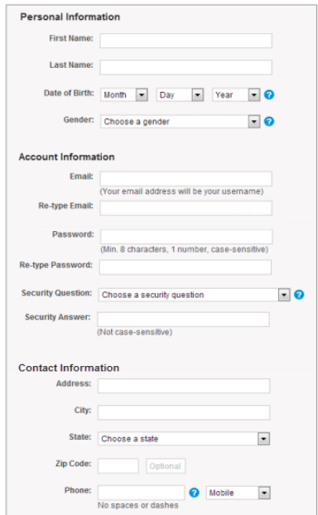

HTML TAGS USED IN THIS WEB PAGE :

* <head> - Heading content of the html file
* <body> - Body content of the html file
* <link> - To link CSS file
* <br> - Breaking line
* <div> - To create a division like a separate container
* <img> - To link an image into the website
* <hx> - heading tag followed by a number noting its size
* <p> - Paragraph tag for text
* <form> - Creating Form
* <input> - To take input from user
* <a> - Attribute link tag
* <select> - Provide a drop down list for the user
* <option> - Display the dropdown options available
* <button> - Create a submit button to the form

HTML CODE FOR MAIN WEB PAGE :

<!DOCTYPE html>

<html lang="en">

<head>

<meta charset="UTF-8">

<meta http-equiv="X-UA-Compatible" content="IE=edge">

<meta name="viewport" content="width=device-width, initial-scale=1.0">

<title>Form</title>

<link rel="icon" type="image" href="https://icons-for-free.com/iconfiles/png/512/clipboard+inventory+list+report+tasks+todo+icon-1320184207175705647.png">

<link rel="stylesheet" href="style.css">

</head>

<body style="padding-left:360px">

<br><br>

<div class="content" >

<form action="data.csv"style="padding-left:50px">

<h4 style="font-size: 120%;font-weight: bold;">Personal Information</h4>

<p style="padding-left: 35px;">First name: <input type="text" placeholder=""></p>

<p style="padding-left: 35px;">Last name: <input type="text" placeholder=""></p>

<p style="padding-left: 35px;">Date of Birth:

<select name="day" id="day">

<option value="0">Month</option>

<option value="1">1</option>

<option value="1">2</option>

<option value="1">3</option>

</select>

<select name="month" id="month">

<option value="0">Day</option>

<option value="1">1</option>

<option value="1">2</option>

<option value="1">3</option>

</select>

<select name="year" id="year">

<option value="0">year</option>

<option value="1">2020</option>

<option value="1">2021</option>

<option value="1">2022</option>

</select>

<img id="question" src="question.png"<p></p>

</p>

<p style="padding-left: 35px;">Gender:

<select name="gender" id="gender">

<option value="0">select your gender</option>

<option value="Female">Female</option>

<option value="male">male</option>

<option value="swaroop">LGBTQ</option>

<option value="ratan">Not to specify</option>

</select> <img id="question" src="question.png"></p>

<h4 style="font-size: 120%;font-weight: bold;">Account Information</h4>

<p style="padding-left: 35px;">Email: <input type="email" placeholder=""> <br><p style="padding-left: 75px;font-size: 70%;">(Your mail adress is your username)</p></p>

<p style="padding-left: 35px;">Re-Type Email: <input type="email" placeholder=""> <br></p>

<p style="padding-left: 35px;">Password: <input type="password" placeholder=""> <br><p style="padding-left: 95px;font-size: 70%;">(Min. 8 characters, 1 number)</p></p>

<p style="padding-left: 35px;">Re-Type Password: <input type="password" placeholder=""> <br></p>

<p style="padding-left: 35px;">Security-Question:

<select name="sq" id="sq">

<option value="0">Choose Your Security Question</option>

<option value="Female">Your pet name</option>

<option value="male">First school name</option>

<option value="swaroop">Your Favourite Teacher Name</option>

<option value="ratan">Your Favourite Quote</option>

</select> <img id="question" src="question.png"></p>

<p style="padding-left: 35px;">Security Answer: <input type="text" placeholder=""> <br><p style="padding-left: 145px;font-size: 70%;">(Not Case-Sensitive)</p></p>

<h4 style="font-size: 120%;font-weight: bold;">Contact Information</h4>

<p style="padding-left: 35px;">Adress: <input type="text" placeholder=""></p>

<p style="padding-left: 35px;">City: <input type="text" placeholder=""></p>

<p style="padding-left: 35px;">State:

<select name="sq" id="sq">

<option value="0">Choose Your State</option>

<option value="1">Arunachal Prades</option>

<option value="2">Andhra pradesh</option>

<option value="3">Assam</option>

<option value="4">Bihar</option>

<option value="5">Chandigarh</option>

<option value="6">Chattisgarh</option>

<option value="7">Delhi</option>

<option value="8">Goa</option>

<option value="1">Gujarat</option>

<option value="2">Haryana</option>

<option value="3">Jammu & kashmir</option>

<option value="4">Karnataka</option>

<option value="5">Kerala</option>

<option value="6">Madya pradesh</option>

<option value="7">Nagaland</option>

<option value="8">Punjab</option>

<option value="3">Tamil Nadu</option>

<option value="4">Telagana</option>

<option value="5">Tripura</option>

<option value="6">Uttarakhand pradesh</option>

<option value="7">Uttar pradesh</option>

<option value="8">West bengal</option>

</select></p>

<p style="padding-left: 35px;">ZipCode: <input type="number" placeholder=""> <br></p>

<p style="padding-left: 35px;">Phone: <input type="number" placeholder="">

<img id="question" src="question.png">

<select name="sq" id="sq">

<option value="0">Mobile</option>

<option value="1">Landline</option>

<option value="2">Telephone</option>

</select>

<br>

<p style="padding-left: 95px;font-size: 70%;">(Not Case-Sensitive)</p>

</p>

<button>Submit</button>

</form>

<br><br>

</div>

<br><br>

</body>

</html>

CSS CODE FOR Main Site :

body{

background-image: url("bg.jpeg");

}

.content {

padding-left: 2px;

border: none;

overflow: scroll;

height:520px;

width:70%;

background-color: rgba(255, 255,255, 0.7);

border-radius: 10px;

}

/\* Scrollbar styles \*/

::-webkit-scrollbar {

width: 12px;

height: 12px;

}

::-webkit-scrollbar-thumb {

background: white;

border-radius: 10px;

}

.content .q .a{

background-image: url(question.png);

}

#question{

width: 2%;

}

SCREENSHOTS :

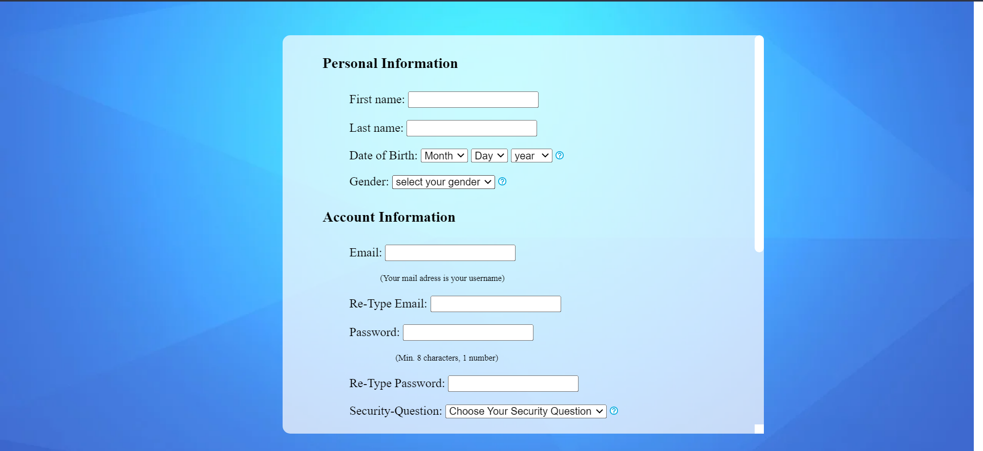

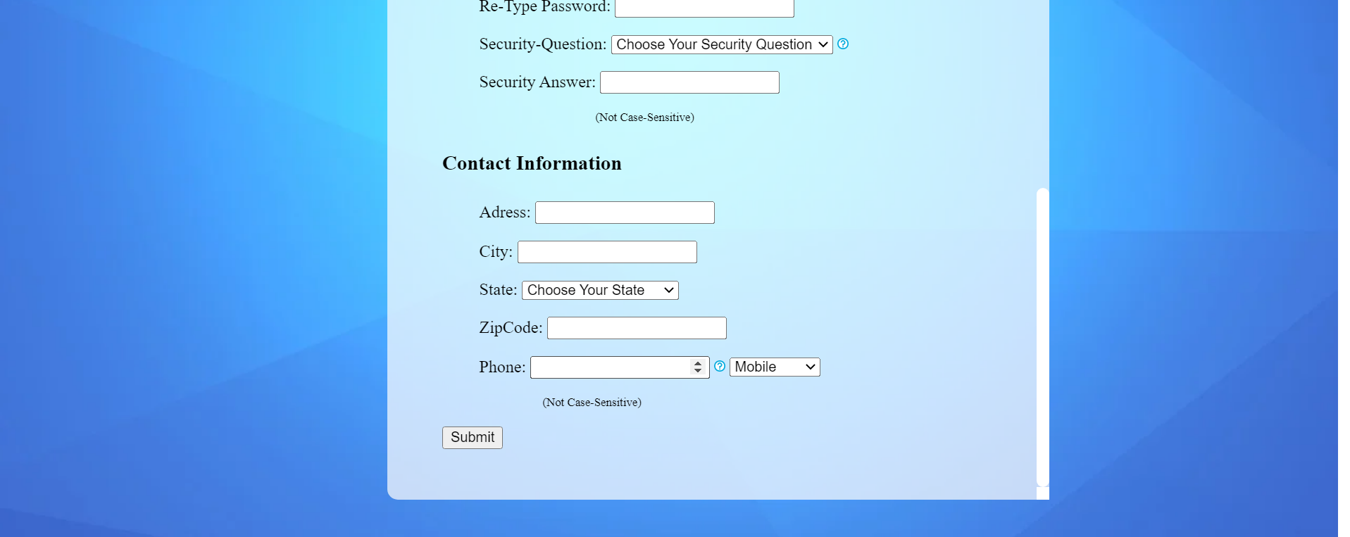

CONCLUSION :

1) We have successfully created a webpage for form submissions.

2) By using various html tags we have created this webpage.