CSS

AIM : Create simple single web page demonstrating CSS borders, backgrounds, any one TEXT effects and Using Layout

HTML TAGS USED IN THIS WEB PAGE :

* <head> - Heading content of the html file
* <body> - Body content of the html file
* <link> - To link CSS file
* <br> - Breaking line
* <div> - To create a division like a separate container
* <img> - To link an image into the website
* <p> - Paragraph tag for text
* <centre> - Creating Form
* <textarea> - To take input from user

HTML CODE FOR MAIN WEB PAGE :

<!DOCTYPE html>

<html lang="en">

<head>

<meta charset="UTF-8">

<meta http-equiv="X-UA-Compatible" content="IE=edge">

<meta name="viewport" content="width=device-width, initial-scale=1.0">

<title>CSS Styles</title>

<link rel="stylesheet" href="styles.css">

</head>

<body>

<div class="one">

<center >

<p>First Div </p></center>

<p>whose heading is contained in double red border </p>

<p>And whole div having dashed border of green color</p>

</div>

<div class="two">

<center >

<p>Second Div </p>

<p>whose Background is filled with an image </p>

<p>And whole div having double border of yellow color</p></center>

</div>

<div class="three">

<center >

<p>Third Div </p></center>

<p>whose background color is bisque color </p>

</div>

<div class="four">

<center >

<p>Textbox Div </p></center>

<textarea cols="41" rows="10">

This is text box wrapped in a div of grid display

Lorem ipsum dolor sit amet, consectetur adipisicing elit. Fugit perspiciatis quae placeat nulla, magnam ducimus ab rem quia est dolore rerum possimus distinctio cumque quos quis eveniet nesciunt sed illum officia beatae! Perspiciatis voluptate tenetur voluptatem est blanditiis nobis quis laborum, architecto nemo hic alias doloribus, molestias cupiditate, accusamus sequi!

</textarea>

</div>

<div class="five">

<img src="download.png" alt="" width="100%">

</div>

<div class="six" style="display: grid; grid-template-columns: auto auto; grid-template-rows: auto auto; color:aliceblue">

<div style="background-color: rgba(237, 10, 10);">

<p>grid 1</p>

</div>

<div style="background-color: rgba(94, 6, 6);">

<p>grid 2</p>

</div>

<div style="background-color: rgb(255, 4, 4);">

<p>grid 3</p>

</div>

<div style="background-color: rgb(165, 6, 6);">

<p>grid 4</p>

</div>

</div>

<div class="seven">

<p>End of Boarders content havig mixed borders</p>

</div>

</body>

</html>

CSS CODE FOR Main Site :

body{

background-color: black;

border: dotted 4px orange;

display: grid;

grid-template-columns: auto auto auto;

grid-template-rows: auto auto auto;

column-gap: 20px;

row-gap: 20px;

}

.one{

color: white;

background-color: rgba(13, 1, 1, 0.062);

border: dashed 4px green;

}

.one center{

background-color: whitesmoke;

color: black;

border: double 5px red;

}

.two{

color: black;

background: url('download.jpg');

border: double 4px yellow;

}

.three{

border: ridge 2px olive;

background-color: bisque;

}

.four{

border: solid 2px white;

}

.four center{

background-color: whitesmoke;

color: black;

border: inset 5px orangered;

}

.five{

border: solid 2px orange;

}

.six{

border: outset 2px goldenrod;

}

.seven{

border-style: dashed double dotted inset;

border-color: aqua;

color: azure;

}

SCREENSHOTS :

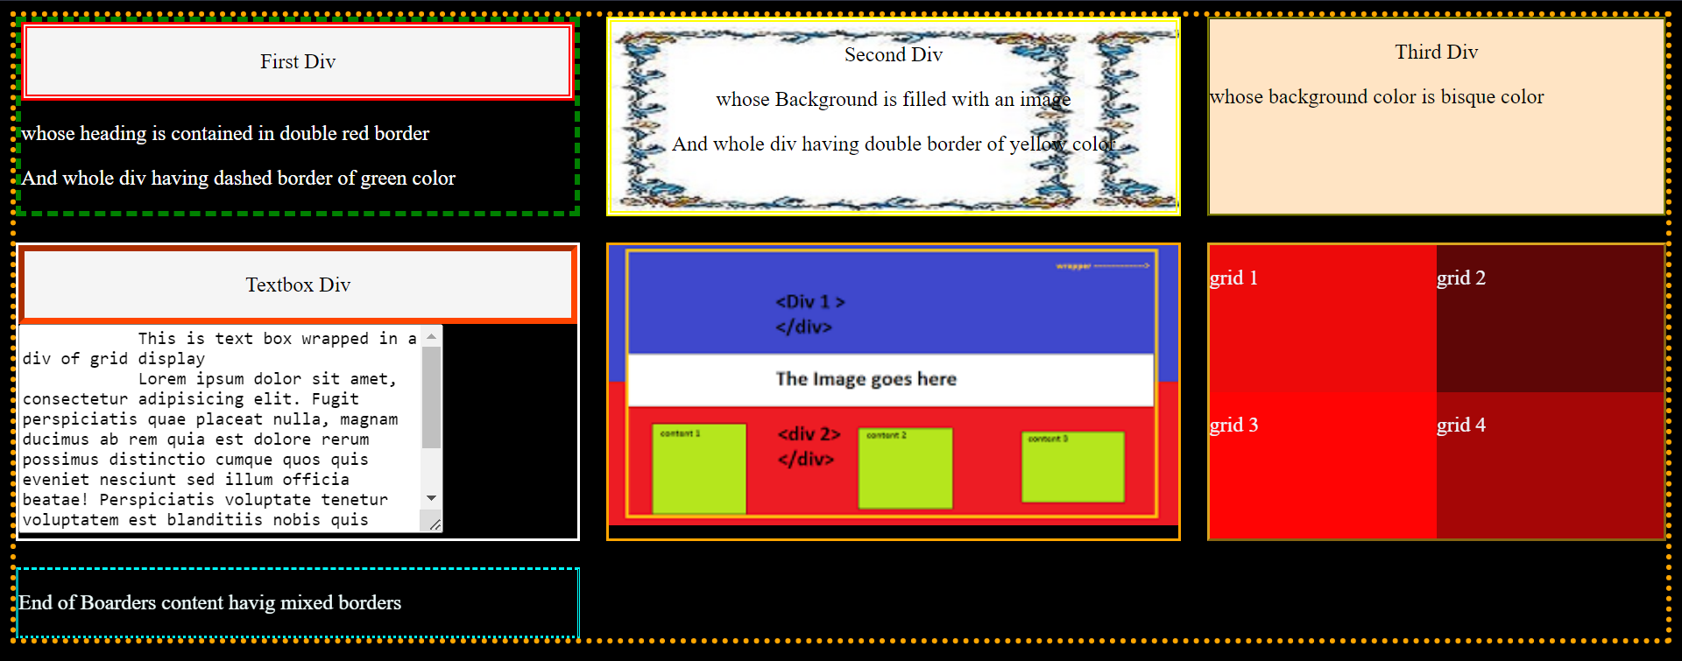

CONCLUSION :

1) We have successfully created a webpage which can explain css layouts.

2) By using various css styles we have created this webpage.