**TASK 6 - 9**

**NAME: JAI CHIRANJEEVA DADI**

**SUBJECT: UID LAB**

**ROLL NO: 21122**

**CLASS: CSE-B**

# Task 6

**Program 1 - Ask the User to enter name and displaying the same name with welcome message.**

**Solution:-**

**HTML:**

<!DOCTYPE html>

<html lang="en">

<head>

<meta charset="UTF-8">

<meta http-equiv="X-UA-Compatible" content="IE=edge">

<meta name="viewport" content="width=device-width, initial-scale=1.0">

<title>Document</title>

<script src="main.js"></script>

<link rel="stylesheet" href="style.css">

</head>

<body>

<center>

<div class="name">

<form action="">

<label for="">Enter Your Name : </label>

<input type="text" name="" id="data"> <br>

<input type="button" value="Submit" onclick = "operate()">

</form>

</div>

</center>

</body>

</html>

Css:

.name{

margin:200px 500px;

}

input[type="button"] {

border: 0ch;

background-color: red;

margin:12px 50px;

padding:5px;

}

Java Script:

function operate()

{

var name = document.getElementById("data").value;

document.write(“<center> welcome to the world of JS "+ name + " ! </center>");

}

Screenshots:

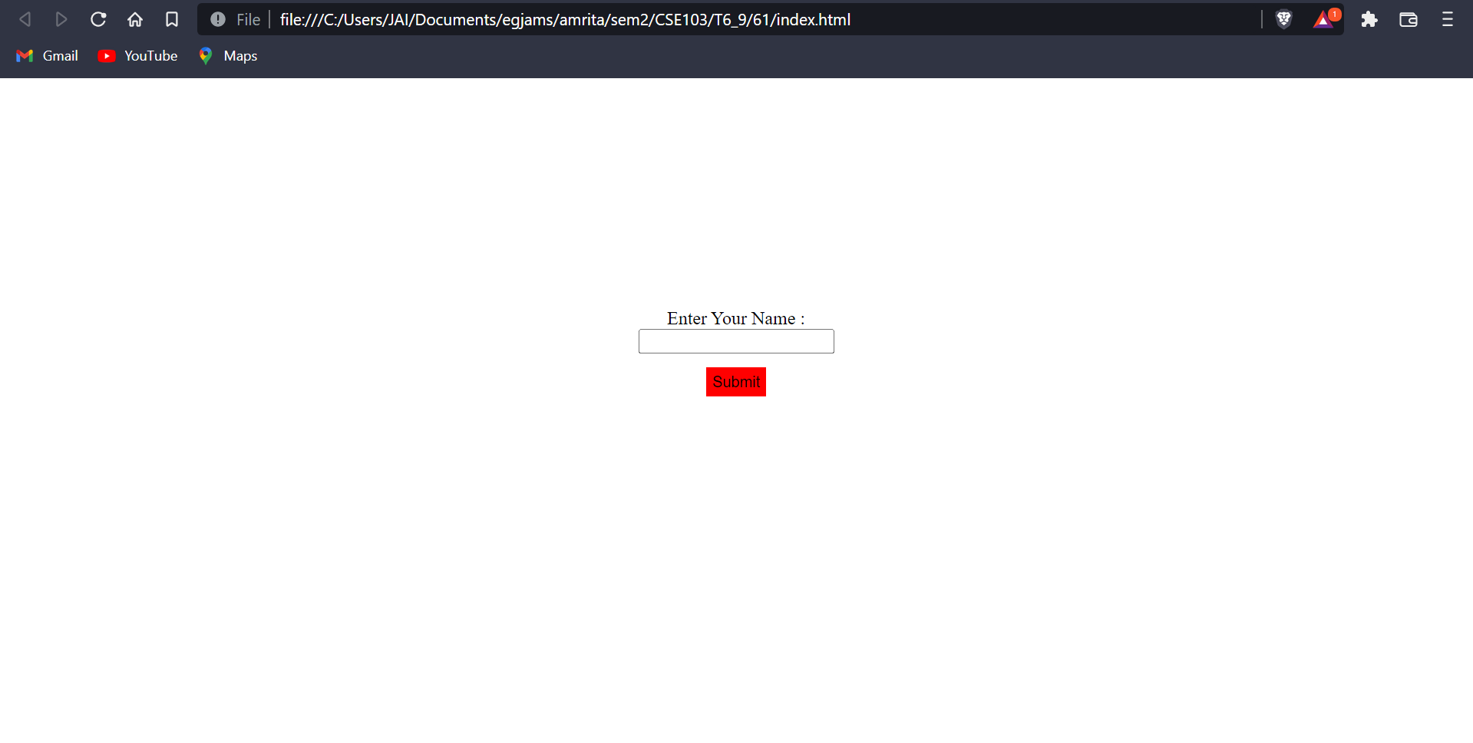

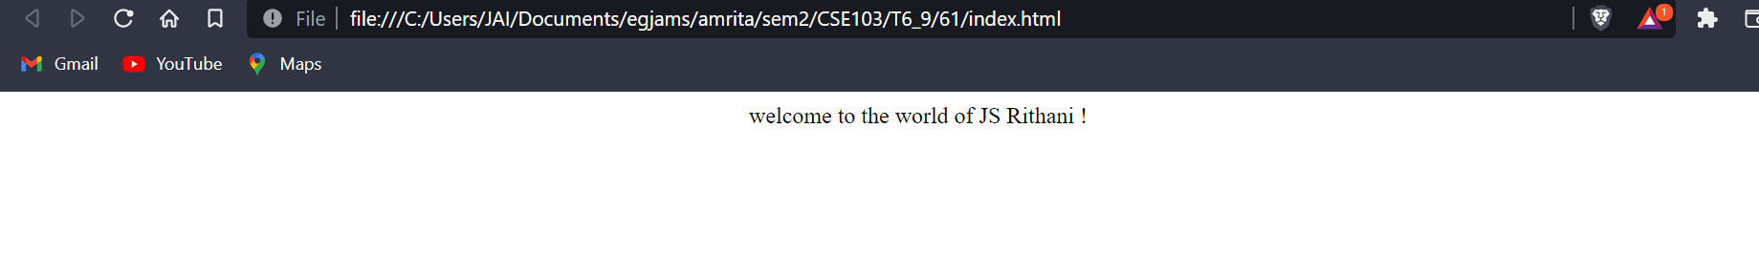

**Program 2-Print the user entered string in reverse order.**

**Solution:-**

**HTML:**

<!DOCTYPE html>

<html lang="en">

<head>

<meta charset="UTF-8">

<meta http-equiv="X-UA-Compatible" content="IE=edge">

<meta name="viewport" content="width=device-width, initial-scale=1.0">

<title>Reverse string</title>

<script src="main.js"></script>

<link rel="stylesheet" href="style.css">

</head>

<body>

<div class="form_1">

<form action="">

<label for="">Enter String here : </label>

<input type="text" name="" id="str"> <br>

<input type="button" value="Submit" onclick = "reverseString()">

<br>

</form>

<span id="rev"></span>

</div>

</body>

</html>

**CSS:**

input[type="button"] {

background-color: black;

color: white;

margin:12px 50px;

border-radius: 2px;

padding:5px;

}

**JavaScript:**

function reverseString()

{

var str = document.getElementById("str").value;

var rev = "";

for(var i = str.length - 1; i >= 0; i--) {

rev += str[i];

}

//alert("Reverse of entered String is " + rev);

//document.write("Reverse of entered String is " + rev);

document.querySelector('#rev').innerHTML +=

`

<p>Reverse of entered String is ${rev} </p>

`;

}

Screenshots:

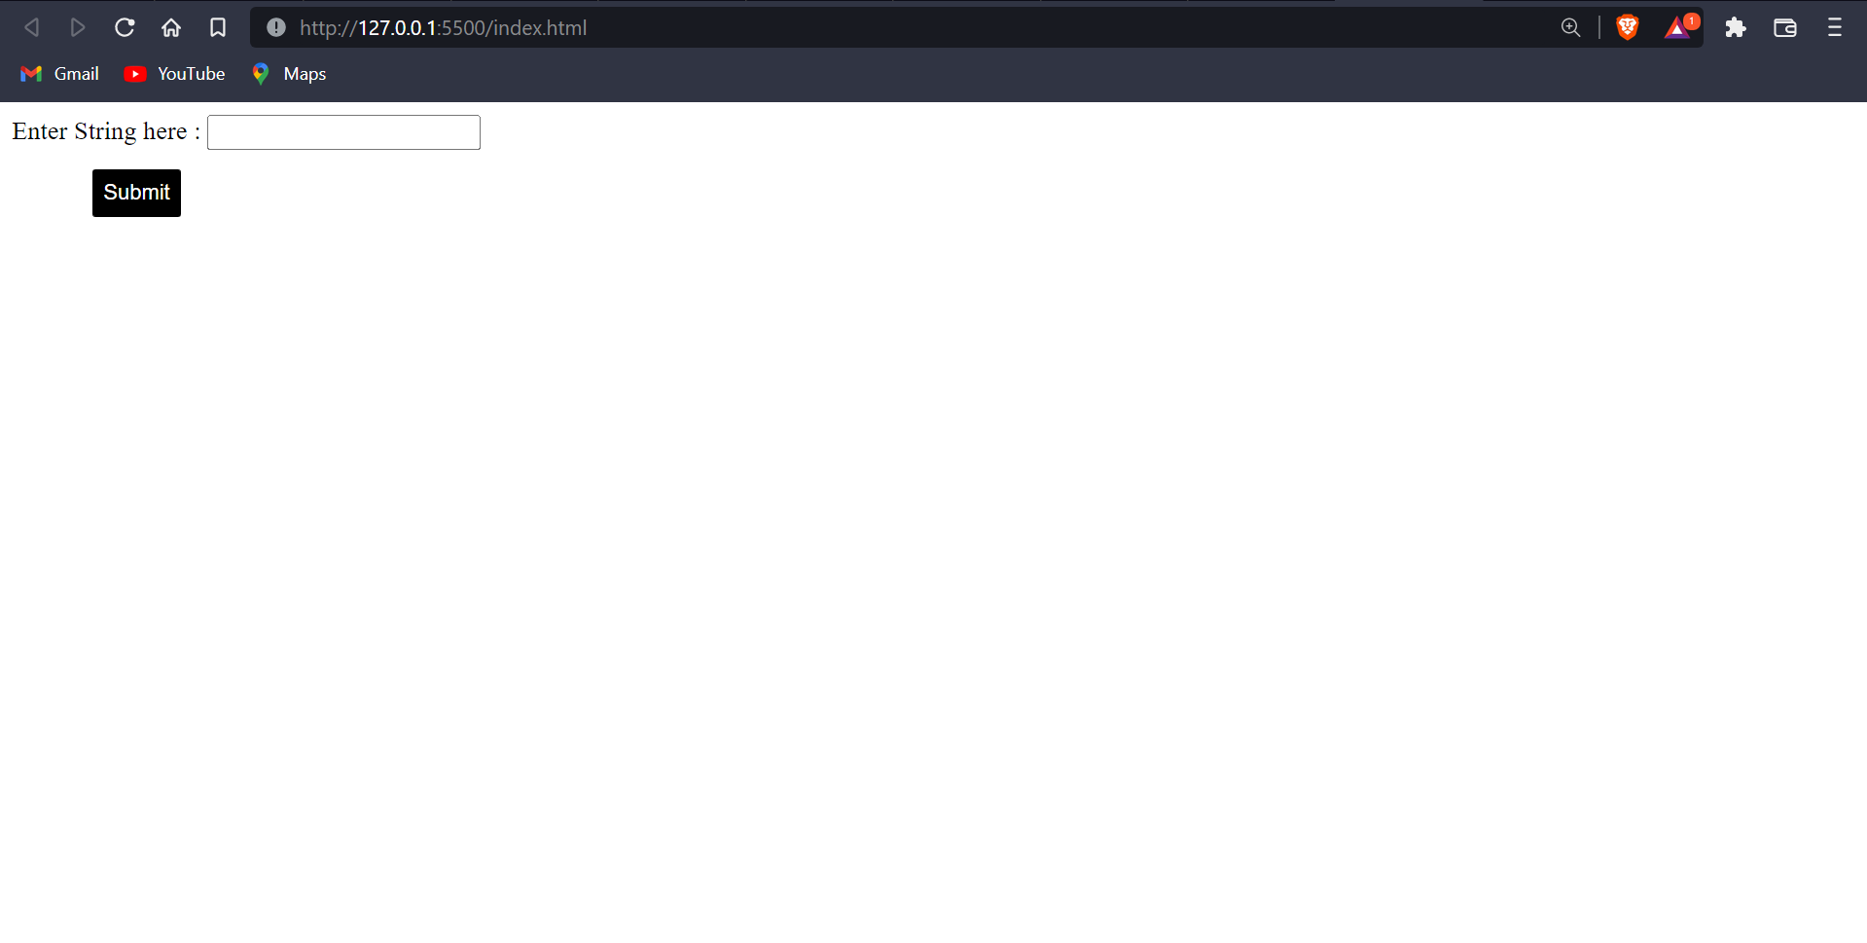

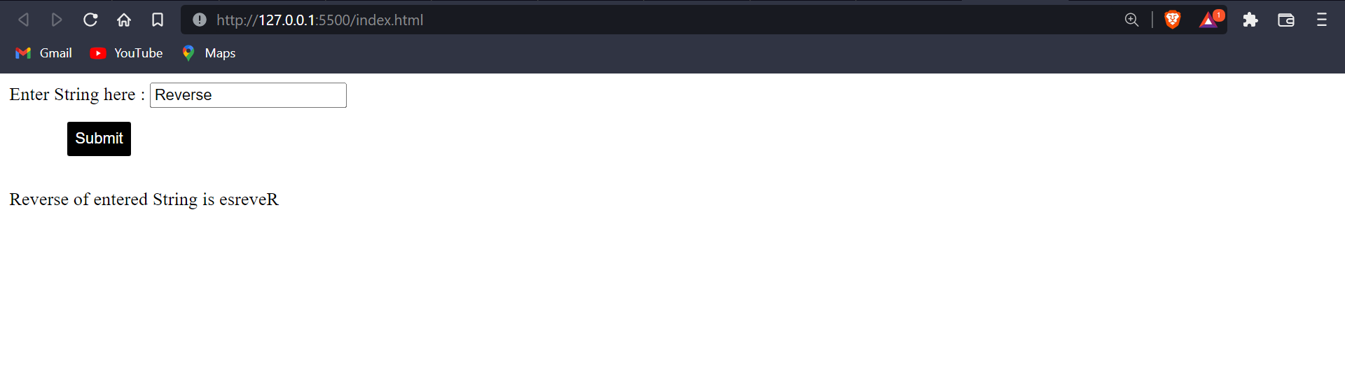

**Program 3-Add two floating point and Integer number and display the result. Use prompt function.**

**Solution:-**

**HTML:**

<!DOCTYPE html>

<html lang="en">

<head>

<meta charset="UTF-8">

<meta http-equiv="X-UA-Compatible" content="IE=edge">

<meta name="viewport" content="width=device-width, initial-scale=1.0">

<title>Finding sum</title>

<script src="main.js"></script>

</head>

<body>

<div>

<form action="">

<p>Enter First Floating point number:</p>

<input type="number" id="f1">

<p>Enter Second Floating point number:</p>

<input type="number" id="f2">

<p>Enter Integer number:</p>

<input type="number" id="i"><br>

<input type="button" value="Submit" onclick = "sum()">

</form>

<span id="res"></span>

</div>

</body>

</html>

**JavaScript:**

function sum(){

var sum = parseFloat(document.getElementById("f1").value) + parseFloat(document.getElementById("f2").value)+ parseInt(document.getElementById("i").value);

document.querySelector('#res').innerHTML +=

`

<p>Sum of entered Numbers is ${sum} </p>

`;

}

Screenshots:

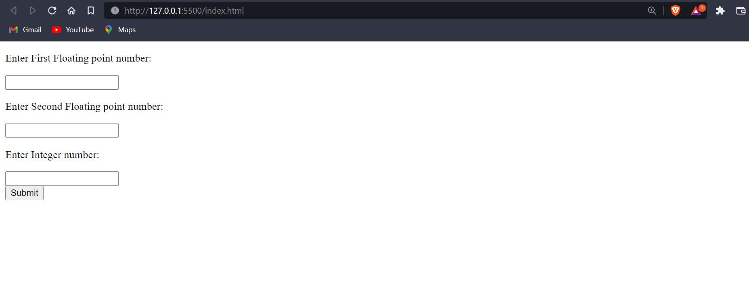

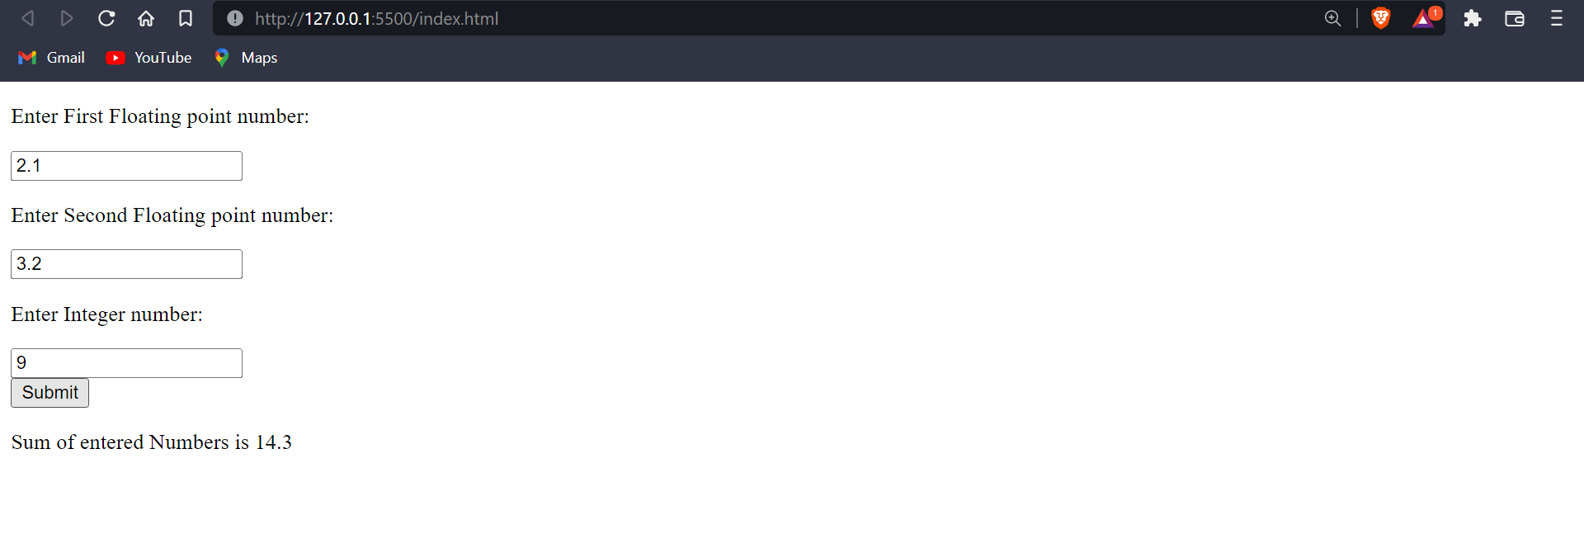

**Program 4- Multiplication table of a user entered number.**

**Solution:-**

**HTML:**

<!DOCTYPE html>

<html lang="en">

<head>

<meta charset="UTF-8">

<meta http-equiv="X-UA-Compatible" content="IE=edge">

<meta name="viewport" content="width=device-width, initial-scale=1.0">

<title>Multiplication Table</title>

<script src="main.js"></script>

</head>

<body>

<form action="">

<p>Enter The number to Get table</p>

<input type="number" id="num">

<input type="button" value="Submit" onclick="table()">

</form>

<span id="mult"></span>

</body>

</html>

**JavaScript:**

function table(){

var n=parseInt(document.getElementById("num").value);

var x;

for (var i = 1; i<=10; i++) {

x=n*parseInt(i);

console.log(x);

document.querySelector("#mult").innerHTML+=

`

<p>${n} * ${i} = ${x}</p>

`;

}

}

Screenshots:

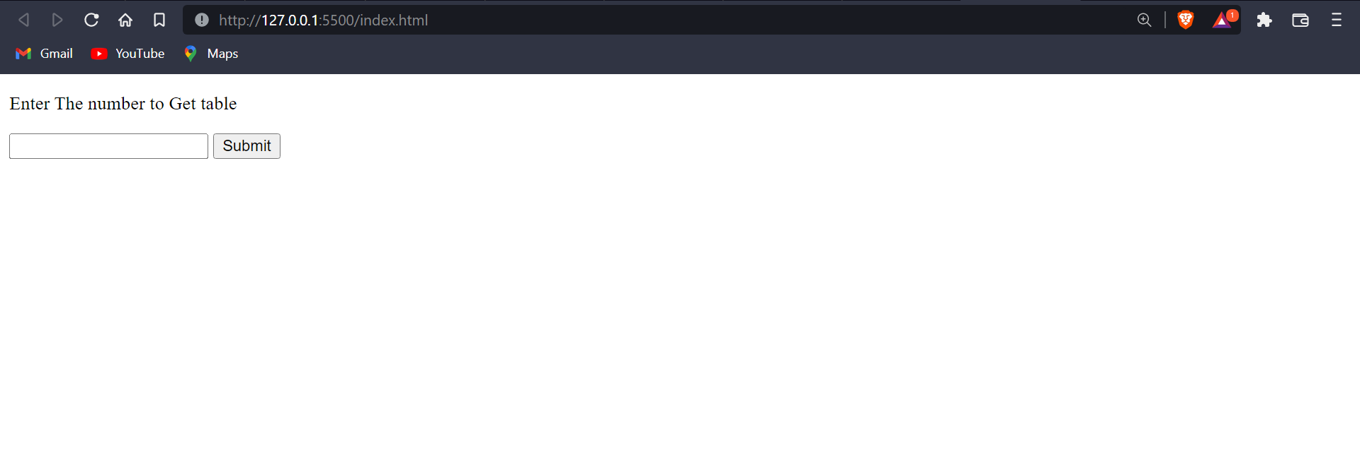

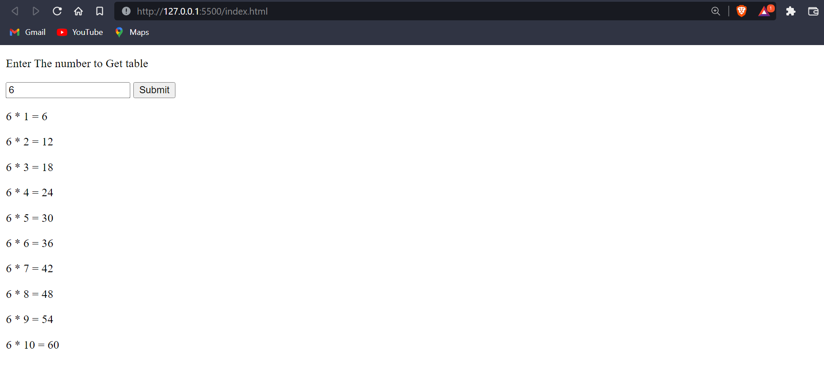

**Task 7**

**JavaScript program for event handling ( Any four events) - onclick, onmouseup, onmousedown, ondblclick**

**Solution:-**

**HTML:**

<!DOCTYPE html>

<html lang="en">

<head>

<meta charset="UTF-8">

<meta http-equiv="X-UA-Compatible" content="IE=edge">

<meta name="viewport" content="width=device-width, initial-scale=1.0">

<title>Event Handlers</title>

<script src="main.js"></script>

</head>

<body>

<div>

<p>Click on the button to get an alert which is handled by onclick <button type="submit" id="oncl" onclick="aler()">Click</button></p><br><br><br><br>

<p>Click on the button twice to get an alert which is handled by ondblclick <button type="submit" id="oncl"ondblclick="aler()">Click twice</button></p><br><br><br><br>

<p>mouseup , This button gets triggerred on Right Click of the mouse also <button type="submit" id="oncl" onmouseup="aler()"> mouseup</button></p><br><br><br><br>

<p>MouseDown , This Button gets triggered on Left Click of the mouse also <button type="submit" id="oncl" onmousedown="aler()">MouseDown</button></p>

</div>

</body>

</html>

**JavaScript:**

function aler() {

alert("U clicked on the button for a check on event Handlers");

}

Screenshots:

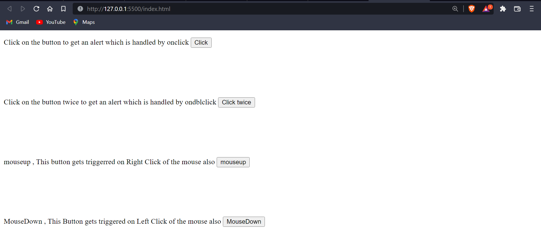

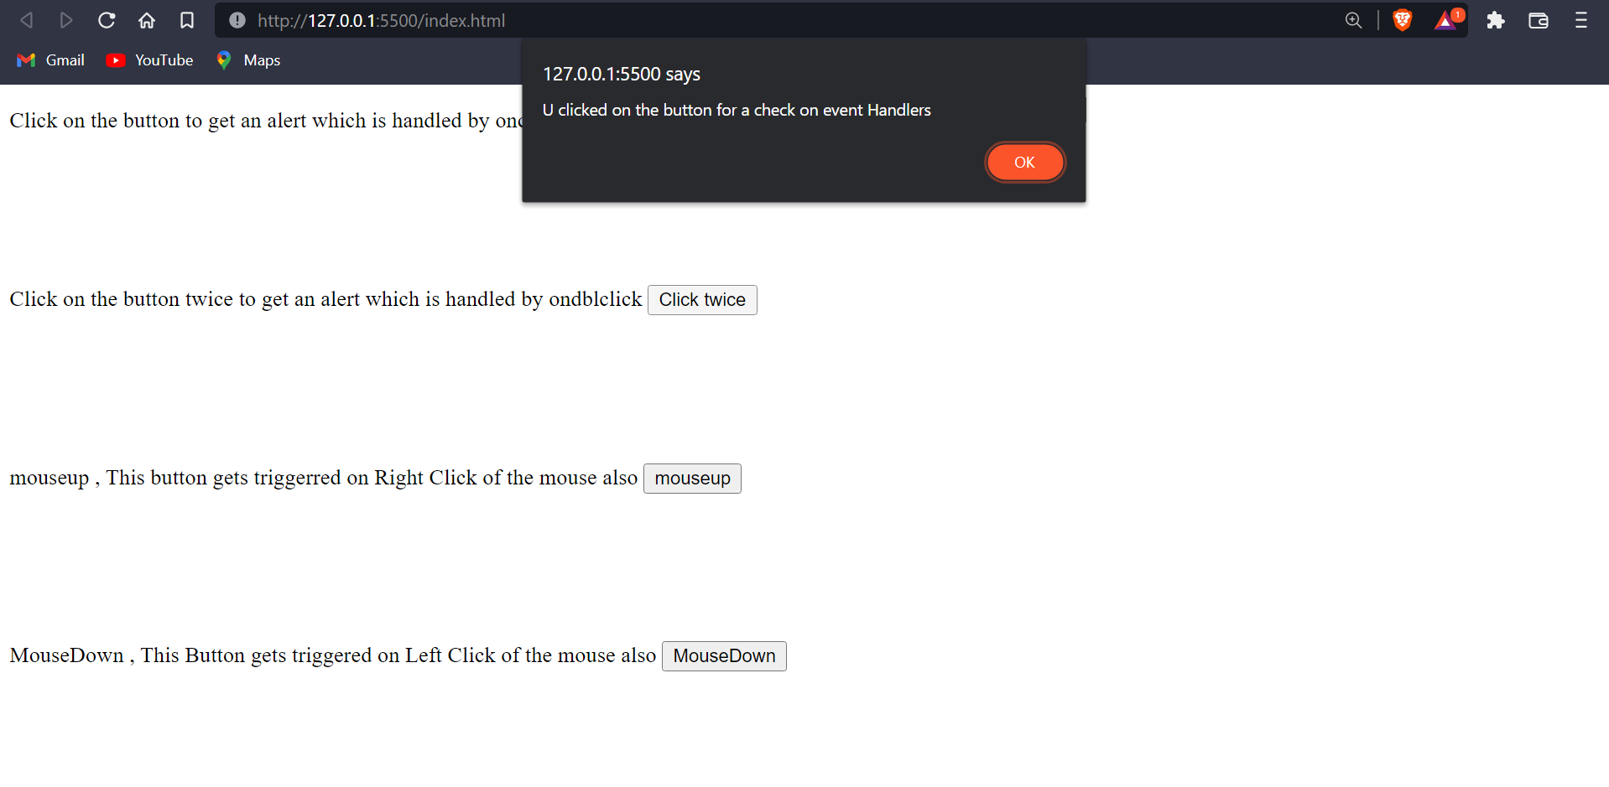

**Task 8**

* **Create a script that check if a number is odd or even.**

**Solution:-**

**HTML:**

<!DOCTYPE html>

<html lang="en">

<head>

<meta charset="UTF-8">

<meta http-equiv="X-UA-Compatible" content="IE=edge">

<meta name="viewport" content="width=device-width, initial-scale=1.0">

<title>Eve / Odd Checker</title>

<script src="main.js"></script>

</head>

<body>

<form action="">

<p>Enter The number to Check Whether its an odd / Even Number</p>

<input type="number" id="num">

<input type="button" value="Submit" onclick="check()">

</form>

<span id="mult"></span>

</body>

</html>

**JavaScript:**

function check(){

var n=parseInt(document.getElementById("num").value);

if (n%2==0) {

document.querySelector("#mult").innerHTML+=

`

<p>${n} is an Even Number</p>

`;

} else {

document.querySelector("#mult").innerHTML+=

`

<p>${n} is an Odd Number</p>

`;

}

}

Screenshots:

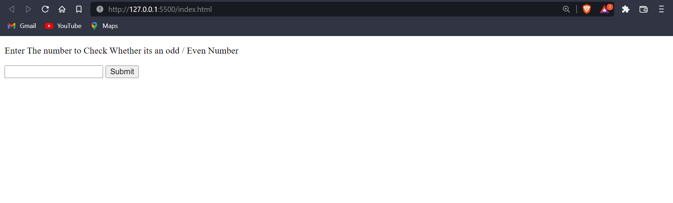

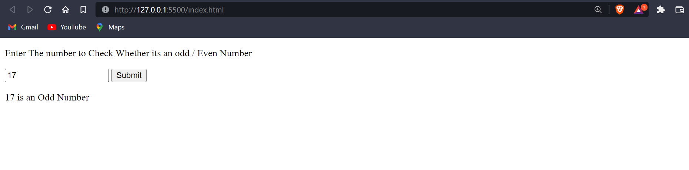

* **Create a script for calculator that collects numbers from a page and then adds, sub, mul, div them up and prints them to a blank field on the page**

**Solution:-**

**HTML:**

<!DOCTYPE html>

<html lang="en">

<head>

<meta charset="UTF-8">

<meta http-equiv="X-UA-Compatible" content="IE=edge">

<meta name="viewport" content="width=device-width, initial-scale=1.0">

<title>Simple Calculator</title>

<link rel="stylesheet" href="style.css">

<script src="main.js"></script>

</head>

<body>

<div class= "formstyle">

<form name = "form1">

<input id = "calc" type ="text" name = "answer"> <br> <br>

<input type = "button" value = "7" onclick = "form1.answer.value += '7' ">

<input type = "button" value = "8" onclick = "form1.answer.value += '8' ">

<input type = "button" value = "9" onclick = "form1.answer.value += '9' ">

<input type = "button" value = "*" onclick = "form1.answer.value += '*' ">

<br> <br>

<input type = "button" value = "4" onclick = "form1.answer.value += '4' ">

<input type = "button" value = "5" onclick = "form1.answer.value += '5' ">

<input type = "button" value = "6" onclick = "form1.answer.value += '6' ">

<input type = "button" value = "-" onclick = "form1.answer.value += '-' ">

<br> <br>

<input type = "button" value = "1" onclick = "form1.answer.value += '1' ">

<input type = "button" value = "2" onclick = "form1.answer.value += '2' ">

<input type = "button" value = "3" onclick = "form1.answer.value += '3' ">

<input type = "button" value = "+" onclick = "form1.answer.value += '+' ">

<br> <br>

<input type = "button" value = "/" onclick = "form1.answer.value += '/' ">

<input type = "button" value = "0" onclick = "form1.answer.value += '0' ">

<input type = "button" value = "." onclick = "form1.answer.value += '.' ">

<input type = "button" value = "=" onclick = "form1.answer.value = eval(form1.answer.value) ">

<br>

<input type = "button" value = "Clear All" onclick = "form1.answer.value = ' ' " id= "clear" >

<br>

</form>

</div>

</body>

</html>

**CSS:**

#clear{

width: 270px;

border: 3px solid gray;

border-radius: 3px;

padding: 20px;

background-color: red;

}

.formstyle{

width: 300px;

height: 450px;

margin: auto;

padding: 20px;

}

input

{

width: 20px;

background-color: lightgoldenrodyellow;

color: black;

border: 3px solid gray;

border-radius: 5px;

padding: 26px;

margin: 5px;

font-size: 15px;

}

#calc{

width: 250px;

border: 5px solid lightcoral;

border-radius: 3px;

padding: 20px;

margin: auto;

}

Screenshots:

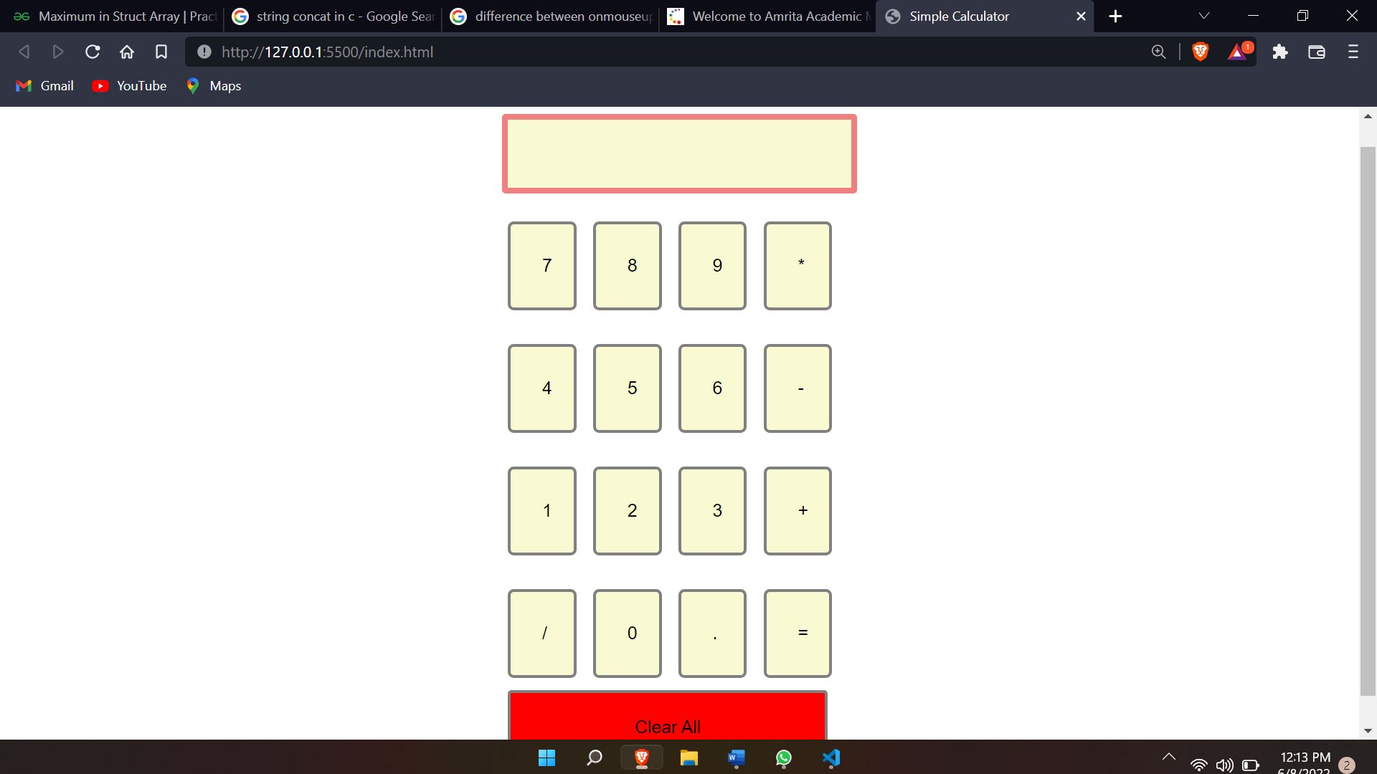

**TASK-9**

**Javascript program for form validation (including email, password, zipcode)**

**Solution:-**

**HTML:**

**<!DOCTYPE html>**

**<html lang="en">**

**<head>**

**<meta charset="utf-8" />**

**<title>JavaScript Form Validation using a sample registration form</title>**

**<meta**

**name="keywords"**

**content="example, JavaScript Form Validation, Sample registration form"**

**/>**

**<meta**

**name="description"**

**content="This document is an example of JavaScript Form Validation using a sample registration form. "**

**/>**

**<link rel="stylesheet" href="js-form-validation.css" type="text/css" />**

**<script src="sample-registration-form-validation.js"></script>**

**</head>**

**<body onload="document.registration.userid.focus();">**

**<h1>Registration Form</h1>**

**Use tab keys to move from one input field to the next.**

**<form name="registration" onSubmit="return formValidation();">**

**<ul>**

**<li><label for="userid">User id:</label></li>**

**<li><input type="text" name="userid" size="12" /></li>**

**<li><label for="passid">Password:</label></li>**

**<li><input type="password" name="passid" size="12" /></li>**

**<li><label for="username">Name:</label></li>**

**<li><input type="text" name="username" size="50" /></li>**

**<li><label for="address">Address:</label></li>**

**<li><input type="text" name="address" size="50" /></li>**

**<li><label for="country">Country:</label></li>**

**<li>**

**<select name="country">**

**<option selected="" value="Default">**

**(Please select a country)**

**</option>**

**<option value="AF">Australia</option>**

**<option value="AL">Canada</option>**

**<option value="DZ">India</option>**

**<option value="AS">Russia</option>**

**<option value="AD">USA</option>**

**</select>**

**</li>**

**<li><label for="zip">ZIP Code:</label></li>**

**<li><input type="text" name="zip" /></li>**

**<li><label for="email">Email:</label></li>**

**<li><input type="text" name="email" size="50" /></li>**

**<li><label id="gender">Sex:</label></li>**

**<li>**

**<input type="radio" name="msex" value="Male" /><span>Male</span>**

**</li>**

**<li>**

**<input type="radio" name="fsex" value="Female" /><span>Female</span>**

**</li>**

**<li><label>Language:</label></li>**

**<li>**

**<input type="checkbox" name="en" value="en" checked /><span**

**>English</span**

**>**

**</li>**

**<li>**

**<input type="checkbox" name="nonen" value="noen" /><span**

**>Non English</span**

**>**

**</li>**

**<li><label for="desc">About:</label></li>**

**<li><textarea name="desc" id="desc"></textarea></li>**

**<li><input type="submit" name="submit" value="Submit" /></li>**

**</ul>**

**</form>**

**</body>**

**<script>**

**function formValidation() {**

**var uid = document.registration.userid;**

**var passid = document.registration.passid;**

**var uname = document.registration.username;**

**var uadd = document.registration.address;**

**var ucountry = document.registration.country;**

**var uzip = document.registration.zip;**

**var uemail = document.registration.email;**

**var umsex = document.registration.msex;**

**var ufsex = document.registration.fsex;**

**if (userid_validation(uid, 5, 12)) {**

**if (passid_validation(passid, 7, 12)) {**

**if (allLetter(uname)) {**

**if (alphanumeric(uadd)) {**

**if (countryselect(ucountry)) {**

**if (allnumeric(uzip)) {**

**if (ValidateEmail(uemail)) {**

**if (validsex(umsex, ufsex)) {**

**}**

**}**

**}**

**}**

**}**

**}**

**}**

**}**

**return false;**

**}**

**function userid_validation(uid, mx, my) {**

**var uid_len = uid.value.length;**

**if (uid_len == 0 || uid_len >= my || uid_len < mx) {**

**alert(**

**"User Id should not be empty / length be between " + mx + " to " + my**

**);**

**uid.focus();**

**return false;**

**}**

**return true;**

**}**

**function passid_validation(passid, mx, my) {**

**var passid_len = passid.value.length;**

**if (passid_len == 0 || passid_len >= my || passid_len < mx) {**

**alert(**

**"Password should not be empty / length be between " + mx + " to " + my**

**);**

**passid.focus();**

**return false;**

**}**

**return true;**

**}**

**function allLetter(uname) {**

**var letters = /^[A-Za-z]+$/;**

**if (uname.value.match(letters)) {**

**return true;**

**} else {**

**alert("Username must have alphabet characters only");**

**uname.focus();**

**return false;**

**}**

**}**

**function alphanumeric(uadd) {**

**var letters = /^[0-9a-zA-Z]+$/;**

**if (uadd.value.match(letters)) {**

**return true;**

**} else {**

**alert("User address must have alphanumeric characters only");**

**uadd.focus();**

**return false;**

**}**

**}**

**function countryselect(ucountry) {**

**if (ucountry.value == "Default") {**

**alert("Select your country from the list");**

**ucountry.focus();**

**return false;**

**} else {**

**return true;**

**}**

**}**

**function allnumeric(uzip) {**

**var numbers = /^[0-9]+$/;**

**if (uzip.value.match(numbers)) {**

**return true;**

**} else {**

**alert("ZIP code must have numeric characters only");**

**uzip.focus();**

**return false;**

**}**

**}**

**function ValidateEmail(uemail) {**

**var mailformat = /^\w+([\.-]?\w+)@\w+([\.-]?\w+)(\.\w{2,3})+$/;**

**if (uemail.value.match(mailformat)) {**

**return true;**

**} else {**

**alert("You have entered an invalid email address!");**

**uemail.focus();**

**return false;**

**}**

**}**

**function validsex(umsex, ufsex) {**

**x = 0;**

**if (umsex.checked) {**

**x++;**

**}**

**if (ufsex.checked) {**

**x++;**

**}**

**if (x == 0) {**

**alert("Select Male/Female");**

**umsex.focus();**

**return false;**

**} else {**

**alert("Form Succesfully Submitted");**

**window.location.reload();**

**return true;**

**}**

**}**

**</script>**

**<style>**

**h1 {**

**margin-top: 70px;**

**}**

**form li {**

**list-style: none;**

**margin-bottom: 5px;**

**}**

**form ul li label {**

**float: left;**

**clear: left;**

**width: 100px;**

**text-align: right;**

**margin-right: 10px;**

**font-family: Verdana, Arial, Helvetica, sans-serif;**

**font-size: 14px;**

**}**

**form ul li input,**

**select,**

**span {**

**float: left;**

**margin-bottom: 10px;**

**}**

**form textarea {**

**float: left;**

**width: 350px;**

**height: 150px;**

**}**

**[type="submit"] {**

**clear: left;**

**margin: 20px 0 0 230px;**

**font-size: 18px;**

**}**

**p {**

**margin-left: 70px;**

**font-weight: bold;**

**}**

**</style>**

**</html>**

**Screenshot:**

