**Create a react app for Student Management Portal**

Create a react app for Student Management Portal named scorecalculatorapp and create a function component named “CalculateScore” which will accept Name, School, Total and goal in order to calculate the average score of a student and display the same.

**Outputs and Results:**

**1.localhost**

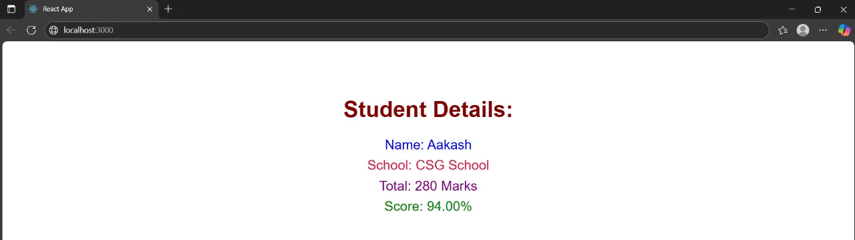

**2.compilation**

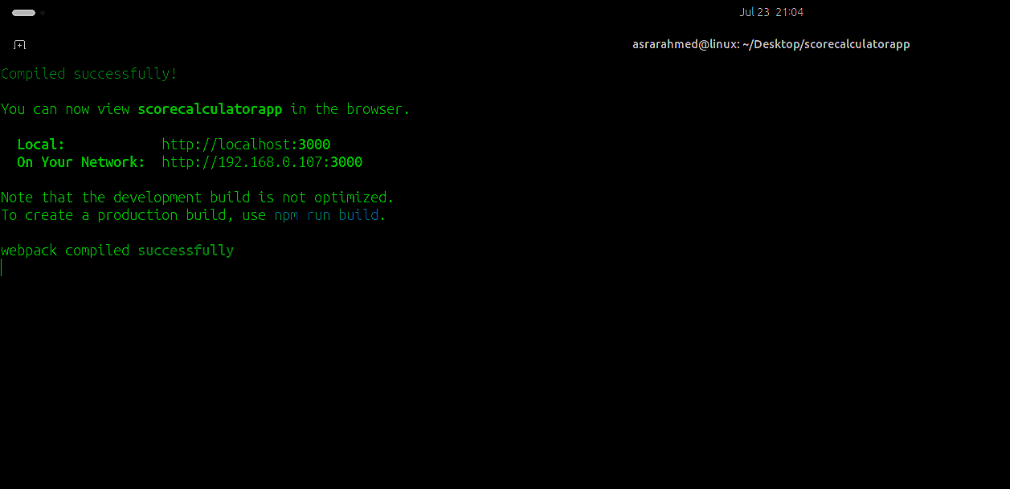

**3. File Structure and App.js**

