**Q1). Create a File with Hole in it**

**Ans:-**

#include <stdio.h>

#include <stdlib.h>

int main() {

// Define a file pointer

FILE *file;

// Open a file for writing (creating if it doesn't exist)

file = fopen("example.txt", "w");

if (file == NULL) {

perror("Error opening file for writing");

return 1;

}

// Write data to the file

fprintf(file, "Hello, World!\n");

fprintf(file, "This is a test file.\n");

// Close the file

fclose(file);

// Open the file for reading

file = fopen("example.txt", "r");

if (file == NULL) {

perror("Error opening file for reading");

return 1;

}

// Read and print the contents of the file

char buffer[256];

while (fgets(buffer, sizeof(buffer), file) != NULL) {

printf("%s", buffer);

}

// Close the file

fclose(file);

return 0;

}

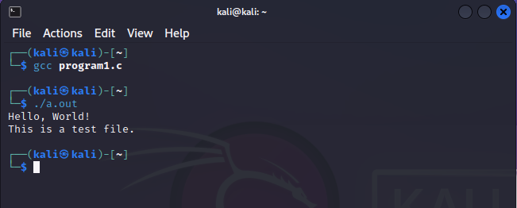**Output:-**

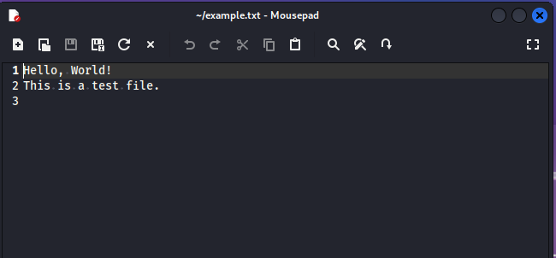

# Q.2 Takes multiple files as Command Line Arguments And print their inode number.

#include<stdio.h>

#include<sys/stat.h> #include<unistd.h> int main(int argc, char*argv[]){ struct stat buf; int I;

// loop through coom for(i=0;i<argc;i++){

// get file

if(stat(argv[i],&buf)<0){ perror("stat error"); continue;

}

//print node

printf("%s:inode=%ld\n",argv[i],buf.st_ino);} return 0;

}

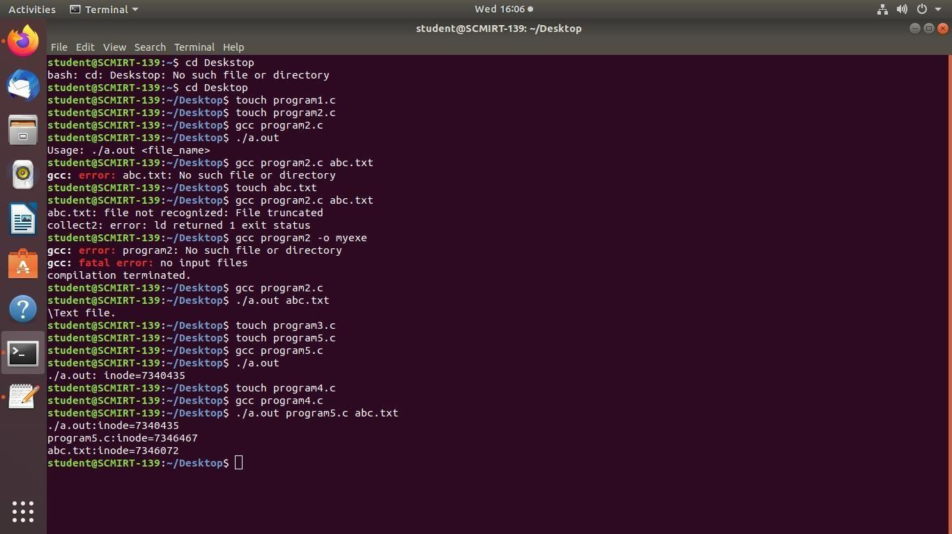Output:

# Q .4 Print the type of file where file name accepted Through Command line.

#include <stdio.h>

#include <stdlib.h> #include <string.h> int main(int argc, char *argv[]) { if (argc != 2)

{

printf("Usage: %s <file_name>\n", argv[0]); return 1;

}

char *file_name = argv[1];

char *extension = strrchr(file_name, '.'); if (extension

== NULL) {

printf("File type cannot be determined.\n"); return 1;

}

if (strcmp(extension, ".txt") == 0) { printf("Text file.\n");

} else if (strcmp(extension, ".doc") == 0 || strcmp(extension, ".docx") == 0) {

printf("Microsoft Word document.\n"); } else if (strcmp(extension, ".pdf") == 0) { printf("PDF document.\n");

} else {

printf("File type not recognized.\n");

}

return 0;

}

Output: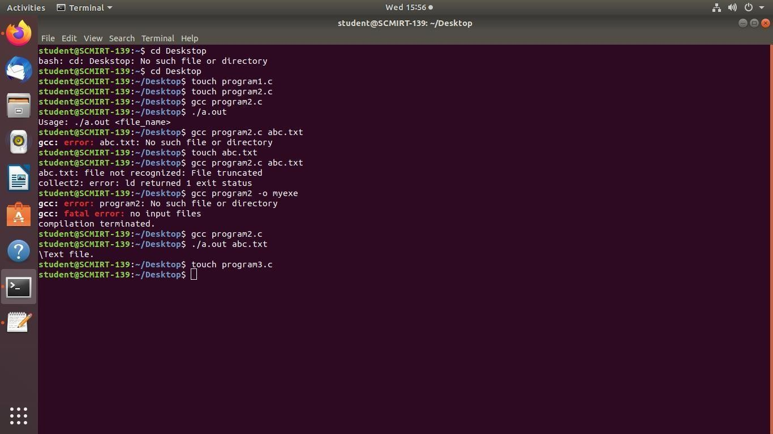

# Q7. Read the current directory and display the name of the files, no of files in current directory.

#include <dirent.h> #include <stdio.h> int main() {

DIR *d;

struct dirent *dir; int count = 0;

d = opendir("."); if (d) {

while ((dir = readdir(d)) != NULL) { printf("%s\n", dir->d_name); count++;

}

closedir(d);

}

printf("Number of files: %d\n", count); return 0;

}

Output:

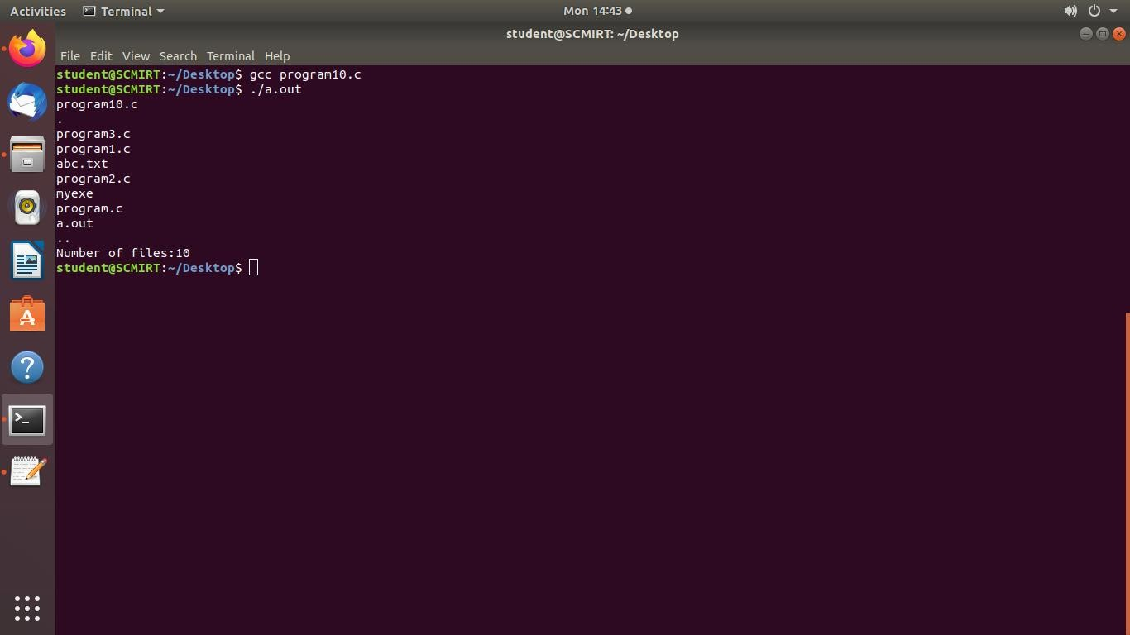

Q8. Write a C program which receives file names as command line arguments and display those filenames in ascending order according to their sizes

Program:

#include <stdio.h> #include <stdlib.h> #include <sys/stat.h>

int compare(const void *a, const void *b) { struct stat *stat_a = (struct stat *) a;

struct stat *stat_b = (struct stat *) b; return stat_a->st_size - stat_b->st_size;

}

int main(int argc, char *argv[]) {

struct stat *stats = malloc(sizeof(struct stat) * argc); if (stats == NULL) {

fprintf(stderr, "Failed to allocate memory.\n"); return EXIT_FAILURE;

}

for (int i = 1; i < argc; i++) {

if (stat(argv[i], &stats[i]) != 0) {

fprintf(stderr, "Failed to get file size for %s.\n", argv[i]); return EXIT_FAILURE;

}

}

qsort(&stats[1], argc - 1, sizeof(struct stat), compare); for (int i = 1; i < argc; i++) {

printf("%s - %ld bytes\n", argv[i], stats[i].st_size);

}

free(stats);

return EXIT_SUCCESS;

}

Output:

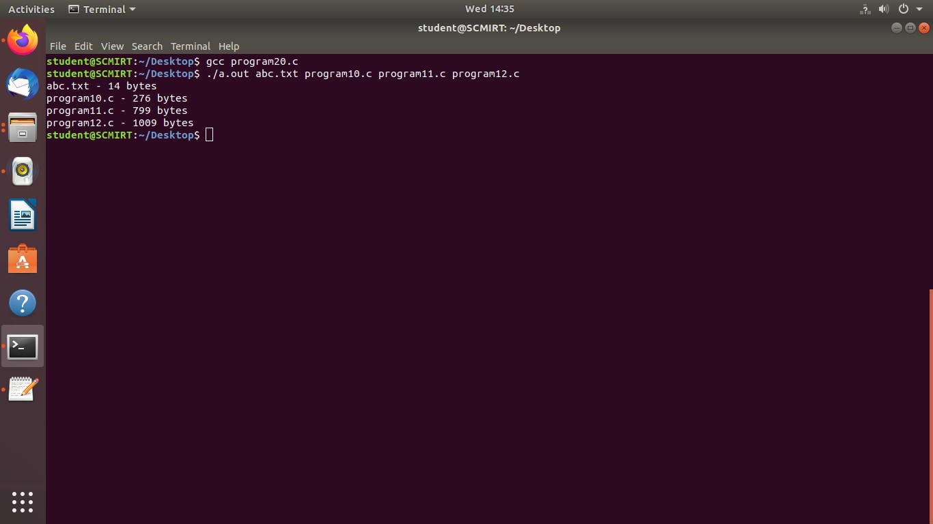

Q 9. Write a C program to display all the files from current directory which are created in particular month programing code in c

#include <dirent.h> #include <stdio.h> #include <sys/stat.h> #include <time.h>

int main() { DIR *d;

struct dirent *dir; struct stat st;

int month = 4; // change to desired month (1-12)

char month_str[4][4] = {"Jan", "Feb", "Mar", "Apr", "May", "Jun",

"Jul", "Aug", "Sep", "Oct", "Nov", "Dec"};

d = opendir("."); if (d) {

while ((dir = readdir(d)) != NULL) {

if (stat(dir->d_name, &st) == -1) { perror("stat");

continue;

}

int file_month = localtime(&st.st_ctime)->tm_mon; if (file_month == month-1) {

printf("%s\n", dir->d_name);

}

}

closedir(d);

} else {

perror("opendir");

}

return 0;

}

Output:

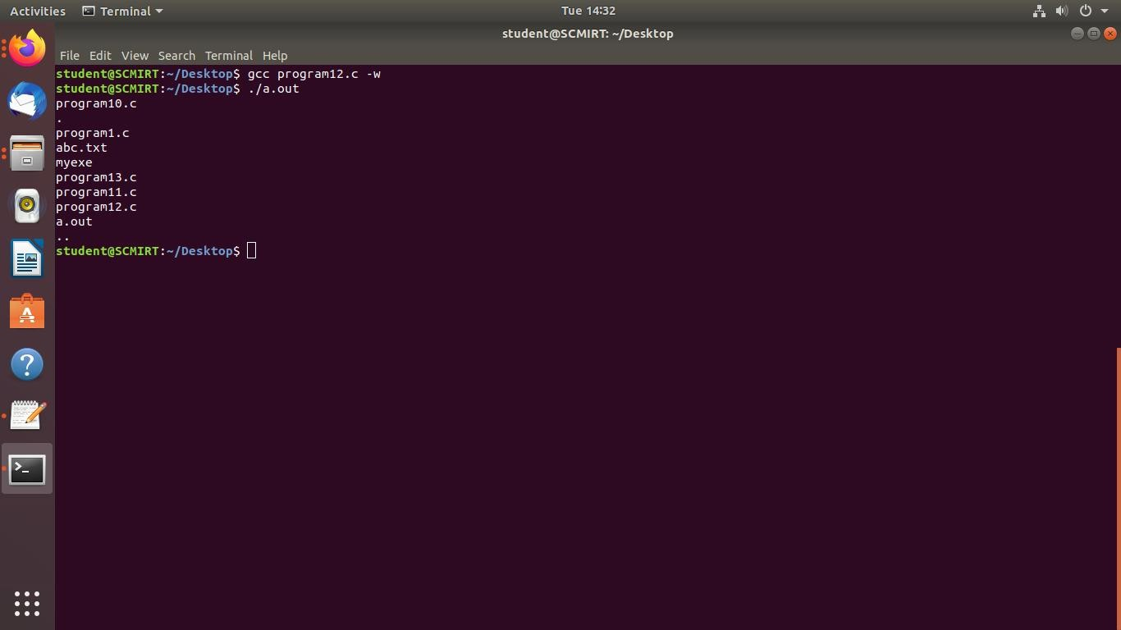

# Q 10. Write a C program to display all the files from current directory whose size is greater that n Bytes , Where n is accept from user.

#include <dirent.h> #include <stdio.h> #include <sys/stat.h>

int main() { DIR *d;

struct dirent *dir; struct stat st;

long min_size;

printf("Enter minimum file size in bytes: "); scanf("%ld", &min_size);

d = opendir("."); if (d) {

while ((dir = readdir(d)) != NULL) {

if (stat(dir->d_name, &st) == -1) { perror("stat");

continue;

}

if (st.st_size > min_size) {

printf("%s\n", dir->d_name);

}

}

closedir(d);

} else {

perror("opendir");

}

return 0;

}

Output:

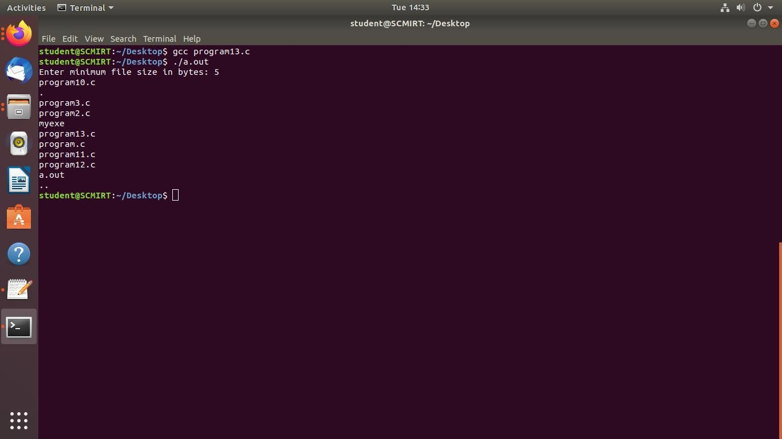

Q11.Write a C Program that demonstrates redirection of standard output to a file.

Program:

#include <stdio.h> int main() {

FILE *fp;

// Open a file for writing

fp = freopen("output.txt", "w", stdout);

// Print some text

printf("Hello, world!\n");

// Close the file fclose(fp); return 0;

}

Output:

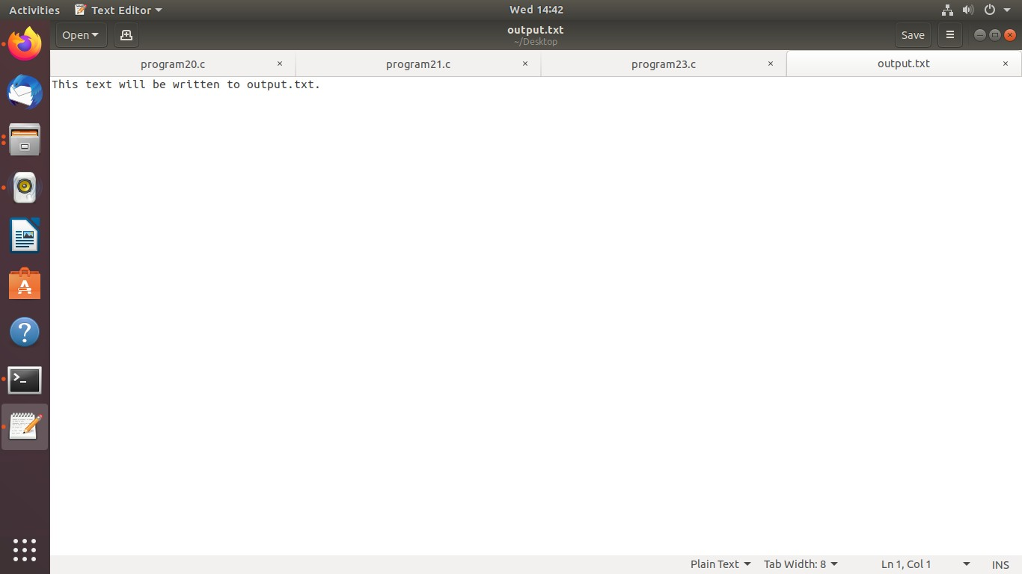

# Q 15.To generate parent process to write unnamed Pipe and will read from it.

**#include<stdio.h> #include<stdlib.h> #include<unistd.h>**

**#include<string.h> #define BUFFER_SIZE 25 int main() { int fd[2]; pid_t pid;**

**char write_msg[BUFFER_SIZE]="Hello, child!"; char read_msg[BUFFER_SIZE]; if(pipe(fd)<0) { perror("pipe error"); exit(1);**

**}**

**pid=fork(); if(pid<0){ perror("fork error");**

**exit(1);**

**}else if (pid==0) { close(fd[1]);**

**if(read(fd[0], read_msg,BUFFER_SIZE)<0){ perror("read error"); exit(1);**

**}**

**printf("child read from pipe:%s\n", read_msg); close(fd[0]); exit(0); }else { close(fd[0]);**

**if(write(fd[1],write_msg, strlen(write_msg)+1)<0){ perror("write error"); exit(1);**

**}**

**printf("parent wrote to pipe:%s\n",write_msg); close(fd[1]); exit(0);**

**}**

**return 0;**

**}**

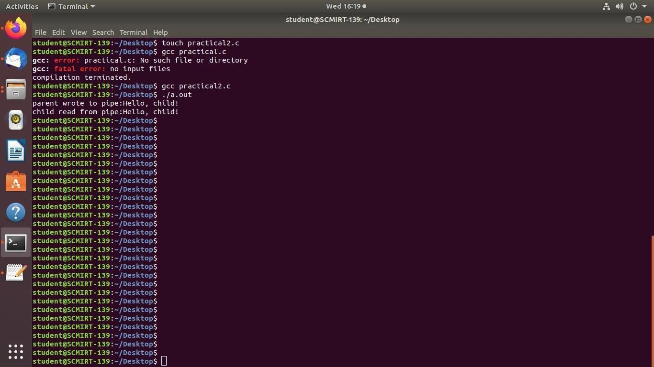Output:

# Q16.To handle the two way communication between Parent and child using pipe.

#include<stdio.h> #include<unistd.h> #include<stdlib.h> #include<string.h>

#define BUFFER_SIZE 1024 //buffer size in bytes int main()

{

int fd[2]; //file descriptors for the pipe pid_t pid; //process ID

char parent_message[]="hello from parent!"; char

child_message[]="hello from child!"; char buffer[434]; // CREATE PIPE if(pipe(fd)>0)

{

perror("pipe error");

printf("helloo"); exit(1);

}

return 0;

}

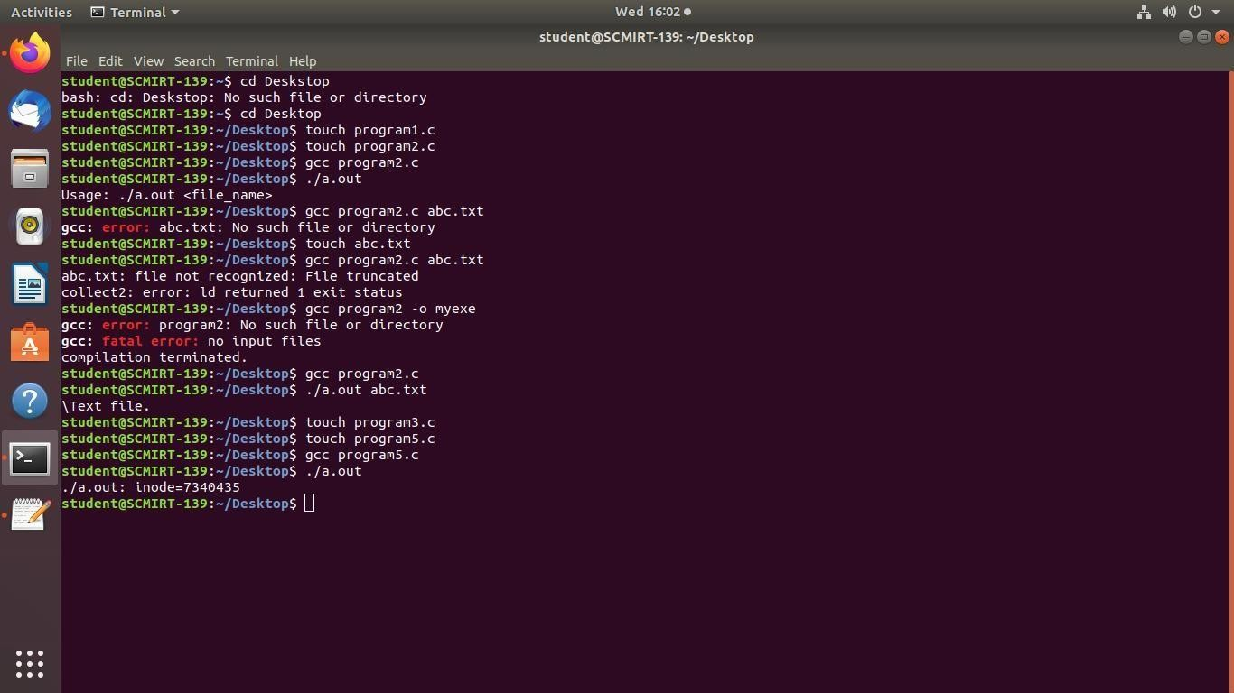Output:

# Q17.To demonstrate the use of atexit() function.

#include <stdio.h> #include

<stdlib.h> void cleanup1() { printf("Cleanup 1\n");

}

void cleanup2() { printf("Cleanup 2\n");

}

int main() { atexit(cleanup1); atexit(cleanup2); printf("Hello, world!\n"); return 0;

}

Output:

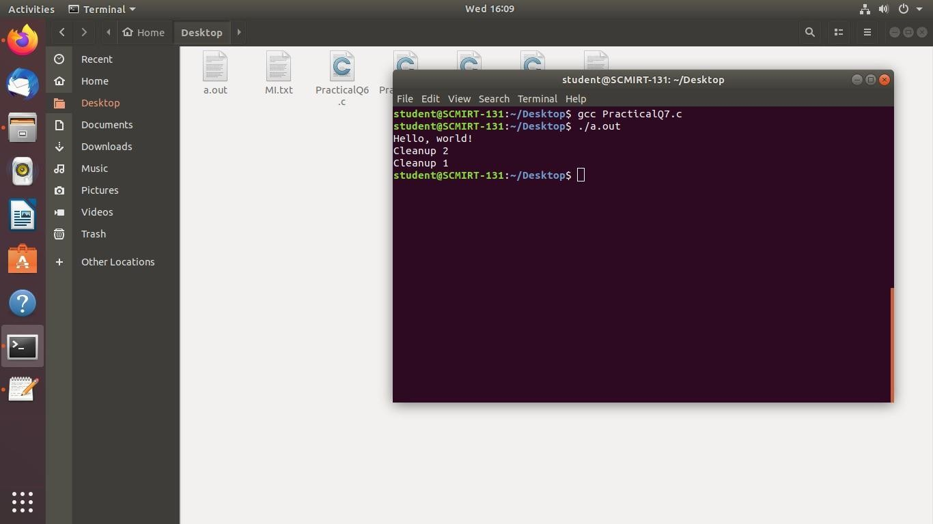

# Q 19. Write a C program to implement the following unix/linux command (use fork, pipe and exec system call) ls –l | wc –l

#include <unistd.h> #include <stdlib.h> #include <stdio.h> #include <sys/wait.h> int main() {

int fd[2];

pid_t pid1, pid2;

// create pipe

if (pipe(fd) == -1) {

perror("pipe");

exit(EXIT_FAILURE);

}

// fork first child (ls -l) pid1 = fork();

if (pid1 == -1) {

perror("fork");

exit(EXIT_FAILURE);

} else if (pid1 == 0) {

// redirect stdout to write end of pipe dup2(fd[1], STDOUT_FILENO);

// close unused read end of pipe close(fd[0]);

// execute ls -l

execlp("ls", "ls", "-l", NULL); perror("execlp");

exit(EXIT_FAILURE);

}

// fork second child (wc -l) pid2 = fork();

if (pid2 == -1) {

perror("fork");

exit(EXIT_FAILURE);

} else if (pid2 == 0) {

// redirect stdin to read end of pipe dup2(fd[0], STDIN_FILENO);

// close unused write end of pipe close(fd[1]);

// execute wc -l

execlp("wc", "wc", "-l", NULL); perror("execlp");

exit(EXIT_FAILURE);

}

// parent process

// close both ends of pipe close(fd[0]);

close(fd[1]);

// wait for both children to finish wait(NULL);

wait(NULL); return 0;

}

# Output

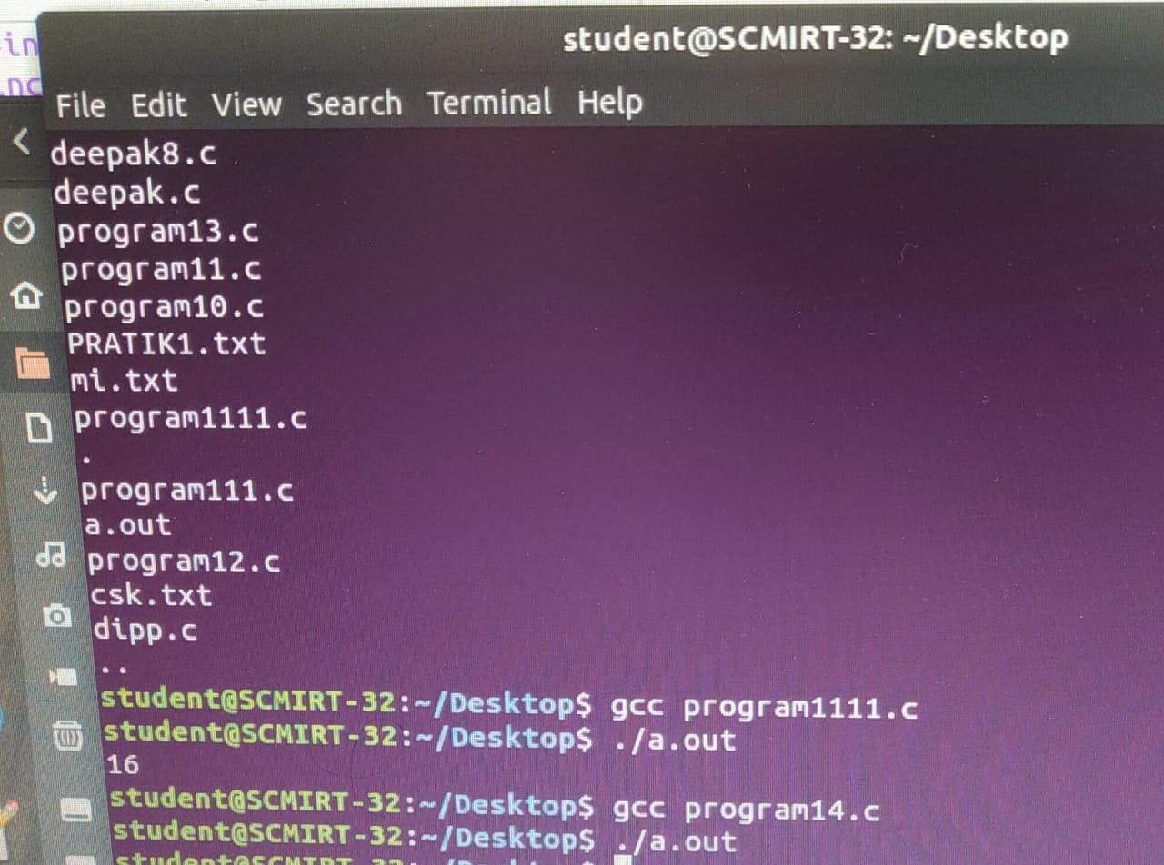

# Q20. To create ‘n’ children . When the children will terminate,display total cumulative time children Spent in user and kernel mode.

#include<stdio.h> #include<stdlib.h> #include<sys/time.h>

#include<sys/resource.h>

#include<sys/wait.h>

#include<unistd.h> int main(int argc , char **argv){ int n = atoi(argv[1]); int i,status; pid_t pid; struct rusage r_usage;

struct timeval user_time,kernel_time;

long total_user_usec=0, total_kernal_usec=0;

for(i<0; i<n; i++){ pid

= fork(); if(pid < 0){ perror("fork error");

exit(1);

}

else if(pid==0){

printf("child %d started \n",i+1); sleep(5); printf("child %d finished \n",i+1);

exit(0);

}

}

while((pid = wait(&status))>0){

if(getrusage(RUSAGE_CHILDREN,& r_usage) < 0){ perror("getrusage error");

exit(1);

}

user_time = r_usage.ru_utime; kernel_time = r_usage.ru_stime;

printf("child %d: user time =%ld microseconds,kernel time = %ld

microseconds.\n",pid,user_time.tv_usec,kernel_time.tv_usec); total_user_usec

+= user_time.tv_usec;

total_kernal_usec += kernel_time.tv_usec;

}

printf("Total time spend :%ld \n",total_user_usec); printf("Total time spend :%ld \n",total_kernal_usec); return 0;

}

**Output**

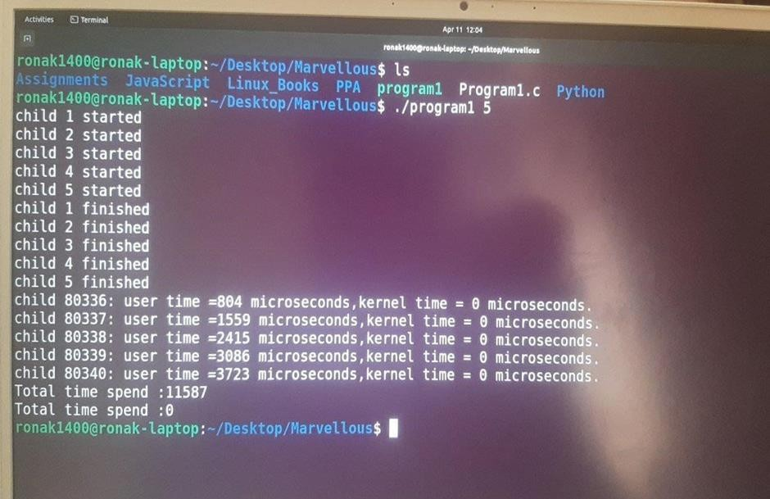

Q23.Write a program that illustrates how to execute two commands concurrently with a pipe.

Program:

#include <stdio.h> #include <stdlib.h> #include <unistd.h> #include <sys/wait.h> int main() {

int pipefd[2]; pid_t pid1, pid2;

// Create a pipe

if (pipe(pipefd) == -1) { perror("pipe");

exit(EXIT_FAILURE);

}

// Fork first child process pid1 = fork();

if (pid1 == -1) {

perror("fork");

exit(EXIT_FAILURE);

} else if (pid1 == 0) {

// Child process 1

// Close the read end of the pipe close(pipefd[0]);

// Redirect stdout to the write end of the pipe dup2(pipefd[1], STDOUT_FILENO);

// Execute the first command execlp("ls", "ls", NULL);

// Exit the child process if execlp fails perror("execlp");

exit(EXIT_FAILURE);

}

// Fork second child process pid2 = fork();

if (pid2 == -1) {

perror("fork");

exit(EXIT_FAILURE);

} else if (pid2 == 0) {

// Child process 2

// Close the write end of the pipe close(pipefd[1]);

// Redirect stdin to the read end of the pipe dup2(pipefd[0], STDIN_FILENO);

// Execute the second command execlp("wc", "wc", "-l", NULL);

// Exit the child process if execlp fails perror("execlp");

exit(EXIT_FAILURE);

}

// Parent process

// Close both ends of the pipe close(pipefd[0]);

close(pipefd[1]);

// Wait for both child processes to exit waitpid(pid1, NULL, 0);

waitpid(pid2, NULL, 0);

return 0;

}

Output:

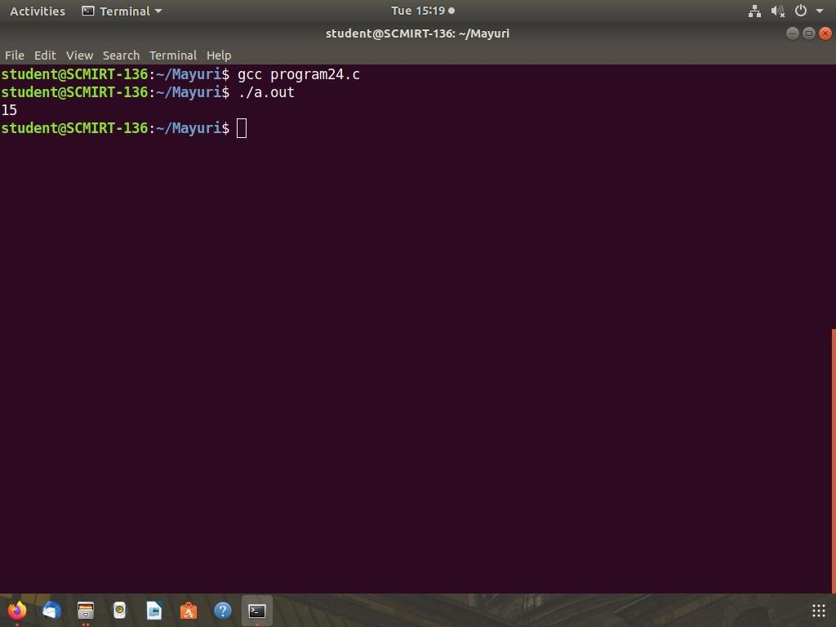

Q 26.Write a C program which create a child process which catch a signal sighup, sigint and sigquit. The Parent process send a sighup or sigint signal after every 3 seconds, at the end of 15 second parent send sigquit signal to child and child terminates my displaying message "My Papa has Killed me!!!”.

Program:

#include <stdio.h> #include <stdlib.h> #include <signal.h> #include <unistd.h> #include <sys/wait.h>

volatile sig_atomic_t flag = 0; void signal_handler(int signal) {

flag = 1;

}

int main() {

pid_t pid = fork(); if (pid == -1) {

fprintf(stderr, "Failed to fork.\n"); return EXIT_FAILURE;

}

if (pid == 0) { // child process signal(SIGHUP, signal_handler); signal(SIGINT, signal_handler); signal(SIGQUIT, signal_handler); while (1) {

if (flag) {

printf("Signal received.\n"); flag = 0;

}

sleep(1);

}

} else { // parent process

for (int i = 1; i <= 10; i++) { sleep(3);

if (i % 2 == 0) {

kill(pid, SIGHUP);

} else {

kill(pid, SIGINT);

}

}

kill(pid, SIGQUIT); int status; wait(&status);

if (WIFEXITED(status)) {

printf("Child process terminated with status %d.\n", WEXITSTATUS(status));

} else if (WIFSIGNALED(status)) {

printf("Child process terminated by signal %d.\n", WTERMSIG(status));

}

}

return EXIT_SUCCESS;

}

Output:

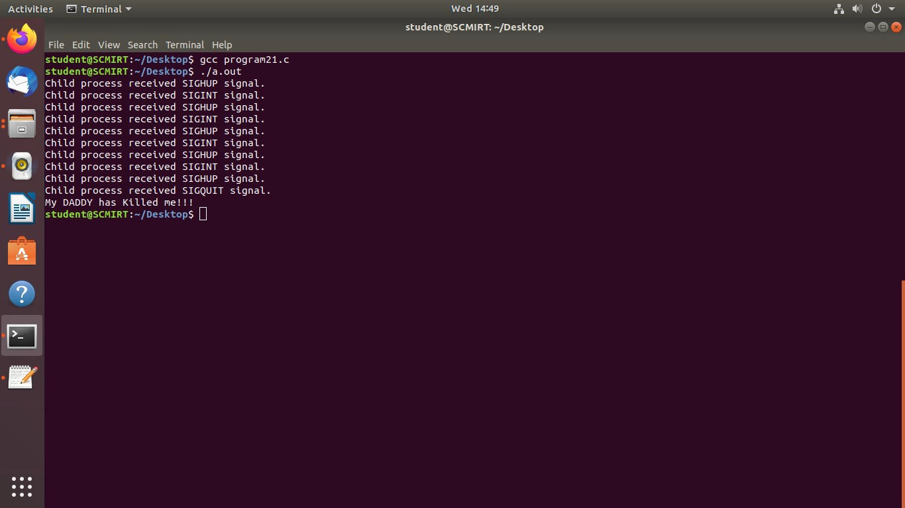

Q28. Write a C program that illustrates suspending and resuming processes using signals.

Program:

#include <stdio.h> #include <stdlib.h> #include <unistd.h> #include <signal.h>

void sigint_handler(int signum) {

printf("Caught signal %d (SIGINT)\n", signum);

}

int main() {

struct sigaction sa;

sigemptyset(&sa.sa_mask); sa.sa_flags = 0;

sa.sa_handler = sigint_handler; sigaction(SIGINT, &sa, NULL);

printf("Press Ctrl+C to suspend the program...\n"); while (1) {

sleep(1);

printf("Still running...\n"); kill(getpid(), SIGSTOP);

printf("Resuming...\n");

}

return 0;

}

Output:

