**“Indian Railway System”**

Project Synopsis Submitted in partial fulfilment for the award of

**BTECHFY –Part 2**

By

**yourname**

**degree**

**Roll No- 00000**



Department

**Mahatma Gandhi Mission’s**

**Jawaharlal Nehru Engineering College, Aurangabad**

**(Aug-2018)**

**Table of Contents**

1. Introduction
   1. Objective
   2. Scope
   3. Project & it’s Function
   4. Benefits & Goals
2. Overall Description
   1. Project Description
   2. Project Functions
3. Requirement Specification
   1. Hardware Requirement
   2. Software Requirement
4. Module
   1. Admin
   2. Passenger
   3. Search
   4. Ticket
   5. Cancel Reservation
   6. Login
   7. Registration
   8. Source & Destination
5. Diagram
   1. E-R Diagram
   2. Use Case Diagram
6. Future Scope
7. Limitation
8. **Introduction**

To make ticketing more convenient for travellers, we start an online reservation system, which helps us in booking tickets from the comfort of our homes or offices. While this is convenient for most people, it’s made things particularly easy for people residing in remote locations.

This software comprises reserving and cancelling seats for the passengers, it contains information about trains, information about passenger, it contains the details of reservation fees, any concessions etc. it makes entries for reservation, cancelled tickets, it will update for uptime and downtime trains. All the information is safely stored in the backed i.e. MySql data base.

* 1. **Objective:**

The purpose of this to describe the railway reservation system which provides the train timing details, reservation, billing, and cancellation of reservation. We need to provide source and destination names or codes and then we will be given the train names between those two stations, Reservation forms it has the easiest of the user interface making it user friendly and easy to use, for Cancellation one just needs the PNR number which is again easy, Reservation enquiry and Fare records which is a from used for the fare between two station with a specific class. User friendly interface to administrator and customer. The system is so easy that even a native user can use this to book tickets online and the system is such that it stands up to the user expectations. The system is so secured and clerk and manager utilize it. Nobody can able to access the system without his or her permission because of providing login facility to the system.

The origin of most software is in the need of a client, who either wants to automate the existing manual system or desires a new software system. Finally, the end user will use the completed system. Thus, there are three major parties interested in a new system, the client, the user, and the developer. Somehow the requirements for the system that will satisfy the needs of the client.

A few factors that direct us to develop a new system are given below:-

1. Faster system
2. Accuracy
3. Reliability
4. Informative
5. Reservation and cancellation from anywhere to any place
   1. **Scope:**

Administrator is a person who updates the Train Information by entering his own Password. The system can handle only reservation and train details efficiently and it doesn’t contain other details about the railway administration. The main scope of this system is:

* Searching train
* Creating reservation
* Cancel reservation
* View reservation status
* View train schedule
* Payment
* Generation tickets
* Update train schedule
* Update reservation details
  1. **Project & its function:**

The Product of this project is Railway Reservation System, which is to create Reservation, Cancel Reservation, Viewing Train Information, Viewing Reservation Details, Updating Train Information, Updating Reservation Details and Generate Reports.

* 1. **Benefits & Goals:**

The Benefit of this project is to reduce the work of Reservation Clerk and it is easy to check the remaining seats present in the Train and easily view the Reservation Status of the Train and tells to the passenger.

The Goals of this project is that, from any Railway Station we can Create Reservation, which is updated automatically in all the stations. Hence, there is no confusion to the Reservation Clerk in all the stations to create the Reservation.

1. **Overall Description** 
   1. **Project Description:**

 The Reservation Admin gets the details from the passenger and he checks whether the seats are remaining in order to the Reservation. If the seats are available, then system allocate the seat to the passenger by giving the Reservation Slip to the passenger and he Update the Reservation details.

The Reservation Admin gets the details from the passenger in order to cancel the Reservation and Cancels Reservation. He also Update the Reservation details after cancelling the Reservation and he creates the Reservation.

* 1. **Project Functions:**
* **Search:** This function allows user to search for train that are available between the two travel cities, namely the “Departure city” and “Arrival city” as desired by the traveller. The system initially prompts the user for departure and arrival city, date of departure, preferred time slot and the number of passengers.
* **Create Reservation:** A passenger should be able to reserve seats in the train. A reservation form fill by the passenger and submit to the system, if seats are available then the entries are insert in the system data base with person and train details. Then passenger needs to pay the required fare and tickets print.
* **Cancel Reservation:** If the passenger wish to cancel the ticket then the passenger required to enter the PNR number and mobile number. Then the entries of that passenger delete from the system data base.
* **Payment:** System asks passenger to enter the various card details for booking the ticket.
* **Update Train Info:** The administrator can modify the train details if he want to change it.
* **View Reservation Status:** Passengers can see the reservation status online by using the PNR number that printed on his ticket. The system show the status like confirmed or RAC.

1. **Requirement Specification**
   1. **Hardware Requirements:**

* Processor : Intel i3
* RAM : 128 MB
* Hard Disk : 40 GB
* Cache : 512 KB
  1. **Software Requirement:**
* Operating system : windows-8 or above.
* Browser : Google chrome, [Mozilla Firefox](https://en.wikipedia.org/wiki/Mozilla_Firefox), IE etc.
* Text editor : Sublime Text.
* Front End : HTML, CSS, Bootstrap.
* Back End : PHP, MYSQL.

1. **Module Specification** 
   1. **Admin:**

Admin can update the train details, adds the trains, remove the trains, manage the users, and also manage the reservation.

* 1. **Passenger:**

Passenger module can view the train details, book the ticket, search train, Make payment, cancel reservation and update personal details if want.

* 1. **Search:**

This module helps user to find train details from source location to destination location for specific date or day.

* 1. **Ticket:**

This is module shows the confirmation of reserve seats of the passenger. Ticket will get to passenger after completing payment.

* 1. **Cancel Reservation:**

This module used to cancel the reservation if passenger wants. To cancel the reservation passenger required to provide PRN and Mobile No.

* 1. **Login:**

This module used to give the access to the authentication users only. So it helps from fraud and give security to the system,

* 1. **Register:**

This module show the form to the user so user can register himself by filling the registration form. So he get the authentication to access the system.

* 1. **Source & Destination:**

This module takes the location and shows the train details to passenger.

1. **Diagram**
   1. 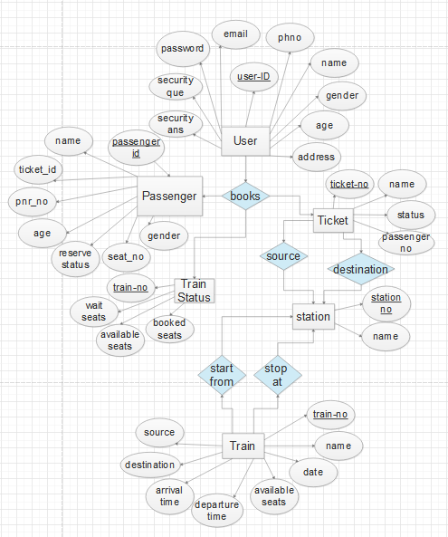**E-R Diagram:**
   2. **Use Case Diagram:**

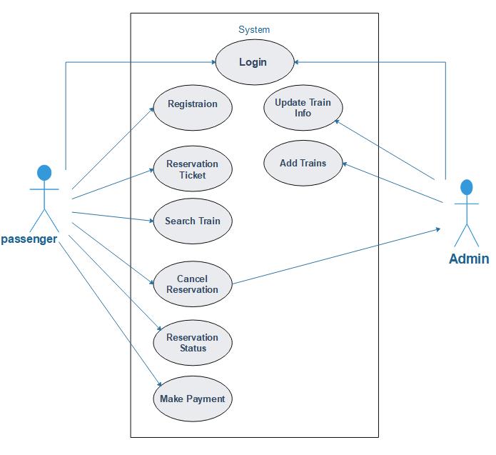

1. **Future Scope**

* User will get Ticket on mobile phone through the SMS.
* Website will use OTP verification so it controls the fraud logins.
* User will have the various option for do payment.
* User will track the train current location using new features.
* User will also book flit ticket using same website.
* User will get the help of AI assistant so user can ask anything related to train.
* In future there will be the android application which based on web-application content.
* More understandable user-interface will be designed.

1. **Limitation**

* User don’t get SMS after booking ticket.
* User don’t get any email.
* User use only debit card for payment process.
* User need internet connection to access the website.