Microstructure Evolution in Hot-Rolled Steel During Multi-Pass Deformation
Anna Kowalska^{1,*}, Jan Nowak², Maria Lewandowska¹
¹ AGH University of Krakow, Faculty of Metals Engineering, al. Mickiewicza 30, 30-059 Krakow, Poland
² Lukasiewicz Research Network, Institute for Ferrous Metallurgy, K. Miarki 12, 44-100 Gliwice, Poland
E-mails: a.kowalska@agh.edu.pl, j.nowak@imz.pl, m.lewandowska@agh.edu.pl
Keywords: hot rolling, microstructure, recrystallization, finite element modelling, steel
Grain refinement during thermomechanical processing controls the strength and toughness of structural steels [1], yet industrial multi-pass schedules retain strain between passes in a way that single-pass Johnson-Mehl-Avrami-Kolmogorov (JMAK) calibrations do not capture [2]. This work quantifies how inter-pass time and temperature govern recrystallization in low-carbon steel. Plane-strain compression specimens were deformed between 900 and 1100 °C following the four-pass schedule of Table 1, then interrupted-quenched for metallography.
Table 1. Four-pass plane-strain compression schedule.
Pass | Temperature (°C) | Strain, ε (–) | Inter-pass time (s)
1 | 1100 | 0.30 | 10
2 | 1050 | 0.30 | 5
3 | 1000 | 0.25 | 3
4 | 950 | 0.25 | –

Figure 1 shows the recrystallized fraction as a function of inter-pass time at two temperatures. Above 1000 °C the kinetics are dominated by inter-pass time rather than peak strain; a JMAK law fitted to single-pass data over-predicts grain refinement in the multi-pass case by up to 18% [2].
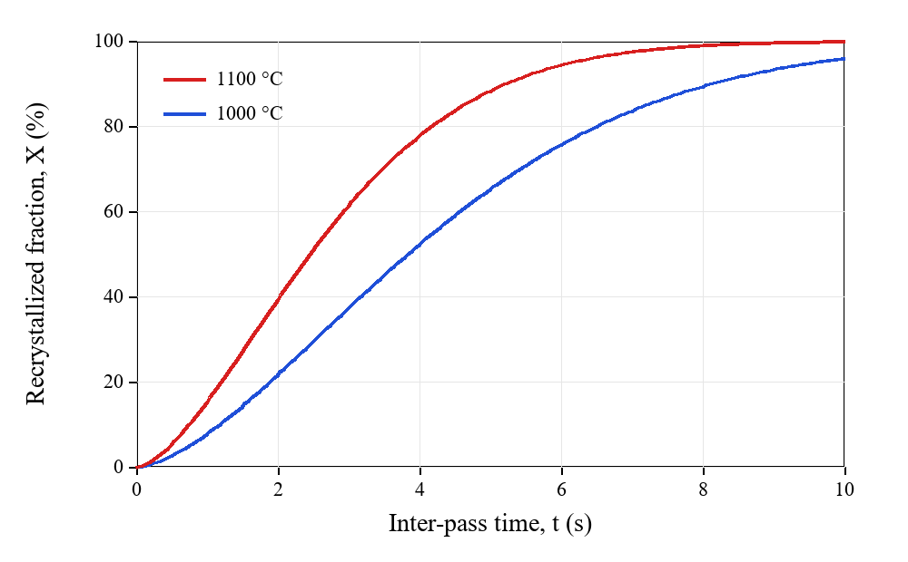
Fig. 1. Recrystallized fraction X(t) versus inter-pass time at 1000 °C and 1100 °C.
A retained-strain correction to the JMAK law reconciles laboratory and industrial bar-mill data, improving grain-size prediction across the schedule [3].
References
[1] F. J. Humphreys, M. Hatherly, Recrystallization and Related Annealing Phenomena, 2nd ed., Elsevier, Oxford, 2004.
[2] C. M. Sellars, J. A. Whiteman, Recrystallization and grain growth in hot rolling, Met. Sci. 13 (1979) 187-194.
[3] A. Kowalska, J. Nowak, Retained strain in multi-pass hot rolling, Mater. Sci. Eng. A 812 (2021) 141-152.
Format: A4, 2.5 cm margins, Times New Roman. Title 14 pt bold; authors 12 pt; affiliations/e-mails/captions/references 9 pt; body 11 pt justified. Table caption above, figure caption below. Two pages maximum.

