Title of the Abstract (Times New Roman 14 pt, bold, centred; max 2 lines)
Given Name Surname^{1,*}, Given Name Surname² (presenting author marked with *)
¹ Department, Institution, City, Country
² Department, Institution, City, Country
E-mails: presenting@author.org, co.author@institution.org (in author order)
Keywords: keyword one, keyword two, keyword three (3-6, comma-separated)
Write your abstract as continuous text (Times New Roman 11 pt, justified, single spacing). State the problem, the method, the key results and the conclusion in one flowing narrative - no section headings. You may include one table and one figure, and cite references in order as [1], [2]. Keep the whole document to two pages.
Table 1. Caption above the table (Times New Roman 9 pt, centred).
Column | Column | Column

Continue the narrative: present and interpret the results and refer to the figure as Figure 1.
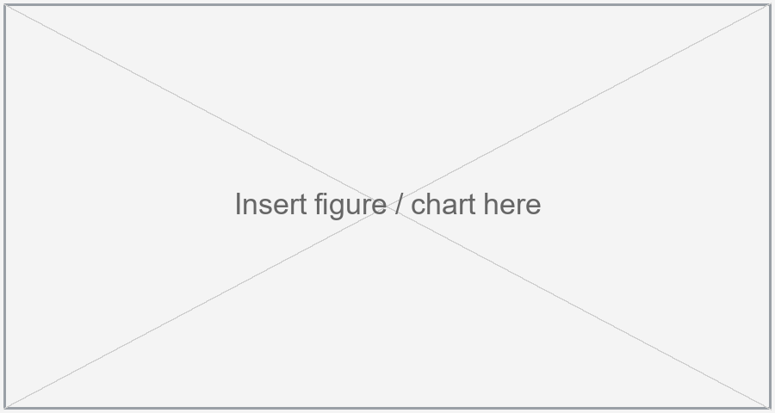
Fig. 1. Caption below the figure (Times New Roman 9 pt, centred).
Close with the conclusion in the same paragraph flow.
References
[1] Author A. A., Author B. B., Title of the work, Journal Vol. (Year) pages.
[2] Author C. C., Title of the book, Publisher, City, Year.
Format: A4, 2.5 cm margins, Times New Roman. Title 14 pt bold; authors 12 pt; affiliations/e-mails/captions/references 9 pt; body 11 pt justified. Table caption above, figure caption below. Two pages maximum.

