Abrams Event Address: Addressing Events in a Moving Four-Dimensional Universe
AEA-STATE/1 · Framework, physical context, and a single-epoch state record
Joshua Abrams
Abrams Research Systems LLC
ORCID: 0009-0003-0443-3225 • Email: contact@abramsresearch.net • Web: https://abramsresearch.net
PREPRINT — NOVEMBER 2026
Abstract
In physics and systems engineering, an event is a physical occurrence or state at a specific point in three-dimensional space and one-dimensional time. While modern physics treats space and time as a single four-dimensional structure, navigation, tracking, and archival systems still rely on domain-specific coordinate conventions—terrestrial datums for Earth's surface, celestial frames for deep space, and independent clocks for time. Because everyday maps move with the Earth, locations appear static; in reality, Earth is rotating, orbiting the Sun at roughly 29.78 km/s (67,000 mph), and moving through the Milky Way at roughly 220–230 km/s. Once an event record leaves its local system, defining where it occurred requires explicitly locking down when it happened, on which time scale, on which celestial body, and relative to what reference frame. Stephen Hawking’s 2009 reception for time travelers illustrates this problem: a street address, a calendar date, and a wall-clock time work on Earth's surface through shared human convention, but outside our moving terrestrial frame, those inputs are incomplete. The Abrams Event Address (AEA) unifies seven physical and contextual declarations into a single explicit state record: target celestial body, epoch, atomic time scale, coordinate reference frame, 3D spatial position, frame-relative velocity, and spatial orientation, sealed with a cryptographic integrity digest. The published AEA-STATE/1 specification encodes this single-epoch state into a deterministic 136-byte binary record built on established geodetic, astrometric, and metrological standards, enabling unambiguous event addressing and cross-system state correlation across terrestrial, orbital, and planetary domains.

1. Introduction: Spacetime as an Addressable Namespace

1.1 The Question Behind Hawking’s Reception
In four-dimensional spacetime, a location is not merely a place on a surface; it is an event—a physical state at a specific spatial coordinate and a specific moment in time. This raises a deceptively simple question: if you had a time machine and could travel anywhere in spacetime, what coordinates would you actually enter?
On June 28, 2009, Stephen Hawking explored this idea by hosting a reception for time travelers at Gonville & Caius College, University of Cambridge (52.2058° N, 0.1179° E), releasing the invitation only after the party ended. The invitation provided what any person would give: a room location, a calendar date, and a wall-clock time (12:00 UTC). Those details succeed in everyday life only because every guest already shares Earth's crust, its calendar, and its local time conventions.
Step outside an Earth-bound map, however, and the coordinate grid itself is in continuous, multi-layered motion:
- Diurnal Rotation: At the latitude of Cambridge, Earth's crust rotates eastward about its axis at approximately 286 m/s (1,030 km/h).
- Heliocentric Orbit: Earth orbits the Solar System Barycenter (SSB) at approximately 29.78 km/s (67,000 mph).
- Galactic Orbit: The Solar System orbits the Milky Way galactic center at roughly 220–230 km/s.
- Extragalactic Motion: The Milky Way moves relative to the Cosmic Microwave Background (CMB) rest frame at approximately 627 km/s.
One second after Hawking raised his glass of champagne, that reception room had traveled nearly 30 kilometers relative to the Solar System Barycenter. One day later, it was 2.57 million kilometers away. Over the years since 2009, that coordinate has traced a path tens of billions of miles long in a galactic frame. A building in Cambridge has not contradicted itself by remaining stationary on a local map while moving billions of miles through space—both descriptions are physically valid, depending on the reference frame.
While current science does not support backward time travel, the thought experiment exposes a fundamental systems-engineering gap: a place name and a calendar date are not a complete spacetime address. To make any event in space and time explicitly addressable across systems or eras, a record must answer four questions:
- On which celestial body, and relative to which origin and reference frame, is the position expressed?
- At what exact epoch, and using which continuous atomic time scale, is the state evaluated?
- Within that same declared frame, what velocity and orientation describe the object or state at that moment?
- Which external realizations and models are referenced to interpret those numbers?
Existing navigation and astrometric systems already compute time, reference frames, and relativistic corrections internally. The Abrams Event Address (AEA) asks how that essential physical context can be bound directly to the event record itself—so that when a state is transmitted, archived, or combined with data from other platforms, its meaning never depends on implicit assumptions.
THE FOUNDATIONAL INSIGHT: ADDRESSES COME BEFORE TRANSPORTATION
The core insight of AEA is a design principle: addresses come before transportation. Before asking how to reach or compare events, establish what the address means. Just as a street address depends on a map and a naming system, an event address depends on a chart, a time convention, and a physical interpretation. AEA brings those declarations together with position, velocity, and orientation in a deterministic record. The address describes a state; relating states at other times requires external transformations, ephemerides, and propagation models.
By unifying these declarations into a single self-describing address, AEA provides a common coordinate language across disparate systems. When every recorded event carries its own planetary origin, atomic time scale, reference frame, and 6-DoF kinematic state, isolated observations can be correlated across deep time and space—from autonomous drones, submersibles, and spacecraft reconciling state after signal blackouts to planetary archives that remain mathematically interpretable centuries later.
THE ROLE OF THE PUBLISHED RECORD
AEA is the event-address framework; AEA-STATE/1 is its 136-byte state representation. It binds declared context and kinematics. Richer uncertainty, provenance, calibration, and model histories remain external.

1.2 Scope: What an Event Address Establishes
A point in spacetime is not a complete account of the object present there. AEA carries position and time together with contextual identifiers and associated kinematics; velocity and orientation describe the object’s state, not additional spacetime dimensions.
- Not a Navigation Engine: AEA does not observe GNSS signals, track stars, filter sensor noise, or improve a position estimate.
- Not a Physics Solver: It does not integrate trajectories, calculate frame transformations, or solve gravitational dynamics.
- Not a Transport Mechanism: Declaring a state does not establish a route, a propulsion method, or the feasibility of reaching it.
- An Explicit State Declaration: A record preserves what the producer supplied, including an erroneous or uncertain estimate. It cannot guarantee that different producers used the same realization, model, or calibration merely because their enum values agree. Interoperability depends on shared definitions and retained context.

1.3 Reading a Published Example Address
The following published Cambridge example illustrates the text representation. Its values form a reproducible encoding vector (§7). The authoritative representation for digest computation is the binary prefix (§5).
AEA:399:TAI:1246190426.0:ITRF2020:3916909.5232774816,8057.749278632174,5016918.648210711:0,0,0:0,0,0,1:9f6cc1096562729a902167fd622e66a264a239f3e9a9d804414659e3ab97800e
How to Read the Declared State
- 399: Central body is Earth (NASA JPL NAIF catalog).
- TAI:1246190426.0: Integer seconds and nanoseconds under AEA’s TAI epoch rule (§4.4). A time scale is not a particular clock.
- ITRF2020: The declared terrestrial Cartesian frame.
- 3916909.52..., 8057.74..., 5016918.64...: The example’s Cartesian position in metres; its assumed height and datum treatment are discussed in §7.1.
- 0,0,0: Zero coordinate velocity in the declared terrestrial frame.
- 0,0,0,1: Identity quaternion (used for aligned or unmeasured attitude; see §9).
- 9f6cc109...: Unkeyed SHA-256 digest over the canonical binary prefix. It verifies the integrity of the encoded record (see §9).
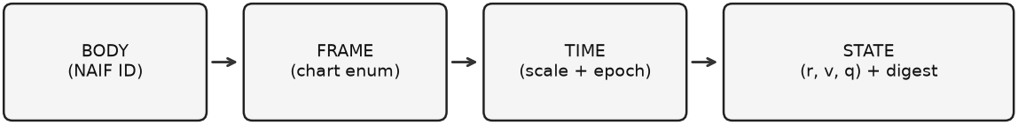
Figure 1. The AEA declaration chain. Body, frame, time, and kinematic state are bound into one declared record.

1.4 Summary of Contributions
- The Event-Address Framework: Seven groups of fields bind body, epoch, time scale, frame, position, velocity, and orientation in one declared context.
- Physical Interpretation: Worked distinctions among time scales, frame-relative velocity, height conventions, and coordinate epochs explain why an address must state its assumptions.
- Deterministic Representation: AEA-STATE/1 defines a 104-byte prefix plus 32-byte unkeyed SHA-256 digest, with finite-float validation and negative-zero canonicalization.
- Cross-Body Generality: Worked Known-Answer Test (KAT) vectors for Earth (ITRF2020) and Mars (BODY) demonstrate how the identical 136-byte structure addresses events across distinct planetary origins and reference frames.
- Reproducible Supporting Tools: A reference implementation and known-answer vectors support examination of the record; implementation details appear after the framework and its limitations.

2. Why the Declarations Matter: Five Physical Distinctions
A coordinate tuple cannot be interpreted in isolation; identical numerical values describe vastly different physical states if their time scale, reference frame, datum, or epoch conventions diverge.
- Atomic Time Scale vs. Civil Time (TAI vs. UTC): Civil time scales such as UTC insert discontinuous leap seconds to stay aligned with Earth's irregular rotation, creating non-monotonic timestamps (23:59:60) in telemetry loops. In June 2009, the cumulative offset was TAI − UTC = +34 s [5] (rising to +37 s by 2026). Omitting or mislabeling the time scale shifts the evaluated epoch by tens of seconds—corresponding to over 1,000 km of heliocentric orbital motion at Earth's 29.78 km/s velocity.
- Gravitational Clock Skew (Pound-Rebka Geopotential Shift): Under General Relativity, atomic clocks at different gravitational potentials tick at different rates. For two terrestrial stations separated by orthometric elevation Δh, the fractional frequency shift is given by the Pound-Rebka relation:
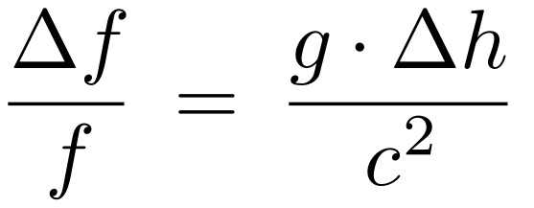
Comparing a clock near sea level (h₁ ≈ 10 m) with a clock in Colorado (h₂ ≈ 1,609 m, Δh = 1,599 m) yields Δf/f ≈ (9.80665 m/s²)(1,599 m)/(2.99792 × 10⁸ m/s)² ≈ 1.745 × 10⁻¹³, or a cumulative drift of 15.07 nanoseconds per day. Binding 3D position and explicit time scales (TAI, TT, TCB, TDB) ensures relativistic rate offsets can be evaluated without ambiguity.
- Frame-Relative Velocity & Kinetic Energy Scale: A point at rest in an Earth-fixed frame (v_{ITRF} = [0, 0, 0] m/s) is moving at ≈ 286 m/s in a geocentric inertial frame (GCRS) at Cambridge's latitude, and ≈ 29,780 m/s in a solar-system barycentric frame (BCRS). Why velocity must be bound to the same chart as position is illustrated by the classical kinetic energy scale of a frame mismatch:
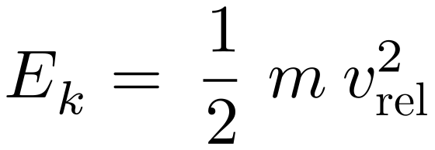
For a reference mass m = 75 kg with a frame-relative speed mismatch of v_{rel} = 29,780 m/s, the state energy difference is E_{k} ≈ 3.326 × 10¹⁰ J (33.26 GJ). Velocity is therefore an essential physical state parameter, not an optional annotation.
- Physical Geodesy & Geoid Undulation (h = H + N): Satellite navigation ellipsoids such as WGS 84 define a smooth geometric surface, whereas physical elevation above mean sea level (orthometric height H) is measured relative to the geoid—the gravitational equipotential surface W(x) = W₀ (W₀ = 62,636,856.0 m²/s² under IUGG 2015 conventions). Converting orthometric height H to the geometric ellipsoidal height h required for 3D Cartesian coordinates requires the local geoid undulation N(ϕ, λ) from spherical harmonic models such as EGM2008 [4,13]:
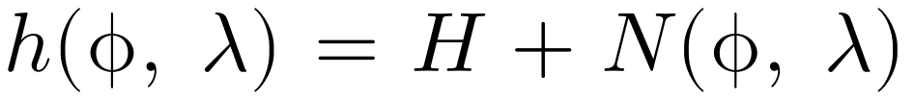
At Cambridge (52.2058° N, 0.1179° E), the geoid sits N ≈ +46.0 m above the reference ellipsoid. Confusing orthometric height (H = 10 m) with ellipsoidal height (h = 56 m) introduces a 46-meter vertical coordinate error (placing the computed state deep inside solid bedrock).
- The ‘2040 Student Problem’ & Tectonic Plate Kinematics (ITRF2020 PMM): Even within an Earth-fixed frame, the crust is not frozen. Under the ITRF2020 Plate Motion Model (PMM) [3,26], the Eurasian tectonic plate rotates with Euler angular velocity Ω_{Eurasia} = [−0.085, −0.531, +0.769]^{T} milliarcseconds/yr. The linear crust velocity at position x_{ECEF} is:
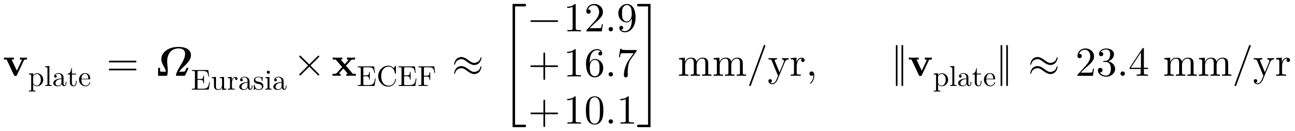
Propagating a coordinate from epoch t₀ to a future reading at t₁ follows x(t₁) = x(t₀) + v_{plate} · (t₁ − t₀) + δ_{post-seismic}(t). Over the 31-year baseline from Hawking's 2009 reception to a researcher reading the record in 2040, Cambridge shifts by Δx ≈ 31 yr × 2.34 cm/yr ≈ 72.5 cm relative to the geocenter. Recording the exact event epoch (time_sec) allows any future consumer to apply plate motion models accurately.

3. Related Work and Standards
AEA builds on established systems rather than replacing them. Geodesy, astrometry, time metrology, telemetry, and robotics already address much of this context within their domains. The comparison below distinguishes their purposes [1–9,16,21–24].
- World Geodetic System 1984 (WGS 84): Defines a terrestrial reference system and reference ellipsoid [4].
- International Terrestrial Reference Frame (ITRF2020): Provides a terrestrial realization with station positions, velocities, and modeled nonlinear motion [3]. AEA references it by declared frame identifier.
- Celestial Reference Systems (GCRS & BCRS): IAU resolutions define geocentric and barycentric relativistic systems [2,6,7]. ICRF3 realizes celestial orientation using extragalactic radio sources [1].
- IRIG Serial Time Code Formats (IRIG Standard 200-16): Maintained by the Range Commanders Council, IRIG-B serial time codes synchronize telemetry instrumentation; they do not carry spatial reference frames or kinematics [21].
- IEEE 1588 Precision Time Protocol: Specifies network clock synchronization [22]. Its accuracy depends on the implementation and network; it is not a spatial state format.
- CCSDS Time Code Formats (CCSDS 301.0-B-4): Specifies unsegmented and segmented binary time codes for space telemetry, serving as a clock representation rather than a 4D state vector [23].
- CCSDS Orbit & Attitude Data Messages: Already convey epochs, time systems, frames, and kinematic data, with uncertainty in applicable message types [9,24]. AEA offers a compact single-epoch companion representation.
- Robotics (ROS 2 nav_msgs/Odometry): Carries a timestamp, frame identifiers, pose, twist, and covariance [16]. Resolving local frames requires external frame definitions and transforms.
Table 1. Coordinate and Telemetry Standards Comparison Matrix
Standard | Time Scale | Frame | Velocity | Attitude | Wire Format | Integrity | Operational Role
WGS 84 [4] | Datum / epoch | Earth-fixed | No | No | Geodetic | None | Terrestrial reference system and ellipsoid; GNSS also uses time.
ITRF2020 [3] | Epoch-tagged | Yes | Optional | No | SINEX / Cartesian | None | Terrestrial realization: station coordinates, velocities, nonlinear models.
GCRS / ICRF3 [1,2] | TCG / TT | Yes | Yes | No | Mathematical | None | Geocentric relativistic system; ICRF3 realizes celestial orientation.
BCRS / DE440 [6,17] | TCB / TDB | Yes | Yes | No | Double vectors | None | Barycentric system and externally supplied ephemerides.
IRIG-B [21] | Civil / TOY | No | No | No | Serial BCD | None | Range telemetry timing synchronization.
IEEE 1588 PTP [22] | Clock sync | No | No | No | Network packets | Optional | Network clock synchronization; accuracy is implementation-dependent.
CCSDS 301.0 [23] | Yes | No | No | No | Binary / Segmented | None | Space telemetry timestamp encoding.
CCSDS OEM / ADM [9,24] | Yes | Yes | Yes | Yes | ASCII KVN / XML | Optional | Rich trajectory / attitude interchange with contextual metadata.
ROS 2 nav_msgs [16] | Header stamp | Local tag | Yes | Yes | Dynamic CDR | None | Timestamped local pose/twist and covariance; transforms external.
AEA-STATE/1 | Declared scale | Declared Enum | Yes | Yes | 136-byte binary | Unkeyed SHA-256 | Single-epoch state; external definitions and models required.

4. Mathematical Foundations & Relativistic Framework

4.1 Spacetime Manifold & State Definition
In relativity, an event p is an idealized point on a four-dimensional manifold M with metric g. Coordinates describe p within a chart; they are not invariant physical labels. An AEA-STATE/1 record associates a single-epoch state with a declared body, frame, and time scale. Those enum fields identify the declared conventions:
Formal state definition. The tuple includes protocol fields and a digest in addition to the event’s coordinates and associated kinematics.

4.2 The Master Equation
Mapping a physical event into an AEA-STATE/1 address follows a four-step deterministic pipeline:
- Context Selection: The producer declares the target celestial body (body_naif), the coordinate reference frame (frame), and the continuous atomic time scale (time_scale).
- Temporal Mapping: The event's timestamp is converted into continuous integer seconds (time_sec) and nanoseconds (time_nsec) on the declared atomic scale (§4.4).
- Spatial & Kinematic Mapping: The object's 3D position (pos_m), velocity (vel_mps), and unit quaternion attitude (quat_xyzw) are evaluated in SI units strictly within that single declared reference frame, forming the state tuple Π(p;φ).
- Canonical Sealing: AEA validates all field bounds, canonicalizes negative floating-point zeros (−0.0 to +0.0), serializes the tuple into a 104-byte Little-Endian binary prefix 𝒮, and appends a 32-byte SHA-256 integrity digest:
Master Equation: Canonical serialization of the externally evaluated prefix, concatenated with its integrity digest.
For a terrestrial-to-celestial comparison, external tools may evaluate the standard IAU/IERS frame chain [2]. In the convention used here, the matrices below map ITRF coordinates toward GCRS; transpose conventions must be checked against the library in use:
Frame chain. W represents polar motion, R Earth rotation, and Q celestial orientation. The complete calculation needs Earth orientation parameters and a consistent time argument.
At leading order, geocentric and barycentric positions differ by Earth’s barycentric position. The schematic relation below suppresses post-Newtonian spatial corrections and the transformation of the time argument:
Barycentric translation (schematic). Full GCRS/BCRS transformations use the IAU relativistic conventions and appropriate ephemerides [6,14,17].
For reference, the IAU post-Newtonian BCRS metric has the following component form, where w and w^{i} are scalar and vector gravitational potentials and c is the speed of light [6,14]:
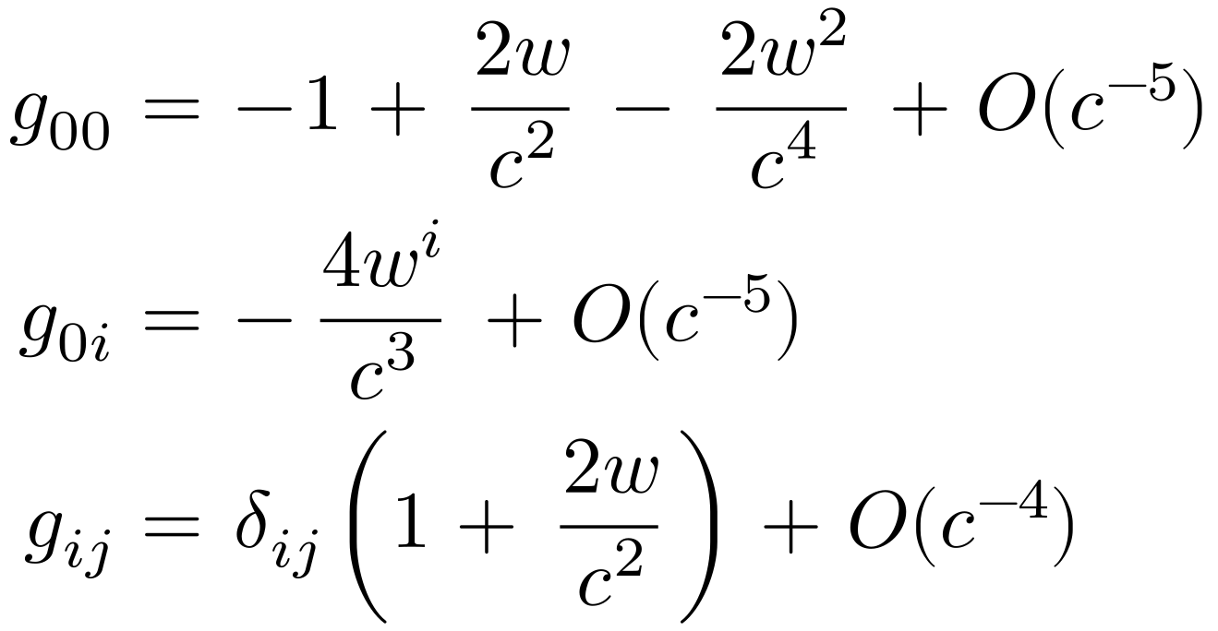
BCRS metric components. δᵢⱼ is the Kronecker delta. These established equations supply the physical context in which AEA declarations are interpreted.

4.3 Interpreting the Frame Choices
The four frame enums select distinct conventions, each with its own definition, realization, model versions, and domain of validity:
- Barycentric (Frame 3 — BCRS): Origin at the Solar System barycenter with celestial orientation consistent with the ICRS. It is the solar-system reference system for ephemerides and relativistic time conventions.
- Geocentric / Body-Fixed (Frames 2 and 4): GCRS is centered on Earth. BODY denotes a body-fixed convention associated with the NAIF identifier. Its rotation model and realization are drawn from the IAU/NAIF definitions [8,12].
- Terrestrial (Frame 1 — ITRF2020): Earth-fixed Cartesian positions require an epoch and realization context. Converting geodetic heights to Cartesian positions requires the appropriate ellipsoid; orthometric heights also need a geoid model. A geoid is an equipotential reference surface, not a terrain model [3,4,13].

4.4 Primary Enums & The Epoch Rule
/* Coordinate Reference Frame Enums (frame) */
enum AeaFrame {
AEA_FRAME_INVALID = 0, /* Reserved: catches uninitialized memory */
AEA_FRAME_ITRF2020 = 1, /* Earth-fixed Cartesian metres (IERS ITRF2020) */
AEA_FRAME_GCRS = 2, /* Geocentric Celestial Reference System (IAU) */
AEA_FRAME_BCRS = 3, /* Barycentric Celestial Reference System (IAU) */
AEA_FRAME_BODY = 4 /* Body-fixed Cartesian (centered on body_naif) */
};
/* Coordinate Time Scale Enums (time_scale) */
enum AeaTimeScale {
AEA_TIME_INVALID = 0, /* Reserved: catches uninitialized memory */
AEA_TIME_TAI = 1, /* International Atomic Time (continuous SI seconds) */
AEA_TIME_TT = 2, /* Terrestrial Time (TT = TAI + 32.184 s) */
AEA_TIME_TCB = 3, /* Barycentric Coordinate Time (BCRS time) */
AEA_TIME_TDB = 4 /* Barycentric Dynamical Time (rescaled TCB) */
};
Timestamps consist of signed 64-bit integer seconds (time_sec) and 32-bit fractional nanoseconds (time_nsec). For AEA_TIME_TAI, AEA-STATE/1 defines the counting origin at the 1970-01-01T00:00:08 TAI epoch (reflecting the nominal 8-second integer offset from the 1970 civil Unix epoch), such that post-1972 UTC timestamps convert deterministically via time_sec = POSIX_{UTC} + (TAI − UTC) − 8. For other declared scales (TT, TCB, TDB), producers and consumers must adhere to the scale-specific epoch convention defined by their mission profile.
Leap seconds enter only through the applicable TAI − UTC offset, so the conversion rule is written explicitly:
Epoch Conversion Rule: Reconciling civil POSIX UTC with continuous atomic TAI elapsed seconds.
The 8-second integer anchor reflects the historical TAI − UTC offset of approximately 8.000082 s at 1970-01-01; instants before 1972 require the historical rate and offset tables. For Terrestrial Time, the rule adds 32.184 s with an integer nanosecond carry [5–7]:
TT Carry Rule: Integer seconds and nanoseconds, so the 0.184 s fraction is never truncated.
Across relativistic reference frames, proper time and coordinate time scales diverge according to gravitational potential and velocity [5–7,14]. Table 2 summarizes the IAU metric rate relations and standard clock offsets relative to TAI:
Table 2. Time Scales, Associated Frames, and IAU Rate Relations
Time Scale | Associated Frame | Physical Definition & IAU Rate Relation
TAI (1) | Terrestrial Geoid | Continuous International Atomic Time; SI second on the rotating geoid. Zero leap seconds.
TT (2) | Geoid / GCRS | Terrestrial Time; ideal continuous geoid time: t_{TT} = t_{TAI} + 32.184 s.
TCG (ext) | Geocentric (GCRS) | Geocentric Coordinate Time: dTT/dTCG = 1 − L_{G}, where L_{G} = 6.969290134 × 10⁻¹⁰.
TCB (3) | Barycentric (BCRS) | Barycentric Coordinate Time at SSB: dTT/dTCB ≈ 1 − L_{B}, where L_{B} = 1.550519768 × 10⁻⁸ (≈ +49 s/century drift vs. TT).
TDB (4) | Barycentric (BCRS) | Barycentric Dynamical Time; linear rescaling of TCB (1 − L_{B}) staying within ~2 ms of TT at Earth.
GPS / GST (ext) | GNSS Broadcast | Continuous satellite time scales; convert to TAI via t_{TAI} = t_{GPS} + 19.0 s.

4.5 Kinematics: The One-Chart Rule & Lie Group SO(3) Attitude
- Position r = [X, Y, Z]: Cartesian metres in the declared frame.
- Velocity v = [V_{x}, V_{y}, V_{z}]: Metres per second evaluated strictly within the same declared frame and time_scale. A terrestrial ITRF2020 record never adds heliocentric orbital velocity into its local velocity vector.
- Attitude q = [q_{x}, q_{y}, q_{z}, q_{w}] ∈ S³ ≅ SO(3): Unlike Euler angles (roll, pitch, yaw), which suffer from trigonometric gimbal-lock singularities at ±90° pitch, unit quaternions satisfy ‖q‖² = q_{x}² + q_{y}² + q_{z}² + q_{w}² = 1.0 and propagate continuously under body angular velocity ω = [ω_{x}, ω_{y}, ω_{z}]^{T} [15]:
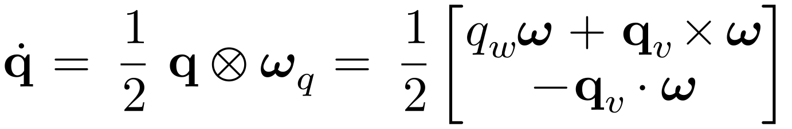
- Rejection of Signaling NaNs for Unmeasured Attitude: When attitude is unmeasured, AEA-STATE/1 mandates the identity quaternion [0.0, 0.0, 0.0, 1.0] (§9). Encoding unmeasured fields via IEEE-754 NaN bit patterns was explicitly rejected because signaling/quiet NaN payloads trigger hardware FPU exceptions on embedded flight microcontrollers and carry non-unique bit representations that break SHA-256 hash determinism.

4.6 External Trajectory Chaos & Relativistic Light-Time Correlation
While AEA-STATE/1 records a single-epoch state rather than propagating orbits internally, its explicit context fields provide the exact boundary conditions required by external astrodynamics and relativistic timing engines:
- Bounding Lyapunov Trajectory Divergence: In multi-body gravitational regimes (such as cislunar Near-Rectilinear Halo Orbits), state estimation error δx(t) grows exponentially with the maximum Lyapunov exponent λ= 1/τ_{L}:
By sealing periodic state observations at interval Δt_{reset} ≪ τ_{L} (using onboard star trackers, radiometric updates, or X-ray pulsar navigation [25]), external navigation filters cap accumulated drift to ε_{max} ≈ σ_{sensor} · e^{λΔt}reset.
- Relativistic Light-Time & Pulsar Arrival Correlation: Relating an event recorded in spacecraft proper time t_{proper} to BCRS/TCB coordinate time t_{bary} across interplanetary distances requires evaluating four relativistic time delays—Rømer light-travel delay (Δ_{R} = −(1/c) k · r_{sc/SSB}), Einstein gravitational/kinematic dilation (Δ_{E} = ∫ (v²/2c² + w/c²) dt), Shapiro gravitational path delay (Δ_{S} = −(2GM⊙/c³) ln(1 + cos θ)), and finite-distance wavefront parallax (Δ_{P}):
Because AEA-STATE/1 explicitly binds body_naif, frame, time_scale, and 3D state vectors, external solvers can evaluate these transformations without guessing the coordinate origin.

5. The Record: Binary Wire Format
AEA-STATE/1 defines a 136-byte wire record: 104 prefix bytes and a 32-byte digest. The field offsets place each 64-bit field on an 8-byte boundary. Implementations assert sizes and offsets and serialize fields explicitly.
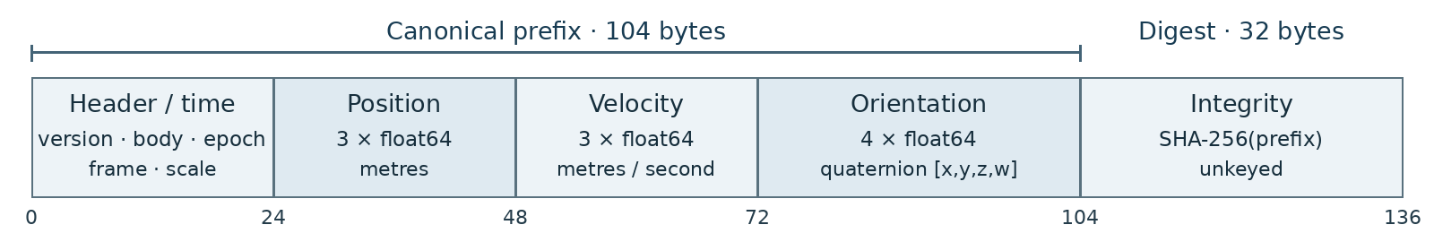
Figure 2. AEA-STATE/1 field offsets. The wire encoding is little-endian.
Table 3. AEA-STATE/1 Binary Layout Specification (136 Bytes)
Offset | Size | Data Type | Field Name | Operational Description
0..3 | 4 B | uint32_t | version | Protocol wire version. Must equal 1.
4..7 | 4 B | uint32_t | body_naif | AEA body ID: 399 = Earth; 499 = Mars. The implementation reserves 0 for none, not the Solar System barycenter. BCRS origin is determined by the frame. Negative spacecraft IDs are outside this unsigned field.
8..15 | 8 B | int64_t | time_sec | Continuous integer seconds since the declared epoch (Section 4.4).
16..19 | 4 B | uint32_t | time_nsec | Fractional nanoseconds (0 ≤ nsec ≤ 999,999,999).
20..21 | 2 B | uint16_t | frame | Coordinate reference chart enum (1..4).
22..23 | 2 B | uint16_t | time_scale | Coordinate time scale enum (1..4).
24..47 | 24 B | double[3] | pos_m | Cartesian position [X, Y, Z] in metres in declared frame.
48..71 | 24 B | double[3] | vel_mps | Cartesian velocity [V_{x}, V_{y}, V_{z}] in m/s in declared frame.
72..103 | 32 B | double[4] | quat_xyzw | Attitude quaternion [q_{x}, q_{y}, q_{z}, q_{w}]. Null convention: [0, 0, 0, 1].
104..135 | 32 B | uint8_t[32] | hash | FIPS 180-4 SHA-256 digest computed over prefix offsets [0, 104).

5.1 Optional Covariance Sidecar Pattern (AEA-COV/1)
State estimators such as Extended Kalman Filters (EKF) produce a symmetric 6 × 6 position-velocity covariance matrix P alongside the state vector:
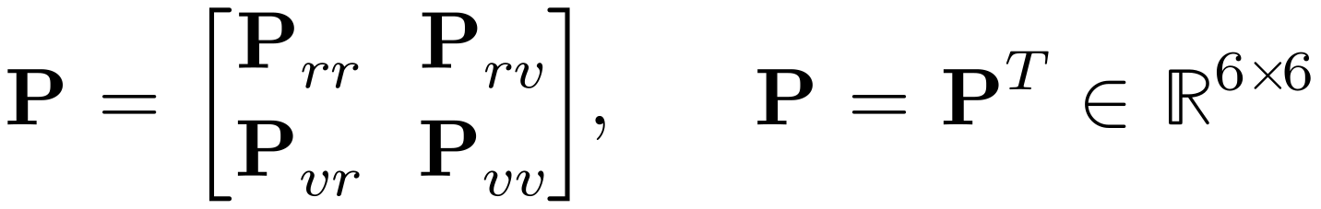
To keep the core AEA-STATE/1 record invariant at 136 bytes, uncertainty is carried via an optional 84-byte companion sidecar (AEA-COV/1) containing the (6 × 7)/2 = 21 upper-triangular elements of P encoded as float32[21] (21 × 4 B = 84 bytes, forming a 220-byte combined packet when appended).

5.2 Avionics & Telemetry Data Bus Encapsulation
Because AEA-STATE/1 has a deterministic 136-byte footprint with zero dynamic pointers, it maps predictably across standard aerospace and defense hardware buses:
Table 4. Avionics and Telemetry Bus Encapsulation Profiles
Avionics / Telemetry Bus | Max Frame Payload | AEA-STATE/1 Encapsulation Profile
SpaceWire (ECSS-E-50-12C) | Variable (up to 64 KB) | Single contiguous 136-byte packet payload.
Ethernet (UDP / IP) | 1,500 B MTU | Single datagram; packs up to 10 AEA-STATE/1 records per standard frame.
MIL-STD-1553B | 32 words (64 B) | Deterministic 3-subaddress block transfer (64 B + 64 B + 8 B).
CAN-FD / CAN Aerospace | 64 B per frame | Deterministic 3-frame sequence (64 B + 64 B + 8 B).

5.3 Canonical Text String
The published text representation follows this ABNF grammar [20]. Despite the familiar sec.nsec appearance, nsec is an integer nanosecond field, not an arbitrary decimal fraction (for example, .1 denotes one nanosecond under this grammar):
aea-string = "AEA:" body ":" scale ":" sec "." nsec ":" frame ":" triple ":" triple ":" quat ":" digest
body = 1*DIGIT ; body_naif
scale = "TAI" / "TT" / "TCB" / "TDB"
sec = ["-"] 1*DIGIT ; time_sec
nsec = 1*9DIGIT ; time_nsec, integer 0..999999999
frame = "ITRF2020" / "GCRS" / "BCRS" / "BODY"
triple = num "," num "," num ; X,Y,Z then Vx,Vy,Vz
quat = num "," num "," num "," num ; qx,qy,qz,qw
num = ["-"] 1*DIGIT ["." 1*DIGIT]
digest = 64(DIGIT / %x61-66) ; lowercase hex
The trailing digest is lowercase hexadecimal SHA-256 over the 104-byte little-endian binary prefix, not over the ASCII text. Decimal spellings need not be unique, so the binary record is authoritative. The text omits an explicit wire-version token and depends on the stated AEA-STATE/1 convention.

6. Encoding and Validation Algorithms
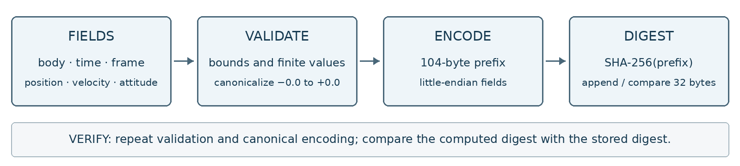
Figure 3. Reference sealing and verification flow. A digest match checks the canonical prefix.

6.1 Sealing Procedure
- Validation: Checks that version == 1, frame and time_scale are in [1, 4], time_nsec < 10⁹, and all 10 floats are strictly finite (!⁠isnan && !⁠isinf). Returns negative error codes on failure.
- Negative-Zero Canonicalization: IEEE-754 defines both +0.0 (0x0000000000000000) and −0.0 (0x8000000000000000) [11]. While equal in arithmetic, they produce completely different SHA-256 hashes. The serializer coerces any −0.0 to +0.0 across all 10 floats prior to hashing:
- Prefix Serialization: Serializes the 104-byte Little-Endian prefix buffer.
- Digest Generation: Computes FIPS 180-4 SHA-256 [10] over bytes [0, 104) and writes the 32-byte digest into record->hash.

6.2 Verification Procedure
The reference procedure validates fields, canonicalizes floating-point zeros, recomputes SHA-256 over the 104-byte prefix, and compares the digest using a fixed-length loop. A match returns 0; a mismatch returns 1; invalid fields return negative codes. Negative zero verifies as equivalent to positive zero.

7. Worked Encoding Examples: Cambridge & Mars
The following vectors serve as deterministic Known-Answer Test (KAT) benchmarks to verify byte-level serialization and digest reproducibility across terrestrial and planetary frames; they use illustrative coordinate inputs rather than surveyed site telemetry.

7.1 Cambridge-Inspired Earth Vector (2009)
- Civil timestamp: 2009-06-28T12:00:00 UTC.
- TAI conversion inputs: POSIX = 1,246,190,400; TAI − UTC = 34 s [5]. The project epoch rule gives:
- Position assumptions: latitude 52.205878° N, longitude 0.117867° E; H = 10.0 m and assumed N = 46.0 m, so h = 56.0 m. The vector uses a WGS 84 ellipsoidal conversion [4,13]:
- Kinematic assumptions: v = [0,0,0] m/s in the declared terrestrial frame; q = [0,0,0,1] under the unmeasured-attitude convention.
- Enums: body_naif = 399 (Earth), frame = 1 (ITRF2020), time_scale = 1 (TAI).
Canonical String:
AEA:399:TAI:1246190426.0:ITRF2020:3916909.5232774816,8057.749278632174,5016918.648210711:0,0,0:0,0,0,1:9f6cc1096562729a902167fd622e66a264a239f3e9a9d804414659e3ab97800e
Binary Hex Dump (136 Bytes, Little-Endian):
0000: 01 00 00 00 8f 01 00 00 5a 5b 47 4a 00 00 00 00 ........Z[GJ....
0010: 00 00 00 00 01 00 01 00 ab c1 fa c2 36 e2 4d 41 ............6.MA
0020: c7 74 b9 d0 bf 79 bf 40 c7 48 7c a9 55 23 53 41 .t...y.@.H|.U#SA
0030: 00 00 00 00 00 00 00 00 00 00 00 00 00 00 00 00 ................
0040: 00 00 00 00 00 00 00 00 00 00 00 00 00 00 00 00 ................
0050: 00 00 00 00 00 00 00 00 00 00 00 00 00 00 00 00 ................
0060: 00 00 00 00 00 00 f0 3f 9f 6c c1 09 65 62 72 9a .......?.l..ebr.
0070: 90 21 67 fd 62 2e 66 a2 64 a2 39 f3 e9 a9 d8 04 .!g.b.f.d.9.....
0080: 41 46 59 e3 ab 97 80 0e AFY.....

7.2 Jezero-Inspired Mars Vector (2021)
This example changes the body and frame without changing the record layout. Its rounded inputs are inspired by Perseverance’s Jezero landing.
- Civil timestamp: 2021-02-18T20:55:00 UTC.
- TAI conversion inputs: POSIX = 1,613,681,700; TAI − UTC = 37 s [5].
- Position assumptions: latitude 18.38° N, longitude 77.58° E; h = −2,570 m treated as ellipsoidal height, not areoid height. The calculation uses a = 3,396,190 m and b = 3,376,200 m; no areoid model is applied [12].
- The resulting radius is approximately 3,391.7 km.
- Enums: body_naif = 499 (Mars), frame = 4 (BODY), time_scale = 1 (TAI).
Canonical String:
AEA:499:TAI:1613681729.0:BODY:693057.483,3146968.022,1058117.54:0,0,0:0,0,0,1:705f8364f56f7e3f961f6721776c7aeac4cc3ca527233e450fd2cc049c96273f

8. Verification and Reproducibility

8.1 Automated Reproduction
The archived reference materials identify the following reproduction commands:
# Commands documented for the cited implementation baseline
cargo test
python3 tools/gen_kat.py --check
python3 tools/aea.py verify tests/kat/cambridge.bin
cd examples/c_caller
cargo build --release --manifest-path ../../Cargo.toml
make run

8.2 Known-Answer Test (KAT) Vectors
Table 5. Known-Answer Test (KAT) Reference Vectors
Benchmark Vector | Target Body | Time Scale | Coordinate Epoch (t_{sec}) | Frame | Expected SHA-256 Digest
Cambridge 2009 | Earth (399) | TAI (1) | 1246190426 | ITRF2020 (1) | 9f6cc1096562729a902167fd622e66a264a239f3e9a9d804414659e3ab97800e
Mars 2021 | Mars (499) | TAI (1) | 1613681729 | BODY (4) | 705f8364f56f7e3f961f6721776c7aeac4cc3ca527233e450fd2cc049c96273f

8.3 Single-Bit Mutation Check
An independent byte-level implementation of the specified field validation, negative-zero canonicalization, and SHA-256 comparison was applied to all 1,088 single-bit mutations of the 136-byte Cambridge vector.
- Result: 1,082 of 1,088 mutations (99.45%) failed validation or digest comparison. All 32 digest bytes and all nonzero floating-point values were covered.
- Six accepted mutations: The sign bits of the six zero-valued velocity and quaternion components can change +0.0 to −0.0. Verification maps both forms to +0.0 before hashing, so their digests agree. This is the intended canonical equivalence of zero.

9. Limitations
To maintain engineering rigor, the operational boundaries of AEA-STATE/1 must be explicitly understood:
- Evidence Scope: The reference materials describe host-level software checks. They do not establish flight qualification, hardware-in-the-loop validation, field deployment, or measured navigation performance. This paper makes no operational performance claim.
- Integrity vs. Authenticity: The unkeyed SHA-256 digest detects accidental changes subject to canonicalization. It is not sender authentication, tamper-proofing, provenance, or non-repudiation. An active writer can recompute it. Authentication requires a separately designed keyed or signature envelope and its trust model.
- Attitude Null Convention: Unmeasured attitude is represented by the identity quaternion [0, 0, 0, 1]. While [0, 0, 0, 1] is also a physically valid orientation aligned with frame axes, v1 provides no dedicated boolean flag to distinguish between unmeasured and aligned attitude.
- Unit Quaternion Normalization Not Enforced: The library checks float finiteness but does not enforce unit length (‖q‖ = 1.0). Caller algorithms must normalize quaternions prior to sealing.
- Uncertainty and Context: The core stores a point estimate, not its covariance, sensor calibration, clock realization, or complete model history. Sidecars and catalogs must remain available and unambiguously associated. The record is not universally independently self-contained.
- Decadal Tectonic Drift: Coordinates in ITRF2020 represent physical positions at event epoch. Over multi-decade baselines, continental drift requires external Plate Motion Models (PMM) to project coordinates forward to a modern epoch.
- Delegated Transformations: The library does not compute orbital mechanics or coordinate rotations. Planetary ephemerides and frame transformations remain the responsibility of external astrodynamics libraries (NASA SPICE, IAU SOFA).

10. Threats to Validity
- Evidence Transfer: Byte-layout checks and synthetic host tests do not establish memory use, timing bounds, safety, or behavior on every target. Qualification requires target-specific measurements and independent review; none is inferred from the choice of implementation language. A fixed-length comparison loop is not by itself a target-level constant-time guarantee.
- Endianness: The wire format is strictly Little-Endian. Big-endian host architectures must perform explicit byte swapping before sealing or verifying.
- Unkeyed Digest: The SHA-256 trailer is an unkeyed integrity checksum. Anyone with write access to the 104-byte prefix can recompute a valid matching digest.
- Quaternion Sign Ambiguity: The quaternions q and −q represent the identical physical rotation in SO(3), but produce completely different SHA-256 digests. Applications must adhere to consistent hemisphere conventions.
- Profile Epoch Agreement: For TAI, AEA-STATE/1 fixes the counting origin at 1970-01-01T00:00:08 TAI (§4.4). TT, TCB, and TDB records follow the scale-specific epoch convention of the declared mission profile, so producers and consumers must share that profile; enum agreement alone does not convey it.
- External Models and Catalogs: Reinterpreting or transforming a record depends on frame realizations, Earth orientation data, leap-second history, rotation models, and ephemeris versions. Differences in those inputs change results; no universal numerical bound is established here.

11. Future Work
Advancing the AEA framework from a host-verified specification (TRL 3) toward broader scientific and operational adoption involves four primary directions:
- Authenticated Provenance: Define a separate envelope, signature coverage, signer identity, key management, and replay policy. A 64-byte signature alone is not a complete authentication protocol.
- Explicit Validity and Context: Distinguish unmeasured attitude from aligned attitude; identify covariance associations, frame realizations, rotation models, and time-scale epoch conventions without changing the meaning of archived records.
- Independent Implementation Checks: Compare encodings across compilers and architectures, assess floating-point/text round trips, and publish target-specific memory and timing evidence where relevant.
- Multi-System Modeling, Spatial Indexing & Operational Evaluation: Future work will evaluate AEA-STATE/1 in cross-platform telemetry handoffs after communications blackouts, planetary observation catalogs, long-term scientific archives, and high-density spatial indexing (such as mapping 3D Cartesian coordinates into 64-bit Morton3D Z-order curves for rapid proximity queries), alongside conceptual links to relativistic positioning systems [18,19].

12. Supporting Implementation
To turn the theoretical addressing model into a practical engineering tool, the AEA-STATE/1 specification is accompanied by a deterministic, bare-metal reference implementation verified at TRL 3. Its core is written in #![no_std] Rust and exposes a zero-overhead C ABI (aea.h) designed to run alongside existing flight, navigation, and archival software. The excerpts below document the published representation and canonicalization rule.
12.1 The Bare-Metal Rust Reference Implementation  #![no_std]  #![deny(unsafe_code)]  use core::mem::size_of;  pub const AEA_WIRE_VERSION: u32 = 1;  pub const AEA_RECORD_BYTES: usize = 136;  pub const AEA_PREFIX_BYTES: usize = 104;  pub const AEA_HASH_BYTES: usize = 32;  #[repr(C)]  #[derive(Copy, Clone, Debug, PartialEq)]  pub struct AeaRecord {  pub version: u32,  pub body_naif: u32,  pub time_sec: i64,  pub time_nsec: u32,  pub frame: u16,  pub time_scale: u16,  pub pos_m: [f64; 3],  pub vel_mps: [f64; 3],  pub quat_xyzw: [f64; 4],  pub hash: [u8; 32],  }  const _: () = assert!(size_of::<AeaRecord>() == 136);  #[inline]  pub fn canonicalize_f64(x: f64) -> f64 {  if x == 0.0 { 0.0 } else { x }  }  12.2 Reference Core Properties  - Zero-Heap Allocation: The reference implementation operates strictly under #![no_std] Rust with panic = "abort". There is zero dynamic memory allocation (0 malloc, 0 free, no alloc, no Box).  - Zero External Dependencies: The implementation contains zero third-party crate dependencies. FIPS 180-4 SHA-256 is vendored internally.  - C Interface: Exports aea_seal, aea_verify, and aea_version. Integration from another language requires compatible calling conventions, bindings, and memory handling.  - Layout Checks: The specified offsets allow 8-byte alignment of 64-bit fields on compatible targets. New targets still require size/offset assertions and explicit endianness handling. | 12.3 Exported Public C Interface (aea.h)  #ifndef AEA_H  #define AEA_H  #include <stdint.h>  #include <stdbool.h>  #define AEA_OK 0  #define AEA_ERR_MISMATCH 1  #define AEA_ERR_NULL_PTR (-1)  #define AEA_ERR_VERSION (-2)  #define AEA_ERR_NSEC_BOUND (-3)  #define AEA_ERR_FRAME (-4)  #define AEA_ERR_TIME_SCALE (-5)  #define AEA_ERR_NON_FINITE (-6)  typedef struct {  uint32_t version;  uint32_t body_naif;  int64_t time_sec;  uint32_t time_nsec;  uint16_t frame;  uint16_t time_scale;  double pos_m[3];  double vel_mps[3];  double quat_xyzw[4];  uint8_t hash[32];  } AeaRecord;  _Static_assert(sizeof(AeaRecord) == 136,  "AeaRecord must be exactly 136 bytes");  #ifdef __cplusplus  extern "C" {  #endif  int32_t aea_seal(AeaRecord *record);  int32_t aea_verify(const AeaRecord *record);  uint32_t aea_version(void);  #ifdef __cplusplus  }  #endif  #endif

13. Code and Data Availability
The repository provides implementation materials; the DOI below identifies the archived white paper, not a separate software deposit:
- Repository: https://github.com/Abrams-Research-Systems-LLC/Abrams-Event-Address-AEA
- Commit Hash: 287392912020d2a8ec33d81fe426ba17ce350a5f
- White paper archive: https://doi.org/10.5281/zenodo.23970628
- Licence: MIT OR Apache-2.0

References
- Charlot, P., Jacobs, C. S., Gordon, D., et al. (2020). The third realization of the International Celestial Reference Frame by very long baseline interferometry. Astronomy & Astrophysics, 644, A159. doi:10.1051/0004-6361/202038368.
- Petit, G., & Luzum, B. (Eds.). (2010). IERS Conventions (2010) (IERS Technical Note No. 36). Verlag des Bundesamts für Kartographie und Geodäsie.
- Altamimi, Z., Rebischung, P., Collilieux, X., et al. (2023). ITRF2020: an augmented reference frame refining the modeling of nonlinear station motions. Journal of Geodesy, 97(5), 47. doi:10.1007/s00190-023-01738-w.
- National Geospatial-Intelligence Agency. (2014). World Geodetic System 1984: Its Definition and Relationships with Local Geodetic Systems (NGA.STND.0036, Version 1.0.0).
- Bureau International des Poids et Mesures. Time metrology: International Atomic Time (TAI), UTC, and TT(BIPM). https://www.bipm.org/en/time-metrology (accessed November 2026).
- International Astronomical Union. (2000). Resolutions Adopted at the XXIVth General Assembly (Manchester): Resolution B1.3 (BCRS and GCRS); Resolution B1.9 (Terrestrial Time).
- International Astronomical Union. (2006). Resolutions Adopted at the XXVIth General Assembly (Prague): Resolution B3 (Re-definition of Barycentric Dynamical Time).
- Acton, C. H. (1996). Ancillary data services of NASA's Navigation and Ancillary Information Facility. Planetary and Space Science, 44(1), 65–70. doi:10.1016/0032-0633(95)00107-7.
- Consultative Committee for Space Data Systems. (2023). Orbit Data Messages (Recommended Standard CCSDS 502.0-B-3, Blue Book / ISO 26900:2024).
- National Institute of Standards and Technology. (2015). Secure Hash Standard (SHS) (Federal Information Processing Standards Publication FIPS 180-4). doi:10.6028/NIST.FIPS.180-4.
- Standards Committee of the IEEE Computer Society. (2019). IEEE Standard for Floating-Point Arithmetic (IEEE Std 754‑2019). doi:10.1109/IEEESTD.2019.8766229.
- Archinal, B. A., Acton, C. H., A'Hearn, M. F., et al. (2018). Report of the IAU Working Group on Cartographic Coordinates and Rotational Elements: 2015. Celestial Mechanics and Dynamical Astronomy, 130(3), 22. doi:10.1007/s10569-017-9805-5.

- Pavlis, N. K., Holmes, S. A., Kenyon, S. C., & Factor, J. K. (2012). The development and evaluation of the Earth Gravitational Model 2008 (EGM2008). Journal of Geophysical Research: Solid Earth, 117(B4), B04406. doi:10.1029/2011JB008916.
- Soffel, M., Klioner, S. A., Petit, G., et al. (2003). The IAU 2000 Resolutions for Astrometry, Celestial Mechanics, and Metrology in the Relativistic Framework: Explanatory Supplement. The Astronomical Journal, 126(6), 2687–2706. doi:10.1086/378162.
- Shuster, M. D. (1993). A survey of attitude representations. Journal of the Astronautical Sciences, 41(4), 439–517.
- Open Robotics. ROS 2 interface definition: nav_msgs/msg/Odometry. https://docs.ros.org/en/rolling/p/nav_msgs/msg/Odometry.html (accessed November 2026).
- Park, R. S., Folkner, W. M., Williams, J. G., & Boggs, D. H. (2021). The JPL Planetary and Lunar Ephemerides DE440 and DE441. The Astronomical Journal, 161(3), 105. doi:10.3847/1538-3881/abd414.
- Coll, B. (2006). Relativistic Positioning Systems. arXiv:gr-qc/0601110.
- Rovelli, C. (2002). GPS observables in general relativity. Physical Review D, 65(4), 044017. doi:10.1103/PhysRevD.65.044017.
- Crocker, D., & Overell, P. (2008). Augmented BNF for Syntax Specifications: ABNF (RFC 5234). Internet Engineering Task Force.
- Range Commanders Council (RCC). (2016). IRIG Serial Time Code Formats (IRIG Standard 200-16). Telecommunications and Timing Group, White Sands Missile Range.
- IEEE Instrumentation and Measurement Society. (2020). IEEE Standard for a Precision Clock Synchronization Protocol for Networked Measurement and Control Systems (IEEE Std 1588‑2019). doi:10.1109/IEEESTD.2020.9120376.
- Consultative Committee for Space Data Systems. (2010). Time Code Formats (Recommended Standard CCSDS 301.0-B-4, Blue Book; technical corrigendum, 2012).
- Consultative Committee for Space Data Systems. (2024). Attitude Data Messages (Recommended Standard CCSDS 504.0-B-2, Blue Book).
- Sheikh, S. I., Pines, D. J., Ray, P. S., Wood, K. S., Lovellette, M. N., & Wolff, M. T. (2006). Spacecraft navigation using X-ray pulsars. Journal of Guidance, Control, and Dynamics, 29(1), 49–63. doi:10.2514/1.13331.
- Altamimi, Z., Métivier, L., Rebischung, P., Collilieux, X., Chanard, K., & Barnéoud, J. (2023). ITRF2020 plate motion model. Geophysical Research Letters, 50(24), e2023GL106373. doi:10.1029/2023GL106373.

