
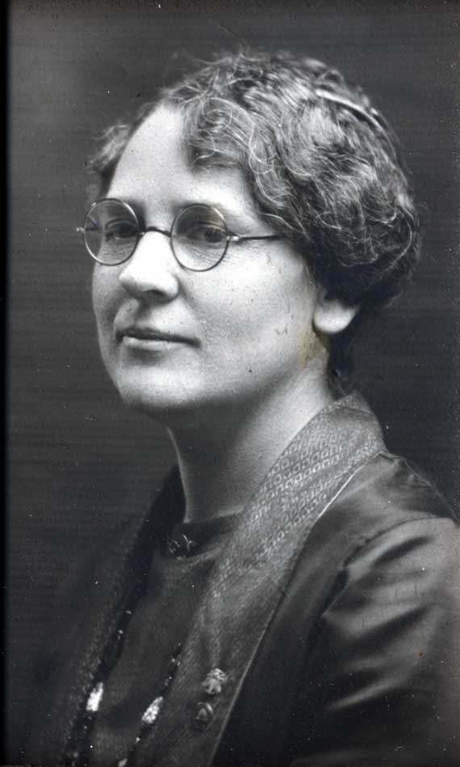
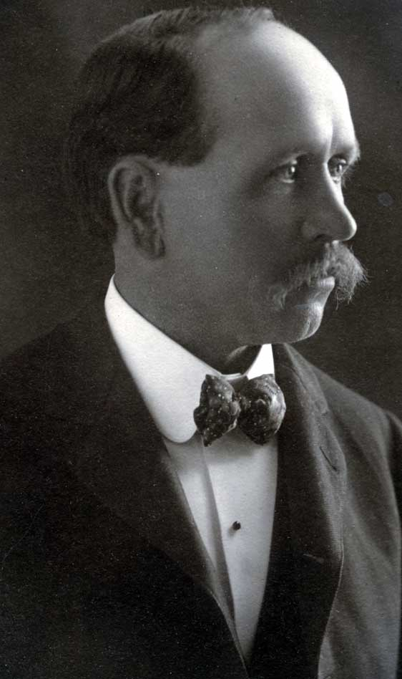
Old Folks, Young Folks, Everybody Come
Meet your Burton Relatives and have a lot of fun
Bring your favorite salad or a nice dessert to share
Barbecued beef & drink will be waiting for you there.

HEBER F. BURTON FAMILY REUNION
Saturday, August 13, 2005
GRANITE VIEW STAKE PAVILION
9880 South 3100 East
Sandy, UT 84092

TIMES AND ACTIVITIES ARE “PLEASANTLY SORT OF ARRANGED”:
2:00 pm – Homemade Ice Cream and Sign In with Outdoor Activities for all:

Tug of War Volleyball
Stick Pull 3 legged race
Water Balloon Toss Bob for apples
Dunk Tank (bring change of clothes!)
RSVP’s are welcome but come anyway!
Alice Snedeger (801) 619-6500 or
alice1s@deseretgt.com
Mary Jeanne Jenness (801) 566-1083 or
mary_jeanne_jenness@hotmail.com
Tiny tots: Pioneer Handcart Parade,
Fabric paint “B” on bandanas and aprons
Make Ancestor paper sack puppets
Make toy boats and blow them over Mississippi
Sprinkler fun (bring change of clothes!)
And more . . .

Humanitarian Aid Projects: Tie Quilts, Make Dolls, Finish Toy Cars

3:30 pm – “MEET OUR ANCESTORS” as we cool off inside with skits and songs and lots of fun: Bring instruments for orchestra!
4:30 pm – FAMILY HISTORY/GENEALOGY MEETING inside Stake Center with History/genealogy CD’s available (please send contributions to Shauna Buchanan: shaunadelecta@hotmail.com)
Outdoor activities will resume during the meeting.
5:30 pm – PICNIC: Barbecued beef sandwiches; drinks and table service provided
BRING SALAD, DESSERT, ETC. TO SHARE.
Evening -- FAMILY DANCE inside Stake Center

