Lab 02
  - Operationalization, Variables & Measurement

Walk-through (15 points)
Instructions
Identify Types of Variables
For each of the variables listed below, highlight (use yellow) whether it is quantitative (values reflect a count or measurement) or qualitative (values correspond to category membership). For each quantitative, you also need to highlight (use yellow) whether it is continuous (can take on any value; e.g., decimal values) or discrete (integer or whole number values only).
- List of descriptive characteritic variables
Variable | Description | Example Values | Qual or  Quant | Discrete or  Continuous
type | Type of media: 1=Movie, 2=TV Series, 3=Serial/Short Film | 1, 2
first_appear | Year first debuted (YYYY) | 1978, 2025
clark_height | Height of Superman actor in meters (to 2 decimal places) | 1.93, 1.85
height_grp | Whether or not Superman actor is over 6ft tall: 1=Yes (≥1.83m/6'0"), 2=No (<1.83m/6'0") | 1, 2
lois_height | Height of Lois Lane actor in inches (rounded up) | 63, 68
height_diff | Height difference (Clark's height - Lois's height) in feet (to 2 decimal places) | 0.98, 0.72

- List of enjoyment/quality variables
Variable | Description | Example Values | Qual or  Quant | Discrete or  Continuous
rt_critics_score | Rotten Tomatoes critics score (0-100%) | 94, 56
rt_status | Rotten Tomatoes status (1=Fresh, 2=Certified Fresh, 3=Rotten) | 1, 3
rt_audience_score | Rotten Tomatoes audience score (0-100%) | 88, 62
lb_avg_stars | Letterboxd average rating (1-5 stars) | 4.2, 3.8
lb_reviews | Letterboxd number of reviews | 1250, 890
metacritic_score | Metacritic score (0-100) | 78, 52
emotion | Primary emotion response while watching (1=fear, 2=joy, 3=sadness, 4=anger, 5=disgust, 6=anxiety) | 2, 2
emo | Emotional Impact Subscale of Subjective Movie Enjoyment Scale (SMES) sum of 4-items (1-5 scale) measuring emotional response | 16, 18
aes | Aesthetic Appeal Subscale of Subjective Movie Enjoyment Scale (SMES) sum of 3-items (1-5 scale) measuring visual appeal | 12, 14
cog | Cognitive Engagement Subscale of Subjective Movie Enjoyment Scale (SMES) average of 4-items (0-7 scale) measuring cognitive stimulation | 6.3, 4.7

Discussion Question: In the above dataset we have several variables that represent different operationalizations of the same or similar behavior/characteristics.
How might these different operationalizations (i.e., different measures of height or quality) influence generalizability or how we interpret the results?

In-Class (30 points)
Instructions
Find a partner and work on the next few sections together!!
Part A. Creating conceptual definitions
In Part A below, you will practice identifying conceptual definitions for different psychological constructs.
Conceptual definition: describes the behaviors or internal processes that might make up a psychological construct, along with how it relates to other variables.

- EXAMPLE: Binge-watching
- Conceptual definition: Watching multiple episodes of a TV show in a single sitting, often leading to the neglect of other activities or responsibilities.
- Physical attractiveness
- Conceptual definition:
- Social Media Addiction
- Conceptual definition:
- Risky behavior
- Conceptual definition:
- Emotional intelligence
- Conceptual definition:

Instructions
Part B. Operationalizing variables
In the next section, you and your partner will practice creating operational definitions by identifying both self-report and observational/behavioral measures for each given variable.
Operational definition: a definition of a variable in terms of precisely how it is to be measured.
- EXAMPLE: Binge-watching
- Self-report: Participants rate how many times in the last 6-months they have binged watched television (defined as watching 3+ consecutive episodes or 2+ hours of continuous viewing of the same show with breaks <15 minutes between episodes) on a scale from 1 (never) to 10 (all the time).
- Observational/Behavioral: A researcher monitors participants actual TV/streaming viewing behavior over a 6-month period by installing a TV monitoring box/device that automatically records their TV viewing patterns. Researchers count the number of times the device shows 3+ hours of continuous viewing the same program.
- Fear experienced while watching a scary movie
- Self-report:
- Observational/Behavioral:
- Ability to perceive the difference between colors
- Self-report:
- Observational/Behavioral:
- Current Relationship Status
- Self-report:
- Observational/Behavioral:
- Willingness to engage in risky behavior
- Self-report:
- Observational/Behavioral:

Instructions
Part C. Identifying variables from research questions
Finally, in the next section you and your partner will work to identify and define variables within existing research questions.
For each research question, first identify the target population is that is being studied. Second, identify the grouping/independent variable (IV) and the dependent variable (DV) described in the research question. Next, provide an operational definition for each variable. Finally, classify each variable as either quantitative or qualitative. For quantitative variables, also specify if they are continuous or discrete.

- EXAMPLE: Is there a relationship between the amount of television watched (hours per day) and happiness (self-report survey 1-10 scale) among adult women?
- Target population: Adult Women
- Grouping/Independent Variable:
- Grouping/Independent Variable: Amout of television watched
- IV Operationalization: Hours per day
- IV type (quantitative or qualitative): quant
- If IV quant (continuous or discrete): discrete (i.e., hours)
- Dependent Variable:
- Dependent Variable: Happiness
- DV Operationalization: self-report survey 1-10 scale
- DV type (quantitative or qualitative): quant
- If DV quant (continuous or discrete): discrete

- Is there a relationship between weather conditions and depression in Nebraskan high school students?
- Target population:
- Grouping/Independent Variable:
- Grouping/Independent Variable:
- IV Operationalization:
- IV type (quantitative or qualitative):
- If IV quant (continuous or discrete):
- Dependent Variable:
- Dependent Variable:
- DV Operationalization:
- DV type (quantitative or qualitative):
- If DV quant (continuous or discrete):

- Are wealthy, upper-class people more likely to engage in unethical behavior?
- Target population:
- Grouping/Independent Variable:
- Grouping/Independent Variable:
- IV Operationalization:
- IV type (quantitative or qualitative):
- If IV quant (continuous or discrete):
- Dependent Variable:
- Dependent Variable:
- DV Operationalization:
- DV type (quantitative or qualitative):
- If DV quant (continuous or discrete):

- Does daily social media use affect sleep quality in teenagers?
- Target population:
- Grouping/Independent Variable:
- Grouping/Independent Variable:
- IV Operationalization:
- IV type (quantitative or qualitative):
- If IV quant (continuous or discrete):
- Dependent Variable:
- Dependent Variable:
- DV Operationalization:
- DV type (quantitative or qualitative):
- If DV quant (continuous or discrete):

- Does exposure to non-violent, cooperative video games increase prosocial behaviors in children?
- Target population:
- Grouping/Independent Variable:
- Grouping/Independent Variable:
- IV Operational definition:
- IV type (quantitative or qualitative):
- If IV quant (continuous or discrete):
- Dependent Variable:
- Dependent Variable:
- DV Operationalization:
- DV type (quantitative or qualitative):
- If DV quant (continuous or discrete):

Take-Home (15 points)
Instructions
Developing empirically testable research hypotheses
Develop a research idea into a working hypothesis based on some current news headlines. There are three news articles that you can use for this assignment. You will need to answer the questions and develop a research hypothesis for two of them.
Please do not forget to indicate which article you selected below.


Article 1
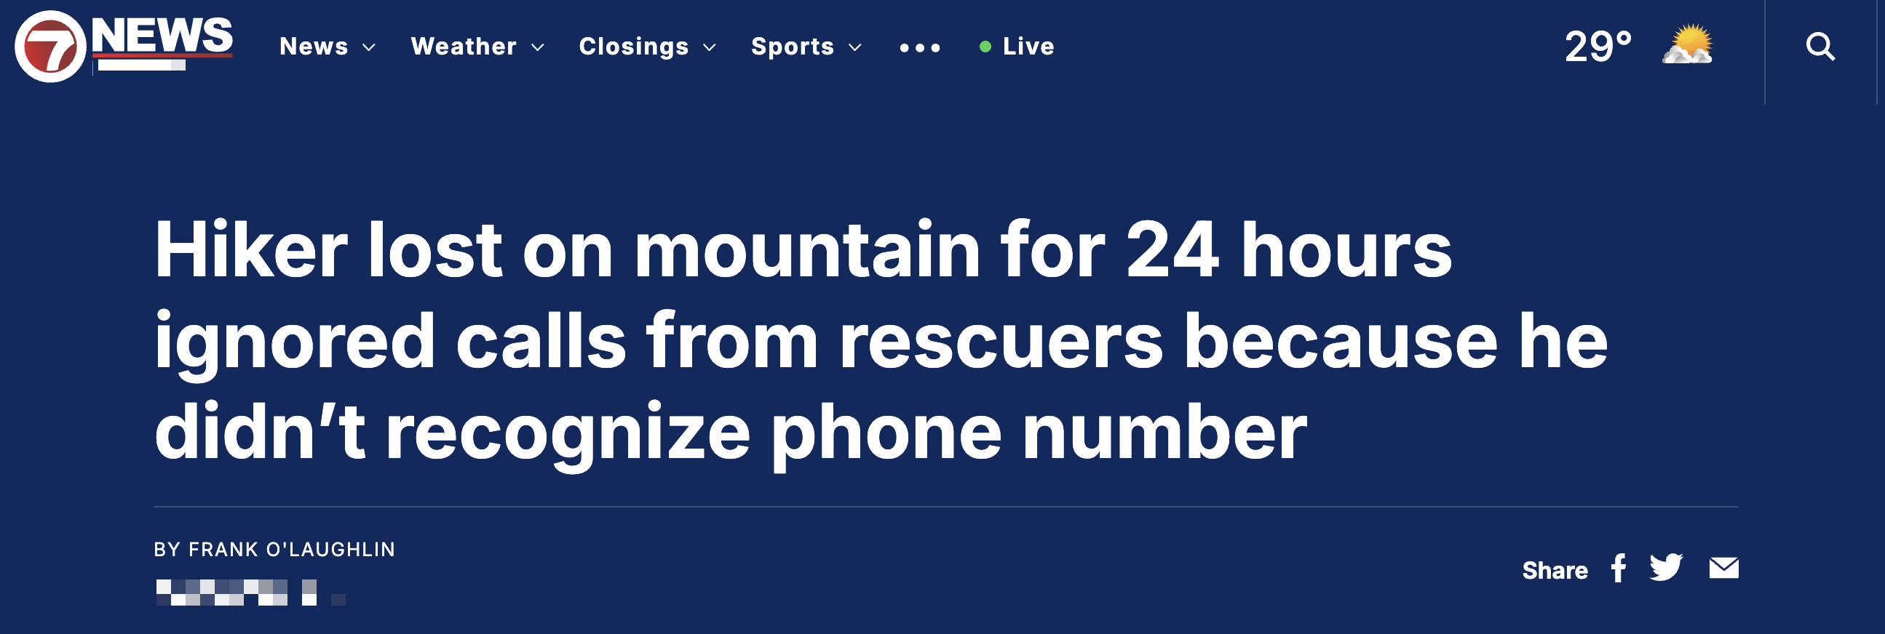
Article 2

Article 3

1. Select your first news headline and write it below (ie., Article 1 or Article 2 or Article 3)
- State your initial, general research question based on the article:
- Research question:
- List and conceptually define all the behaviors/characteristics/concepts/ideas that need to be defined and/or measured to answer your research question.
- Behaviors/characteristics/concepts/ideas:
- Define an grouping/independent and a dependent variable that can be used to test your research question:
- Grouping/Independent Variable:
- Grouping/Independent Variable:
- IV Operationalization:
- IV type (quantitative or qualitative):
- If IV quant (continuous or discrete):
- Dependent Variable:
- Dependent Variable:
- DV Operationalization:
- DV type (quantitative or qualitative):
- If DV quant (continuous or discrete):
- Identify the target population
- Target population:
- Finally, state a research hypothesis that details your expectation/prediction about the relationship between the grouping/independent and dependent variable.
- Research hypothesis:

2. Select your second news headline and write it below (ie., Article 1 or Article 2 or Article 3)
- State your initial, general research question based on the article:
- Research question:
- List and conceptually define all the behaviors/characteristics/concepts/ideas that need to be defined and/or measured to answer your research question.
- Behaviors/characteristics/concepts/ideas:
- Define an grouping/independent and a dependent variable that can be used to test your research question:
- Grouping/Independent Variable:
- Grouping/Independent Variable:
- IV Operationalization:
- IV type (quantitative or qualitative):
- If IV quant (continuous or discrete):
- Dependent Variable:
- Dependent Variable:
- DV Operationalization:
- DV type (quantitative or qualitative):
- If DV quant (continuous or discrete):
- Identify the target population
- Target population:
- Finally, state a research hypothesis that details your expectation/prediction about the relationship between the grouping/independent and dependent variable.
- Research hypothesis:

