Lab 03 - Research Critique 1
  - Research Critique 1

Applying hypotheses, designs & validity (15 points)
Instructions
Read and critique the research article
The purpose of this activity is to give you practice identifying and evaluating each of these important parts of a research report. Whereas it is tempting to start reading the research report and expect that you’ll identify important aspects of the study as you go along, we will proceed in a more orderly manner—focusing on each aspect listed in turn.
STEP 1: GET THE BIG PICTURE: Read through the article quickly – don’t really look for anything, just skim it for basic content and to get the gist of what the researchers did.
STEP 2. FIND THE RESEARCH HYPOTHESIS (Highlight in Yellow): Mark & label any statements about the Research Hypothesis that you can use to help determine if the researchers intended this to be an examination of an associative or causal relationship. Which is it?
STEP 3. EVALUATE EXTERNAL VALIDITY (Highlight in Green): Mark & label all procedures related to External Validity & identify the component in a comment. Be sure to note any disparity between the avowed purpose of the research and the procedures that were used.
STEP 4. EVALUATE INTERNAL VALIDITY (Highlight in Blue): Mark & label all procedures related to Internal Validity & identify the component in a comment. Find & comment on: things done well, things done poorly and things that you can’t evaluate without more information.

The Effect of Video Game Competition and Violence on Aggressive Behavior: Which Characteristic Has the Greatest Influence?
Psychology of Violence, 2011, vol.1, no. 4, pp. 259-274
Abstract. This study is the first to our knowledge to isolate the effect of video game competitiveness on aggressive behavior. In the study, competitiveness was isolated by matching games on difficulty and pace of action, and systematically controlling for violence. The effect of video game competition on aggressive behavior was then examined. We found that competition, not violence, may be the video game characteristic that has the greatest influence on aggressive behavior.
Introduction. The effect of violent video games on aggression, defined as behavior intended to harm another individual (Coie & Dodge, 1998), remains a hot topic as video games continue to grow in popularity. While some research has failed to find a relationship between violent video games and aggression (Ferguson & Reuda, 2010), other studies suggest playing violent video games increases short-term aggressive behavior (Anderson, Gentile, & Buckley, 2007). The General Aggression Model (GAM; Anderson & Bushman, 2002) proposes that violent video games increase aggressive behavior through changes in cognition (aggressive scripts or hostile thoughts), affect (anger and frustration), and arousal (elevated heart rate or blood pressure). However, violence (e.g., fighting, shooting, killing) is not the only video game characteristic that could influence aggressive behavior through similar mechanisms. For example, a game’s level of competitiveness (e.g., competing against other players or computer-controlled opponents) may also independently affect heart rate, hostility, or aggressive thoughts.
Consequently, studies showing that violent video games produce more aggression than nonviolent games, but fail to account for differences in competitiveness, cannot conclude that violent content alone was responsible for the increased aggression observed in experienced gamers. This is particularly important because violent video games tend to be more competitive than nonviolent ones (Carnagey & Anderson, 2005).
In the current study, we examined the effect of video game competitiveness on short-term aggressive behavior more directly. Based on previous research, we expected that highly competitive violent video games would lead to more aggressive behavior than noncompetitive violent games.
Participants. Sixty undergraduates from a large midwestern university. Students taking “advanced statistics” courses in the Sociology, Psychology and Political Science departments were invited to participate in the project for a $10.00 payment and course credit. The only criterion for participation in the study was that participants must report currently or previously owning at least one video gaming console (i.e., PS5, Xbox-360, Nintendo Switch, etc.). Separate signup lists were provided to instructors of each class, each of which requested the participation of five males and five females. APA guidelines for informed consent were followed.
Materials. Video games and equipment. Two games were selected through extensive pilot testing and matched on level of violence, difficulty and pace of action, but differed on competitiveness. The resulting two games conditions were: (1) Competitive: Mortal Kombat 11 (a ﬁghting game in which the main character must battle another opponent character in hand-to-hand combat) and (2) Noncompetitive: Helldivers 2 (a 3rd person squad-based co-op multiplayer shooter in which players must work together in a satirical dystopian future).
Aggressive behavior. The Hot Sauce Paradigm (Lieberman et al., 1999) was used to measure overt aggressive behavior. In the Hot Sauce Paradigm, the participant is given an already completed food preference questionnaire and told that another participant down the hall has completed this questionnaire and, as indicated by the questionnaire, does not like hot or spicy food. The participant is then given four bottles of hot sauce ranked in terms of hotness and is informed that his or her job is to choose one of the four bottles and mix up some hot sauce for the other participant to drink. The amount of hot sauce given and the degree of hotness is indicative of overt aggressive behavior (Barlett et al., 2009), and there are no competitive beneﬁts gained from administering a hotter sauce to the confederate.
Scores on the Hot Sauce Paradigm are determined by calculating the sum of the standardized number (i.e., hotness rating) of sauce selected and the weight in grams (Barlett et al., 2009).
Hot sauce was purchased from a local food establishment that has a ranked system of hotness for the sauces and four sauces were selected that ranked in order from least to most hot. Each sauce was transferred into a plastic squeeze bottle and was given a number from one to four (with one being the least hot and four being the hottest). In addition, a Styrofoam cup to place the hot sauce into, a cup of water, popsicle sticks, and white bread (to help ease the hot sensation after tasting the sauce) were used.
Participants were asked to prepare some hot sauce for another participant to drink who does not like hot sauce (note that there actually was no other participant). Participants were asked to choose the intensity of hot sauce (ranging from 1 = least hot to 4 = most hot) and the amount, knowing that the other participant had to drink whatever amount was in the cup.
Scores on this Hot Sauce Paradigm are positively related to both trait and physical aggression measures and have demonstrated reliability and validity as a measure of aggressive behavior inside the lab (Lieberman et al., 1999). The Buss-Perry Aggression Questionnaire (Buss & Perry, 1992) was also used to measure trait aggression and to confirm the convergent validity of the Hot Sauce Paradigm. The internal consistency for this scale was good (alpha =.89) and hot sauce scores were positively correlated with trait aggression as is consistent with previous results (e.g., Ferguson & Rueda, 2009; Lieberman et al., 1999).
Procedure. All participants completed the procedure in a single computer resource room during one of 10 sessions that were conducted by one of the researchers or one of their four undergraduate research assistants. Sessions included 2-6 participants each of whom was individually assigned to one of the game conditions. Participants were randomly assigned to game conditions with the single constraint that participants from session 4 and 7 were all assigned to the competitive game condition because of a computer issue on the day.
Participants were told they were participating in two unrelated studies looking at (a) video game play and eyegaze and (b) food preference and personality (the Hot Sauce Paradigm). For the food study, participants were told that they were randomly assigned to the role of “food administrator” and that when the time came their job would be to prepare a certain type of food for another participant who had been assigned to the role of “food taster.” Next, participants were told that they were going to begin the video game and eye-gaze study. Participants in the competitive condition (Mortal Kombat 11) were told to complete two best of out three battle or rounds of the game. Those in non-competitive condition (Helldivers 2) were told to complete only one battle or round of the game. They then played the assigned game for 10-35 minutes. Upon completion, participants were then given the questionnaire assessing the video game characteristics and were then told it was time to begin the second food preference study. Speciﬁcally, the experimenter explained that it was time for the participant to prepare some food for the food taster. Participants were given an already completed food preference questionnaire and were told that the food taster completed this questionnaire. The food preference questionnaire clearly indicated that the food taster did not like hot or spicy food.
The experimenter then provided the participant with the materials for the food preference study (i.e., the hot sauce, a cup, a cup of water, bread, and popsicle sticks) and explained that the participant could choose the intensity of hot sauce and the amount, and that the food taster would have to drink whatever amount was in the cup. As in Barlett et al. (2009), participants were told that they could not mix sauces. Also, if they wished to know how hot the sauces were before choosing one, they could sample the sauces using the popsicle stick. The experimenter left the room and watched from behind a two-way mirror as the task was performed, and then returned to retrieve the cup of hot sauce to allegedly bring to the food taster. The time lapse between the video game play and hot sauce preparation was 2 to 3 min, well within the 5- to 10-min time frame in which the effect of violent video games on aggression has been shown to last (Barlett et al., 2009).
Results.The mean scores on the Hot Sauce Paradigm by game type are presented in Figure 1. As hypothesized, ANOVA revealed that aggression was significantly influenced by game competitiveness F(1, 58) = 29.36, p < .001. Participants who played competitive games (Mortal Kombat 11) scored significantly higher (m = 0.65, sd = 0.22) on the Hot Sauce Paradigm than those who played non-competitive (Helldivers 2) games (m = 0.43, sd = 0.35).
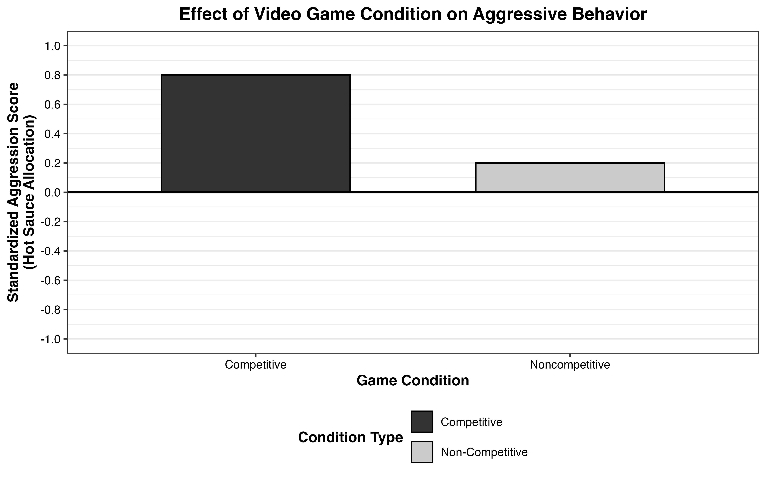
Discussion. The present study demonstrated that competitiveness, not violence, is the primary video game characteristic influencing aggression. Our results revealed that competitive games, regardless of violent content, produced higher levels of aggression compared to less competitive games.
Overall, these findings challenge the belief that violent video games inherently promote aggression. Instead, they suggest that competitive contexts are more critical in causing aggressive behavior. Future research is needed to explore the mechanisms through which video game competitiveness inﬂuences aggressive behavior. However, these findings suggest that parents should begin limiting their young childrens’ access to competitive video games, and not just those that involve violence, if they want to prevent those children from growing into overly aggressive young adults.

Constructive problem solving and research design (15 points)
Instructions
Go back through your annotations and identify at least one problem you had with the design that related to internal validity and one problem related to external validity. In the questions below, briefly describe your concerns and then make a suggestion as to how the study could be run differently to resolve each specific validity issue.
Don’t change the purpose, hypothesis, or overall design, just the methods & procedures!!!

- Brief description of the internal validity problem you identified, how it might impact interpretability or generalizability, and your proposed fix:
- Problem:
- Solution:
- Brief description of the external validity problem you identified, how it might impact generalizability, and your proposed fix:
- Problem:
- Solution:

The original article has been modified for the purposes of this assignment.

