Lab 02
  - Operationalization, Variables & Measurement

Walk-through (15 points)
 Instructions

Identify Types of Variables
For each of the variables listed below, highlight (use yellow) whether it is quantitative (values reflect a count or measurement) or qualitative (values correspond to category membership). For each quantitative, you also need to highlight (use yellow) whether it is continuous (can take on any value; e.g., decimal values) or discrete (integer or whole number values only).

1. Variable Details |  |  | Highlight (correct):
Variable  Name | Description  (Details) | Example  Values | Quantitative  or Qualitative? | Continuous  or Discrete?
type | Type of media:  1=Movie, 2=TV Series, 3=Serial/Short Film | 1, 2 | Quantitative  or  Qualitative | Discrete  or  Continuous
first_appear | Year first debuted (YYYY) | 1978, 2025 | Quantitative  or  Qualitative | Discrete  or  Continuous
clark_height | Height of Superman actor in meters  (to 2 decimal places) | 1.93, 1.85 | Quantitative  or  Qualitative | Discrete  or  Continuous
height_grp | Whether or not Superman actor is over 6ft tall:  1=Yes (≥1.83m/6'0"), 2=No (<1.83m/6'0") | 1, 2 | Quantitative  or  Qualitative | Discrete  or  Continuous
lois_height | Height of Lois Lane actor in centimeters (rounded up) | 160, 172 | Quantitative  or  Qualitative | Discrete  or  Continuous
height_diff | Height difference (Clark's height - Lois's height)  in meters (to 2 decimal places) | 0.30, 0.22 | Quantitative  or  Qualitative | Discrete  or  Continuous
Discussion Question
In the above dataset we have several variables that represent different operationalizations of the characteristic of height.
How might these different operationalizations of height (quantitative/qualitative and continuous/discrete) influence how we interpret the results and generalizability?

2. Variable Details |  |  | Highlight (correct):
Variable  Name | Description  (Details) | Example  Values | Quantitative  or Qualitative? | Continuous  or Discrete?
rt_critics_score | Rotten Tomatoes critics score  (0-100%) | 94, 56 | Quantitative  or  Qualitative | Discrete  or  Continuous
rt_status | Rotten Tomatoes status:  Fresh/Certified Fresh/Rotten | Fresh, Rotten | Quantitative  or  Qualitative | Discrete  or  Continuous
rt_audience_score | Rotten Tomatoes audience score  (0-100%) | 88, 62 | Quantitative  or  Qualitative | Discrete  or  Continuous
lb_avg_stars | Letterboxd average rating  (1-5 stars) | 4.2, 3.8 | Quantitative  or  Qualitative | Discrete  or  Continuous
lb_reviews | Letterboxd number of reviews | 1250, 890 | Quantitative  or  Qualitative | Discrete  or  Continuous
metacritic_score | Metacritic score  (0-100) | 78, 52 | Quantitative  or  Qualitative | Discrete  or  Continuous
cinema_score | CinemaScore grade  (A+ to F) | A, B+ | Quantitative  or  Qualitative | Discrete  or  Continuous
emotion | Emotional Impact Subscale of  Subjective Movie Enjoyment Scale (SMES)  sum of 4-items (1-5 scale) measuring emotional response | 16, 18 | Quantitative  or  Qualitative | Discrete  or  Continuous
aes | Aesthetic Appeal Subscale of  Subjective Movie Enjoyment Scale (SMES)  sum of 3-items (1-5 scale) measuring visual appeal | 12, 14 | Quantitative  or  Qualitative | Discrete  or  Continuous
cog | Cognitive Engagement Subscale of  Subjective Movie Enjoyment Scale (SMES)  average of 4-items (0-7 scale) measuring cognitive stimulation | 6.3, 4.7 | Quantitative  or  Qualitative | Discrete  or  Continuous

In-Class (30 points)
Instructions

Find a partner and work on the next few sections together.

Part A. Creating conceptual definitions
In Part A below, you will practice identifying conceptual definitions for different psychological constructs.
Conceptual definition: describes the behaviors or internal processes that might make up a psychological construct, along with how it relates to other variables.

- EXAMPLE: Binge-watching
- Conceptual definition: Watching multiple episodes of a TV show in a single sitting, often leading to the neglect of other activities or responsibilities.
- Physical attractiveness
- Conceptual definition:
- Social Media Addiction
- Conceptual definition:
- Risky behavior
- Conceptual definition:
- Aggression
- Conceptual definition:
- Emotional intelligence
- Conceptual definition:

Instructions

Part B. Operationalizing variables
In the next section, you and your partner will practice creating operational definitions by identifying both self-report and observational/behavioral measures for each given variable.
Operational definition: a definition of a variable in terms of precisely how it is to be measured.

- EXAMPLE: Fear experienced while watching a scary movie
- Self-report: Participants rate their level of fear immediately after a scary movie ends from 1 (no fear) to 10 (extreme fear).
- Observational/Behavioral: A researcher observers participants watching a scary movie and counts the number of times a participant screams during the movie.
- Memory capacity for different images of faces
- Self-report:
- Observational/Behavioral:
- Enjoyment of video games
- Self-report:
- Observational/Behavioral:
- Ability to perceive the difference between colors
- Self-report:
- Observational/Behavioral:
- Current Relationship Status
- Self-report:
- Observational/Behavioral:
- Willingness to engage in risky behavior
- Self-report:
- Observational/Behavioral:

Instructions

Part C. Identifying variables from research questions
Finally, in the next section you and your partner will work to identify and define variables within existing research questions.
For each research question, first identify the target population is that is being studied. Second, identify the grouping/independent variable (IV) and the dependent variable (DV) described in the research question. Next, provide an operational definition for each variable. Finally, classify each variable as either quantitative or qualitative. For quantitative variables, also specify if they are continuous or discrete.

- Is there a relationship between weather conditions and depression in Nebraskan high school students?
- Target population:
- Grouping/Independent Variable:
- Grouping/Independent Variable:
- IV Operationalization:
- IV type (quantitative or qualitative):
- If IV quant (continuous or discrete):
- Dependent Variable:
- Dependent Variable:
- DV Operationalization:
- DV type (quantitative or qualitative):
- If DV quant (continuous or discrete):

- Is there a relationship between the amount of television watched (hours per day) and happiness (self-report survey 1-10 scale) among adult women?
- Target population:
- Grouping/Independent Variable:
- Grouping/Independent Variable:
- IV Operationalization:
- IV type (quantitative or qualitative):
- If IV quant (continuous or discrete):
- Dependent Variable:
- Dependent Variable:
- DV Operationalization:
- DV type (quantitative or qualitative):
- If DV quant (continuous or discrete):

- Does daily social media use affect sleep quality in teenagers?
- Target population:
- Grouping/Independent Variable:
- Grouping/Independent Variable:
- IV Operationalization:
- IV type (quantitative or qualitative):
- If IV quant (continuous or discrete):
- Dependent Variable:
- Dependent Variable:
- DV Operationalization:
- DV type (quantitative or qualitative):
- If DV quant (continuous or discrete):

- Does exposure to non-violent, cooperative video games increase prosocial behaviors in children?
- Target population:
- Grouping/Independent Variable:
- Grouping/Independent Variable:
- IV Operational definition:
- IV type (quantitative or qualitative):
- If IV quant (continuous or discrete):
- Dependent Variable:
- Dependent Variable:
- DV Operationalization:
- DV type (quantitative or qualitative):
- If DV quant (continuous or discrete):

Take-Home (15 points)
Instructions

Developing empirically testable research hypotheses
Develop a research idea into a working hypothesis based on some current news headlines. There are three news articles that you can use for this assignment. You will need to answer the questions and develop a research hypothesis for two of them.
Please do not forget to indicate which article you selected below.

  Article #1 | 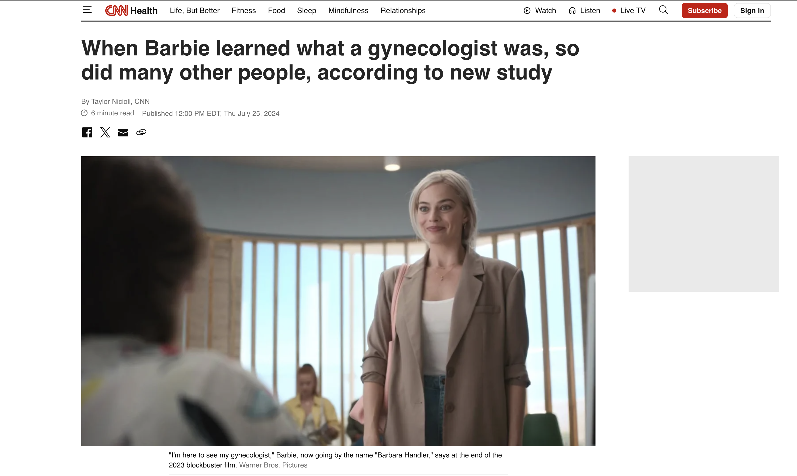  Article #2


Article #3

1. Select your first news headline and write it below (ie., Article 1 or Article 2 or Article 3)
- State your initial, general research question based on the article:
- Research question:
- List and conceptually define all the behaviors/characteristics/concepts/ideas that need to be defined and/or measured to answer your research question.
- Behaviors/characteristics/concepts/ideas:
- Define an grouping/independent and a dependent variable that can be used to test your research question:
- Grouping/Independent Variable:
- Grouping/Independent Variable:
- IV Operationalization:
- IV type (quantitative or qualitative):
- If IV quant (continuous or discrete):
- Dependent Variable:
- Dependent Variable:
- DV Operationalization:
- DV type (quantitative or qualitative):
- If DV quant (continuous or discrete):
- Identify the target population
- Target population:
- Finally, state a research hypothesis that details your expectation/prediction about the relationship between the grouping/independent and dependent variable.
- Research hypothesis:

2. Select your second news headline and write it below (ie., Article 1 or Article 2 or Article 3)
- State your initial, general research question based on the article:
- Research question:
- List and conceptually define all the behaviors/characteristics/concepts/ideas that need to be defined and/or measured to answer your research question.
- Behaviors/characteristics/concepts/ideas:
- Define an grouping/independent and a dependent variable that can be used to test your research question:
- Grouping/Independent Variable:
- Grouping/Independent Variable:
- IV Operationalization:
- IV type (quantitative or qualitative):
- If IV quant (continuous or discrete):
- Dependent Variable:
- Dependent Variable:
- DV Operationalization:
- DV type (quantitative or qualitative):
- If DV quant (continuous or discrete):
- Identify the target population
- Target population:
- Finally, state a research hypothesis that details your expectation/prediction about the relationship between the grouping/independent and dependent variable.
- Research hypothesis:

