For next week’s lab, I’ve (referring Erica DeFrain from UNL Libraries) replaced the library tutorial with four links that I’ve added to the PSYC 350 Library Course Guide (this guide is embedded in the Canvas PSYC 350 site, under the UNL Library Resources navigation link-in the Menu off to the left of the Canvas Course Window- it appears lower for section 250 (below “respondus”), but it’s there). I also have a direct link to this site within the Lab Schedule, so all the materials needed for this lab are still located within the schedule.
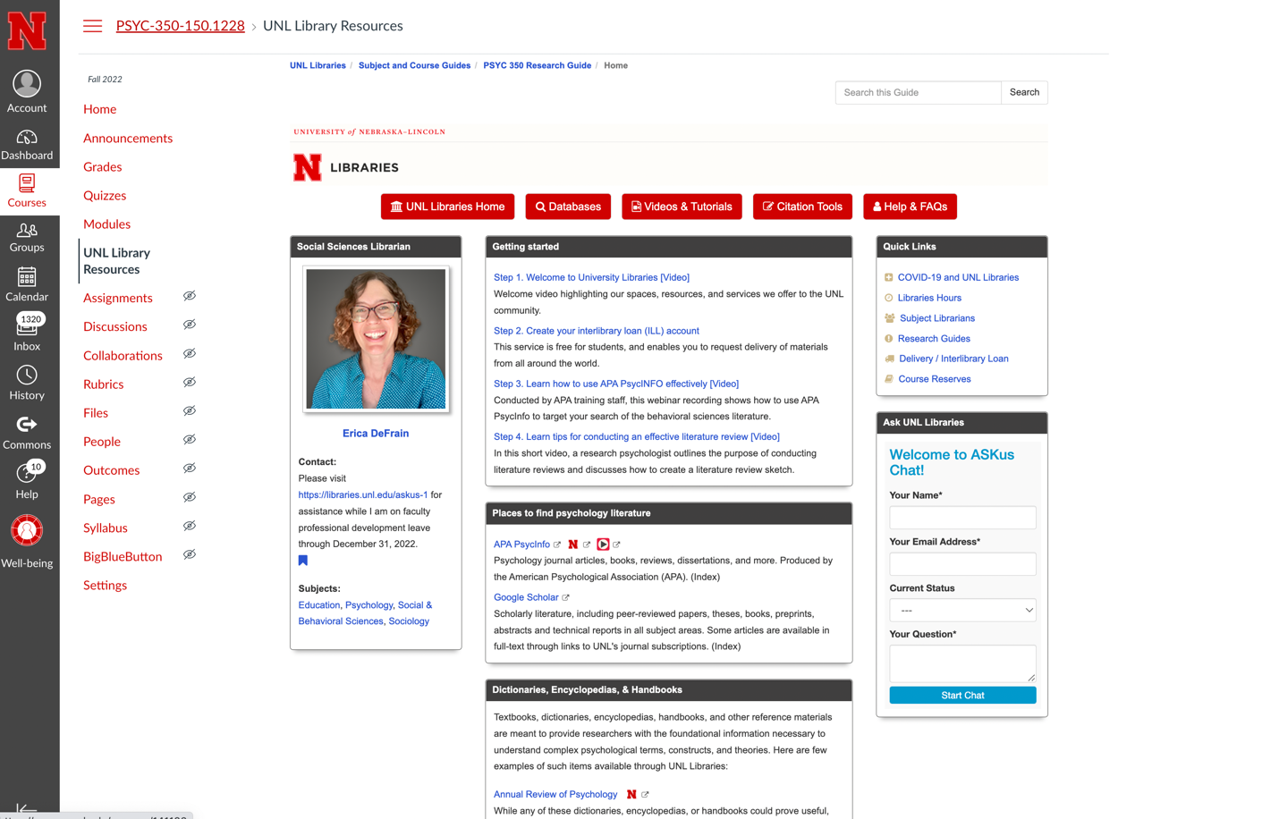

These resources should be more relevant and stable for your students, and work together to provide an introduction to UNL Libraries and give them a better understanding of research tools and skills needed for conducting literature reviews in psychology.

Please ask that your students complete all four steps in the top box as they consider their bibliographic research assignment:
- Step 1. Welcome to University Libraries [Video]
Welcome video highlighting our spaces, resources, and services we offer to the UNL community.
- Step 2. Create your interlibrary loan (ILL) account
This service is free for students, and enables you to request delivery of materials from all around the world.
- Step 3. Learn how to use APA PsycINFO effectively [Video]
Conducted by APA training staff, this recording shows how to use APA PsycInfo to target your search of the behavioral sciences literature.
- Step 4. Learn tips for conducting an effective literature review [Video]
In this short video, a research psychologist outlines the purpose of conducting literature reviews and discusses how to create a literature review sketch.
Note: In order for you to be able to walk students through these links, Erica also made a powerpoint presentation, located here: (I will upload this link into the Lab Schedule so students, and you can access from there during your lab)
https://go.unl.edu/psyc350library
PLEASE GO THROUGH THESE SLIDES BEFORE WE MEET ON TUESDAY AND BRING QUESTIONS!
We’ll cover lab 2 (this lab) and lab 3 next Tuesday.

