Essential spectrum of Y-branched chain of rings in magnetic field
P.I.Smirnov, I.Yu.Popov
St. Petersburg National Research University of Information Technologies, Mechanics and Optics, Kronverkskiy, 49, St. Petersburg, 197101, Russia

p.i.smirnov@gmail.com
Abstract. The model we study is a quantum graph presented by Y-branched chain of rings placed in magnetic field. The dependency of essential spectrum of this model from orthogonal magnetic field component is considered.
- Introduction
To date, the quantum graphs have proved to be very useful mathematical model for various nano-systems (see, e.g., [1, 2, 3]). Among them chained graphs gradually gaining popularity as a model for single-layer crystal conductors in particular thanks to the increased interest in graphene. From physical point of view the spectral and transport properties of the system are the most interesting.
In the present paper we consider an infinite straight chain of rings. Namely, we study the dependency of the essential spectrum of the system from the orthogonal component of magnetic field.

Fluid flow in nanostructures attracts great attention last decade due to its unusual properties and possible intriguing applications. At present there is no general theory in nanohydrodynamics (see, e.g., [1] - [4] and references therein). Recently, a model based on crystalline theory of liquid is suggested [5]. There is one interesting task more – how to create a flow inside a nanotube. A possible way is to initialize wall soliton which, in its turn, produce a flow inside the nanotube [6]. In the present paper we apply the crystallite model to this problem.
Namely, we consider soliton induced 3D flow in cylindrical nanotube with the crystallite in its center. The flow is described in the Stokes approximation:
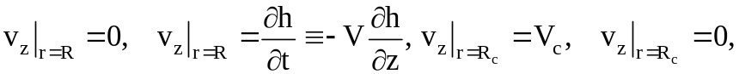
where 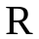 , 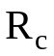 are the nanotube and the crystallite radii , 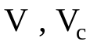 are soliton and crystallite velocities 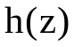 is the soliton profile.
- Flow in nanotube and the crystallite velocity
We present the axisymmetric flow velocity between the nanotube wall and the crystallite using the stream function 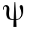 as follows
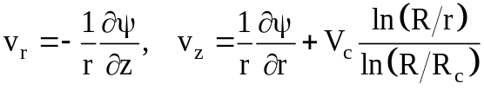 (1)
The flow velocity,and, correspondingly, the stream function are related with the soliton profile:
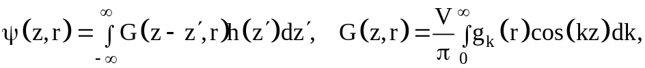 (2)
where
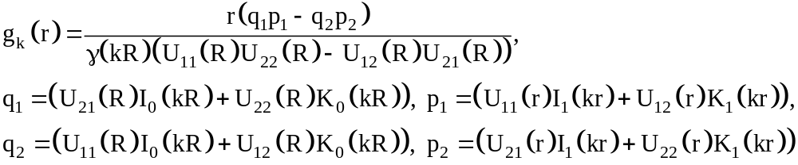
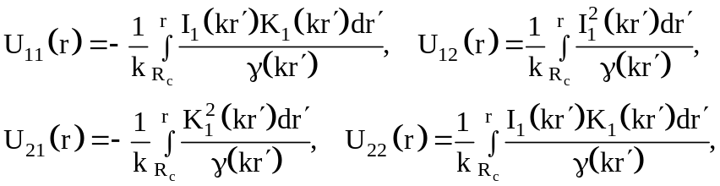
where 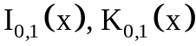 are modified Bessel and Macdonald functions.
To calculate the crystallite speed we consider the condition that the viscous friction force applied to the crystallite, is zero. It gives us
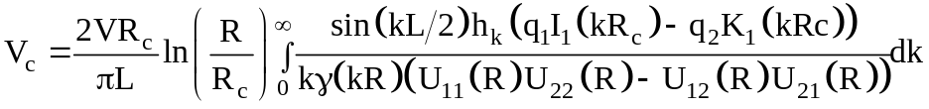
The full stream function is 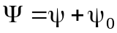, where is determined by equation (2), and 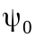 is as follows
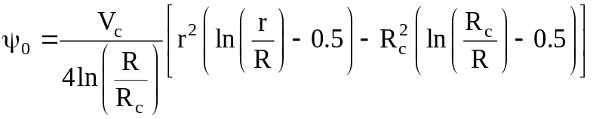.
Thus, the model allows us to describe the mass transport in nanotube. It can be used in studying of nanopumping and chemical nanoreactors.
References
- D.Li (Ed.) Encyclopedia of microfluidics and nanofluidics. New York, Springer, 2008
- T.-D.Li, J.Gao, R.Szoszkeiwicz, U.Landnan, E.Riedo. Phys. Rev. B., 75, 115415/1-6 (2007)
- I.Yu.Popov. Phys. Scripta. 83, 045601/1-3 (2011)
- V.P.Maslov. Theor. Math. Phys. 153 (3), 1677-1696 (2007)
- S.A.Chivilikhin, V.V.Gusarov, I.Yu.Popov, A.I.Svitenkov. Russian J. Math. Phys. 15 (3), 410-412 (2008).
- M.B.Belonenko, S.A.Chivilikhin, I.Yu.Popov, O.A.Rodygina, V.V.Gusarov. EPL, 101, 6, 66001, (2013)

