Introduction
In this homework, you will learn about the LabVIEW programming environment. You will also write a simple Virtual Instrument (VI) to incorporate basic operations in LabVIEW. Finally, you will convert your programs into subVIs.

Objectives
- Learn the three parts of a VI.
- Learn the three palettes.
- Learn how data is passed in LabVIEW.
- Distinguish between controls and indicators on the front panel and block diagram.
- Create a subVI using two different methods.

Theory
LabVIEW Programming Basics

Introduction

LabVIEW is a graphical programming language that uses icons instead of lines of text to create applications. In contrast to text-based programming languages, where instructions determine program execution, LabVIEW uses dataflow programming, where the flow of data determines execution.

In LabVIEW, you build a user interface by using a set of tools and objects.
The user interface is known as the front panel. You then add code using graphical representations of functions to control the front panel objects.
The block diagram contains this code. In some ways, the block diagram resembles a flowchart.

LabVIEW programs are called virtual instruments, or VIs, because their appearance and operation imitate physical instruments, such as oscilloscopes and multimeters. Every VI uses functions that manipulate input from the user interface or other sources and display that information or move it to other files or other computers.

A VI contains the following three components:
• Front panel—Serves as the user interface.
• Block diagram—Contains the graphical source code that defines the functionality of the VI.
• Icon and connector pane—Identifies the VI so that you can use the VI in another VI. A VI within another VI is called a subVI. A subVI corresponds to a subroutine in text-based programming languages.
Front Panel

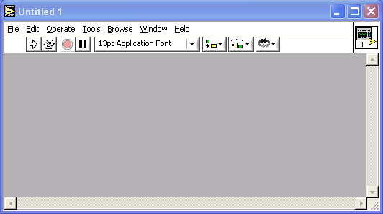

The front panel is the user interface of the VI. You build the front panel with controls and indicators, which are the interactive input and output terminals of the VI, respectively. Controls are knobs, pushbuttons, dials, and other input devices. Indicators are graphs, LEDs, and other displays. Controls simulate instrument input devices and supply data to the block diagram of the VI. Indicators simulate instrument output devices and display data the block diagram acquires or generates.

Block Diagram

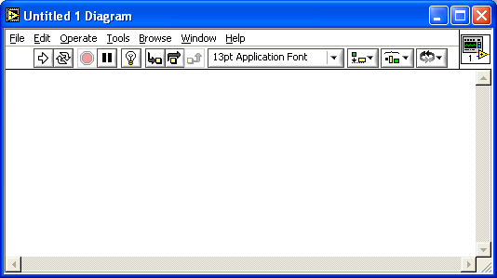

After you build the front panel, you add code using graphical representations of functions to control the front panel objects. The block diagram contains this graphical source code. Front panel objects appear as terminals on the block diagram.

Additionally, the block diagram contains functions and structures from built-in LabVIEW VI libraries. Wires connect each of the nodes on the block diagram, including control and indicator terminals, functions, and structures.

LabVIEW Palettes

LabVIEW palettes give you the options you need to create and edit the front panel and block diagram.

The Tools palette is available on the front panel and the block diagram.
A tool is a special operating mode of the mouse cursor. When you select a tool, the cursor icon changes to the tool icon. Use the tools to operate and modify front panel and block diagram objects.

Select Window»Show Tools Palette to display the Tools palette. You can place the Tools palette anywhere on the screen.

If automatic tool selection is enabled and you move the cursor over objects on the front panel or block diagram, LabVIEW automatically selects the corresponding tool from the Tools palette.

The Controls palette is available only on the front panel. The Controls palette contains the controls and indicators you use to create the front panel. Select Window»Show Controls Palette or right-click the front panel workspace to display the Controls palette. You can place the Controls palette anywhere on the screen.

The Functions palette is available only on the block diagram. The Functions palette contains the VIs and functions you use to build the block diagram. Select Window»Show Functions Palette or right-click the block diagram workspace to display the Functions palette. You can place the Functions palette anywhere on the screen.

Dataflow Programming

LabVIEW follows a dataflow model for running VIs. A block diagram node executes when all its inputs are available. When a node completes execution, it supplies data to its output terminals and passes the output data to the next node in the dataflow path.

Creating SubVIs

Introduction

After you build a VI and create its icon and connector pane, you can use it in another VI. A VI called from the block diagram of another VI is called a subVI. A subVI corresponds to a subroutine in text-based programming languages. A subVI node corresponds to a subroutine call in text-based programming languages. The node is not the subVI itself, just as a subroutine call statement in a program is not the subroutine itself.

Setting up the Connector Pane

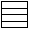

To use a VI as a subVI, you need to build a connector pane. The connector pane is a set of terminals that corresponds to the controls and indicators of that VI, similar to the parameter list of a function call in text-based programming languages. The connector pane defines the inputs and outputs you can wire to the VI so you can use it as a subVI.

Define connections by assigning a front panel control or indicator to each of the connector pane terminals. To define a connector pane, right-click the icon in the upper right corner of the front panel window and select Show Connector from the shortcut menu. The connector pane replaces the icon. Each rectangle on the connector pane represents a terminal. Use the rectangles to assign inputs and outputs. The number of terminals LabVIEW displays on the connector pane depends on the number of controls and indicators on the front panel.

The connector pane has, at most, 28 terminals. If your front panel contains more than 28 controls and indicators that you want to use programmatically, group some of them into a cluster and assign the cluster to a terminal on the connector pane.

Select a different terminal pattern for a VI by right-clicking the connector pane and selecting Patterns from the shortcut menu. Select a connector pane pattern with extra terminals. You can leave the extra terminals unconnected until you need them. This flexibility enables you to make changes with minimal effect on the hierarchy of the VIs.

If you create a group of subVIs that you use together often, give the subVIs a consistent connector pane with common inputs in the same location to help you remember where to locate each input. If you create a subVI that produces an output another subVI uses as the input, align the input and output connections to simplify the wiring patterns. Place the error in clusters on the lower left corner of the front panel and the error out clusters on the lower right corner.

Setting Required, Recommended, and Optional Inputs and Outputs

You can designate which inputs and outputs are required, recommended, and optional to prevent users from forgetting to wire subVI connections.

Right-click a terminal in the connector pane and select This Connection Is from the shortcut menu. A checkmark indicates the terminal setting. Select Required, Recommended, or Optional.

For terminal inputs, required means that the block diagram on which the
subVI is dropped will be broken if the required inputs are not wired.
Required is not available for terminal outputs. For terminal inputs and outputs, recommended means that the block diagram on which the subVI is dropped can be run if the input is not wired but the Warnings dialog box will generate a warning that the input has not been wired. Optional means that the block diagram on which the subVI is dropped can be run and will not generate any warnings if the terminal input or output is not wired.

Inputs and outputs of VIs in vi.lib are already marked as Required, Recommended, or Optional. LabVIEW sets inputs and outputs of VIs you create to Recommended by default. Set a terminal setting to required only if the VI must have the input or output to run properly.

In the Context Help window, required connections are bold, recommended connections are plain text, and optional connections are dimmed if you have the Detailed view selected or do not appear if you have the Simple view selected.

Creating an Icon

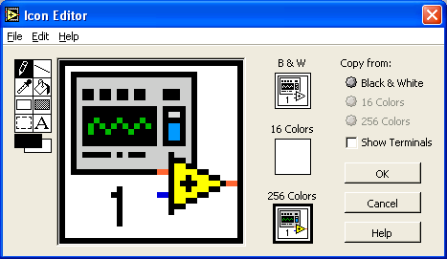

Every VI displays an icon in the upper right corner of the front panel and block diagram windows. An icon is a graphical representation of a VI. It can contain text, images, or a combination of both. If you use a VI as a subVI, the icon identifies the subVI on the block diagram of the VI.

The default icon contains a number that indicates how many new VIs you have opened since launching LabVIEW. Create custom icons to replace the default icon by right-clicking the icon in the upper right corner of the front panel or block diagram and selecting Edit Icon from the shortcut menu or by double-clicking the icon in the upper right corner of the front panel.

You also can drag a graphic from anywhere in your file system and drop it in the upper right corner of the front panel or block diagram. LabVIEW converts the graphic to a 32 X 32 pixel icon.

Depending on the type of monitor you use, you can design a separate icon for monochrome, 16-color, and 256-color mode. LabVIEW uses the monochrome icon for printing unless you have a color printer.

Creating SubVIs from Sections of a VI

Convert a section of a VI into a subVI by using the Positioning tool to select the section of the block diagram you want to reuse and selecting Edit»Create SubVI. An icon for the new subVI replaces the selected section of the block diagram. LabVIEW creates controls and indicators for the new subVI and wires the subVI to the existing wires.

Creating a subVI from a selection is convenient but still requires careful planning to create a logical hierarchy of VIs. Consider which objects to include in the selection and avoid changing the functionality of the resulting VI.

1. What is a VI? What are the three main parts of a VI? Briefly describe each.

2. What are the three palettes? Briefly describe each.

3. How is data passed in LabVIEW?

4. How can you tell the difference between controls and indicators on the front panel? On the block diagram?

5. Explain the two methods of creating a subVI.

6. What are the differences between a For Loop and a While Loop?

7. How is data transferred between iterations of a loop?

