Laboratory Goals

 How to use the 4511 7-segment decoder/display driver IC
 Gain familiarity with the BCD code
 How to use 7-segment LED assemblies to create decimal digit displays
 Use combinational logic for problem solving in circuits

Pre-lab reading
 4511 data sheet (http://ecelabs.pbwiki.com/ECE-321-Labs#pbedit)
 Logic and Computer Design Fundamentals by Morris M. Mano and Charles R.
Kime.

Equipment needed

 Lab notebook, pen
 Prototyping board
 Anti-Static mat
 Logic Probe (obtain one or make your own from wire)

Parts needed
 Lab parts kit
 4511 CMOS BCD to 7-segment display driver (x2)
 3211 7-segment display (x2)
 10kΩ resister (x6)
 390Ω resister (x14)
❑ 7408 2-input AND IC (To be determined)
 7402 2-input NOR IC (To be determined)
❑ 7404 inverter (To be determined)
- 7432 2-input OR IC (To be determined)
- 7400 2-Input NAND IC (To be determined)

Laboratory Safety Concerns

 Make sure all circuit connections are correct, and no shorted wires exist.
 Be sure that the power is off while constructing and designing circuit
 Be sure to do all work over Anti-Static Mat (the 4511 display driver is a
CMOS integrated circuit and therefore sensitive to static electricity

1. Pre-Lab Calculation and Design

1) In your laboratory notebook, draw and complete a table that displays BCD and decimal values from 0000 to 1010.

2) In the following circuit, what values must inputs A,B,C and D so that input E will be the output?

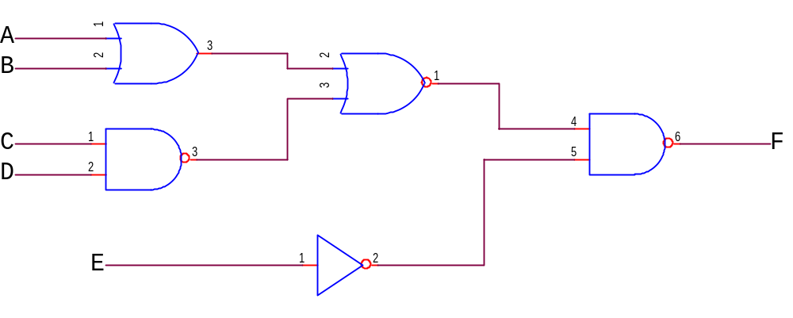

3) If you have a 3-bit binary counter that will generate input values 0-7, show the reduced product of sums expression when F=1 for values 2,5,7.

4) A. Draw the NAND/NOR representation of the previous problem
B. Draw the CMOS representation of the previous problem

2. Circuit Construction and Testing

The 7-segment display is a very common electrical component and the 4511 decoder is a good example of a typical driver IC. Use the data sheets to determine where the inputs and outputs of the driver are located. The BCD inputs are designated A, B, C, and D in order from least significant to most significant. Outputs are labeled a, b, c, d, e, f, and g, each letter corresponding to a standardized segment designation for 7-segment displays.

Be sure the input signals have a corresponding 10kΩ resister tied to ground. (see Figure 1 below). The DIP switch shown in Figure 1 may not fit properly in your breadboard and is not required.

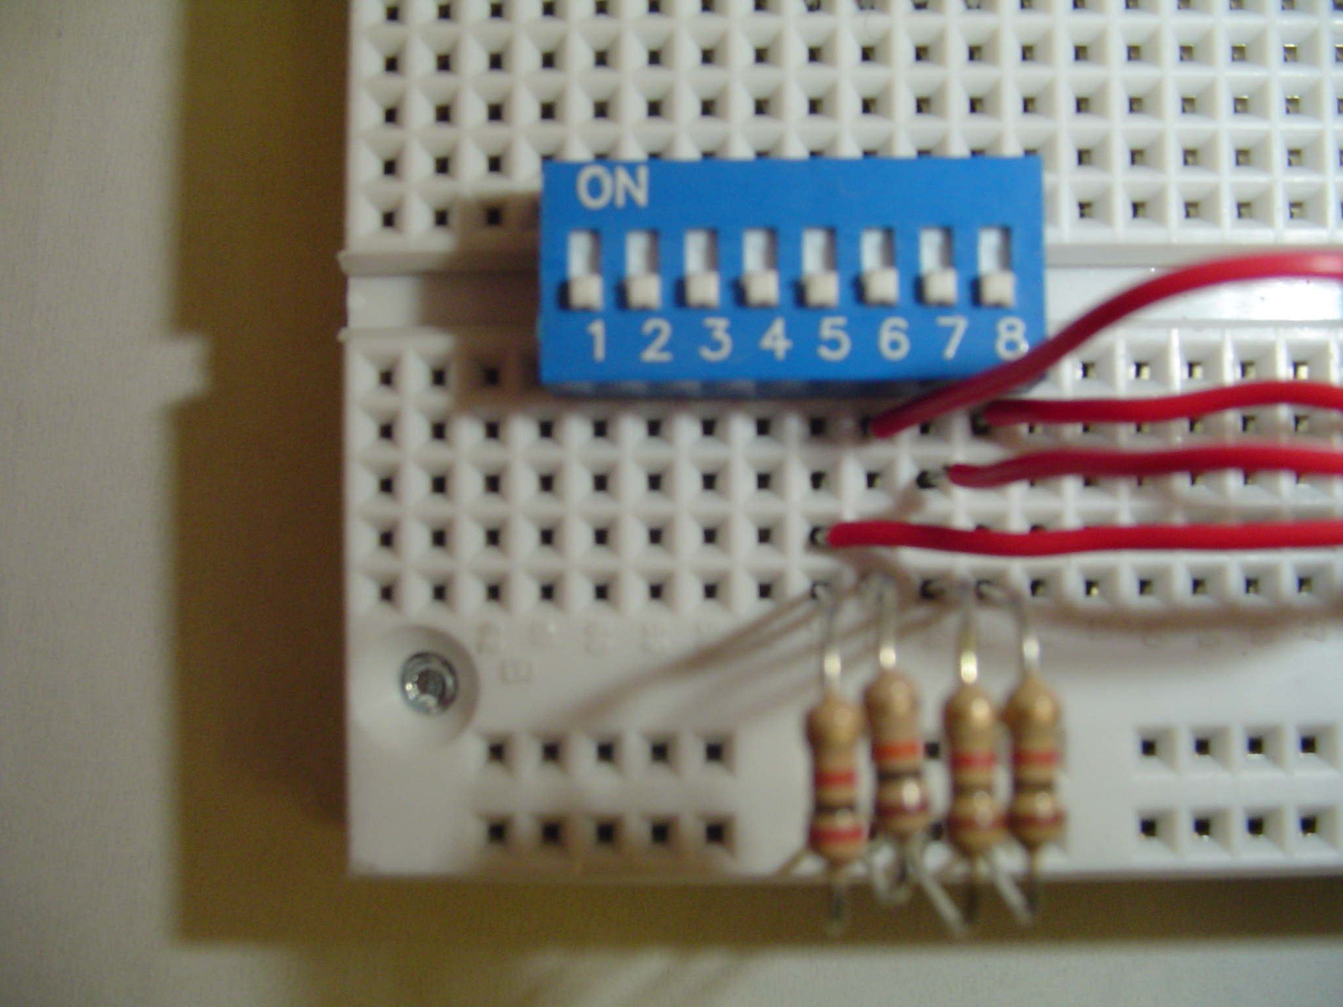
Figure 1

Using the datasheet, determine the pins on the 7-segment display, which will correspond with the outputs given by the driver. Remember, each LED segment requires its own dropping resistor, we must use seven 390Ω resistors placed in series between the 4511's output terminals and the corresponding terminals of the display unit.

After building the circuit and applying power, operate the four switches in a binary counting sequence (0000 to 1001), noting the 7-segment display. A 0000 input should result in a decimal "0" display, a 0001 input should result in a decimal "1" display, and so on.

Demonstrate your working circuit to your laboratory TA.

What happens with inputs 1010? Record in your laboratory notebook.

(Hint: Apply voltage to the lamp test and blanking pins. Ground the Latch/strobe enable pin.)

3. Circuit Implementation

Devise a method for displaying the decimal value of 10 on two 7-segment displays, while using the 4511 decoder/driver. You may use NAND, NOR, AND, OR and Inverter gates to help you. You may use, but are NOT limited to the parts listed above.

Demonstrate your circuit and results to your lab TA.

Before leaving the lab, take a few minutes to make sure all equipment and test leads are returned to your cabinet, and that you have cleaned up your work space.

4. Analysis

- Write a summary report for this lab. Be sure to also include the following topics:

- In the data sheet for the 4511 driver, there are specified for Lamp Test, Blanking and Latch enable. What are some possible uses for these functions?

- What is a possible method for displaying digits 1-16?

- Explain any difficulties you had with this lab.
(Please include suggestions to improve the lab, if you have them).

