Laboratory Goals

- Introduce students to the PMOS transistor
- Familiarize students with the PMOS characteristics
- Use the curve tracer to verify the IV curve

Pre-lab / lab reading

- Course Textbook
- Oscilloscope User’s Guides (Copies of these reference books are available in the lab, or at the website)
- Tektronics 571 Curve Tracer Manual
- BS 250 Transistor Data Sheet (http://ecelabs.pbwiki.com/ECE-321-Labs)

Equipment needed

- Lab notebook, pencil
- Oscilloscope (Agilent or Tektronics)
- 2 oscilloscope probes (already attached to the oscilloscope)
- BNC/EZ Hook test leads
- Tektronics 571 Curve Tracer
- PB-503 Proto-Board
- Workstation PC, with PSICE application

Parts needed

- Circuit breadboard
- Resistors
- 1 BS250 PMOS Transistor
- ECE 206 Parts kit

Lab safety concerns

- Make sure before you apply an input signal to a circuit, all connections are correct, and no shorted wires exist.
- Do not short the function generator signal and ground connections together
- Do not touch the circuit wiring while power is applied to it
- Ensure you connect the correct terminal of the transistor to prevent blowing the transistor

1. Pre-Lab Calculations

In this PMOS transistor, calculate I_{d}, V_{GS} and V_{DS} if Kp= -.111806 A/V², and W/L =1,
V_{TP}=-1V.
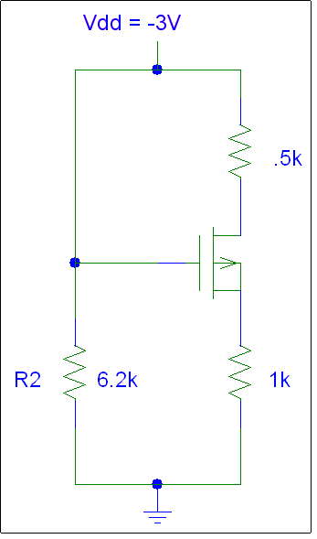
Figure 1: PMOS Circuit

- Create the following table in your lab notebook:

Element | Measured Resistance | Current | Voltage
R2 |  |  | N/A
Rs |  |  | N/A
Rd |  |  | N/A
Vg | N/A | N/A
V_{ds} | N/A | N/A
V_{gs} | N/A | N/A

2. Circuit Construction and Signal Measurement

- Build the circuit shown above in Figure 1 using a transistor provided by your teaching assistant and available resistors
- Read the transistor data sheet to identify which pins correspond to the source, drain, and gate
- Analyze all node voltages and currents completing the chart created in the pre-lab
- Using the Oscilloscope, generate an IV curve for the circuit
- In your lab notebook accurately graph the IV curve
- When all measurements are complete, turn the equipment off
- Disconnect the test leads from the circuit

3. Curve Tracer

- Use the Tektronics Curve tracer to verify the IV curve produced by the transistor
- The Teaching Assistant will verify the produced curve and sign your lab notebook

4. SPICE Simulation

- Perform a SPICE simulation of the circuit shown in Figure 1
- Print out the source code and node voltages of the simulation to include in your lab report

Before leaving the lab, take a few minutes to clean up your workstation, and return all equipment to your cabinet.

5. Analysis

Write a brief summary report for the lab. Be sure to also include the following topics:

Draw a PMOS diagram including the channel, body, gate, drain, source, etc.

Identify and explain the operating regions of the IV curve generated for the transistor.

Compare and contrast the results of the hand computation, physical experiment, SPICE simulation and curve tracer output graph. Do the values generally agree? Explain possible reasons for any differences in the data.

Having completed both the introduction to NMOS and PMOS characteristics, compare and contrast the similarities and differences between the two.

Explain any difficulties you had with these labs. (Please include any suggestions to improve them).

