ECE 439 – Introduction to Digital Signal Processing
Exam 1 Take Home – October 24, 2013
Due date October 29, 2013 during class

Yes calculators, smart and dumb phones, tablets, laptops, and consultants are acceptable!!!!!

IN-CLASS and ON-LINE STUDENTS:
- Place your write-ups and MATLAB code in a directory called name-lastname-EXAM1. Write-ups in PDF format; include this page with your name and signature. Then ZIP the directory name-lastname-EXAM1.zip and email to me rjordan@ece.unm.edu and Eric Hamke ehamke@unm.edu by 9:15am October 29 of this year!!!!!! If you developed an 8x11 cheat sheet please include it.
Please sign the following agreement: I acknowledge that if I do not follow instructions I will not receive any credit.
NAME:____________________________________
Signature: ___________________________________

Total Points = 200
READ, READ, READ!!!!!!!!!!!!!!!!!
If you do not follow instructions you will not receive ANY credit!!!!!

Paint/draw your work; please make your writing legible; show step-by-step your solution in an orderly manner; all work must be shown.

SHOW YOUR WORK AND CHECK YOUR WORK!!!!
Use MATLAB to verify your results.

Problem 1: [15 points] Given the sequence x(n) = {-3,-2,1,0,-5,6,7,-4}; and x(n=0) = 0
- Plot the sequence
- Find its DTFT
- Find its ZT and ROC
Problem 2: [10 points] Determine if the systems y(n) are linear and shift-invariant
- y(n) = L[x(n)] = x(n+2) – x(2-n)
- y(n) = L[x(n)] = -2x(n-2) + 7
Problem 3: [10 points] Given h(n) and x(n) find the output y(n) = h(n) * x(n). Where
h(n) = {1,0,1,0,1} and x(n) = {0,2,0,3,0,5,0}
Problem 4: [10 points] Solve the difference equation using the Residue Theorem
y(n) + a²y(n-2) = 0 for n>=0; |a| < 1; y(-1) = 0 and y(-2) = -1
Problem 5: [10 points] Given h(n) and x(n) find the output y(n) = h(n) * x(n). Where
h(n) = {1,0,1,0,1} and x(n) = {0,2,0,3,0,5,0}; in red h(n=0) and x(n=0)
Problem 6: [10 points] Given x(n) = (0.85e^{jpi/3})^{n} , -10<= n <= 10 find X(e^{jw}) and investigate the periodicity and conjugate-symmetry properties.
Problem 7: [10 points] Given x(n) = (0.8)^{n} , 0<= n <= 10 find X(e^{jw}) and investigate the periodicity and conjugate-symmetry properties.
Problem 8: [10 points] The analog signal x_{a}(t) = 5 + 2cos(200πt + π/3) – 3sin(400πt) is sample at F_{s} = 300 samples/second to obtain the discrete-time signal x(n). Determine x(n) and its corresponding DTFT X(e^{jw}).
Problem 9: [10 points] Find the IZT of X(z) and specify the ROCs.
X(z) = z/(3z²-4z + 1)
Problem 10: [15 points] Given the causal system H(z)
H(z) = (z+1) / (z² - 0.9z + 0.81), find
- its transfer function representation,
- its difference equation representation, and
- its impulse response representation.
Problem 11: [10 points] Given x(n) = {-1, 0, 2, 3}; and x(n=0) = -1
- compute its DTFT X(e^{jw})
- sample X(e^{jw}) at kw₁ = 2πk/4, k = 0,1,2,3 and show that is equal to X~(k) which is the DFS of x~(n)
Problem 12: [10 points] Demonstrate the difference between the high-density spectrum and the high-resolution spectrum of a sequence x(n), consider the sequence x(n) = cos(0.48πn) – cos(0.52πn). Want to determine its spectrum based on the finite number of samples.
- find and plot the DTFT of x(n), 0 <= n <= 10, and
- find and plot the DTFT of x(n), 0 <= n <= 100.
Problem 13: [10 points] Explain the difference between circular and linear convolution. How do we make circular convolution to be identical to linear convolution.
Problem 14: [15 points] Find the FT of the following aperiodic CT signal.
- find and plot the magnitude spectra,
- find and plot the phase spectra, and
- demonstrate Parseval’s theorem to find the distribution of power of x(t).
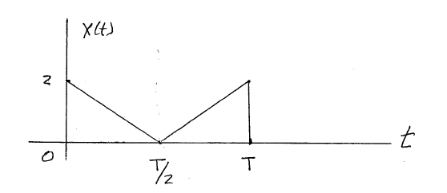
Problem 15: [15 points] Find the FS (Complex Form) of the following periodic CT signal.
- find and plot the magnitude spectra,
- find and plot the phase spectra, and
- demonstrate Parseval’s theorem to find the distribution of power of x(t).
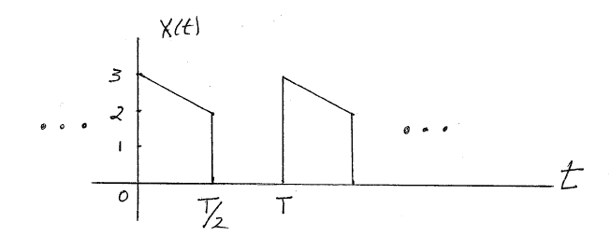
Problem 16: [10 points] What is the connection/relationship between the FT and FS?
Problem 17: [10 points] What is aliasing and give an example to demonstrate its effects.
Problem 18: [10 points] Draw a digital picture of the instructor and TA.

