

**DEPARTMENT OF MATHEMATICS**

**PROJECT RECORD**

**ON**

**SUBSCRIBER GALORE: EXPLORING WORLD’S TOP YOUTUBE CHANNELS**

* **FUNDAMENTAL OF DATA ANALYTICS WITH TABLEAU**

**2023-2024**

**TAMILNADU SKILL DEVELOPMENT CORPORATION, GOVERNMENT OF TAMILNADU,**

**NAAN MUDHALVAN PROGRAM**

**Submitted**

**By**

**1.DHARSHINI.K (222106813)**

**2.ABITHA.M (222106815)**

**3. REVATHY.D (222106825)**

**4.TAMILSELVI.V (222106829)**

**(III B.Sc MATHEMATICS)**

**CERTIFICATE**

THIS IS TO CERTIFY THAT THE PROJECT IS TITLED **UNEARTHING THE ENVIRONMENTAL IMPACT OF HUMAN ACTIVITY: A GLOBAL CO2 EMISSION ANALYSIS- FUNDAMENTALS OF DATA ANALYTICS WITH TABLEAU.**

THIS PROJECT IS SUBMITTED BY DHARSHINI.K(222106813), ABITH.M(222106815),REVATHY.D(222106825),TAMILSELV.V(222106829) OF III B.SC MATHEMATICS, Dr.MGR JANAKI COLLEGE OF ARTS AND SCIENCE FOR WOMEN, CHENNAI IN FULFILLMENT OF THE REQUIREMENTS FOR **TAMILNADU SKILL DEVELOPMENT CORPORATION, GOVERNMENT OF TAMILNADU,NAAN MUDHALVAN PROGRAM**. THIS PROJECT WAS AN AUTHENTIC WORK DONE BY HIM UNDER MY SUPERVISION AND GUIDANCE.

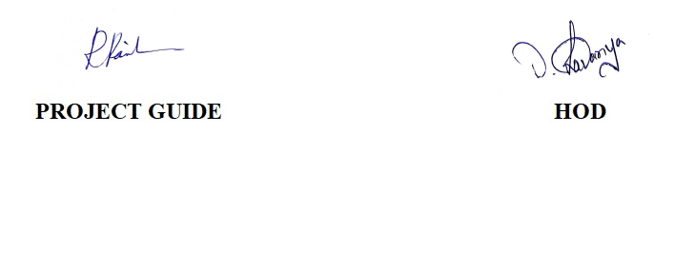

**TABLE OF CONTENTS**

|  |  |  |
| --- | --- | --- |
| **S.NO** | **CONTENTS** | **PAGE NO** |
| **1** | **INTRODUCTION** | 2 |
|  | 1.1 OVERVIEW | 2 |
|  | 1.2 PURPOSE | 2 |
| **2** | **PROBLEM DEFINITION & DESIGN THINKING** | 3 |
|  | 2.1 EMPATHY MAP | 3 |
|  | 2.2 IDEATION & BRAINSTORMING MAP | 4 |
| **3** | **RESULT** | 5 |
| **4** | **ADVANTAGES & DISADVANTAGES** | 7 |
| **5** | **APPLICATIONS** | 7 |
| **6** | **CONCLUSION** | 8 |
| **7** | **FUTURE SCOPE** | 9 |
| **8** | **REFERENCE** | 9 |
| **9** | **VIDEO LINK** | 10 |

**ACTIVITY: SUBSCRIBER GALORE: EXPLORING WORLD’S TOP YOUTUBE CHANNELS**

**1.INTRODUCTION:**

* 1. **OVERVIEW**

**About the report:**

A subscriber to a channel on the video-sharing YouTube is a user who has chosen to receive the channel’s content by clicking on that channel’s “Subscribe” button, and each user’s subscription feed consists of videos published by channels to which the user is subscribed. The ability to subscribe to users was introduced in October 2005. YouTube began publishing a list of its most- subscribed channels in April 2006. An early archive of the list dates to May 2006.

Automatically generated channels that lack their own videos (such as Music and News) and channels that have been made effectively obsolete as a result of the transferal of their content (such as Justin Bieber VEVO and Taylor Swift VEVO) are excluded.

**1.2 PURPOSE:**

The purpose of YouTube is to provide a platform where users can upload, share, and watch videos. The platform was founded in 2005 with the goal of making it easy for people to share videos with one another, and it has since become one of the most popular websites in the world.

YouTube allows users to upload a wide range of video content, including music videos, movie trailers, educational videos, comedy skits, and more. Users can watch these videos for free, and they can also upload their own videos and share them with others. In addition to providing a space for users to watch and share videos, YouTube also serves as a platform for businesses, organizations, and individuals to promote their products, services, and ideas.

**2.PROBLEM DEFINITION & DESIGN THINKING :**

**2.1 EMPATHY MAP:**

An empathy map is a collaborative tool teams can use to gain a deeper insight into their customers. Much like a user persona, an empathy map can represent a group of users, such as a customer segment. The empathy map was originally created by Dave Gray and has gained much popularity within the agile community Assemble your team and have them bring any personas, data, or insights about the target of your empathy map. Print out or sketch the empathy map template on a large piece of paper or whiteboard. Hand each team member sticky notes and a marker. Each person should write down their thoughts on stickier. Ideally everyone would add at least one sticky to every section. You might ask questions, such as:

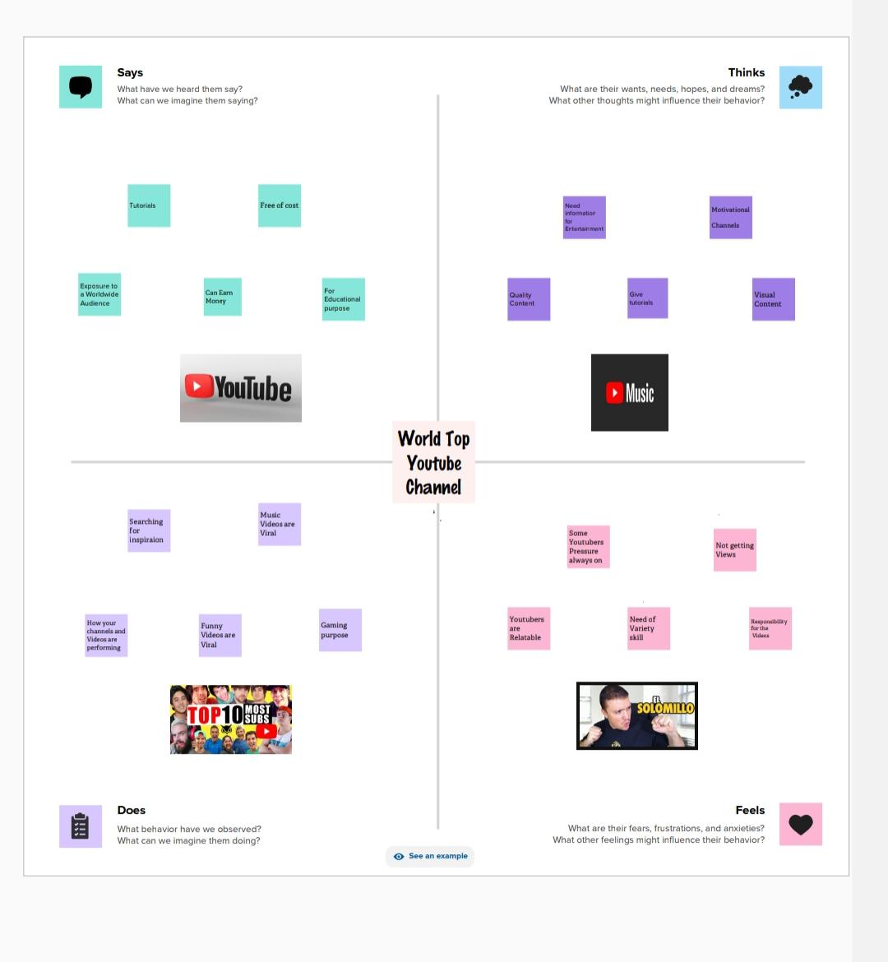

**2.2 IDEATION & BRAINSTORMING MAP:**

Brainstorming is a method of generating ideas and sharing knowledge to solve a particular commercial or technical problem, in which participants are encouraged to think without interruption. Brainstorming is a group activity where each participant shares their ideas as soon as they come to mind. At the conclusion of the session, ideas are categorized and ranked for follow-on action.When planning a brainstorming session it is important to define clearly the topic to be addressed. A topic which is too specific can constrict thinking, while an ill-defined topic will not generate enough directly applicable ideas. The composition of the brainstorming group is Important too. It should include people linked directly with the subject as well as those who can contribute novel and unexpected ideas. It can comprise staff from inside or outside the organization.

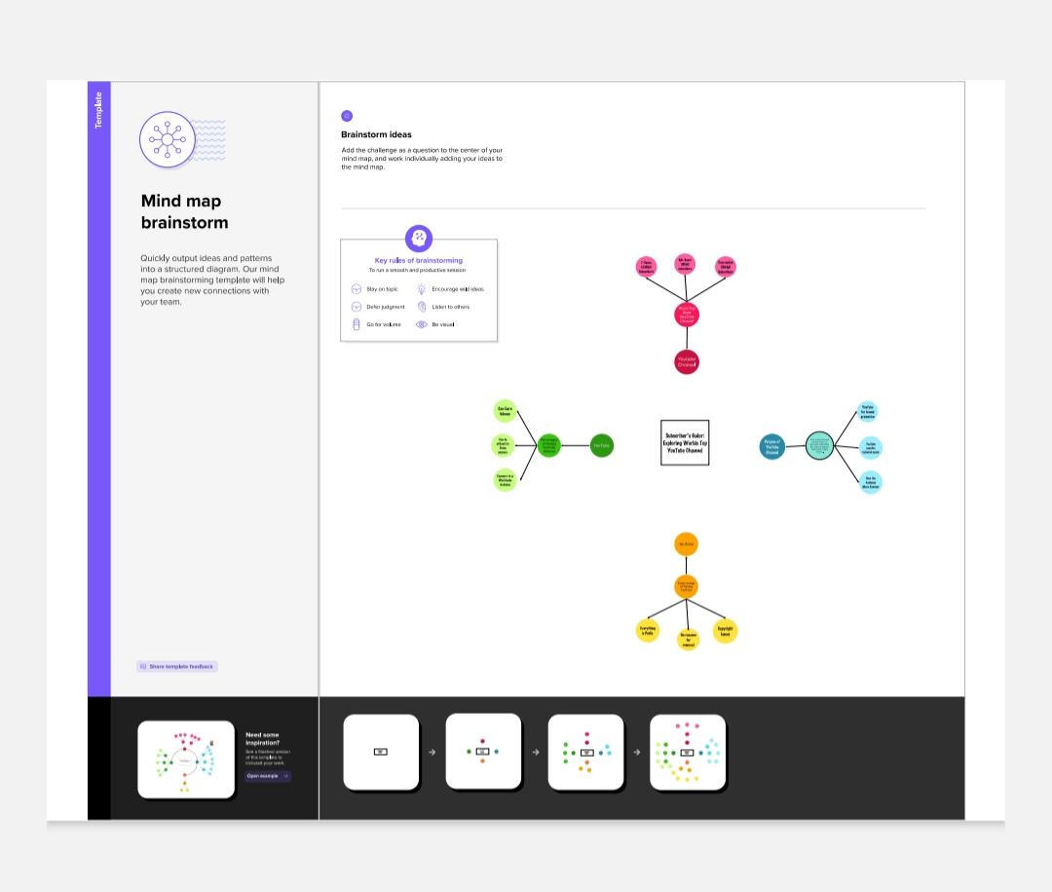

**3.RESULT:**

**DASHBOARDS:**

**Brand and Ranks YouTube channel**

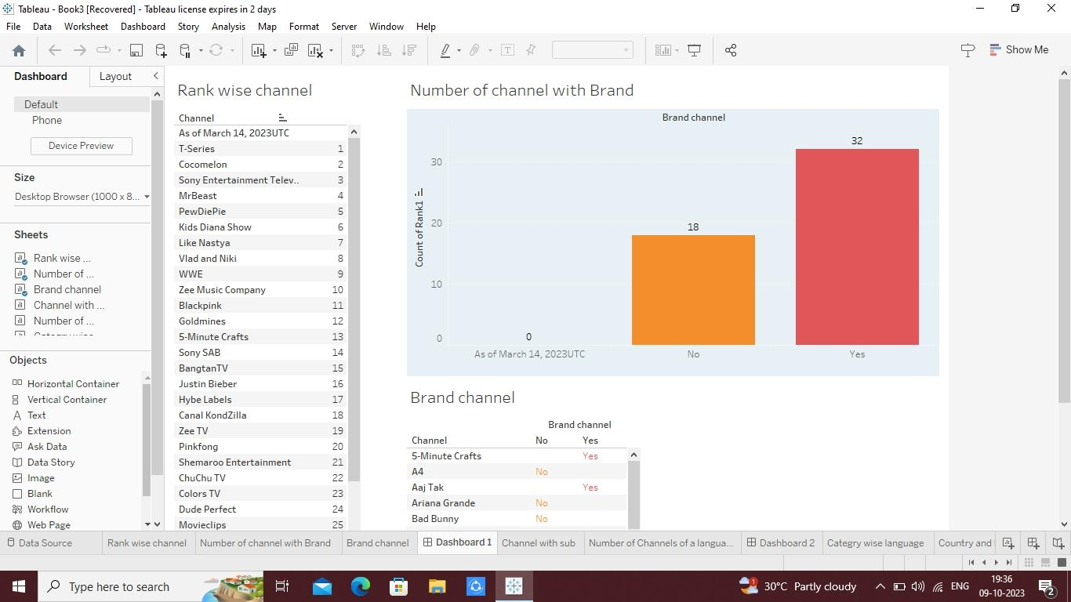

**CHANNELS OF LANGUAGE AND SUBSCRIBER:**

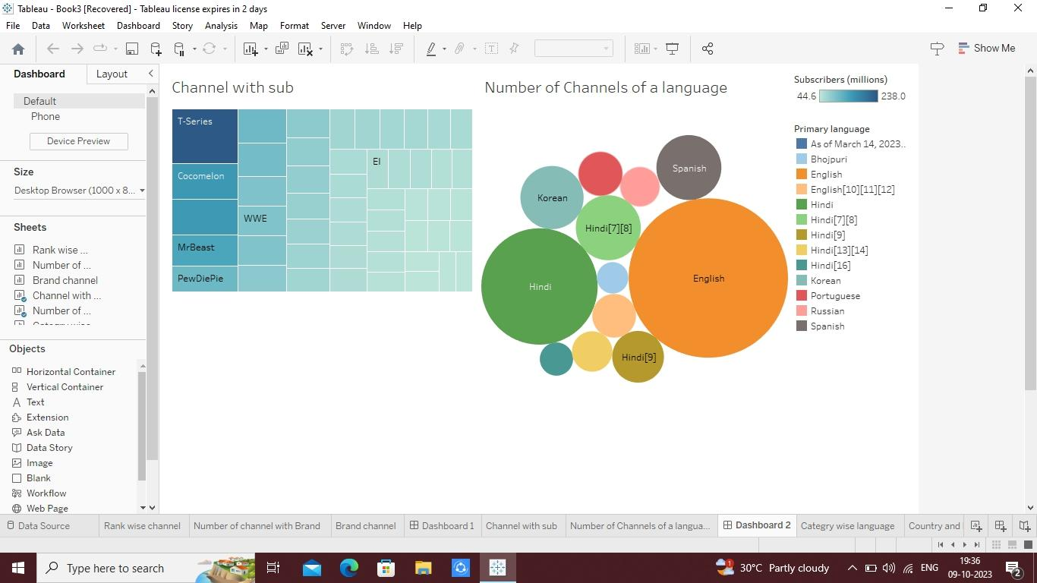

**COUNTRY AND LANGUAGES:**

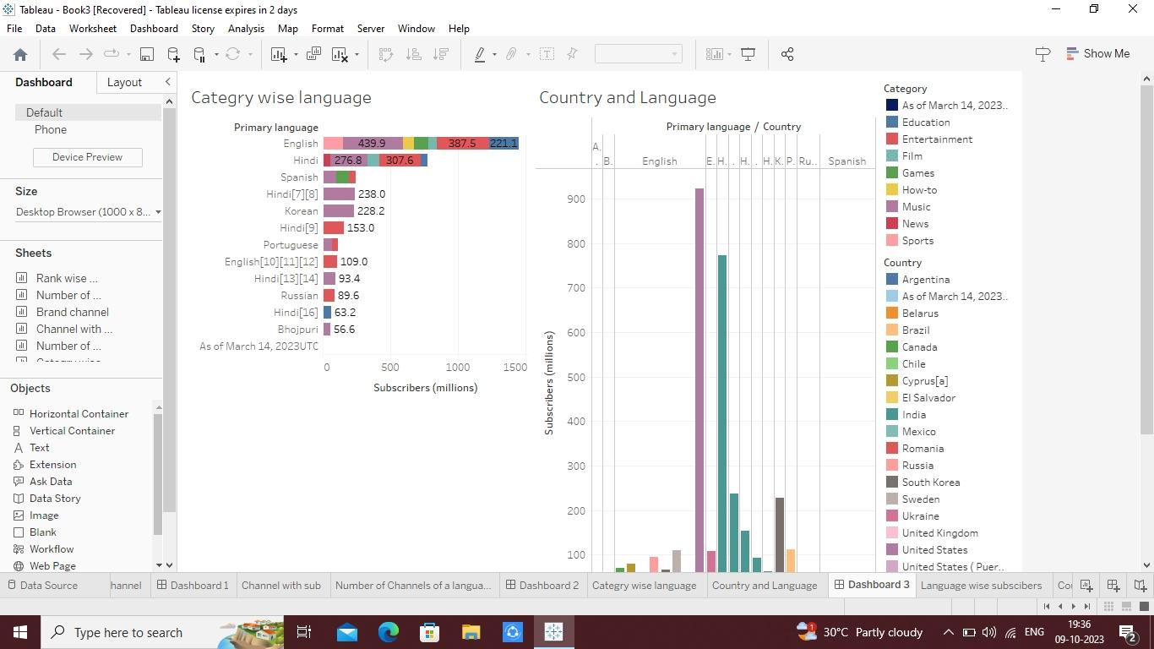

**COUNTRY AND LANGUAGE SUBSCRIBERS:**

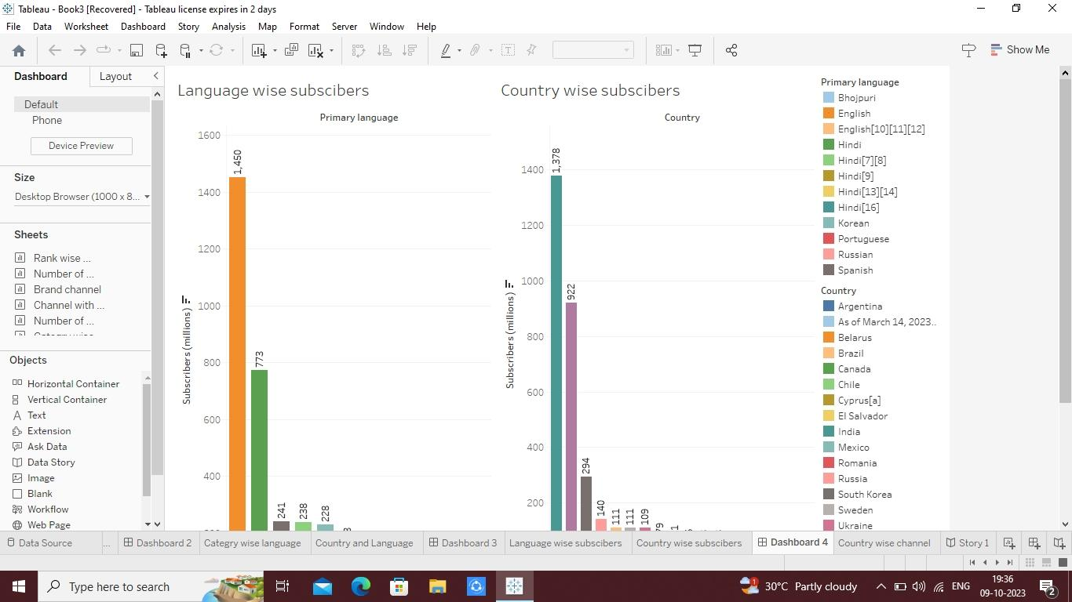

**STORY :**

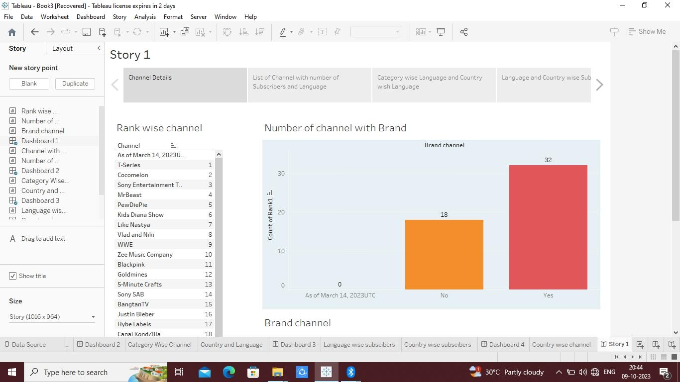

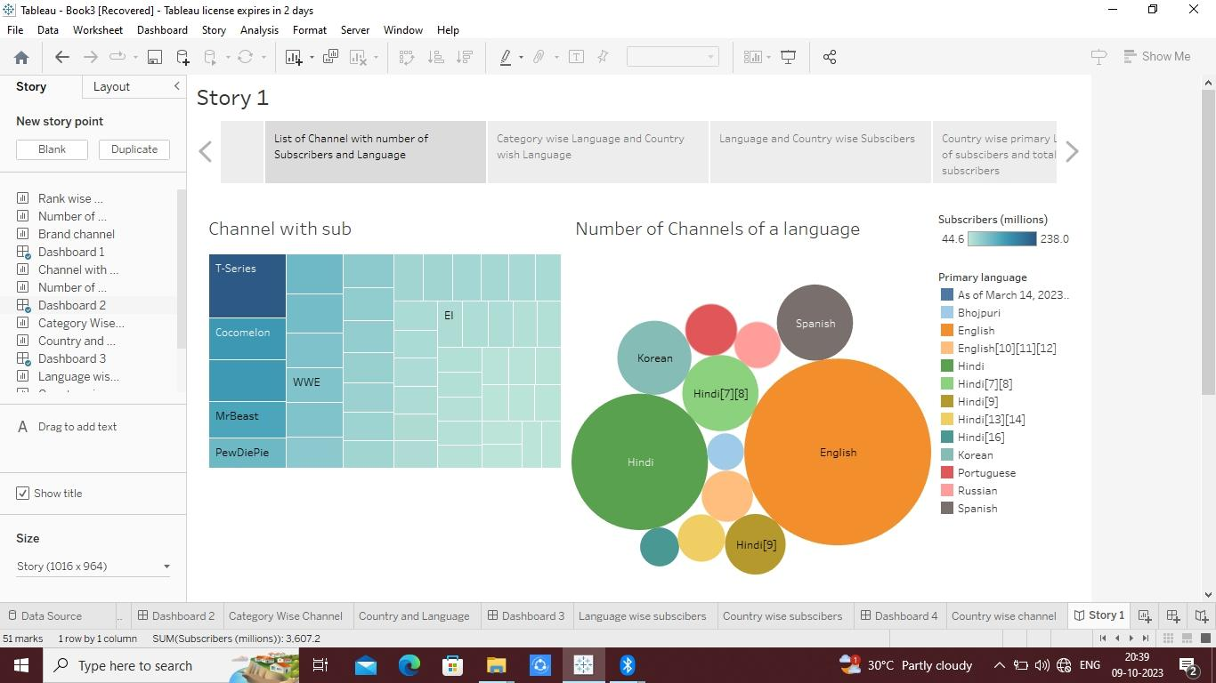

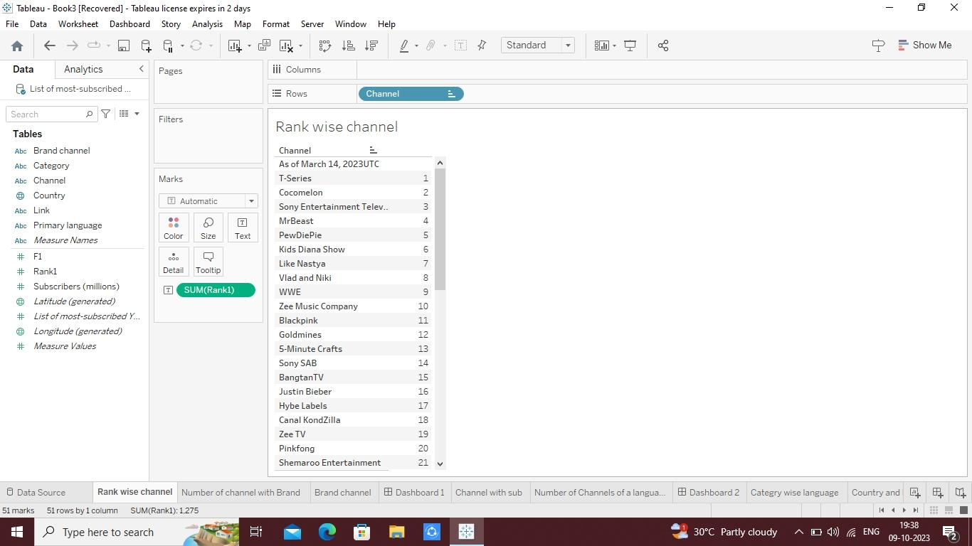

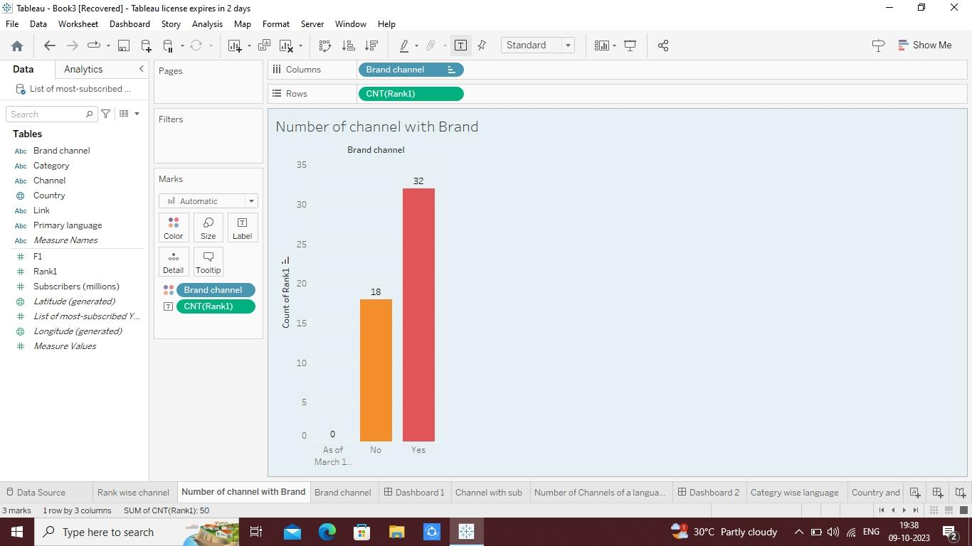

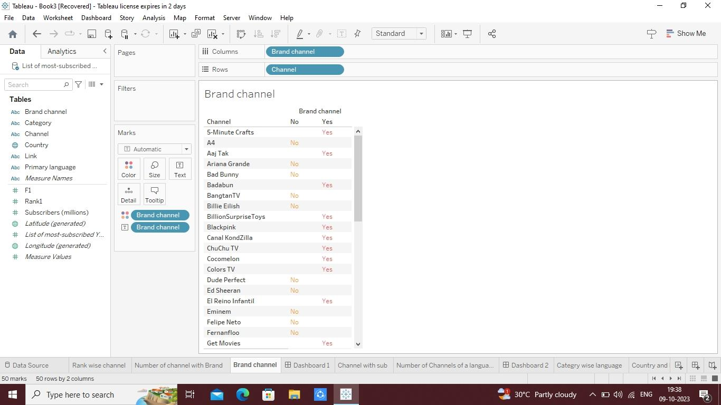

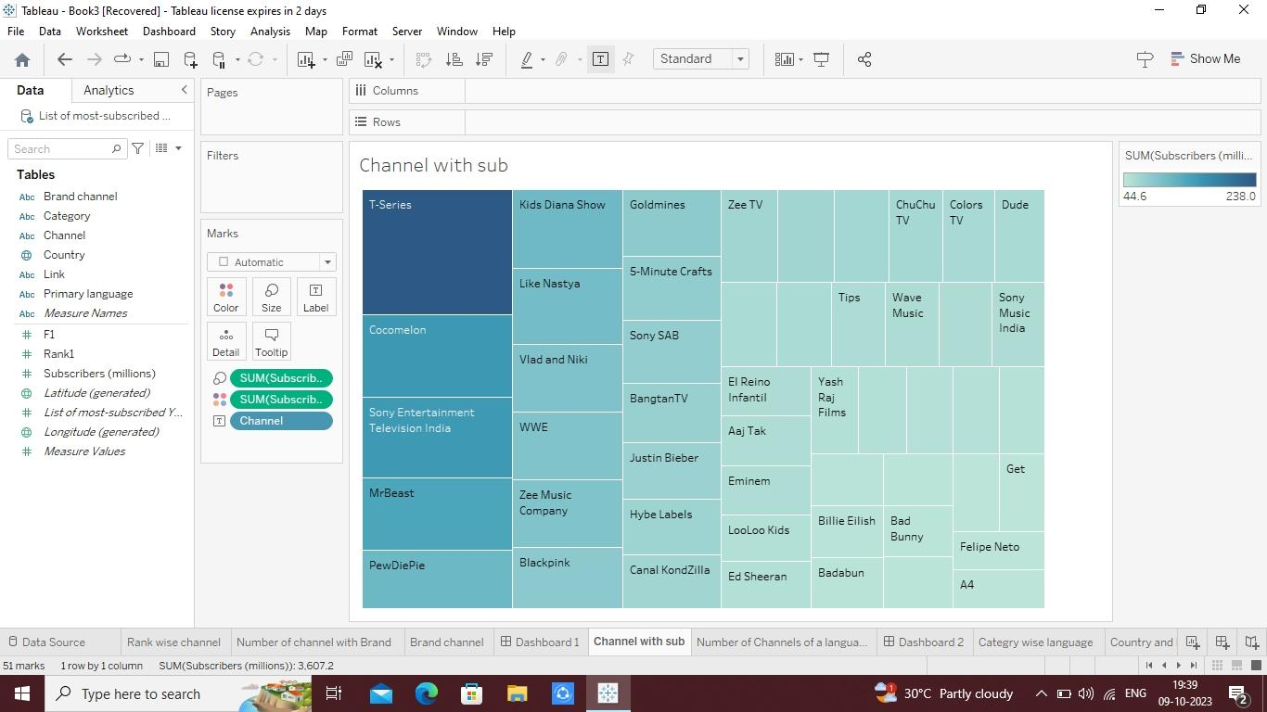

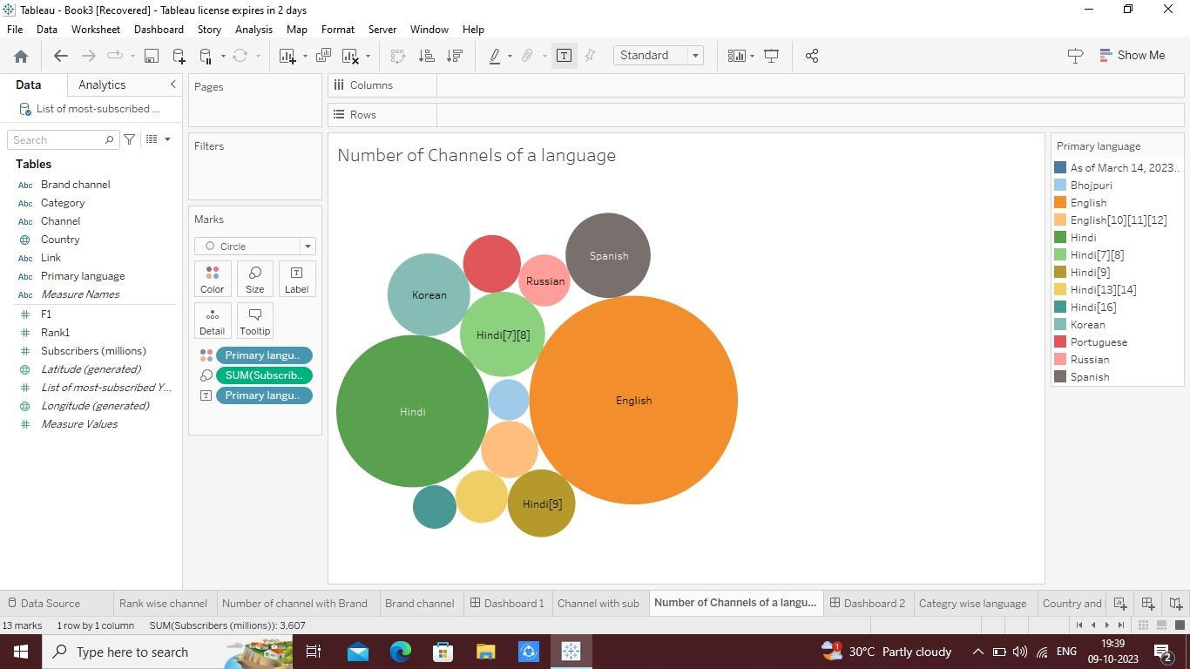

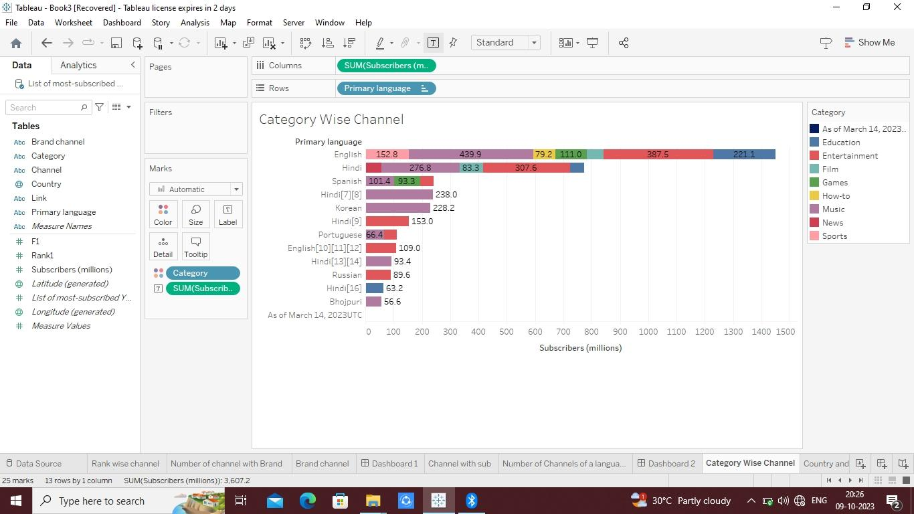

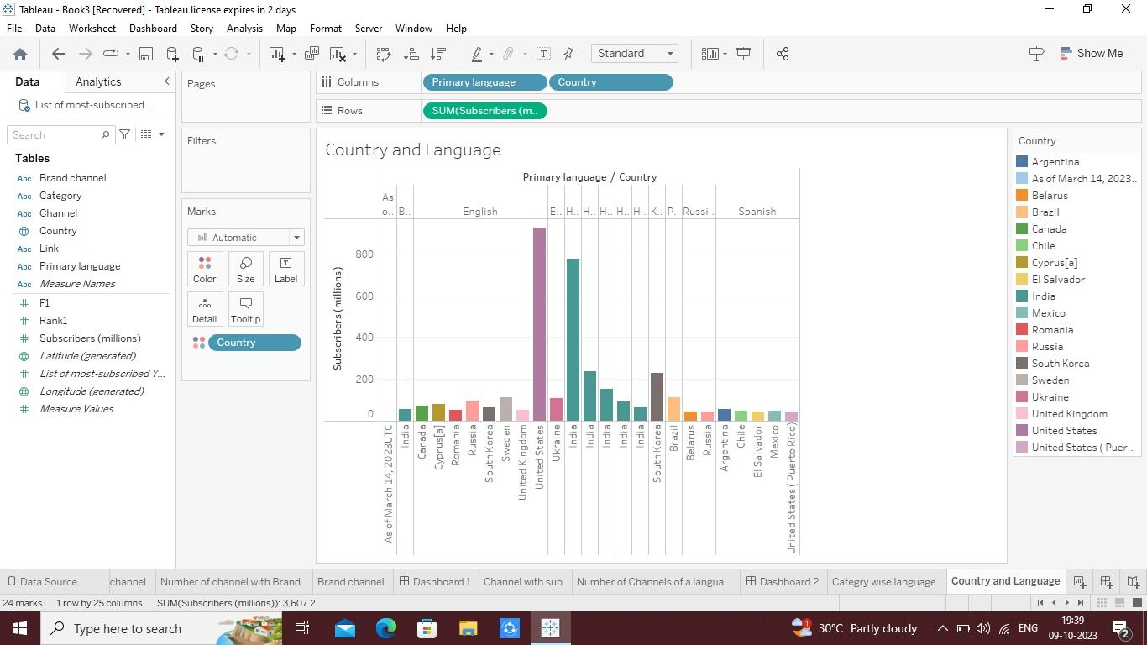

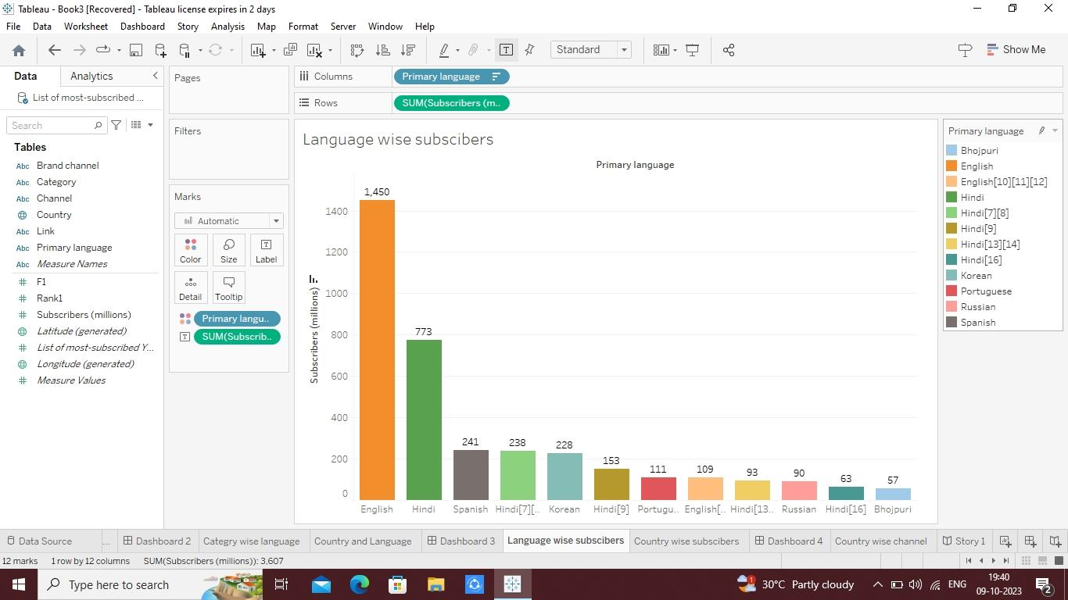

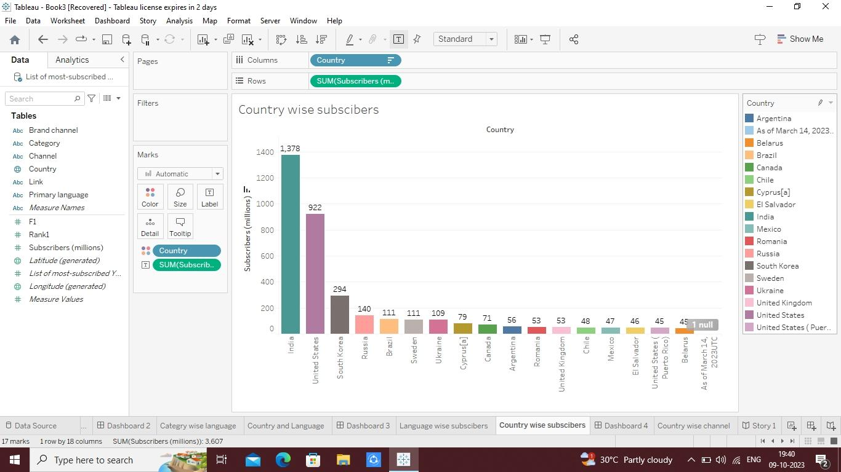

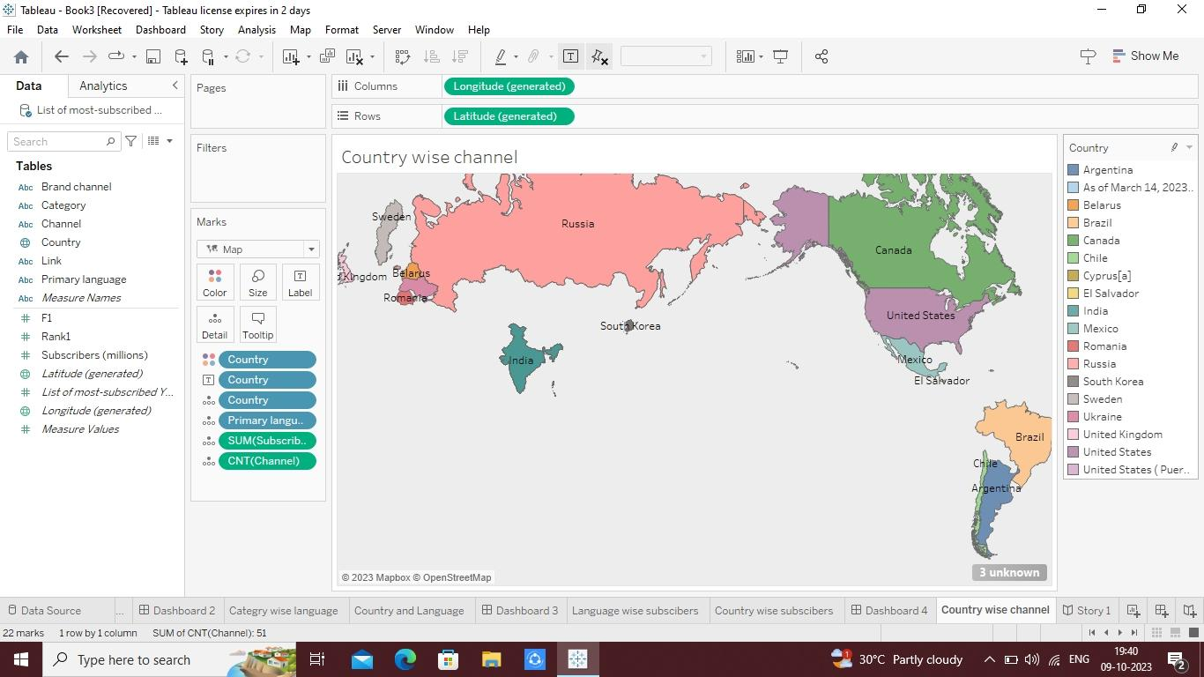

**4.ADVANTAGES AND DISADVANTAGES:**

**Advantages**:

It is a very popular and a powerful social media to all generation of people. It is also cost free app where you can upload, watch as much videos as possible. Here the user can watch and learn on many useful subjects. If the user wants to learn a new hobby YouTube can be the best platform. This is the only app where you can earn money by uploading content based videos into the public domain, live stream as much as you can, and upload cost free videos without any timeline. Here the user can be as creative as he can through his videos. Its easier way to connect with public and to share information through an easier manner. Here the user can also initiative the business plans or ideas in the videos or can also show the establishment of the venture this can be an inspiration to people.

**Disadvantages**:

The app consumes lot of data and uploading too might consume time as well.

Here everything is public so this might hamper the users privacy as people don’t need account to enter into the app.

Here age restricted videos can be uploaded and the restriction isn’t be followed properly. As many confirm them by being an under aged user.

Any advertisement can be uploaded in the middle of a video without any permission this can hamper a creators videos and also effect his followers.

YouTube can have all rights in disabling any video or adding red flags for the video without any reason this too can hamper the user.

**5.APPLICATION:**

YouTube is a great place to discover new things, learn and get entertainment, however, there are some things parents and teens should be aware of when using the service.

Users do not need to sign-in to access the website or to view videos. There is, however, a YouTube kids version now available to download for free. YouTube kids is designed for children aged 3-8 years old and make it easier for children and parents to find content they are interested in. Click here for more info the YouTube Kids app.

**6.CONCLUSION**:

It seems like YouTube is the place to be if you want your content seen. More and more people use their smartphones for everything, including watching videos on social media platforms such as Facebook and Instagram.

But there’s a lot of competition, so how do you get noticed? We offer marketing consulting services that will help give your channel an edge by providing expert advice in SEO/SEM, YouTube Marketing Consulting, Social Media Management, Google Adwords Strategy & Optimization, Content Creation Services, and much more!

**7.Future scope:**

YouTube has become one of the leading social media platforms in the last few years. It will not be wrong if we say that it has completely taken the world of the Internet by storm. YouTube has also provided thousands of golden career opportunities to today’s youth. Especially after the coronavirus outbreak in the world, Youtube has become a booming medium for people to earn a hefty amount each month by creating and sharing engaging creative content for the audience. That’s why nowadays, many people are turning to YouTube vlogging, as it has become their primary source of income. While some people are creating content on YouTube as a part-time hobby, many have chosen YouTube content creation as their full-time employment. Not only general people but many celebrities also have started their YouTube channels, primarily to satisfy their desire to perform in front of an audience.

Apart from offering money-making opportunities, YouTube also provides people with an excellent opportunity to show their hidden creative sides and share their valuable opinions in front of a global audience. As smartphone digitization has taken over the entire world, the eye-catching red and white play button has given birth to a brand new profession – The YouTuber. If you have a passion for creating engaging content, extraordinary video editing skills, and are not camera-shy, becoming a YouTuber can be an ideal career choice for you. Here in this article, we will discuss how one can pursue their career as Youtubers, what skills are required, how much money one can make through YouTube, and more. Let’s first know who a YouTuber is.

**8.REFERENCE:**

APA Publishing Training. (n.d.). Home [YouTube channel]. YouTube. Retrieved February 20, 2020, from <https://www.youtube.com/user/PsycINFO/>

Walker, A. (n.d.). Playlists [YouTube channel]. YouTube. Retrieved October 8, 2019, from <https://www.youtube.com/user/DjWalkzz/playlists>

Parenthetical citations: (APA Publishing Training, n.d.; Walker, n.d.)Narrative citations: APA Publishing Training (n.d.) and Walker (n.d.)

YouTube channel pages begin on the “Home” tab by default. If you want to cite one of the other tabs (e.g., “Videos,” “Playlists”), use the name of that tab rather than “Home” in the title element of the reference (as in the Walker example).Italicize the title of the channel.Include the description “[YouTube channel]” in square brackets after the title.Provide a retrieval date because the content is designed to change over time and is not archived.

**9.VIDEO LINK:**

[**https://drive.google.com/file/d/1EeOHEY2i-JL8QNR581daTJWI5SbbKpQU/view?usp=drivesdk**](https://drive.google.com/file/d/1EeOHEY2i-JL8QNR581daTJWI5SbbKpQU/view?usp=drivesdk)