**UNVEILING MARKET INSIGHTS : ANALYSING SPENDING BEHAVIOUR AND IDENTIFYING OPPORTUNITIES FOR GROWTH**

*INTRODUCTION:*

* 1. **OVERVIEW:**

My project is about “UNVEILING MARKET INSIGHTS”. My project collects the information about “MARKETING”. Wholesaling or distributing is the sale of goods to retailer to industrial, commercial, institutional or other professional Businessman to other wholesalers and related subordinator services.

* 1. **PURPOSE:**

The main objective of this project is to give important information and view points to company decision makers helping them to make wise decisions and create plans.

***2. PROBLEM DEFINITION AND DESIGN THINKING:***

**2.1 EMPATHY MAP:**

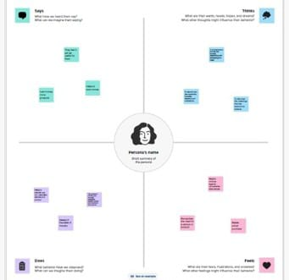

**2.2 IDEATION AND BRAINSTROMING:**

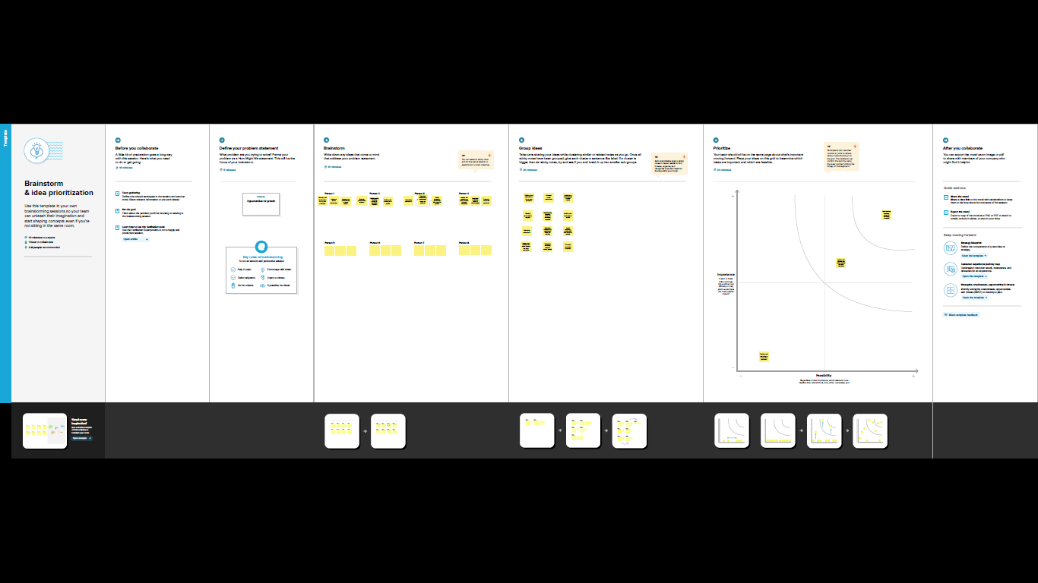

**3. OUTPUT OF THE PROJECT:**







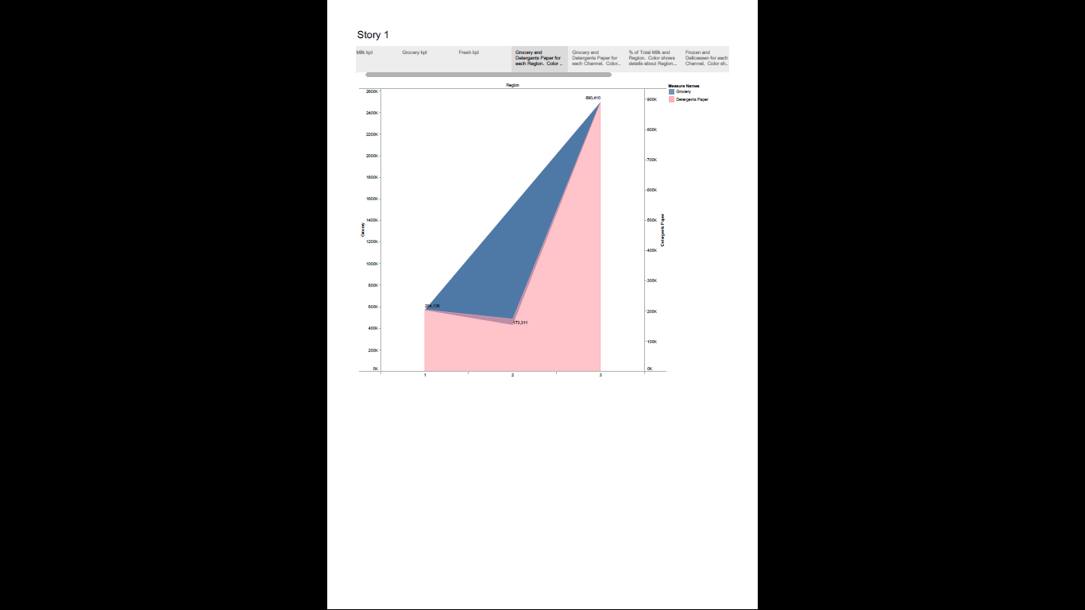

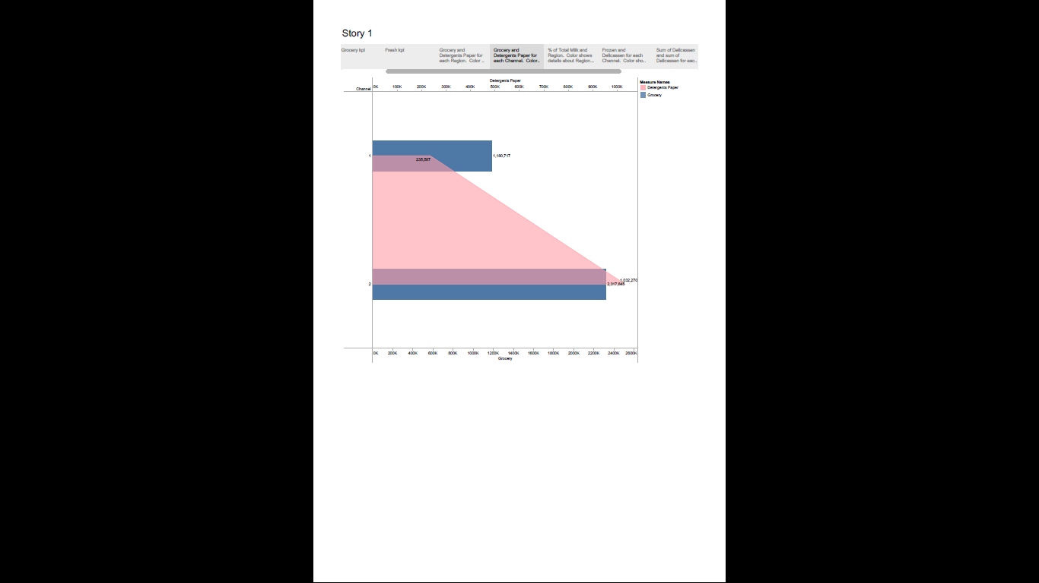

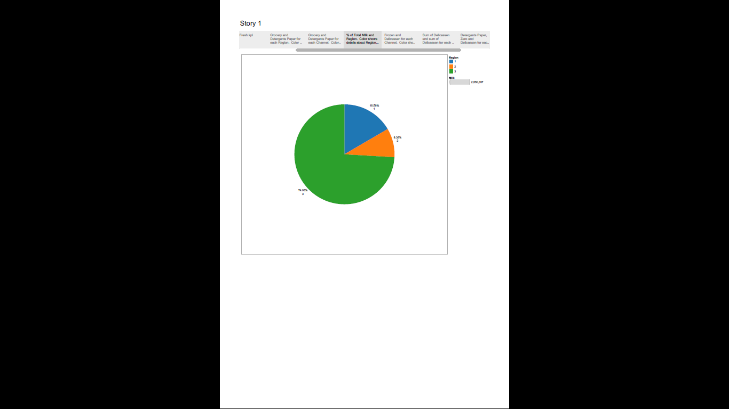

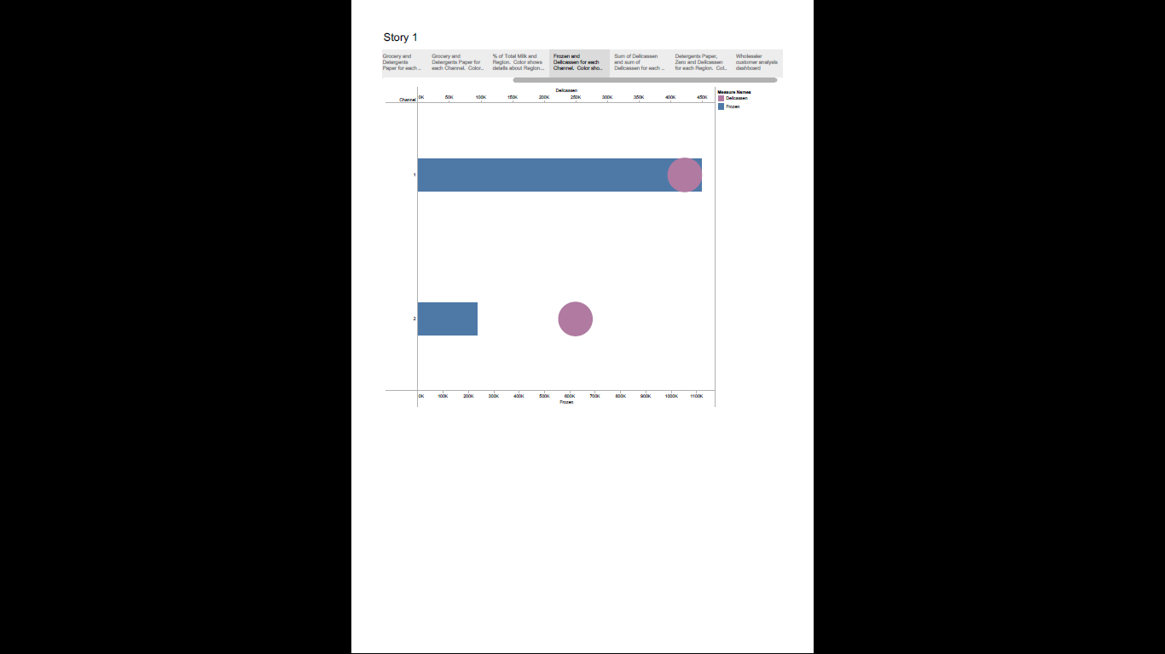

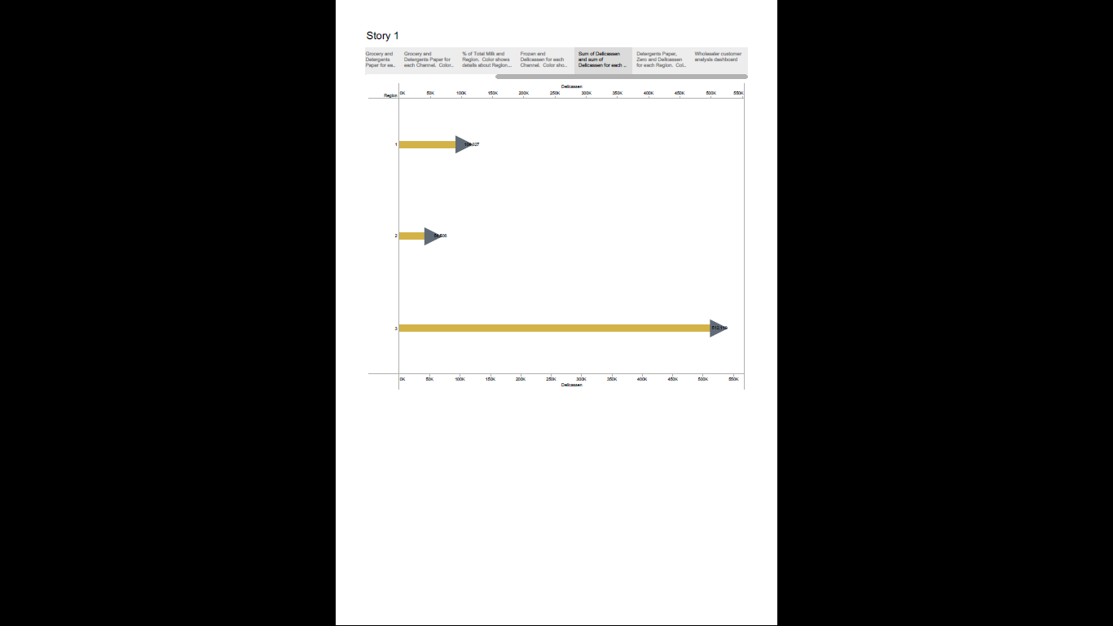

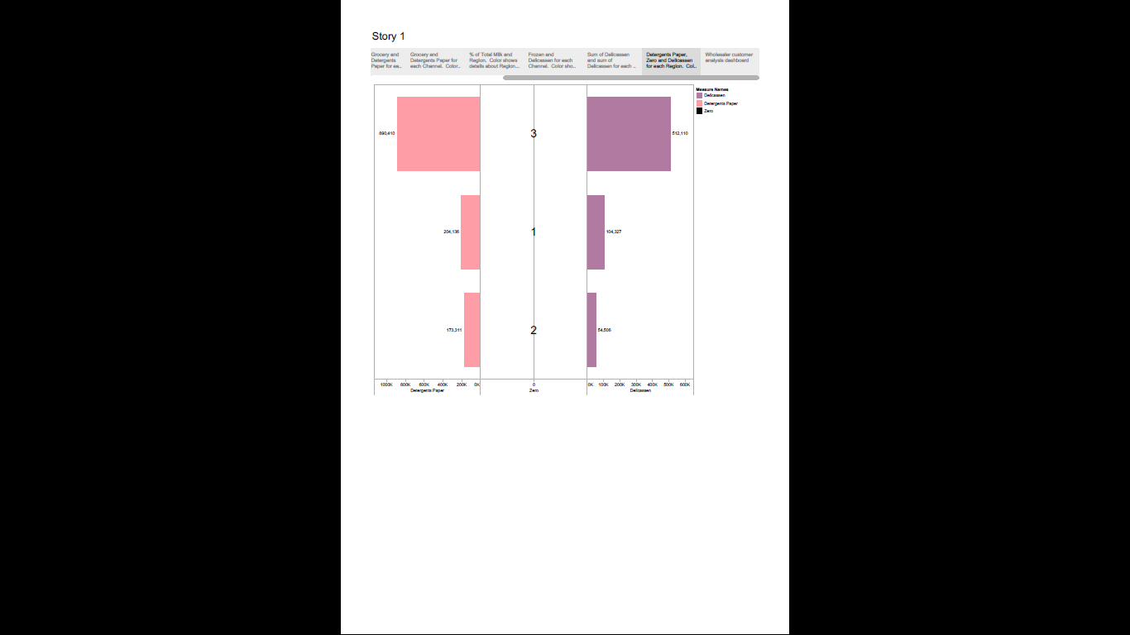

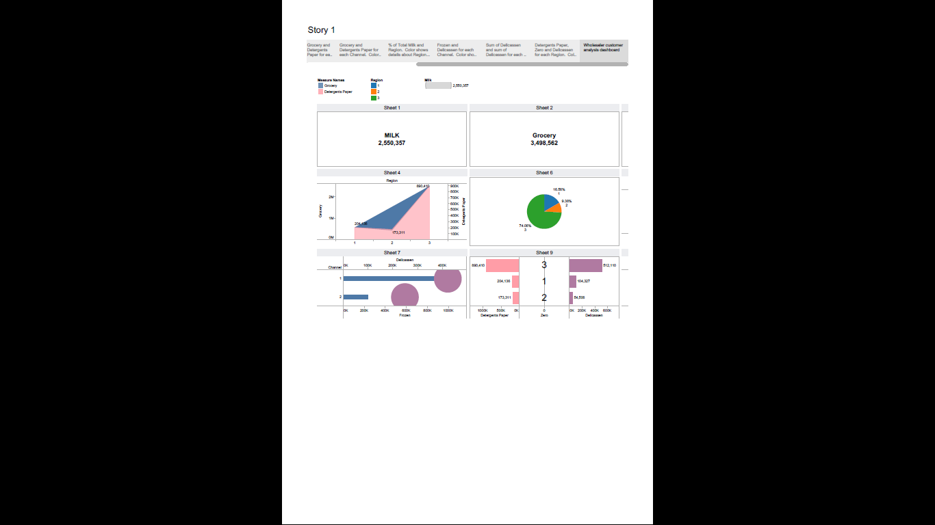

**4. ADVANTAGES:**

* Marketing that is properly researched and targeted will bring new and returning customers.
* Opinions of current and former customers can identify areas for improvement.
* Raising brand awareness.
* Allows for a more personal relationship between the business and the customer.
* Increased market share.

**DISADVANTAGES:**

* There is a lot of competition.
* Working overtime is sometimes necessary.
* You may have to cope with tense deadlines.

**5. APPLICATION:**

Based on what people want now and in the future, insights allow you to perceive needs that aren’t even known yet by the buyer themselves. As they’re not raw data, insights can’t predict the future — but they can enable trend detection by revealing a more complete picture of your market in real time.

**6. CONCLUSION:**

Consumer behaviour plays an important role for sales folks or marketers. As products are made to cater to consumer's needs and demands, the products should be carefully marketed for the successful achievements of organizational goals.

7. FUTURE SCOPE:

Scope of marketing research refers to the areas covered or the aspects studied under marketing research. In other words, it implies where or on which areas marketing research can be applied. In fact, marketing research concerns with almost each and every activity of marketing management.