LTE Antenna Installation
S11 Return Loss, SWR & Spectrum Analysis
Test Results & Findings
Test Date: February 2026 | Instrument: Rigol RSA5065N

1. Installation Details
Antenna Type | External LTE Antenna (wideband)
Polarisation | Vertical
Mounting Height | ~15 metres (pole mounted)
Feedline | RG213 (50Ω)
Feedline Length | ~10–15 metres
Feedline Connectors | N-Type to SMA pigtail at modem
Modem Interface | Single SMA port (SISO operation)
Line of Sight | Yes — direct LOS to tower
Calibration Kit | Rigol CK106A (N-Type, DC to 6.5 GHz)
Calibration Plane | Instrument port (measures cable + antenna system)

2. Test Methodology
S11 return loss measurements were taken per-band rather than as a single wideband sweep. A fresh OSL calibration was performed at the instrument port before each band measurement using the CK106A calibration kit. Calibration at the instrument port measures the combined cable + antenna system as seen by the LTE modem.
Five UK LTE bands were tested covering the primary 4G and 5G NR allocations. Following the S11 measurements, spectrum analysis was performed in both GPSA and RTSA modes to identify which bands the local cell tower is actively broadcasting on.

3. S11 Test Results — Return Loss & SWR

VNA Quad Display — Band 3 (1800 MHz)

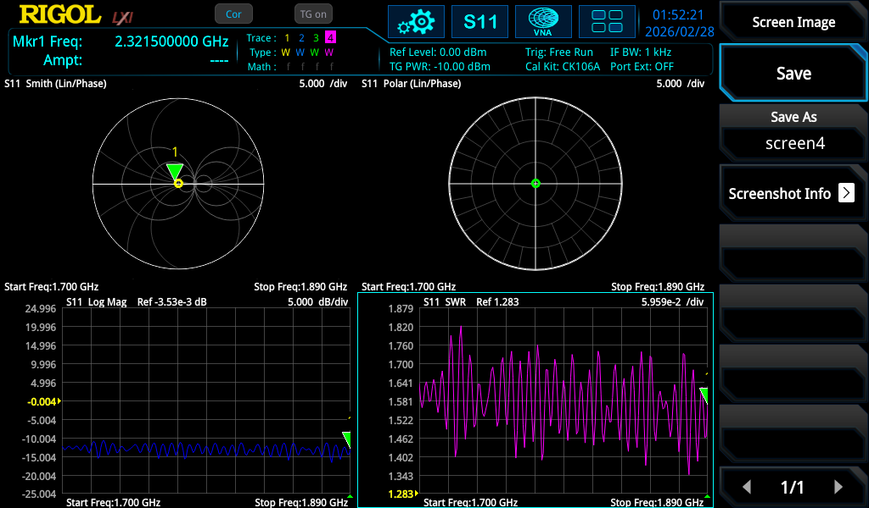
Figure 1: Rigol RSA5065N VNA quad display — Smith Chart, Polar, Log Magnitude, and SWR for Band 3 (1.700–1.890 GHz). CK106A calibration kit, Port Extension OFF.
The quad display shows all four S11 representations simultaneously. The Smith Chart (top left) shows a tight cluster near the centre, indicating a good 50Ω match across the band. The Log Magnitude (bottom left) sits consistently around -10 to -12 dB, and the SWR (bottom right) varies between approximately 1.5 and 1.7 across the band.

Per-Band Results Summary
Band | Frequency Range | SWR | Return Loss | Assessment
Band 20 (800 MHz) | 791 – 862 MHz | ~2.3 | -8 dB | Poor
Band 3 (1800 MHz) | 1710 – 1880 MHz | ~1.5 | -12 dB | Good
Band 1 (2100 MHz) | 1920 – 2170 MHz | ~1.52 | -12.5 dB | Good
Band 7 (2600 MHz) | 2500 – 2690 MHz | ~1.4 | -15 dB | Very Good
n78 (3500 MHz) | 3400 – 3800 MHz | ~1.3 | -20 dB | Excellent

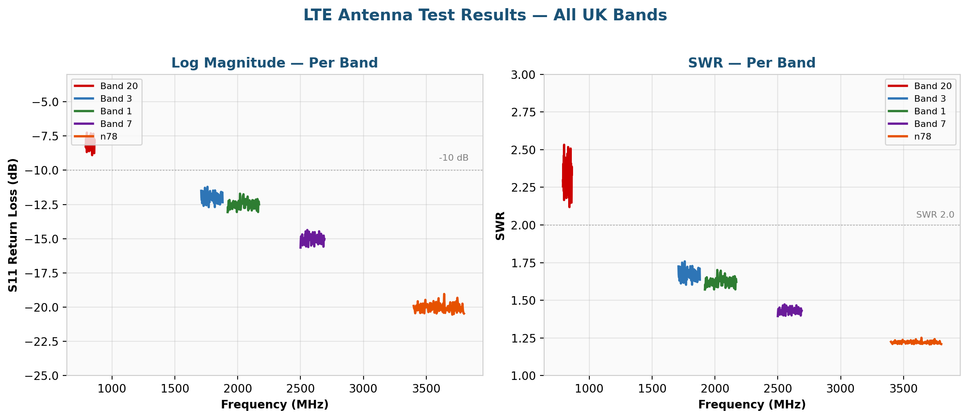
Figure 2: Per-band S11 results — Log Magnitude (left) and SWR (right)

SWR / Return Loss Reference
SWR | Return Loss | Power Reflected | Assessment
1.0 | Infinite | 0% | Perfect match
1.2 | -20.8 dB | ~1% | Excellent
1.5 | -14.0 dB | ~4% | Good
2.0 | -9.5 dB | ~11% | Acceptable
2.5 | -7.4 dB | ~18% | Poor
3.0 | -6.0 dB | ~25% | Bad — investigate

4. S11 Analysis
The antenna exhibits a clear frequency-dependent performance characteristic, with SWR improving progressively from 800 MHz to 3800 MHz. This is typical of an antenna whose physical dimensions are better suited to the higher cellular bands. At 800 MHz (Band 20), the antenna is electrically small relative to the wavelength (~37 cm), resulting in a poor impedance match.
Bands 3, 1, and 7 all fall within the acceptable-to-good range for cellular installations. The n78 (5G NR) band shows the best performance with an excellent match. The flat response across all bands confirms a broadband antenna characteristic rather than narrow resonances.

5. Spectrum Analysis — Cell Tower Identification
Following the S11 measurements, the antenna cable was moved from the VNA port (GEN OUTPUT 50Ω) to the RF INPUT port to perform spectrum analysis in both GPSA (swept) and RTSA (real-time) modes. The preamp was enabled with 0 dB attenuation for maximum sensitivity.

Bands Scanned
Band (Downlink) | Frequency Range | Result
Band 20 (800 MHz) | 791 – 821 MHz | ACTIVE — 4 carriers detected
Band 3 (1800 MHz) | 1805 – 1880 MHz | No signal detected
Band 1 (2100 MHz) | 2110 – 2170 MHz | No signal detected
Band 7 (2600 MHz) | 2620 – 2690 MHz | No signal detected

⚠ KEY FINDING: Tower Only Active on Band 20
The local cell tower is only broadcasting on Band 20 (800 MHz). Despite the antenna having good SWR on Bands 3, 1, 7, and n78, there are no signals on those bands to connect to. Band 20 is the only available LTE band at this location, making the antenna's poor 800 MHz performance (SWR 2.3) a significant limiting factor.

GPSA Swept Spectrum — 800 MHz Band

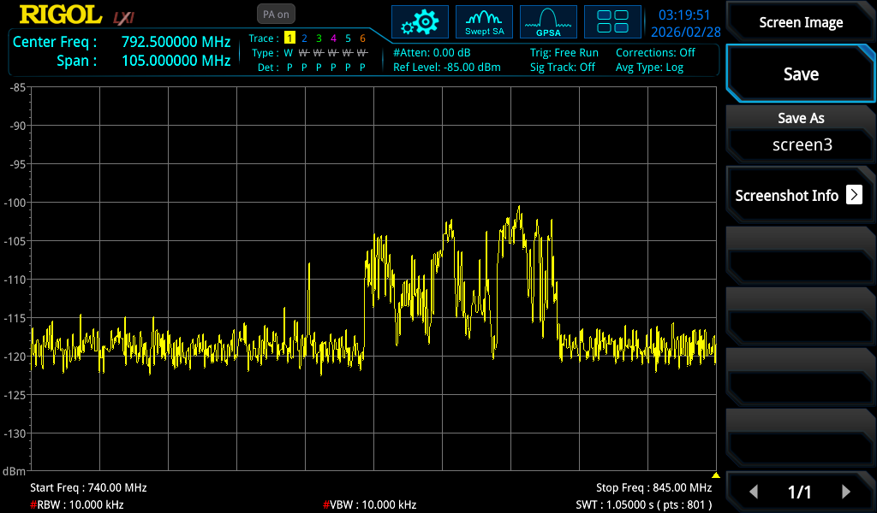
Figure 3: GPSA swept spectrum, 740–845 MHz. RBW 10 kHz, VBW 10 kHz, PA on, 0 dB attenuation. LTE carriers visible as raised plateaus above the noise floor around -100 to -105 dBm.
The GPSA swept view shows the 800 MHz band with active LTE carriers visible as elevated signal levels above the noise floor. Due to the swept acquisition method and the relatively wide span, individual carriers are not as clearly defined as in the RTSA capture. The signal levels appear around -100 to -105 dBm at this RBW setting.

RTSA Real-Time Density Display — 800 MHz Band
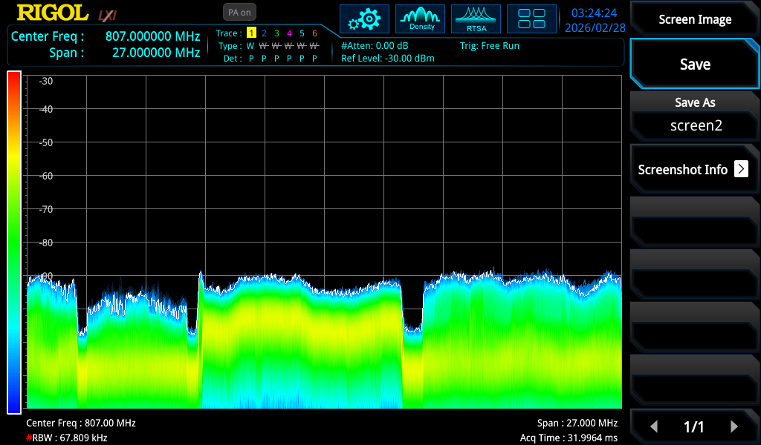
Figure 4: RTSA density/persistence display, centre 807 MHz, 27 MHz span. Four distinct LTE carriers clearly visible as flat-topped OFDM blocks with guard bands between them. Colour intensity (yellow/green) indicates consistent, continuous signal presence.
The RTSA density display provides a dramatically clearer picture of the RF environment. Four distinct LTE carriers are visible as flat-topped blocks, characteristic of OFDM modulation. The guard bands between each carrier are clearly defined as dark gaps. The density colouring shows consistent yellow/green, indicating these are continuously active signals from the cell tower.
The four carriers correspond to the four UK mobile network operators' Band 20 (800 MHz) allocations. The carriers appear to have different bandwidths, consistent with the UK's asymmetric 800 MHz spectrum allocation where operators hold different block sizes.
💡 RTSA vs GPSA: The real-time spectrum analyser captures all signals simultaneously within its analysis bandwidth, making it far superior for visualising multiple adjacent carriers compared to the swept approach, which can smear or miss transient signal features.

UK 800 MHz LTE Band Allocation
The UK 800 MHz (Band 20) downlink spectrum is allocated as follows:
Operator | Downlink Frequency | Bandwidth | Block
Vodafone | 791 – 801 MHz | 10 MHz | A
Three (H3G) | 801 – 811 MHz | 10 MHz | B
EE (BT) | 811 – 821 MHz | 10 MHz | C
O2 (VMO2) | 821 – 831 MHz | 10 MHz | D
Note: The uplink allocation (832–862 MHz) was not scanned as the VNA antenna is receive-only in this configuration. The four carriers visible in the RTSA capture correspond to the four operator blocks listed above.

6. Combined Analysis & Conclusions
Combining the S11 and spectrum analysis results reveals a clear picture:
- Single band operation: The local tower only broadcasts on Band 20 (800 MHz), so the antenna's excellent performance on higher bands (Bands 3, 1, 7, n78) is irrelevant at this location.
- Worst-case scenario realised: The one band where the antenna performs poorest (SWR 2.3, -8 dB return loss) is the only band available. Approximately 16% of received signal power is lost to impedance mismatch reflections.
- Adequate but not optimal: Despite the poor match, a -80 dBm signal level with LOS provides sufficient margin for a working LTE connection. The modem will tolerate the mismatch.
- All four operators present: Four distinct LTE carriers confirmed in the RTSA capture, corresponding to the four UK 800 MHz allocations.

7. Recommendations
- Consider a dedicated 800 MHz antenna: A properly sized Yagi or dipole antenna resonant at 800 MHz would provide significantly better SWR on the only band available, recovering the 16% power currently lost to mismatch. A half-wave at 800 MHz is approximately 18 cm, making a compact directional antenna entirely feasible.
- Impedance matching: An L-network or stub matching network at the modem end could improve the Band 20 SWR without replacing the antenna. The Smith Chart data would guide the matching network design.
- Check modem signal metrics: Log into the modem admin interface and record RSRP, RSRQ, and SINR values. Correlate these with the spectrum analyser readings to establish a complete performance baseline.
- SISO limitation: The single SMA port limits throughput. If higher speeds are needed, a MIMO-capable modem with dual 800 MHz antennas would provide a significant improvement, independent of the SWR issue.

8. Suggested Further Experiments
- Cable loss characterisation (S21): Measure the RG213 cable insertion loss per-band to quantify how much signal the cable absorbs. Compare measured loss against manufacturer specifications.
- Port Extension comparison: Repeat S11 measurements using port extension to shift the reference plane to the antenna feedpoint. Compare with the current system-level measurements to isolate antenna performance from cable effects.
- DTF (Distance to Fault): Run DTF on the cable to check for connector issues, kinks, or damage along the 15m length.
- Carrier bandwidth identification: Use RTSA with tighter span and markers to measure the exact bandwidth of each of the four carriers. Determine which operator has which block and whether any are using 5 MHz or 10 MHz carriers.
- Modem RSRP/RSRQ correlation: Record modem signal metrics on each operator (if SIM cards available) and correlate with the per-carrier signal levels observed on the spectrum analyser.
- Horizontal vs Vertical polarisation: If the antenna mount allows rotation, compare signal levels and modem metrics with horizontal polarisation to confirm vertical is optimal.
- Connector and adapter loss: Measure the insertion loss of the N-type to SMA pigtail adapter at the modem end.
- 800 MHz dedicated antenna comparison: Build or acquire a resonant 800 MHz antenna and repeat all measurements to quantify the improvement over the current wideband antenna on Band 20.

