Understanding S11 Measurements
A Practical Guide to Return Loss, SWR,
and Smith Chart Interpretation on the VNA
Instrument: Rigol RSA5065N
RF-Hub Project | February 2026

1. What is S11?
S11 is one of the S-parameters (scattering parameters) used to describe how RF energy behaves when it encounters a device or component. Specifically, S11 measures the input reflection coefficient — the ratio of signal power reflected back from a device compared to the signal power that was sent into it.
In practical terms, when you connect an antenna to a VNA and measure S11, you are asking: "How much of the signal power that I send down this cable is being reflected back instead of being radiated by the antenna?"
A perfect antenna would absorb all the power sent to it and reflect nothing back — giving an S11 of negative infinity in dB. A perfect mirror (open circuit or short circuit) would reflect everything — giving an S11 of 0 dB. Real antennas fall somewhere in between.

The S-Parameter Naming Convention
The numbers in "S11" tell you where the signal is measured and where it was injected. The first digit is the measurement port, the second is the stimulus port. So S11 means "signal goes into Port 1 and is measured coming back out of Port 1" — a reflection measurement. S21 would mean "signal goes into Port 1 and is measured at Port 2" — a transmission measurement.

2. S11 Display Formats on the Rigol RSA5065N
The VNA captures S11 as a complex number (magnitude and phase) at each frequency point. This raw data can be displayed in several formats, each revealing different information about the device under test. On the Rigol, these are accessed via Trace > Trace Format.
Format | What It Shows | Best Used For
Log Mag | Return loss in dB vs frequency | Quantifying how much power is reflected; comparing bands; pass/fail testing
SWR | Standing Wave Ratio vs frequency | Quick assessment of impedance match quality; familiar to amateur radio operators
Smith Chart | Complex impedance (R + jX) on a circular plot | Understanding whether mismatch is resistive, inductive, or capacitive; impedance matching design
Phase | Phase angle of reflection vs frequency | Cable length measurement; identifying resonant frequencies
Lin Mag | Linear magnitude (0 to 1) vs frequency | Rarely used for antennas; shows reflection coefficient directly
Polar | Magnitude and phase on a polar plot | Similar to Smith chart but without impedance grid lines
Group Delay | Rate of phase change vs frequency | Identifying dispersion; filter characterisation
For antenna work, the three most important formats are Log Magnitude, SWR, and Smith Chart. These three views show the same underlying data in different ways, and each reveals information the others do not.

3. Log Magnitude (Return Loss)
Log Magnitude displays S11 as return loss in decibels (dB) plotted against frequency. This is the most commonly used format for antenna measurements because it directly tells you how much power is being lost to reflections at each frequency.

Reading the Axes
Y-axis (Return Loss in dB): Always 0 dB or negative for S11. Zero dB means total reflection (all power bounced back). More negative values mean less reflection, which is better. The scale typically runs from 0 dB at the top to -30 dB or -50 dB at the bottom.
X-axis (Frequency): Spans the frequency range you configured (Start Freq to Stop Freq). For narrow band measurements, this might cover a single LTE band. For wideband sweeps, it could cover hundreds of MHz.

Key Thresholds
Return Loss | Power Reflected | Power Delivered | Practical Meaning
0 dB | 100% | 0% | Total reflection (open/short)
-3 dB | 50% | 50% | Half power reflected — very bad
-6 dB | 25% | 75% | Poor match, usable in emergencies
-8 dB | 16% | 84% | Marginal (your Band 20 result)
-10 dB | 10% | 90% | Minimum acceptable for most RF
-14 dB | 4% | 96% | Good match
-20 dB | 1% | 99% | Excellent match
-30 dB | 0.1% | 99.9% | Laboratory grade

What the Trace Shape Tells You
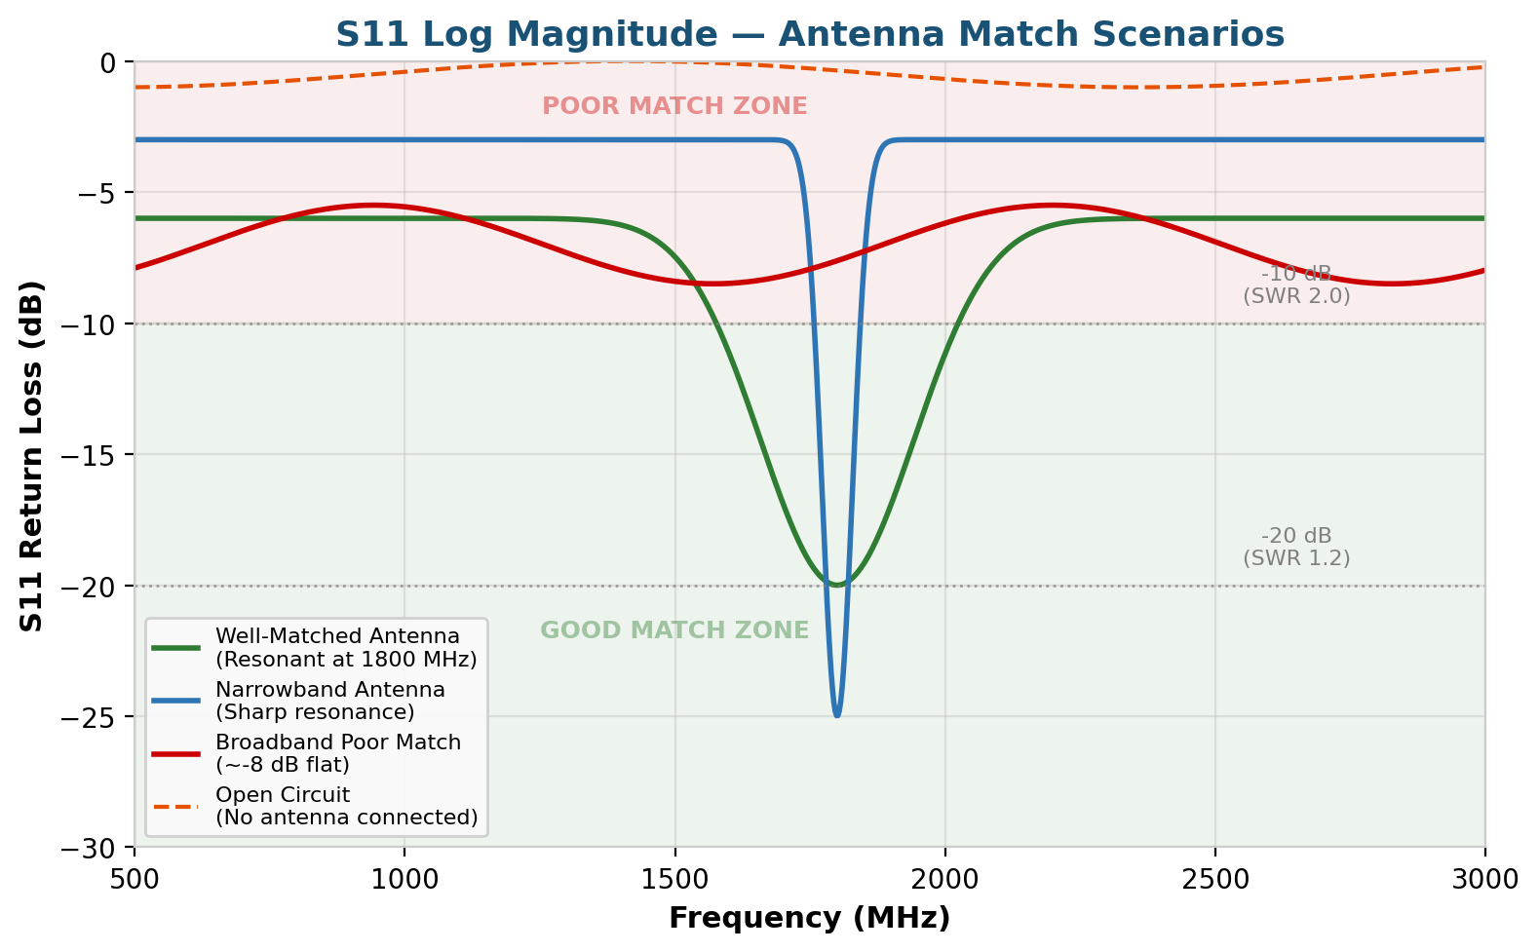
Figure 1: Log Magnitude traces showing four different antenna scenarios
Flat line near 0 dB (orange dashed): Open circuit or no antenna connected. Almost all energy is reflected. This is what you should see after calibration with nothing connected to the port.
Flat line at moderate level (red): A broadband antenna that is consistently poorly matched. It radiates some energy but wastes a significant portion to reflections across the entire band. This is similar to what was observed on Band 20 during testing.
Broad dip (green): A well-matched wideband antenna. The dip shows frequencies where the antenna resonates and the impedance is closest to 50Ω. The width of the dip indicates usable bandwidth.
Sharp narrow dip (blue): A narrowband antenna. Excellent match at the resonant frequency but poor performance even slightly off-tune. The antenna is only usable over a very small frequency range. This would be problematic for wideband signals like LTE.

4. Standing Wave Ratio (SWR)
SWR (also called VSWR — Voltage Standing Wave Ratio) is an alternative way to express the same impedance mismatch information shown by Log Magnitude. Where Log Mag works in decibels, SWR expresses the mismatch as a ratio from 1.0 to infinity. A perfect match is 1.0:1 (often written simply as 1.0). An open or short circuit gives infinite SWR.

The Physical Meaning
When a signal travels down a transmission line and encounters an impedance mismatch (such as a poorly matched antenna), some energy reflects back. The forward-travelling and reflected waves combine to create a standing wave pattern on the cable. SWR is the ratio of the peak voltage to the minimum voltage in this standing wave pattern. When there is no reflection, the voltage is uniform along the cable and SWR = 1.0. The more reflection, the bigger the peaks and troughs, and the higher the SWR.
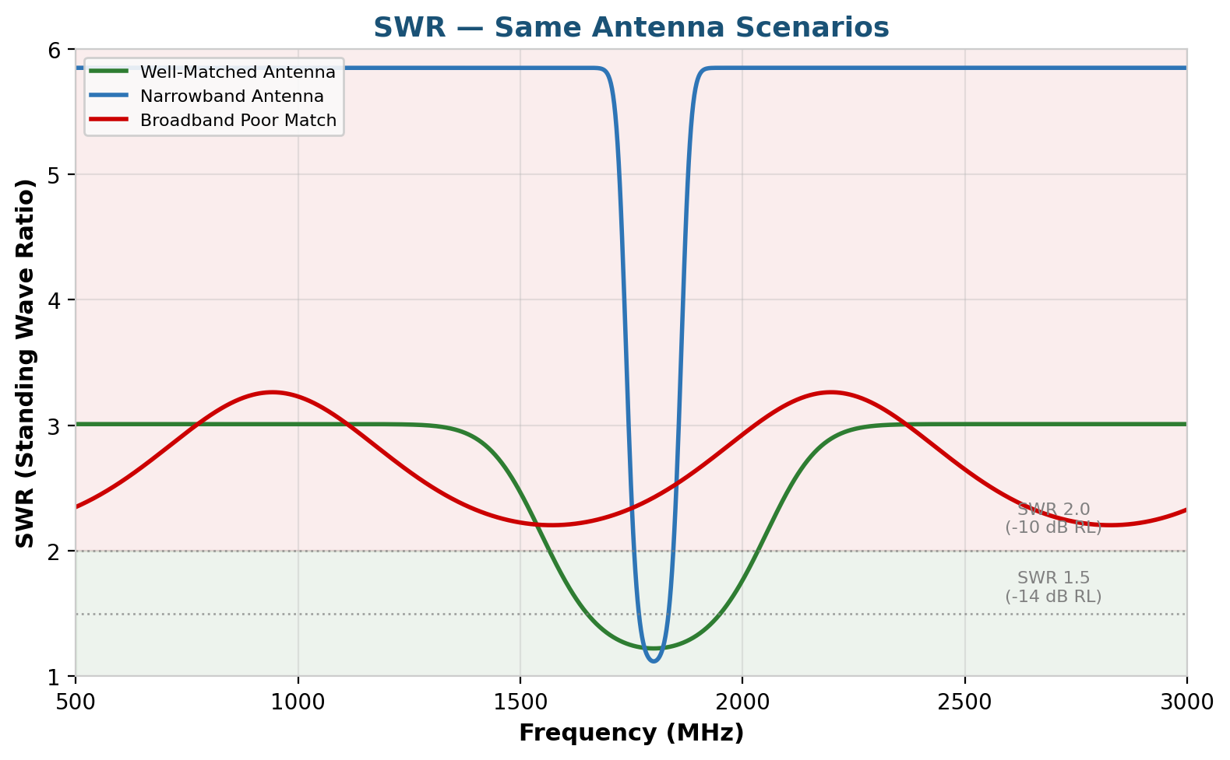
Figure 2: SWR traces for the same antenna scenarios as Figure 1

SWR Quick Reference
SWR | Assessment | Typical Application | Return Loss
1.0 | Perfect | Calibration load | Infinite
1.0–1.5 | Excellent | Commercial antennas, lab equipment | -14 dB or better
1.5–2.0 | Good | Amateur radio, most cellular | -10 to -14 dB
2.0–3.0 | Acceptable | Portable/compromise antennas | -6 to -10 dB
3.0+ | Poor | Needs investigation or matching | Worse than -6 dB

5. The Mathematical Relationship
Return Loss (Log Mag) and SWR are mathematically linked through the reflection coefficient (Γ, gamma). They are not independent measurements — they are different representations of the same underlying quantity.

The Formulas
Reflection Coefficient (Γ): A complex number representing the ratio of reflected to incident voltage. Its magnitude ranges from 0 (perfect match) to 1 (total reflection).
Return Loss (dB) = 20 × log₁₀(|Γ|)
SWR = (1 + |Γ|) / (1 – |Γ|)
Power Reflected (%) = |Γ|² × 100
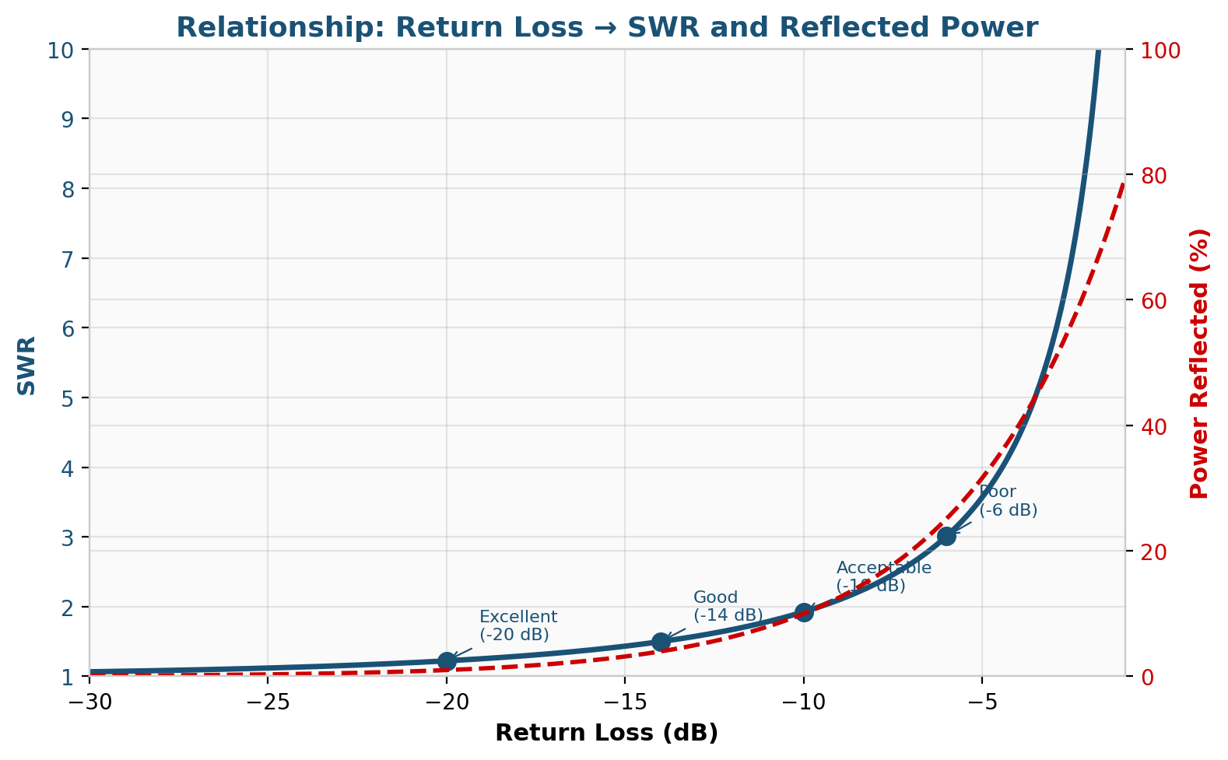
Figure 3: The non-linear relationship between Return Loss, SWR, and Reflected Power
The graph shows that the relationship is non-linear. Small improvements in return loss near the -10 dB region produce significant improvements in SWR and reflected power. Beyond about -20 dB, further improvement in return loss has diminishing returns — you are already delivering over 99% of the power.
💡 PRACTICAL NOTE: This is why chasing a return loss better than -20 dB is usually unnecessary for antenna work. The difference between -20 dB (1% reflected) and -30 dB (0.1% reflected) is only 0.9% of your total power — completely negligible in practice.

6. The Smith Chart
The Smith Chart is a specialised plot that shows complex impedance on a circular graph. While Log Mag and SWR only show how much signal is reflected (the magnitude), the Smith Chart also reveals the nature of the mismatch — whether the impedance is too high, too low, inductive, or capacitive.

Navigating the Smith Chart
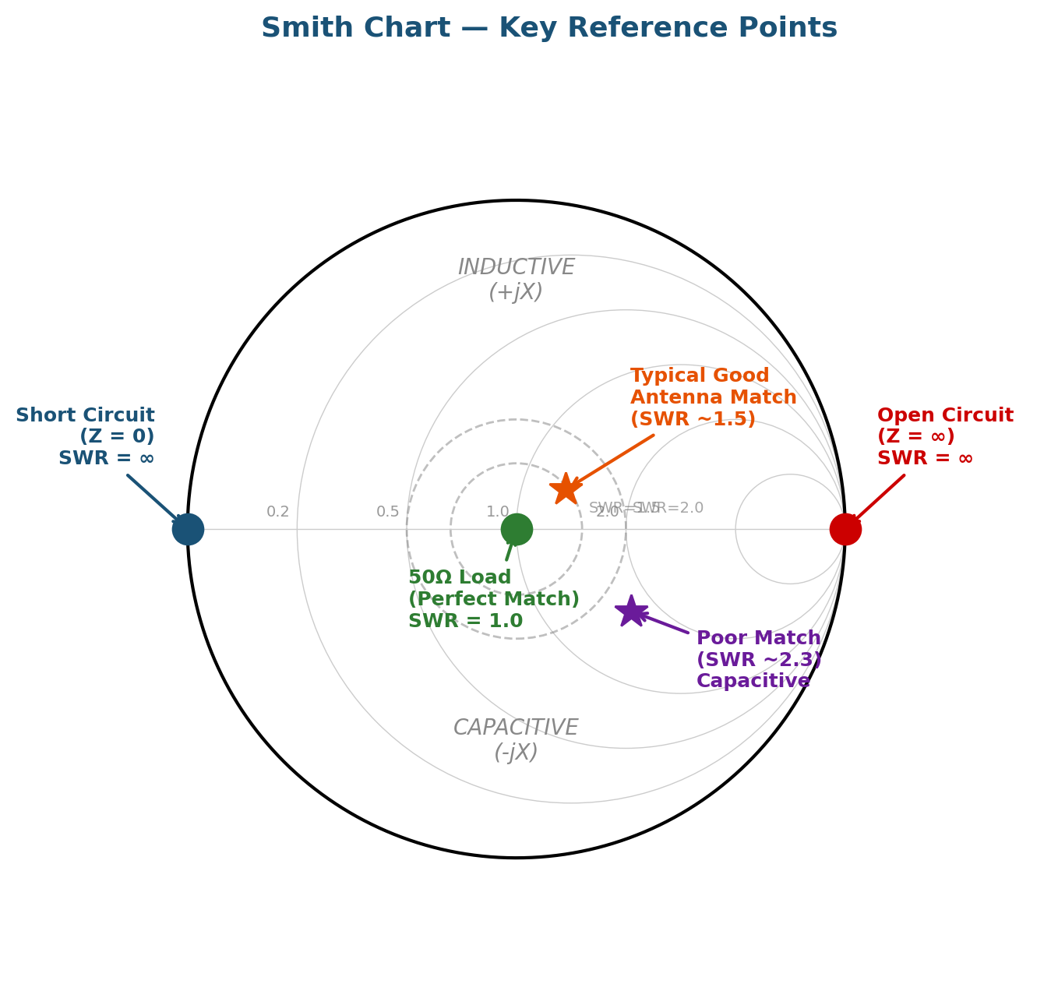
Figure 4: Smith Chart with key reference points annotated

Key Landmarks
Centre (green dot): This is 50Ω purely resistive — a perfect match. After calibration with the Load standard connected, you should see a dot right here. The closer your antenna measurement sits to the centre, the better the match.
Far right (red dot): Infinite impedance — an open circuit. This is where the trace should jump when you disconnect everything from the port after calibration.
Far left (blue dot): Zero impedance — a short circuit. This must appear on the far left edge of the centre line. If it appears below the centre line (in the capacitive region), there is a calibration error.

Upper Half vs Lower Half
Upper half = Inductive (+jX): The impedance has a positive reactive component. The antenna appears electrically too long, or there is excess inductance in the system.
Lower half = Capacitive (-jX): The impedance has a negative reactive component. The antenna appears electrically too short, or there is excess capacitance.
Centre horizontal line = Purely Resistive: No reactive component. Points on this line have impedance that is purely real — resistance only. The ideal antenna measurement sits on this line at the centre point (50Ω).

SWR Circles on the Smith Chart
The dashed circles centred on the middle of the Smith Chart represent constant SWR values. Any point on the SWR = 1.5 circle has an SWR of 1.5, regardless of whether the mismatch is resistive, inductive, or capacitive. A tight cluster of measurement points near the centre means good match across the measured frequency range. A large arc sweeping across the chart means the impedance is changing significantly with frequency.

7. What Cables Do to Your Measurements
When measuring an antenna through a length of coaxial cable, the cable affects your S11 measurement in two important ways. Understanding these effects is essential for interpreting results correctly.

Cable Loss Masks True Performance
The signal travels from the VNA up the cable to the antenna, reflects, and travels back down the cable. The cable attenuates the signal in both directions, so the reflected signal is weakened by twice the cable loss. This makes the return loss appear better than it really is — the cable is absorbing the reflected energy and hiding the true antenna mismatch.
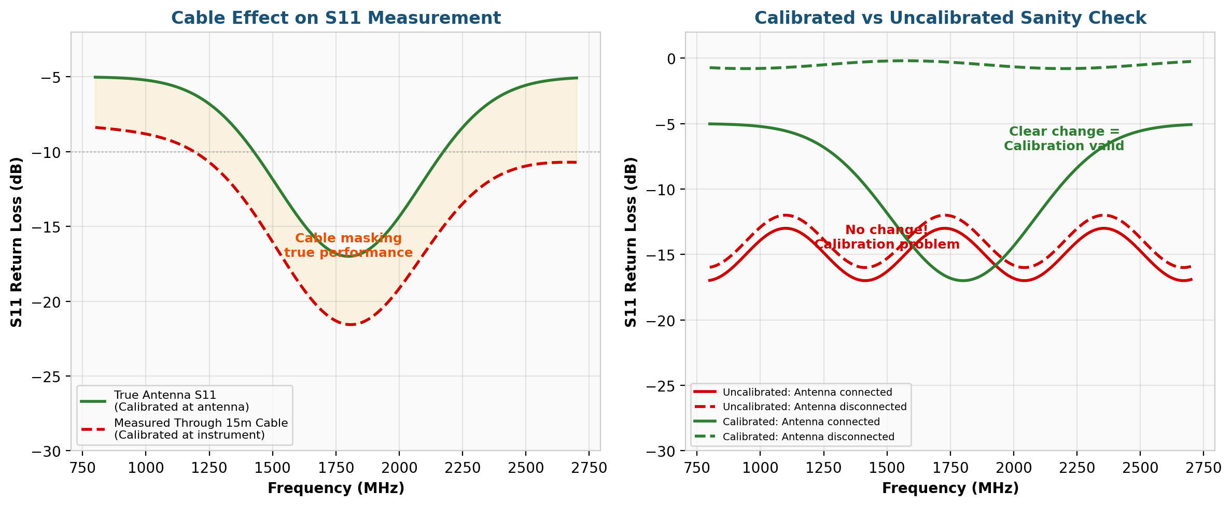
Figure 5: Left — Cable loss masking true antenna performance. Right — Calibrated vs uncalibrated sanity check
In the left graph, the green trace shows the true antenna S11 measured with calibration at the antenna feedpoint. The red dashed trace shows what the same antenna looks like when measured through 15 metres of cable with calibration at the instrument. The orange shaded area represents the measurement error introduced by the cable — it makes everything look artificially good.

Calibration Sanity Check
The right graph illustrates the critical sanity check. With a valid calibration (green traces), disconnecting the antenna produces a dramatic change in the measurement — from a reasonable return loss to near 0 dB. Without valid calibration (red traces), the measurement barely changes whether the antenna is connected or not. If disconnecting the antenna does not significantly change your trace, the calibration is not working correctly.
💡 KEY INSIGHT: When calibrating at the instrument port and measuring through a cable, you are measuring the combined cable + antenna system. This is what the modem actually sees, so it is a valid and useful measurement. But be aware that the true antenna performance at the feedpoint may be worse than what the VNA shows.

8. Putting It All Together — Real LTE Results
The following results were captured from an actual LTE antenna installation, measured through approximately 15 metres of RG213 coaxial cable. Each band was measured individually with a fresh calibration to maximise measurement accuracy.
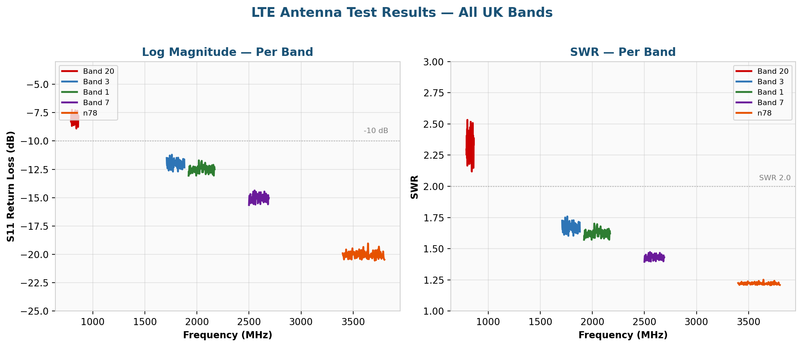
Figure 6: Actual LTE antenna test results across all UK bands — Log Magnitude (left) and SWR (right)
The results clearly show the antenna improving at higher frequencies. Band 20 (800 MHz) sits in the poor zone with about 16% power reflected, while n78 (3500 MHz) achieves an excellent match with only 1% reflected. This frequency-dependent behaviour is characteristic of an antenna that is physically small relative to the lower band wavelengths.
The flat response within each band confirms the antenna has a broadband characteristic — it does not have sharp resonances that would create sweet spots or dead spots within a single LTE band. This is desirable for cellular operation where the modem may use different channels within the same band.

9. Which Display Format Should You Use?
If You Want To Know... | Use This Format
"Is my antenna well-matched?" | Log Mag — look for values below -10 dB
"What SWR will my radio see?" | SWR — direct readout of the ratio
"Is the mismatch inductive or capacitive?" | Smith Chart — check if trace is above or below centre line
"What impedance is the antenna presenting?" | Smith Chart — read R + jX from the grid
"Over what bandwidth is the antenna usable?" | Log Mag — measure the width of the dip below -10 dB
"Is my calibration valid?" | Any format — disconnect the DUT and check for a dramatic change
"Which LTE band gives the best antenna performance?" | Log Mag or SWR — compare per-band measurements
"Would an impedance matching network help?" | Smith Chart — identify the direction and magnitude of the mismatch
The best approach is to use multiple formats together. Start with Log Mag or SWR for a quick pass/fail assessment, then switch to the Smith Chart to understand why any mismatch exists and what you might do about it.

