System Specification — Dota AI Analyst
  - Version 2.0.0-RELEASE
Dota AI Analyst Platform Team
2026-07-13
Table of Contents

Chapter 1. General Provisions and System Context

1.1. Business goals and platform purpose
This specification defines the architectural, functional, technical and mathematical requirements for the Dota AI Analyst intelligent analytics platform. The project’s goal is the aggregation, processing, long-term storage and deep intelligent analysis of Dota 2 game data.
The system is intended to address the following key business tasks:
- Professional analytics (B2B) — providing esports organizations, coaches and scouts with an automated tool for dissecting opponents’ strategies, match preparation and evaluating potential recruits.
- Personal training (B2C) — providing ordinary players with an interactive AI Coach to detect systematic mistakes, build individual training plans and raise their matchmaking rating (MMR).
- Meta-trend forecasting — mathematically modeling game balance to predict changes in hero and item effectiveness when updates (patches) are released.
- Media and broadcasting — supplying data and visualizations to studios and casters to enrich broadcasts (real-time win probability, heatmaps, timings).

1.1.1. Value proposition by segment
Segment | Core pain | Platform solution | Key value metric
Professional teams | Manual replay review takes hours | Automated strategy and draft diffing | Analyst hours saved per match
Coaches / analysts | No objective error metrics | Error Detection Engine + Win Probability | Error classification accuracy
Casual players (Pub) | Unclear “why we lost” | AI Coach with textual breakdown | MMR gain per season
Scouts | Hard to compare players | Similarity Engine + radar profiles | Time to scout one player
Bookmakers / betting analysts | No live probability | Win Probability API | Calibration (Brier score)
Media / broadcasters | Dull static graphics | Live visualizations and overlays | Viewer engagement

1.1.2. Product success metrics (North Star)
Identifier | Metric | Target (12 months)
KPI-01 | Number of processed matches in DB | > 100,000,000
KPI-02 | Median express replay analysis time | < 10 s
KPI-03 | Win Probability calibration (Brier score) | < 0.18
KPI-04 | Error Detection Engine accuracy (F1) | > 0.82
KPI-05 | Monthly active users (MAU) | > 250,000
KPI-06 | Free → paid conversion | > 4.5%
KPI-07 | API Gateway uptime | ≥ 99.95%

1.2. System constraints and non-functional requirements (NFRs)
Non-functional requirements are release acceptance criteria and are subject to mandatory automated validation in the CI/CD loop and load testing.

1.2.1. Performance and scalability
Identifier | Category | Validation criterion / Target
NFR-PERF-01 | Parsing performance | Processing one .dem replay of ~40 minutes ≤ 10 s from ingestion into the pipeline.
NFR-PERF-02 | Recommendation speed | Similarity Engine and Draft Engine response time ≤ 2 s (p95).
NFR-PERF-03 | REST API latency | p95 ≤ 300 ms, p99 ≤ 800 ms for read endpoints.
NFR-PERF-04 | Parsing throughput | ≥ 2,000 replays/hour per parser cluster.
NFR-SCAL-01 | Storage scalability | Indexing and analytical queries over > 100,000,000 matches without degradation.
NFR-SCAL-02 | Horizontal scaling | All stateless services scale linearly up to 50 replicas via HPA.

1.2.2. Reliability and availability
Identifier | Category | Validation criterion / Target
NFR-SLA-01 | API Gateway and UI availability | Uptime ≥ 99.95% in 24/7/365 mode (≤ 21.9 min downtime/month).
NFR-REL-01 | Fault tolerance | Failure of one node of any stateless service causes no request loss.
NFR-REL-02 | Event delivery guarantees | Kafka: at-least-once for all topics; idempotent consumers.
NFR-REL-03 | Recovery (RPO/RTO) | RPO ≤ 5 min, RTO ≤ 30 min for critical stores.
NFR-REL-04 | Parse deduplication | Re-uploading the same replay creates no duplicates (idempotency key).

1.2.3. Extensibility, maintainability, security
Identifier | Category | Validation criterion / Target
NFR-EXT-01 | Extensibility (Multi-game) | Isolation of the core from Dota 2 specifics via abstract data interfaces. Porting to Deadlock/LoL without changing ML Service and API Gateway.
NFR-EXT-02 | Model pluggability | Adding a new ML model without changing consumer service code (via Model Registry).
NFR-MNT-01 | Test coverage | Line coverage of critical modules ≥ 80%.
NFR-MNT-02 | Traceability | Every request carries an end-to-end trace_id across all services.
NFR-SEC-01 | Encryption in transit | TLS 1.3 for all external and mTLS for all internal connections.
NFR-SEC-02 | Encryption at rest | All PII and credentials encrypted at rest (AES-256).
NFR-SEC-03 | Compliance | GDPR compliance for deletion and export of personal data.

1.2.4. NFR prioritization (MoSCoW)
Priority | Requirements
Must | NFR-PERF-01, NFR-PERF-02, NFR-SCAL-01, NFR-SLA-01, NFR-REL-02, NFR-SEC-01
Should | NFR-PERF-03, NFR-PERF-04, NFR-REL-03, NFR-EXT-01, NFR-MNT-01
Could | NFR-SCAL-02, NFR-EXT-02, NFR-MNT-02, NFR-SEC-03

1.3. Roles, actors and stakeholders

1.3.1. Human actors
Actor | Role | Key scenarios
Player (Free) | Casual user | Upload replay, view basic breakdown
Player (Premium) | Paying user | AI Coach, training plans, metric history
Coach / Analyst | Professional | Draft analysis, team comparison, export
Scout | Professional | Find similar players, radar profiles
Administrator | System operator | User management, moderation
ML engineer | Internal | Train/deploy models, monitor drift
SRE / DevOps | Internal | Operations, incident response

1.3.2. External systems (system actors)
System | Integration type | Purpose
OpenDota API | REST (pull) | Match metadata, public statistics
Steam Web API | REST + OAuth | Steam authentication, player profiles
Dotabuff | HTML/REST | Additional meta statistics
Liquipedia | REST/MediaWiki | Tournament data, rosters
Tournament Operators (PGL, ESL, DreamLeague) | REST/webhooks | Official replays and schedules
Payment provider | REST + webhooks | Subscriptions and billing
Email/push provider | REST | User notifications

1.4. System boundaries and context diagram (C4 — Level 1)
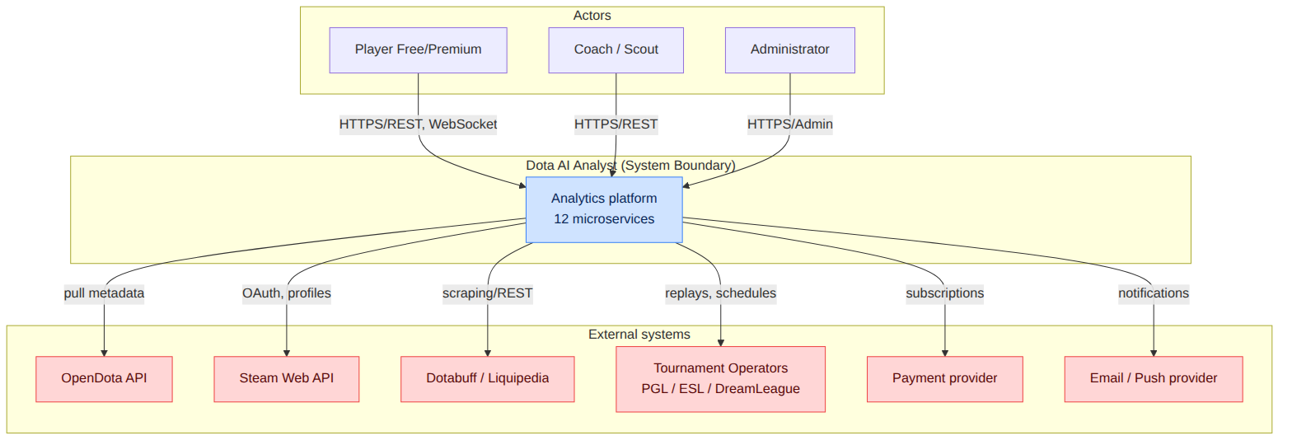

1.4.1. In scope vs. out of scope
In scope | Out of scope
Collection, parsing and storage of matches | Anti-cheat / Valve game-client moderation
Analytics, ML evaluation, AI Coach | Modifying the Dota 2 gameplay
Web interface and visualizations | Native mobile apps (phase 2+)
Subscription billing (via provider) | In-house payment processing
Meta and draft forecasting | Guaranteeing real betting outcomes

1.5. Key user scenarios (Use Cases)

1.5.1. UC-01 — Express analysis of an uploaded replay
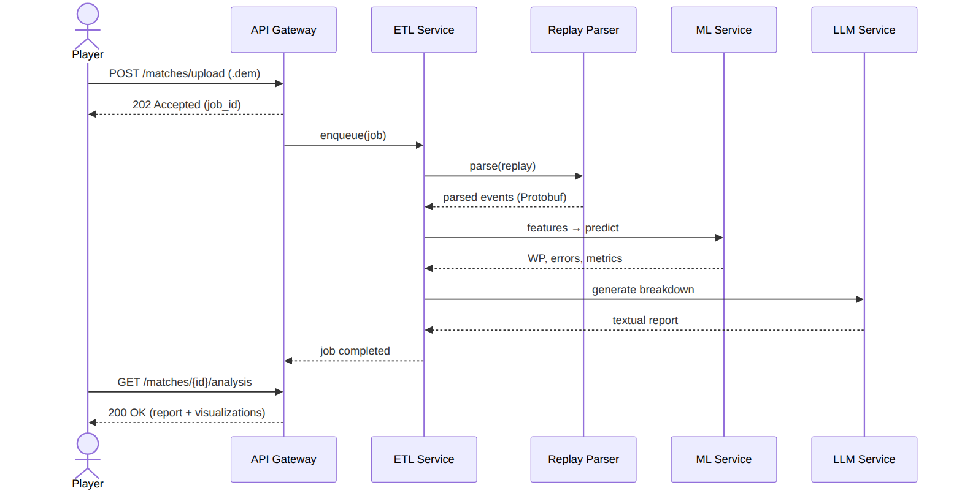
Field | Value
ID | UC-01
Actor | Player (Free/Premium)
Precondition | User authenticated; file is a valid .dem
Main flow | Upload → parse → features → prediction → report
Postcondition | Analysis available in the user’s history
NFR | NFR-PERF-01 (≤ 10 s parsing)

1.5.2. Catalog of main scenarios
ID | Scenario | Primary actor | Related services
UC-01 | Express replay analysis | Player | ETL, Parser, ML, LLM
UC-02 | Real-time draft simulation | Coach | Draft Engine, Meta Engine
UC-03 | Personal training plan | Premium player | Recommendation, ML
UC-04 | Search for similar matches/players | Scout | Similarity Engine
UC-05 | AI Coach report over a game series | Premium player | LLM, Feature Store
UC-06 | Meta-trend monitoring | Analyst | Meta Engine
UC-07 | Live Win Probability for broadcast | Media | ML, API Gateway (WS)
UC-08 | Subscription management | Player | API Gateway, Billing

1.6. Glossary and terminology
Term | Definition
Tick | Discrete frame of game state; Source 2 runs at 30 ticks/s.
.dem | Dota 2 replay file format (Source 2 Demo), a compressed Protobuf message stream.
Win Probability (WP) | Dynamic probability of a team winning at time t.
ΔWP | Increment of WP characterizing the value/mistake of a player’s action.
Safety Index (SI) | Positional risk index of a hero being at a map point.
Draft | The hero pick/ban stage before a match.
Meta | Current balance state: popular heroes, items, strategies.
Feature Store | Centralized feature registry for training and inference.
PSI | Population Stability Index — a data distribution drift metric.
GNN | Graph Neural Network — models hero synergy.
RAG | Retrieval-Augmented Generation.
MMR | Matchmaking Rating.
Last Hit (LH) / Deny (DN) | Killing an allied/enemy creep.
GPM / XPM | Gold / Experience per minute.
Buyback | Instant hero respawn for gold.
Roshan | Key neutral boss granting a strategic advantage.
SLO / SLA / SLI | Service Level Objective / Agreement / Indicator.

1.7. Assumptions, constraints and top-level risks
Type | Statement | Impact
Assumption | Valve keeps the .dem format stable within Source 2 | High
Assumption | External APIs (OpenDota) keep availability and limits | Medium
Constraint | PII processing is governed by GDPR | High
Constraint | Replay parsing is CPU-intensive, requires horizontal scaling | High
Risk | Dota 2 network protocol change via a patch | Requires parser adapters
Risk | Meta drift after a major patch | Model auto-retraining (Ch. 10)
A detailed risk register and mitigation strategies are in Chapter 14.

Chapter 2. Microservice Architecture and Infrastructure

2.1. Global system topology
The platform implements a distributed microservice architecture. Inter-service communication is split into two planes:
- A synchronous high-performance RPC plane based on gRPC — for low-latency request/response calls (e.g. ML inference, similar-match search).
- An asynchronous event pipeline based on Apache Kafka — for streaming processing, service decoupling and resilience under peak load.

2.1.1. Specification of the 12 key microservices
# | Service | Core technology | Workload type | State
1 | API Gateway | Go | I/O-bound | Stateless
2 | Data Collector | Python / Go | I/O-bound | Stateful (scheduler)
3 | Replay Parser | C++ / Go | CPU-bound | Stateless
4 | ETL Service | Python (Faust/Flink) | CPU+I/O | Stateless
5 | Feature Store | Python + Feast | I/O-bound | Stateful
6 | ML Service | Python (PyTorch/LightGBM/XGBoost) | CPU/GPU | Stateless
7 | LLM Service | Python (RAG orchestration) | I/O+GPU | Stateless
8 | Recommendation Engine | Python | CPU-bound | Stateless
9 | Draft Engine | Go / Python | CPU-bound | Stateless
10 | Meta Engine | Python + Graph DB | I/O-bound | Stateful
11 | Similarity Engine | Python + Vector DB | CPU-bound | Stateful
12 | Frontend Service | React + TypeScript / Nginx | I/O-bound | Stateless

2.1.2. Service roles
- API Gateway — the single entry point. Implements routing, authentication (JWT), rate limiting, TLS termination and response aggregation (BFF pattern).
- Data Collector — schedules and collects data from external sources (OpenDota API, Dotabuff, Liquipedia, official APIs of tournament operators PGL, ESL, DreamLeague).
- Replay Parser — an isolated high-performance service performing low-level parsing of binary .dem files.
- ETL Service — validation, cleaning, normalization of parsed data and routing to ClickHouse and PostgreSQL.
- Feature Store — a centralized feature registry serving ML models in real time and building training datasets.
- ML Service — a containerized runtime for predictive models (PyTorch, LightGBM, XGBoost).
- LLM Service — orchestration of large language models and a RAG architecture to generate AI Coach textual reports.
- Recommendation Engine — builds personal training plans and selects learning materials from a player profile.
- Draft Engine — real-time simulation of the hero pick/ban stage.
- Meta Engine — a graph analytics module tracking win-rate trends, strategy popularity and object distribution.
- Similarity Engine — search for spatiotemporal and strategic analogies in the historical match database.
- Frontend Service — a React + TypeScript SPA served behind a resilient Nginx cluster.

2.2. Container diagram (C4 — Level 2)
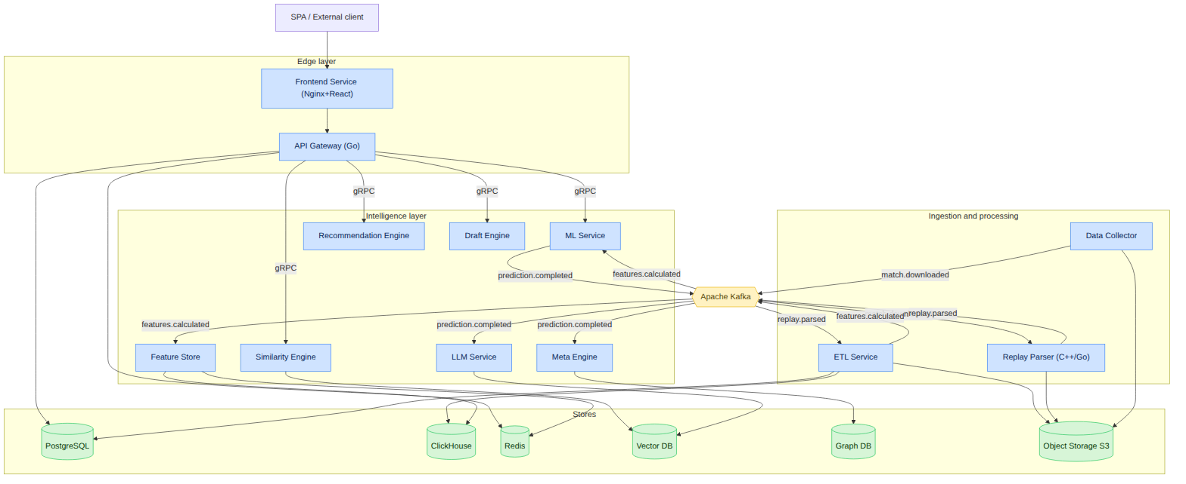

2.3. Inter-service communication and message queues
Asynchronous communication is implemented over the Apache Kafka data bus. The main topics and event types are captured in the table below.

2.3.1. Kafka topic registry
Topic | Producer | Consumers | Payload format | Partitions | Retention
match.downloaded | Data Collector | Replay Parser | JSON: match ID, .dem URL, tournament metadata | 24 | 7 days
replay.parsed | Replay Parser | ETL Service | Protobuf: binary stream of tick events | 48 | 3 days
features.calculated | ETL Service | Feature Store, ML Service | Avro: aggregated feature vectors by window | 24 | 14 days
prediction.completed | ML Service | LLM Service, Meta Engine | JSON: probability matrices, error IDs, anomaly vectors | 12 | 14 days
report.generated | LLM Service | API Gateway (notify) | JSON: report ID, link, summary | 6 | 7 days
meta.updated | Meta Engine | Draft Engine, Frontend | JSON: meta snapshot, win-rate deltas | 3 | 30 days
dlq.parser | Replay Parser | Ops monitoring | JSON: failure reason, payload | 6 | 30 days

2.3.2. Message standards
- Partition key — match_id (guarantees per-match ordering).
- Headers — trace_id, schema_version, producer, timestamp, content_type.
- Schema management — Confluent Schema Registry; BACKWARD compatibility.
- Serialization — Avro for analytics, Protobuf for high-frequency streams, JSON for control events.

2.3.3. Event envelope
{
"event_id": "e2b1c9a4-6f0d-4b1a-9c5e-1f2a3b4c5d6e",
"event_type": "replay.parsed",
"schema_version": "1.3.0",
"trace_id": "9f8e7d6c-...",
"occurred_at": "2026-07-13T10:22:31.114Z",
"producer": "replay-parser@2.0.0",
"partition_key": "match_id:7654321098",
"payload": { "...": "..." }
}

2.4. Synchronous plane: gRPC
Internal RPC calls use gRPC over HTTP/2 with mTLS. Contracts are defined in Protobuf files (see the proto appendix).

2.4.1. gRPC dependency matrix
Caller | Callee | RPC method | Timeout | Retries
API Gateway | ML Service | Predict | 2 s | 1
API Gateway | Similarity Engine | FindSimilar | 2 s | 2
API Gateway | Draft Engine | SimulateDraft | 1.5 s | 1
API Gateway | Recommendation | BuildPlan | 2 s | 1
ETL Service | Feature Store | WriteFeatures | 3 s | 3
ML Service | Feature Store | GetOnlineFeatures | 500 ms | 2
LLM Service | Similarity Engine | RetrieveContext | 2 s | 1

2.4.2. Resilience policies
Mechanism | Implementation | Parameters
Circuit breaker | gRPC interceptor | 50% error threshold / 10 s window
Retry with backoff | exponential + jitter | base 100 ms, max 3 attempts
Deadline propagation | gRPC context | inherited from incoming request
Bulkhead | per-dependency connection pool | max 100 conn/service
Rate limiting | token bucket at Gateway | per user and per endpoint

2.5. Architectural patterns
Pattern | Where applied | Why
API Gateway / BFF | Edge layer | Single entry point, aggregation, security
Database per Service | All stateful services | Schema isolation, independent deploys
Event-driven / Pub-Sub | Data pipeline | Decoupling, resilience, scaling
CQRS | Analytics vs. transactions | PostgreSQL (write) / ClickHouse (read-heavy)
Saga (choreography) | Match processing pipeline | Long distributed processes without 2PC
Outbox | ETL, Data Collector | Atomic DB write and event publish
Sidecar | All pods | mTLS, metrics, tracing (service mesh)
Strangler Fig | Multi-game extension | Gradual replacement of Dota specifics with abstractions
Anti-Corruption Layer | External API integration | Protect the core from foreign data models

2.5.1. Match-processing saga (choreography)
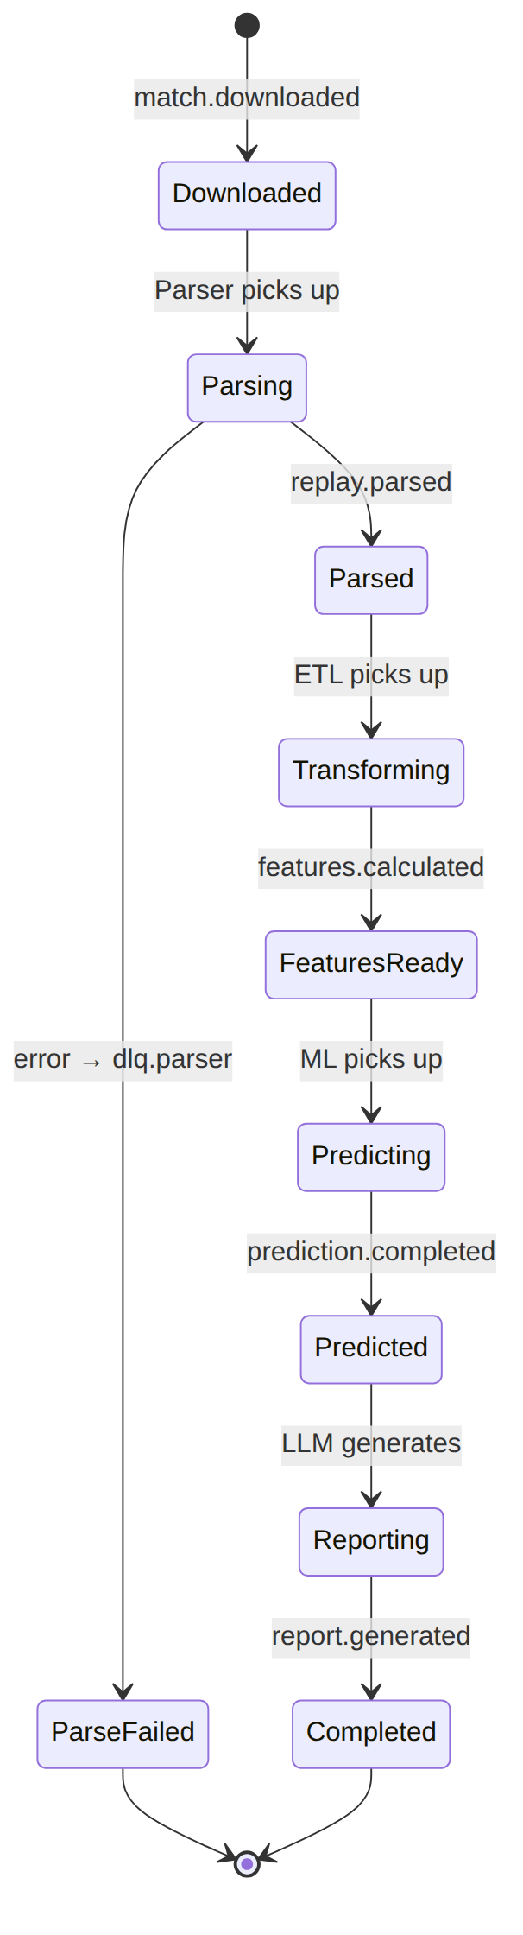

2.6. Infrastructure landscape

2.6.1. Infrastructure technology stack
Layer | Technology | Purpose
Orchestration | Kubernetes | Container management
Service Mesh | Istio / Linkerd | mTLS, tracing, traffic management
Ingress | Nginx Ingress / Envoy | TLS termination, routing
Message broker | Apache Kafka (KRaft) | Event pipeline
Schema Registry | Confluent Schema Registry | Avro/Protobuf schema management
Cache | Redis Cluster | Online features, sessions, rate-limit
OLTP | PostgreSQL (Patroni HA) | Transactional data
OLAP | ClickHouse (sharded) | Analytical queries
Vector DB | Qdrant / Milvus | Embeddings for Similarity/RAG
Graph DB | Neo4j / JanusGraph | Hero synergy graph
Object Storage | S3-compatible (MinIO) | Replays, model artifacts
Workflow | Apache Airflow | Batch pipelines and retraining
IaC | Terraform + Helm | Provisioning and deployment
Secrets | Vault / Sealed Secrets | Secret management
CI/CD | GitHub Actions + ArgoCD | Build and GitOps deploy
Observability | Prometheus, Grafana, Loki, Tempo | Metrics, logs, traces

2.6.2. Environment matrix
Environment | Purpose | Data | Scale
dev | Local development | Synthetic/sample | 1 replica/service
staging | Pre-release validation | Anonymized prod slice | ~30% of prod
production | Live operation | Full data | Autoscaling
ml-training | Model training | DVC datasets | GPU nodes on demand

2.7. Design principles and ADRs
Key architectural decisions are recorded as Architecture Decision Records (ADRs) in docs/adr/. Overview of the main decisions:
ADR | Decision | Rationale
ADR-001 | Kafka as the main event bus | High throughput, retention, replay
ADR-002 | ClickHouse for replay events | Columnar storage, aggregation speed
ADR-003 | gRPC for internal calls | Latency, strict contracts, streaming
ADR-004 | Parser in C++/Go | CPU efficiency of binary stream parsing
ADR-005 | Feast as Feature Store | Unified online/offline feature registry
ADR-006 | Istio service mesh | mTLS and observability without code changes
ADR-007 | Core abstraction for Multi-game | NFR-EXT-01, porting to Deadlock/LoL
Detailed responsibilities, SLOs and the internal structure of each service are covered in Chapter 3.

Chapter 3. Detailed Microservice Specifications
Each service is described using a single template: purpose, responsibilities, technology stack, input/output interfaces, data ownership, dependencies, scaling strategy, service level objectives (SLOs) and failure modes.

3.1. Common template and summary matrix

3.1.1. Service summary matrix
Service | Language/runtime | Protocols | Owns data | Key SLO
API Gateway | Go | REST, WS, gRPC-client | — | p95 ≤ 300 ms
Data Collector | Python/Go | REST-client, Kafka | Source registry | Collection completeness ≥ 99%
Replay Parser | C++/Go | Kafka, gRPC | — (stateless) | ≤ 10 s/replay
ETL Service | Python | Kafka, gRPC | Staging tables | Lag ≤ 30 s
Feature Store | Python+Feast | gRPC, Redis, CH | Feature registry | GetOnline p95 ≤ 50 ms
ML Service | Python | gRPC, Kafka | Model artifacts | Predict p95 ≤ 400 ms
LLM Service | Python | gRPC, Kafka, REST | Prompts, RAG cache | Report ≤ 8 s
Recommendation | Python | gRPC | Training plans | BuildPlan ≤ 2 s
Draft Engine | Go/Python | gRPC | Draft cache | SimulateDraft ≤ 1.5 s
Meta Engine | Python+Graph | gRPC, Kafka | Meta graph | Update ≤ 24 h
Similarity Engine | Python+Vector | gRPC | Embedding index | FindSimilar ≤ 2 s
Frontend Service | React/Nginx | HTTPS | — | LCP ≤ 2.5 s

3.1.2. Service × store matrix (CRUD)
Service / Store | PostgreSQL | ClickHouse | Redis | Vector DB | Graph DB | S3 | Kafka
API Gateway | R | — | RW | — | — | — | —
Data Collector | RW | — | R | — | — | W | P
Replay Parser | — | — | — | — | — | RW | P/C
ETL Service | RW | W | — | — | — | R | P/C
Feature Store | — | R | RW | — | — | — | C
ML Service | — | R | R | — | — | R | P/C
LLM Service | R | — | R | R | — | — | C
Recommendation | R | R | R | R | — | — | —
Draft Engine | R | R | RW | — | R | — | C
Meta Engine | R | R | — | — | RW | — | P/C
Similarity Engine | — | R | R | RW | — | — | —
R — read, W — write, P — Kafka producer, C — Kafka consumer.

3.2. API Gateway
Attribute | Value
Purpose | Single entry point for all external clients.
Technologies | Go, Gin/Fiber, gRPC client, Redis.
Type | Stateless, horizontally scalable.
Responsibilities:
- TLS 1.3 termination and proxying to internal services.
- Authentication (JWT validation) and authorization (RBAC checks).
- Rate limiting (token bucket) per user, IP and endpoint.
- Response aggregation (BFF) for composite frontend screens.
- WebSocket connection management for live updates (WP, draft).
- Propagating trace_id and collecting latency metrics.
Main endpoints (overview; full contract in Ch. 7):
Method | Path | Purpose
POST | /api/v1/matches/upload | Upload replay
GET | /api/v1/matches/{id}/analysis | Analysis result
POST | /api/v1/draft/simulate | Draft simulation
GET | /api/v1/players/{id}/profile | Player profile
POST | /api/v1/similarity/search | Similar search
WS | /api/v1/live/{match_id} | Live win probability
SLO: availability ≥ 99.95%, p95 ≤ 300 ms, error rate < 0.1%.
Failure modes: on downstream unavailability — graceful degradation (partial response + partial: true flag), circuit breaker, cache fallback.

3.3. Data Collector
Attribute | Value
Purpose | Scheduling and collecting data from external sources.
Technologies | Python (APScheduler/Celery) or Go, HTTP clients, S3.
Type | Stateful (stores cursors/schedules).
Responsibilities:
- Periodic polling of OpenDota, Dotabuff, Liquipedia, tournament operator APIs.
- Deduplicating matches by match_id and idempotency keys.
- Downloading .dem into Object Storage, publishing match.downloaded.
- Respecting external API limits (adaptive rate limiting, backoff).
- Anti-Corruption Layer: mapping foreign models to the internal schema.
Collection strategies:
Source | Mode | Frequency | Notes
OpenDota | pull (REST) | every 5 min | pagination by seq_num
Tournament Operators | webhook + pull | on event | priority queue
Dotabuff | scraping/REST | hourly | polite rate limit
Liquipedia | REST/MediaWiki | daily | rosters, schedules
SLO: public match collection completeness ≥ 99%, new-match detection lag ≤ 10 min.

3.4. Replay Parser
Attribute | Value
Purpose | Low-level parsing of binary .dem files (Source 2 Demo).
Technologies | C++17 (core) + Go (wrapper/gRPC), Protobuf.
Type | Stateless, CPU-bound, vertically boosted.
Responsibilities:
- Decoding the compressed Protobuf message stream and networked entities.
- Extracting positions, economy, combat events, map vision (see Ch. 5).
- Serializing the normalized event stream to Protobuf → replay.parsed.
- Handling corrupted files → dlq.parser.
Key NFRs: NFR-PERF-01 (≤ 10 s per 40-min replay), NFR-PERF-04 (≥ 2000 replays/h per cluster).
Internal submodules:
Module | Responsibility
DemoReader | Reading frames, decompression (snappy/LZ4)
EntityDecoder | Decoding networked entities and delta updates
StringTables | Parsing string tables (heroes, items)
EventExtractor | Combat log, purchases, wards, abilities
Serializer | Building the output Protobuf stream
SLO: parse success ≥ 99.5%, parse-time p95 ≤ 10 s.

3.5. ETL Service
Attribute | Value
Purpose | Validation, cleaning, normalization and routing of data.
Technologies | Python (Faust/Flink), Great Expectations, Avro.
Type | Stateless stream processor.
Responsibilities:
- Consuming replay.parsed, deduplication and data-quality validation (see Ch. 5.4).
- Enrichment (join with match/player metadata).
- Windowed feature aggregation (temporal windows) → features.calculated.
- Writing raw events to ClickHouse and structured entities to PostgreSQL.
- Implementing the Outbox pattern for atomic write and publish.
SLO: end-to-end processing lag ≤ 30 s (p95), share of dropped “dirty” records < 0.5%.

3.6. Feature Store
Attribute | Value
Purpose | Centralized feature registry (online/offline).
Technologies | Python + Feast, Redis (online), ClickHouse (offline).
Type | Stateful.
Responsibilities:
- Registering feature definitions (feature views) and their versions.
- Online serving (GetOnlineFeatures) with p95 ≤ 50 ms latency.
- Building training datasets with point-in-time correctness (no leakage).
- Monitoring feature freshness and coverage.
Feature categories (overview):
Group | Examples | Update
Laning | LH@5, DN@5, farm deviation | per match
Economy | GPM, XPM, net worth timeline | per window
Positioning | average position, Safety Index | per window
Draft | hero embeddings, synergy | per patch
Player | historical win rate, MMR | daily
SLO: GetOnlineFeatures p95 ≤ 50 ms, online feature freshness ≤ 1 min.

3.7. ML Service
Attribute | Value
Purpose | Executing predictive models.
Technologies | Python, PyTorch, LightGBM, XGBoost, Triton/ONNX Runtime.
Type | Stateless, CPU/GPU.
Responsibilities:
- Loading model versions from the Model Registry (MLflow).
- Inference: Win Probability, Laning Evaluator, Draft Predictor, Error Detection.
- Publishing prediction.completed.
- A/B and shadow model deploys, collecting production quality metrics.
Served models (details in Ch. 6):
Model | Algorithm | Task
Win Probability | ensemble (GBDT+NN) | probability regression
Laning Evaluator | XGBoost Regressor | laning evaluation
Draft Predictor | GNN (PyTorch) | draft win-rate prediction
Error Detection | LightGBM Classifier | error classification
SLO: Predict p95 ≤ 400 ms, availability ≥ 99.9%.

3.8. LLM Service
Attribute | Value
Purpose | Generating AI Coach textual breakdowns via RAG.
Technologies | Python, LLM orchestrator, Vector DB, prompt cache.
Type | Stateless, I/O+GPU.
Responsibilities:
- Building RAG context: retrieving relevant match/meta facts from the Vector DB.
- Prompt templating and calling the LLM with cost/latency limits.
- Post-processing: structuring the report, fact validation (guardrails).
- Caching responses by request signature.
RAG pipeline:
SLO: report generation ≤ 8 s (p95), share of guardrail-rejected reports < 2%.

3.9. Recommendation Engine
Attribute | Value
Purpose | Personal training plans and material selection.
Technologies | Python, hybrid (collaborative + content-based + rule).
Type | Stateless.
Responsibilities:
- Analyzing a player’s weakness profile (from Error Detection and metrics).
- Building a prioritized plan of exercises/materials.
- Ranking learning content by relevance and skill level.
SLO: BuildPlan p95 ≤ 2 s, recommendation coverage ≥ 95% of active players.

3.10. Draft Engine
Attribute | Value
Purpose | Real-time pick/ban simulation.
Technologies | Go/Python, Redis cache, GNN inference (via ML Service).
Type | Stateless, CPU-bound.
Responsibilities:
- Step-by-step draft simulation accounting for bans, synergy and counter-picks.
- Recommending the next pick/ban with an expected win-rate estimate.
- Accounting for the current meta (from Meta Engine) and patch.
SLO: SimulateDraft p95 ≤ 1.5 s, recommendation stability across calls.

3.11. Meta Engine
Attribute | Value
Purpose | Tracking global meta trends.
Technologies | Python, Graph DB (Neo4j/JanusGraph), Airflow.
Type | Stateful.
Responsibilities:
- Building and updating the hero synergy/counter-pick graph.
- Computing win-rate and popularity trends by patch and rank.
- Publishing meta.updated for Draft Engine and Frontend.
SLO: meta snapshot update ≤ 24 h after data availability, graph consistency.

3.12. Similarity Engine
Attribute | Value
Purpose | Search for spatiotemporal and strategic analogies.
Technologies | Python, Vector DB (Qdrant/Milvus), ANN indexes (HNSW).
Type | Stateful.
Responsibilities:
- Indexing embeddings of matches/players/situations.
- ANN search for similar matches and players by feature vector.
- Serving RAG retrieval for the LLM Service.
SLO: FindSimilar p95 ≤ 2 s, recall@10 ≥ 0.9 vs. exact search.

3.13. Frontend Service
Attribute | Value
Purpose | Delivering the SPA and static assets.
Technologies | React + TypeScript, Zustand, Nginx.
Type | Stateless.
Responsibilities:
- Serving the built SPA bundle and assets via CDN/Nginx.
- Interactive 2D map (Canvas/WebGL), radar profiles, dashboards.
- Managing client state and WebSocket subscriptions.
SLO: LCP ≤ 2.5 s, TTI ≤ 3.5 s, static availability ≥ 99.95%. Frontend details are in Chapter 8.

3.14. Service degradation matrix
Failed service | User impact | Degradation strategy
ML Service | No fresh predictions | Serve cache + “updating” banner
LLM Service | No textual breakdown | Show metrics without narrative
Similarity Engine | No “similar” | Hide block, core still works
Draft Engine | No live simulation | Static meta recommendations
Meta Engine | Stale meta | Use last snapshot
Feature Store (online) | Slow inference | Fallback to offline features
Data Collector | No new matches | Process the accumulated queue

Chapter 4. Data Storage Architecture and Feature Store

4.1. Storage strategy (Polyglot Persistence)
The platform uses polyglot persistence: each workload type is served by a specialized store. Separation of reads and writes implements the CQRS pattern.
Store | Model | Workload | Data
PostgreSQL | Relational (OLTP) | ACID transactions | Players, accounts, matches, subscriptions
ClickHouse | Columnar (OLAP) | Analytics, aggregations | Replay events, time series
Redis | Key-value | Cache, online features | Sessions, rate-limit, online features
Vector DB | Vector (ANN) | Similarity/RAG | Match/player embeddings
Graph DB | Graph | Relationship traversal | Hero synergy graph
Object Storage | BLOB | Large objects | .dem files, model artifacts

4.2. Relational layer (PostgreSQL DDL)
The relational database stores structured entities requiring ACID transactions, uniqueness control and strict relational links.
-- Base enumerations (Enums)
CREATE TYPE match_tier AS ENUM ('Pub', 'Premium', 'Professional', 'Tournament');
CREATE TYPE lane_position AS ENUM ('Safe_Safe', 'Safe_Mid', 'Mid', 'Off_Safe', 'Off_Mid', 'Roaming');
CREATE TYPE subscription_status AS ENUM ('active', 'past_due', 'canceled', 'trialing');
-- Players table
CREATE TABLE Players (
player_id BIGINT PRIMARY KEY,
steam_id_64 VARCHAR(20) UNIQUE NOT NULL,
nickname VARCHAR(100) NOT NULL,
avatar_url TEXT,
registered_at TIMESTAMP WITH TIME ZONE DEFAULT NOW(),
updated_at TIMESTAMP WITH TIME ZONE DEFAULT NOW()
);
-- Platform accounts table
CREATE TABLE Accounts (
account_id UUID PRIMARY KEY DEFAULT gen_random_uuid(),
player_id BIGINT REFERENCES Players(player_id) ON DELETE CASCADE,
email VARCHAR(255) UNIQUE NOT NULL,
password_hash VARCHAR(255) NOT NULL,
current_mmr INT DEFAULT 0,
behavior_score INT DEFAULT 10000,
is_active BOOLEAN DEFAULT TRUE,
created_at TIMESTAMP WITH TIME ZONE DEFAULT NOW()
);
-- Matches table
CREATE TABLE Matches (
match_id BIGINT PRIMARY KEY,
tournament_id INT,
duration_seconds INT NOT NULL,
radiant_win BOOLEAN NOT NULL,
game_mode INT NOT NULL,
lobby_type INT NOT NULL,
start_time TIMESTAMP WITH TIME ZONE NOT NULL,
tier match_tier DEFAULT 'Pub',
cluster_id INT NOT NULL,
patch_version VARCHAR(16)
);
-- Match participants (M:N junction table)
CREATE TABLE MatchPlayers (
match_id BIGINT REFERENCES Matches(match_id) ON DELETE CASCADE,
player_id BIGINT REFERENCES Players(player_id) ON DELETE RESTRICT,
hero_id INT NOT NULL,
player_slot INT NOT NULL,
kills INT DEFAULT 0,
deaths INT DEFAULT 0,
assists INT DEFAULT 0,
gold_per_min INT NOT NULL,
xp_per_min INT NOT NULL,
lane lane_position,
PRIMARY KEY (match_id, player_id)
);
-- Tournaments
CREATE TABLE Tournaments (
tournament_id INT PRIMARY KEY,
name VARCHAR(200) NOT NULL,
operator VARCHAR(50),
prize_pool_usd BIGINT,
start_date DATE,
end_date DATE
);
-- Subscriptions
CREATE TABLE Subscriptions (
subscription_id UUID PRIMARY KEY DEFAULT gen_random_uuid(),
account_id UUID REFERENCES Accounts(account_id) ON DELETE CASCADE,
status subscription_status NOT NULL DEFAULT 'trialing',
plan_code VARCHAR(50) NOT NULL,
started_at TIMESTAMP WITH TIME ZONE DEFAULT NOW(),
renews_at TIMESTAMP WITH TIME ZONE
);
-- Analysis jobs
CREATE TABLE AnalysisJobs (
job_id UUID PRIMARY KEY DEFAULT gen_random_uuid(),
account_id UUID REFERENCES Accounts(account_id),
match_id BIGINT,
status VARCHAR(20) NOT NULL DEFAULT 'queued',
replay_url TEXT,
created_at TIMESTAMP WITH TIME ZONE DEFAULT NOW(),
completed_at TIMESTAMP WITH TIME ZONE
);
-- Indexes
CREATE INDEX idx_matches_start_time ON Matches (start_time DESC);
CREATE INDEX idx_matches_tier ON Matches (tier);
CREATE INDEX idx_matchplayers_hero ON MatchPlayers (hero_id);
CREATE INDEX idx_jobs_account_status ON AnalysisJobs (account_id, status);

4.2.1. Key table dictionary
Table | Purpose | Cardinality (estimate)
Players | Steam players | ~50M
Accounts | Platform accounts | ~1M
Matches | Matches | > 100M
MatchPlayers | Participants (10 per match) | > 1B
Tournaments | Tournaments | ~10K
Subscriptions | Subscriptions | ~1M
AnalysisJobs | Analysis jobs | tens of millions

4.3. ER diagram of the relational model
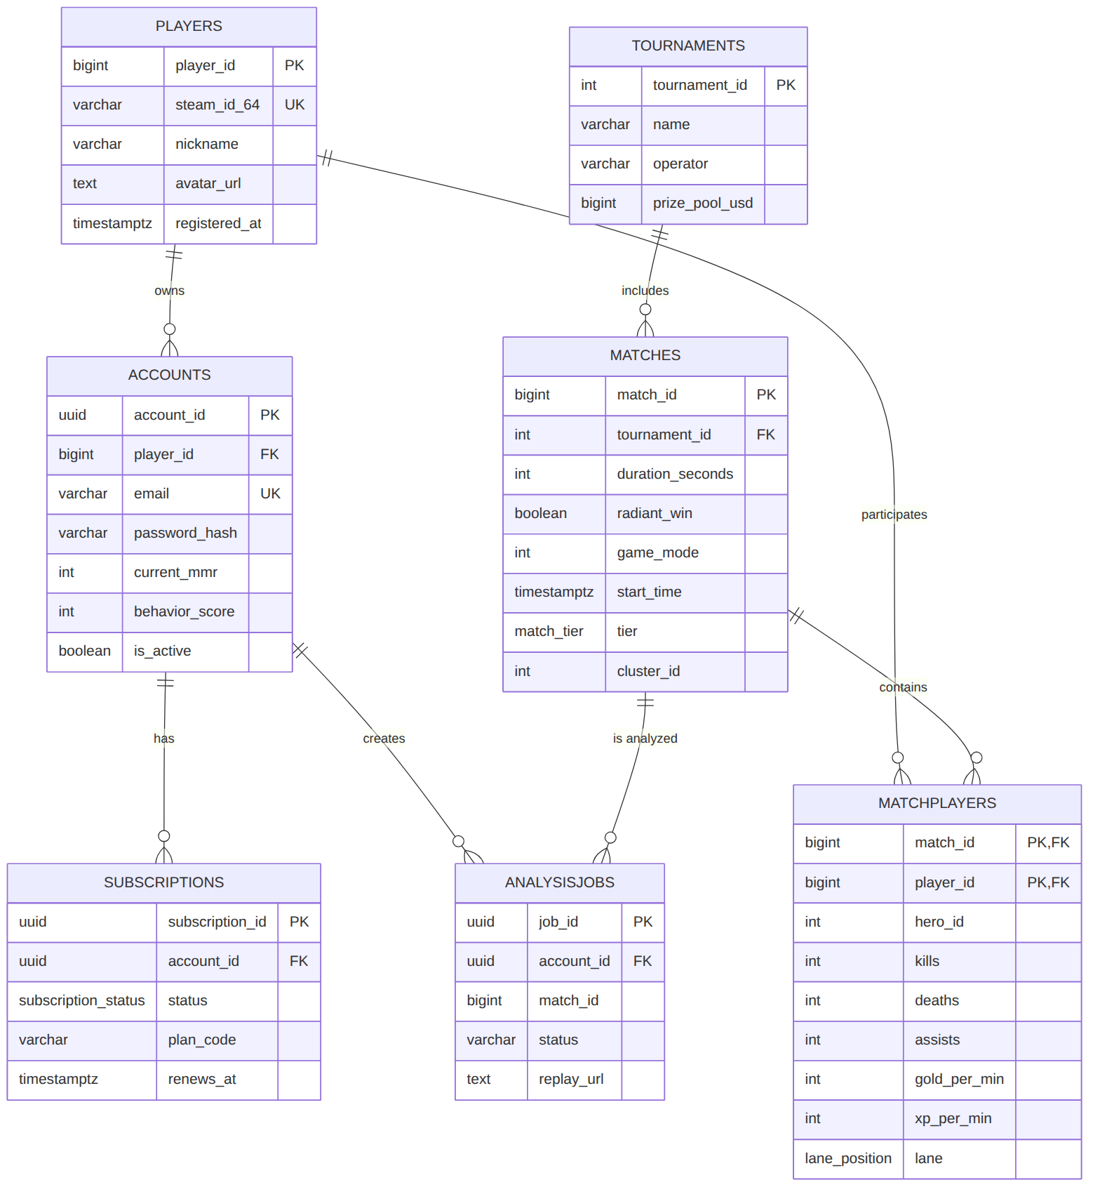

4.4. Analytical layer (ClickHouse)
ClickHouse is used for columnar storage of high-intensity event streams from replays. The schema is optimized for aggregating spatial coordinates.
CREATE TABLE default.ReplayEvents (
match_id UInt64,
tick UInt32,
game_time Int32,
event_type Enum8('DAMAGE'=1, 'HEAL'=2, 'KILL'=3, 'ABILITY_CAST'=4,
'ITEM_PURCHASE'=5, 'WARD_PLACE'=6),
player_id UInt64,
target_id UInt64,
x Float32,
y Float32,
z Float32,
value_amount Int32,
inflictor String
) ENGINE = ReplacingMergeTree()
PARTITION BY toYYYYMM(FROM_UNIXTIME(game_time))
ORDER BY (match_id, event_type, tick, player_id);

4.4.1. Additional analytical tables
-- Per-player economy time series (for WP and net worth charts)
CREATE TABLE default.EconomyTimeline (
match_id UInt64,
player_id UInt64,
game_time Int32,
net_worth Int32,
total_gold Int32,
total_xp Int32,
lh UInt16,
dn UInt16
) ENGINE = MergeTree()
PARTITION BY toYYYYMM(FROM_UNIXTIME(game_time))
ORDER BY (match_id, player_id, game_time);
-- Positions for heatmaps (downsampled)
CREATE TABLE default.PositionSnapshots (
match_id UInt64,
player_id UInt64,
game_time Int32,
x Float32,
y Float32,
is_alive UInt8
) ENGINE = MergeTree()
PARTITION BY toYYYYMM(FROM_UNIXTIME(game_time))
ORDER BY (match_id, game_time, player_id);
-- Materialized view of hero win rate by patch
CREATE MATERIALIZED VIEW default.HeroWinrateMV
ENGINE = SummingMergeTree()
ORDER BY (patch_version, hero_id)
AS SELECT
patch_version, hero_id,
countIf(won) AS wins,
count() AS games
FROM default.HeroMatchResults
GROUP BY patch_version, hero_id;

4.4.2. ClickHouse modeling principles
Principle | Implementation
Partitioning | by month (toYYYYMM) for efficient TTL
Sorting (ORDER BY) | by frequent filters: match_id, event_type
Deduplication | ReplacingMergeTree by sort key
Pre-aggregation | Materialized Views (SummingMergeTree)
TTL | raw events — 18 months, aggregates — indefinite
Sharding | by match_id (Distributed tables)
Compression codecs | Delta, DoubleDelta, ZSTD for time series

4.5. Feature Store
The Feature Store (based on Feast) provides unified access to features for training (offline) and inference (online), guaranteeing no training/serving skew.

4.5.1. Feature Store architecture
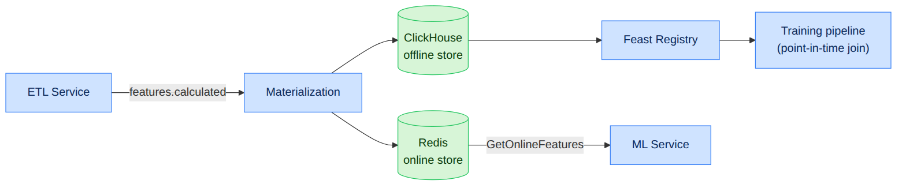

4.5.2. Feature View registry
Feature View | Entity | Features | Online | TTL
laning_fv | (match_id, player_id) | lh_5, dn_5, dmg_5, consumables_5 | yes | 90 d
economy_fv | (match_id, player_id) | gpm, xpm, nw_10, nw_20 | yes | 90 d
position_fv | (match_id, player_id, window) | avg_x, avg_y, safety_index | yes | 30 d
draft_fv | (patch, hero_id) | hero_embedding, synergy_vec | yes | per patch
player_fv | (player_id) | hist_winrate, mmr, main_role | yes | 1 d

4.5.3. Correctness guarantees
Guarantee | Mechanism
No data leakage | Point-in-time correct join on event_timestamp
Online feature freshness | Materialization ≤ 1 min after features.calculated
Versioning | Each feature view is versioned; changes via PR
Drift detection | PSI on key features (see Ch. 10)

4.6. Data lifecycle management
Category | Store | Retention | Action on expiry
.dem files | S3 | 90 days (Pub), indefinite (Pro) | archive/delete
Raw events | ClickHouse | 18 months | TTL DROP
Aggregates/MVs | ClickHouse | indefinite | —
Online features | Redis | 24 hours | eviction
PII (accounts) | PostgreSQL | until deletion request | GDPR erasure
Model artifacts | S3 + MLflow | per version policy | archiving

4.6.1. Backup and recovery
Store | Strategy | RPO | RTO
PostgreSQL | WAL archiving + PITR | ≤ 5 min | ≤ 30 min
ClickHouse | incremental backups to S3 | ≤ 1 h | ≤ 2 h
Vector/Graph DB | snapshots | ≤ 6 h | ≤ 2 h
S3 | versioning + replication | ≈ 0 | ≤ 15 min

Chapter 5. Data Processing Module and Replay Parser

5.1. Specification of low-level .dem parsing
Dota 2 replay files (Source 2 Demo format) are a compressed stream of messages packed with Google Protocol Buffers. The parser reads ticks and networked entities.

5.1.1. Extracted data categories
Data category | Extraction and processing method | Frequency / Trigger
Object coordinates | Reading networked properties m_cellX, m_cellY, m_vecOrigin for every active unit (heroes, creeps, wards, summoned units). | Every 3rd tick (~100 ms)
Vision (map awareness) | Tracking CDOTA_NPC_Observer_Ward and CDOTA_NPC_Sentry_Ward. Computing the visibility polygon accounting for terrain height (Grid Nav). | On entity creation/destruction
Player economy | Reading m_iTotalEarnedGold, m_iCurrentGold, m_iTotalEarnedXP from the player data table. | Every second (every 30th tick)
Combat events | Parsing the combat log: damage, healing, deaths, ability and item usage. | On combat-log event
Item purchases | DOTA_COMBATLOG_PURCHASE events and inventory changes. | On event
Abilities | Casts, skill levels, cooldowns from entity properties. | On event / change
Objectives | Tower/barracks destruction, Roshan, runes. | On event

5.1.2. Source 2 Demo format (structure)
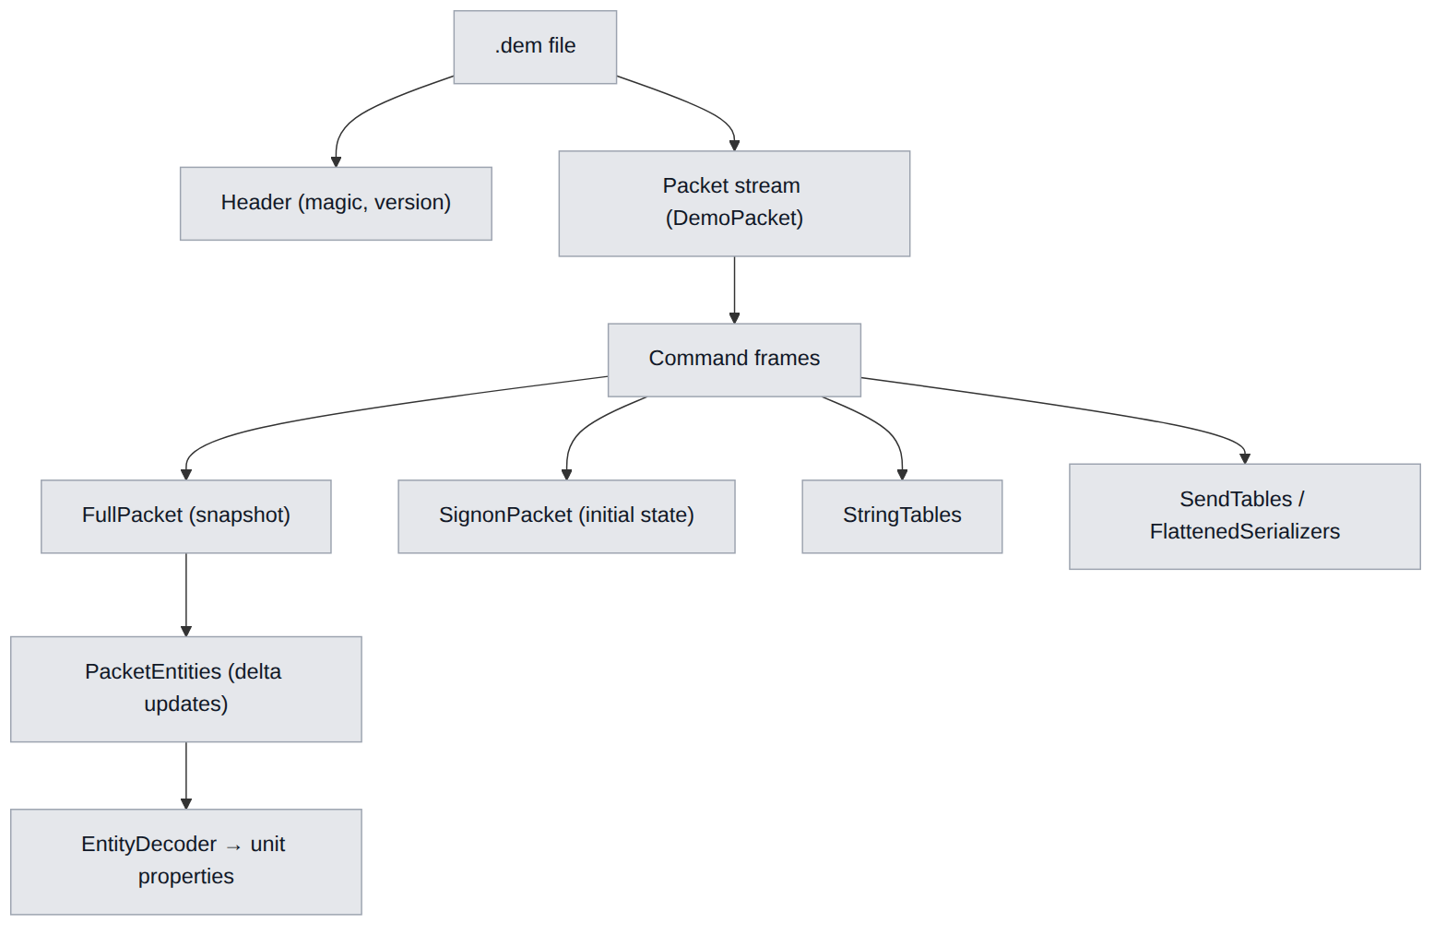

5.1.3. Internal parser pipeline
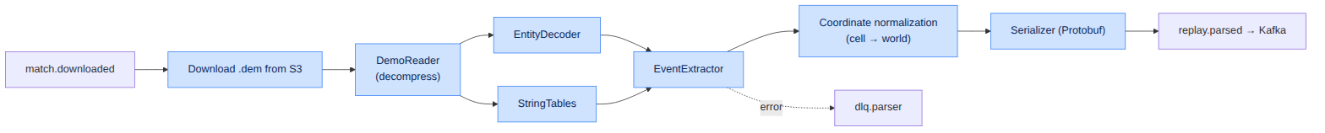

5.2. Coordinate transformation
Source 2 stores coordinates in a cell system (cell + offset). World coordinates are computed as:
$$x_{world}=(cell_{x}−2^{n−1})⋅S_{cell}+offset_{x}$$
$$y_{world}=(cell_{y}−2^{n−1})⋅S_{cell}+offset_{y}$$
where $S_{cell}=128$ units is the cell size, $n$ is the bit width of cell coordinates, and $offset$ is the fractional offset within the cell (m_vecOrigin). The resulting world coordinates are then projected into minimap coordinates for heatmaps.
Parameter | Value
Cell size S_cell | 128 game units
Full map size | ~16384 × 16384 units
Position sampling rate | every 3rd tick (~10 Hz)
Heatmap downsampling | to ~1 Hz on save

5.3. Output event specification (Protobuf)
The parser serializes the normalized stream into the Protobuf message ParsedReplay.
syntax = "proto3";
package dota.replay.v1;
message ParsedReplay {
uint64 match_id = 1;
uint32 duration_ticks = 2;
repeated PlayerMeta players = 3;
repeated GameEvent events = 4;
ReplayMeta meta = 5;
}
message GameEvent {
uint32 tick = 1;
int32 game_time = 2;
EventType type = 3;
uint64 player_id = 4;
uint64 target_id = 5;
Vec3 position = 6;
int32 value_amount = 7;
string inflictor = 8;
}
message Vec3 { float x = 1; float y = 2; float z = 3; }
enum EventType {
UNKNOWN = 0;
DAMAGE = 1;
HEAL = 2;
KILL = 3;
ABILITY_CAST = 4;
ITEM_PURCHASE = 5;
WARD_PLACE = 6;
POSITION = 7;
ECONOMY = 8;
OBJECTIVE = 9;
}
Mapping of event types to target tables:
EventType | Target ClickHouse table | Comment
DAMAGE/HEAL/KILL | ReplayEvents | combat events
ABILITY_CAST | ReplayEvents | ability casts
ITEM_PURCHASE | ReplayEvents | purchases
WARD_PLACE | ReplayEvents | wards (vision)
POSITION | PositionSnapshots | positions (heatmap)
ECONOMY | EconomyTimeline | economy
OBJECTIVE | ReplayEvents | objectives

5.4. ETL pipeline and data quality
The ETL Service consumes replay.parsed, validates and normalizes the data, then routes it to the stores and publishes aggregated features.

5.4.1. ETL stages
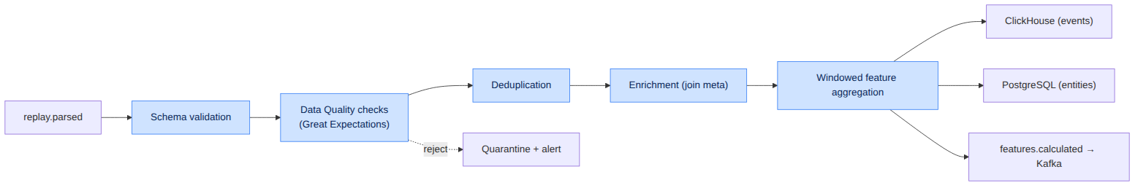

5.4.2. Data quality rules
Rule | Check | Action on violation
DQ-01 | match_id unique and present | reject → quarantine
DQ-02 | duration_seconds in [300, 7200] | flag as suspicious
DQ-03 | exactly 10 players per match | reject
DQ-04 | coordinates within map bounds | clip + flag
DQ-05 | game_time monotonicity | sort/correct
DQ-06 | GPM/XPM ≥ 0 and within sane bounds | flag anomaly
DQ-07 | no tick “gaps” > N | interpolate positions

5.4.3. Windowed feature aggregation
Window | Duration | Features
Laning | 0–10 min | LH/DN@5, damage, consumables, farm deviation
Mid-game | 10–25 min | net worth, rotations, fight participation
Late-game | 25+ min | objective control, teamfight WP deltas
Sliding | 2 min | average position, Safety Index

5.5. Idempotency and error handling
Mechanism | Implementation
Idempotency key | match_id + schema_version
Deduplication | ReplacingMergeTree in CH + upsert in PG
Reprocessing | reprocess endpoint with the same key (no duplicates)
DLQ | dlq.parser with reason and payload
Retries | exponential backoff, max 5 attempts
Poison-pill protection | attempt limit → quarantine + alert

5.5.1. Parse job lifecycle
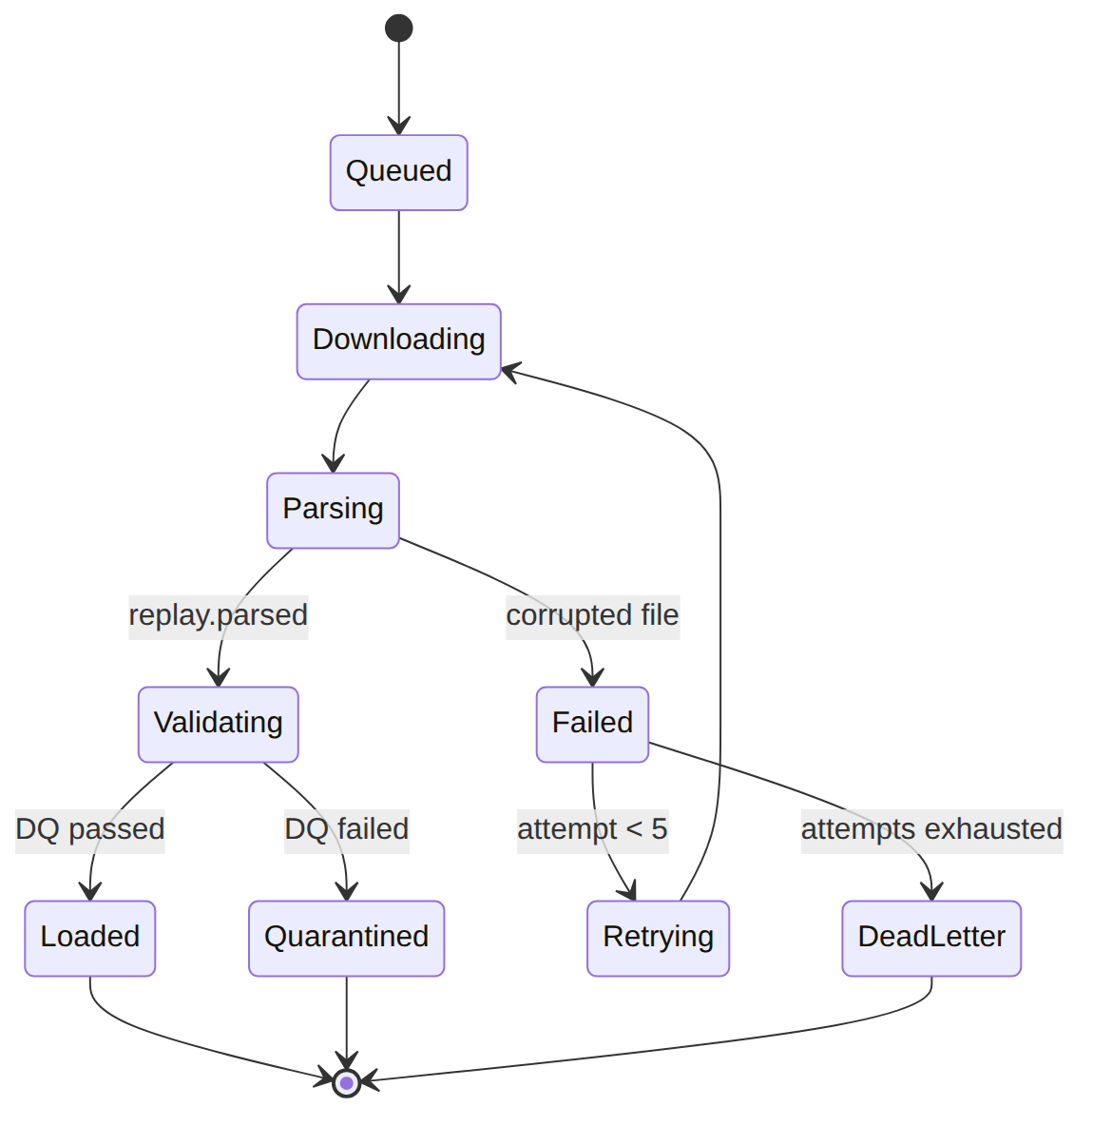

5.6. Parsing performance and scaling
Parameter | Value / strategy
Workload type | CPU-bound
Scaling | Horizontal (Kafka partitions = degree of parallelism)
Target throughput | ≥ 2000 replays/hour per cluster (NFR-PERF-04)
Target time | ≤ 10 s per 40-min replay (NFR-PERF-01)
Autoscaling | HPA on the replay.parsed consumer group lag
Profiling | flamegraph over EntityDecoder hot paths
Optimizations | zero-copy reads, buffer pools, SIMD decoding
Target parser pod resources and HPA policy are described in Chapter 12.

Chapter 6. Mathematical Models, AI and Evaluation Modules

6.1. Mathematical apparatus for game evaluation
The central element of the analytics core is the calculation of the dynamic Win Probability ($WP$) at each discrete time $t$. The change in win probability ($ΔWP$) under a player’s action $A$ determines the value or the fault of that action.

6.1.1. Dynamic Win Probability change
The formula for the dynamic change in win probability:
$$ΔWP(t)=WP(t)−WP(t−Δt)$$
where $WP(t)=f(F_{t},M_{t})$, $F_{t}$ is the match-state feature vector from the Feature Store, and $M_{t}$ is the trained ensemble model.
Interpretation of the increment sign:
Condition | Interpretation | Use
$ΔWP>0$ | Action raised the team’s chances | positive player contribution
$ΔWP<0$ | Action lowered the chances | error candidate
$|ΔWP|>τ$ | Critical moment | highlight in the breakdown
Attribution of the increment to a specific player $p$ is computed as the share of their contribution to the state change:
$$ΔWP_{p}(t)=ΔWP(t)⋅\frac{c_{p}(t)}{\sum_{k=1}^{10}{c_{k}}(t)}$$
where $c_{p}(t)$ is the player’s contribution to the event (damage dealt, kill participation, ward placement, etc.).

6.1.2. Positional risk model (Safety Index)
The positional risk index $SI$ defines how dangerous it is for a hero to be at point $(x,y)$ at time $t$ given no direct line of sight to enemy heroes:
$$SI(x,y,t)=\sum_{i=1}^{5}{P_{alive}}(H_{i})⋅\int_{0}^{D_{max}}{N}​\left(μ_{pos}(H_{i}),σ^{2}⋅Δt\right) ds$$
where:
- $P_{alive}(H_{i})$ — the probability that enemy hero $H_{i}$ is alive;
- $N(μ_{pos}(H_{i}),σ^{2}⋅Δt)$ — the probability density of the enemy’s spatial position distribution, computed from their last known position, movement speed and available teleports;
- $D_{max}$ — the maximum distance the enemy can cover within interval $Δt$.
Symbol | Meaning | Source
$P_{alive}(H_{i})$ | enemy alive probability | death/respawn timings
$μ_{pos}(H_{i})$ | expected enemy position | last vision + speed
$σ$ | position uncertainty | grows with time out of vision
$Δt$ | time since last vision | from combat/vision logs
$D_{max}$ | reach radius | speed + TP scrolls

6.1.3. Other derived metrics
Metric | Formula / definition | Purpose
Farm Efficiency | $FE=\frac{GPM_{actual}}{GPM_{ideal}(hero,t)}$ | farm evaluation
Lane Deviation | RMS deviation of the trajectory from the ideal | laning evaluation
Map Control | share of map area under team vision | map control
Tempo | rate of net worth advantage gain | game tempo
Impact Score | t​ΔWPp(t) over the match | total player contribution

6.2. Machine learning architecture specification

6.2.1. Model catalog
Model name | Algorithm stack | Input features | Output targets
Win Probability | Ensemble: LightGBM + NN calibrator | Net worth diff, objectives, alive heroes, timings, Map Control | Radiant win probability ∈ [0,1]
Laning Evaluator | XGBoost Regressor | LH/DN at minute 5, damage to opponent, consumables used, deviation from ideal farm trajectory | Laning efficiency coefficient (Score 0–1.0)
Draft Predictor | Graph Neural Network (GNN) + PyTorch | Hero synergy graph adjacency matrix, player embeddings, current bans, global hero win rate in the patch | Draft baseline win rate before match start
Error Detection Engine | LightGBM Classifier | Gold/XP increment vector, $ΔWP$, positional risk index, buyback loss timing | Error class: positional failure, suboptimal macro rotation, critical death

6.2.2. Win Probability model — details
Target variable: binary outcome (radiant_win), trained on historical matches.
Features (main groups):
Group | Features
Economy | net worth diff, GPM/XPM diff, item difference
Objectives | towers, barracks, Roshan, runes
State | number of alive heroes, buyback availability, ult cooldowns
Time | game time, game phase
Positional | Map Control, average proximity to objectives
Calibration: isotonic regression / Platt scaling over the GBDT output; target Brier ≤ 0.18.
Inference: streaming — WP is recomputed every N seconds of game time to build the curve.

6.2.3. Draft Predictor — synergy graph
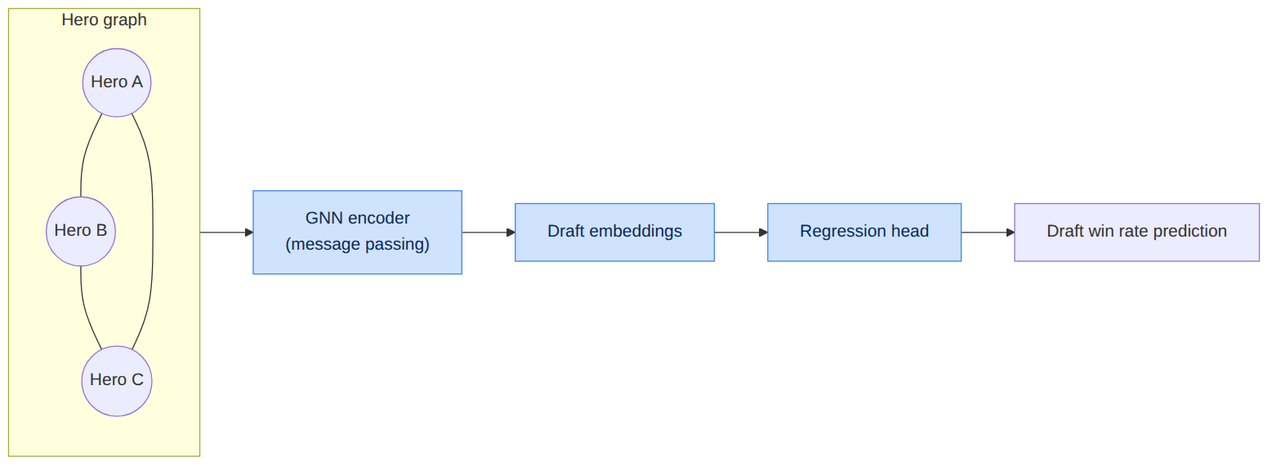
Graph component | Meaning
Node | hero (features: role, attributes, win rate)
Edge (within a team) | pair synergy
Edge (between teams) | counter-pick / counter-matchup
Edge weight | statistical link strength in the patch

6.2.4. Error Detection Engine — error classes
Error class | Trigger features | Example
Positional failure | high $SI$ + $ΔWP<0$ + death | death in fog of war without vision
Suboptimal rotation | low contribution + missed objective | fruitless gank, tempo loss
Critical death | death with buyback available but unused | high-ground loss
Economic error | negative GPM deviation + idle | inefficient farm pattern
Draft error | low synergy/counter | pick ignoring composition

6.3. Training data and features

6.3.1. Building training datasets
Aspect | Approach
Source | ClickHouse (offline store) via Feast
Correctness | point-in-time join (no future leakage)
Split | by time: train (old patches) / val / test (recent patch)
Balancing | stratification by rank and outcome
Versioning | DVC datasets, bound to a commit

6.3.2. Model quality metrics
Model | Primary metric | Target
Win Probability | Brier score / LogLoss | ≤ 0.18
Laning Evaluator | RMSE / R² | R² ≥ 0.75
Draft Predictor | AUC / accuracy@draft | AUC ≥ 0.70
Error Detection | F1 (macro) | ≥ 0.82

6.3.3. Validation strategy
- Time-series cross-validation to exclude leakage.
- Backtesting on historical tournaments to check WP calibration.
- Slice-based error analysis: by rank, role, patch, duration.
- Human-in-the-loop: expert analyst labeling of an error sample as ground truth.

6.4. LLM Service RAG architecture (mathematical context)
The LLM Service uses numerical model outputs as facts for narrative generation. Context retrieval is based on the proximity of situation embeddings:
$$\text{score}(q,d)=cos(e_{q},e_{d})=\frac{e_{q}⋅e_{d}}{\left\|e_{q}\right\| \left\|e_{d}\right\|}$$
where $e_{q}$ is the embedding of the current game situation and $e_{d}$ are the embeddings of reference situations/knowledge in the Vector DB. The top-$k$ nearest are used as prompt context.
RAG parameter | Value
Embedding dimension | 768 / 1024 (configurable)
Index | HNSW (Qdrant/Milvus)
$k$ (top-k) | 5–10
Metric | cosine similarity
Guardrails | reconcile report numbers with model facts

6.5. Uncertainty management and explainability
Aspect | Mechanism
WP confidence intervals | bootstrap ensemble / quantile regression
Prediction explainability | SHAP values for GBDT models
Feature importance | global and local feature importance
Abstaining from prediction | confidence threshold → “insufficient data”
Drift | PSI monitoring (see Chapter 10)
Explainability is critical for user trust: each detected error is accompanied by a list of the features that most influenced the model’s decision (local SHAP values).

Chapter 7. API Design and Interface Specifications

7.1. API design principles
Principle | Implementation
Resource model | REST for external clients, plural resource names
Versioning | /api/v1 prefix; breaking changes → new major version
Unified error format | RFC 7807 (Problem Details)
Idempotency | Idempotency-Key header for POST mutations
Pagination | cursor-based (cursor, limit)
Authentication | Bearer JWT (see Ch. 9)
Rate limiting | X-RateLimit-* headers
Tracing | traceparent (W3C Trace Context)
Internal calls | gRPC over HTTP/2 + mTLS

7.2. REST API Specification (OpenAPI fragment)
openapi: 3.0.3
info:
title: Dota AI Analyst Core API
version: 2.0.0
paths:
/api/v1/matches/upload:
post:
summary: Upload a binary replay file (.dem) for express analysis
operationId: uploadReplay
requestBody:
required: true
content:
multipart/form-data:
schema:
type: object
properties:
file:
type: string
format: binary
user_id:
type: string
format: uuid
responses:
'202':
description: File accepted and queued for ETL processing
content:
application/json:
schema:
type: object
properties:
job_id:
type: string
format: uuid
estimated_time_seconds:
type: integer
example: 10
'400':
description: Invalid file format or corrupted header structure
'401':
description: Access token authorization error
The full contract is provided in a separate file: openapi/dota-ai-analyst.yaml.

7.3. REST endpoint catalog

7.3.1. Matches and analysis
Method | Path | Purpose | Auth
POST | /api/v1/matches/upload | Upload replay | Bearer
GET | /api/v1/matches/{id} | Match metadata | Bearer
GET | /api/v1/matches/{id}/analysis | Analysis result | Bearer
GET | /api/v1/matches/{id}/timeline | WP/net worth time series | Bearer
GET | /api/v1/matches/{id}/heatmap | Heatmap data | Bearer
GET | /api/v1/jobs/{job_id} | Job status | Bearer

7.3.2. Players and profiles
Method | Path | Purpose | Auth
GET | /api/v1/players/{id}/profile | Player profile | Bearer
GET | /api/v1/players/{id}/metrics | Aggregated metrics | Bearer
GET | /api/v1/players/{id}/errors | Error history | Premium
GET | /api/v1/players/{id}/training-plan | Training plan | Premium

7.3.3. Draft, similarity, meta
Method | Path | Purpose | Auth
POST | /api/v1/draft/simulate | Draft simulation | Bearer
POST | /api/v1/similarity/search | Search similar matches/players | Bearer
GET | /api/v1/meta/heroes | Hero meta (win rates) | public
GET | /api/v1/meta/trends | Meta trends | public

7.3.4. Live (WebSocket)
Protocol | Path | Purpose
WS | /api/v1/live/{match_id} | Win Probability stream
WS | /api/v1/live/draft/{session_id} | Live draft simulation

7.4. Response data models (examples)

7.4.1. Match analysis result
{
"match_id": 7654321098,
"status": "completed",
"win_probability": {
"final_radiant": 0.73,
"timeline": [
{ "game_time": 0, "radiant": 0.50 },
{ "game_time": 600, "radiant": 0.58 },
{ "game_time": 1500, "radiant": 0.71 }
]
},
"players": [
{
"player_id": 12345,
"hero_id": 8,
"laning_score": 0.81,
"impact_score": 0.144,
"errors": [
{
"type": "positional_failure",
"game_time": 1320,
"delta_wp": -0.061,
"safety_index": 0.87,
"explanation": "Death in fog of war without vision near enemies."
}
]
}
],
"narrative": "AI Coach: the team dominated the mid game...",
"partial": false
}

7.4.2. Draft simulation request
{
"patch": "7.36c",
"radiant_picks": [8, 74],
"dire_picks": [1, 35],
"bans": [86, 41],
"next_action": "radiant_pick"
}
Response:
{
"predicted_winrate_radiant": 0.54,
"recommendations": [
{ "hero_id": 26, "expected_winrate": 0.58, "reason": "synergy + counter to Dire" },
{ "hero_id": 5, "expected_winrate": 0.56, "reason": "laning boost" }
]
}

7.5. Unified error format (RFC 7807)
{
"type": "https://api.dota-ai-analyst.com/errors/invalid-replay",
"title": "Invalid replay file",
"status": 400,
"detail": "The file is not a valid Source 2 Demo (.dem).",
"instance": "/api/v1/matches/upload",
"trace_id": "9f8e7d6c-..."
}

7.5.1. Error code table
HTTP | Code (type) | Meaning
400 | invalid-replay | Malformed/corrupted file
401 | unauthorized | Missing/invalid token
403 | forbidden | Insufficient rights (RBAC)
404 | not-found | Resource not found
409 | duplicate-job | Idempotency conflict
422 | validation-error | Field validation error
429 | rate-limited | Request limit exceeded
500 | internal-error | Internal error
503 | service-unavailable | Downstream unavailable

7.6. Internal gRPC contracts
Full .proto files are in the proto directory. Service overview:
service MLService {
rpc Predict(PredictRequest) returns (PredictResponse);
rpc PredictStream(stream FeatureFrame) returns (stream WinProbability);
}
service SimilarityService {
rpc FindSimilar(SimilarityQuery) returns (SimilarityResult);
}
service DraftService {
rpc SimulateDraft(DraftState) returns (DraftRecommendation);
}
service FeatureStore {
rpc GetOnlineFeatures(FeatureRequest) returns (FeatureVector);
rpc WriteFeatures(FeatureBatch) returns (WriteAck);
}

7.6.1. REST → gRPC mapping
REST endpoint | Internal gRPC call
GET /matches/{id}/analysis | MLService.Predict + LLM (async)
POST /draft/simulate | DraftService.SimulateDraft
POST /similarity/search | SimilarityService.FindSimilar
GET /players/{id}/training-plan | RecommendationService.BuildPlan
WS /live/{match_id} | MLService.PredictStream

7.7. Versioning, compatibility and deprecation
Aspect | Policy
API version | in the path (/api/v1); v2 on breaking changes
gRPC/Avro compatibility | BACKWARD (optional fields may be added)
Deprecation | Deprecation + Sunset headers, minimum 6 months
Change detection | contract tests in CI (see Ch. 10)

7.8. Rate limits
Tier | Limit (requests/min) | Replay uploads/day
Free | 60 | 5
Premium | 300 | 100
Pro (B2B) | 1200 | 2000
Internal | unlimited | unlimited
Response headers: X-RateLimit-Limit, X-RateLimit-Remaining, X-RateLimit-Reset. On exceedance — 429 + Retry-After.

Chapter 8. Frontend Architecture and Visualization

8.1. React + TypeScript application structure
The interface layer is built on a modular principle using the Zustand state manager to minimize re-renders when rendering interactive maps.

8.1.1. Frontend technology stack
Layer | Technology | Purpose
Language | TypeScript (strict) | Type safety
UI framework | React 18 | Component rendering
State manager | Zustand | Local/global state
Server state | TanStack Query | Cache and API sync
Map rendering | Canvas 2D / WebGL (PixiJS) | Heatmaps, trajectories
Charts | Recharts / D3 | Radar, line charts
Routing | React Router | SPA navigation
Build | Vite | Bundling and HMR
Styling | CSS Modules / Tailwind | Style isolation
Transport | REST (TanStack Query) + WebSocket | Data and live updates
Tests | Vitest + Testing Library + Playwright | Unit/component/e2e

8.1.2. Component architecture diagram
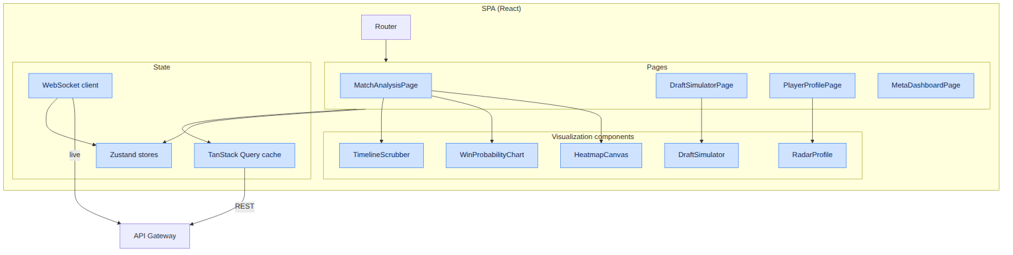

8.2. Key visualization components

8.2.1. Interactive 2D map (Canvas/WebGL)
Component-based rendering of the Dota 2 minimap with several layers:
Layer | Content | Technology
Base | minimap texture | Canvas/WebGL
Heatmap | player/team position density | WebGL shader
Trajectories | team movement during teamfights | Canvas paths
Vision | ward vision polygons | Canvas polygons
Events | death and objective markers | sprites
Time scrubber | binding to game_time | overlay
Render performance requirements:
Metric | Target
FPS during playback | ≥ 60
Heatmap points without lag | ≥ 50,000
Initial map render time | ≤ 200 ms

8.2.2. Profile comparison component (Radar Charts)
A graphical module overlaying the current user’s metrics onto professional players’ polygons (Radar Charts) using the Recharts library.
Radar axis | Metric
Farming | Farm Efficiency
Fighting | Impact Score in fights
Laning | Laning Evaluator score
Vision | contribution to Map Control
Objectives | objective participation
Positioning | 1 − average Safety Index risk

8.2.3. Win Probability Chart and Timeline
- Line chart of WP over game time with highlighted critical moments ($|ΔWP|>τ$).
- The scrubber synchronizes the position on the chart, map and event list.
- Overlay of net worth advantage and objective timings.

8.2.4. Draft Simulator
Interactive pick/ban interface:
- Hero grid with filters by role/attribute.
- Live request to POST /draft/simulate with debounce.
- Display of win-rate prediction and recommendations (via WebSocket for live mode).

8.3. State management

8.3.1. Zustand stores
Store | Responsibility
useMatchStore | current match, selected game_time, map layers
useDraftStore | draft state, recommendations
usePlayerStore | profile, metrics, training plan
useAuthStore | JWT, user, permissions
useUIStore | theme, modals, toasts

8.3.2. Separation of server and client state
Data type | Tool
Cacheable server data | TanStack Query
Live stream (WP, draft) | WebSocket → Zustand
Local UI state | Zustand
Form/validation | component-local state

8.4. API interaction
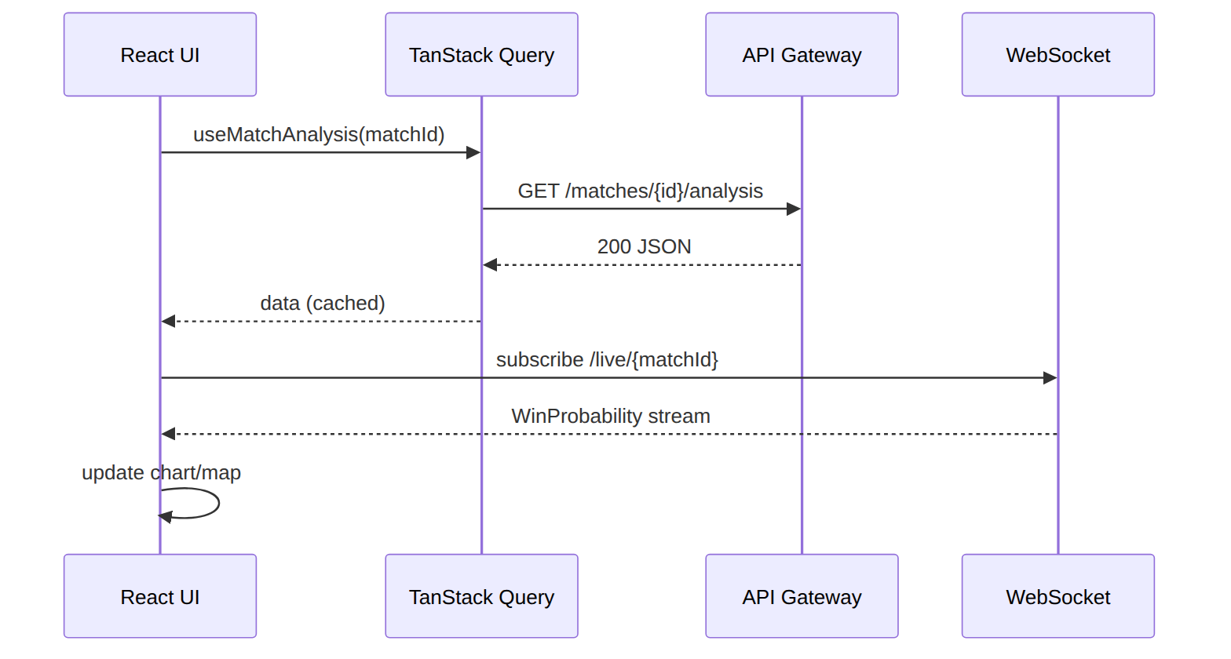

8.4.1. Handling loading/error states
State | UI behavior
loading | component skeletons
partial (partial:true) | “data updating” banner
error 4xx | message with a user action
error 5xx/503 | retry + degradation (show cache)
rate-limited 429 | “too frequent” toast, backoff

8.5. Frontend performance and accessibility

8.5.1. Target metrics (Web Vitals)
Metric | Target
LCP | ≤ 2.5 s
TTI | ≤ 3.5 s
CLS | ≤ 0.1
INP | ≤ 200 ms
Initial bundle size | ≤ 250 KB gzip

8.5.2. Optimizations
Technique | Application
Code splitting | by routes and heavy components (map)
Lazy loading | Draft Simulator, WebGL layers
Memoization | React.memo, useMemo for heavy computations
Virtualization | long match/event lists
Web Workers | heatmap data prep off the main thread
CDN | static assets and minimap assets

8.5.3. Accessibility (a11y) and i18n
Aspect | Implementation
Keyboard navigation | all interactive elements focusable
ARIA | roles and labels for charts (alternative tables)
Contrast | WCAG AA compliance
Internationalization | translation keys (ru/en), number/date formats
Theme | light/dark, synced with the system

8.6. Frontend build and deployment
Aspect | Solution
Build | Vite → static assets
Serving | Nginx (cluster) + CDN
Caching | content hashes in filenames, immutable for assets
Configuration | runtime config via /config.json
Monitoring | Web Vitals → analytics, Sentry for errors
The Frontend Service deployment infrastructure is described in Chapter 12.

Chapter 9. Security, Authentication and Authorization

9.1. Security model (overview)
Platform security follows defense-in-depth and zero-trust principles: each layer has independent controls, and internal services do not trust the network by default.
Layer | Mechanism
Perimeter | WAF, DDoS protection, TLS 1.3 termination
Authentication | JWT (Bearer), OAuth with Steam
Authorization | RBAC + resource ownership check
Transport (internal) | mTLS via service mesh
Data | encryption at rest (AES-256), password hashing
Secrets | Vault / Sealed Secrets
Audit | immutable action log

9.2. Authentication

9.2.1. Authentication flows
Flow | Usage
Steam OpenID/OAuth | login via Steam account
Email + password | classic registration
Refresh token | session renewal without re-login
Service-to-service | mTLS + short-lived tokens

9.2.2. JWT — structure and policy
Parameter | Value
Signing algorithm | RS256 (asymmetric)
Access token TTL | 15 minutes
Refresh token TTL | 30 days (rotation)
Claims | sub, role, plan, iat, exp, jti
Revocation | denylist by jti in Redis
Key rotation | JWKS endpoint, kid versioning
{
"sub": "account-uuid",
"role": "premium",
"plan": "premium_monthly",
"iat": 1752400000,
"exp": 1752400900,
"jti": "token-uuid"
}

9.2.3. Password storage
Aspect | Implementation
Algorithm | Argon2id (or bcrypt cost ≥ 12)
Salt | unique per user
Password policy | minimum 12 characters, breach-list checks
Brute-force protection | rate limit + progressive delay + CAPTCHA

9.3. Authorization (RBAC)

9.3.1. Roles and permissions
Role | Permissions
anonymous | public meta, landing
free | upload (limited), basic analysis
premium | AI Coach, plans, history, extended metrics
pro (B2B) | team analytics, export, higher limits
admin | user management, moderation
service | internal calls (by mTLS identity)

9.3.2. Access matrix (example)
Resource / Role | anonymous | free | premium | pro | admin
GET /meta/* | ✅ | ✅ | ✅ | ✅ | ✅
POST /matches/upload | ❌ | ✅ (limit) | ✅ | ✅ | ✅
GET /players/{id}/training-plan | ❌ | ❌ | ✅ | ✅ | ✅
Team analytics | ❌ | ❌ | ❌ | ✅ | ✅
Admin panel | ❌ | ❌ | ❌ | ❌ | ✅

9.3.3. Resource ownership check
Beyond role, ownership is checked: a player can see their own private breakdowns but not others’ (unless the owner shared access). Enforced at the API Gateway and data-service level.

9.4. Threat model (STRIDE)
Category (STRIDE) | Threat | Mitigation
Spoofing | Identity forgery | JWT signature, mTLS, MFA (opt.)
Tampering | Data change in transit | TLS 1.3, mTLS, payload integrity
Repudiation | Denial of actions | Immutable audit log with trace_id
Information Disclosure | PII leakage | Encryption at rest, data minimization
Denial of Service | Overload | Rate limiting, autoscaling, WAF
Elevation of Privilege | Privilege escalation | Strict RBAC, least privilege

9.4.1. Domain-specific threats
Threat | Mitigation
Uploading a malicious “.dem” | magic/size validation, parser sandbox
API scraping/abuse | rate limit, anomaly detection, API keys
Prompt injection into the LLM | input sanitization, guardrails, context isolation
Data exfiltration via RAG | limit context sources, ACL on Vector DB

9.5. Data and ML pipeline protection
Aspect | Measure
Parser isolation | run in sandbox/gVisor, seccomp, no network
Schema validation | Schema Registry, reject incompatible messages
Model integrity | artifact signing, checksum verification
Data poisoning defense | anomaly detection of input matches, quarantine
Secrets in pipelines | injection from Vault, no hardcoding

9.6. Secret and key management
Secret | Store | Rotation
JWT keys (RSA) | Vault | 90 days
DB passwords | Vault (dynamic secrets) | per policy
External API keys | Vault | per provider
TLS certificates | cert-manager / mesh CA | auto (short TTL)
Data encryption keys | KMS | yearly (envelope encryption)

9.7. Compliance and privacy (GDPR)
Requirement | Implementation
Right to erasure | erasure endpoint → cascading PII deletion
Right to export | user data export (JSON)
Data minimization | store only what is necessary
Consent | explicit processing consent
Pseudonymization | separate PII and analytical identifiers
Retention | retention policies (see Ch. 4.6)

9.8. Infrastructure and SDLC security
Area | Practice
Container images | scanning (Trivy), distroless, non-root
Dependencies | SCA (Dependabot/Snyk), SBOM
Code | SAST in CI, secret scanning
Cluster | Network Policies, Pod Security Standards
Access | least privilege RBAC in Kubernetes, kube-api audit
Response | incident runbooks, rotation on compromise

9.8.1. Security requirements (summary)
ID | Requirement
SEC-AUTH-01 | All external connections use TLS 1.3
SEC-AUTH-02 | All internal calls use mTLS
SEC-AUTH-03 | Access tokens live ≤ 15 min
SEC-DATA-01 | PII encrypted at rest (AES-256)
SEC-DATA-02 | Passwords hashed with Argon2id/bcrypt
SEC-PIPE-01 | Parser isolated in a sandbox without network
SEC-COMP-01 | GDPR erasure/export support

Chapter 10. MLOps, Testing, Logging and CI/CD

10.1. MLOps pipeline and data drift management
To keep predictions stable as the game meta changes, the following technology stack is adopted:
- MLflow Model Registry — storage of model versions, neural-network weights and training-run artifacts.
- DVC (Data Version Control) — versioning of binary feature datasets extracted from ClickHouse.
- Evidently AI / Monitoring Layer — automatic computation of the Population Stability Index (PSI) every 24 hours. When the data drift threshold is exceeded ($PSI>0.25$), an automatic model retraining pipeline is triggered on a fresh pool of matches from Apache Airflow.

10.1.1. Full model lifecycle

10.1.2. PSI formula
$$PSI=\sum_{i=1}^{B}{\left(p_{i}^{curr}−p_{i}^{ref}\right)}⋅ln​\left(\frac{p_{i}^{curr}}{p_{i}^{ref}}\right)$$
where $B$ is the number of bins, and $p_{i}^{ref}$ and $p_{i}^{curr}$ are the shares of observations in bin $i$ for the reference and current distributions.
PSI range | Interpretation | Action
$PSI<0.1$ | No drift | no action
$0.1≤PSI≤0.25$ | Moderate drift | observe, warning alert
$PSI>0.25$ | Significant drift | auto-retrain

10.1.3. Production model quality monitoring
Metric | Model | Alert threshold
Brier score (rolling) | Win Probability | > 0.20
F1 (on labeled) | Error Detection | < 0.78
Feature drift (PSI) | all | > 0.25
Prediction drift | all | sharp distribution shift
Latency p95 | all | > SLO

10.2. Training pipelines (Airflow)
DAG | Trigger | Action
retrain_win_probability | PSI alert / schedule | retrain WP model
retrain_draft_gnn | new patch | update graph + GNN
refresh_meta_graph | daily | recompute meta
materialize_features | scheduled | materialize features (Feast)
data_quality_report | daily | data quality report

10.2.1. Model promotion gates
Gate | Criterion
G1: quality | metric ≥ baseline on hold-out
G2: calibration | Brier ≤ threshold (for WP)
G3: slices | no degradation on key slices
G4: shadow | agreement with current ≥ threshold
G5: canary | no increase in errors/latency

10.3. Testing strategy

10.3.1. Testing pyramid
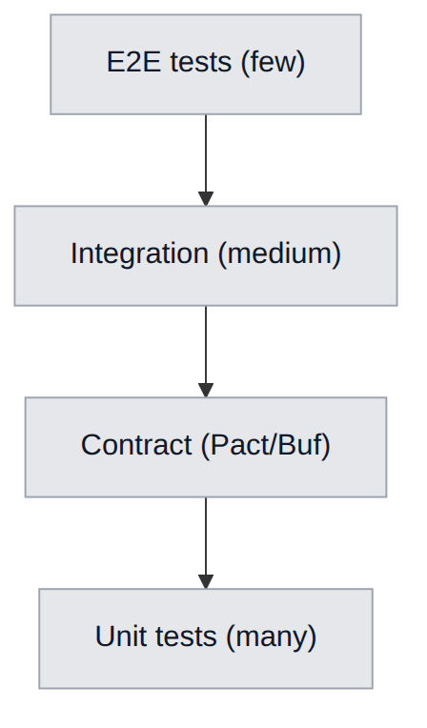
Level | Covers | Tools | Coverage target
Unit | functions, modules | pytest, go test, Vitest | ≥ 80% critical
Contract | REST/gRPC/Avro schemas | Pact, Buf, schema-compat | 100% of contracts
Integration | service + DB + Kafka | Testcontainers | key flows
E2E | user scenarios | Playwright | UC-01…UC-08
Load | NFR-PERF/SCAL | k6, Locust | NFR thresholds
ML tests | data, model, invariance | Great Expectations, deepchecks | key models

10.3.2. ML-specific tests
Type | Check
Data tests | schema, ranges, missing rate
Invariance tests | invariance to irrelevant perturbations
Directional tests | expected direction of a feature’s influence
Calibration tests | consistency of probabilities with frequencies
Regression tests | no worse than the previous version on the benchmark

10.3.3. NFR validation in CI
NFR | Automatic check
NFR-PERF-01 | parser load test on a reference replay
NFR-PERF-02/03 | k6 API latency profile
NFR-SCAL-01 | query test on a large synthetic dataset
NFR-SEC-* | SAST/SCA/secret scans, mTLS verification

10.4. CI/CD and GitOps

10.4.1. CI/CD pipeline

10.4.2. Deployment strategies
Strategy | Application
Rolling update | stateless services by default
Blue/Green | API Gateway, critical services
Canary | ML Service (models), risky changes
Shadow | new model versions (no user impact)

10.4.3. CI pipeline example (ci-cd-pipeline.yml, fragment)
name: ci-cd-pipeline
on: [push, pull_request]
jobs:
test:
runs-on: ubuntu-latest
steps:
- uses: actions/checkout@v4
- name: Lint
run: make lint
- name: Unit tests
run: make test
- name: Contract tests
run: make contract-test
security:
runs-on: ubuntu-latest
steps:
- name: SCA + SAST
run: make security-scan
build:
needs: [test, security]
runs-on: ubuntu-latest
steps:
- name: Build & sign images
run: make build sign sbom
- name: Push
run: make push

10.5. Logging and observability (link to Ch. 11)
Aspect | Standard
Log format | structured JSON
Mandatory fields | timestamp, level, service, trace_id, span_id
Levels | DEBUG/INFO/WARN/ERROR
PII in logs | forbidden (masking)
Correlation | end-to-end trace_id across all services
The full metrics, tracing, alerting and error-budget strategy is described in Chapter 11.

10.6. Artifact and version management
Artifact | Store | Versioning
Models | MLflow + S3 | semver + run_id
Datasets | DVC + S3 | content hash
Images | Container Registry | tag = git sha
Schemas | Schema Registry | schema version
Helm charts | Chart repo | semver
IaC | Git (Terraform) | commit

Chapter 11. Observability, Monitoring and SRE

11.1. The three pillars of observability
Platform observability rests on three pillars — metrics, logs, traces — unified by an end-to-end trace_id and a single visualization stack.
Pillar | Technology | Purpose
Metrics | Prometheus + Grafana | numeric time series, alerts
Logs | Loki (+ Promtail) | structured events
Traces | Tempo + OpenTelemetry | distributed tracing
Profiling | Pyroscope (opt.) | CPU/mem profiles
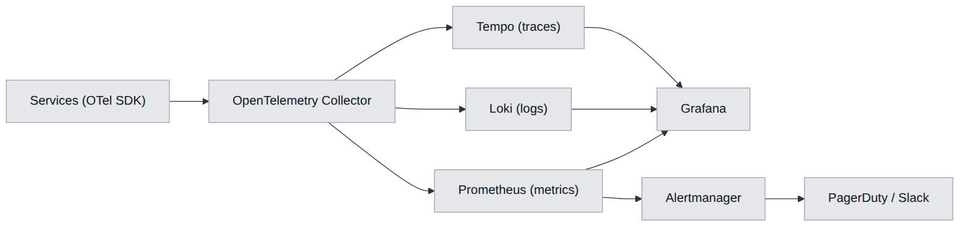

11.2. Metrics

11.2.1. Metric classification
Type | Method (RED/USE) | Examples
Rate | RED | requests/s per endpoint
Errors | RED | 5xx share, ETL reject share
Duration | RED | latency p50/p95/p99
Utilization | USE | CPU/mem/GPU
Saturation | USE | Kafka consumer lag, queue depth
Errors (resource) | USE | OOMKilled, pod restarts

11.2.2. Key business and system metrics
Metric | Type | Owner
replay_parse_duration_seconds | histogram | Replay Parser
etl_consumer_lag | gauge | ETL Service
ml_predict_latency_seconds | histogram | ML Service
api_request_duration_seconds | histogram | API Gateway
wp_brier_score_rolling | gauge | ML Service
feature_freshness_seconds | gauge | Feature Store
kafka_topic_lag | gauge | all consumers
job_completion_rate | counter | ETL/Gateway

11.3. Distributed tracing
Aspect | Implementation
Standard | W3C Trace Context (traceparent)
Propagation | via HTTP, gRPC metadata, Kafka headers
Instrumentation | OpenTelemetry SDK (auto + manual)
Sampling | tail-based (errors and slow — always)
Log correlation | trace_id/span_id in every log
The end-to-end trace of scenario UC-01 spans Gateway → ETL → Parser → ML → LLM, revealing at which step time is lost.

11.4. Logging
Aspect | Standard
Format | JSON
Mandatory fields | timestamp, level, service, trace_id, span_id, message
Forbidden | PII, secrets, full payloads
Rotation/retention | hot 14 days, cold (S3) 90 days
Indexing | by service, level, trace_id
Correlation | click from trace → related logs

11.5. SLO, SLI and Error Budget

11.5.1. SLO catalog
Service | SLI | SLO | Window
API Gateway | availability | 99.95% | 30 days
API Gateway | latency p95 | ≤ 300 ms | 30 days
Replay Parser | parse success | ≥ 99.5% | 30 days
Replay Parser | parse time p95 | ≤ 10 s | 30 days
ML Service | Predict latency p95 | ≤ 400 ms | 30 days
ETL Service | end-to-end lag p95 | ≤ 30 s | 7 days
Feature Store | GetOnline p95 | ≤ 50 ms | 7 days

11.5.2. Error Budget
For a 30-day window and a 99.95% SLO, the allowed downtime ≈ 21.9 min/month. Error budget policy:
Budget state | Policy
Budget healthy | normal release cadence
Budget < 25% | freeze risky changes
Budget exhausted | stop feature releases, focus on reliability

11.6. Alerting

11.6.1. Principles
- Alert on symptoms (SLO violations), not on every metric spike.
- Each alert has a runbook and a severity level.
- Multi-tier: warning (Slack) → critical (PagerDuty).

11.6.2. Key alert catalog
Alert | Condition | Severity | Runbook
API error budget burn | fast budget burn | critical | RB-API-01
Parser SLO breach | p95 > 10 s | critical | RB-PARSE-01
Kafka consumer lag | lag grows > threshold | warning | RB-KAFKA-01
Model drift | PSI > 0.25 | warning | RB-ML-01
WP calibration | Brier > 0.20 | warning | RB-ML-02
DB replication lag | replica lag > threshold | critical | RB-DB-01
Pod crashloop | restarts > N/5 min | critical | RB-K8S-01

11.7. Grafana dashboards
Dashboard | Audience | Panels
Platform Overview | all | RED per service, SLO status
Ingestion Pipeline | backend/SRE | Kafka lag, parser throughput, ETL
ML Health | ML engineers | latency, drift, model quality
API Gateway | backend/SRE | latency, response codes, rate-limit
Data Stores | SRE/DBA | PG/CH load, replication, disk
Business KPIs | product | MAU, conversion, matches processed

11.8. SRE practices
Practice | Implementation
Runbooks | per alert, versioned in the repo
On-call | rotation, escalation, PagerDuty
Postmortems | blameless, with action items
Chaos engineering | scheduled fault injections in staging
Capacity planning | forecasting from metric and KPI trends
Game days | incident response drills

11.8.1. Incident classification
Severity | Description | Target response time
SEV-1 | Full outage / data loss | ≤ 15 min
SEV-2 | Partial degradation of a key function | ≤ 30 min
SEV-3 | Minor impact | ≤ 4 h
SEV-4 | Cosmetic | scheduled

11.8.2. Health-check endpoints
Endpoint | Purpose
/healthz | liveness (process alive)
/readyz | readiness (ready to accept traffic)
/metrics | Prometheus metric export
/startupz | startup probe for slow starts

Chapter 12. Deployment and Infrastructure (Kubernetes, IaC)

12.1. Deployment topology
The platform is deployed on Kubernetes. Logical separation by namespaces provides isolation and resource governance.
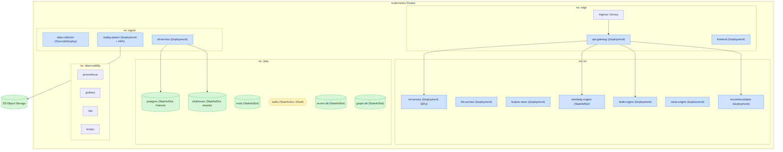

12.2. Kubernetes manifests (examples)

12.2.1. ML Service Deployment
apiVersion: apps/v1
kind: Deployment
metadata:
name: ml-service
namespace: ml
spec:
replicas: 3
selector:
matchLabels: { app: ml-service }
template:
metadata:
labels: { app: ml-service }
spec:
containers:
- name: ml-service
image: registry/ml-service:{{git_sha}}
ports: [{ containerPort: 50051 }]
resources:
requests: { cpu: "2", memory: "4Gi" }
limits: { cpu: "4", memory: "8Gi", nvidia.com/gpu: "1" }
readinessProbe:
grpc: { port: 50051 }
initialDelaySeconds: 10
livenessProbe:
httpGet: { path: /healthz, port: 8080 }

12.2.2. Parser HPA (hpa-parser.yaml)
apiVersion: autoscaling/v2
kind: HorizontalPodAutoscaler
metadata:
name: replay-parser-hpa
namespace: ingest
spec:
scaleTargetRef:
apiVersion: apps/v1
kind: Deployment
name: replay-parser
minReplicas: 3
maxReplicas: 50
metrics:
- type: External
external:
metric:
name: kafka_consumergroup_lag
selector:
matchLabels: { topic: replay.parsed }
target:
type: AverageValue
averageValue: "100"

12.3. Service resource profiles
Service | CPU (req/limit) | Mem (req/limit) | GPU | Replicas (min/max)
api-gateway | 0.5 / 2 | 512Mi / 1Gi | — | 3 / 20
replay-parser | 2 / 4 | 2Gi / 4Gi | — | 3 / 50
etl-service | 1 / 3 | 2Gi / 4Gi | — | 3 / 20
ml-service | 2 / 4 | 4Gi / 8Gi | 1 (opt.) | 3 / 15
llm-service | 1 / 2 | 2Gi / 4Gi | 1 (opt.) | 2 / 10
feature-store | 1 / 2 | 2Gi / 4Gi | — | 2 / 8
similarity-engine | 2 / 4 | 4Gi / 8Gi | — | 2 / 8
frontend | 0.25 / 1 | 256Mi / 512Mi | — | 3 / 10

12.4. Autoscaling
Service | Scaling trigger | Metric
replay-parser | replay.parsed topic lag | kafka_consumergroup_lag
etl-service | features.calculated topic lag | lag + CPU
ml-service | RPS / latency | ml_predict_latency + CPU
api-gateway | RPS | CPU + RPS
frontend | RPS | CPU
Additionally: KEDA for event-driven scaling on Kafka, Cluster Autoscaler for node scaling, and VPA (recommendation mode) for tuning resource requests.

12.5. Infrastructure as Code (IaC)
Layer | Tool | Describes
Cloud resources | Terraform | networks, clusters, DB instances, S3, IAM
Applications | Helm | service charts, per-environment values
Deployment | ArgoCD | GitOps state sync
Secrets | Vault / Sealed Secrets | secret injection
Policies | OPA/Gatekeeper | security admission policies

12.5.1. Terraform structure (example)
module "network" { source = "./modules/network" }
module "kubernetes" { source = "./modules/eks" }
module "postgres" { source = "./modules/rds-postgres" }
module "clickhouse" { source = "./modules/clickhouse" }
module "kafka" { source = "./modules/msk" }
module "object_store"{ source = "./modules/s3" }

12.5.2. Helm chart structure
deployments/
helm/
api-gateway/
replay-parser/
ml-service/
...
values/
dev.yaml
staging.yaml
production.yaml

12.6. Docker Compose (local development)
For local development a docker-compose.yml brings up lightweight versions of dependencies (Kafka, PostgreSQL, ClickHouse, Redis, MinIO) and the services in dev mode.
Component | Image (dev)
kafka | KRaft single-node
postgres | postgres:16
clickhouse | clickhouse/clickhouse-server
redis | redis:7
minio | S3-compatible storage
kafka-ui / schema-registry | development tools

12.7. Multi-region, resilience and DR
Aspect | Strategy
Availability zones | pod distribution across AZs (anti-affinity)
PodDisruptionBudget | minimum available replicas during maintenance
Multi-region | active region + data replicas (phase 2+)
DB failover | Patroni (PG), CH replicas
DR | periodic recovery drills (RPO/RTO — Ch. 4.6)
Backups | automated + recovery verification

12.8. Configuration and environment management
Mechanism | Usage
ConfigMap | non-critical configuration
Secret (from Vault) | credentials, keys
Feature flags | gradual feature rollout
Frontend runtime config | /config.json without rebuild
Namespace isolation | edge / ingest / ml / data / observability
The environment matrix (dev/staging/production/ml-training) is in Chapter 2.

Chapter 13. Project Structure Down to Files and Modules

13.1. Repository strategy
The project is organized as a monorepo with clear separation into applications (apps/), shared libraries (libs/), infrastructure (deployments/, infra/) and documentation (docs/). This approach simplifies atomic changes to cross-service contracts and a unified CI.
Principle | Implementation
Service isolation | each service is a self-contained deploy unit in apps/
Reuse | shared contracts and utilities in libs/ and proto/
Unified contracts | proto/ and openapi/ as the source of truth
Infra alongside code | deployments/, infra/ versioned with code
Unified CI | .github/workflows/ with a per-service matrix

13.2. Monorepo root tree
dota-ai-analyst/
├── .github/
│ └── workflows/
│ ├── ci-cd-pipeline.yml
│ ├── security-scan.yml
│ └── ml-retrain.yml
├── apps/
│ ├── api-gateway/
│ ├── data-collector/
│ ├── replay-parser/
│ ├── etl-service/
│ ├── feature-store/
│ ├── ml-service/
│ ├── llm-service/
│ ├── recommendation-engine/
│ ├── draft-engine/
│ ├── meta-engine/
│ ├── similarity-engine/
│ └── frontend/
├── libs/
│ ├── proto/ # generated gRPC stubs
│ ├── py-common/ # shared Python utilities
│ ├── go-common/ # shared Go packages
│ └── schemas/ # Avro/JSON Kafka schemas
├── proto/ # source .proto (source of truth)
├── openapi/
│ └── dota-ai-analyst.yaml
├── deployments/
│ ├── docker-compose.yml
│ ├── helm/
│ └── kubernetes/
│ ├── deployment-ml.yaml
│ └── hpa-parser.yaml
├── infra/
│ └── terraform/
├── docs/
│ ├── specification/
│ └── adr/
├── Makefile
└── README.md

13.3. Structure of key services

13.3.1. API Gateway (Go)
apps/api-gateway/
├── cmd/
│ └── server/
│ └── main.go
├── internal/
│ ├── config/
│ ├── middleware/
│ │ ├── auth.go
│ │ ├── ratelimit.go
│ │ └── tracing.go
│ ├── handlers/
│ │ ├── matches.go
│ │ ├── players.go
│ │ ├── draft.go
│ │ └── live_ws.go
│ ├── clients/ # gRPC clients to internal services
│ └── router/
├── pkg/
├── Dockerfile
├── go.mod
└── go.sum

13.3.2. Replay Parser (C++/Go)
apps/replay-parser/
├── include/
│ ├── parser_core.hpp
│ ├── demo_reader.hpp
│ ├── entity_decoder.hpp
│ └── event_extractor.hpp
├── src/
│ ├── parser_core.cpp
│ ├── demo_reader.cpp
│ ├── entity_decoder.cpp
│ ├── string_tables.cpp
│ ├── event_extractor.cpp
│ └── serializer.cpp
├── go/ # wrapper and gRPC/Kafka
│ ├── worker.go
│ └── kafka_consumer.go
├── tests/
│ ├── fixtures/ # reference .dem files
│ └── parser_test.cpp
├── CMakeLists.txt
└── Dockerfile

13.3.3. ML Service (Python)
apps/ml-service/
├── models/
│ ├── laning_xgboost.pkl
│ ├── draft_gnn.pt
│ ├── win_probability.pkl
│ └── error_detection.pkl
├── src/
│ ├── app.py # gRPC server
│ ├── predictors/
│ │ ├── win_probability.py
│ │ ├── laning.py
│ │ ├── draft_gnn.py
│ │ └── error_detection.py
│ ├── registry/ # MLflow integration
│ ├── features/ # Feature Store client
│ ├── serving/ # batching, cache, calibration
│ └── explain/ # SHAP explanations
├── tests/
│ ├── test_predictors.py
│ └── test_calibration.py
├── requirements.txt
└── Dockerfile

13.3.4. Frontend (React + TypeScript)
apps/frontend/
├── src/
│ ├── components/
│ │ ├── HeatmapCanvas.tsx
│ │ ├── DraftSimulator.tsx
│ │ ├── WinProbabilityChart.tsx
│ │ ├── RadarProfile.tsx
│ │ └── TimelineScrubber.tsx
│ ├── pages/
│ │ ├── MatchAnalysisPage.tsx
│ │ ├── DraftSimulatorPage.tsx
│ │ ├── PlayerProfilePage.tsx
│ │ └── MetaDashboardPage.tsx
│ ├── store/
│ │ ├── useMatchStore.ts
│ │ ├── useDraftStore.ts
│ │ └── useAuthStore.ts
│ ├── api/
│ │ ├── client.ts # TanStack Query
│ │ └── ws.ts # WebSocket client
│ ├── hooks/
│ ├── workers/ # Web Workers (heatmap)
│ └── App.tsx
├── public/
├── tests/
│ ├── unit/
│ └── e2e/ # Playwright
├── package.json
├── vite.config.ts
├── tsconfig.json
└── Dockerfile

13.3.5. ETL Service (Python)
apps/etl-service/
├── src/
│ ├── app.py
│ ├── consumers/
│ │ └── replay_parsed.py
│ ├── validation/
│ │ └── data_quality.py # Great Expectations
│ ├── enrichment/
│ ├── aggregation/
│ │ └── windows.py
│ ├── sinks/
│ │ ├── clickhouse.py
│ │ └── postgres.py
│ └── outbox/
├── tests/
├── requirements.txt
└── Dockerfile

13.4. Shared libraries
Library | Language | Content
libs/proto | gen | generated gRPC stubs (Go/Python/TS)
libs/schemas | Avro/JSON | Kafka event schemas + versions
libs/py-common | Python | logging, tracing, config, Kafka helpers
libs/go-common | Go | middleware, telemetry, errors

13.5. Code conventions and standards
Area | Standard
Go | gofmt, golangci-lint, cmd/internal/pkg layout
Python | ruff/black, type hints, pyproject.toml
TypeScript | ESLint + Prettier, strict mode
C++ | clang-format, C++17, RAII
Service naming | kebab-case directories, domain in the name
Commits | Conventional Commits
Branching | trunk-based + short-lived branches

13.6. Service-to-directory mapping
Service (Ch. 3) | Directory | Language | Artifact
API Gateway | apps/api-gateway | Go | image + binary
Data Collector | apps/data-collector | Python/Go | image
Replay Parser | apps/replay-parser | C++/Go | image
ETL Service | apps/etl-service | Python | image
Feature Store | apps/feature-store | Python | image
ML Service | apps/ml-service | Python | image + models
LLM Service | apps/llm-service | Python | image
Recommendation | apps/recommendation-engine | Python | image
Draft Engine | apps/draft-engine | Go/Python | image
Meta Engine | apps/meta-engine | Python | image
Similarity Engine | apps/similarity-engine | Python | image
Frontend | apps/frontend | TS/React | static + Nginx image

13.7. Makefile (root targets)
Target | Action
make lint | linters across all services
make test | unit tests
make contract-test | contract tests (proto/OpenAPI)
make proto | generate gRPC stubs from proto/
make build | build images
make up | local run via docker-compose
make security-scan | SAST/SCA/secret scans

Chapter 14. Implementation Roadmap

14.1. Project phases
Phase | Key milestones | Duration
Phase 1: Infrastructure | Deploying PostgreSQL and ClickHouse clusters, baseline Apache Kafka and API Gateway setup. | Sprints 1–4
Phase 2: Parsing and ETL | Completing the C++ Replay Parser core, building the Data Collector pipelines. Populating ClickHouse. | Sprints 5–8
Phase 3: Analytics and ML | Training error-evaluation models, deploying the Feature Store, integrating the Draft Engine and Similarity Engine. | Sprints 9–14
Phase 4: UI, MLOps and Release | Final React app build, configuring data-drift monitoring in MLflow, running load tests. | Sprints 15–20

14.2. Gantt chart
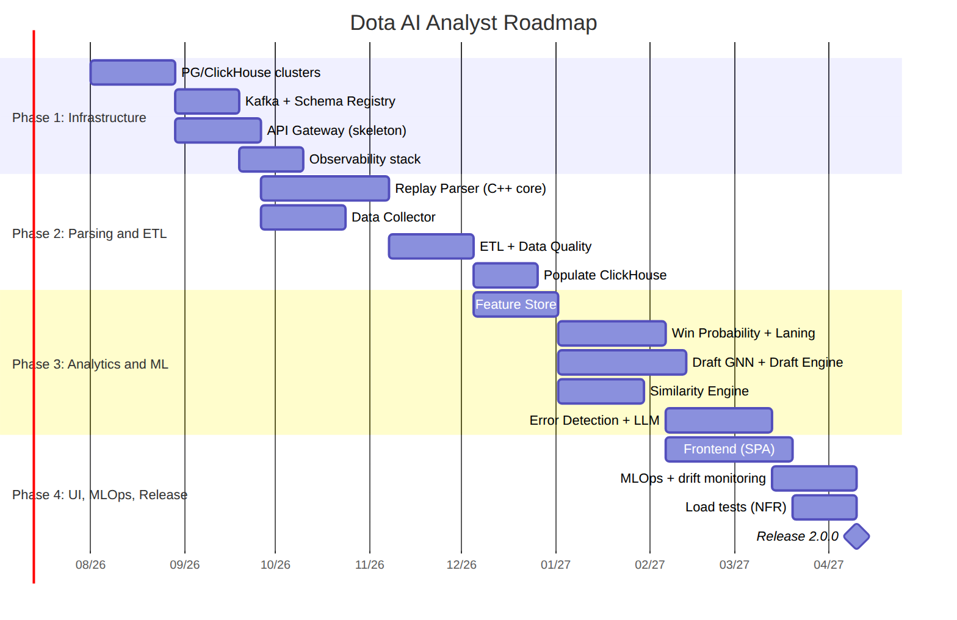

14.3. Sprint breakdown
Sprint | Focus | Key deliverables
1–2 | Bootstrap | repository, CI, K8s cluster, IaC skeleton
3–4 | Stores | PG (Patroni), ClickHouse (shards), Kafka
5–6 | Parser (core) | DemoReader, EntityDecoder, position extraction
7–8 | ETL/Collector | Data Quality, sinks, CH population
9–10 | Feature Store | feature views, online/offline, materialization
11–12 | ML baseline | Win Probability, Laning Evaluator, calibration
13–14 | Graph/search | Draft GNN, Meta Engine, Similarity Engine
15–16 | Error/LLM | Error Detection, RAG, AI Coach
17–18 | Frontend | map, charts, draft simulator
19 | MLOps | drift monitoring, auto-retraining
20 | Release | load tests, NFR acceptance, go-live

14.4. Phase acceptance criteria (Definition of Done)
Phase | Acceptance criteria
Phase 1 | DB clusters HA-available; Kafka accepts events; Gateway serves /healthz; observability works
Phase 2 | Parser meets NFR-PERF-01 on the reference replay; ETL populates CH; DQ rules active
Phase 3 | Models pass quality gates (Ch. 10.2.1); Feature Store serves online features within SLO
Phase 4 | UI passes e2e (UC-01…UC-08); NFR-PERF/SCAL validated by load; drift monitoring active

14.5. Work-stream dependencies
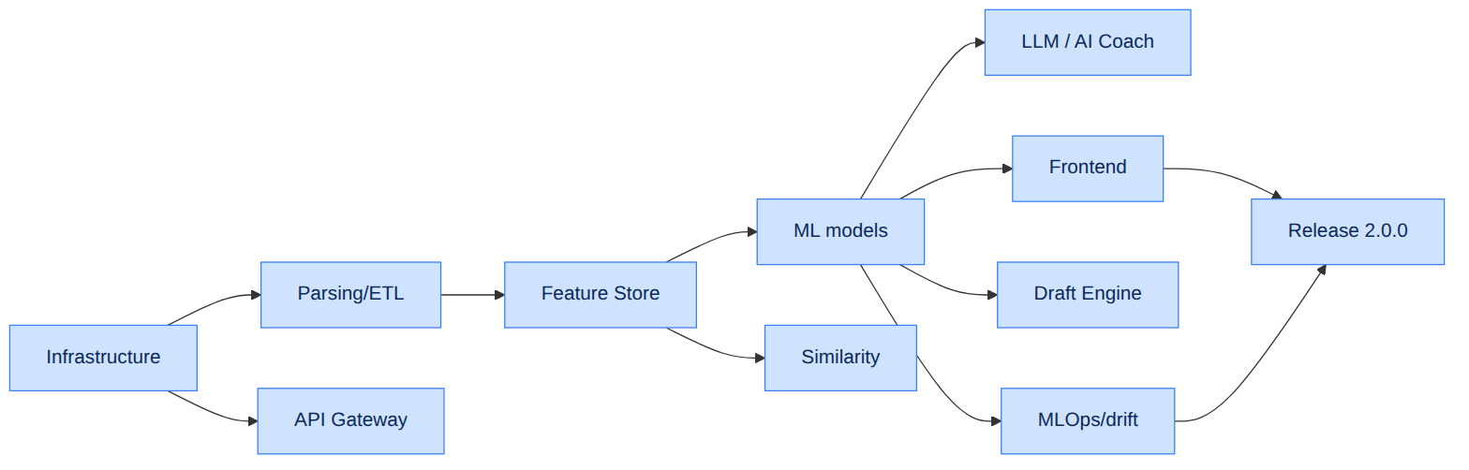

14.6. Risk register
ID | Risk | Likelihood | Impact | Mitigation strategy
R-01 | .dem format change via Valve patch | Medium | High | Parser adapters, fast release cycle, fixture tests
R-02 | Meta drift after a major patch | High | Medium | Auto-retraining (PSI), fast model rollout
R-03 | Insufficient model accuracy | Medium | High | Human-in-the-loop labeling, iterative improvement
R-04 | External API limits/outage | Medium | Medium | Cache, backoff, multiple sources, ACL
R-05 | Peak loads (tournaments) | High | Medium | Autoscaling, priority queues
R-06 | GPU/LLM inference cost | Medium | Medium | Response cache, batching, quotas, degradation
R-07 | PII leakage | Low | High | Encryption, RBAC, audit, GDPR processes
R-08 | Tech debt from rushing | Medium | Medium | ADRs, code review, test coverage threshold

14.7. Release 2.0.0 metrics (Go-Live checklist)
Category | Criterion
Functionality | UC-01…UC-08 pass e2e
Performance | NFR-PERF-01/02/03/04 validated
Scalability | NFR-SCAL-01 confirmed under load
Reliability | NFR-SLA-01 (99.95%) in staging ≥ 2 weeks
Security | SAST/SCA/pentest passed, GDPR processes
Observability | dashboards, alerts, runbooks ready
MLOps | drift monitoring and auto-retraining active
Documentation | specification, ADRs, runbooks up to date

14.8. Post-release evolution (Multi-game and beyond)
Direction | Description
Multi-game (NFR-EXT-01) | core abstraction, adapters for Deadlock/LoL
Mobile apps | native clients over the same API
Real-time on broadcasts | expanding the live plane (WP overlays)
Analytics marketplace | B2B API and partner integrations
AI Coach personalization | fine-tuning to a player’s style
This concludes the main body of the specification. The appendices (OpenAPI, gRPC proto) are located in the openapi/ and proto/ directories.

