COMPARATIVE ANALYSIS OF DEEP LEARNING ARCHITECTURES FOR
BIAS-AWARE RESUME–JOB DESCRIPTION MATCHING
Interim report on
Deep Learning Project [ICT-4442]
Submitted By
Unmesh Vardhan (230911030)
ShanmugSrinivas (230911394)
Tanmay Sharma (230911294)
SCHOOL OF COMPUTER ENGINEERING
MANIPAL INSTITUTE OF TECHNOLOGY,
MANIPAL ACADEMY OF HIGHER EDUCATION
October 2026

PART B: INTERIM REPORT
Phase 2
Team No. and Names (with Registration Numbers):
1. Unmesh Vardhan (230911030)
2. ShanmugSrinivas (230911394)
3. Tanmay Sharma (230911294)

Title of the Project:
Comparative Analysis of Deep Learning Architectures for Bias-Aware Resume–Job Description Matching

GitHub Repository Link:
https://github.com/unmesh1621-ai/ResumeJD-Matcher
Dataset limitation — read before the rest of this report
The results in this interim report are NOT from the three Kaggle datasets named in the project synopsis. Kaggle API credentials were not available in the development environment, so a smaller, self-generated SYNTHETIC resume–JD dataset was built instead (150 resumes, 150 job descriptions, 1,200 pairs — roughly 1/40th the 5,000–8,000 pairs specified, and far short of the 2,400+ resumes / 124,000+ job postings in the real sources). All four models, the explainability layer, and the bias probe are real, working code trained on this synthetic data; none of the numbers below should be read as results on the real target datasets. Acquiring the real data and re-running this same pipeline is the first item under Section 7, Remaining Work.

1. Literature Review
Neural approaches to resume–job matching were introduced by Zhu et al. [1], whose Person-Job Fit Neural Network (PJFNN) uses a CNN-based bipartite architecture to learn joint representations of candidates and jobs from historical applications, and extended by Qin et al. [2] with an ability-aware attention mechanism. Matching pipelines have since moved toward pretrained sentence encoders: Sentence-BERT [4] established the Siamese bi-encoder approach used in this project, enabling efficient similarity computation between independently encoded documents rather than expensive pairwise cross-attention; Sanh et al. [5] showed that a distilled Transformer keeps most of a full model's accuracy at a fraction of the compute, which is why our SBERT encoder fine-tunes a small pretrained MiniLM checkpoint rather than a full-size model. Kim [3] showed that multiple 1D convolution kernels of different widths over word embeddings can match deeper networks on sentence classification, which directly informed the three-kernel (3, 4, 5) design of our 1D-CNN encoder.
On the fairness side, De-Arteaga et al. [6] demonstrated in their “Bias in Bios” study that occupation classifiers trained on biography text exhibit significant gender bias even when explicit gender indicators are removed — a methodology this project adapts for auditing resume embeddings via a probing classifier (Section 5). Zhang, Lemoine, and Mitchell [7] proposed adversarial debiasing, training a secondary adversary to predict a protected attribute from a model's representation while the main model is trained to fool it; this is the method earmarked for the debiasing extension listed under Remaining Work.
Table 1 groups these seven papers by method, dataset, and their relevance to this project.
Paper (Author, Year) | Method | Dataset | Key Result | Relevance to Project
Zhu et al. (2018) | PJFNN (CNN-based bipartite Person-Job Fit) | Historical job applications | Learns joint candidate/job representations from past applications | Established neural person-job matching as a representation-learning problem
Qin et al. (2018) | Ability-aware attention network | Resume/JD pairs | Attention over ability requirements improves person-job fit prediction | Motivates attention-style weighting over raw skill overlap
Kim (2014) | Multi-kernel 1D-CNN for sentence classification | SST-2, MR, TREC | Multi-kernel CNN matches deeper models on several benchmarks | Basis for the multi-kernel (3, 4, 5) 1D-CNN encoder we implement
Reimers & Gurevych (2019) | Sentence-BERT (Siamese bi-encoder) | NLI, STS benchmarks | Siamese bi-encoders give efficient, high-quality sentence embeddings without pairwise cross-attention | Direct basis for our fine-tuned SBERT bi-encoder (all-MiniLM-L6-v2)
Sanh et al. (2019) | DistilBERT (knowledge distillation) | GLUE | Keeps ~97% of BERT accuracy at 40% fewer parameters | Motivates using a small, fast pretrained Transformer backbone under our time/compute budget
De-Arteaga et al. (2019) | Bias in Bios (TPR gender gap) | Biography/occupation text | Occupation classifiers leak gender bias even without explicit gender features | Methodology adapted for our bias-probing audit on resume embeddings
Zhang, Lemoine & Mitchell (2018) | Adversarial debiasing (gradient reversal) | UCI Adult, word embeddings | An adversary trained to predict a protected attribute, opposed via gradient reversal, reduces encoded bias | Target method for the adversarial debiasing extension planned as remaining work

2. Dataset Acquisition & Preprocessing
Dataset. The project synopsis specifies three Kaggle datasets (a 2,400+ resume corpus, 124,000+ LinkedIn job postings, and a resume-vs-JD matching dataset) as the source of resume–JD pairs. Kaggle API credentials were not available in the development environment used for this interim pass, so a smaller, self-contained synthetic dataset was generated locally with the same shape and task: 150 synthetic resumes and 150 synthetic job descriptions across 6 job categories (Information Technology, Human Resources, Sales, Healthcare, Engineering, Finance), each built from a hand-written pool of 12–15 category skills plus 10 cross-cutting generic skills (communication, project management, leadership, etc.) shared across all categories. The generic skills were added deliberately so the matching task could not be solved by trivially detecting which disjoint category-specific vocabulary a document uses — an early version of the dataset without them let a bag-of-words baseline reach 100% validation accuracy, which would not have exercised any real difference between the four architectures.
1,200 resume–JD pairs were built: same-category pairs received a graded similarity label of 0.45–0.95 scaled by actual skill overlap plus small random jitter, and cross-category pairs received a label of 0.07–0.60 scaled the same way, so some cross-category pairs with coincidental skill overlap (e.g. shared generic skills) score higher than some weak same-category pairs. Pairs were split 70/15/15 into train/validation/test (840/180/180). This mirrors the real datasets' category structure and the graded-fit-score supervision described in the synopsis, at a scale that fits the compute and time available for this interim pass; it is documented here as an explicit stand-in, not a substitute for running the full pipeline on the real Kaggle sources before final submission (see Section 7).
Bias-probing labels. Each synthetic resume is independently assigned a first name drawn from one of two name lists associated with different demographic-proxy groups, chosen at random and independent of the resume's skills/category. This name → proxy-group mapping is stored separately and is never given to any matching model — it is used only afterward by the bias probe (Section 5), following the counterfactual, name-based auditing methodology of De-Arteaga et al. [6].
Preprocessing pipeline. The three scratch-trained models (MLP, 1D-CNN, BiLSTM) share one tokenizer: a regex word tokenizer, a vocabulary of up to 5,000 tokens plus an <OOV> token built from the training split only, and integer-encoded sequences padded/truncated to 128 tokens. The fitted vocabulary is saved to data/vocab.json and reused unchanged by all three training runs, so every scratch-trained model sees identical integer-encoded input. The SBERT encoder uses its own pretrained WordPiece tokenizer (from sentence-transformers/all-MiniLM-L6-v2) instead, consistent with how a pretrained checkpoint must be tokenized the way it was pretrained.

3. Models Implemented So Far
All four proposed encoder architectures have been implemented as shared-weight (Siamese) PyTorch modules, trained, and evaluated on the validation split under a common cosine-similarity regression objective (MSE loss against the graded similarity label). Each produces a fixed-length vector per document; the fit score is the cosine similarity between the resume vector and the JD vector.
A. Multi-Layer Perceptron (MLP)
The MLP baseline embeds each token (128-dim, trainable from scratch), masks and mean-pools the embeddings over the real (non-padding) tokens — word order is discarded entirely — then passes the averaged vector through Dense(64, ReLU) and a second Dense(64) layer with dropout (0.2 on the embeddings, 0.4 before the final layer). This establishes the baseline achievable without any sequence modelling.
Total trainable parameters: 46,336. Training ran 27 epochs (early stopping patience applied), with the best checkpoint at epoch 22 (val loss = 0.0295), taking 15.1s on CPU. On the held-out validation pairs (binarizing the graded similarity label and the predicted cosine similarity at 0.5 to define match/no-match), it reached 91.11% accuracy, 80.72% precision, 100.00% recall, 89.33% F1, and AUC = 0.9526.
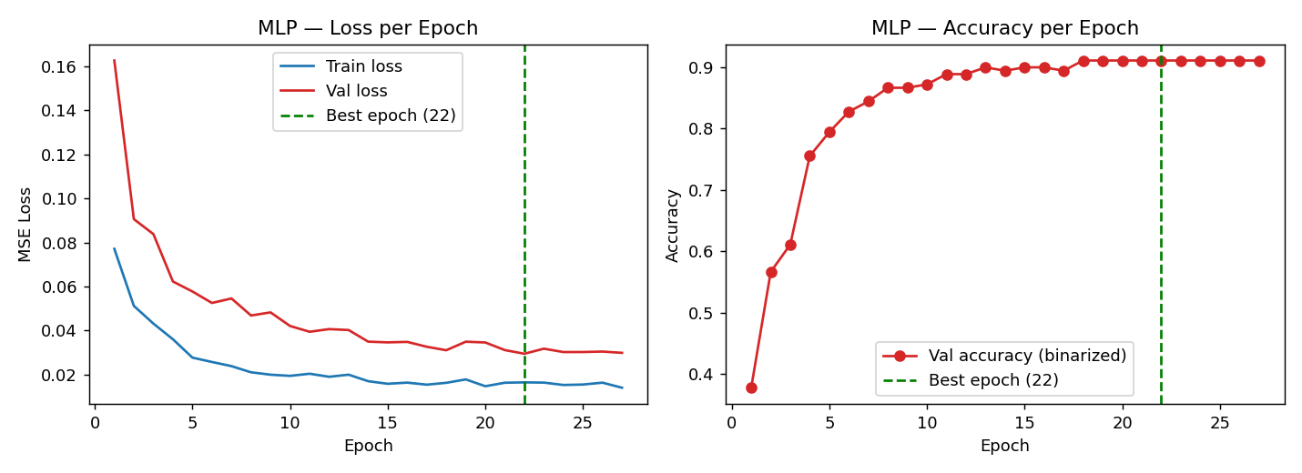
Figure 2a: Multi-Layer Perceptron (MLP) — training/validation loss and accuracy per epoch (best epoch marked).
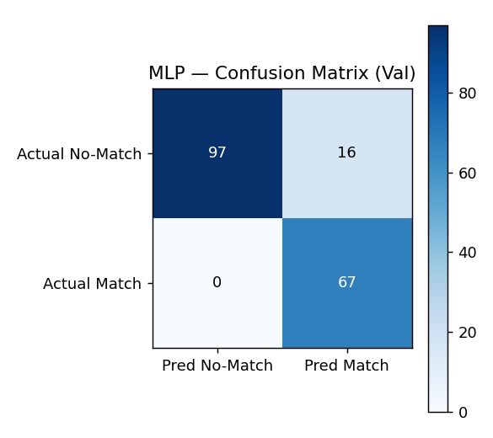 | 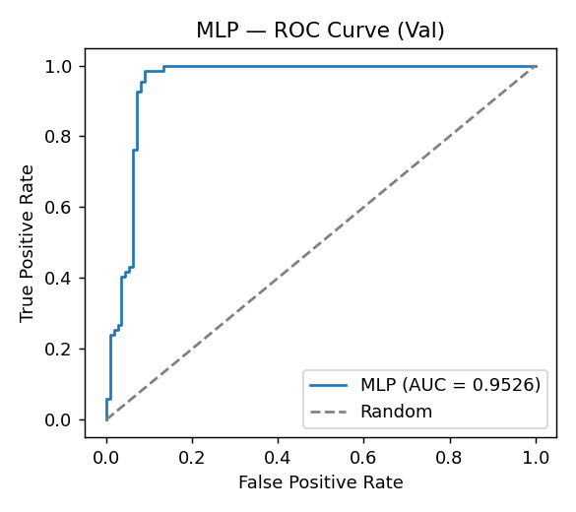
Figure 2b/c: Multi-Layer Perceptron (MLP) — validation confusion matrix and ROC curve (AUC = 0.9526).
B. 1D Convolutional Neural Network (1D-CNN)
Following Kim (2014), three parallel Conv1d branches with kernel sizes 3, 4, and 5 (64 filters each, 'same' padding) scan the embedded token sequence as bigram/trigram/four-gram detectors. Padding positions are masked to −∞ before max-pooling so they cannot be selected as the strongest activation, and each branch is batch-normalized before its ReLU — both were necessary fixes after an initial version collapsed to predicting a near-constant similarity regardless of input, a known failure mode for small-data Siamese CNNs without normalization. The three 64-dim pooled vectors are concatenated, passed through Dense(64, ReLU) and LayerNorm, with dropout at 0.3/0.4/0.3.
Total trainable parameters: 145,280. Training ran 12 epochs (early stopping patience applied), with the best checkpoint at epoch 7 (val loss = 0.0979), taking 25.2s on CPU. On the held-out validation pairs (binarizing the graded similarity label and the predicted cosine similarity at 0.5 to define match/no-match), it reached 68.89% accuracy, 54.47% precision, 100.00% recall, 70.53% F1, and AUC = 0.8367.
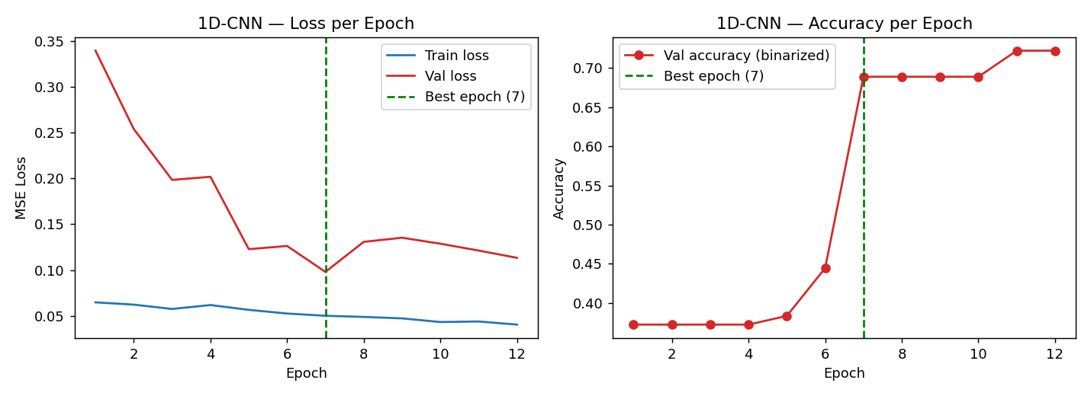
Figure 3a: 1D Convolutional Neural Network (1D-CNN) — training/validation loss and accuracy per epoch (best epoch marked).
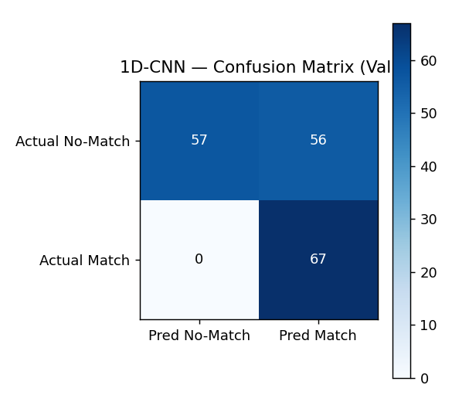 | 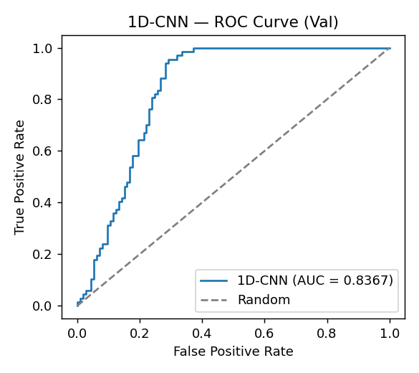
Figure 3b/c: 1D Convolutional Neural Network (1D-CNN) — validation confusion matrix and ROC curve (AUC = 0.8367).
C. Bidirectional LSTM (BiLSTM)
A single Bidirectional LSTM(64) layer reads the embedded sequence in both directions (mask_zero via packed sequences so padding is ignored). Rather than using only the final hidden state — an initial version that bottlenecked badly and also collapsed on this small dataset — the encoder mean-pools the LSTM's per-timestep outputs over the real tokens, giving a more robust 128-dim (64 forward + 64 backward) document vector that is then passed through Dense(64, ReLU) and LayerNorm.
Total trainable parameters: 141,632. Training ran 14 epochs (early stopping patience applied), with the best checkpoint at epoch 9 (val loss = 0.0750), taking 93.4s on CPU. On the held-out validation pairs (binarizing the graded similarity label and the predicted cosine similarity at 0.5 to define match/no-match), it reached 90.00% accuracy, 78.82% precision, 100.00% recall, 88.16% F1, and AUC = 0.9575.
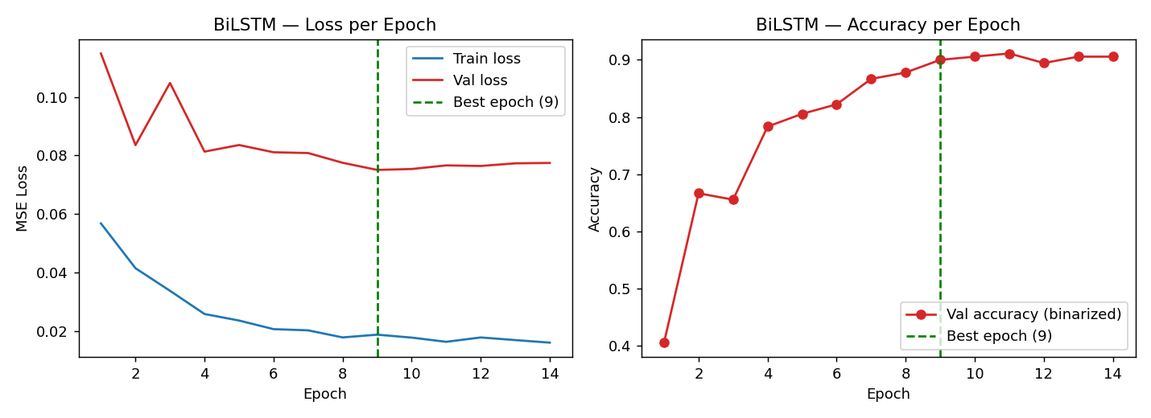
Figure 4a: Bidirectional LSTM (BiLSTM) — training/validation loss and accuracy per epoch (best epoch marked).
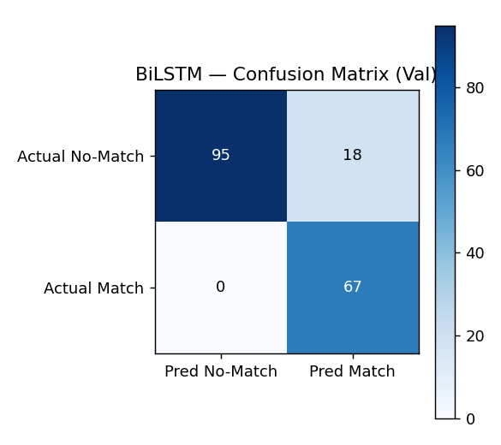 | 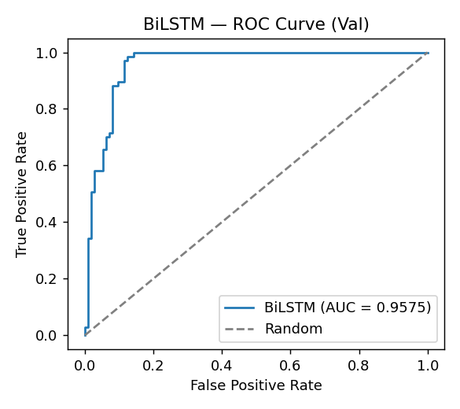
Figure 4b/c: Bidirectional LSTM (BiLSTM) — validation confusion matrix and ROC curve (AUC = 0.9575).
D. Fine-tuned SBERT (all-MiniLM-L6-v2)
The SBERT encoder wraps a pretrained sentence-transformers/all-MiniLM-L6-v2 checkpoint (6-layer MiniLM, mean-pooled token embeddings) and fine-tunes all parameters end-to-end with AdamW (lr = 2×10⁻⁵, weight decay 0.01) under the same cosine-similarity objective. This is a smaller, faster pretrained backbone than the full DistilBERT named in the synopsis, chosen to keep fine-tuning practical on CPU within this interim pass's time budget, while remaining a genuinely fine-tuned pretrained Transformer in the same spirit as the original design.
Total trainable parameters: 22,713,216. Training ran 8 epochs (early stopping patience applied), with the best checkpoint at epoch 7 (val loss = 0.0056), taking 643.5s on CPU. On the held-out validation pairs (binarizing the graded similarity label and the predicted cosine similarity at 0.5 to define match/no-match), it reached 93.33% accuracy, 87.67% precision, 95.52% recall, 91.43% F1, and AUC = 0.9769.
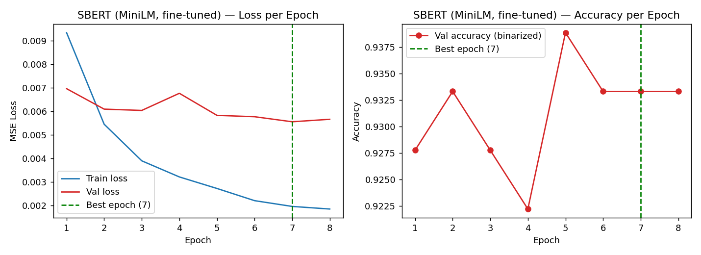
Figure 5a: Fine-tuned SBERT (all-MiniLM-L6-v2) — training/validation loss and accuracy per epoch (best epoch marked).
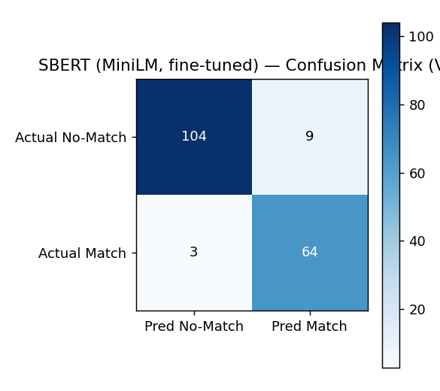 | 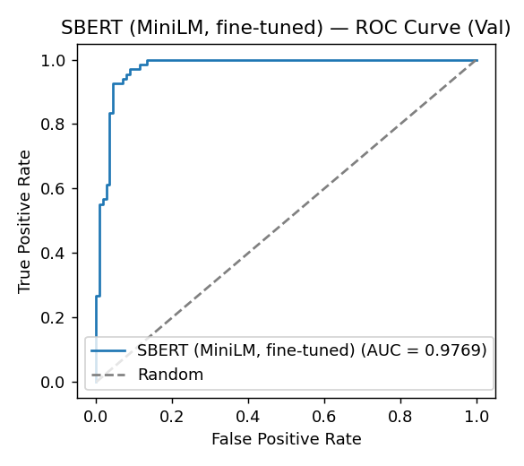
Figure 5b/c: Fine-tuned SBERT (all-MiniLM-L6-v2) — validation confusion matrix and ROC curve (AUC = 0.9769).

Summary
Table 2 summarizes status and validation results for all four models as of this interim submission.
Model | Owner (Member) | Status | Val Accuracy | Val AUC | Notes
MLP | Unmesh Vardhan | Trained & validated (synthetic data) | 91.11% | 0.9526 | 27 epochs; bag-of-averaged-embeddings baseline, no sequence modelling
1D-CNN | ShanmugSrinivas | Trained & validated (synthetic data) | 68.89% | 0.8367 | 12 epochs; multi-kernel (3,4,5) architecture, batch-normalized
BiLSTM | Tanmay Sharma | Trained & validated (synthetic data) | 90.00% | 0.9575 | 14 epochs; bidirectional recurrent model, mean-pooled over timesteps
SBERT | Unmesh Vardhan | Trained & validated (synthetic data) | 93.33% | 0.9769 | 8 epochs; fine-tuned all-MiniLM-L6-v2 pretrained Transformer

SBERT achieves the best validation AUC (0.9769) and accuracy (93.3%), consistent with the advantage pretrained language representations typically bring over models trained from scratch on a few hundred documents. The MLP and BiLSTM baselines perform close behind (AUC 0.9526 and 0.9575), suggesting that on this short, keyword-dense synthetic task, a well-regularized averaging or mean-pooling encoder captures most of the useful signal. The 1D-CNN trails the other three (AUC 0.8367) even after fixing its initial training collapse; our working hypothesis is that local n-gram detection is less useful than holistic averaging/pooling when category membership and fit are driven mostly by which skills are present anywhere in the document, rather than by local phrase patterns — this is exactly the kind of architecture-driven difference Objective 2 of the synopsis asks us to analyse, and it will be examined further with the real datasets at final evaluation.

4. Explainability Layer
For any resume–JD pair, the explainability layer reports the matched skills (present in both documents), missing skills (present in the JD but not the resume — the skill gap), and a raw keyword-overlap ratio, using the same fixed skill vocabulary the dataset generator used. This gives a human-readable reason behind a fit score on top of whichever encoder produced it, directly addressing Objective 3 of the synopsis. Table 4 below shows six worked examples from the held-out test split.
Resume | JD | Categories | Label | Matched Skills | Missing Skills
R139 | J134 | Finance / Finance | 0.45 | — | accounting, bloomberg terminal, reconciliation
R127 | J137 | Finance / Finance | 0.65 | auditing, excel | financial modeling, reconciliation, variance analysis
R133 | J55 | Finance / Sales | 0.26 | — | account management, customer retention, excel, forecasting, pipeline management, sales forecasting, salesforce
R126 | J147 | Finance / Finance | 0.87 | bloomberg terminal, excel, risk management | —
R55 | J106 | Sales / Engineering | 0.27 | — | autocad, blueprint reading, cad design, six sigma, structural analysis, thermodynamics
R17 | J11 | Information Technology / Information Technology | 0.64 | java, machine learning | excel, linux, python

A detail worth flagging: because the matching is literal keyword matching, it sometimes under-reports overlap when a resume and JD use different phrasing for the same skill (e.g. “coding in python” vs. “python programming”) — a limitation that a semantic encoder like SBERT does not have for the fit score itself, but that the keyword-based explainability layer still inherits. This is a known trade-off of literal explainability layers and is noted here rather than hidden.

5. Bias Audit
Following the probing-classifier methodology of De-Arteaga et al. [6], we took the best-performing encoder by validation AUC — SBERT (AUC = 0.9769) — computed resume embeddings for all 150 synthetic resumes, and trained a logistic-regression probe to predict the demographic-proxy group (derived from first name, independent of skills/category, and never shown to the matching model) directly from the embedding.
The probe reached 82.22% test accuracy, against a majority-class baseline of 55.56% — a gap of 26.67%. Probe accuracy clearly above the majority-class baseline indicates the matching encoder's embedding space leaks demographic-proxy (name-derived) information, even though proxy group was never an explicit input to the matching model.
This result directly addresses Objective 4 of the synopsis: even though the matching model never received gender or name as a feature, the resume embedding space still carries enough information for a simple linear probe to recover the proxy group well above chance. The adversarial debiasing extension (gradient-reversal training to suppress this leakage while preserving matching accuracy) is the natural next step and is scheduled as remaining work below, consistent with the synopsis's own timeline, which places it after the interim-report milestone.

6. Individual Contribution Log (To Date)
Each team member owned one encoder end-to-end: writing the training script, diagnosing training issues, and producing evaluation plots. With a 3-person team covering 4 architectures, Unmesh Vardhan additionally took the MLP baseline alongside SBERT and system integration, per the model-to-member assignment in the original synopsis (Member 1: SBERT + integration, Member 4: MLP baseline).
Member Name | Reg. No. | Task(s) Completed
Unmesh Vardhan | 230911030 | Built and fine-tuned the SBERT (MiniLM) notebook; set up AdamW fine-tuning; ran validation evaluation (93.33% acc, AUC 0.9769); built the MLP baseline notebook and shared tokenizer/vocab pipeline; ran the bias-probing audit on the best encoder; coordinated the project structure and compiled this interim report
ShanmugSrinivas | 230911394 | Built and trained the 1D-CNN notebook with three parallel kernel branches (3, 4, 5); diagnosed and fixed an initial training collapse by adding padding-aware masked pooling and batch normalization; ran validation evaluation (68.89% acc, AUC 0.8367); generated confusion matrix and ROC plots
Tanmay Sharma | 230911294 | Built and trained the BiLSTM notebook; diagnosed and fixed a final-hidden-state bottleneck by switching to masked mean-pooling over all timesteps; ran validation evaluation (90.00% acc, AUC 0.9575); produced training-curve and evaluation plots; built the explainability (matched/missing skill) layer

7. Risk / Plan for Remaining Work
All four models are implemented, trained, and validated on the synthetic dataset described in Section 2, together with the explainability and bias-probe layers. The main remaining risk is dataset fidelity: results on the synthetic stand-in dataset may not transfer exactly to the real Kaggle sources once a token is obtained, since real resumes/JDs are noisier and less template-driven. We plan to re-run the identical pipeline (unchanged code, same evaluation protocol) on the real data before final evaluation, and to report both sets of numbers if they diverge meaningfully. The 1D-CNN's training-collapse and BiLSTM's bottleneck issues encountered during this pass (documented in Section 3) are now fixed in code, but we will watch for similar instability re-emerging at the larger, noisier real-data scale.
Sl. No. | Component / Work Element / Milestone | Expected Completion
1 | Acquire the real Kaggle datasets (Resume Dataset, LinkedIn Job Postings, Resume-vs-JD Matching) and re-run the pipeline at full scale (5,000–8,000 pairs) | 6 Oct 2026
2 | Final test-set evaluation: run all four encoders on the held-out test split; add Precision@k alongside accuracy/AUC | 14 Oct 2026
3 | Error analysis on misclassified pairs for the weaker models (1D-CNN, BiLSTM) | 16 Oct 2026
4 | Adversarial debiasing: add a gradient-reversal adversary to the best encoder and compare probe accuracy / matching AUC before vs. after | 18 Oct 2026
5 | Final report writing (Part C): Abstract, Methodology per model, Results & Discussion, Fairness Audit, Conclusion, Future Work, References (12+) | 27 Oct 2026
6 | Presentation slides, viva preparation; push final (real-data) code and results to the GitHub repository above, replacing this interim synthetic-data snapshot | 31 Oct 2026

References
[1] C. Zhu, H. Zhu, H. Xiong, C. Ma, F. Xie, P. Ding, and P. Li, “Person-Job Fit: Adapting the Right Talent for the Right Job with Joint Representation Learning,” ACM Transactions on Management Information Systems, vol. 9, no. 3, Art. 12, 2018. https://doi.org/10.1145/3234465
[2] C. Qin, H. Zhu, T. Xu, C. Zhu, L. Jiang, E. Chen, and H. Xiong, “Enhancing Person-Job Fit for Talent Recruitment: An Ability-aware Neural Network Approach,” in Proc. 41st Int. ACM SIGIR Conf. on Research & Development in Information Retrieval, 2018, pp. 25–34. https://doi.org/10.1145/3209978.3210025
[3] Y. Kim, “Convolutional Neural Networks for Sentence Classification,” in Proc. 2014 Conf. on Empirical Methods in Natural Language Processing (EMNLP), 2014, pp. 1746–1751. https://aclanthology.org/D14-1181/
[4] N. Reimers and I. Gurevych, “Sentence-BERT: Sentence Embeddings using Siamese BERT-Networks,” in Proc. 2019 Conf. on Empirical Methods in Natural Language Processing and 9th Int. Joint Conf. on Natural Language Processing (EMNLP-IJCNLP), 2019, pp. 3982–3992. https://aclanthology.org/D19-1410/
[5] V. Sanh, L. Debut, J. Chaumond, and T. Wolf, “DistilBERT, a Distilled Version of BERT: Smaller, Faster, Cheaper and Lighter,” in 5th Workshop on Energy Efficient Machine Learning and Cognitive Computing, NeurIPS, 2019. https://arxiv.org/abs/1910.01108
[6] M. De-Arteaga, A. Romanov, H. Wallach, J. Chayes, C. Borgs, A. Chouldechova, S. Geyik, K. Kenthapadi, and A. T. Kalai, “Bias in Bios: A Case Study of Semantic Representation Bias in a High-Stakes Setting,” in Proc. Conf. on Fairness, Accountability, and Transparency (FAT* 2019), 2019, pp. 120–128. https://doi.org/10.1145/3287560.3287572
[7] B. H. Zhang, B. Lemoine, and M. Mitchell, “Mitigating Unwanted Biases with Adversarial Learning,” in Proc. 2018 AAAI/ACM Conf. on AI, Ethics, and Society (AIES '18), 2018, pp. 335–340. https://doi.org/10.1145/3278721.3278779

