

**Experiment No. 6**

**Title: Modelling Behavior - Activity and State Chart Diagram using UML**

# Batch:A2 Roll No.:1714028 Experiment:06

**Aim: To model Behavior- Activity and State Chart Diagram using UML.**

**Resources needed:** IBM Rational Rose/Open Source UML Tool

# Procedure:

Prepare mentioned behavior diagrams for chosen problem using Rational Rose/ any other Open Source UML tool.

# Results: Printout of mentioned behavior diagrams

**Activity Diagrams:Fitness Mangement System APP**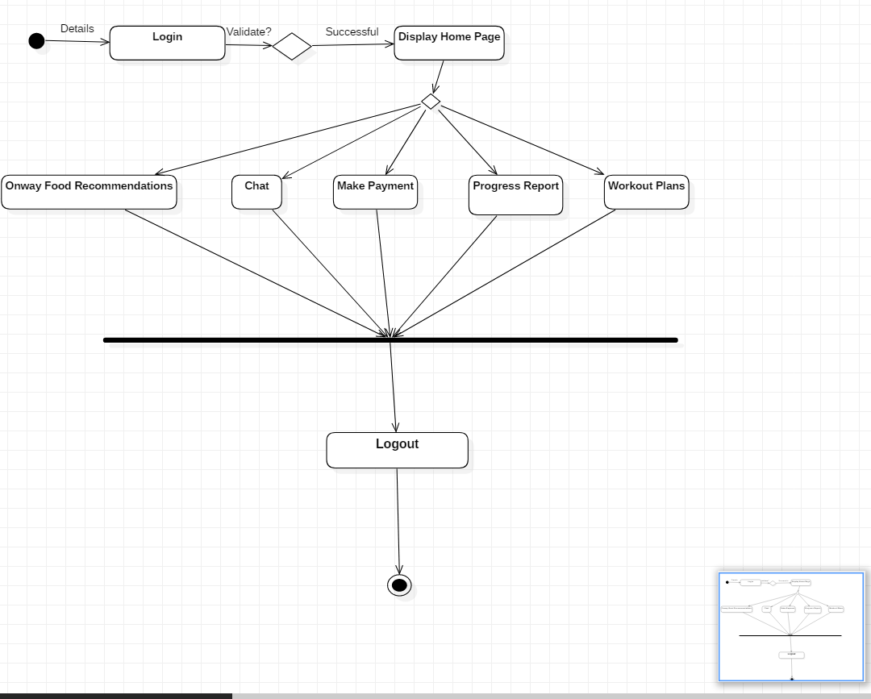

NO

YES

YES

NO

**State Chart Diagram:Fitness Mangement System APP**

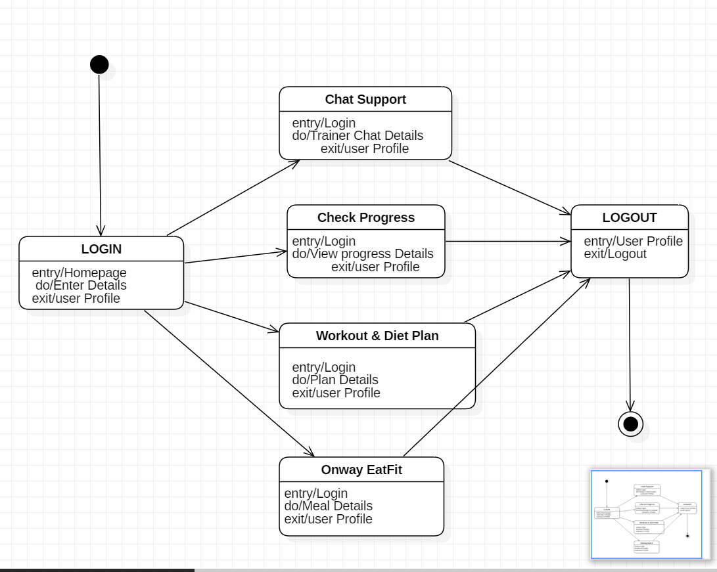

**Questions:**

1. Explain the difference between activity diagram and state chart diagram.

Answer:

|  |  |
| --- | --- |
| **Activity diagram** | **State chart diagram** |
| Activity diagram is flow of functions without trigger (event) mechanism. | State chart diagram consists of triggered states. |
| Activity diagram shows the workflow of step wise activities/tasks for a process or a scenario. | In state diagram, State is the status of a system/subsystem/object at a particular time. |
| Activity diagram does not focus on the stages changing for events and just focuses on next step. | The entire focus is on, how the system changes its state for some particular event and what action need to be performed during this state transition. |
| Activity diagrams describe activities which involve concurrency and synchronization. | State Machines give us the means to control decisions and each state is like a 'mode of operation' for the object which behaves differently depending on its state. |

# Outcomes:Model the requirements using UML

**Conclusion:**I was able to develop activity diagram and state chart diagram for my mini- project successfully.

**Grade: AA / AB / BB / BC / CC / CD /DD Signature of faculty in-charge with date**

**References:**

**Books/ Website:**

1. Michael Blaha, James Rumbaugh, “Object-Oriented Modeling and Design with UML”, Prentice-Hall of India, 2ndEdition
2. Mahesh P. Matha, “Object-Oriented Analysis and Design using UML”, Prentice-Hall of India
3. Timothy C Lethbridge, Robert Laganiere, “Object-Oriented Software Engineering – A practical software development using UML and Java”, Tata McGraw-Hill, NewDelhi.
4. <http://www.uml-diagrams.org/uml-23-diagrams.html>
5. <http://vlabs.iitkgp.ernet.in/se/>